Project Description
MERN Application to use: https://github.com/UnpredictablePrashant/TravelMemory
Tasks:
Part 1: Infrastructure Setup with Terraform
1. AWS Setup and Terraform Initialization:
- Configure AWS CLI and authenticate with your AWS account.
- Initialize a new Terraform project targeting AWS.
2. VPC and Network Configuration:
- Create an AWS VPC with two subnets: one public and one private.
- Set up an Internet Gateway and a NAT Gateway.
- Configure route tables for both subnets.
3. EC2 Instance Provisioning:
- Launch two EC2 instances: one in the public subnet (for the web server) and another in the private subnet (for the database).
- Ensure both instances are accessible via SSH (public instance only accessible from your IP).
4. Security Groups and IAM Roles:
- Create necessary security groups for web and database servers.
- Set up IAM roles for EC2 instances with required permissions.
5. Resource Output:
- Output the public IP of the web server EC2 instance.

Part-1 Project Implementation using Terraform
Architecture overview

Internet
↓
[Internet Gateway]
↓
[Public Subnet]
→ EC2 (Node.js MERN App)
↓ (via NAT)
[Private Subnet]
→ EC2 (MongoDB)

Step: 1:
AWS Setup + Terraform Init

Aws configure
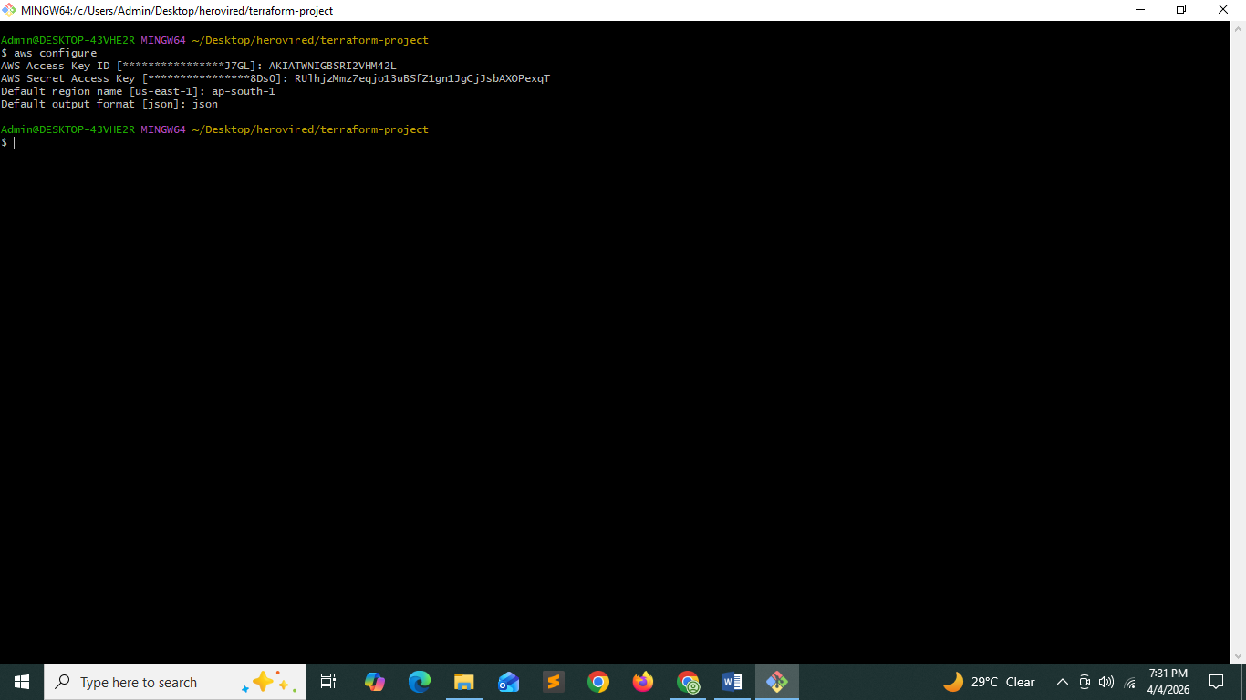

Project Structure
terraform-mern/
│── main.tf
│── variables.tf
│── outputs.tf
│── provider.tf

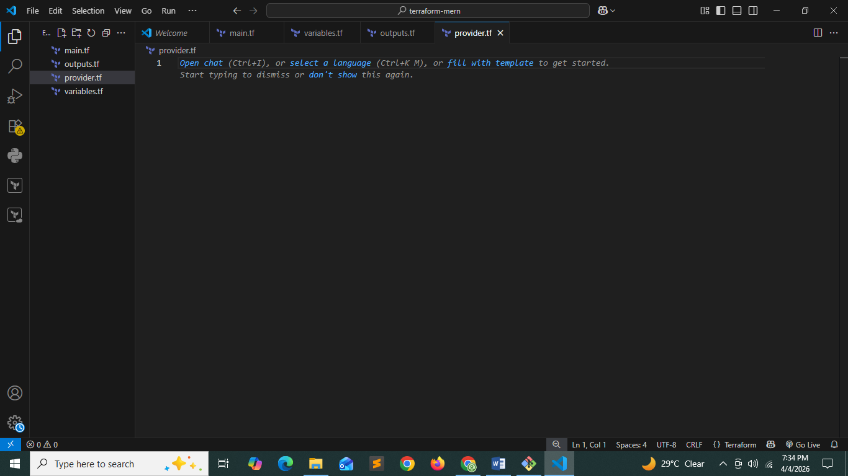

Provider.tf

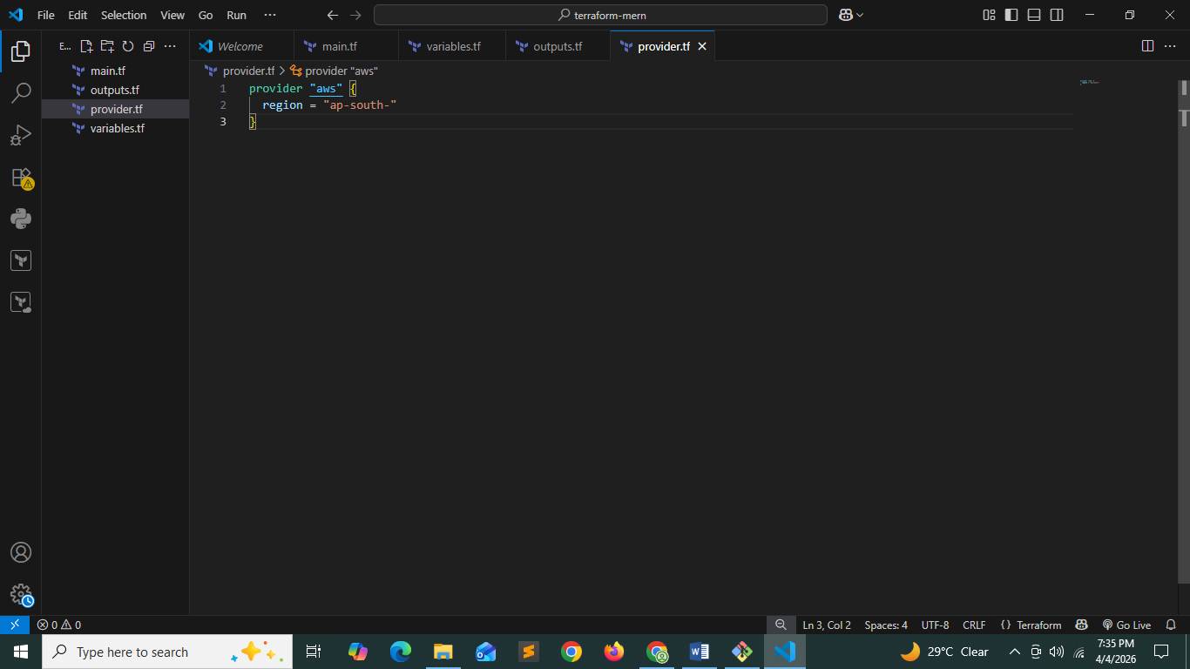

Step: main.tf

terraform {
required_providers {
aws = {
source = "hashicorp/aws"
version = "6.39.0"
}
}
}

# vpc
resource "aws_vpc" "mern_vpc" {
cidr_block = "10.0.0.0/16"
tags = {
Name = "mern-vpc"
name = "mern-vpc"
}
}

# Public Subnet
resource "aws_subnet" "public_subnet" {
vpc_id = aws_vpc.mern_vpc.id
cidr_block = "10.0.1.0/24"
availability_zone = "ap-south-1a"
map_public_ip_on_launch = true
tags = {
Name = "mern-public-subnet"
}

}

# private subnet
resource "aws_subnet" "private_subnet" {
vpc_id = aws_vpc.mern_vpc.id
cidr_block = "10.0.2.0/24"
availability_zone = "ap-south-1a"
tags = {
Name = "mern-private-subnet"
}
}

# internet gateway
resource "aws_internet_gateway" "igw" {
vpc_id = aws_vpc.mern_vpc.id
tags = {
Name = "mern-igw"
}
}

# Route Table (Public)
resource "aws_route_table" "public_rt" {
vpc_id = aws_vpc.mern_vpc.id
tags = {
name = "mern-public-rt"
}
}

resource "aws_route" "public_route" {
route_table_id = aws_route_table.public_rt.id
destination_cidr_block = "0.0.0.0/0"
gateway_id = aws_internet_gateway.igw.id
}

resource "aws_route_table_association" "public_assoc" {
subnet_id = aws_subnet.public_subnet.id
route_table_id = aws_route_table.public_rt.id
}

# NAT Gateway (for private subnet)
resource "aws_eip" "nat_eip" {
}

resource "aws_nat_gateway" "nat" {
allocation_id = aws_eip.nat_eip.id
subnet_id = aws_subnet.public_subnet.id
tags = {
Name = "mern-natgw"
}
}

# Private Route Table
resource "aws_route_table" "private_rt" {
vpc_id = aws_vpc.mern_vpc.id
tags = {
name = "mern-private-rt"
}
}

resource "aws_route" "private_route" {
route_table_id = aws_route_table.private_rt.id
destination_cidr_block = "0.0.0.0/0"
nat_gateway_id = aws_nat_gateway.nat.id
}

resource "aws_route_table_association" "private_assoc" {
subnet_id = aws_subnet.private_subnet.id
route_table_id = aws_route_table.private_rt.id
}

# security groups

# frontend-sg creation
resource "aws_security_group" "web_sg" {
vpc_id = aws_vpc.mern_vpc.id

ingress {
from_port = 22
to_port = 22
protocol = "tcp"
cidr_blocks = ["0.0.0.0/0"]
}

ingress {
from_port = 3000
to_port = 3000
protocol = "tcp"
cidr_blocks = ["0.0.0.0/0"]
}

ingress {
from_port = 80
to_port = 80
protocol = "tcp"
cidr_blocks = ["0.0.0.0/0"]
}

ingress {
from_port = 443
to_port = 443
protocol = "tcp"
cidr_blocks = ["0.0.0.0/0"]
}

egress {
from_port = 0
to_port = 0
protocol = "-1"
cidr_blocks = ["0.0.0.0/0"]
}

tags = {
name = "mern-frontend-sg"
}
}

# database sg creation:
resource "aws_security_group" "db_sg" {
vpc_id = aws_vpc.mern_vpc.id

ingress {
from_port = 22
to_port = 22
protocol = "tcp"
cidr_blocks = ["0.0.0.0/0"]
}

ingress {
from_port = 3001
to_port = 3001
protocol = "tcp"
cidr_blocks = ["0.0.0.0/0"]
}
tags = {
name = "mern-backend-sg"
}
}

# ec2 instance creation:
# frontend ec2 instance
resource "aws_instance" "frontend" {
ami = "ami-05d2d839d4f73aafb" # Amazon Linux
instance_type = "t2.micro"
subnet_id = aws_subnet.public_subnet.id
key_name = "mern-key"

associate_public_ip_address = true

vpc_security_group_ids = [aws_security_group.web_sg.id]
tags = {
name = "mern-frontend"
}
}

# backend ec2 instance creation
resource "aws_instance" "backend" {
ami = "ami-05d2d839d4f73aafb"
instance_type = "t2.micro"
subnet_id = aws_subnet.private_subnet.id
key_name = "mern-key"

vpc_security_group_ids = [aws_security_group.db_sg.id]
tags = {
name = "mern-backend"
}
}

# iam role
resource "aws_iam_role" "ec2_role" {
name = "ec2-role"

assume_role_policy = jsonencode({
Version = "2012-10-17",
Statement = [{
Action = "sts:AssumeRole",
Effect = "Allow",
Principal = {
Service = "ec2.amazonaws.com"
}
}]
})
}

Outputs.tf
output "frontend_public_ip" {
value = aws_instance.frontend.public_ip
}
output "backend_public_ip" {
value = aws_instance.backend.public_ip
}

Folder structure

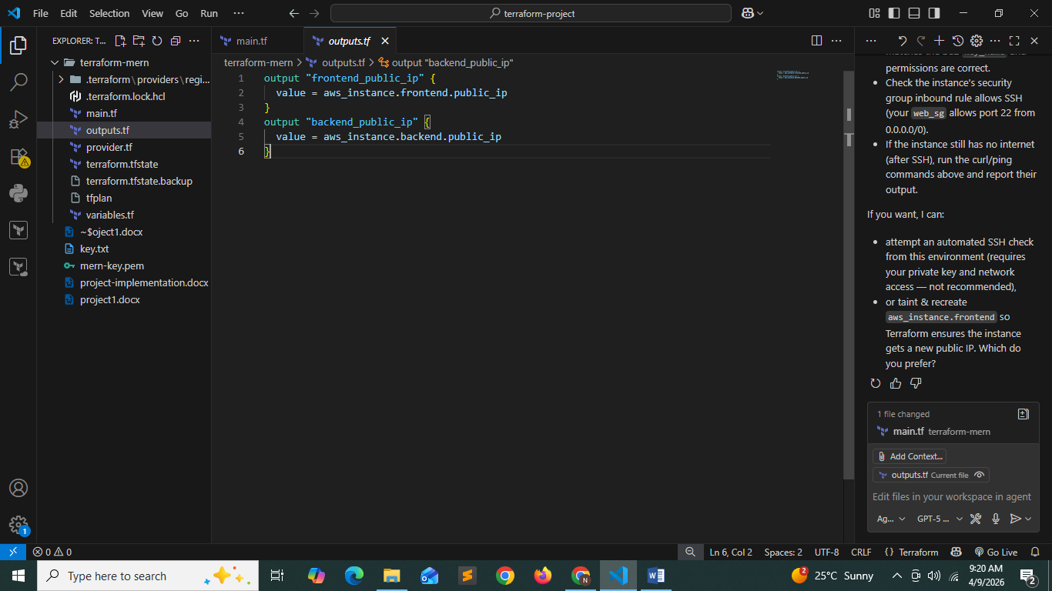

Part-2 Project Implementation using Ansible
Windows:
- wsl --install -d Ubuntu
- sudo apt update
- sudo apt install ansible -y
- ansible –version

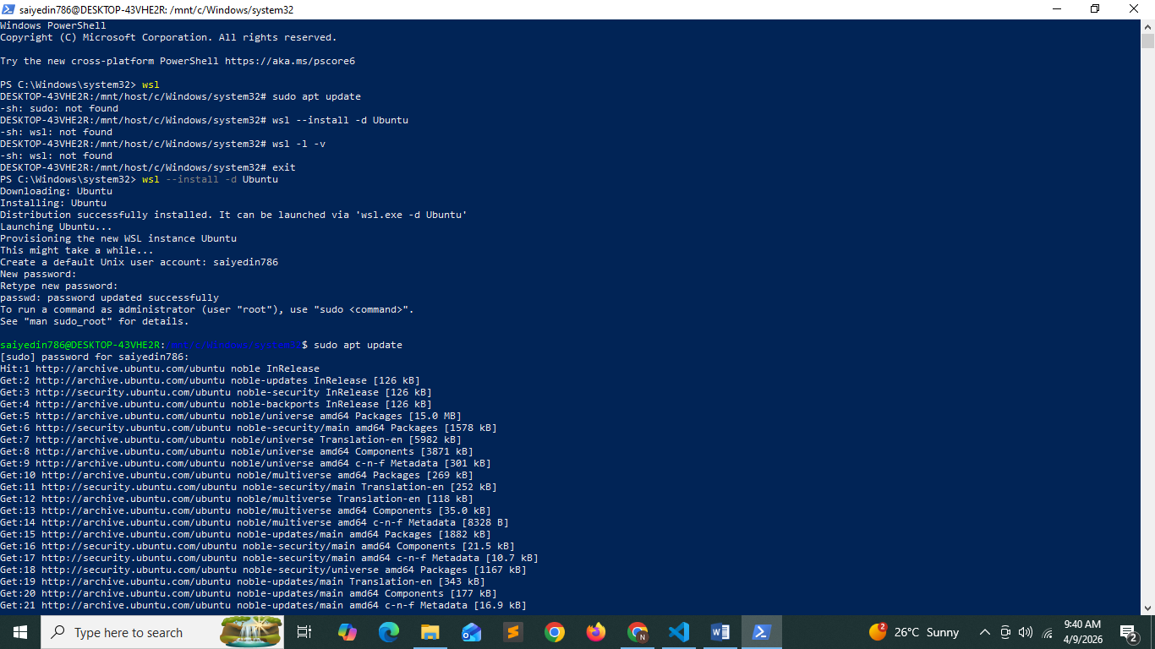

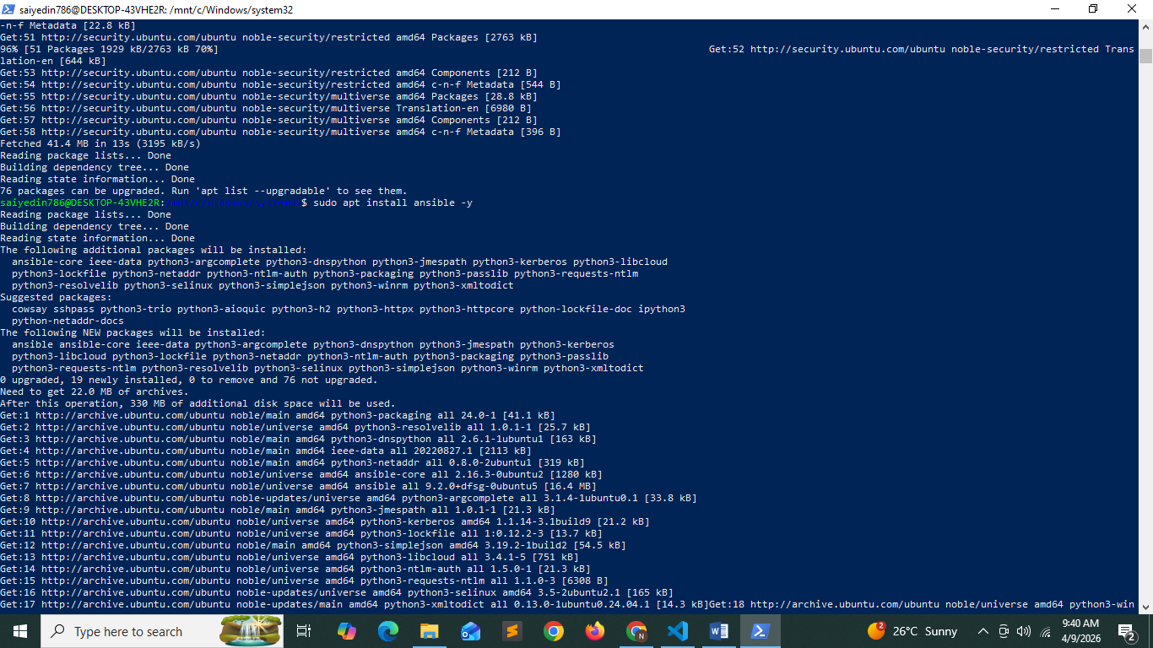

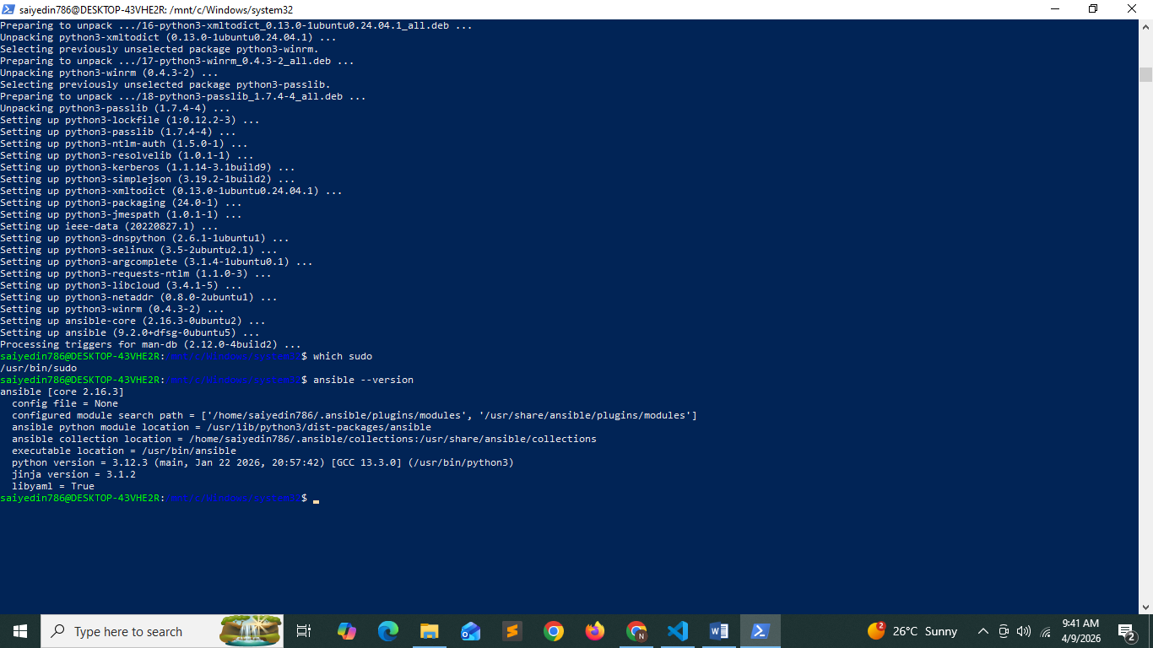

Creating hosts.ini
[web]
bastion ansible_host=13.233.92.171 ansible_user=ubuntu ansible_ssh_private_key_file=~/mern-key.pem

[db]
private1 ansible_host=10.0.2.158 ansible_user=ubuntu ansible_ssh_private_key_file=~/mern-key.pem ansible_ssh_common_args='-o ProxyCommand="ssh -i ~/mern-key.pem ubuntu@13.233.92.171 -W %h:%p"'

Creating db.yml for database mongodb configuration on aws instance in private subnet
- name: Setup MongoDB Server
hosts: db
become: yes

vars:
mongo_admin_user: admin
mongo_admin_password: password123 # ⚠️ change in real projects

tasks:

- name: Update apt cache
apt:
update_cache: yes

#Install dependencies
- name: Install required packages
apt:
name:
- gnupg
- curl
state: present

# Add MongoDB GPG key and official repo only on supported distro (jammy)
- name: Import MongoDB GPG key
shell: |
curl -fsSL https://pgp.mongodb.com/server-6.0.asc | \
gpg -o /usr/share/keyrings/mongodb-server-6.0.gpg --dearmor
args:
creates: /usr/share/keyrings/mongodb-server-6.0.gpg

- name: Add MongoDB repository
copy:
dest: /etc/apt/sources.list.d/mongodb-org-6.0.list
content: |
deb [ arch=amd64 signed-by=/usr/share/keyrings/mongodb-server-6.0.gpg ] https://repo.mongodb.org/apt/ubuntu jammy/mongodb-org/6.0 multiverse

- name: Update apt cache again
apt:
update_cache: yes

# Install MongoDB: use official mongodb-org for jammy, otherwise install distro package
- name: Install MongoDB
apt:
name: mongodb-org
state: present

- name: Enable and start MongoDB service
systemd:
name: mongod
state: started
enabled: yes

# Create admin user using mongosh if available, otherwise mongo
- name: Create MongoDB Admin User
shell: |
if command -v mongosh >/dev/null 2>&1; then
mongosh --eval "db = db.getSiblingDB('admin'); if (!db.getUser('{{ mongo_admin_user }}')) { db.createUser({ user: '{{ mongo_admin_user }}', pwd: '{{ mongo_admin_password }}', roles: [{ role: 'root', db: 'admin' }] }); }"
elif command -v mongo >/dev/null 2>&1; then
mongo --eval "db = db.getSiblingDB('admin'); if (!db.getUser('{{ mongo_admin_user }}')) { db.createUser({ user: '{{ mongo_admin_user }}', pwd: '{{ mongo_admin_password }}', roles: [{ role: 'root', db: 'admin' }] }); }"
else
echo "No mongo shell available" >&2
exit 1
fi
args:
executable: /bin/bash

- name: Allow remote access in MongoDB config
replace:
path: /etc/mongod.conf
regexp: '^ bindIp: 127.0.0.1'
replace: ' bindIp: 0.0.0.0'

#Firewall setup
- name: Install UFW
apt:
name: ufw
state: present

- name: Enable UFW
ufw:
state: enabled
policy: allow

- name: Allow required ports
ufw:
rule: allow
port: "{{ item }}"
loop:
- 22
- 80
- 443
- 3000
- 3001
- 27017

# SSH security
- name: Disable root SSH login
lineinfile:
path: /etc/ssh/sshd_config
regexp: '^PermitRootLogin'
line: 'PermitRootLogin no'
backup: yes

- name: Restart SSH service
service:
name: ssh
state: restarted

Creating web.yml for ec2 instance in public subnet

- name: Setup Web Server
hosts: web
become: yes

vars:
app_dir: /home/ubuntu/app
frontend_dir: "{{ app_dir }}/frontend"
backend_dir: "{{ app_dir }}/backend"
backend_url: "http://13.206.107.143:3001"

tasks:

# ================= BASIC SETUP =================

# - name: Update apt cache
# apt:
# update_cache: yes

- name: Install required packages
apt:
name:
- curl
- git
state: present

- name: Add NodeSource repo
shell: curl -fsSL https://deb.nodesource.com/setup_18.x | bash -
args:
executable: /bin/bash

- name: Install Node.js
apt:
name: nodejs
state: present

# ================= CLONE CODE =================

- name: Clone Repository
git:
repo: "https://github.com/saiyedin786/TravelMemory_prashant.git"
dest: "{{ app_dir }}"
force: yes

- name: Set ownership to ubuntu
file:
path: "{{ app_dir }}"
owner: ubuntu
group: ubuntu
recurse: yes

# ================= PM2 SETUP =================

- name: Install PM2 globally
npm:
name: pm2
global: yes
become: yes

- name: Set npm global bin path manually
set_fact:
npm_global_bin: "/usr/bin"

# ================= BACKEND =================

- name: Install Backend Dependencies
command: npm install
args:
chdir: "{{ backend_dir }}"
become_user: ubuntu

# - name: Stop existing backend
# shell: |
# pm2 PATH={{ npm_global_bin.stdout }}:$PATH pm2 delete backend || true
# become_user: ubuntu

- name: Start Backend
command: pm2 start index.js --name backend
args:
chdir: "{{ backend_dir }}"
become_user: ubuntu

# ================= FRONTEND =================

- name: Install Frontend Dependencies
command: npm install
args:
chdir: "{{ frontend_dir }}"
become_user: ubuntu

# - name: Create frontend .env file
# copy:
# dest: "{{ frontend_dir }}/.env"
# content: |
# REACT_APP_API_URL={{ backend_url }}
# become_user: ubuntu

- name: Build Frontend
command: npm run build
args:
chdir: "{{ frontend_dir }}"
become_user: ubuntu

- name: Install serve globally
npm:
name: serve
global: yes
become: yes

# - name: Stop existing frontend
# shell: |
# pm2 PATH={{ npm_global_bin.stdout }}:$PATH pm2 delete frontend || true
# become_user: ubuntu

- name: Start Frontend
command: pm2 start npx --name frontend -- serve -s /home/ubuntu/app/frontend/build -l 3000
args:
chdir: "{{ frontend_dir }}"
become_user: ubuntu

# ================= PM2 SAVE =================

- name: Save PM2 process list
command: pm2 save
become_user: ubuntu

- name: Setup PM2 startup
command: pm2 startup systemd -u ubuntu --hp /home/ubuntu

Terraform commands:
- terraform init
- terraform plan
- terraform apply

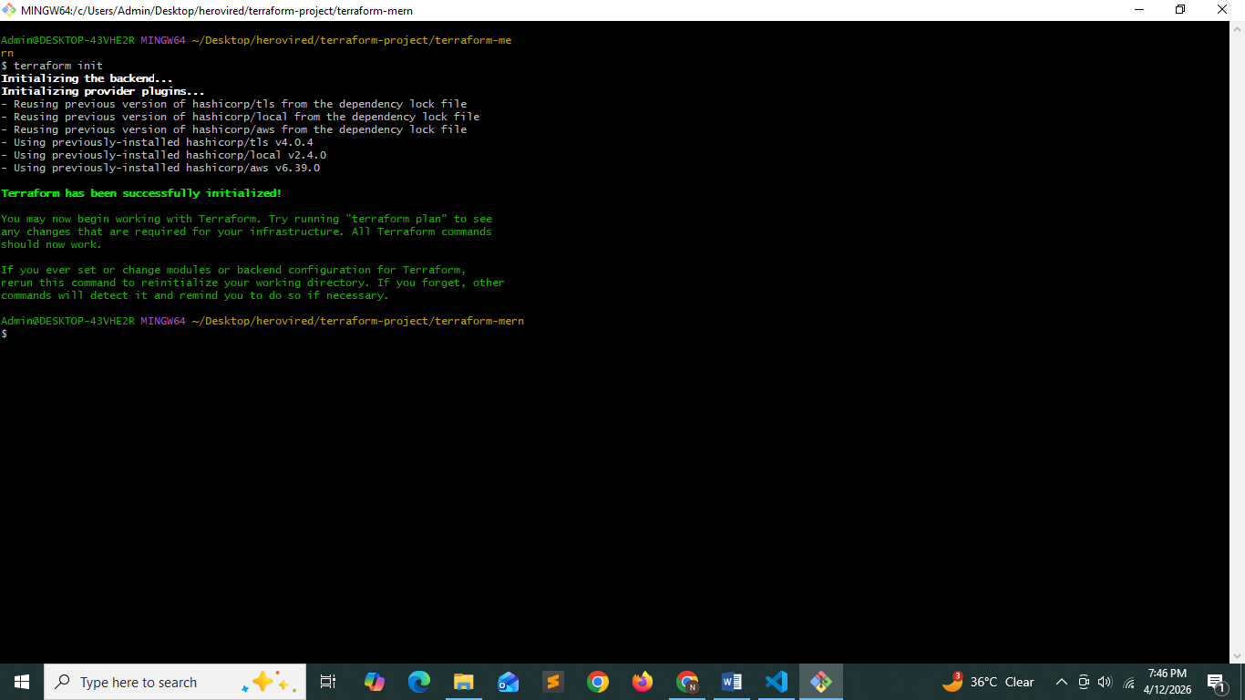

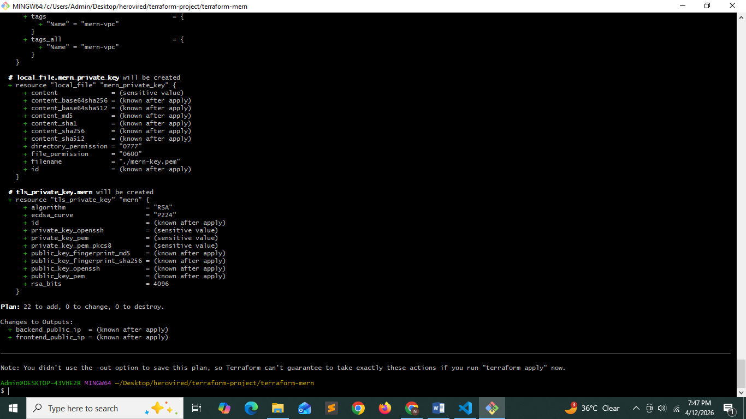

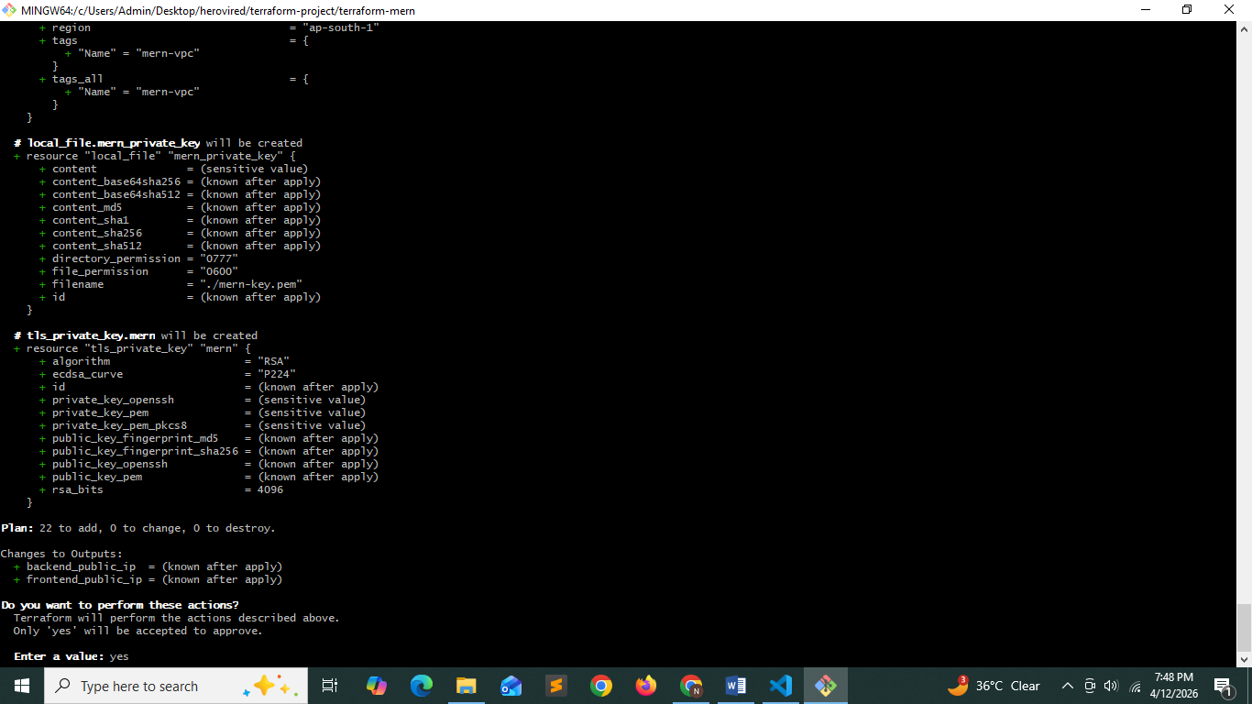

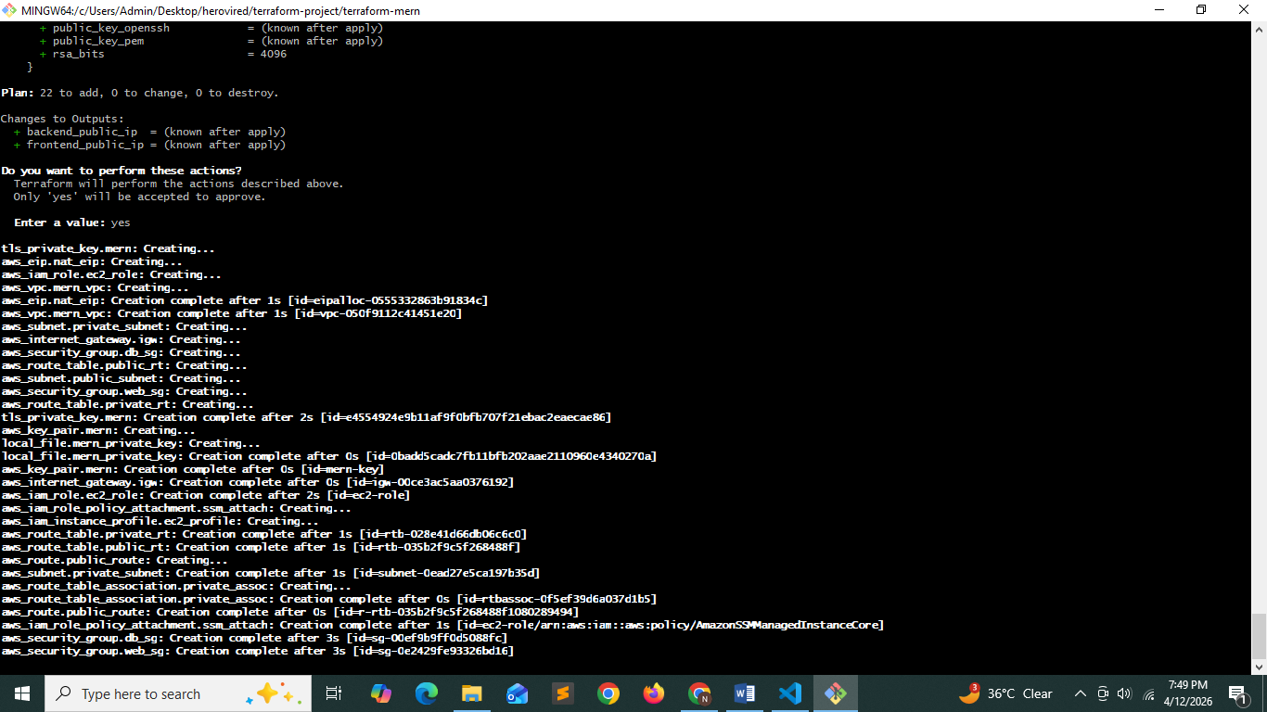
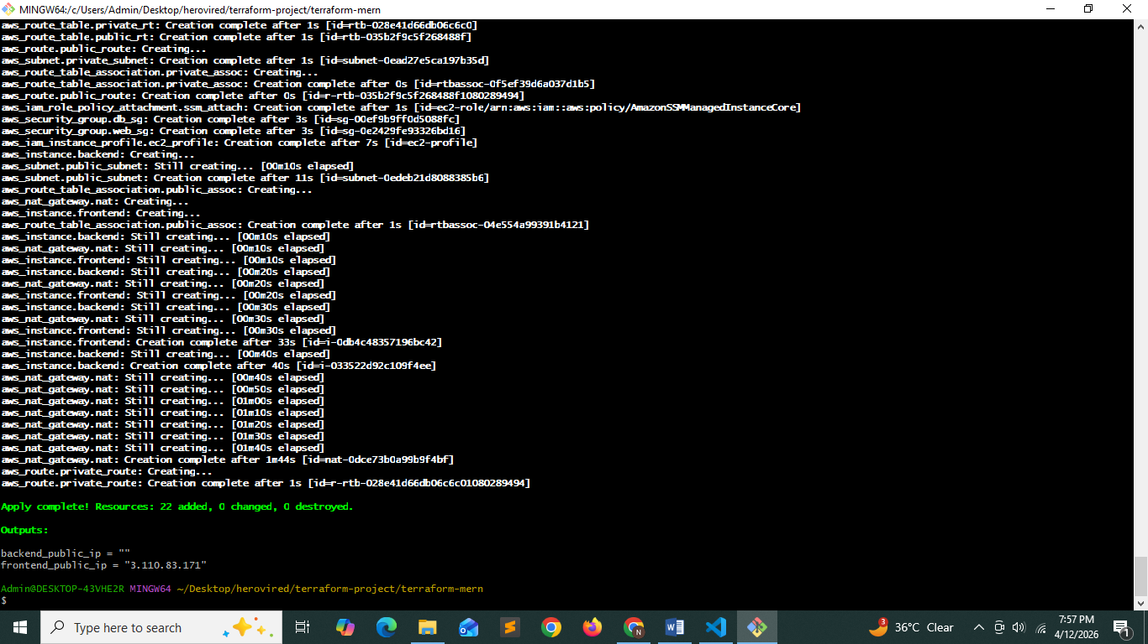
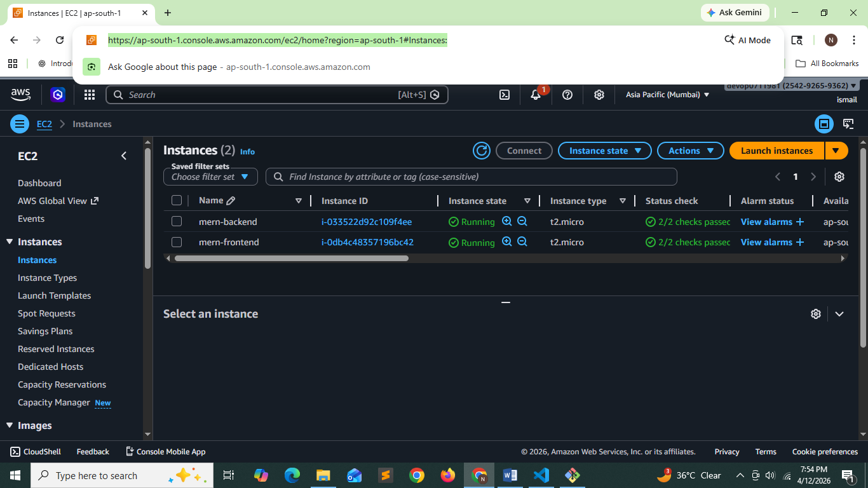

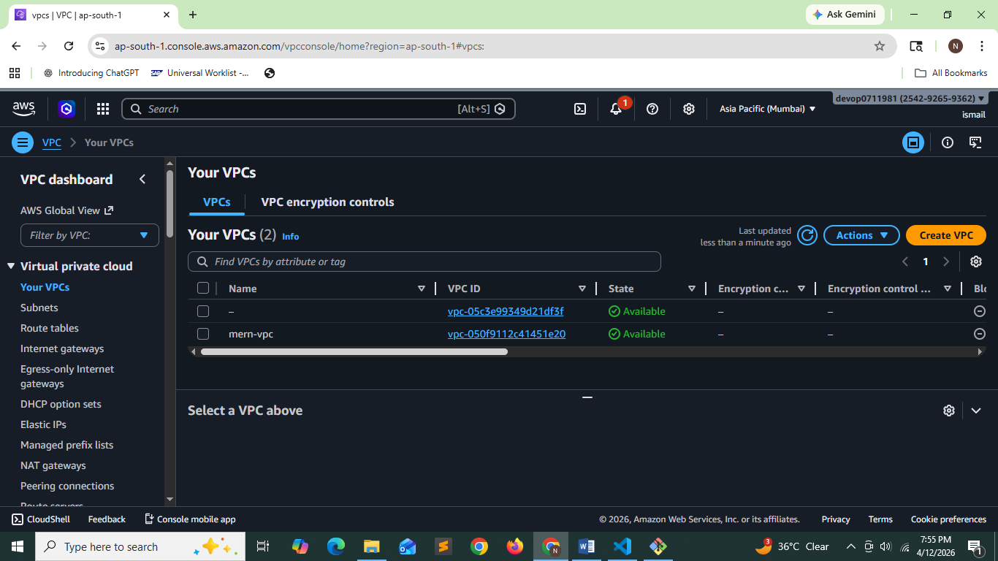
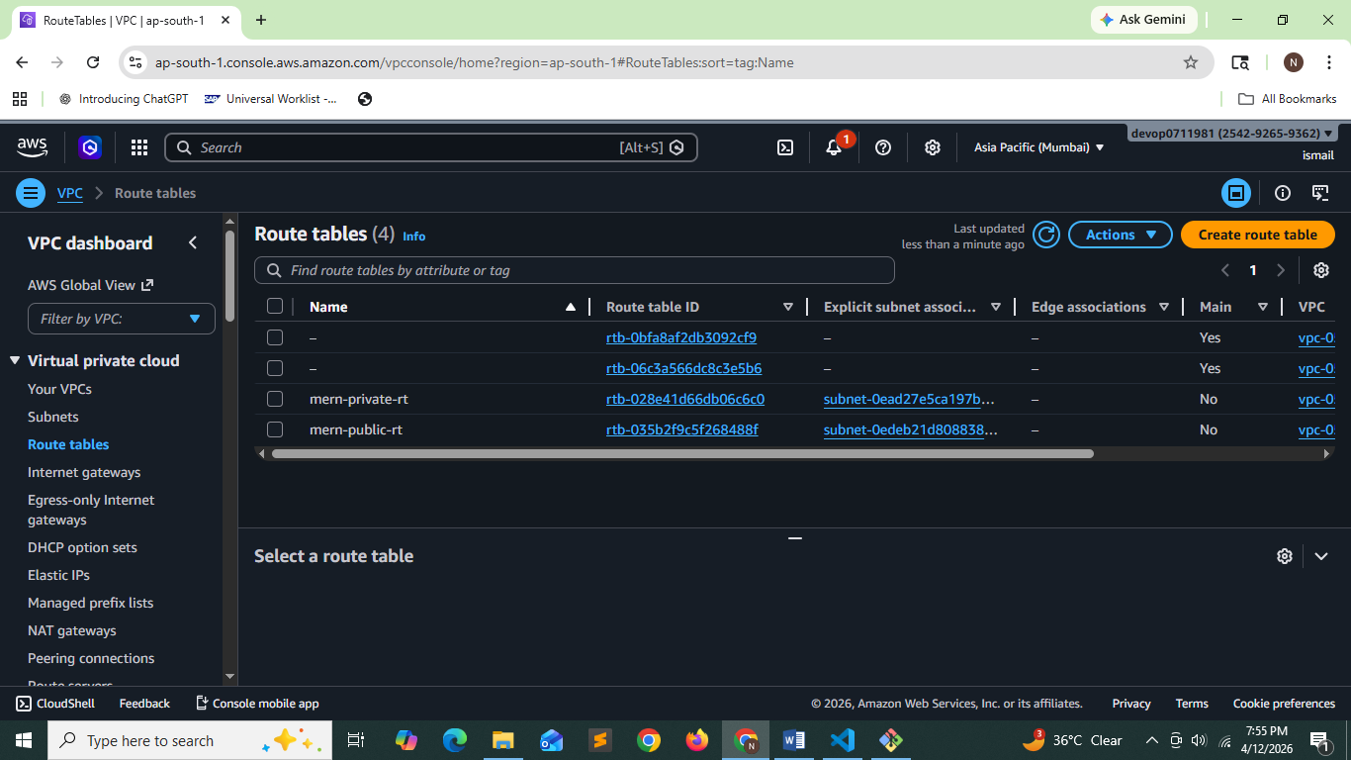
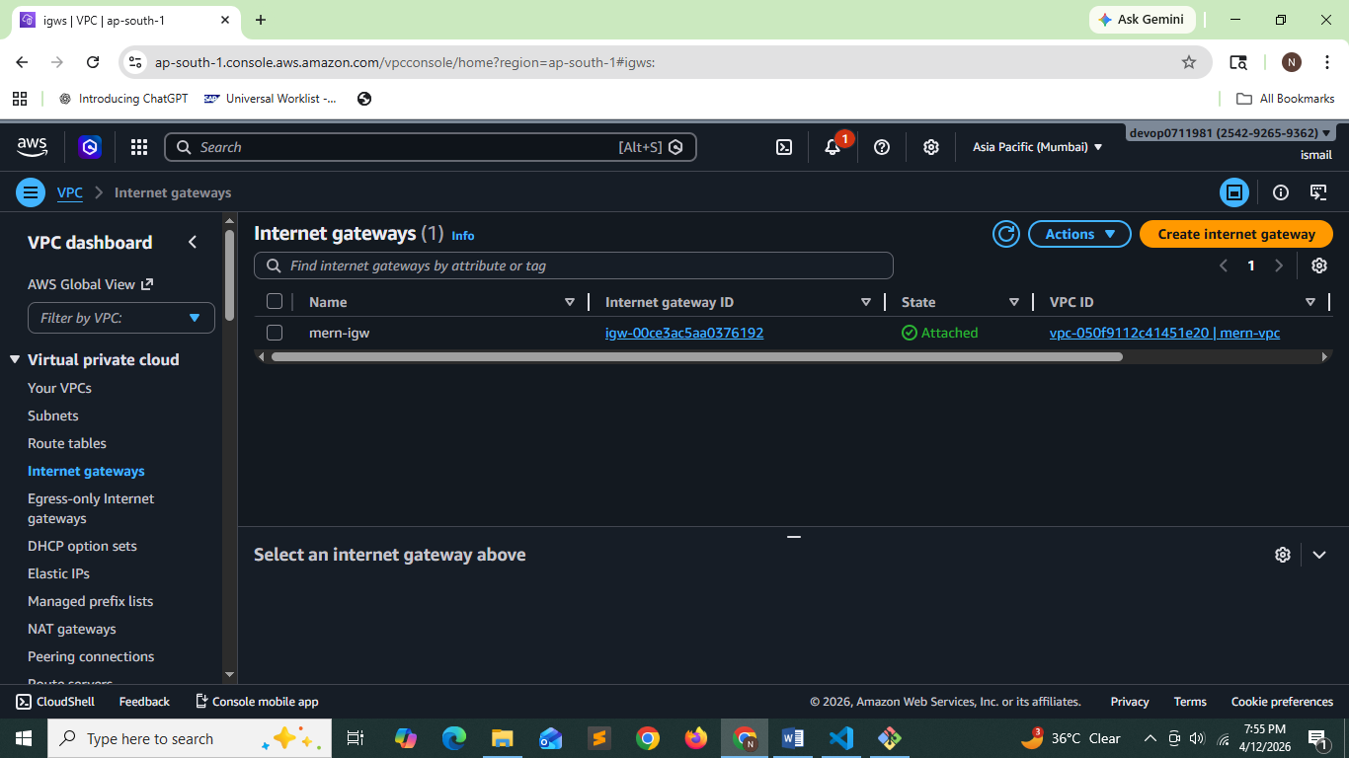
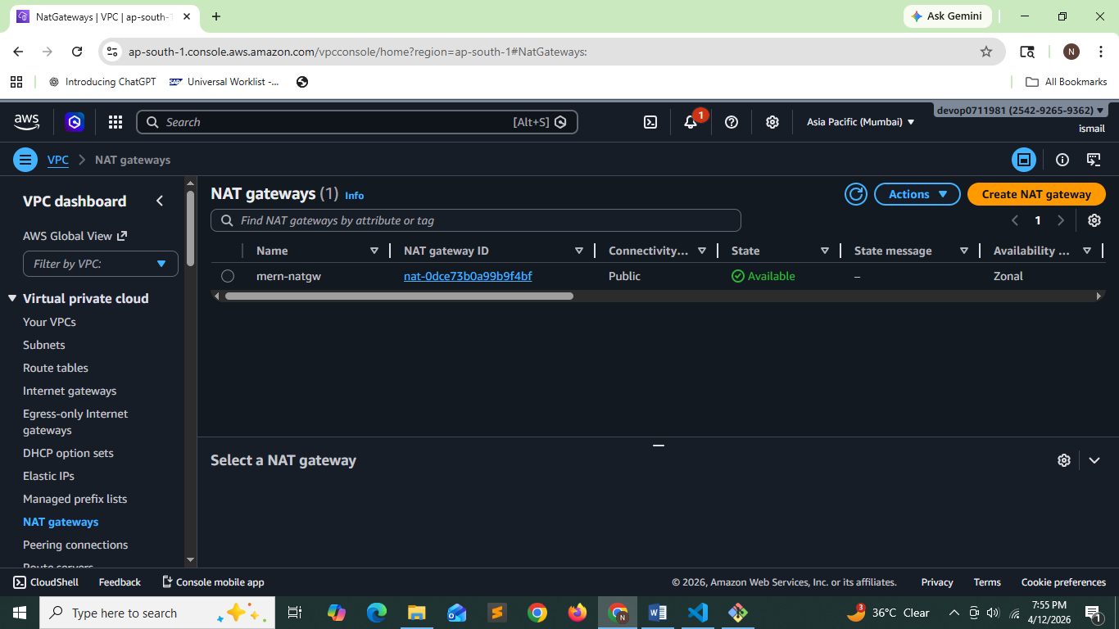
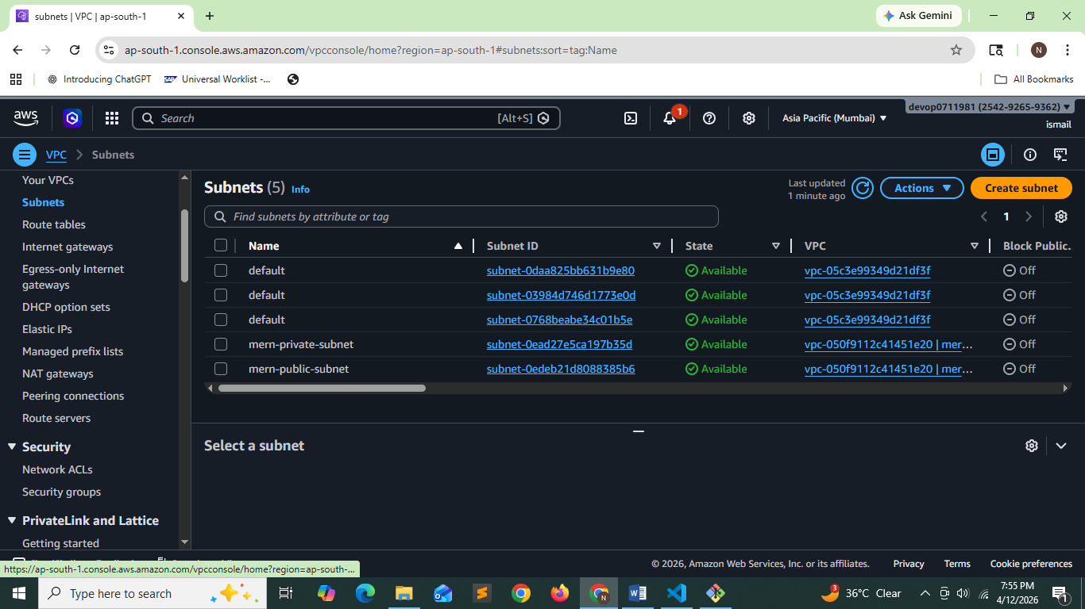

Connecting to ec2 instance in public subnet and configuration as a bastion host
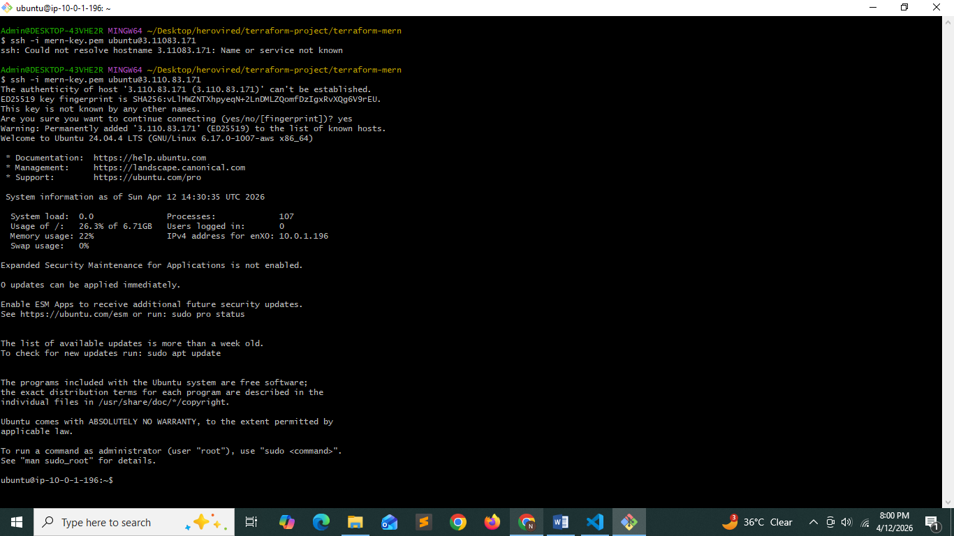
Copying the content of mern-key.pem private key into the bastion host
Touch mern-key.pm
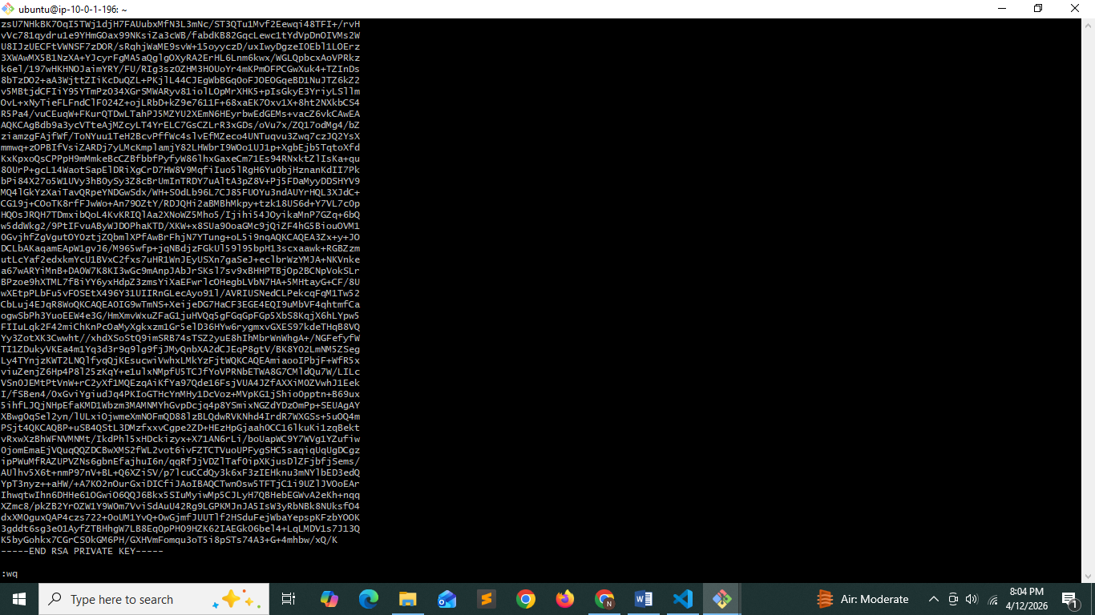

Connecting from bastion host to ec2 instance in private subnet
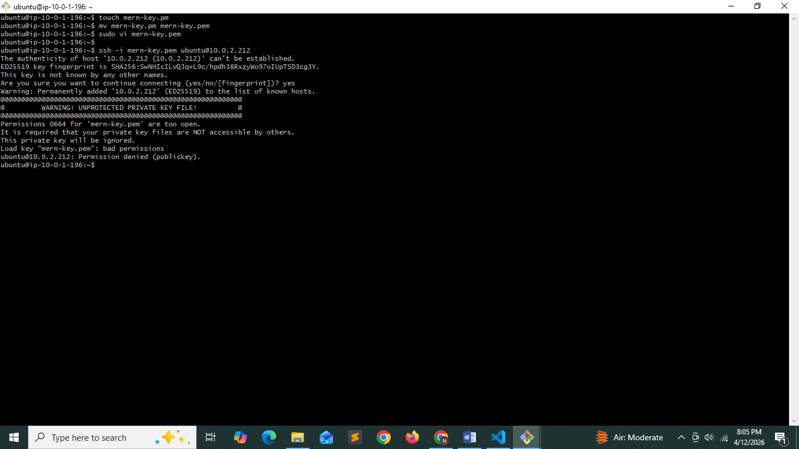

Now my ansible files are
Db.yml – this will create install mongodb in ec2 instance in private subnet
Web.yml :- this will configure frontend and backend in ec2 instance in public subnet

Ansible commands
- ansible-playbook -i hosts.ini db.yml
- ansible-playbook -i hosts.ini web.yml

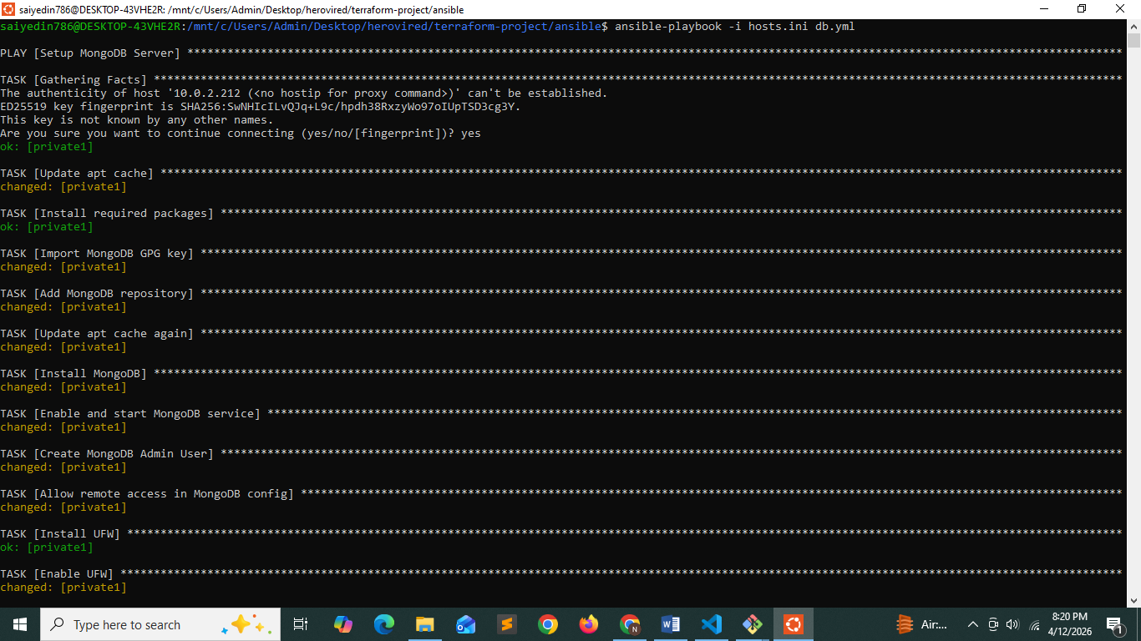
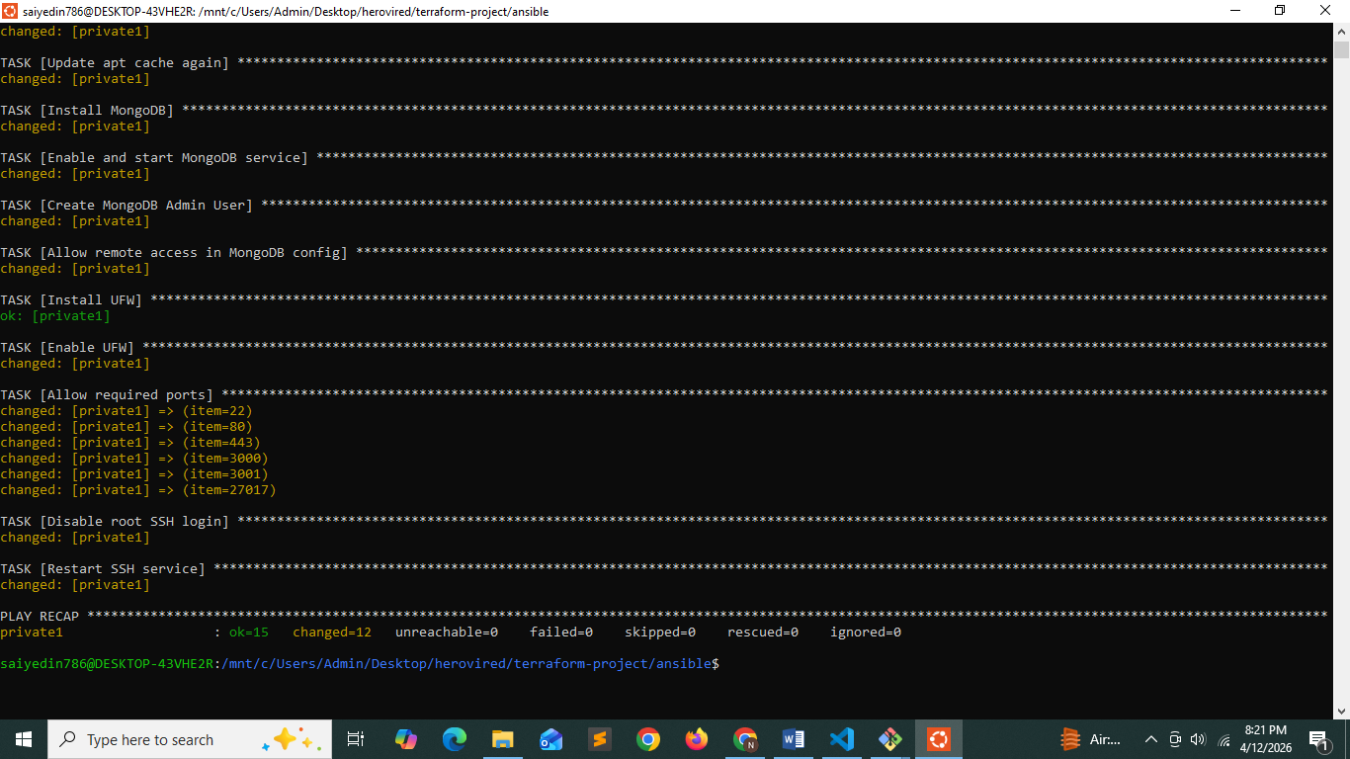
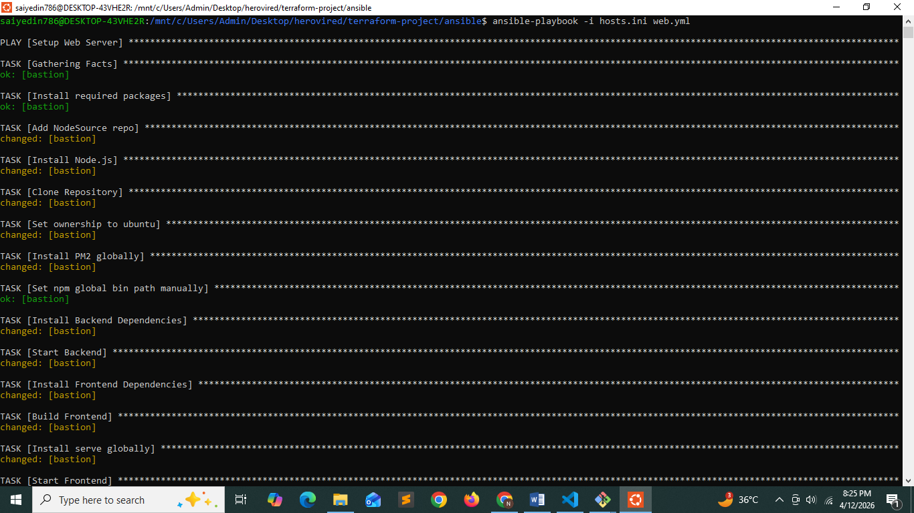
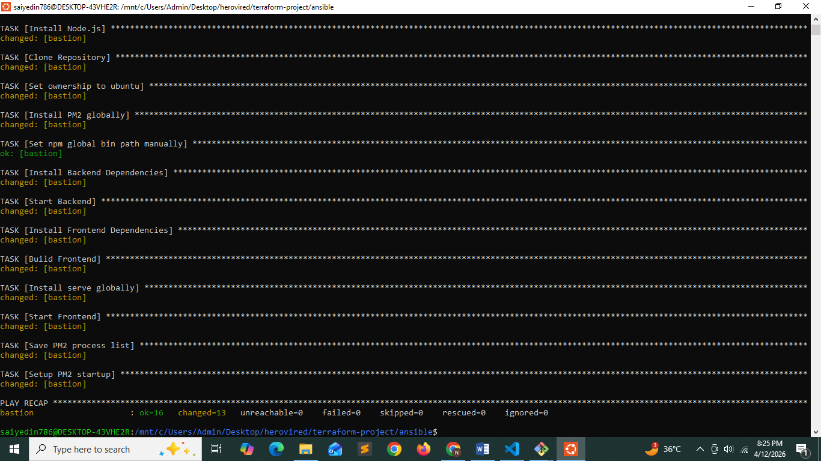

Testing from the browser:
http://3.110.83.171:3000/
