Q. State the concept of pipelining of 8086.
Ans.: concept of pipeline: (2 Mark)
• In pipelined processor, fetch, decode and execute operation are performed simultaneously or in parallel.
• When first instruction is being decoded ,same time next instruction‟s code is fetches. When first instruction is getting executed, second one‟s is decoded and third instruction code is fetches from memory. This process is known as pipelining. It improves speed of operation to great extent.

Q. Draw the pin diagram of 8086. (4M)
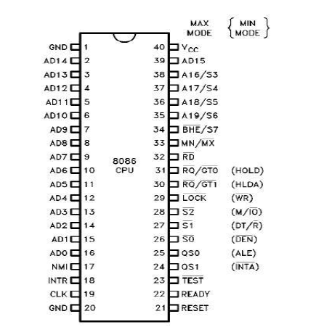

Q. Draw the neat labeled functional block diagram of 8086.
Ans.: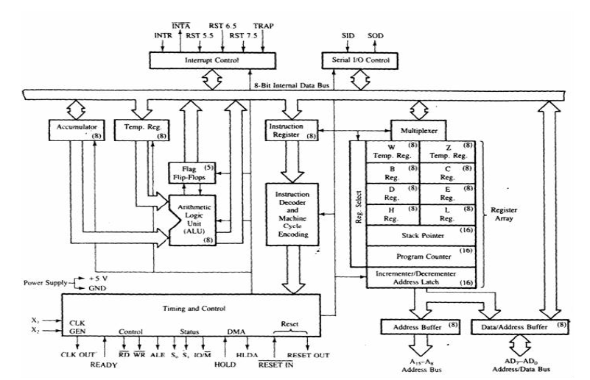

Q. Draw the flag register format of microprocessor 8086 and explain any two flags.
Ans.: (2 Mark for format, 2 Mark for explanation)
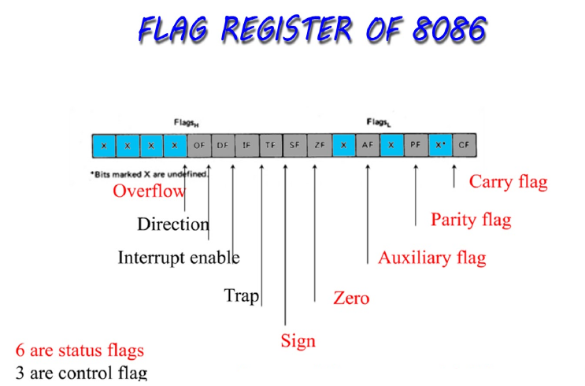
(Any two Flag explanation can be considered in Answer as per format. )
• Carry flag: This flag is set when there is a carry out of MSB in case of addition or a borrow in case of subtraction.
• Parity flag: This flag is set to 1if the lower byte of the result contains even numbers of 1s
• Auxiliary carry flag : this is set if there is a carry from the lowest nibble, i.e. bit three during addition or borrow for the lowest nibble i.e. bit three during subtraction.
• Zero flag: This flag is set if the result of the computation or comparison performed by previous instruction is zero.
• Sign flag: this flag is set when the result of any computation is negative. For signed computations the sign flag equals the MSB of the result.
• Trap flag If this flag is set the processor enters the single step execution mode.
• Interrupt flag: If this flag is set the maskable interrupts are recognized by the cpu, otherwise they are ignored.
• Direction flag: This flag is used by string manipulation instructions. If this flag bit is „0‟ the string is processed beginning from the lowest address to the highest address, otherwise the string is processed from the highest address towards lowest address.
• Overflow flag: This flag is set if an overflow occurs.

Q. State the functions for the following Pins of 8086.
(i. TEST ii. BHE iii. INTA iv. DT/R)
Ans.:
Functions of each pin – 1M
i) : TEST
This input is examined by the Wait instruction. If this is low, execution continues otherwise processor waits in idle state.
ii) : BHE
Bus High Enable is used to enable data onto most significant half of the data bus. This signal also signifies the byte which is read from even address or odd address.
iii) : INTA
Interrupt Acknowledge is used as read signal for interrupt acknowledge given by the microprocessor.
iv) DT / R
Data Transmit / Receive. It is used to control the direction of data flow through the transceiver 8286 or 74LS245.When the processor sends the data out, this signal is high and when this signal is low the data is received.

Q. Explain de multiplexing of address and data bus using a neat labeled diagram.
Explanation – 1M; Diagram: multiplexed lines at microprocessor drawn -1M; ALE & DT/ signals -1M; overall connections -1M)
Note: De multiplexing in 8085 or 8086 or in general can also be considered.)
Ans.:
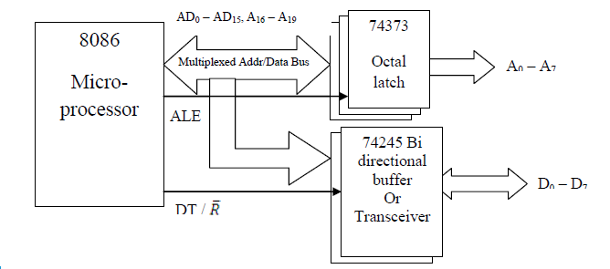
The data and address buses are multiplexed as AD0- AD7 in 8085 and AD0 – AD15 in 8086. In the first clock cycle of a read or write cycle, the address is taken on the address/data bus using the Octal latch 74373. The ALE signal is used to strobe the address, after which the address/data bus becomes the data bus. When ALE is zero, the data lines are taken through the transceiver. The diagram above shows the de-multiplexing of address line and data lines in 8086.
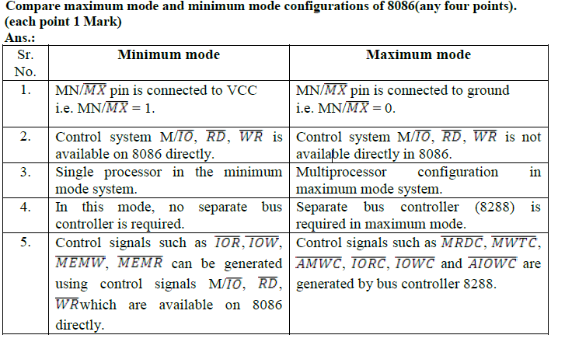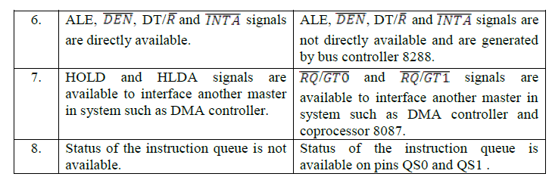
Q. Compare microprocessors 8085 and 8086(any four points) (Each comparison -1M)
8085 |  | 8086
1 | 8 bit microprocessor | 16 bit microprocessor
2 | 16 address lines | 20 address lines
3 | Total memory supported 64 KB | Total memory supported 1MB
4 | 8 bit operations can be performed using 8  bit registers an ALU | 16 bit as well as 8 bit operations can be performed using 16 bit registers an ALU
5 | Operates in single mode | Designed to operate in two modes, Maximum and Minimum
6 | Doesn‟t support multiprogramming | Supports Multiprogramming
7 | Doesn‟t support pipelining | Supports pipelining
8 | Memory segmentation is not implemented | Memory segmentation is implemented
9 | Supports 5 hardware interrupts | Supports 2 hardware interrupts
10 | Has Five Addressing modes | Has 12 addressing modes
11 | Single unit Microprocessor | Architecture has 2 units EU and BIU

Q. Draw and describe the maximum mode diagram of 8086.
Ans.: (Diagram 4 marks, explanation 4 marks)
• In the maximum mode, the 8086 is operated by strapping the MN/MX- pin to ground.
• In this mode, the processor derives the status signal S2, S1, S0. Another chip called bus controller derives the control signal using this status information.
• In the maximum mode, there may be more than one microprocessor in the system configuration.
• The components in the system are latches, trans-receiver and clock generator, memory and I/O devices.
• Latches are generally buffered output D-type flip-flop like 74LS373 of 8282 .latches are used for separating valid addresses from the multiplexer address /data signal and controlled by ALE signal generated by 8086.
• Transceiver are the bidirectional buffers and also called as data amplifiers. They are required to separate the valid data from time multiplexed address /data signal. They are controlled by two signals namely DEN- and DT-/R . DEN signal indicated that the valid data is available on data bus. DT/R indicates the direction of data i.e. from or to the processor
The basic function of the bus controller chip IC8288, is to derive control signals like RD and WR (for memory and I/O devices), DEN, DT/R, ALE etc. using the information by the processor on the status lines.
The bus controller chip has input lines S2, S1, S0 and CLK. These inputs to 8288 are driven by CPU.
It derives the outputs ALE, DEN, DT/R, MRDC, MWTC, AMWC, IORC, IOWC and AIOWC. The AEN, IOB and CEN pins are especially useful for multiprocessor systems.

Q. Describe how 20 bit physical address is generated in 8086 microprocessor. Give one example.(Description – 2 Marks , Example – 2 Marks)
Ans: Formation of a physical address:- Segment registers carry 16 bit data, which is also known as base address. BIU attaches 0 as LSB of the base address. So now this address becomes 20-bit address. Any base/pointer or index register carry 16 bit offset. Offset address is added into 20-bit base address which finally forms 20 bit physical address of memory location.
Example:- Assume DS= 2632H, SI=4567H
DS : 26320H ……...0 added by BIU(or Hardwired 0)
+ SI : 4567H
----------------------------
2A887H

Q. List all 16 bit registers in 8086 and write their functions.
(List : 2 Marks , Correct function of any 4: ½ Mark each)
Ans: EU contains 8 general purpose registers : AX, BX, CX, DX, SP, BP, SI, DI, DS, CS, SS, ES,IP and
flag register.
AX, BX, CX, DX : used as eight 8-bit registers i.e AL, AH, BL, BH, CL, CH, DL, DH or 16-bit register.
AL functions as 8-bit accumulator and AX functions as 16-bit accumulator.
CX : used as counter register. BX :used as pointer register. DX :used for I/O addressing.
SP , BP : used as pointer register , SP holds 16-bit offset within stack segment and BP contains offset
within the data segment
SI, DI : The register SI is used to store the offset of source data in data segment. The register DI
is used to store the offset of destination in data or extra segment.
DS, CS, SS and ES : These are used for Data, Code, Stack and Extra Data ( Strings) respectively.
IP: is used as an instruction pointer which holds the address of the next instruction to be executed by the microprocessor.
Flag register is used to hold the status of arithmetic and logic operations along with control flags.
Q. Describe memory segmentation in 8086 microprocessor and list it‟s four advantages.
Ans : (Description: 2 Marks, Any 4 Advantages : ½ Mark each)
Memory Segmentation: The memory in 8086 based system is organized as segmented memory.
8086 can access 1Mbyte memory which is divided into number of logical segments. Each
segment is 64KB in size and addressed by one of the segment register. The 4 segment register in
BIU hold the 16-bit starting address of 4 segments. CS holds program instruction code. Stack
segment stores interrupt & subroutine address. Data segment stores data for program. Extra
segment is used for string data.
Advantages of segmentation
1) With the use of segmentation the instruction and data is never overlapped.
2) The major advantage of segmentation is Dynamic relocatability of program which
Means that a program can easily be transferred from one code memory segment to
another code memory segment without changing the effective address.
3) Segmentation can be used in multi-user time shared system.
4) Segmentation allows two processes to share data.
5) Segmentation allows you to extend the addressability of a processor i.e., address up to
1MB although the actual addresses to be handled are of 16 bit size.
6) Programs and data can be stored separately from each other in segmentation.
Q. Explain the minimum mode configuration of 8086 microprocessor. Write
comparison between 8086 in minimum mode and maximum mode.
(Explanation: 4 Marks [Diagram not necessary], Comparison - Any 4 points: 1
Mark each)
When MN/̅ ̅̅̅ ̅ pin is in logic 1, the 8086 microprocessor operates in minimum mode system.
In this mode, the microprocessor chip itself gives out all the control signals.
• This is a single processor mode.
• The remaining components in the system are latches, transceivers, clock generator, memory or I/O
devices.
• This system has three address latches(8282) and two octal data buffers(8286) for the complete 20-bit
address and 16 bit data Separation.
• The latches are used for separating the valid address from the multiplexed address/data signals and the
controlled by the ALE signal generated by 8086.
• Transceivers are the bi-directional buffers. They are required to separate the valid data from the time
multiplexed address/data signal. This is controlled by two signals, DEN & DT/ ̅.
• DT/ ̅ indicates that the direction of data, ie. from or to the microprocessor.
• ̅ ̅̅ ̅̅ ̅ signal indicates the valid data is available on the data bus.
• This system contains memory for the monitor and users program storage. It also contains I/O devices to
communicate with the processor.
• The clock generator in the system is used to generate the clock and to synchronize some external signals
with the system clock.

Q. Write the difference between 8085 and 8086 with respect to
(i) Register size
(ii) Address bus size
(iii) Pipelining
(iv) Segmented memory
(for each comparison 1 Mark)
Ans:
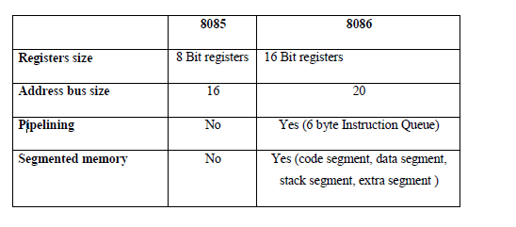

Draw architecture of 8086 and label it. Write the function of BIU and EU.
( Diagram :4 Marks; Any TWO functions of each unit : 2Marks)
Ans:
FUNCTIONS OF EXECUTION UNIT:
1.To tell BIU to fetch the instructions or data from memory
2.To decode the instructions.
3.To generate different internal and external controls signal.
4.To execute the instructions.
5.To perform Arithmetic and Logic Operations
FUNCTIONS OF BUS INTERFACE UNIT:
1.Communication with External devices and peripheral including memory via bus.
2.Fetch the instruction or data from memory.
3.Read data from the port.
4.Write the data to memory and port.
5.Calculation of physical address for accessing the data to and from memory

Q. Explain maskable and non maskable interrupt used in 8086.
( Maskable any two points : 2Marks; non maskable any two points : 2Marks)
Ans:
Non-Maskable interrupt:
• 8086 has a non-maskable interrupt input pin (NMI) that has highest priority among the
external interrupts.
• The NMI is not maskable internally by software.
• TRAP (single step-type1) is an internal interrupt having highest priority amongst all the interrupts except Divide by Zero (Type 0) exception.
• The NMI is activated on a positive transition (low to high voltage).
• The NMI pin should remain high for at least two clock cycles and need not synchronized with the clock for being sensed.
Maskable interrupt:
• 8086 also provides a INTR pin, that has lower priority as compared to NMI.
• The INTR signal is level triggered and can be masked by resetting the interrupt flag.
• It is internally synchronized with the high transition of the CLK.
• For the INTR signal, to be responded to in the next instruction cycle; it must go high in the last clock cycle of the current instruction or before that.

Q. Draw labelled flag register format of 8086 microprocessor.
Ans: (Correct Diagram: 2 Marks)
Flag Register Format Of 8086:

Q. What is pipelining? How it is implemented in 8086 microprocessor.
Ans: (Definition -1 Mark, Description -1 Mark)
Definition:
• Process of fetching the next instruction while the current instruction is executing is called pipelining which will reduce the execution time.

Description:
• In 8086, pipelining is the technique of overlapping instruction fetch and execution mechanism.
• To speed up program execution, the BIU fetches as many as six instruction bytes ahead of time from
• memory. The size of instruction prefetch queue in 8086 is 6 bytes.
• While executing one instruction other instruction can be fetched. Thus it avoids the waiting time for execution unit to receive other instruction. BIU stores the fetched instructions in a 6 byte FIFO queue. The BIU can be fetching instructions bytes while the EU is decoding an instruction or executing an instruction which does not require use of the buses.
• When the EU is ready for its next instruction, it simply reads the instruction from the queue in the BIU.
• This is much faster than sending out an address to the system memory and waiting for memory to send back the next instruction byte or bytes.
• This improves overall speed of the processor.

Q. State the function of following pins of 8086 microprocessor.
(i) NMI
(ii) 𝐓𝐄𝐒𝐓̅̅̅̅̅̅̅
(iii) 𝐃𝐄𝐍̅̅̅̅̅̅
(iv) MN/𝐌𝐗̅̅̅̅̅
Ans: (Correct one function of each: 1 Mark)
(i) NMI:
• An edge triggered signal on this pin causes 8086 to interrupt the program it is executing and execute

• Interrupt service Procedure corresponding to Type-2 interrupt.
• NMI is Non-maskable by software.

(ii) 𝐓𝐄𝐒𝐓̅̅̅̅̅̅̅:
• Used to test the status of math co-processor 8087.
• If signal goes low, execution will continue, else processor remains in an idle state.

(iii) 𝐃𝐄𝐍̅̅̅̅̅̅:
• This is active low signal, to indicate availability of valid data over AD0-AD15.
• Used to enable transceivers(bi-directional buffers) 8286 or 74LS245 to separate data from multiplexed address/data signal.

(iv) MN/𝐌𝐗̅̅̅̅̅:
• This signal indicates operating mode of 8086, minimum or maximum.
• When this pin connected to:
1) Vcc, the processor operates in minimum mode,
2) Ground, processor operates in maximum mode.

Q. Explain how 20-bit physical address is generated by 8086 microprocessor. Calculate the physical address if CS=2308H and IP=76A9H
Ans: (Description: 2 Marks, Example: 2 Marks)
• Generation of a physical address in 8086:-

Segment registers carry 16 bit data, which is also known as base address. BIU attaches four 0 bits to LSB of the base address. So now this address becomes 20-bit address. Any base/pointer or index register carry 16 bit offset. Offset address is added into 20-bit base address which finally forms 20 bit physical address of memory location.
Example:- Given : CS = 2308H, IP = 76A9H
CS : 23080H ……...0 added by BIU(or Hardwired 0)
+ IP : 76A9H

Q. State all the control signal generated by So, S1, S2 with their function by 8086 micro Processor.
Ans:- (Correct control signal 4 marks)

Q. Draw interfacing diagram of 74LS373 octal latch with 8086 microprocessor and explain it. Ans: (Diagram 2 marks, explanation 2 marks)
Q. Differentiate between 8085 and 8086 microprocessor.
Ans: (Any four points each point 1 mark)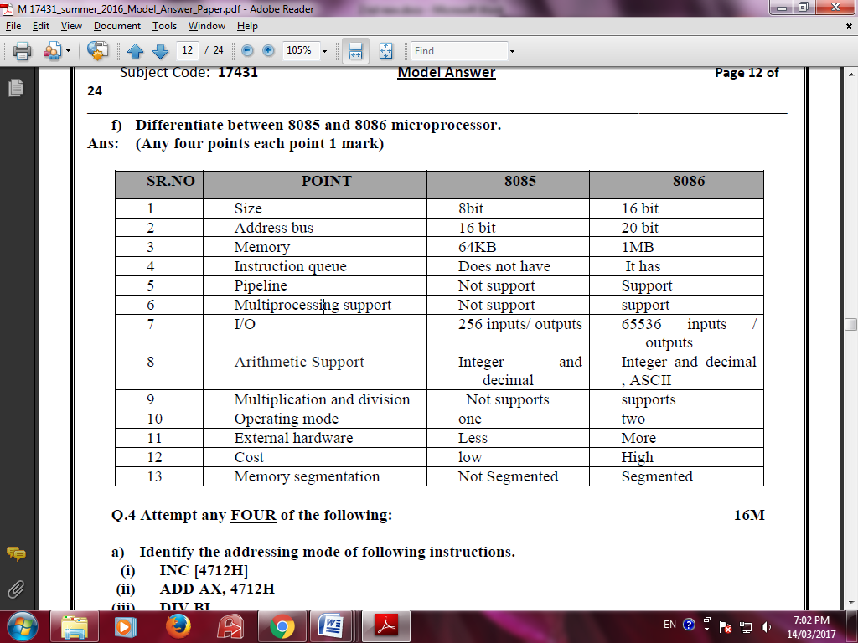

Q. Explain the following instructions with suitable of 8086 with suitable example.
(i) XLAT
(ii) AAA
Ans: (each instruction 2 marks)
(i) XLAT:

XLAT No operands Translate byte from table.
Copy value of memory byte at DS:[BX + unsigned AL] to AL register.
Algorithm:
AL = DS:[BX + unsigned AL]
Example:
ORG 100H
LEA BX, DAT
MOV AL, 2
XLATB ; AL = 33H
RET
DAT DB 11H, 22H, 33H, 44H, 55H
ii) AAA (ASCII Adjust after Addition):
Corrects result in AH and AL after addition when working with BCD values.
It works according to the following Algorithm:
if low nibble of AL > 9 or AF = 1 then:
AL = AL + 6
AH = AH + 1
AF = 1
CF = 1
else
AF = 0
CF = 0
In both cases:
clear the high nibble of AL.
Example:
MOV AX, 15 ; AH = 00, AL = 0Fh
AAA ; AH = 01, AL = 05
RET
Q. Draw and explain the timing diagram of 8086 in minimum mode.
Ans: (Description 4 Marks and Diagram 4 Marks each for Read and Write Timing Diagrams)
• In a minimum mode 8086 system, the microprocessor 8086 is operated in minimum mode by strapping its MN/MX̅̅̅̅ pin to logic 1.
• The working of the minimum mode configuration system can be better described in terms of the timing diagrams.
• The opcode fetch and read cycles are similar. Hence the timing diagram can be categorized in two parts, the first is the timing diagram for read cycle and the second is the timing diagram for write cycle.
• The read cycle begins in T1 with the assertion of address latch enable (ALE) signal and also M / IO̅̅̅ signal. During the negative going edge of this signal, the valid address is latched on the local bus.
• The BHE and A0 signals address low, high or both bytes. From T1 to T4, the M/IO signal indicates a memory or I/O operation.
• At T2, the address is removed from the local bus and is sent to the output. The bus is then tristated. The read (RD̅̅̅̅) control signal is also activated in T2.
• The read (RD̅̅̅̅) signal causes the address device to enable its data bus drivers. After RD̅̅̅̅ goes low, the valid data is available on the data bus.
• The addressed device will drive the READY line high. When the processor returns the read signal to high level, the addressed device will again tristate its bus drivers

• A write cycle also begins with the assertion of ALE and the emission of the address. The M/IO̅̅̅ signal is again asserted to indicate a memory or I/O operation.
• In T 2, after sending the address in T1, the processor sends the data to be written to the addressed location.

• The data remains on the bus until middle of T 4 state. The WR becomes active at the beginning of T 2 (unlike RD̅̅̅̅ is somewhat delayed in T 2 to provide time for floating).
• The BHE̅̅̅̅̅̅ and A0 signals are used to select the proper byte or bytes of memory or I/O word to be read or write.
• The M/IO̅̅̅, RD̅̅̅̅ and WR̅̅̅̅̅ signals indicate the type of data transfer.
Q .State the names of segment registers in 8086 microprocessor.
(For each register - ½ Marks)
Ans: Segment registers in 8086 microprocessor:
o Code Segment register(CS)
o Data Segment register(DS)
o Stack Segment register(SS)
o Extra Segment register(ES)
Compare 8085 microprocessor & 8086 microprocessor.( with respect to)
(i) No. of data lines
(ii) No. of address lines.
(iii)Frequency of operation
(iv) Registers
(Each comparison - 1 Mark) 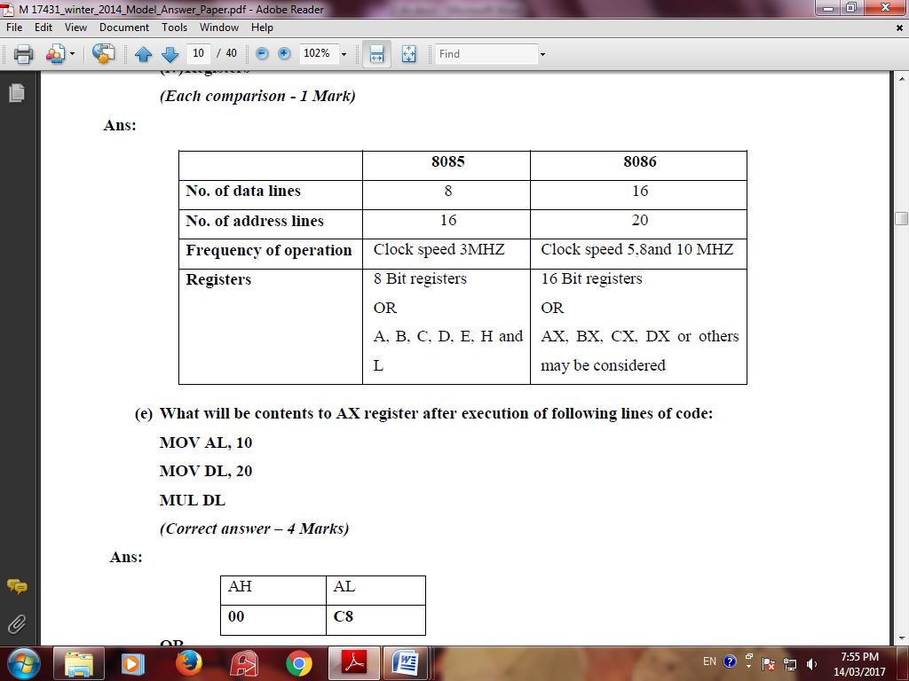

Q .Describe the physical memory address generation process in 8086 microprocessor. If, CS =69FAH & IP = 834CH, calculate the physical address generated. (Description – 2 Marks, Calculation - 2 Marks)
Ans: The 8086 addresses a segmented memory. The complete physical address which is 20-bits long is
generated using segment and offset registers each of the size 16-bit.The content of a segment
register also called as segment address, and content of an offset register also called as offset
address. To get total physical address, put the lower nibble 0H to segment address and add offset
address. The figure shows formation of 20-bit physical address.

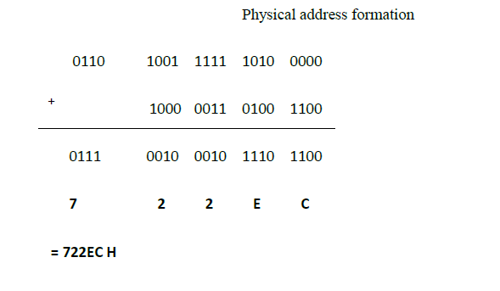

Q . State the functions of following pins of 8086 microprocessor:
(i) ALE
(ii) DT / ̅R
(iii) M / ̅ ̅ ̅̅ ̅
(iv) HOLD
(Per pin description – 1 Mark)
Ans:
(i) ALE: - This output signal is used to indicate availability of valid address on address/data lines
and is connected to latch enable input of latches .This signal is active high and never tristate.
(ii) DT/ ̅:- This output line is used to decide the direction of data flow through the transceivers
(bidirectional buffer). When the processor sends the data, this signal is high and when the
processor is receiving data, this signal is low.
(iii) M/̅ :- This is status line logically equivalent to ̅ ̅ ̅ in maximum mode .When it is low, it
indicates the CPU is having an I/O operation, and when it is high, it indicates that CPU is
having memory operation. This line becomes active in Previous T4 of current cycle. It is tristated
during local bus hold acknowledgment.
(iv) HOLD:-This line is used to indicate to 8086 that another master is requesting the bus access.

Q .Draw the interfacing of 8284 clock generator with 8086 microprocessor. List and explain interfacing signals.
(Diagram – 2 Marks, List – 1 Mark, function -1 Mark)
Page 16 of 40
c) Draw the interfacing of 8284 clock generator with 8086 microprocessor. List and explain
interfacing signals.
(Diagram – 2 Marks, List – 1 Mark, function -1 Mark)
Ans:
1. Generate system clock: The Clock logic results in three different frequencies required
for the system. These outputs are CLOCK, OSC and PCLK.
2. Generate READY signal: The Ready logic has a READY output which is connected to
the processor. When this is low, wait states are added in the bus cycle.
3. Generate RESET signal: The Reset logic generates a RESET input for the
microprocessor. When this signal is High, processor performs reset sequence.

Q . Write any four important functions of any two units of 8086 microprocessor.
(Any four functions from BIU and EU may be considered, Each Function - ½ Marks)
[Note: Any other function related to individual unit can be considered]

Ans:
8086 has two blocks BIU (Bus Interface Unit) and EU (Execution Unit).
Functions of bus interface unit
• The BIU performs all bus operations such as instruction fetching, reading and writing operands for memory and calculating the addresses of the memory operands.
• The instruction bytes are transferred to the instruction queue.
• BIU contains Instruction queue, Segment registers, Instruction pointer, and Address adder.
• BIU controls the address, data and control buses.
• It provides a full 16 bit bidirectional data bus and 20 bit address bus.
• The bus interface unit is responsible for performing all external bus operations.
• Instruction fetch, Instruction queuing, Operand fetch and storage, Address relocation and Bus control are the operations performed by BIU
• The BIU uses a mechanism known as an instruction stream queue to implement a pipeline architecture.
Functions of Execution Unit
• EU executes instructions from the instruction system byte queue.
• Both units operate asynchronously to give the 8086 an overlapping instruction fetch and
execution mechanism which is called as Pipelining. This results in efficient use of the system bus and system performance.
• EU contains Control circuitry, Instruction decoder, ALU, Pointer and Index register, Flag register.
• The Execution unit is responsible for decoding and executing all instructions.
• The EU extracts instructions from the top of the queue in the BIU, decodes them, generates operands if necessary, passes them to the BIU and requests it to perform the read or write bys cycles to memory or I/O and perform the operation specified by the instruction on the operands.
• During the execution of the instruction, the EU tests the status and control flags and updates them based on the results of executing the instruction.
• If the queue is empty, the EU waits for the next instruction byte to be fetched and shifted to top of the queue.
• When the EU executes a branch or jump instruction, it transfers control to a location
corresponding to another set of sequential instructions.
• Whenever this happens, the BIU automatically resets the queue and then begins to fetch
instructions from this new location to refill the queue.
• EU has a 16 bit ALU, which can perform arithmetic and logical operations on 8 bit as well as 16 bit data.
OR
The Instruction Queue:
To implement any instruction first it is to be fetched, then decoded and then executed. The fetching of an instruction involves its address to be sent out to the system memory and then the memory sending back the instruction. While the EU is busy decoding or executing certain instructions which do not need the buses, the BIU fetches next six instruction bytes and stores them in a first-in-first-out (FIFO) register set called queue.
The processor doesn't have to wait for the next instruction to be fetched as it is already made available in the queue registers. Thus, the speed of operation is enhanced.
This prefetching of next instruction while another instruction is still being executed is known as pipelining. General-purpose Registers:
There are eight 8-bit general-purpose registers: AL, AH, BL, BH, CL, CH, DL and DH. These can be used for temporary storage of 8-bit data. They can also be used for storage for 16-bit data words as groups: AXregister (AH and AL), BX register (BH and BL),CX register (CH and CL) and DX register (DH and DL). Their exact functions will be encountered latter.
Flags:
The 16-bit flag register of 8086 contains 9 active flags (six conditional & 3 control) , other 7 flags are undefined. Conditional Flags: indicate certain condition that arises during the execution. They are controlled by the processor. Control Flags: control certain operations of the processor. They are deliberately set/reset by the user.
Other Registers:
The Segment Registers- SS, DS, CS and ES, the pointer and index registers -BP, SP, SI and DI. and the Instruction Pointer (IP) will be discussed along with 8086 memory.
ALU:- ALU is used to perform arithmetic and logical operations

Address generator: - This unit is used to generate 20 bit physical address by adding 16 bit logical address displacement with base address
Instruction Decoder:- This unit is used convert or decode the instructions and provides signals to various units in the EU.

Q. With the neat diagram, describe the maximum mode operation of 8086.
List & describe function of signals of maximum mode of 8086.
(Diagram – 4 Marks, List – 2 Marks, Description - 2 Marks)
AD15-AD0:-These pins acts as multiplexed address and data bus of the microprocessor.
Whenever the ALE pin is high these pins carry the address, when the ALE pin is low it carry the
data.
A19/S6-A16/S3:- These pins are multiplexed to provide the address signals A19-A16 and the
status bits S6-S3. When ALE=1 these pins carry the address and when ALE=0, they carry the
status lines.
NMI: - The non-mask able interrupt input is a hardware interrupt. It can not be disable by
software.
INTR: - The interrupt request is a level-triggered hardware interrupt, which depends on the status
of IF. When IF=1, INTR is held high then 8086 get interrupted. When IF=0, INTR is disabled.
CLK: The clock signal must have a duty cycle of 33% to provide proper internal timing for the
8086. Its maximum frequency can be 5, 8 and 10 MHz for different version of microprocessor.
Vcc: This is power supply pin and provide +5V signals to 8086.
̅ ̅̅ ̅̅̅ ̅/S7: The bus high enable pin used in 8086 to enable the most significant data bus (D15-D8)
during a read/write operation. The state of the states line S7 is always logic 1 or high.
MN/̅ ̅̅̅ ̅: The MN/̅ ̅̅̅ ̅ pin is used to select either the minimum mode or maximum mode
operation of the 8086. This is achieved by connecting this pin to either +5V directly (for
minimum mode) or to the ground (for maximum mode).
̅ ̅̅ ̅̅: Whenever the Read Signals is at logic o, the 8086 reads the data from the memory or I/O
device through the data bus.
̅ ̅̅ ̅̅ ̅̅ ̅: The ̅ ̅ ̅̅ ̅̅ ̅pin is an input that is tested by the WAIT instruction. If the ̅ ̅ ̅̅ ̅̅ ̅ pin is at logic
0, the WAIT instruction functions as NOP instruction. If the ̅ ̅ ̅̅ ̅̅ ̅ pin is at logic 1, the WAIT
instruction waits for the ̅ ̅ ̅̅ ̅̅ ̅pin to become logic 0.
READY: This input is used to insert wait state into the timing cycle of the 8086. If the ready pin
is at logic 1, it has no effect on the operation of the microprocessor. If it is logic 0, the 8086 enters
the waits state and remains the idle. This pin is used to interface the operating peripherals with the
8086.
RESET: This input is used to reset the 8086.

Q. State the functions of the following pin of 8086 microprocessor
(i) ALE
(ii) DT/
(iii) HOLD
(iv) M/
(Correct one function: 1 Mark each)
Ans:
(i) ALE: This output signal is used to indicate availability of valid address on address/data lines and is connected to latch enable pin of latches( 8282 or 74LS373) .This signal is active high and never tri-state.
(ii) DT/ : This output line is used to decide the direction of data flow through the transceivers(bidirectional buffer). When the processor sends the data, this signal is high and
when the processor is receiving data, this signal is low.
(iii) HOLD: This line is used to indicate to 8086 that another master is requesting the bus access.
(iv) (M/ This signal is used to distinguish between Memory access and I/O access. The M/ is
output early in the T1 state and identifies the current bus cycle as a memory(M/ =1) or I/O
(M/ =0).
Q. Name the different types of jump instructions used in 8086 assembly language program. (any
eight)
(Any eight : ½ Mark each; Any Other can be considered)
Ans:
1. JMP Label : unconditional jump to address using 16 bit displacement or CS:IP
2. JZ Label : Transfer control to ‘Label’ if ZF 1
3. JNZ Label : Transfer control to ‘Label’ if ZF 0
4. JS Label : Transfer control to ‘Label’ if SF 1
5. JNS Label : Transfer control to ‘Label’ if SF 0
6. JO Label : Transfer control to ‘Label’ if OF 1
7. JNO Label : Transfer control to ‘Label’ if OF 0
8. JP Label : Transfer control to ‘Label’ if PF 1
9. JNP Label : Transfer control to ‘Label’ if PF 0
10. JPO Label : Transfer control to ‘Label’ if parity odd
11. JPE Label : Transfer control to ‘Label’ if parity even
12. JB Label : Transfer control to ‘Label’ if CF 1
13. JNB Label : Transfer control to ‘Label’ if CF 0
14. JBE Label : Transfer control to ‘Label’ if CF 1or ZF 1
15. JNBE Label : Transfer control to ‘Label’ if CF 0 or ZF 0
16. JL Label : Transfer control to ‘Label’ if SF 1 or OF 1
17. JNL Label : Transfer control to ‘Label’ if SF 0 or OF 0
18. JLE Label : Transfer control to ‘Label’ if ZF 1 or neither SF nor OF is 1
19. JNLE Label : Transfer control to ‘Label’ if ZF 0 or at least any one of SF and OF is 1
Q. State the function of stack pointer and program counter in 8085 microprocessor.
(Any 2 functions of each: 2 Marks)
Ans:
Stack pointer:
1. It is a 16 bit register which is used to store the address of topmost filled memory
location of stack memory.
2. SP always points current top of stack.
3. If data is stored in stack memory, the content of stack pointer is auto-decremented by two
and if data is picked out from stack memory, the content of SP is auto-incremented by two.
Program counter:
1. It maintains sequential execution of program written in memory.
2. The PC stores the address of the next instruction which is going to execute.
3. Since program counter stores the address of memory and in 8085 the address of memory is
16 bit. Hence program counter is 16 bit register.

Q Differentiate between minimum mode and maximum mode of 8086 microprocessor (Eight
points)
(Any eight points: ½ Mark each)
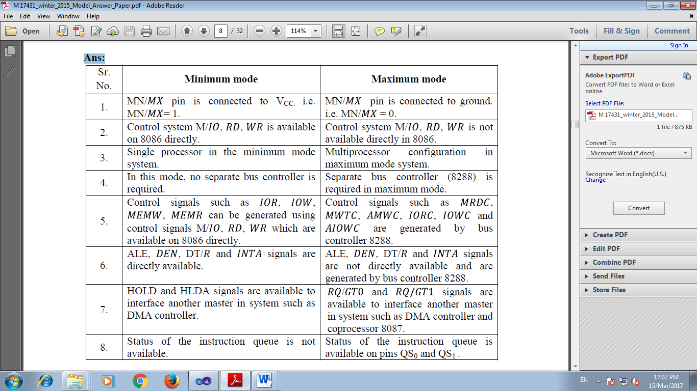
Q . Describe the generation of physical address in 8086. If CS=2000 H, and IP = 1122 H, calculate
the physical address generation.
(Description - 2 Marks, Example - 2 Marks)
Ans:
Generation of a physical address in 8086 :- Segment registers carry 16 bit data, which is also known as base address. BIU attaches four 0 bits to LSB of the base address. So now this address becomes 20-bit address. Any base/pointer or index register carry 16 bit offset. Offset address is added into 20-bit base address which finally forms 20 bit physical address of memory location.

Example:- Given : CS = 2000H, IP = 1122H
CS : 20000H ……...0 added by BIU(or Hardwired 0)
+ IP : 1122H
----------------------------
21122H

Q .What is memory segmentation? How it is done in 8086 microprocessor?
(memory segmentation – 2 Marks, explanation - 2 Marks)
Ans:
Memory Segmentation: The memory in an 8086 microprocessor is organized as a segmented
memory. The physical memory is divided into 4 segments namely,- Data segment, Code Segment,
Stack Segment and Extra Segment.
Description:
Data segment is used to hold data, Code segment for the executable program, Extra segment also holds data specifically in strings and stack segment is used to store stack data.
Each segment is 64Kbytes & addressed by one segment register. The 16 bit segment register holds the starting address of the segment The offset address to this segment address is specified as a 16-bit displacement (offset) between 0000 to FFFFH. Since the memory size of 8086 is 1Mbytes, total 16 segments are possible with each having 64Kbytes.

Q . List all the 16 bit registers of 8086 and write their function.
(List – 2 Marks, Function - 2 Marks)
Ans.
16 bit registers: AX,BX,CX,DX,CS,SS,DS,ES,BP,SP,SI,DI,IP,FLAG REGISTER
1. AX (Accumulator) – Used to store the result for arithmetic / logical operations
2. BX – Base – used to hold the offset address or data
3. CX – acts as a counter for repeating or looping instructions.
4. DX – holds the high 16 bits of the product in multiply (also handles divide operations)
5. CS – Code Segment – holds base address for all executable instructions in a program
6. SS - Base address of the stack
7. DS – Data Segment – default base address for variables
8. ES – Extra Segment – additional base address for memory variables in extra segment.
9. BP – Base Pointer – contains an assumed offset from the SS register.
10. SP – Stack Pointer – Contains the offset of the top of the stack.
11. SI – Source Index – Used in string movement instructions. The source string is pointed to by
the SI register.
12. DI – Destination Index – acts as the destination for string movement instructions
13. IP – Instruction Pointer – contains the offset of the next instruction to be executed.
14. Flags Register – individual bit positions within register show status of CPU or results of
arithmetic operations.

Q . What is pipelining? State its need and how it is done in 8086
(Definition -1 Mark, Description -3 Marks)
Ans:
Definition: Process of fetching the next instruction while the current instruction is executing is called pipelining which will reduce the execution time.
Description: The technique used to enable an instruction to complete with each clock cycle.
Normally, on a non – pipelined processor, nine clock cycles are required for fetch, decode and execute cycles for the three instructions as shown in Fig(a). This takes longer time when compared to pipelined processor. In this ,the fetch, decode and execute operations are performed in parallel, so only five clock cycles are required to execute the same three instructions as shown Fig(b). In 8086, pipelining is implemented by providing 6 byte queue where as long as 6 one byte instructions can be stored well in advance and then one by one instruction goes for decoding and executions. So, while executing first instruction in a queue, processor decodes second instruction and fetches 3ed instruction from the memory In this way, 8086 perform fetch, decode and execute operation in parallel i.e. in single clock cycle as shown in above fig (b)

Needs of Pipelining:
- Pipelining enables many instructions to be execute at the same time.
- It allows execution to be done in fewer cycles.
- Speed up the execution speed of the processor
- More efficient use of processor

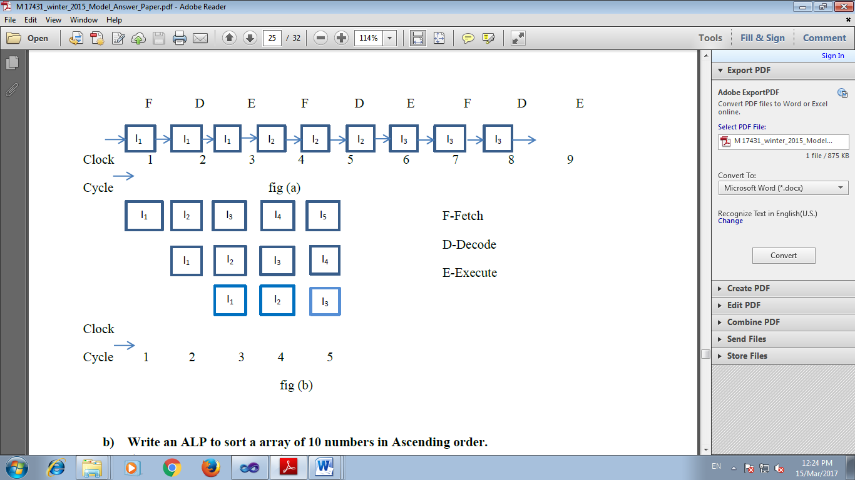
Q . Describe with suitable example how parameter is passed on the stack in 8086 assembly
language procedure.
(Description - 2 Marks, Example - 2 Marks) (Any other Example may be considered)
Ans:
PARAMETER PASSING ON THE STACK:
To pass a large number of parameters to the called procedure, the parameters can be placed on the stack for the calling procedure. Here, it is useful to use the stack base pointer i.e BP register to make a frame boundary for easy access to the parameters. The stack can also be used to pass parameters back from the called procedure to the calling procedure. The procedure during its execution pops back the appropriate parameters as and when required.In the example given below, The variable NUM is used in the called procedure using BP register, which points to the corresponding location in the stack

