**WellFund**

**Project Report**

Project Work Phase - II (EAI 852)

**BACHELOR OF TECHNOLOGY**

**(CSE - Specialization in AI, ML & DL)**

|  |  |
| --- | --- |
| PROJECT GUIDE:  **Dr Saurabh Pathak**  **Assistant Professor** | SUBMITTED BY:  **Saiyam Jain (TCA1959024)** [saiyam.tca1959024@tmu.ac.in](mailto:saiyam.tca1959024@tmu.ac.in) |

May - 2023



**COLLEGE OF COMPUTING SCIENCES & INFORMATION TECHNOLOGY**

**TEERTHANKER MAHAVEER UNIVERSITY, MORADABAD**

**ACKNOWLEDGEMENT**

This project is the outcome of sincere efforts, hard work and constant guidance of not only me but a number of individuals. First and foremost, I would like to thank TEERTHANKER MAHAVEER UNIVERSITY, MORADABAD. I am thankful to my guide, **Dr. Saurabh Pathak** for providing me with help and support throughout the Project Report period. I owe a debt of gratitude to my faculty guide who not only gave me valuable inputs about the industry but was a continuous source of inspiration during these months, without whom this project was never such a great success. Last, but not least, I would like to thank all my faculty members, friends and family members who have helped me directly or indirectly in the completion of the project.

Student Name: **Saiyam Jain (TCA1959024)**

**DECLARATION**

I hereby declare that this Project Report titled “**WellFund**” submitted by me and approved by project guide, Dr. Saurabh Pathak - College of Computing Sciences and Information Technology, Teerthanker Mahaveer University, Moradabad, is a bonafide work undertaken by me and it is not submitted to any other University or Institution for the award of any degree diploma /certificate or published any time before.

|  |  |  |
| --- | --- | --- |
| **Project ID:** | FPA19 | |
| **Student Name:** | Saiyam Jain (TCA1959024) | Signature |
|  |  |  |
| **Project Guide:** | Dr. Saurabh Pathak | Signature |

Table of Contents

1. Project Title 6

2. Problem Statement 6

3. Project Description 9

3.1 Scope of the Work 11

3.2 Project Modules 12

3.3 Project Feasibility 14

3.4 Context Diagram (High Level) 16

3.5 User Classes and Characteristics 17

4. Implementation Methodology 18

5. Technologies to be used 21

5.1 Software Platform 21

5.2 Hardware Platform 23

5.3 Tools 24

6. Advantages of this Project 25

7. Assumptions 27

8. Future Scope and further enhancement of Project 28

9. Project Repository Location 30

10. Definitions and Acronyms 31

10.1 Definitions 31

10.2 Acronyms 32

11. Conclusion 33

12. References 34

**Appendix**

**A: Data Flow Diagram (DFD)**

**B: Activity Diagram**

**C: Use Case Diagram (UCD)**

**D: Screen Shots**

List of Figures

Fig. 1 Simple flow of WellFund 9

Fig. 2 Context Level Diagram 16

Fig. 3 Process Flow Diagram 18

Fig. 4 DFD – Zero Level 35

Fig. 5 Administrator’s Process Diagram 36

Fig. 6 Fund Seeker’s Process Flow Diagram 37

Fig. 7 Use-Case Diagram 38

# Project Title

WellFund - Decentralized Crowdfunding Platform

# Problem Statement

Crowdfunding is one of the most popular ways to raise funds for any project, cause or for helping any individual in need. Crowdfunding is basically a process of raising money from a large number of people. It can be done to fund a project, a company or any social or personal cause. Even in some cases the funders get some rewards or equity for the fund they donate. There is a goal amount in most of the crowdfunding campaigns which tells how much amount is to be raised also it is shown that how many have backed and how much money has been raised yet. Since the emergence of the Covid pandemic, we all have witnessed a noticeable increase in the crowdfunding activities worldwide. These campaigns range from small to big scale which are aimed to providing oxygen and medical help to people. PM Cares fund is one of the large-scale crowdfunding campaigns that we all have witnessed.

Crowdfunding platforms, particularly those primarily focused on donation-based crowdfunding have played an important role in making individuals and organizations capable to raise funds for charitable causes, medical causes, disaster relief causes and more. The current system of centralized platforms faces some challenges that any decentralized platform can handle more effectively. Some of the main problems in the current system are:

1. **Lack of Transparency**:

When it comes to crowdfunding platforms based on donations, transparency has a significant role. Donors or backers have limited visibility to know how their donations are being utilized or being distributed among the recipients. This lack of transparency may lead to skepticism and will ultimately reduce trust in the platform.

1. **High Platform Fees**:

The centralized crowdfunding platforms often charge high amount of fees to cover their operational costs. Also, the transaction fee and the service charges are higher in centralized platforms. These charges can diminish the impact of the overall donation as a good amount of the donation goes towards the platform as its fee rather than being used to benefit the cause.

1. **Trust and Accountability Issues:**

The centralized nature of crowdfunding platforms can lead to challenges of trust and accountability. The donors may question the legitimacy of the campaign as there have been many fraudulent or misleading campaigns that can exploit the donor’s money and goodwill. Mechanisms to verify the authenticity of the campaign are a must.

1. **Limited access for certain regions:**

It is seen that many of crowdfunding platforms have geographical restrictions that limit their access to the individuals of a specific region or country. This can hinder many potential donors from contributing to the cause they care about and will also limit the global reach of the campaign.

Decentralized crowdfunding platforms, powered by blockchain technology came up with a viable solution to all these problems of the current system:

1. **Transparency and Immutability:**

Blockchain technology provides both the transparency and immutability by keeping a record of all the transactions and transfers of funds on a decentralized ledger. This provides us the power to trace the funds and it provides the donors with greater confidence in the system.

1. **Lower Fees:**

By eliminating the intermediaries and automating the process with the help of smart contracts, blockchain-based crowdfunding platforms have significantly reduced the fee. This allows a larger portion of the donated amount to directly reach the intended beneficiaries which will increase the overall impact of the contribution to the cause.

1. **Smart Contract Automation:**

The campaigns are powered by automated smart contracts. These smart contracts automate the process of distribution of the donation, ensuring that the funds reach the intended recipient based on the pre-written conditions in the smart contract. This automation of the overall process minimizes the human intervention which helped in the enhancement of the trustworthiness and efficiency of the platform.

1. **Global Accessibility:**

Crowdfunding platforms powered by blockchain that are also called as decentralized crowdfunding platforms are not bounded by any geographical restrictions. They allow anyone around the globe to participate in the donation and contribute to the cause they want to support. This eventually increase the pool of potential donors and help to build a global community focused on charitable giving.

We can say that the crowdfunding platforms based on blockchain technology, offer more transparency, reduced fees, automated process, global accessibility, and more security and trust. These advantages address the limitations of the current crowdfunding system, empowering the institutions and individuals to raise funds for any causes more efficiently and also with much greater accountability.

# Project Description

WellFund is an innovative decentralized, donation-focused crowdfunding application built on the top of Ethereum blockchain platform, which offers an intuitive and transformative approach of crowdfunding. In WellFund, users or the donors have the opportunity to invest or donate to campaigns that align with their interests.

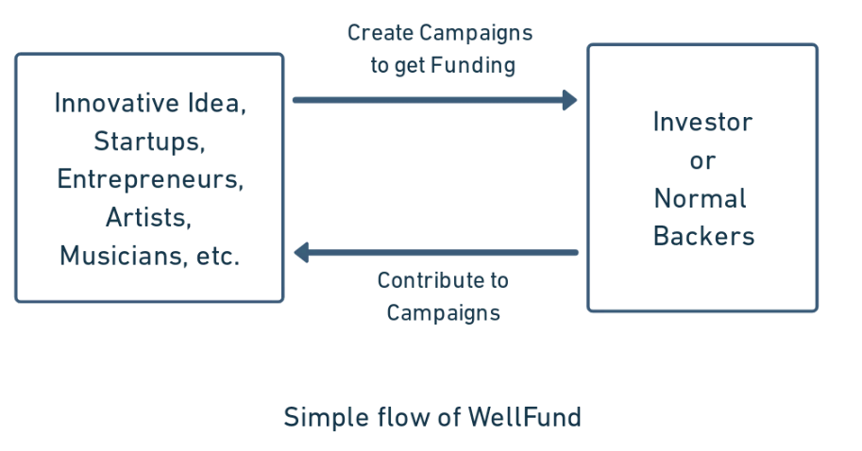

Fig. 1 Simple flow of WellFund

By utilizing the power of blockchain, WellFund comes with a bundle of advantages over traditional crowdfunding platforms. One of the notable benefits of WellFund is the provision of low-risk support for new ventures. Due to the implementation of blockchain, WellFund ensures that crowdfunding activities take place with reduced risk. The immutable nature of the blockchain ensures the transparency and accountability of the platform and allows the donors to track the investment. Moreover, it serves to increase the reach of the campaign by making it globally accessible. Using an efficient approach, WellFund connects project developers with a global audience with a built-in interest in crowdfunding campaigns. Venture creators are able to broaden their reach, boost their awareness, and ultimately improve their chances of raising large amounts in a relatively brief period of time by gaining access to this vast network of backers. In turn, investors get the chance to invest in projects that suit their preferences while perhaps earning significant incentives. WellFund's crowdfunding platform optimizes the procedure by getting rid of pointless middlemen and complicated administrative requirements. The built-in automated features of blockchain, made possible by smart contracts, expedite processes, cut down on administrative work, and free up project founders to concentrate on implementing their ideas.

Established crowdfunding platforms like Indiegogo and Kickstarter have recently had a big impact on the startup scene by bringing novel levels of flexibility and effectiveness to fundraising. These platforms encounter particular challenges because they follow centralized operational structures. They are frequently controlled by enterprises, who limit the possibilities for startup entrepreneurs by charging excessive fees and influencing campaigns. In this context, blockchain-based crowdfunding platforms have shown potential as an advance in the world of fundraising, helping business owners realize their ideas for their prospects. There was a need for a more decentralized alternative because this centralized structure hinders the fundraising process's transparency and fairness. By decentralizing the fundraising model, doing away with intermediaries like Kickstarter, and enabling backers and businesses to communicate directly with each other, blockchain-based crowdfunding platforms offer a solution. The high maintenance fees levied by centralized systems are eliminated by blockchain-based crowdfunding platforms.

The decentralized application for crowdfunding (dApp) offers creators a platform to promote their campaigns and raise funds through a community of interested people. By using this innovative strategy, individuals can reward backers with tokens specific to a campaign after a funding round is successful. The backer receives their investment back in the case that the fundraising effort is unsuccessful. The use of blockchain technology, an immutable distributed ledger that ensures the integrity of all transactions, distinguishes this system from others. The decentralized crowdfunding dApp minimizes the risk of falsification by utilizing blockchain as every transaction is securely recorded and cannot be manipulated. The eradication of illicit influence and manipulation sometimes connected with centralized platforms is another important benefit of using blockchain in crowdfunding. These platforms often have a lot of access to and control over the campaigns that are housed on them, which could have an impact on how financing initiatives turn out. Contrarily, blockchain-based crowdfunding does away with the centralized power and substitutes it with a decentralized, open network. This supports a fair and impartial crowdfunding ecosystem by ensuring that no single entity has an excessive amount of influence over campaigns.

In simple terms, any web-based application falls under the category of a centralized application, where the platform's actions are monitored and controlled by a server that belongs to a single company. But WellFund sets itself apart as an Ethereum Blockchain-based Decentralized Application (DApp). Blockchain technology is used by this innovative platform for storing and exchanging data about campaigns, contributions, withdrawal requests, and funds. In contrast to centralized programs, WellFund makes sure that this data is spread throughout a decentralized network and is available to all users. WellFund protects funds and transactions by ensuring its visibility and storage at each blockchain node by doing away with the need for a centralized server and using a blockchain in its place. As a result, this strategy successfully restricts anyone from taking possession of the money and completely eliminates the risk of misuse. Overall, WellFund provides an advanced and practical solution to the challenge at hand.

## Scope of the Work

The project’s scope includes the development and deployment of the decentralized application (DApp) that operates on the Ethereum Blockchain. The project's primary objective is to create a platform that transforms the transparent and secure control of campaigns, contributions, withdrawal requests, and funds.

The following are the key components of the WellFund project's scope:

1. Development of Decentralized Application:

* Development and implementation of a user-friendly Ethereum Blockchain-based decentralized application (DApp).
* Use smart contracts to manage funds, create campaigns, track donations, and process withdrawal requests.
* Integrate the DApp to the Ethereum network to make transactions transparent and secure.

1. Features for managing campaigns:

* Enable campaign creators to register and develop campaigns by setting objectives, budgets, and timeframes.
* Give campaign creators the option to include in-depth explanations, pictures and videos to attract donors who are interested.
* Create an intuitive dashboard that allows campaign creators to monitor campaign progress, donations, and other information in real time.

1. Contribution Mechanism:

* Support for a variety of donation techniques, such as token transfers and cryptocurrency payments.
* Allow contributors to browse and choose causes that interest them, then make safe and simple contributions.
* Create a mechanism for handling transactions so that contributions are appropriately recorded and verified.

1. Withdrawal Request and Approval Process:

* Enable campaign creators to track the status of withdrawal requests and receive notifications upon approval.

1. Decentralized Data Storage:

* Store campaign data, donor records, withdrawal requests, and fund transactions on the Ethereum Blockchain and display it properly.

1. User Interface and User Experience:

* Design a user interface that is simple to use and visually appealing for easy navigation and interaction.
* Enhance user experience to promote user participation, simplicity of use, and engagement.
* Use responsive design concepts to make sure that your website functions properly on a variety of devices and screen sizes.

1. Testing and Quality Assurance:

* To ensure the stability, functionality, and performance of the DApp, carry out thorough testing, including unit testing, integration testing, and user acceptability testing.
* Fix any errors, problems, or usability challenges found during the testing process.
* In order to provide a seamless user experience, constantly monitor and enhance the DApp's performance.

1. Documentation:

* Create thorough documentation, such as user manuals and technical handbooks, to help users and stakeholders comprehend and make use of the WellFund platform.

## Project Modules

Modules are independent parts of a system or a program that carry out specific tasks or responsibilities. They facilitate modular design, code reuse, and simpler maintenance since they encapsulate related functionality, data, and activities. Modularity and code management are enhanced via modules, which help organize and separate various components of a system.

The following modules are recognized based on the smart contract code for the WellFund project, and an explanation of how they function within the smart contract is listed below:

1. Project Creation and Management Module:

* Using this module, users can develop and manage projects or campaigns.
* By providing information such a title, description, image URL, costs, and expiration date, the "createProject" function enables it possible to initiate a new project.
* The project owner may modify project details, including the title, description, image URL, and expiration date, using the "updateProject" function.
* A campaign can be deleted using the "deleteProject" function, marking it as deleted and granting refunds to backers.

1. Contribution Processing Module:

* Users can make donations to a particular project using the "donateProject" function. By using this function, users can donate any amount of ether to the project. The money donated is kept track of and utilized for estimating the amount of funds is raised overall for each project.

1. Withdrawal Module:

* The platform owner or project owner can start a pay-out for the completed project via the "payOutProject" function. When a project has raised the required amount of money, its status gets upgraded to "APPROVED," and the project owner receives the fund raised minus the project tax. Based on the amount raised, a project tax is calculated and deducted from the pay-out.
* If the campaign reaches the expiration date but does not get the required amount, in such case the funds are refunded to their respective contributors.

1. Campaign Discovery Module:

* By providing the project ID as a parameter, the "getProject" function retrieves the details of a certain project. Donors can discover all the details of all campaigns due to the "getProjects" function, which obtains an array of all the projects created on the site.

1. Project and Backer Data Storage Module:

* Information about the project and backers is stored in the smart contract using a variety of data structures and mappings.
* The "projectStruct" struct has attributes including ID, owner address, title, description, image URL, cost, the fund raised, timestamp, expiration date, number of supporters, and status.
* Each backer's address, donation amount, timestamp, and refund status are all stored in the "backerStruct" structure.
* All of the projects that have been created are stored in the "projects" array, and mappings like "projectsOf" and "backersOf" keep track of the projects and backers associated with specific addresses or project IDs.

1. Project Status Management Module:

* The “statusEnum” enum is used by the smart contract to specify various project stages, which include "OPEN," "APPROVED," "REVERTED," "DELETED," and "PAIDOUT." These status values depict a project's lifecycle, from creation to completion or deletion. In order to enforce appropriate transitions and actions based on the project status, the contract logic consists of several checks and conditions.

1. Tax Management Module:

* The platform owner can change the project tax % using the “changeTax” function.
* As the required amount of any project reaches, the fund is transferred to the campaign owner after deduction of the tax that is transferred to the owner of the platform.

The fundamental functionality for project formation, management, contribution processing, withdrawal requests, and project status tracking is provided by these smart contract modules.

## Project Feasibility

The term "project feasibility" refers to the assessment of a project's viability and likelihood of success. In order to determine whether the project is feasible and advantageous, it includes examining a variety of factors, including technical, financial, commercial, legal, and operational considerations. Making intelligent choices, identifying potential risks and obstacles, effectively allocating resources, and increasing the likelihood that a project will succeed are all made possible with the help of feasibility study. Prior to devoting time, energy, and resources, it is essential to confirm that a project is viable in order to reduce the risk of failure and maximize project results. The overall feasibility of the WellFund project comes out to be positive, some key features supporting its feasibility are as follows:

1. Technical Feasibility:

* The project is accessible to a wide range of users since it uses ReactJS, a framework that offers compatibility with web browsers.
* Utilizing the Ethereum blockchain and the MetaMask browser plugin enhances security and transparency while addressing crowdfunding's current difficulties.

1. Financial Feasibility:

* The overall development cost of the complete project will be relatively low as there would be no extra expense to be made regarding the security as it inherits the security features of the Ethereum blockchain.
* The server costs associated with hosting the application would be the main expense.
* The financial viability may be maintained through effective planning and cost optimization.

1. Market Feasibility:

* By adopting blockchain technology, WellFund aims to address the lack of transparency and trust in crowdfunding.
* This distinctive value proposition has the ability to draw users looking for safe and trustworthy platforms to support diverse causes.
* The project's potential for success is further supported by the rising popularity of crowdfunding.

1. Legal and Regulatory Feasibility:

* The project must adhere to all appropriate legal and regulatory guidelines as it will be managing financial transactions and user data.
* Maintaining the project's feasibility and reputation will depend on ensuring compliance with financial regulations, data protection rules, and user privacy.

1. Operational Feasibility:

* The development process gets simpler by the project's dependency on widely known technologies like ReactJS and the Ethereum Blockchain.
* Operational problems can be reduced with proper planning and strong project management.
* Some user instructions and assistance may be necessary to ensure users install the required MetaMask browser plugin.

The WellFund project has a strong overall feasibility when taking into consideration the technical compatibility, cost-effectiveness, market demand, and operational feasibility.

## Context Diagram (High Level)

An overview of a system or process can be demonstrated visually in a context-level diagram, often referred to as a context diagram or level 0 DFD (Data Flow Diagram). It demonstrates how the system interacts with external elements including users, other systems, and organizations. Without diving into detailed internal operations, the diagram depicts the high-level inputs, outputs, and data flows between these entities and the system. It enables in drawing a distinct line around the system under investigation and acts as a jumping-off point for a more thorough examination and modelling of the system's constituent parts and their interconnections.

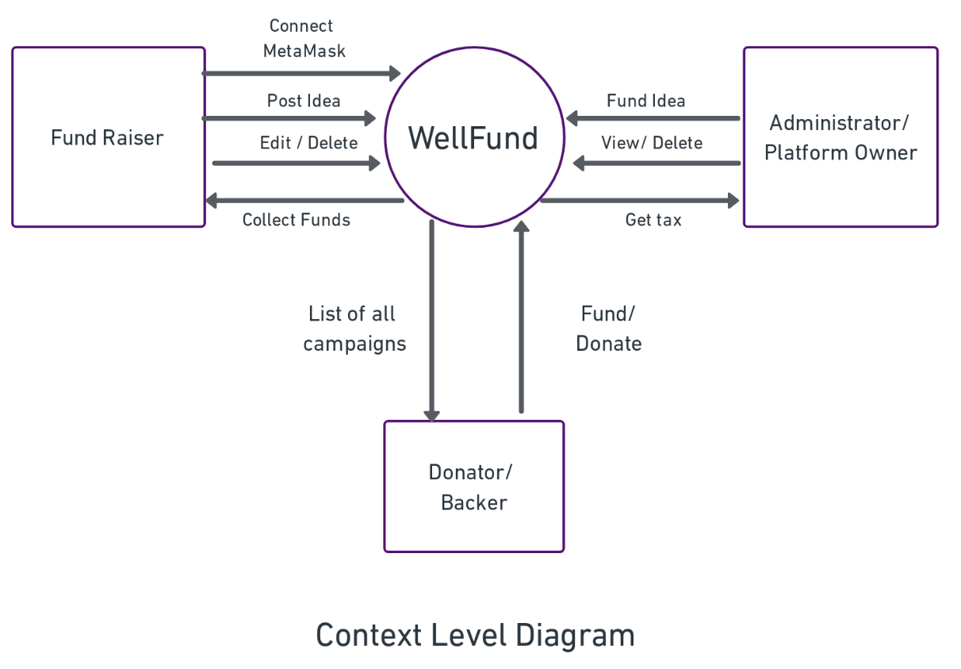

Fig. 2 Context Level Diagram

In the WellFund project, the platform facilitates a crowdfunding system where a user can participate as a fund raiser or as a donor. Fund raisers are those users that need funds for their ideas or needs. They connect their MetaMask wallets for authentication purpose then they can create or manage their fundraising campaigns. They are provided the ability to post their own campaigns, edit campaign details and can even delete the same if needed.

The platform owner or administrator, on the other hand, has additional authority. Any promising or suitable with goals of the platform project may receive funding from them as well. The administrator also has the power to review every campaign and reject any that appears unfair or to be in violation of platform regulations. The viability and maintenance of the platform are further aided by the platform owner receiving a portion of the revenues raised as tax. The WellFund ecosystem depends on donors in a big way. They have the chance to browse and view every campaign that is offered on the platform. Donors can support causes that are significant to them or that are in line with their interests by donating funds. Their contributions encourage a sense of community and a collective influence by supporting the campaigns and causes they support. Overall, WellFund seeks to provide a secure and transparent platform for crowdfunding, encouraging users to be trustworthy as well as accountable. It makes use of the Ethereum blockchain's features and the MetaMask browser extension for safe transaction signatures. This ecosystem enables fundraisers to share their ideas, administrators to uphold ethical standards, and contributors to generously support a range of causes.

## User Classes and Characteristics

There are 3 types of users:

1. Admin/ Administrators: The group of users that has the highest level of permission.

They can:

- Update System and Fund Campaigns

- Approve/ Reject Projects or campaigns

1. Fund Seeker: The entity/organization/user that is in need of the funds

They can:

- Create Campaign

- Edit or delete the campaign if needed

- Withdraw Funds

1. Donor/ Contributor: The entity/organization/user that contributes to funds

They can:

- View Campaign

- Contribute to any campaign

# Implementation Methodology

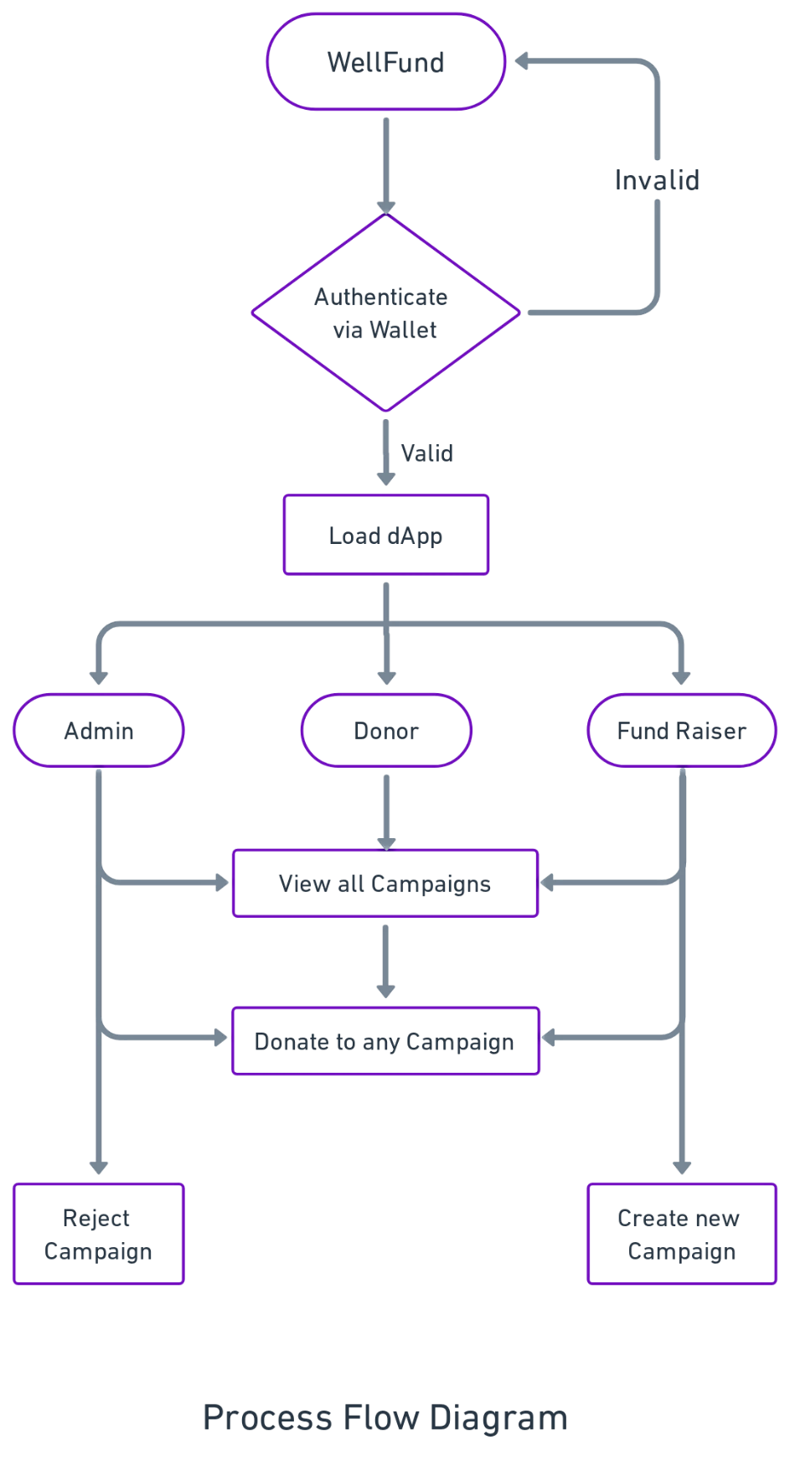

Fig. 3 Process Flow Diagram

To ensure the effective development and deployment of the software system, the WellFund project is implemented in an organized manner. The process is divided into multiple phases:

1. System Design: The system design phase involves the creation of various diagrams and models to represent the system's architecture, data flow, and user interactions. This includes creating the Context Level Diagram, Data Flow Diagrams (DFDs), Class Diagrams, and Use Case Diagrams. These visual representations help in understanding the flow of information and the relationships between different system components.
2. Environment Setup: The development environment for WellFund includes setting up the necessary tools and technologies. This includes installing the required software, such as Solidity compiler, development frameworks like Truffle or Hardhat, and configuring the development network, such as Ganache.
3. Development Phase:
4. Frontend Development: The user interface (UI) is developed using ReactJS, allowing users to interact with the platform. The front end communicates with the smart contracts deployed on the blockchain network, enabling users to connect their wallets, create campaigns, donate to projects, and view project details.
5. Backend/ Smart Contract Development: The core functionality of WellFund is implemented using Solidity smart contracts. The contracts define the functions, and business logic of the crowdfunding platform. The project contract manages the creation, updating, and deletion of campaigns, while the backer and statistics contracts handle backer-related information and platform statistics, respectively.
6. Integration and Testing: Once the smart contracts and front-end components are developed, integration testing is conducted to ensure seamless communication between the different system elements. This includes testing the interaction between the front-end application and the smart contracts, validating data flow, and verifying the expected behaviour of the system. Various test cases are executed to validate different scenarios and ensure proper functioning of features such as project creation, editing, deletion, donation, and project payout.
7. Deployment: The WellFund project is currently deployed on the local system, making use of the local blockchain generated with Hardhat and Ganache.

The chosen implementation technique ensures that the WellFund software system is developed and deployed in the local environment for now in a systematic and controlled manner. It enables extensive testing, local deployment, and ongoing maintenance to guarantee the platform's dependability and efficiency.

Deploying the WellFund project on the main Ethereum network will need additional resources and result in costs, such as transaction fees or hosting fees, hence it is decided to locally deploy the WellFund project instead. These expenses can be reduced by deploying locally, increasing the cost-effectiveness of the process during the development and testing stages. Once the project is thoroughly tested in the local environment, it can be deployed on the main network to make it accessible to a wider audience.

# Technologies to be used

The WellFund project uses a range of technologies and tools to develop a robust and efficient crowdfunding platform. These technologies have been carefully chosen to ensure the smooth functioning of the platform, as well as to provide a seamless user experience for fundraisers, donors, and administrators.

The technologies to be used can be categorized into the software platform, hardware platform, and tools. Each category plays a crucial role in the development, deployment, and maintenance of the WellFund project.

## Software Platform

The WellFund project's front-end and back-end components, which are responsible for implementing the necessary features and providing a user-friendly interface, are all a part of the software platform.

1. **Front-end**

The WellFund platform's user interface will be developed using front-end technologies, offering an intuitive and engaging user experience.

* HTML5, CSS3, JavaScript:

Web pages are structured using HTML5, styled and laid out using CSS3, and dynamic functionality is added to the application using JavaScript. These web technologies will be used in WellFund to develop visually appealing and responsive user interfaces that will make it easy for users to explore campaigns, make donations, and interact with the platform.

* ReactJS:

React.js is a popular JavaScript library for creating user interfaces. It allows the development of reusable UI components, resulting in a codebase that is modular as well as simple to maintain. React.js is implemented in WellFund in order to effectively manage UI state, manage data updates in real-time, and deliver an intuitive and responsive user experience.

* Web3.js:

Web3.js is a JavaScript library that makes it easier to establish a connection with the Ethereum network. It offers an easy-to-use API that allows users to read data from the blockchain, connect to their MetaMask wallets, and execute smart contracts. In order to achieve seamless interaction with the Ethereum network, WellFund will make use of Web3.js. This will allow users to read campaign data, make donations, and track funding progress in a safe and transparent manner.

* Tailwind CSS:

Tailwind CSS, a utility-first CSS framework, is used by WellFund to speed up development and improve UI design. Developers can quickly create unique, responsive designs using Tailwind CSS's collection of pre-built CSS classes that can be simply applied to HTML components without having to write a lot of CSS code.

1. **Back-end**

The WellFund project's back-end technologies make it possible to develop smart contracts, manage data, and carry out the entire business logic.

* Solidity:

It is a programming language, created specifically for developing smart contracts on the Ethereum network. Solidity will be used in WellFund to specify the behaviour and guidelines for the crowdfunding site. With the design, management, and distribution of campaigns managed by smart contracts, the WellFund ecosystem will be transparent, secure, and trustworthy.

* Ethereum Blockchain:

Due to its decentralized nature, immutability, and security, the Ethereum blockchain will be used for the construction of the WellFund platform. All transactions and interactions with smart contracts are recorded on the blockchain, which acts as a distributed ledger. In order to create transparent and auditable fundraising processes where donors may confirm the legality and integrity of campaigns, WellFund will use the Ethereum blockchain.

* Truffle Suite:

Truffle Suite can be understood as a comprehensive development framework, especially for Ethereum-based projects. It provides a set of tools that helps in smart contract development, deployment and testing. Truffle Suite has three components- Truffle, Ganache and Drizzle.

1. Truffle:

It is a development environment and testing framework that helps in the development process. It offers some functionalities that includes contract compilation, deployment and automated testing. It also ensures that the contract is error-free before getting deployed.

1. Ganache:

Truffle Suite offers Ganache, a blockchain for local development. It enables programmers to set up a personal Ethereum network on their local computers. Ganache speeds up development and testing by replicating Ethereum network behaviour locally. It offers a simple user interface for managing accounts, deploying contracts, and seeing transactional information. Before deploying smart contracts to the live Ethereum network, the WellFund project will use Ganache to test and debug them locally to make sure they work properly.

1. Drizzle:

The goal of Drizzle, a group of frontend libraries built around a Redux store, is to facilitate the creation of frontend of dApps. Utilizing the tool can make Ethereum dApp frontend development more predictable and manageable. The framework can be helpful in a variety of ways.

## Hardware Platform

The hardware platform represents the minimum hardware requirements necessary to deploy and run the WellFund project efficiently. These requirements ensure optimal performance and a seamless user experience.

* Processor: Dual-core processor or higher
* Memory: 4GB RAM or higher
* Storage: Minimum 20 GB of free disk space
* Operating System: Compatible with Windows, macOS or Linux
* Network Connection: Stable internet connection for communication with the Ethereum network and external APIs if needed

These hardware specifications guarantee that the system has enough processing power, memory, and storage to efficiently perform the WellFund project. To guarantee the application's optimal performance and responsiveness, it's critical to achieve these basic criteria.

## Tools

1. MetaMask:

Users can connect and interact with the WellFund platform securely by using MetaMask as a web extension wallet. By serving as an interface between users and the Ethereum network, it makes it possible for users to manage their accounts, sign transactions, and interact with decentralized apps (dApps) using their web browsers. Users will be able to securely manage their Ethereum accounts on WellFund, read campaign information, give to campaigns, and track their funding activities with the help of MetaMask.

1. Remix IDE:

Remix IDE is an online integrated development environment created exclusively for creating smart contracts. Solidity smart contracts can be written, compiled, and tested using this browser-based interface. Code autocompletion, syntax highlighting, and contract debugging are some of the capabilities that Remix IDE offers to make developing and testing the WellFund smart contracts more efficient.

1. Git:

Git is a popular version control software that supports group development and code management. It facilitates seamless collaboration by allowing several developers to work on the same codebase simultaneously, tracking changes, resolving issues, and keeping track of changes. Git maintains the codebase's stability and integrity throughout the whole development process.

1. Hardhat:

Hardhat is a robust environment for developing Ethereum smart contracts. A versatile plugin system, extensive debugging, testing capabilities, and other features are all available with Hardhat. Hardhat is used by WellFund to enhance testing techniques, optimize development workflow, and ensure the reliability of smart contracts.

1. VS Code:

It is a code editor developed by Microsoft. It is a feature rich editor that supports code highlighting, code debugging, intelligent code completion and code refactoring to build web applications. It supports wide range of programming languages and has a built-in terminal to execute command line commands.

# Advantages of this Project

Some of the major advantages of the project are:

1. Empowering Fundraisers:

The WellFund project offers a venue for fundraisers to showcase their ideas and obtain funds for their initiatives. Fundraisers benefit from transparency, security, and autonomy in conducting their campaigns by using blockchain technology and decentralized finance (DeFi) concepts. They are able to create, modify, and delete campaigns in order to reach more people and increase the amount of funds they can raise.

1. Efficient Fund Allocation:

WellFund includes smart contract capability, making it possible for funds to be distributed automatically and transparently to authorized fundraisers. This eliminates the need for middlemen, lowers administrative costs, and guarantees the funds go to the initiatives it is intended for. This effective method of allocating funds encourages donors to be reliable and accountable, which improves the platform's overall integrity.

1. Great Donor Confidence:

Donors can browse through various fundraising campaigns on WellFund, read project specifications, and decide about their contributions. Donors can have a high level of trust and confidence due to the immutability and traceability of transactions made possible by the use of blockchain technology. They feel secure knowing that their donations are being put to good use for what they were meant for.

1. Global Accessibility:

Geographical limitations on fundraising and making donations are no longer an issue with the help of WellFund. The platform integrates the internet and blockchain technologies to build a global environment for fundraising. Irrespective of their location, donors from all over the world may donate to projects that appeal to them, and fundraisers can reach a diverse and global audience.

1. Enhanced Transparency:

An important benefit of the WellFund program is transparency. By utilizing blockchain technology, transactions can be transparently and securely recorded, providing transparency in transfers of funds and project updates. By establishing a collaborative atmosphere where fundraisers, contributors, and administrators can actively participate and track campaigns' development, this transparency cultivates trust among stakeholders.

1. Reduced Costs:

WellFund decreases transaction costs by eliminating away with the need for conventional financial middlemen by utilizing blockchain technology and decentralized networks. The platform is affordable for both fundraisers and donors because of the use of open-source tools and technology, which also lower development and maintenance costs.

1. Scalability and Flexibility:

In order to support an increasing number of users and campaigns, the WellFund project is made to be flexible and scalable. The platform's decentralized structure facilitates rapid extension and integration with other blockchain ecosystems. The user experience can be enhanced as the project develops popularity by being able to adjust to changing needs and integrate new features.

The benefits listed above show how the WellFund project has the potential to revolutionize the fundraising industry. WellFund provides a transparent, effective, and inclusive platform that empowers fundraisers, promotes donor confidence, and promotes positive social impact by utilizing blockchain technology, decentralized finance principles, and user-centric design.

# Assumptions

1. Availability of Target Audience: Assuming that there is a significant amount of target audience interested in crowdfunding and supporting charitable causes, and that the public will be willing to contribute towards the project activities.
2. User Accessibility: Assuming that users have access to the necessary tools and technology (computers, smartphones, etc.) and internet connectivity to engage with the platform, and that all users have access to the internet.
3. User Adoption of Cryptocurrencies: Assuming that all users must use cryptocurrencies for transactions on the platform, and that they are familiar with using and managing crypto wallets like MetaMask.
4. Trust in the Platform: Assuming that users trust the platform with their personal and financial information, as well as the transparency and accountability of the campaigns.
5. Fundraiser Engagement: Assuming that fundraisers will actively create and manage campaigns, promoting them effectively to attract donors.
6. Partnerships with Charitable Organizations: Assuming successful collaborations with reputable charitable organizations to validate campaigns and provide credibility.
7. Adequate Funding: Assuming sufficient funding and resources to develop, deploy, and maintain the platform, as well as promote it to attract users and campaigns.
8. Compliance with Regulations: Assuming adherence to crowdfunding regulations, financial laws, and data protection policies.
9. Availability of Crypto Wallets: Assuming that all users of the public have access to crypto wallets for managing their cryptocurrency holdings.
10. Continuous Internet Connectivity: Assuming that all users have continuous access to the internet for interacting with the platform and conducting transactions.

These presumptions list the important factors that will determine if the WellFund project is a success. They contribute to the development of the project's strategy and execution plan. However, it is crucial to periodically review these presumptions and modify the project strategy in light of shifting user behaviour, market realities, and technical improvements.

# Future Scope and further enhancement of Project

The WellFund project exhibits substantial future growth potential and presents a variety of prospects for expansion and improvement. The following are some of the major areas of the project's future scope and advancements:

1. Increased User Adoption: With the growing acceptance of cryptocurrency and blockchain technology with time, WellFund can expect a boost in user adoption. As more individuals recognize the benefits of decentralized crowdfunding, the platform can focus on user acquisition strategies to attract a larger and more diverse user base, both locally and globally.
2. Global Expansion: WellFund has the potential to expand its operations beyond its initial target market. By exploring opportunities in different countries and regions, the platform can cater to a broader range of social initiatives and leverage the power of crowdfunding on a global scale. This expansion can involve localized versions of the platform, multi-language support, and compliance with diverse regulatory frameworks.
3. Partnerships and Collaborations: Collaborating with established organizations, nonprofits, and social impact initiatives can significantly enhance WellFund's credibility and reach. Strategic partnerships can provide access to existing networks, funding opportunities, and resources, while also helping to amplify the platform's social impact.
4. Integration with Decentralized Finance (DeFi): The integration of WellFund with decentralized finance protocols presents exciting possibilities. By offering additional financial services and investment opportunities, such as yield farming and staking, the platform can incentivize user participation and attract a broader range of donors and investors.
5. NFT Crowdfunding: Non-fungible tokens (NFTs) have gained substantial attention in recent years. WellFund can explore the integration of NFT crowdfunding, enabling creators and artists to raise funds by offering unique digital assets or limited editions of their work. This expansion into the realm of NFTs can open up new avenues for fundraising and creative expression.
6. Social Impact Measurement and Reporting: WellFund can further enhance its capabilities for measuring, tracking, and reporting the social impact generated by funded projects. By providing transparent and accountable reporting mechanisms, the platform can attract socially responsible investors and donors who seek tangible outcomes and measurable results.
7. Community Engagement and Governance: Empowering the WellFund community through active engagement and decentralized governance can foster a sense of ownership and participation. Implementing voting systems, community forums, and incentivized models for involvement can allow users to have a say in platform decisions and shape the future direction of WellFund.
8. Mobile Applications: Developing dedicated mobile applications for WellFund can enhance accessibility and user engagement. By providing a seamless and user-friendly mobile interface, the platform can enable users to create campaigns, donate, and track the progress of projects on the go, thereby expanding its user base and reach.
9. Integration with Web3 and Emerging Technologies: WellFund can stay at the forefront of technological advancements by integrating with Web3 standards and emerging technologies. This can involve exploring layer 2 solutions, cross-chain interoperability, decentralized identity systems, and other innovations that can enhance the scalability, security, and user experience of the platform.
10. Continuous Innovation and Improvement: To maintain a competitive edge and adapt to evolving market dynamics, WellFund should prioritize continuous innovation and improvement. Actively seeking feedback from users and incorporating their suggestions can ensure that the platform remains relevant, user-friendly, and aligned with the evolving needs of the crowdfunding community.

By capitalizing on these future opportunities and advancements, WellFund can solidify its position as a leading platform for decentralized social crowdfunding. With a commitment to innovation, user engagement, and social impact, the project has the potential to create meaningful change and empower individuals and communities worldwide.

# Project Repository Location

| **S#** | **Project Artifacts (softcopy)** | **Location** (Mention Lab-ID, Server ID, Folder Name etc.) | **Verified by Project Guide** | **Verified by Lab In-Charge** |
| --- | --- | --- | --- | --- |
|  | Project Synopsis Report (Final Version) |  | Name and Signature | Name and Signature |
|  | Project Progress updates |  | Name and Signature | Name and Signature |
|  | Project Requirement specifications |  | Name and Signature | Name and Signature |
|  | Project Report (Final Version) |  | Name and Signature | Name and Signature |
|  | Test Repository |  | Name and Signature | Name and Signature |
|  | Project Source Code (final version) with executable |  | Name and Signature | Name and Signature |
|  | Any other document |  | Name and Signature | Name and Signature |

# 

# Definitions and Acronyms

The following definitions and explanations are offered to ensure clarity and comprehension of essential terminology and acronyms used throughout the WellFund project:

## Definitions

1. Blockchain: A technology that enables the decentralized and distributed recording of transactions across multiple computers. It ensures transparency, security, and the immutability of data.
2. Crowdfunding: The practice of raising funds for a project, venture, or cause by obtaining small contributions from a large number of individuals. It typically takes place online and allows entrepreneurs, artists, or organizations to secure financial support from a wide community.
3. Decentralized Application (DApp): An application that operates on a blockchain network and utilizes smart contracts for its functionality. By removing intermediaries, DApps provide transparency and foster trust among users.
4. Smart Contract: Self-executing contracts with predefined rules and conditions encoded in software. These contracts automatically execute and enforce agreements without the involvement of intermediaries.
5. Cryptocurrency: Digital or virtual currencies that utilize cryptographic techniques to secure transactions and control the creation of new units. Prominent examples include Bitcoin (BTC) and Ethereum (ETH).
6. Ethereum: A decentralized blockchain platform that empowers the creation of smart contracts and decentralized applications (DApps). It features its native cryptocurrency known as Ether (ETH).
7. MetaMask: MetaMask is a web browser extension that functions as a digital wallet designed for the management of cryptocurrency and facilitating interactions with decentralized applications (DApps) on the Ethereum blockchain. It offers users a secure and user-friendly platform to store their private keys, effectively manage their digital assets, and securely authorize transactions.

## Acronyms

Below is the list of abbreviations and acronyms used frequently:

* DApp - Decentralized Application
* UI - User Interface
* API - Application Programming Interface
* ERC-20 - Ethereum Request for Comments 20
* DAO - Decentralized Autonomous Organization
* UX - User Experience
* ETH - Ethereum
* USD - United States Dollar
* CSS - Cascading Style Sheets
* HTML - Hypertext Markup Language
* API - Application Programming Interface
* JSON - JavaScript Object Notation

These definitions and acronyms help to ensure good communication and comprehension across the project documents by providing clarity and knowledge of essential terminology and abbreviations used within the WellFund project.

# Conclusion

The project's conclusion presents the most important discoveries and results of the WellFund system. The creation and use of this crowdfunding platform have shown how utilizing blockchain technology can completely alter the way fundraising campaigns are carried out. Decentralized applications (DApps) and smart contracts have increased process efficiency, security, and transparency, ensured the reliability of transactions and reduced the need for middlemen. With the help of the WellFund project, funders can now connect their MetaMask wallets, post campaign ideas, and efficiently administer their campaigns using a user-friendly interface. To ensure fairness and authenticity, the platform owner or administrator has the power to evaluate and support campaigns. Donors have the chance to research different campaigns, make wise judgements, and support causes that are significant to them. The seamless operation of the platform is primarily due to the utilization of technologies like Ethereum, ERC20 tokens, and MetaMask. Secure and immutable transactions are now possible because of Ethereum's strong blockchain technology and the power of smart contracts. As a trustworthy digital wallet, MetaMask has given consumers a simple and safe way to use the platform and manage their virtual currency holdings.

Overall, the WellFund project has successfully demonstrated the potential of blockchain technology in revolutionizing crowdfunding platforms. The decentralized and transparent nature of the system ensures trust, eliminates intermediaries, and provides a more inclusive and efficient fundraising experience. With further enhancements and refinements, the WellFund platform has the potential to make a significant impact in the world of crowdfunding and support a wide range of meaningful projects and initiatives.

# References

1. Blockchain & Smart Contracts: <https://www.dappuniversity.com/articles/how-to-build-a-blockchain-app>
2. CryptoRelief Platform: <https://cryptorelief.in>
3. Learning Solidity Language: <https://cryptozombies.io/>
4. Metamask Ethereum Wallet : <https://metamask.io/>
5. Wikipedia: [Solidity - Wikipedia](https://en.wikipedia.org/wiki/Solidity)
6. How data is stored in Ethereum Blockchain: <https://laurentsenta.com/articles/storage-and-dapps-on-ethereum-blockchain/>
7. Ethereum Test Network: <https://www.rinkeby.io/#stats>
8. Nakamoto, S. (2008). Bitcoin: A Peer-to-Peer Electronic Cash System. <https://bitcoin.org/bitcoin.pdf>
9. Buterin, V. (2014). Ethereum White Paper: A Next-Generation Smart Contract and Decentralized Application Platform. <https://ethereum.org/whitepaper/>
10. Zhang, Y., Wen, Y., Zhang, Y., Chen, S., & Hassan, A. E. (2018). Crowdfunding Under Blockchain Technology. IEEE Transactions on Engineering Management, 65(3), 424-434.

|  |  |  |  |  |
| --- | --- | --- | --- | --- |
| **S#** | **Reference Details** | **Owner** | **Version** | **Date** |
|  | Project Synopsis | <Project Group ID> | 1.0 | DD-MM-YY |
|  | Project Requirements | <Project Group ID> |  |  |
|  |  |  |  |  |

**Annexure A**

**Data Flow Diagram (DFD)**

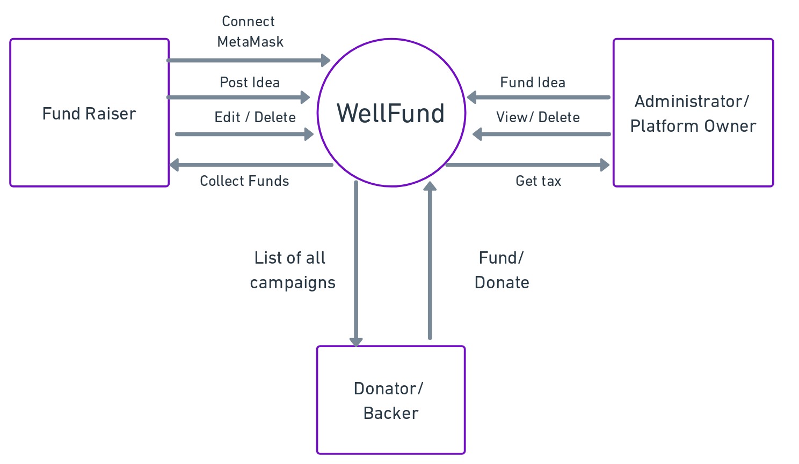

Fig. 4 DFD – Zero Level

**Annexure B**

**Activity Diagram**

1. **Administrator’s Process Diagram**

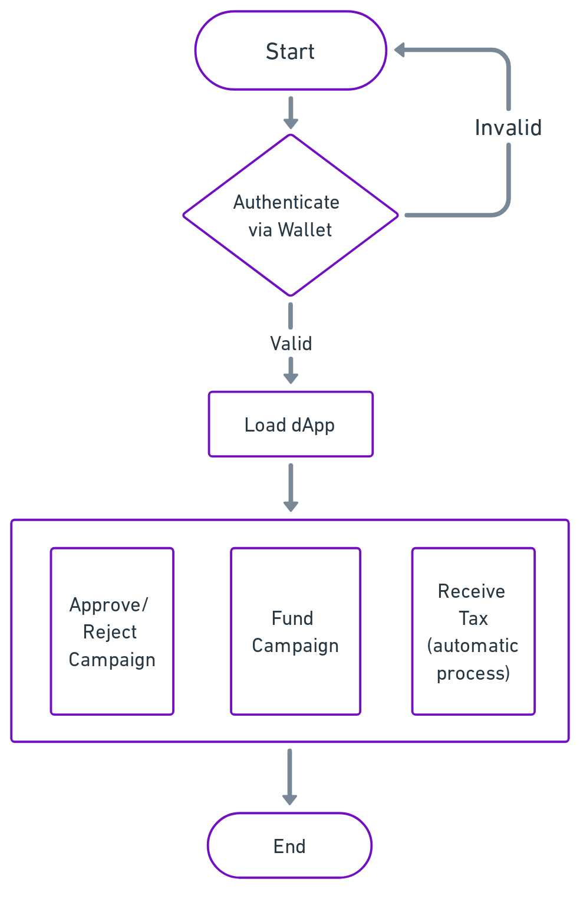

Fig. 5 Administrator’s Process Diagram

1. **Fund Seeker’s Process Diagram**

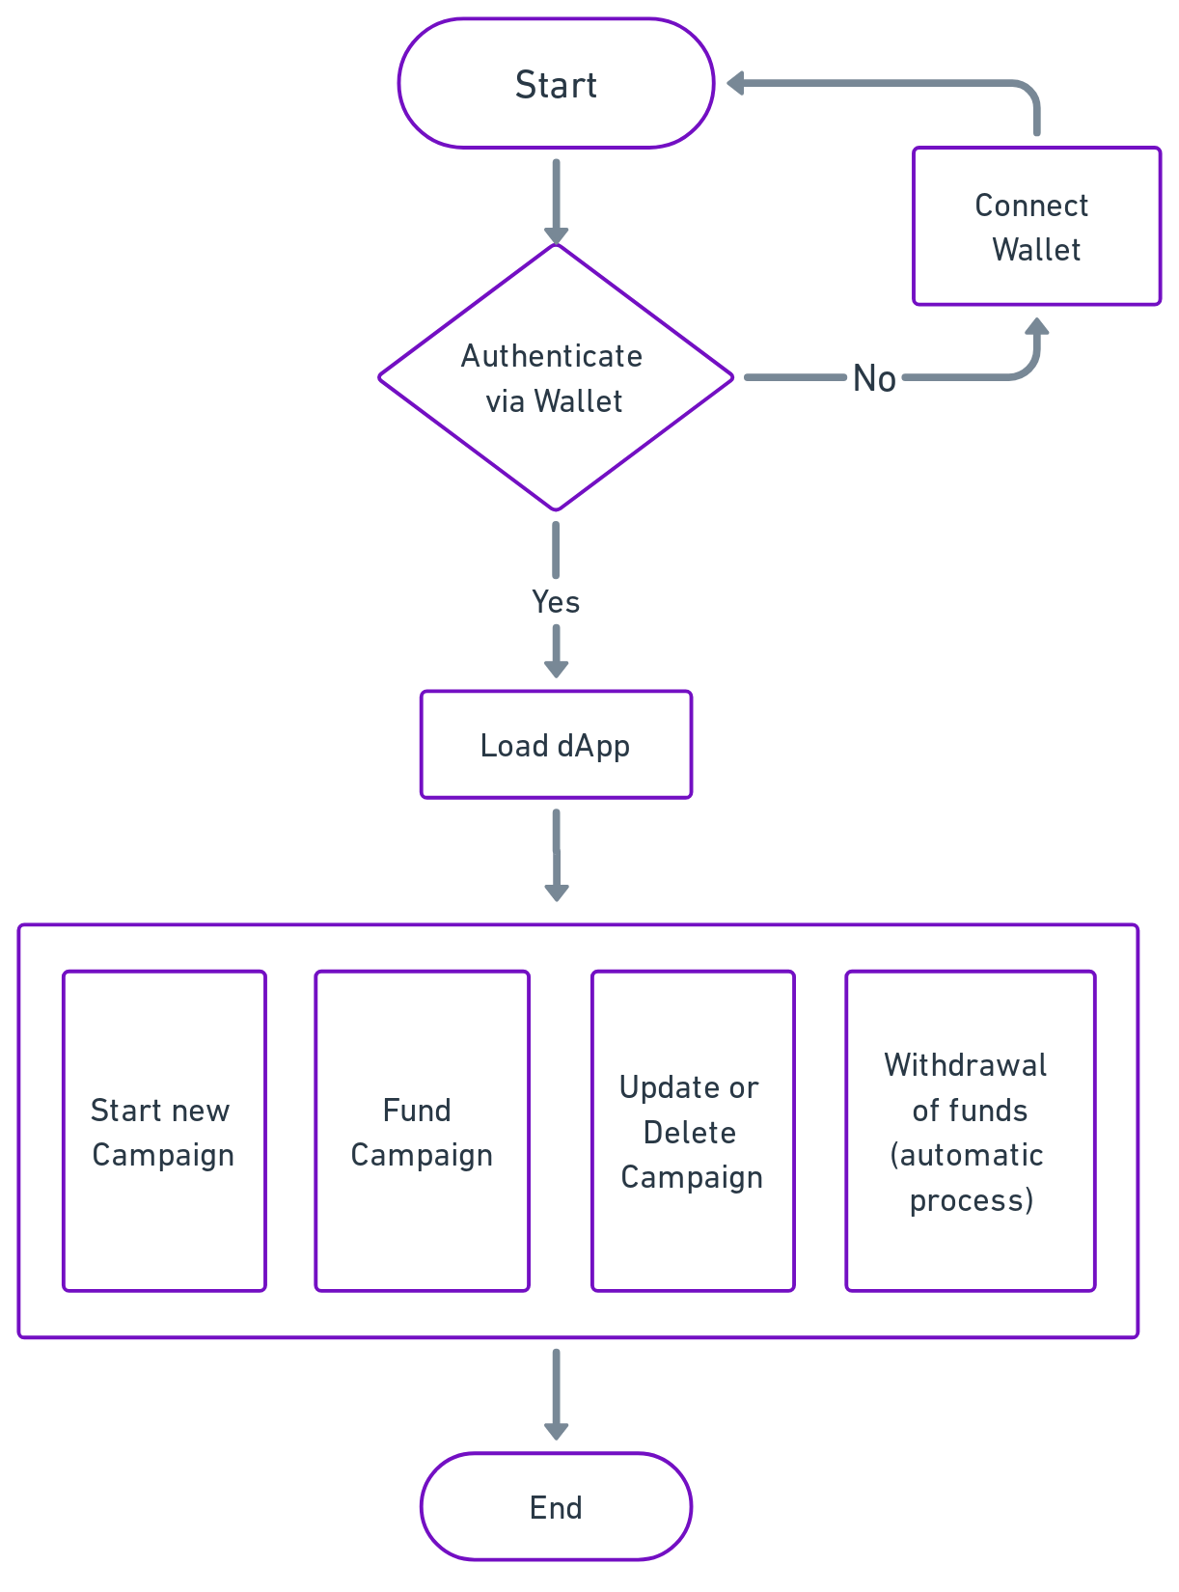

Fig. 6 Fund Seeker’s Process Flow Diagram

**Annexure C**

**Use-Case Diagram (UCD)**

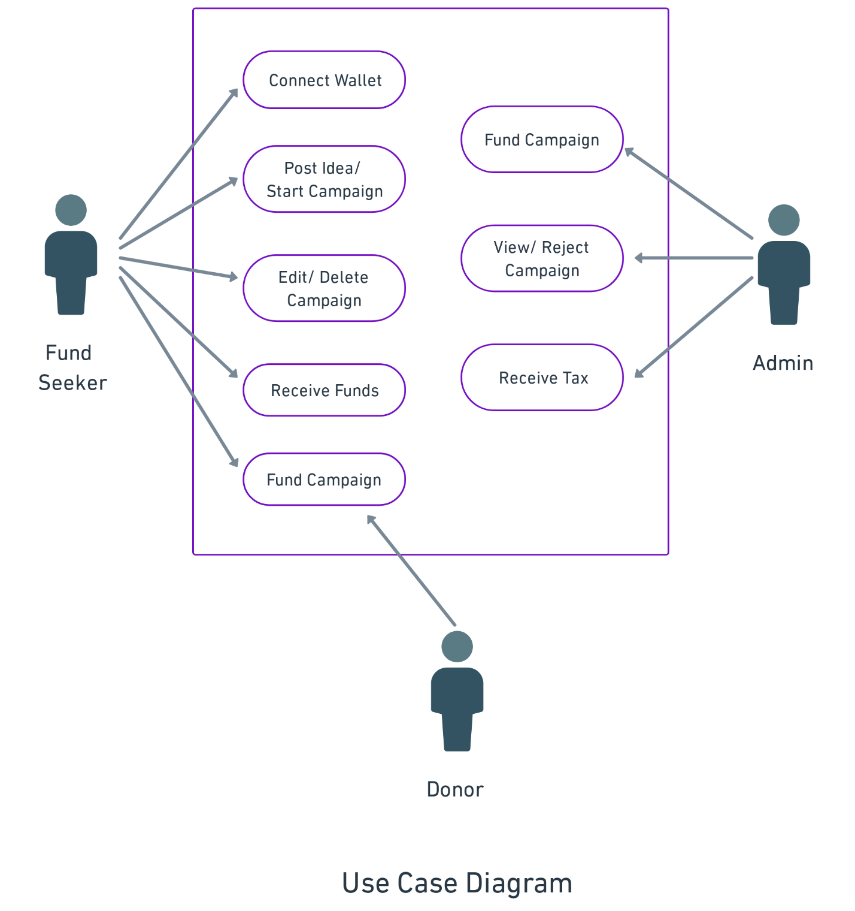

Fig. 7 Use-Case Diagram

**Annexure D**

**Screen Shots**

1. **Home Page:** Before connecting Wallet

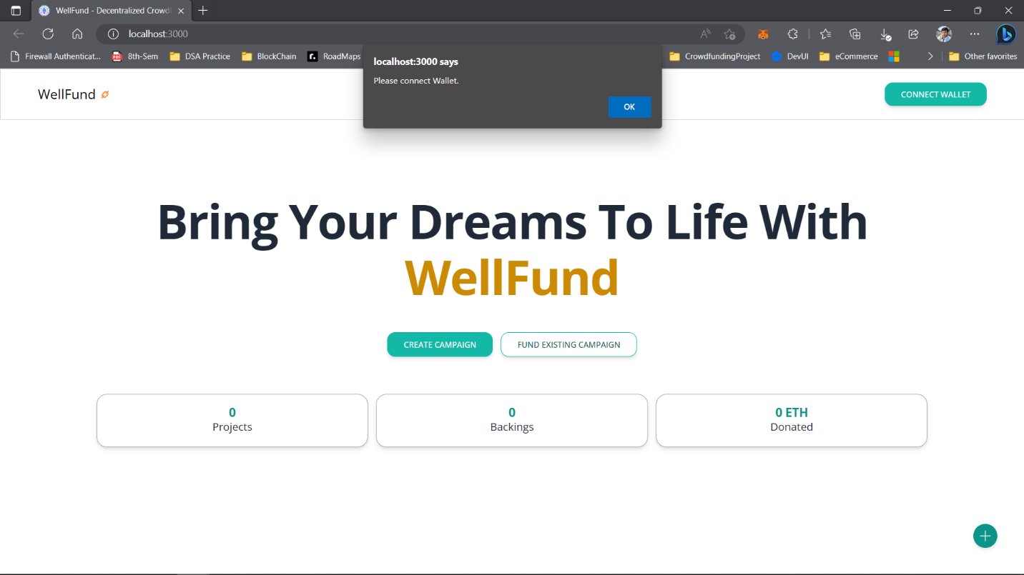

Upon accessing the platform, users are greeted with a visually appealing homepage that showcases key information about the project. Additionally, a popup window promptly appears, inviting users to connect their digital wallets. This feature ensures that users can securely interact with the platform, manage their funds, and participate in various activities such as creating campaigns or making donations. By integrating this wallet connection functionality into the home page, WellFund streamlines the user onboarding process and encourages user engagement from the moment they enter the platform.

1. **Home Page:** After connecting Wallet

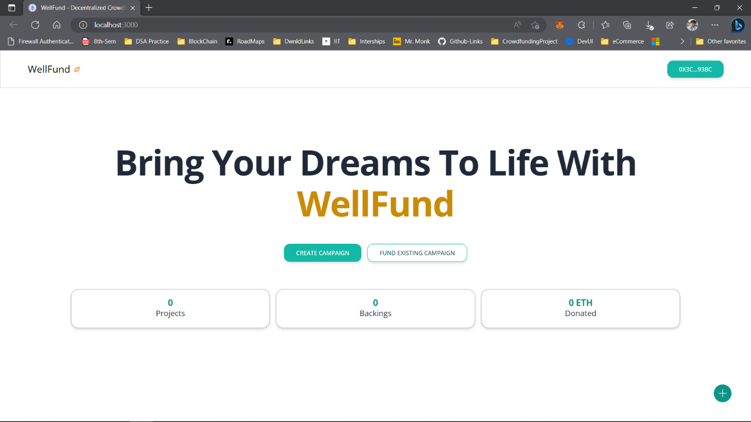

1. Select the network – via MetaMask Extension

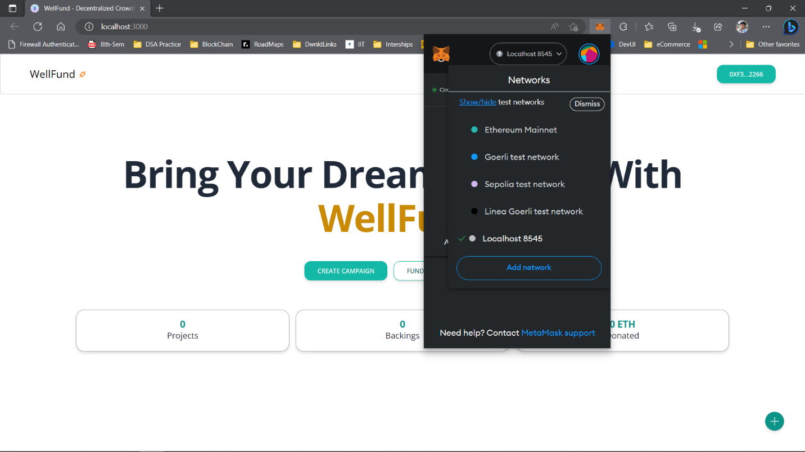

1. **Add Project/ Create Campaign**

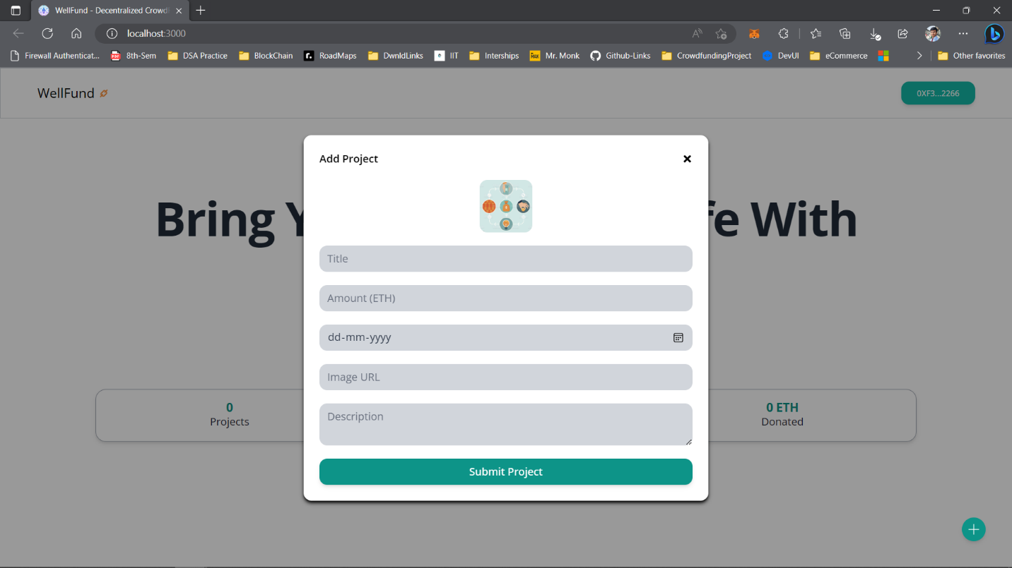

1. **Add Project/ Create Campaign:** fill details, submit and confirm transaction

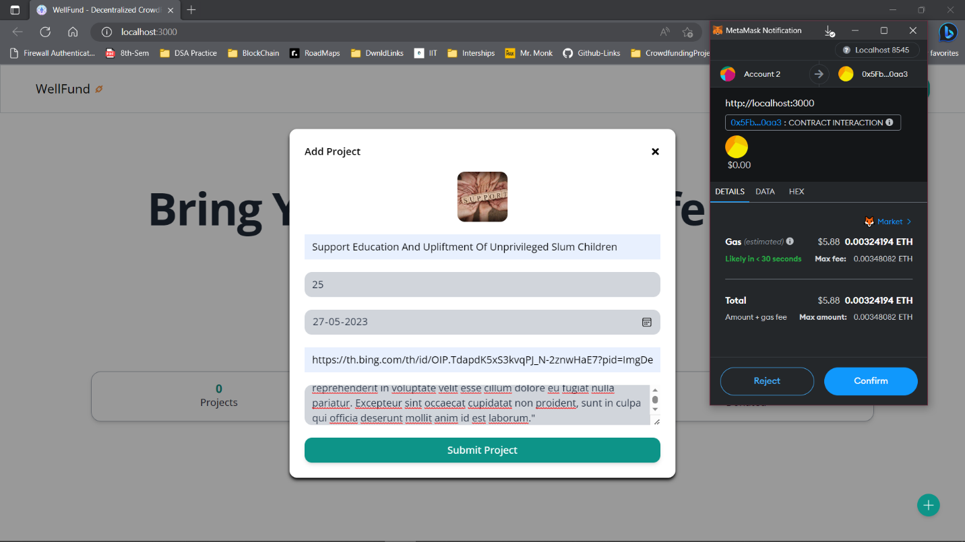

1. **Confirmation of the Creation of Campaign**

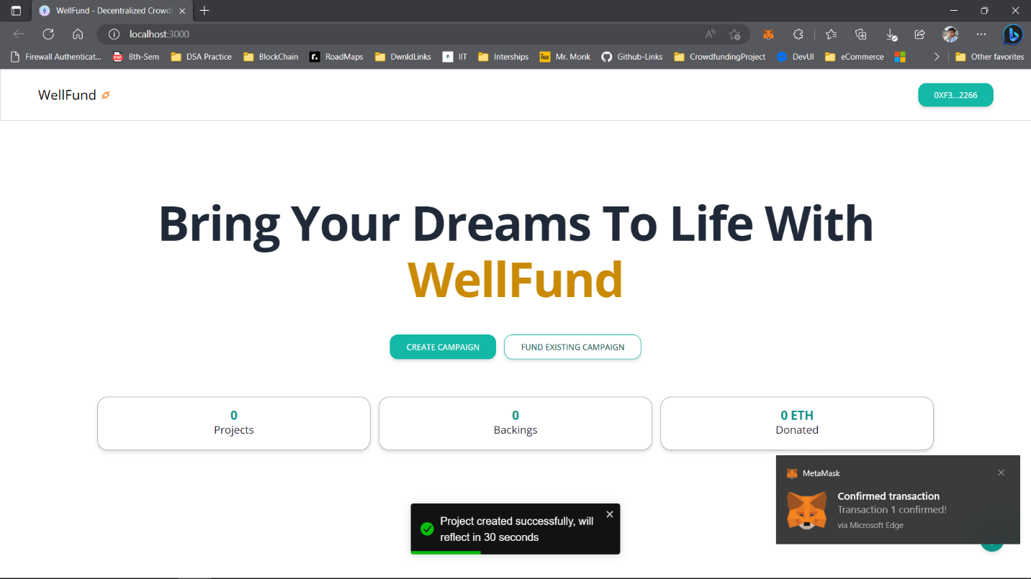

1. **New Campaign added:**

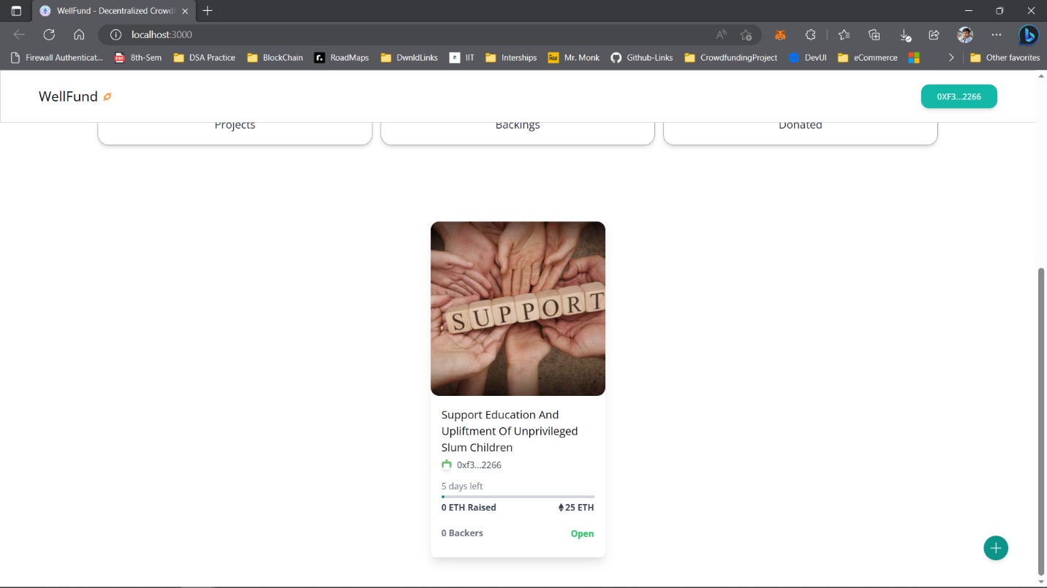

1. **Campaign Details Page (for fund-raiser)**

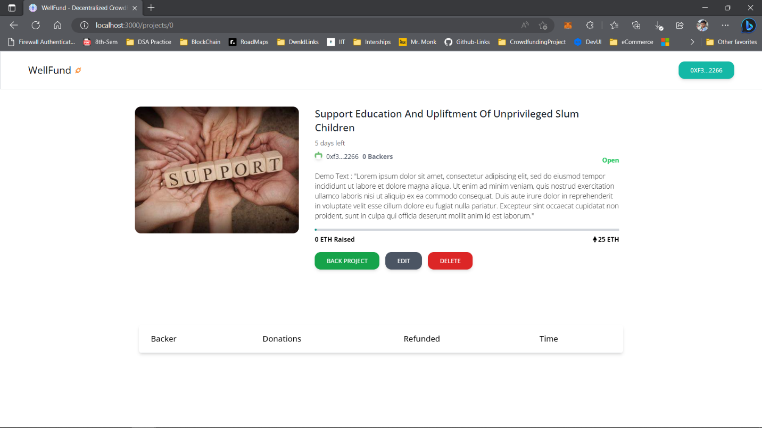

1. **Campaign Details Page (for donor)**

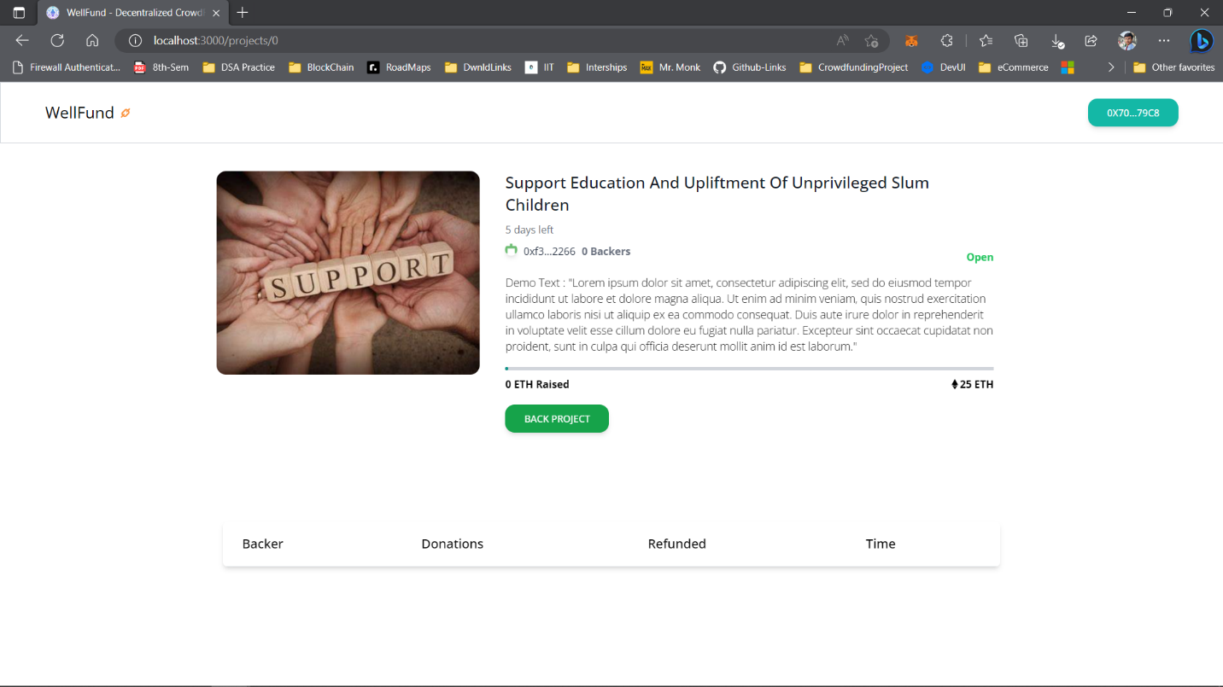

1. **Campaign Details Page (for donor)-** after some donations

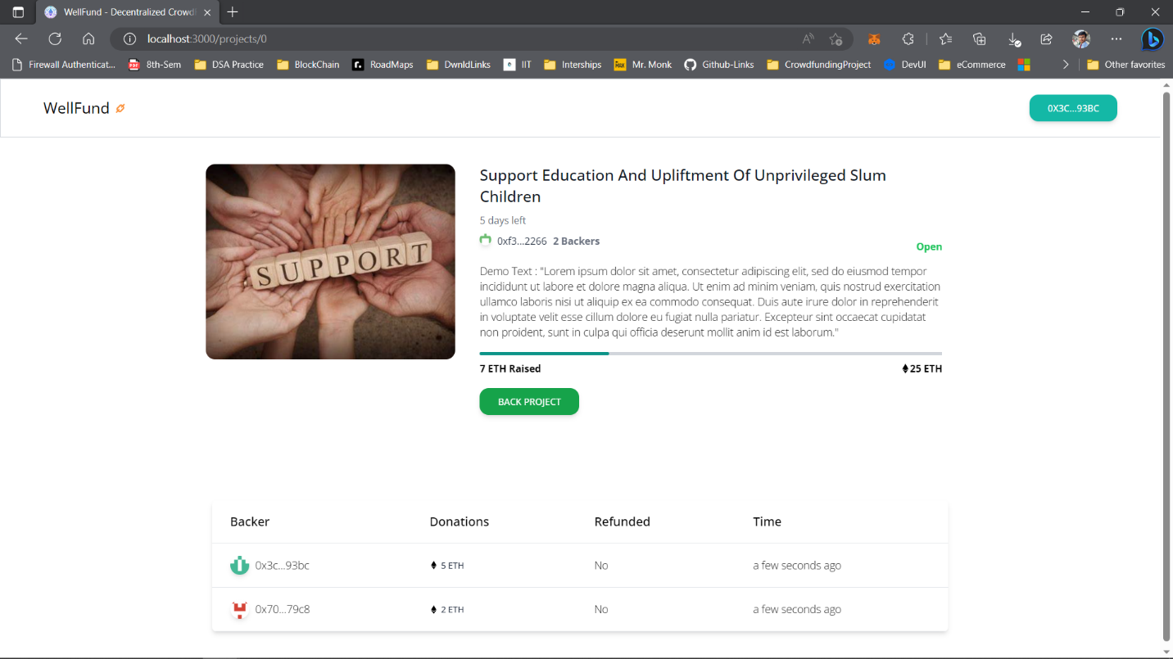

It comprises of all the details of the campaign along with the details of the donors.