**The Rise of Decentralized Crowdfunding:   
A Comprehensive Analysis**

*1Dr Sourabh Pathak, 2Saiyam Jain*

*1Professor, CCSIT, Teerthanker Mahaveer University, Moradabad*

*1Student, CCSIT, Teerthanker Mahaveer University, Moradabad*

**Abstract:**

Blockchain technology is experiencing swift growth with time. With advancements in blockchain technology, traditional crowdfunding platforms are challenged by their disruptive alternative, the decentralized crowdfunding platforms. These platforms are revolutionising the way in which individuals, organisations and societies raise capital for different initiatives by making use of principles such as decentralization, transparency and smart contracts. The paper offers a comprehensive look at the rise of decentralized crowdfunding and its effects on the landscape of fundraising. This study attempts to shed light on the disruptive potential of decentralized crowdfunding through an examination of major characteristics, advantages, obstacles, and potential outcomes. The results show that decentralised crowdfunding has many benefits over traditional approaches, including more accessibility, transparency, and lower costs. Scalability issues, regulatory compliance issues, and user adoption issues still exist. In the research's final section, the prospects and prospective directions for decentralised crowdfunding are discussed. This study offers important insights for researchers, practitioners, and stakeholders in the understanding of decentralised crowdfunding and its effect on the fundraising ecosystem.

**Keywords** - Decentralized crowdfunding, blockchain technology, smart contracts, fundraising, transparency.

**INTRODUCTION**

1. **Background and Context**

Crowdfunding has become a popular alternative to traditional fundraising techniques in recent years, enabling people and organizations to obtain funds from a significant donor base. Traditional crowdfunding platforms, however, have a number of drawbacks that can limit the reach and efficacy of fundraising efforts, such as excessive fees, geographical restrictions, and a lack of transparency [1]. Due to these difficulties, there is now a need for creative answers that may solve these constraints and offer a more effective and transparent crowdfunding experience.

1. **Problem Statement**

The purpose of this research is to develop a decentralized crowdfunding platform that leverages blockchain technology to overcome the limitations of traditional crowdfunding platforms. By utilizing the transparency, security, and efficiency offered by blockchain, we aim to create a platform that empowers fundraisers and donors while fostering trust and transparency in the crowdfunding process. This decentralized approach eliminates the need for intermediaries, reduces transaction costs, and ensures the integrity of transactions [2].

1. **Research Objective**

The main objective of this research paper is to design and implement a decentralized crowdfunding platform that enables transparent and efficient fundraising campaigns. The specific research objectives include:

* Investigating the evolution and challenges of traditional crowdfunding platforms to understand their limitations and shortcomings.
* Exploring the potential applications of blockchain technology in the field of crowdfunding and examining its impact on transparency, security, and efficiency.
* Review relevant literature and studies on decentralized crowdfunding to gain insights into existing approaches and identify gaps in the current research.
* Designing a robust and scalable platform architecture that leverages blockchain technology to facilitate secure and transparent transactions.
* Evaluating the performance and effectiveness of the developed platform through data analysis and user feedback to assess its impact on fundraisers and donors.

1. **Research Questions**

To guide our research efforts, we will address the following research questions:

* What are the key limitations and challenges faced by traditional crowdfunding platforms?
* How can blockchain technology be effectively utilized to create a decentralized crowdfunding platform?
* What are the critical design considerations and features required for developing a robust and user-friendly decentralized crowdfunding platform?
* What are the implications and potential benefits of a decentralized crowdfunding platform for fundraisers and donors?
* How does the developed platform perform in terms of transparency, security, and user satisfaction compared to traditional crowdfunding platforms?

By addressing these research questions, we aim to contribute to the existing knowledge on decentralized crowdfunding, advance the understanding of blockchain technology's impact on the fundraising landscape, and provide valuable insights for the development of innovative crowdfunding platforms.

**LITERATURE REVIEW**

1. **Overview of Crowdfunding**

Crowdfunding is a financing model that allows individuals or organizations to raise funds from a large number of contributors, typically through an online platform [1]. It has gained popularity due to its potential for democratizing access to capital and enabling the realization of diverse projects and ventures. Crowdfunding can be categorized into different types, including donation-based, reward-based, equity-based, and lending-based crowdfunding. Each type offers unique features and benefits for fundraisers and donors.

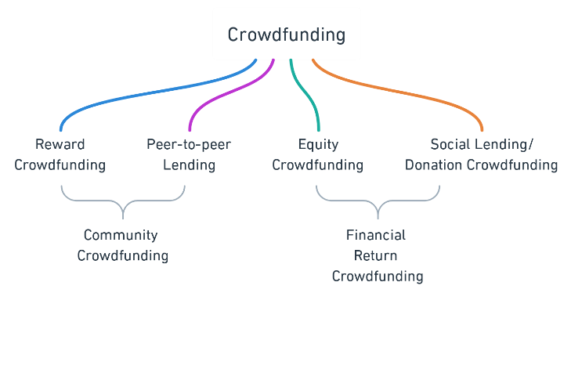

1. **Evolution of Crowdfunding Platforms**

Traditional crowdfunding platforms have played a significant role in facilitating fundraising campaigns. However, they often face limitations such as high transaction fees, geographical restrictions, lack of transparency, and dependence on intermediaries [3]. These limitations have led to the exploration of alternative solutions to improve the crowdfunding landscape.

1. **Challenges and Limitations in Traditional Crowdfunding**

Traditional crowdfunding platforms face several challenges that hinder their effectiveness and reach. High transaction fees imposed by intermediaries reduce the funds available for the intended projects, making them less attractive for fundraisers [4]. Moreover, geographical restrictions limit the global accessibility of campaigns, limiting the potential pool of donors. Lack of transparency and accountability in the distribution and utilization of funds raises concerns among potential contributors. Additionally, the reliance on intermediaries introduces risks and delays in the fundraising process, impacting the overall efficiency of the platforms.

1. **Blockchain Technology and Its Application in Crowdfunding**

Blockchain technology, originally developed for cryptocurrencies like Bitcoin, has gained attention for its potential to revolutionize various industries, including crowdfunding. The decentralized and immutable nature of blockchain provides opportunities to address the limitations of traditional platforms. By eliminating intermediaries and leveraging smart contracts, blockchain-based crowdfunding platforms can ensure transparency, reduce costs, enhance security, and enable global accessibility [5]. Smart contracts enable the automatic execution and enforcement of crowdfunding agreements, removing the need for intermediaries and increasing trust between fundraisers and donors [6].

**LIMITATIONS OF THE CURRENT SYSTEM**

Crowdfunding platforms, particularly those primarily focused on donation-based crowdfunding have played an important role in making individuals and organizations capable to raise funds for charitable causes, medical causes, disaster relief causes and more. The current system of centralized platforms faces some challenges that any decentralized platform can handle more effectively. Some of the main problems in the current system are:

1. **Lack of Transparency:** When it comes to crowdfunding platforms based on donations, transparency has a significant role. Donors or backers have limited visibility to know how their donations are being utilized or being distributed among the recipients. This lack of transparency may lead to skepticism and will ultimately reduce trust in the platform.
2. **High Platform Fees:** The centralized crowdfunding platforms often charge high amount of fees to cover their operational costs. Also, the transaction fee and the service charges are higher in centralized platforms. These charges can diminish the impact of the overall donation as a good amount of the donation goes towards the platform as its fee rather than being used to benefit the cause.
3. **Trust and Accountability Issues:** The centralized nature of crowdfunding platforms can lead to challenges of trust and accountability. The donors may question the legitimacy of the campaign as there have been many fraudulent or misleading campaigns that can exploit the donor’s money and goodwill. Mechanisms to verify the authenticity of the campaign are a must.
4. **Limited access for certain regions:** It is seen that many of crowdfunding platforms have geographical restrictions that limit their access to the individuals of a specific region or country. This can hinder many potential donors from contributing to the cause they care about and will also limit the global reach of the campaign.

**PROPOSED SOLUTION**

WellFund is an innovative decentralized, donation-focused crowdfunding application built on the top of the Ethereum blockchain platform, which offers an intuitive and transformative approach to crowdfunding. In WellFund, users or donors have the opportunity to invest or donate to campaigns that align with their interests.

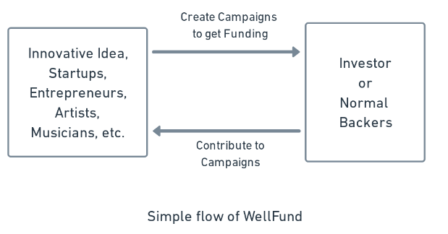

By utilizing the power of blockchain, WellFund comes with a bundle of advantages over traditional crowdfunding platforms. One of the notable benefits of WellFund is the provision of low-risk support for new ventures. Due to the implementation of blockchain, WellFund ensures that crowdfunding activities take place with reduced risk. The immutable nature of the blockchain ensures the transparency and accountability of the platform and allows the donors to track the investment. Moreover, it serves to increase the reach of the campaign by making it globally accessible. Using an efficient approach, WellFund connects project developers with a global audience with a built-in interest in crowdfunding campaigns. Venture creators are able to broaden their reach, boost their awareness, and ultimately improve their chances of raising large amounts in a relatively brief period of time by gaining access to this vast network of backers. In turn, investors get the chance to invest in projects that suit their preferences while perhaps earning significant incentives. WellFund - crowdfunding platform optimizes the procedure by getting rid of pointless middlemen and complicated administrative requirements. The built-in automated features of blockchain, made possible by smart contracts, expedite processes, cut down on administrative work, and free up project founders to concentrate on implementing their ideas.

**SYSTEM DESIGN AND ARCHITECTURE**

The system design and architecture section provides an overview of the WellFund platform, highlighting the integration of blockchain technology, smart contract implementation, user interface design, and security considerations. These elements work together to create a robust and user-friendly decentralized crowdfunding solution.

1. **Overview of the WellFund Platform**

The WellFund platform is a decentralized crowdfunding solution that leverages blockchain technology to address the challenges faced by traditional crowdfunding platforms [1]. It provides a transparent, secure, and efficient environment for fundraisers and donors to connect and support various causes.

The platform facilitates the creation of fundraising campaigns by allowing fundraisers to create detailed campaign profiles, set funding goals, and specify the duration of the campaign. Donors can browse through the available campaigns, view campaign details, and make donations using supported cryptocurrencies.

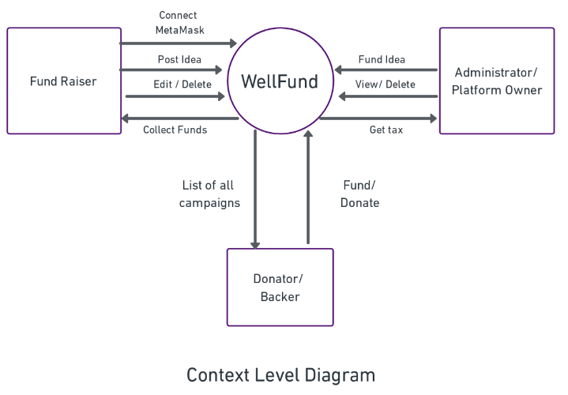

1. **Blockchain Integration and Smart Contract Implementation**

The WellFund platform integrates blockchain technology, specifically the Ethereum blockchain, to ensure transparency, immutability, and security of transactions. Smart contracts are utilized to automate the execution and enforcement of agreements between fundraisers and donors.

Smart contracts are self-executing contracts with predefined rules and conditions encoded in software. They eliminate the need for intermediaries by automating the process of collecting and distributing funds. When a fundraising campaign meets its funding goal or the specified duration ends, the smart contract automatically releases the funds to the fundraiser. The use of smart contracts enhances trust and eliminates the possibility of fraudulent activities or mismanagement of funds. The transparency provided by the blockchain allows all transactions and donation records to be publicly visible and auditable.

1. **User Interface Design and Features**

The user interface (UI) of the WellFund platform is designed to be intuitive, user-friendly, and accessible to both fundraisers and donors. The UI provides a seamless experience for navigating through campaigns, making donations, and tracking the progress of campaigns.

Fundraisers can easily create and manage their campaigns through a user-friendly dashboard. They can update campaign details, and track donation progress. Donors have a straightforward donation process, where they can choose the desired campaign, select the donation amount, and complete the transaction. The UI also provides real-time updates on the campaign's funding progress, allowing donors to see the impact of their contributions.

1. **Security and Privacy Considerations**

Security and privacy are essential aspects of the WellFund platform. The integration with the Ethereum blockchain ensures the security and integrity of transactions through its consensus mechanism and cryptographic techniques.

Private keys, which provide access to users' digital wallets, are securely stored on the users' devices using encryption. This ensures that users have full control over their funds and mitigates the risk of unauthorized access.

**ADVANTAGES**

1. **Empowering Fundraisers**: The WellFund project offers a venue for fundraisers to showcase their ideas and obtain funds for their initiatives. Fundraisers benefit from transparency, security, and autonomy in conducting their campaigns by using blockchain technology and decentralized finance (DeFi) concepts. They are able to create, modify, and delete campaigns in order to reach more people and increase the amount of funds they can raise.
2. **Efficient Fund Allocation:** WellFund includes smart contract capability, making it possible for funds to be distributed automatically and transparently to authorized fundraisers. This eliminates the need for middlemen, lowers administrative costs, and guarantees the funds go to the initiatives it is intended for. This effective method of allocating funds encourages donors to be reliable and accountable, which improves the platform's overall integrity.
3. **Great Donor Confidence:** Donors can browse through various fundraising campaigns on WellFund, read project specifications, and decide about their contributions. Donors can have a high level of trust and confidence due to the immutability and traceability of transactions made possible by the use of blockchain technology. They feel secure knowing that their donations are being put to good use for what they were meant for.
4. **Global Accessibility:** Geographical limitations on fundraising and making donations are no longer an issue with the help of WellFund. The platform integrates the internet and blockchain technologies to build a global environment for fundraising. Irrespective of their location, donors from all over the world may donate to projects that appeal to them, and fundraisers can reach a diverse and global audience.
5. **Enhanced Transparency:** An important benefit of the WellFund program is transparency. By utilizing blockchain technology, transactions can be transparently and securely recorded, providing transparency in transfers of funds and project updates. By establishing a collaborative atmosphere where fundraisers, contributors, and administrators can actively participate and track campaigns' development, this transparency cultivates trust among stakeholders.
6. **Reduced Costs:** WellFund decreases transaction costs by eliminating away with the need for conventional financial middlemen by utilizing blockchain technology and decentralized networks. The platform is affordable for both fundraisers and donors because of the use of open-source tools and technology, which also lower development and maintenance costs.
7. **Scalability and Flexibility:** In order to support an increasing number of users and campaigns, the WellFund project is made to be flexible and scalable. The platform's decentralized structure facilitates rapid extension and integration with other blockchain ecosystems. The user experience can be enhanced as the project develops popularity by being able to adjust to changing needs and integrate new features.

The benefits listed above show how the WellFund project has the potential to revolutionize the fundraising industry. WellFund provides a transparent, effective, and inclusive platform that empowers fundraisers, promotes donor confidence, and promotes positive social impact by utilizing blockchain technology, decentralized finance principles, and user-centric design.

**FUTURE ENHANCEMENTS AND DIRECTIONS**

As the WellFund platform continues to evolve and adapt to the changing landscape of crowdfunding and blockchain technology, there are several areas of future enhancements and directions that can be considered. These include:

1. **Scalability and Global Expansion Strategies**

To accommodate a growing user base and increase the platform's global reach, scalability is a critical aspect to address. The WellFund team should explore solutions such as sharding, sidechains, or layer 2 protocols to enhance transaction throughput and reduce congestion on the blockchain network [7]. Implementing robust infrastructure and optimizing the platform's architecture will ensure a seamless and efficient user experience, even during peak usage periods [8].

Furthermore, global expansion strategies should be devised to cater to a diverse range of regions and countries. This involves adapting the platform to comply with various regulatory frameworks, local languages, and cultural nuances. Establishing strategic partnerships with local organizations and non-profits can facilitate the expansion process and enhance the platform's credibility in new markets [9].

1. **Integration with Emerging Technologies**

To stay at the forefront of technological advancements, the WellFund platform should explore the integration of emerging technologies. This may include incorporating decentralized finance (DeFi) protocols to offer additional financial services and investment opportunities to users [10]. Features such as yield farming, liquidity mining, or staking can incentivize participation and attract a broader range of donors and investors.

Additionally, the platform can leverage emerging technologies like artificial intelligence (AI) and machine learning (ML) to enhance campaign evaluation, fraud detection, and user experience. By automating certain processes and providing personalized recommendations, the platform can streamline operations and deliver tailored experiences to users [11].

1. **Partnerships and Collaborations**

Collaborating with established organizations, non-profits, and social impact initiatives can significantly enhance the WellFund platform's credibility and reach. Strategic partnerships can provide access to existing networks, funding opportunities, and resources [12]. By joining forces with reputable entities in the crowdfunding space, the platform can amplify its social impact and attract a wider audience of fundraisers and donors.

Furthermore, partnerships with blockchain development firms and academic institutions can foster innovation and research in the field of decentralized crowdfunding. Collaborative efforts can lead to the development of new features, methodologies, and best practices that benefit the entire crowdfunding ecosystem [2].

1. **Addressing Regulatory and Legal Considerations**

As decentralized crowdfunding gains traction, regulatory and legal considerations become increasingly important. The WellFund platform should proactively engage with regulatory authorities and legal experts to ensure compliance with relevant laws and regulations. This involves navigating securities regulations, anti-money laundering (AML) requirements, and data protection laws to maintain user trust and security [13].

By adopting a proactive approach and staying up to date with regulatory developments, the platform can establish itself as a trustworthy and compliant crowdfunding solution. Regular audits and transparency in operations will further strengthen the platform's reputation and protect the interests of both fundraisers and donors [14].

By focusing on these future enhancements and directions, the WellFund platform can continue to evolve and stay ahead of the curve in the decentralized crowdfunding space. Embracing scalability, integrating emerging technologies, forming strategic partnerships, and addressing regulatory considerations will contribute to the platform's long-term success and impact.

**CONCLUSION**

The research paper presents a comprehensive study on the implementation of decentralized crowdfunding platforms using blockchain technology. The integration of blockchain in crowdfunding has opened up new possibilities, providing solutions to the challenges faced by traditional crowdfunding models. By leveraging the transparency, security, and efficiency offered by blockchain and smart contracts, decentralized crowdfunding platforms have the potential to revolutionize the fundraising landscape.

Through the literature review, we examined the evolution of crowdfunding platforms and identified the limitations they face. The adoption of blockchain technology in crowdfunding has the ability to address these limitations by ensuring transparency, reducing reliance on intermediaries, and increasing trust among participants. This research contributes to the understanding of how decentralized crowdfunding platforms can reshape the fundraising process. The discussion and analysis provided insights into the advantages of decentralized crowdfunding platforms compared to traditional models. These platforms offer transparency, security, and inclusivity, empowering fundraisers and engaging donors in a more meaningful way. By removing intermediaries and leveraging smart contracts, decentralized crowdfunding platforms ensure the integrity and reliability of transactions, fostering trust among participants.

The research paper also explored future enhancements and directions for decentralized crowdfunding platforms. Scalability, global expansion strategies, integration with emerging technologies, partnerships, and regulatory considerations were identified as key areas for further development. By continuously innovating and addressing the challenges, decentralized crowdfunding platforms have the potential to create a more inclusive and efficient fundraising ecosystem.

In conclusion, this research highlights the transformative potential of decentralized crowdfunding platforms powered by blockchain technology. These platforms offer a decentralized, transparent, and secure environment for fundraising, empowering both fundraisers and donors. By leveraging the advantages of blockchain and smart contracts, decentralized crowdfunding platforms can drive meaningful impact and reshape the future of fundraising.

**References**

|  |  |
| --- | --- |
| [1] | P. A. Belleflamme, T. Lambert, A. Schwienbacher, “Crowdfunding: Tapping the right crowd,” 2014. |
| [2] | A. Tapscott and D. Tapscott, Blockchain revolution: How the technology behind bitcoin is changing money, business, and the world, Penguin, 2016. |
| [3] | Agrawal, A., Catalini, C., & Goldfarb, A., “The Geography of Crowdfunding. NBER Working Paper No. 16820.,” 2013. [Online]. Available: https://www.nber.org. |
| [4] | Cumming, D., & Johan, “Crowdfunding Models: Keep-it-All vs. All-or-Nothing,” *Journal of Business Venturing,* vol. 32(3), pp. 331-349, 2017. |
| [5] | Zhang, Y., Wen, Y., Zhang, Y., Chen, S., & Hassan, A. E., “Crowdfunding Under Blockchain Technology,” *IEEE Transactions on Engineering Management,* vol. 65(3), pp. 424-434, 2018. |
| [6] | Böhme, R., Christin, N., Edelman, B., & Moore, T. , “Bitcoin: Economics, Technology, and Governance,” *Journal of Economic Perspectives,* vol. 29(2), no. 10.1257/jep.29.2.213, pp. 213-238, 2015. |
| [7] | Nakamoto, S., “Bitcoin: A Peer-to-Peer Electronic Cash System,” 2008. [Online]. Available: https://bitcoin.org/bitcoin.pdf. |
| [8] | Buterin, V., “Ethereum White Paper: A Next-Generation Smart Contract and Decentralized Application Platform,” 2014. [Online]. Available: https://ethereum.org/whitepaper/. |
| [9] | Agarwal, A., & Bhandari, R., “Global Crowdfunding: An Overview, Opportunities, and Challenges,” *IEEE Access,* vol. 7, no. 10.1109/ACCESS.2019.2919052, pp. 62073-62086, 2019. |
| [10] | Mougayar, W., “The Business Blockchain: Promise, Practice, and Application of the Next Internet Technology,” Wiley, 2016. |
| [11] | Mohan, A., Pandey, S., & Kumar, A., “Decentralized Crowdfunding: A Comprehensive Review, Research Opportunities, and Challenges,” *Computers & Security,* vol. 95, 2020. |
| [12] | Hossain, M. A., Sobaih, A. E. E., & Hassanein, H. S., “Crowdfunding for Social Good: Review, Framework, and Research Opportunities.,” *IEEE Transactions on Engineering Management,* vol. 66(2), no. 10.1109/TEM.2017.2781565, pp. 431-443, 2019. |
| [13] | “Best Practices for Crowdfunding and Online Investment Platform Operators,” Crowdfunding Professional Association (CFPA), 2021. [Online]. Available: https://thecrowdfundingprofessional.org. |
| [14] | “Code of Conduct for Platforms,” European Crowdfunding Network (ECN), 2018. [Online]. Available: https://eurocrowd.org/code-of-conduct-for-platforms/. |