Data paths & Controller:

Simulation:( pre synthesize)

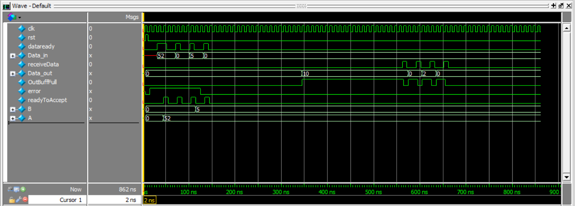

Simulation:( post synthesize)

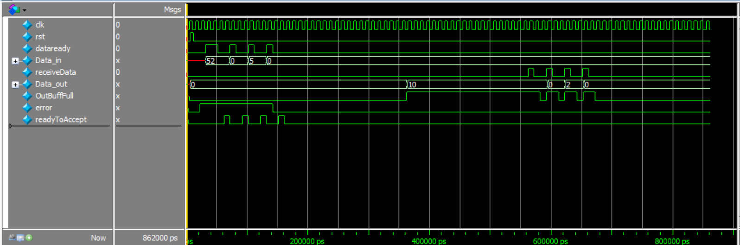

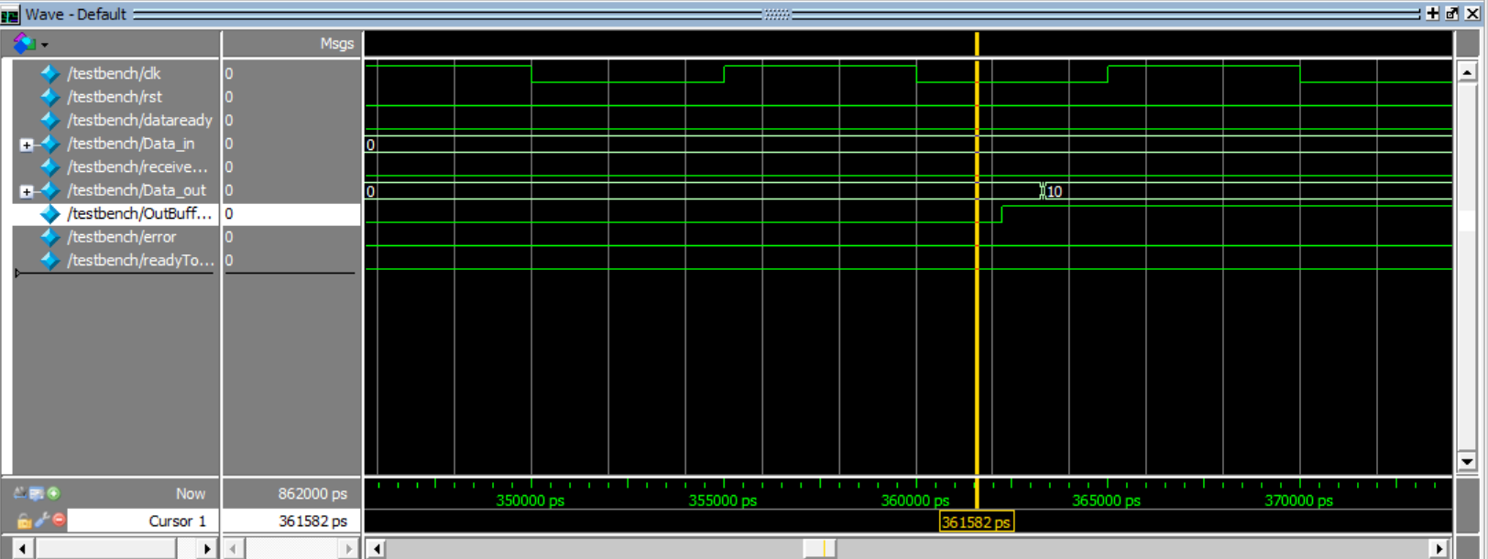

Flow Summary:

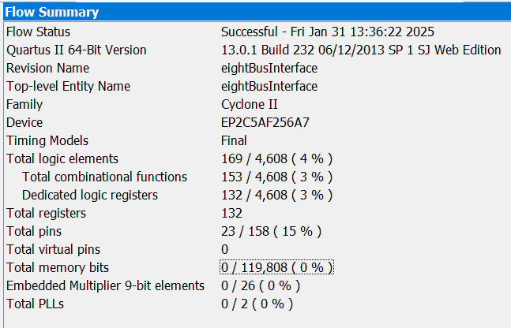

RTL viewer:

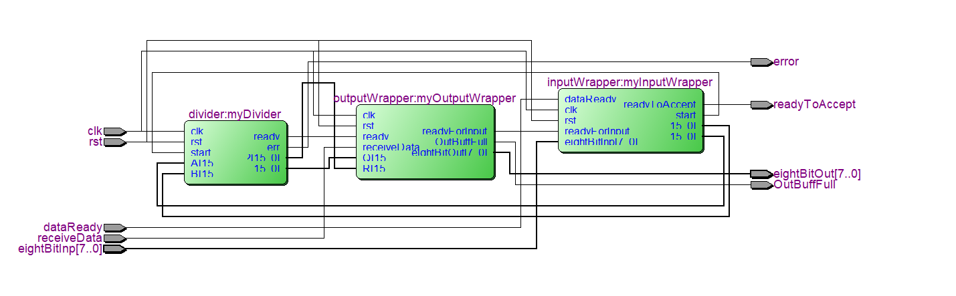

Chip planner:

