Case Study: Online Shopping Delivery System

4.1 Problem in Online Shopping Delivery System:
In an online shopping delivery system, products are packed inside boxes before shipment. A box can contain multiple products as well as smaller boxes, and these smaller boxes may also contain products or even more nested boxes. The system must calculate the total price of all products stored inside the main box regardless of how deeply the products are nested. The problem is that handling products and boxes separately makes the code complex and difficult to maintain because the system needs repeated checks and recursive calculations for every inner box. As the structure grows larger, the implementation becomes harder to extend, and adding new container types or changing the pricing logic may require modifying many parts of the code.
4.2 Applying Composite Pattern as a Solution:
The Composite Pattern provides an effective solution for this problem by allowing both products and boxes to be treated in the same way through a common interface. Each product can directly return its own price, while each box calculates its total price by collecting the prices of all products and smaller boxes contained inside it. Since every object follows the same structure, the system can recursively calculate the final price of the main box without needing complicated conditional statements. This pattern simplifies the design, reduces code duplication, improves maintainability, and makes the delivery system more flexible and easier to extend in the future.
The System consists of :

1. A DeliveryComponent interface that defines the common operations for all delivery objects, such as calculating the price, getting the name, and displaying the structure.
2. A Product class representing the Leaf object, which stores the product name and price and directly returns its own price.
3. A Box class representing the Composite object, which can contain multiple products and smaller boxes, and calculates the total price by summing the prices of all child components.
4. A DeliveryOrder class representing the Client, which uses the root delivery component to calculate the total order price and print the complete delivery structure.

Applying the Composite pattern to Online Shopping Delivery System provides several advantages:
- Uniform treatment of objects (Box & Product)
- Easy recursive price calculation
- Scalability (supports unlimited nesting levels)
- Flexible and extensible structure
- Simplifies client code

Pattern Implementation

5.1 Code without Composite:
In traditional OOP design, the creation of complex objects, such as a game character, is typically handled using constructors that require many parameters:
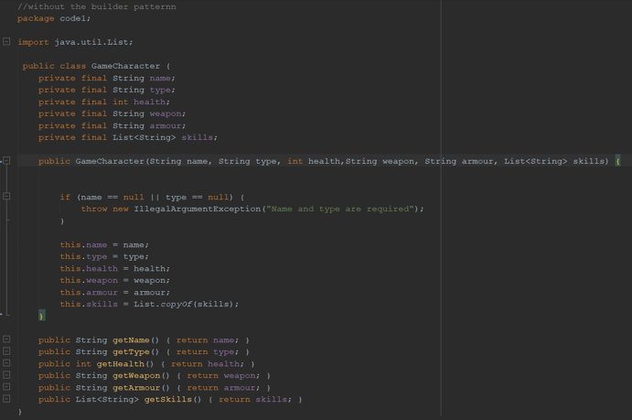
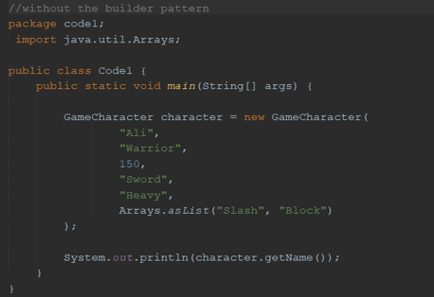
As more parameters are introduced, the constructor becomes harder to read and understand. Developers must remember the exact order and meaning of each parameter, which significantly increases the likelihood of errors. Furthermore, optional attributes must still be provided, often in the form of null or default values, which reduces code clarity and expressiveness.
This method lacks scalability and does not effectively support the construction of complex and flexible objects, making it unsuitable for real-world applications such as game character creation.

5.2 Code with Composite:
To overcome this risk, the Builder Design Pattern provides a more structured and flexible approach to object construction:

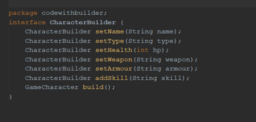

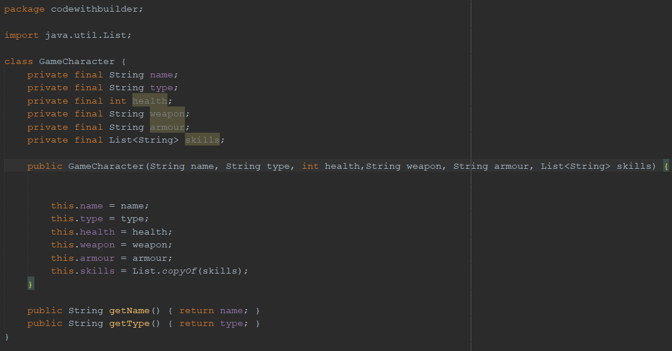
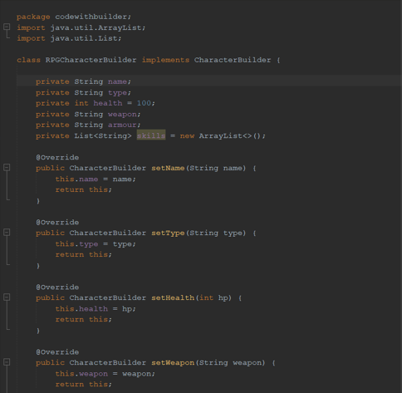
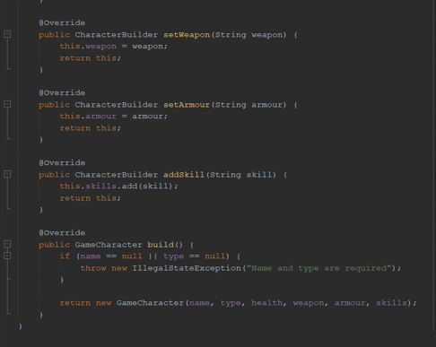

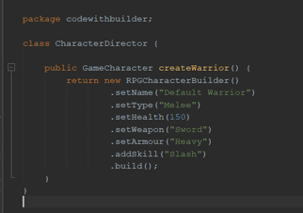
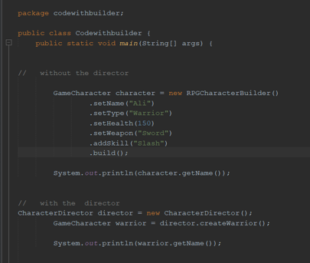
In this approach, the construction process is clearly separated from the final representation of the object. The Builder class allows attributes to be set incrementally through well-defined and descriptive methods.
This step-by-step construction process enhances readability and provides greater control over object creation. It also allows developers to include only the necessary attributes while omitting optional ones without affecting code clarity.

5.3 Key differences:
The primary difference between the traditional programming approach and the Composite Pattern is the way objects are handled within the system. In the traditional approach, products and boxes are managed using separate logic and multiple conditional statements. The system repeatedly checks whether the object is a product or a box, and if it is a box, it must manually iterate through all nested elements to calculate the total price. As the system grows and more nested boxes are added, the code becomes more complex, harder to maintain, and difficult to extend. In contrast, the Composite Pattern treats both products and boxes through the same common interface, allowing the system to interact with all objects uniformly. Each object becomes responsible for handling its own calculation, making the code cleaner, more organized, reusable, and easier to scale without modifying the existing structure.

Advantages of Composite Pattern

Advantages:
The Composite Design Pattern offers several key advantages that make it highly suitable for systems that manage hierarchical and nested structures
1. Uniform Treatment of Objects
Products and boxes can be handled using the same interface, which simplifies the system design.
2. Simplified Client Code
The client does not need to distinguish between single objects and complex object groups.
3. Improved Maintainability
The code becomes easier to read, organize, and maintain because responsibilities are clearly separated.
4. Easy Extensibility
New component types can be added without modifying existing code structure.
5. Supports Recursive Structures
The pattern efficiently handles nested and tree-like structures such as boxes within boxes.

Disadvantages of Composite Pattern

Disadvantages:
1. Increased System Complexity
The recursive structure of the pattern may make the system harder to understand and debug.
2. Reduced Type Safety
Using a common interface for all components may allow unsupported operations on certain objects.
3. Harder Initial Design
Designing the component hierarchy and recursive relationships requires careful planning.

Conclusion

8.1 Summary of the pattern:
The Composite Design Pattern is a structural design pattern that focuses on organizing objects into hierarchical tree-like structures.
It allows individual objects and groups of objects to be treated uniformly through a common interface. By representing simple elements as leaf objects and container elements as composite objects, the pattern simplifies the management of nested structures and recursive operations.
This structured approach makes the Composite pattern highly effective for developing flexible, maintainable, and scalable systems, especially in applications that involve complex hierarchical relationships such as online shopping delivery systems.

8.2 Why it was chosen:
The Composite Design Pattern was chosen for the online shopping delivery system due to the hierarchical nature of the delivery structure.
In the system, a box can contain multiple products as well as smaller boxes, and these smaller boxes may also contain additional products or nested boxes. Using traditional programming approaches in such scenarios leads to complex conditional logic and repetitive recursive calculations.
By applying the Composite pattern, both products and boxes can be treated uniformly through a common interface, allowing the system to calculate prices and manage components in a simpler and more organized way.
This approach not only simplifies the implementation of recursive operations but also improves code readability, maintainability, and scalability.
Additionally, the pattern supports future extensibility, making it easier to introduce new delivery component types or additional features without requiring major modifications to the existing system.

References

Books
- Design Patterns: Elements of Reusable Object-Oriented Software
Gamma, E., Helm, R., Johnson, R., & Vlissides, J. (1994).
Design Patterns: Elements of Reusable Object-Oriented Software. Addison-Wesley.

Websites
- Refactoring Guru
Composite Design Pattern.
https://refactoring.guru/design-patterns/composite
- GeeksforGeeks
Composite Design Pattern in Java.
https://www.geeksforgeeks.org/composite-design-pattern/

