**KATHMANDU UNIVERSITY**

**Department of Computer Science and Engineering**

**Dhulikhel, Kavre**



Lab Sheet 2

**Adder (Half and Ful) Implementation using**

**Proteus Design Suite**

**Embedded System**

**[Course Code: COMP 306]**

**Submitted by:**

Sajag Silwal (Roll no: 48)

CE(3rd Year/ 2nd Semester)

**Submitted to:**

Mr. Satyendra Nath Lohani

Department of Computer Science and Engineering

# Half Adder:

A half adder is a type of adder, an electronic circuit that performs the addition of numbers. The half adder is able to add two single binary digits and provide the output plus a carrying value. It has two inputs, and two outputs S (sum) and C (carry). The Simulation of Half Adder in Proteus is given Below:

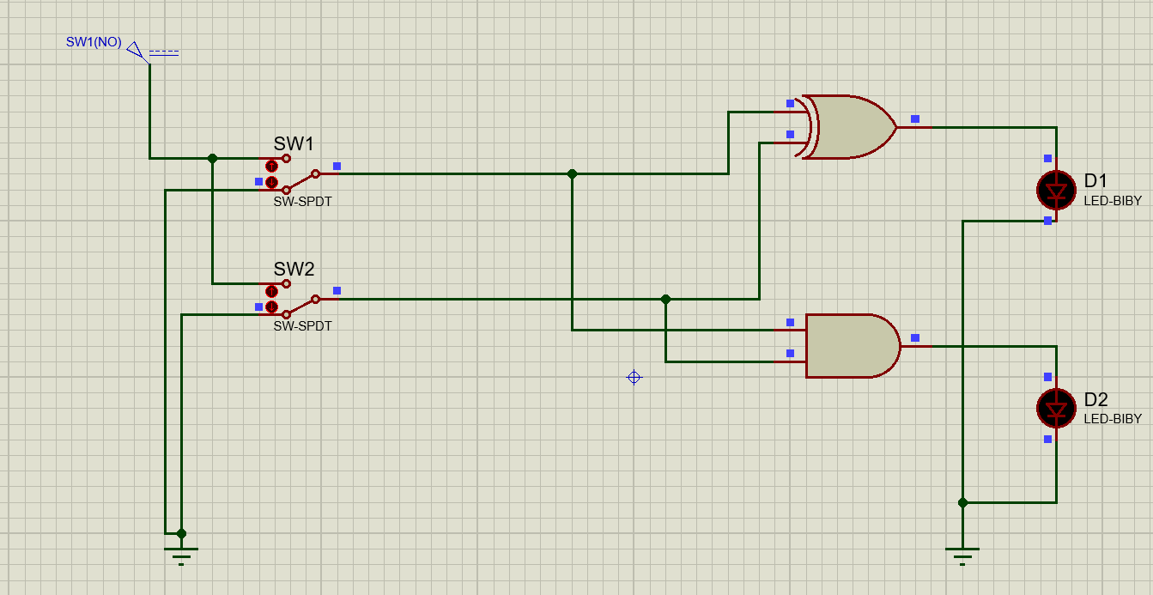

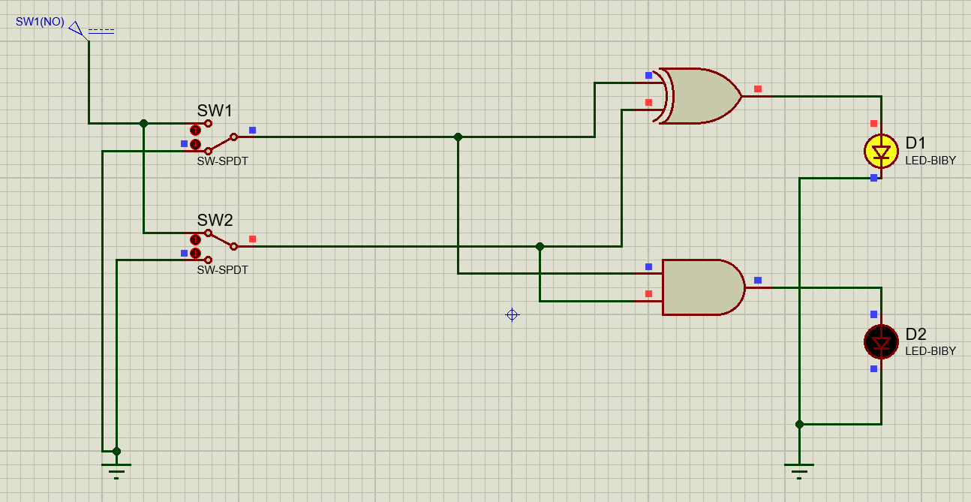

Figure 1.A

Figure 1.B

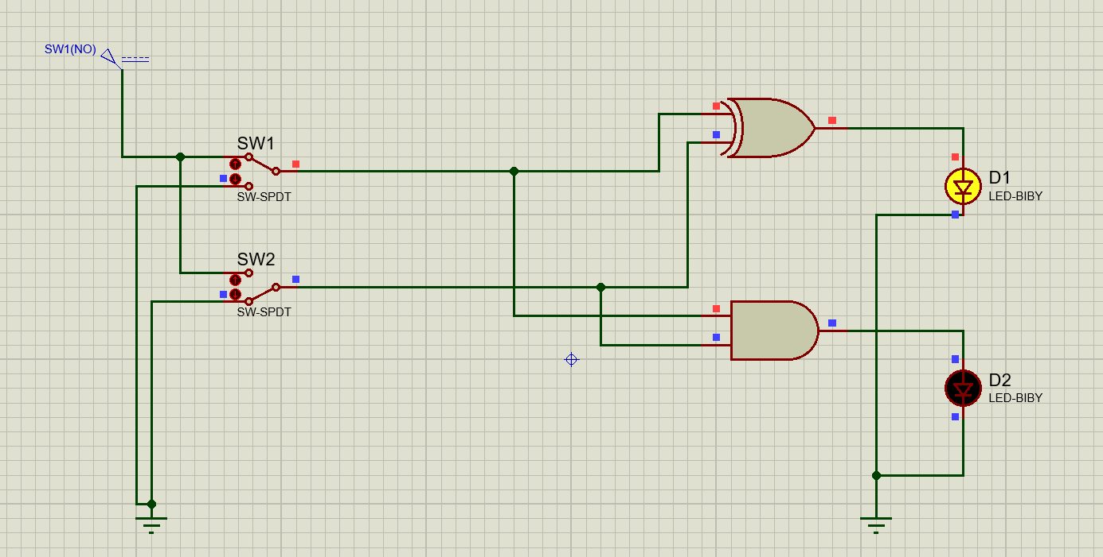

Figure 1.C

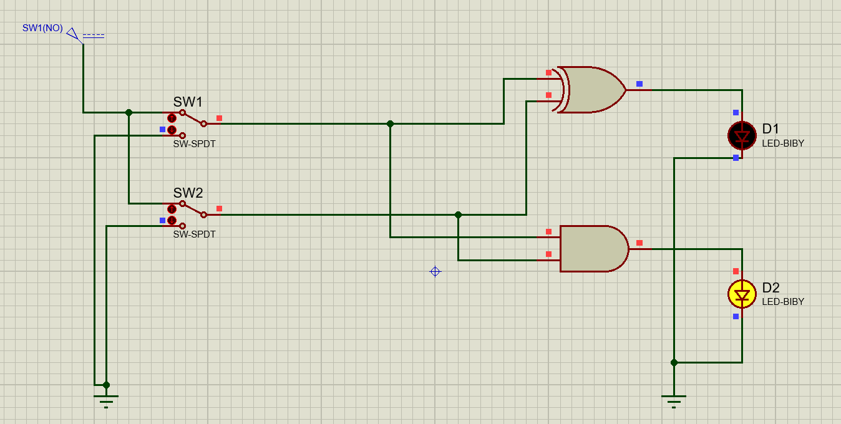

Figure 1.D

## Truth Table

The truth table for AND gate taking the above simulations are reference is given below:

|  |  |  |  |  |
| --- | --- | --- | --- | --- |
| Figure | Input 1 | Input 2 | SUM | CARRY |
| 1.A | 0 | 0 | 0 | 0 |
| 1.B | 0 | 1 | 1 | 0 |
| 1.C | 1 | 0 | 1 | 0 |
| 1.D | 1 | 1 | 0 | 1 |

# Full Adder

A full adder adds binary numbers and accounts for values carried in as well as out. A one-bit full-adder adds three one-bit numbers, often written as A, B, and Cin; A and B are the operands, and Cin is a bit carried in from the previous less-significant stage. The Simulation of a full adder is shown below:

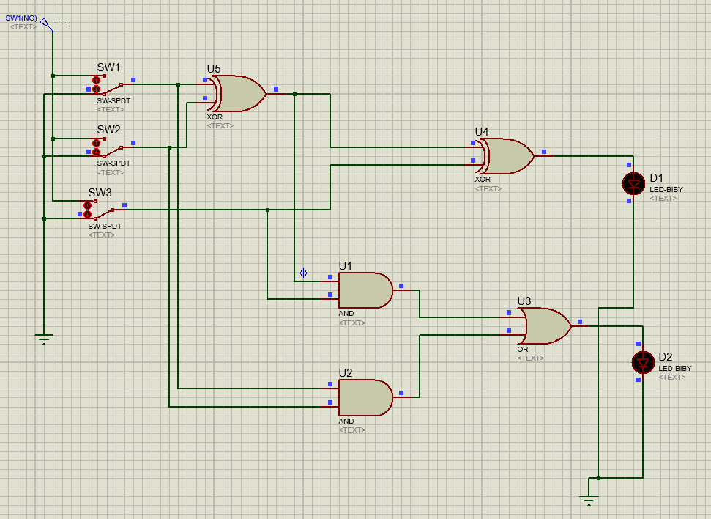

Figure 2.A

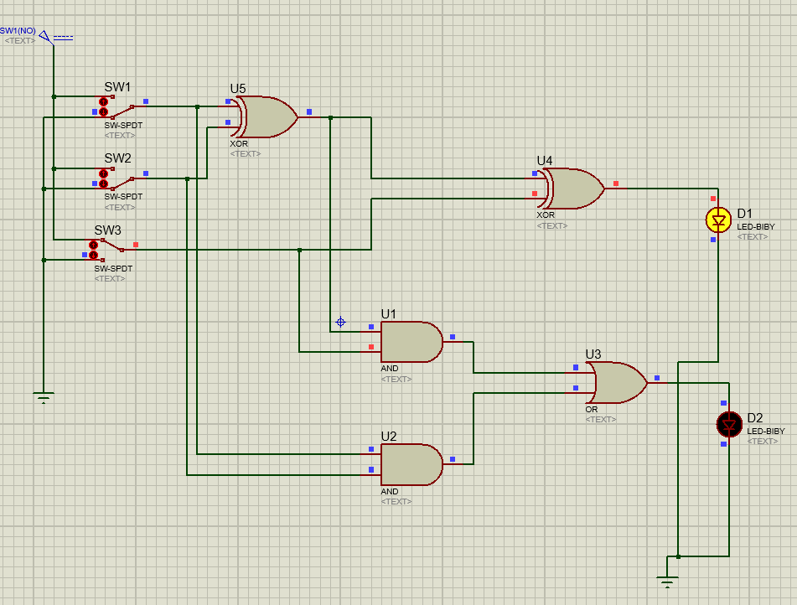

Figure 2.B

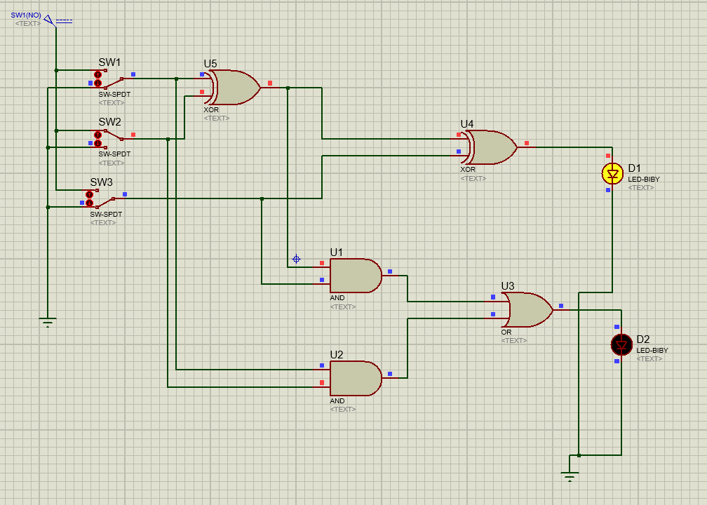

Figure 2.C

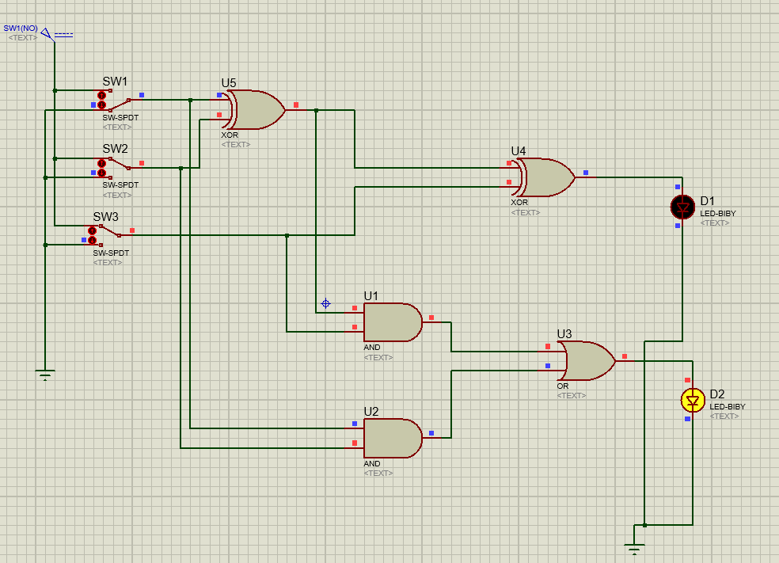

Figure 2.D

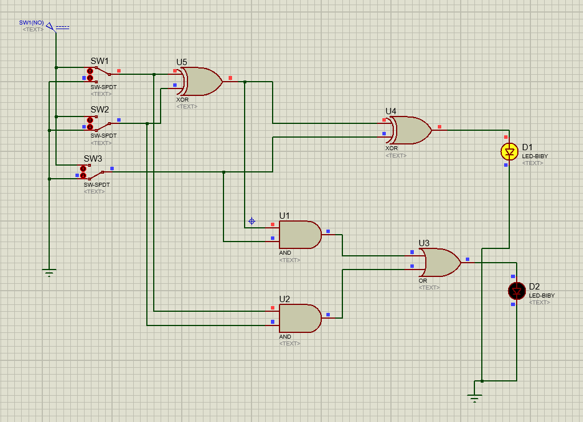

Figure 2.E

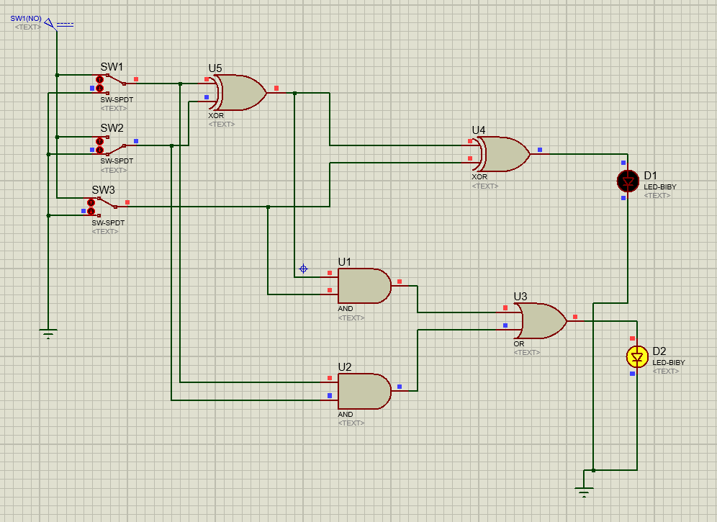

Figure 2.F

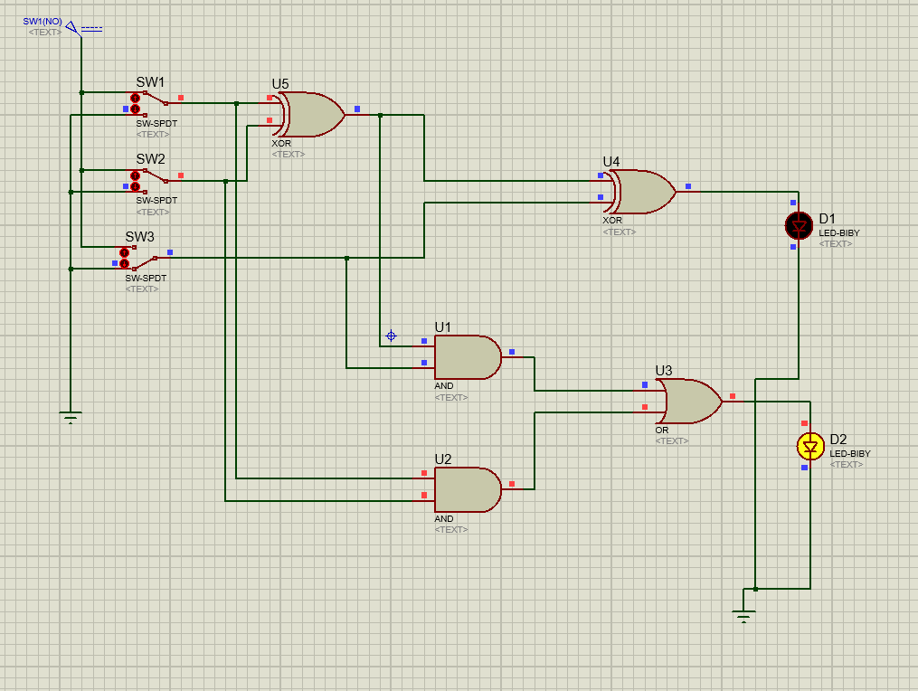

Figure 2.G

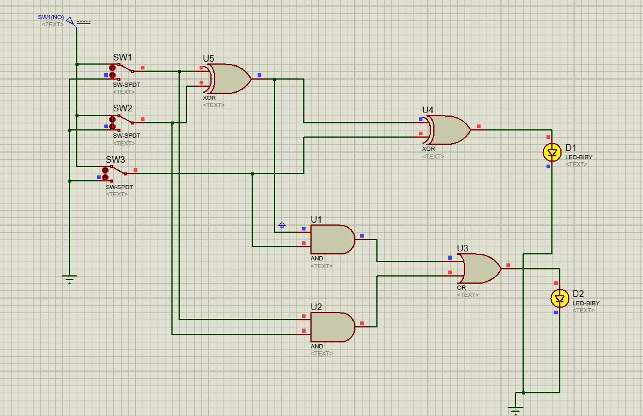

Figure 2.H

## Truth Table

The truth table for Full Adder taking the above simulations are reference is given below:

|  |  |  |  |  |  |
| --- | --- | --- | --- | --- | --- |
| Figure | Input A | Input B | Input Cin | Sum | Carry |
| 2.A | 0 | 0 | 0 | 0 | 0 |
| 2.B | 0 | 0 | 1 | 1 | 0 |
| 2.C | 0 | 1 | 0 | 1 | 0 |
| 2.D | 0 | 1 | 1 | 0 | 1 |
| 2.E | 1 | 0 | 0 | 1 | 0 |
| 2.F | 1 | 0 | 1 | 0 | 1 |
| 2.G | 1 | 1 | 0 | 0 | 1 |
| 2.H | 1 | 1 | 1 | 1 | 1 |