University Annual Yearbook
Web Platform & Artificial Intelligence Integration

Training Project by
Saja H. Jaber

Submitted to the IT Department of the
Lebanese International University
Beirut, Lebanon

August 2026

System Design

Introduction
Before starting to implement the system, we need to specify how the system will work. This chapter documents architectural decisions, structural and behavioural plans of the software before the actual implementation.

Functional Requirements
The system serves five distinct roles: IT Administrator, Content Editor, Reviewer/Approver, Public Visitor, and AI Service. The functional requirements of: Authentication & Access Control, Events Management, Graduation Management, Graduate Profiles, Media Library, Timeline & Galleries, Search & Filters, Reports & Statistics, Publishing Workflow, and AI Tools are respectively represented in Table 3-1, Table 3-2, Table 3-3, Table 3-4, Table 3-5, Table 3-6, Table 3-7, Table 3-8, Table 3-9, and Table 3-10.
Each requirement is assigned a priority level as follows:
- High: Core functionality that is necessary for the system to operate
- Medium: Important, but the system can run without it.
- Low: Desirable enhancement

Authentication and Access Control
Table ‎I-1 Authentication and Access Control Functional Requirements
ID | Functional Requirement | Priority
FR-1.1 | The system allows staff to login in with credentials tied to one of the three roles (Admin, Editor, Review) | High
FR-1.2 | The system maintains secure sessions and logs users out after inactivity | High
FR-1.3 | The system checks role permissions server-side, not just hides UI links | High
FR-1.4 | The system enforces minimum password strength and secure hashing | High
FR-1.5 | The system automatically logs out inactive sessions after a certain timeout period | Medium
FR-1.6 | Self-service password reset via email | Low

Event Management
Table ‎I-2 Event Management Functional Requirements
ID | Functional Requirement | Priority
FR-2.1 | Editors create/edit events with title, date, campus, school, description | High
FR-2.2 | Assign events to categories (academic, cultural, sports, etc.) | High
FR-2.3 | Enforce event status workflow: Draft -> Submitted -> Approved -> Published | High
FR-2.4 | Link uploaded photos/videos to an event | High
FR-2.5 | Add searchable tags to events | Medium
FR-2.6 | Mark select events as featured on the homepage | Low

Graduation Management
Table ‎I-3 Graduation Management Functional Requirements
ID | Functional Requirement | Priority
FR-3.1 | Store ceremony date, venue, description per academic year/campus | High
FR-3.2 | Record speaker names and award recipients | Medium
FR-3.3 | Attach photo galleries to a ceremony | Low
FR-3.4 | Auto-calculate graduate counts per ceremony | Low

Graduate Profiles
Table ‎I-4 Report Generation Functional Requirements
ID | Functional Requirement | Priority
FR-4.1 | Create/edit graduate profile with structured fields (name, school, major, campus, achievements) | High
FR-4.2 | Record consent status, consent date, and consent scope before publishing | High
FR-4.3 | Only expose profile fields the graduate consented to publish | High
FR-4.4 | Attach an approved portrait photo to the profile | High
FR-4.5 | Generate a short AI-assisted biography draft from structured fields, subject to review | Medium
FR-4.6 | Support optional personal elements (quote, future plans) | Low

Media Library
Table ‎I-5 Media Library Functional Requirements
ID | Functional Requirement | Priority
FR-5.1 | Validate uploaded files, restricting allowed file types and sizes | High
FR-5.2 | Store captions, alt text, and credit per media item | High
FR-5.3 | Associate media with events or graduate profiles | High
FR-5.4 | Auto-generate thumbnails on upload | Medium
FR-5.5 | Flag near-duplicate images for review | Low

Timeline & Galleries
Table ‎I-6 Timeline & Galleries Functional Requirements
ID | Functional Requirement | Priority
FR-6.1 | Display events in chronological order across the academic year | High
FR-6.2 | Filter timeline view by category or campus | Medium
FR-6.3 | Provide grid/lightbox browsing of approved photo galleries | Medium
FR-6.4 | Highlight featured stories on the homepage | Low

Search & Filters
Table ‎I-7 Search & Filters Functional Requirements
ID | Functional Requirement | Priority
FR-7.1 | Search events and graduates by keyword | High
FR-7.2 | Filter results by year, campus, school, and major | High
FR-7.3 | Support natural-language semantic search over approved content | Medium

Reports & Statistics
Table ‎I-8 Reports & Statistics Functional Requirements
ID | Functional Requirement | Priority
FR-8.1 | Display dashboard counts of drafts, pending review, and published items | High
FR-8.2 | Generate graduate counts by school, major, and campus | Medium
FR-8.3 | Report total uploaded/approved media assets | Low

Publishing Workflow
Table ‎I-9 Publishing Workflow Functional Requirements
ID | Functional Requirement | Priority
FR-9.1 | Enforce Draft -> Reviewed -> Approved -> Published status progression on all content | High
FR-9.2 | Allow reviewer to approve or reject submitted content with comments | High
FR-9.3 | Block publishing unless consent status is "Granted" | High
FR-9.4 | Archive a completed edition at year-end while preserving reusable structures | Medium
FR-9.5 | Restrict edits to published content to authorized roles only | Medium

AI Tools
Table ‎I-10 AI Tools Functional Requirements
ID | Functional Requirement | Priority
FR-10.1 | Require human review of all AI-generated output before publication | High
FR-10.2 | Log source record, generated text, reviewed text, reviewer, and status for each AI generation | High
FR-10.3 | Restrict AI API calls to server-side only | High
FR-10.4 | Draft event summaries from approved event notes | Medium
FR-10.5 | Draft graduate biographies from structured profile fields | Medium
FR-10.6 | Suggest tags/captions for uploaded media | Low

Use Case Diagrams
A use case diagram represents a user’s interaction with the system. Use case diagrams show stick figures representing actors (someone or something that performs a task) connected to tasks represented by ellipses. The University Annual Yearbook platform include five actors: IT Administrator, Content Editor, Reviewer/Approver and Public Visitor. The use case diagrams of Administration and System Management, Public Digital Yearbook, AI-Assisted Content Generation, and Content Generation and Review are represented in the figures: Figure 3-1, Figure 3-2, Figure 3-3, and Figure 3-4 respectively.

IT Administration and System Management
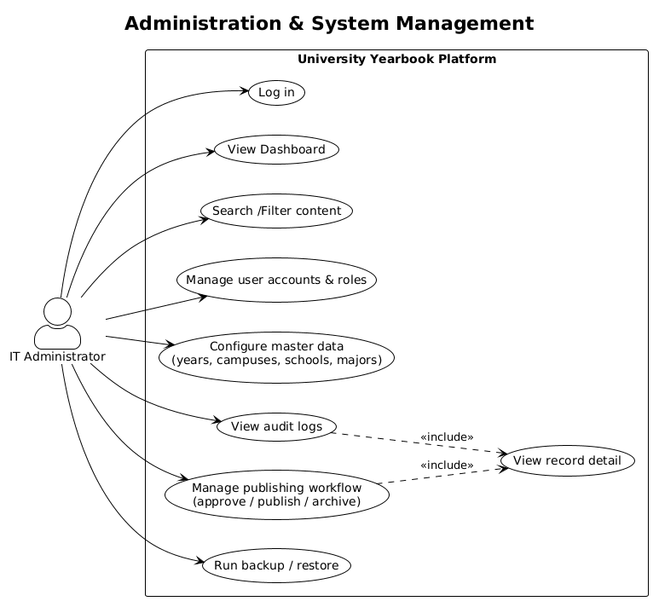
Figure ‎I-1 Use Case Diagram of IT Administration and System Management

Content Creation and Review
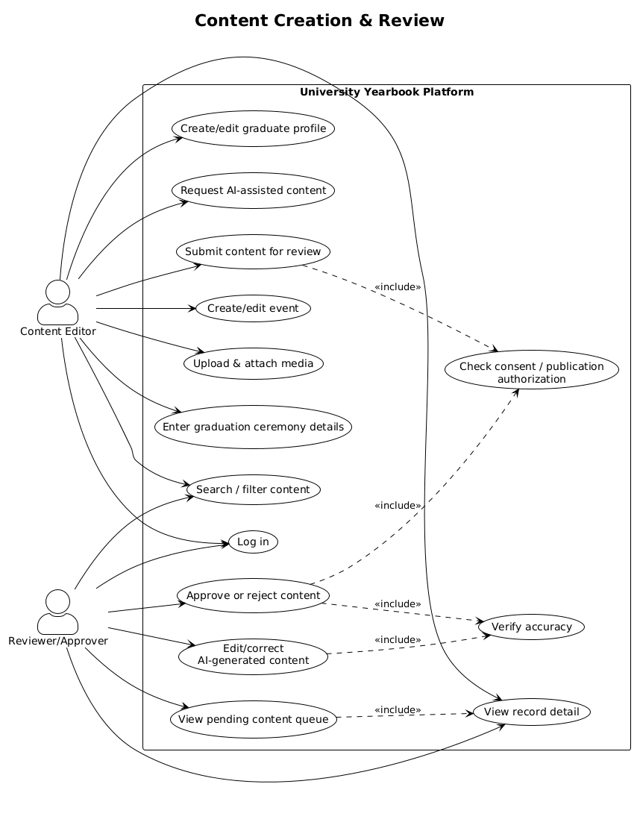
Figure ‎I-2 Use Case Diagram of Content Creation and Review
    - Public Digital Yearbook
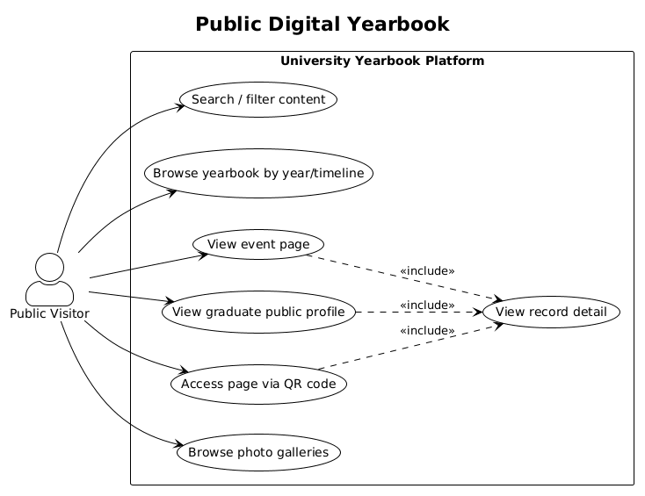
Figure ‎I-3 Use Case Diagram for Public Digital Yearbook

AI-Assisted Content Generation
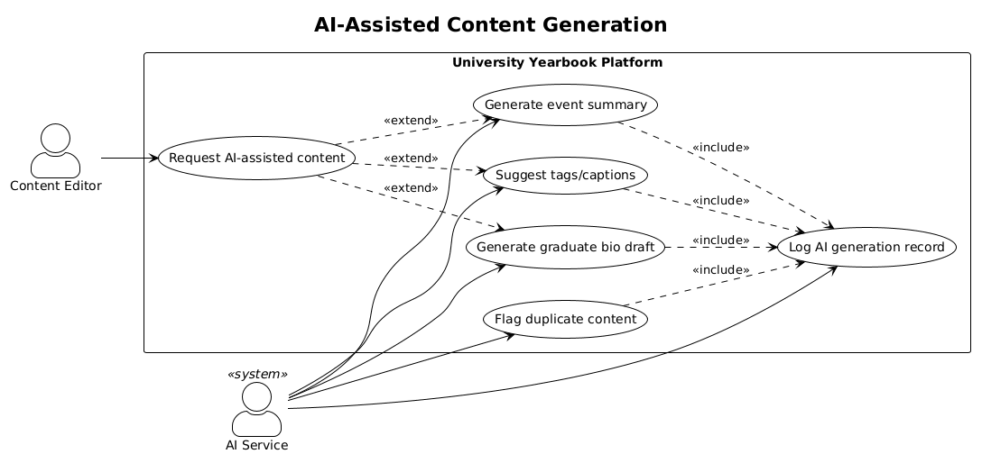
Figure ‎I-4 Use Case Diagram for AI-Assisted Content Generation
  - System Architecture
This section outlines the overall architectural style selected for the Yearbook Platform, and a description of what responsibilities are associated with each layer it.
Figure ‎I-5 UYP Architecture (Request Flow)
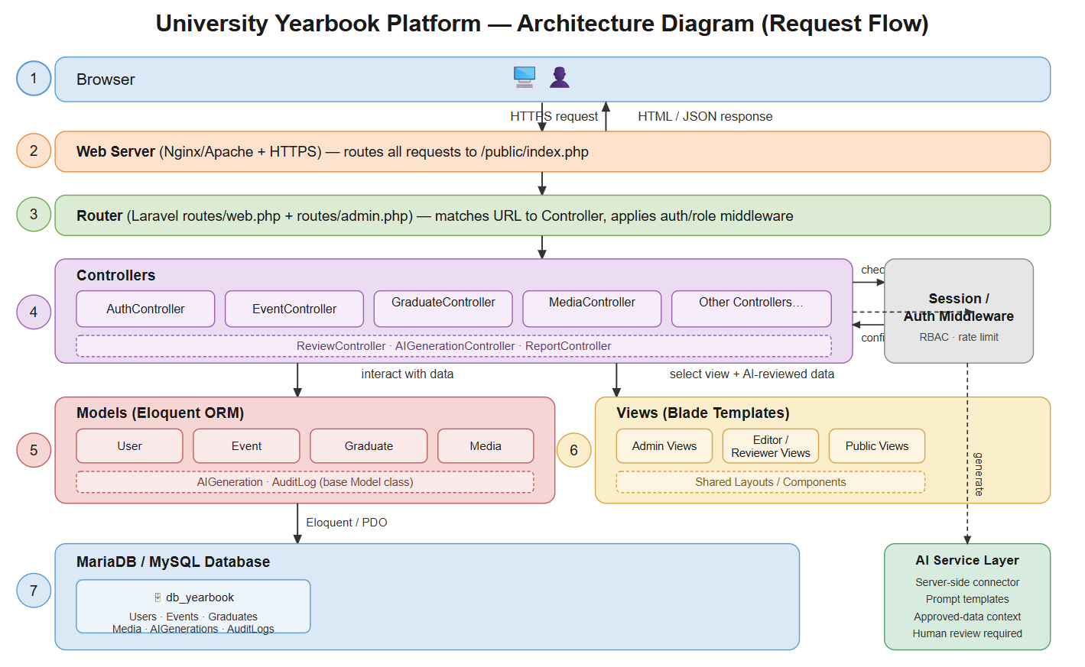

Browser
The client; where a staff member or public visitor interacts with the platform through a web page. Sends HTTPS requests, receives back rendered HTML or JSON.

Web Server (Nginx/Apache + HTTPS)
The entry point on the server. Terminates HTTPS and forwards every incoming request to Laravel's front controller (public/index.php), which bootstraps the whole framework.

Router
Laravel matches the requested URL against the defined routes and decides which Controller should handle it, also where auth/role middleware gets attached to protected routes before the request goes further.

Controllers
The application logic layer. Each Controller handles one area of functionality (auth, events, graduates, media, AI review, reports). A Controller receives the request, talks to Models to fetch/save data, checks Session/Auth Middleware for permissions, and decides which View to return.

Models (Eloquent ORM)
Laravel's ORM layer. Each Model (User, Event, Graduate, Media, AiGeneration, AuditLog) represents one database table and handles reading/writing rows via Eloquent, translating PHP objects into SQL queries under the hood.

Views (Blade Templates)
The presentation layer. Blade templates render the actual HTML sent back to the browser, split by audience (Admin views, Editor/Reviewer views, Public-facing views), pulling in shared layouts/components for consistency.

MariaDB/ MySQL Database
Persistent storage, the actual tables (users, events, graduates, media, ai_generations, audit_logs, etc.) that Models read from and write to via Eloquent/PDO.

AI Service Layer (Side Branch)
A separate, server-side-only connector that Controllers call into for AI features, sends only approved data, uses prompt templates, and always requires human review before anything it generates gets published.

Session/ Auth Middleware (Side Branch)
Runs alongside the Router/Controllers on every request, it checks who's logged in, enforces RBAC (which role can access what), and applies rate limiting; it's what Controllers consult before allowing an action through.
  - Entity-Relationship (ER) Diagrams
This ER diagram reflects the complete data structure of the platform. The ER diagram is divided to four sub-figures for clarity represented in FigureI-6, FigureI-7, FigureI-8 and FigureI-9. Figure I-10 represents the relations between all the entities without their attributes.

Auth & RBAC
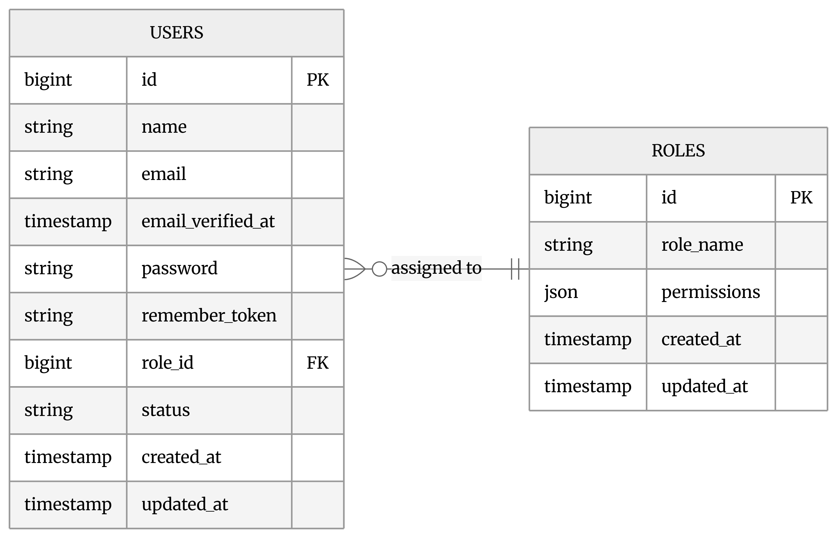

Figure ‎I-6 Auth & RBAC ERD

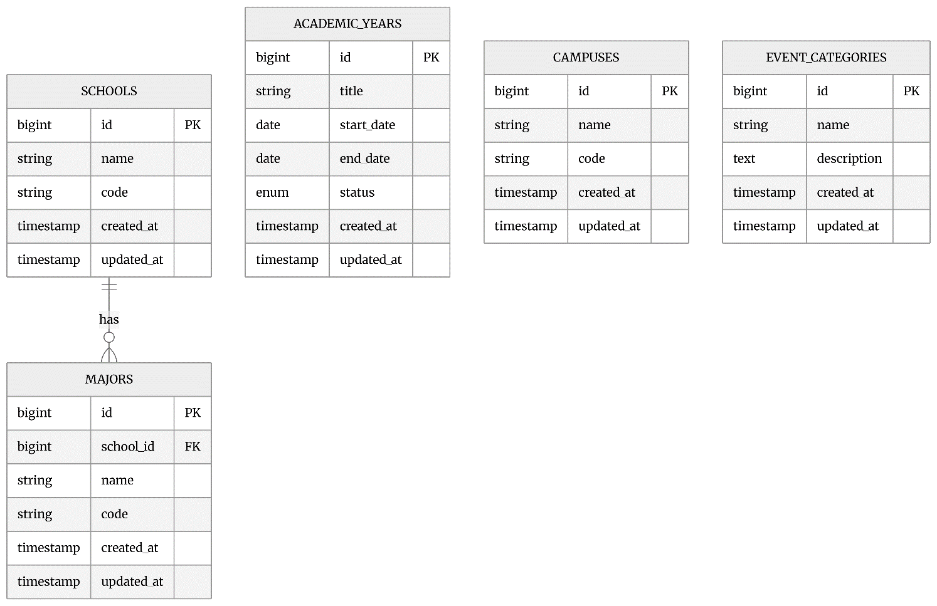
Master Data

Figure ‎I-7 Master Data ERD

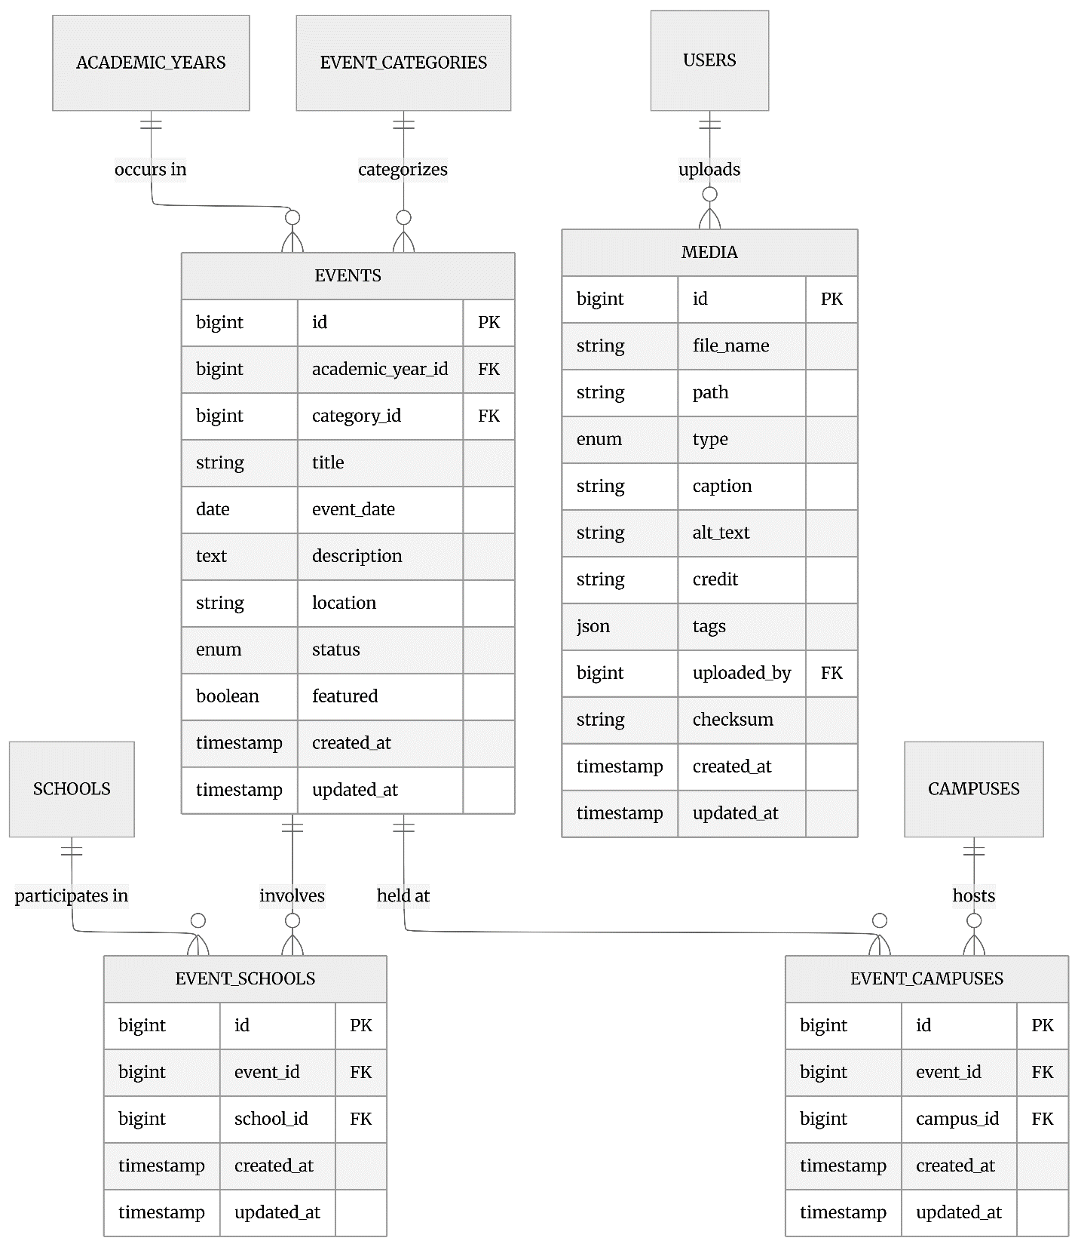
Events & Media

Figure ‎I-8 Events & Media ERD

Graduation and Graduates
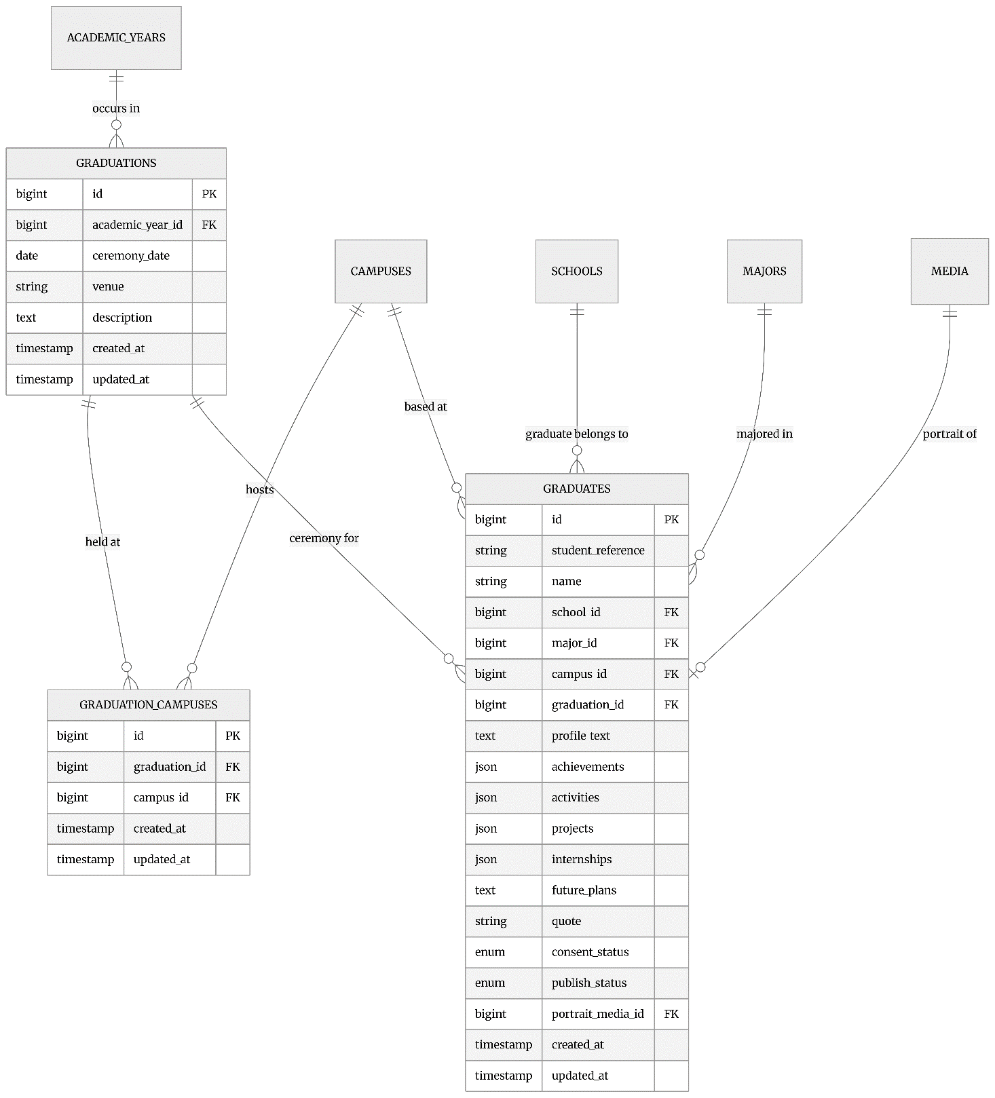

Figure ‎I-9 Graduation & Graduates ERD

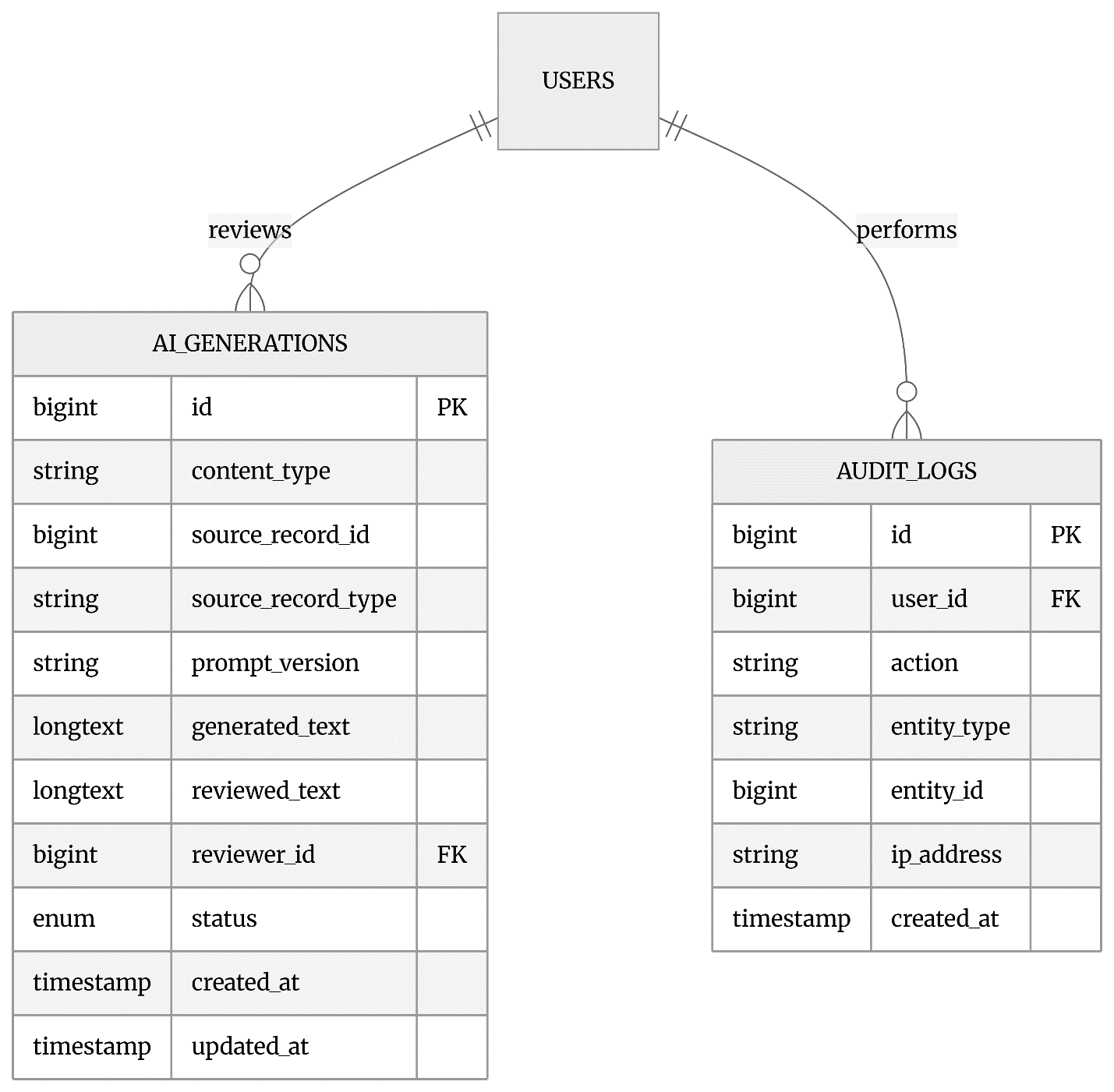
AI & Audit

Figure ‎I-10 AI & Audit ERD

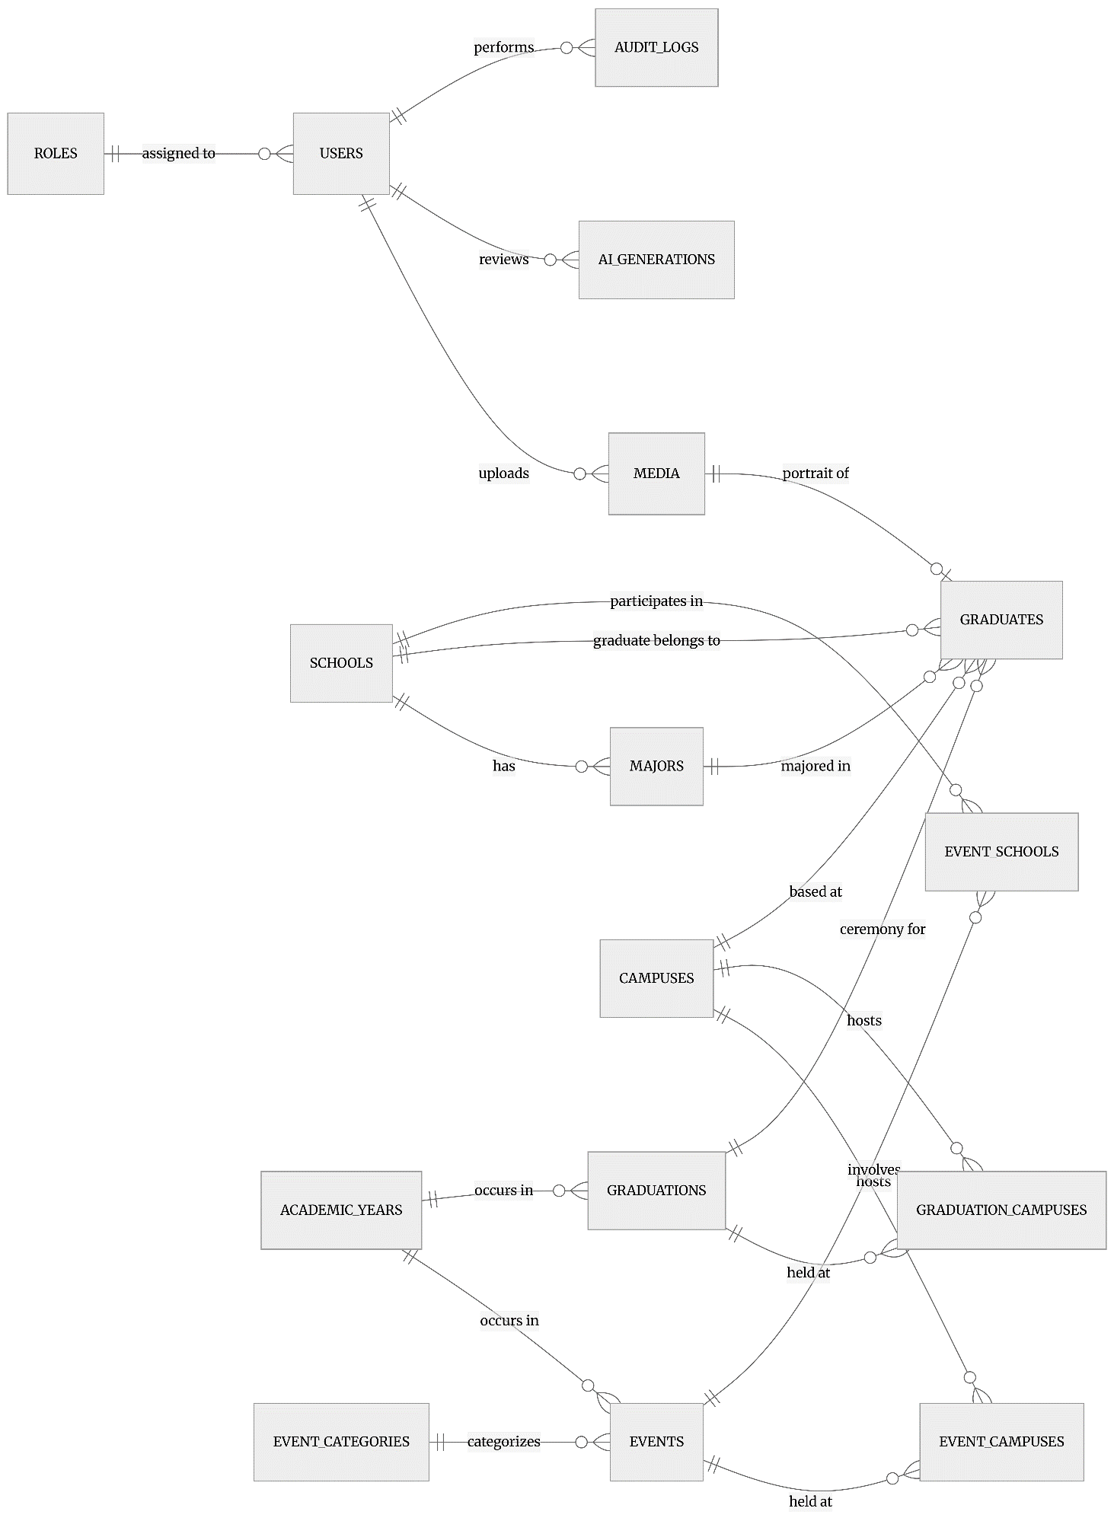
General ERD

Figure ‎I-11 ER Diagram representing all the entities and relationships

  - Sitemaps
    - Public Site Sitemap
Public Homepage (/)
├── Timeline (/timeline)
│ └── Chronological / category views of published events across the academic year
├── Events (/events)
│ ├── Event listing, filterable by campus, school, category, academic year
│ └── Individual event page (/events/{id})
│ — title, date, description, photo gallery, location, tags
├── Graduation (/graduation)
│ ├── Ceremony listing by academic year / campus
│ └── Individual ceremony page (/graduation/{id})
│ — date, venue, description, photo gallery, linked graduates
├── Graduates (/graduates)
│ ├── Graduate directory, filterable by school, major, campus, graduation year
│ └── Individual graduate profile (/graduates/{id})
│ — name, school, major, portrait, achievements, quote, bio
└── Search (/search)
— keyword search across all published content (events, graduates, graduation records)

    - Admin Dashboard Sitemap
├── Master Data (Admin, Editor)
│ ├── Academic Years (/academic-years)
│ ├── Campuses (/campuses)
│ ├── Schools (/schools)
│ ├── Majors (/majors)
│ └── Event Categories (/event-categories)

├── Events & Graduations (Admin, Editor for write; +Reviewer for read/approve)
│ ├── Events (/events) — CRUD, campus/school assignment, AI summary generation
│ └── Graduations (/graduations) — CRUD, campus assignment

├── Graduates (Admin, Editor for write; +Reviewer for read/approve)
│ └── Graduate profiles (/graduates) — CRUD, consent tracking, AI biography generation

├── Media (Admin, Editor)
│ └── Media Library (/media) — upload, caption, credit, alt text

├── Users & Roles (Admin only)
│ └── Staff account management (/users) — create, edit role/status, deactivate

└── AI Review Queue (Admin, Reviewer)
└── (/ai-generations) — pending AI-generated content awaiting human approval, shown alongside the original source record for comparison
  - Wireframe Description
    - Public Homepage
Region | Content
Header | University logo, navigation to Timeline, Events, Graduates, Graduation, Search
Hero | Current academic year banner, optional featured photo
Featured events | 3 cards, pulled from events where featured = true and status = published
Snapshot statistics | Small public-safe counts: total events this year, total graduates, number of campuses
Footer | About, contact, links to archived past years
    - Admin Dashboard
Region | Content
Sidebar navigation | Links to Master Data, Events & Graduations, Graduates, Media, Users, AI Review Queue
Statistic cards (top row) | Total events, total graduates, total media items, pending-review count
Charts / breakdowns | Graduates by school (bar/table), content status breakdown (draft/reviewed/approved/published counts)
    - Admin List Page
Region | Content
Page title + “Add [item]” link | Top of page
Record list | One row per record, showing key identifying fields
Per-row actions | Edit link; Delete or Archive/Unarchive; role-conditional workflow actions (Submit for Review, Approve, Reject) where applicable
Validation feedback | Inline error messages shown on the create/edit forms when a submission fails validation
    - Admin Create/Edit Form
Region | Content
Field inputs | Text/date/textarea inputs for simple fields; dropdowns for single foreign keys (e.g. school for a major); checkboxes for multi-select pivot relationships (e.g. campuses/schools for an event)
Dependent dropdowns | Where relevant (e.g. major list filtered by selected school), updates client-side without a page reload
Submit action | Save (create) or Update (edit), redirecting back to the module's list page

