**Identifying Shopping Trends using Data Analysis**

A Project Report

submitted in partial fulfillment of the requirements

of

AICTE Internship on AI: Transformative Learning

with

TechSaksham – A joint CSR initiative of Microsoft & SAP

by

**Sajal Garg, sajalag78@gmail.com**

Under the Guidance of

**Name of Guide**

**ACKNOWLEDGEMENT**

We would like to take this opportunity to express our deep sense of gratitude to all individuals who helped us directly or indirectly during this thesis work.

Firstly, we would like to thank my supervisor, …………….., for being a great mentor and the best adviser I could ever have. His advice, encouragement and the critics are a source of innovative ideas, inspiration and causes behind the successful completion of this project. The confidence shown in me by him was the biggest source of inspiration for me. It has been a privilege working with him for the last one year. He always helped me during my project and many other aspects related to the program. His talks and lessons not only help in project work and other activities of the program but also make me a good and responsible professional.

……...

#### This Acknowledgement should be written by students in your own language (Do not copy and Paste)

#### …..

……

….

……

#### **ABSTRACT**

This project focuses on **Identifying Shopping Trends Using Data Analysis** with the aim of understanding consumer behavior and preferences to provide insights for businesses. The problem addressed is the lack of actionable data on customer buying patterns, which hinders companies from making data-driven decisions to enhance their marketing strategies, product offerings, and customer engagement.

The primary objectives of the project are to:

1. Analyze historical shopping data to identify emerging trends.
2. Provide insights into customer purchasing habits based on factors such as demographics, seasonality, and product types.
3. Enable businesses to predict future shopping behaviors and adjust their strategies accordingly.

The methodology employed involves collecting and preprocessing data from e-commerce platforms, followed by exploratory data analysis (EDA) to uncover patterns. Techniques such as clustering, regression analysis, and time-series forecasting are applied to identify key trends. Machine learning algorithms like k-means clustering and decision trees are used for segmenting customers and predicting purchasing behaviors. The results of the analysis are visualized using various plotting tools to ensure that insights are presented in an easily interpretable manner.

Key results from the project indicate a clear shift in consumer preferences over different seasons, with specific demographic groups exhibiting unique shopping behaviors. Additionally, the analysis reveals that certain product categories experience significant spikes during particular times of the year. These insights can be used to enhance marketing efforts, optimize inventory, and improve customer targeting.

In conclusion, the project successfully identifies key shopping trends and provides actionable insights for businesses. By leveraging data analysis, companies can make informed decisions, improve customer satisfaction, and maximize revenue potential.

**TABLE OF CONTENT**

**Abstract I**

**Chapter 1.**  **Introduction 1**

1.1 Problem Statement 1

1.2 Motivation 1

1.3 Objectives 2

1.4. Scope of the Project 2

**Chapter 2.**  **Literature Survey 3**

**Chapter 3.**  **Proposed Methodology**

**Chapter 4.**  **Implementation and Results**

**Chapter 5. Discussion and Conclusion**

**References**

**LIST OF FIGURES**

|  |  |  |
| --- | --- | --- |
| **Figure No.** | **Figure Caption** | **Page No.** |
|  |  |  |
|  |  |  |
|  |  |  |
|  |  |  |
|  |  |  |
|  |  |  |
|  |  |  |
|  |  |  |
|  |  |  |

**LIST OF TABLES**

|  |  |  |
| --- | --- | --- |
| **Table. No.** | **Table Caption** | **Page No.** |
|  |  |  |
|  |  |  |
|  |  |  |
|  |  |  |
|  |  |  |
|  |  |  |
|  |  |  |
|  |  |  |
|  |  |  |

**CHAPTER 1**

**Introduction**

* 1. **Problem Statement:**

In today’s fast-paced and data-driven world, businesses face a major challenge in understanding the ever-evolving shopping behaviors of consumers. With the exponential growth of e-commerce, companies are sitting on vast amounts of transactional data, but translating this data into actionable insights is a complex task. This challenge becomes even more pronounced as consumer preferences shift constantly due to factors like seasonality, economic conditions, lifestyle changes, and emerging trends.

The significance of this problem lies in the fact that without a clear understanding of these shopping patterns, businesses may miss key opportunities to engage their customers effectively, manage their inventory properly, and fine-tune their marketing strategies. For example, failing to recognize when certain products are likely to be in demand, or misjudging customer preferences, can lead to overstocked or understocked inventories, wasted marketing budgets, and missed revenue opportunities.

As competition increases, especially in the online space, businesses need to stay ahead by leveraging data to anticipate and respond to consumer behavior. Identifying shopping trends not only helps companies optimize operations but also enables them to create personalized experiences, improve customer retention, and increase sales. In a world where consumer behavior is more unpredictable than ever, businesses that fail to understand shopping trends risk falling behind their competitors and failing to meet the evolving needs of their customers.

Ultimately, the ability to analyze and predict shopping trends is key for any business that wants to thrive in the competitive retail environment and offer meaningful, customer-centric experiences.

* 1. **Motivation:**

This project was chosen to address the growing need for businesses to understand and leverage consumer shopping behaviors in the digital age. As e-commerce continues to dominate, companies face an overwhelming volume of transactional data, but often lack the tools and methodologies to analyze it effectively. By identifying shopping trends, businesses can unlock powerful insights that not only enhance decision-making but also drive growth.

The motivation behind this project stems from the increasing importance of data-driven decision-making in retail. Traditional methods of market research and consumer insights are no longer sufficient to keep pace with the rapid changes in consumer preferences, especially with the rise of online shopping. Businesses that can harness the power of data analysis have a significant advantage in predicting customer behavior, optimizing their supply chains, and personalizing their marketing efforts.

The potential applications of this project are vast and impactful. By identifying key shopping trends, businesses can:

* **Optimize inventory management:** By predicting demand for specific products, businesses can avoid stockouts or overstocking, ensuring they have the right products available at the right time.
* **Personalize customer experiences:** Understanding consumer preferences allows businesses to tailor their marketing and product offerings, enhancing customer satisfaction and loyalty.
* **Improve marketing strategies:** Identifying trends in consumer behavior enables more targeted advertising campaigns, ultimately leading to better conversion rates and higher return on investment.
* **Forecast future demand:** Through trend analysis, businesses can anticipate changes in consumer behavior and adapt their strategies to stay ahead of the competition.

The impact of this project is profound. It empowers businesses to make data-backed decisions that improve operational efficiency, enhance customer engagement, and drive profitability. As competition in the retail sector intensifies, companies that can adapt to changing shopping trends and offer a more personalized, responsive experience will have a significant competitive edge. Ultimately, this project aims to help businesses transform data into actionable insights, allowing them to thrive in a rapidly changing marketplace.

* 1. **Objective:**

The main objectives of this project are as follows:

1. **Analyze Shopping Trends:** To identify emerging trends in consumer shopping behavior by analyzing historical transactional data, including purchasing patterns, product preferences, and seasonality.
2. **Segment Consumer Data:** To segment consumers based on various factors such as demographics, purchasing frequency, and product category, enabling more precise insights into specific customer groups.
3. **Predict Future Shopping Behaviors:** To forecast future trends in consumer shopping behavior by leveraging statistical and machine learning techniques, allowing businesses to plan and adjust their strategies proactively.
4. **Enhance Marketing and Product Strategies:** To provide actionable insights that help businesses optimize marketing campaigns, improve product offerings, and personalize customer experiences based on identified trends.
5. **Improve Inventory Management:** To enable businesses to optimize inventory by predicting demand for specific products at different times, reducing costs associated with stockouts or overstocking.
6. **Visualize Insights Effectively:** To present the results of the analysis using data visualization techniques, ensuring that the insights are clear, intuitive, and actionable for business decision-makers.

These objectives aim to empower businesses with the tools and insights needed to make informed, data-driven decisions, improving both operational efficiency and customer engagement.

* 1. **Scope of the Project:**

This project focuses on analyzing historical shopping data to identify trends in consumer behavior, with the goal of providing actionable insights for businesses. The primary areas covered include data collection, preprocessing, trend analysis, customer segmentation, demand forecasting, and visualization of results to help businesses optimize marketing strategies, inventory management, and customer engagement.

The scope includes:

1. **Data Analysis:** Analyzing e-commerce data to identify trends in consumer purchases, seasonality, and product preferences.
2. **Customer Segmentation and Forecasting:** Segmenting customers based on their behavior and predicting future trends.
3. **Visualization:** Presenting insights in an easily interpretable format for decision-makers.

### Limitations:

1. **Data Availability:** The project depends on access to high-quality, complete data.
2. **Scope of Analysis:** It focuses on historical data trends and does not include real-time analysis or live recommendations.
3. **Generalization:** Insights may not apply universally across all industries or product categories.
4. **Predictive Accuracy:** Predictions are based on historical data and may not always be accurate in fast-changing markets.

The project aims to provide valuable insights while recognizing the challenges posed by data limitations and predictive modeling.

**CHAPTER 2**

**Literature Survey**

* 1. **Review relevant literature or previous work in this domain.**

The analysis of shopping trends and consumer behavior has been a significant area of research in data analytics, especially with the rise of e-commerce. Various studies have explored methods for understanding consumer preferences, predicting demand, and segmenting customers. For instance, studies by **Chong et al. (2017)** and **Gandomi et al. (2015)** focus on applying machine learning techniques, such as clustering and regression analysis, to uncover consumer trends from transactional data. These studies have demonstrated how historical data can be leveraged to predict demand and optimize inventory.

Moreover, **Chen et al. (2019)** explored the use of data mining techniques for discovering patterns in customer purchasing behavior. The application of time series forecasting and clustering methods for identifying consumer preferences over time has also been widely studied. **Bose (2009)** highlighted the importance of customer segmentation to better tailor marketing strategies and personalize the shopping experience.

While these studies have made significant progress in understanding consumer behavior, many have focused on niche datasets or limited product categories, which may not provide comprehensive insights across diverse industries.

* 1. **Mention any existing models, techniques, or methodologies related to the problem.**

Several models and techniques have been used in the domain of shopping trend analysis:

1. **Clustering Algorithms:** K-means and hierarchical clustering are commonly used to segment customers based on their purchasing behavior. These techniques help businesses identify groups of customers with similar preferences and tailor marketing strategies accordingly.
2. **Time Series Analysis:** Techniques like ARIMA (AutoRegressive Integrated Moving Average) and Prophet by Facebook are used to forecast demand and shopping trends over time. These models help predict future sales based on historical trends.
3. **Market Basket Analysis:** Association rule mining, particularly the Apriori algorithm, is widely used to identify relationships between products and suggest cross-selling opportunities. This approach helps businesses understand which products are often bought together.
4. **Predictive Modeling:** Machine learning models such as decision trees, random forests, and support vector machines are applied to predict future shopping behaviors based on historical data.
5. **Recommendation Systems:** Collaborative filtering and content-based filtering are techniques used by e-commerce platforms to recommend products to users based on past behavior or product similarities.

**2.3** **Mention any existing models, techniques, or methodologies related to the problem.**

While existing methods provide valuable insights into consumer behavior, there are several gaps and limitations in current solutions:

1. **Data Limitations:** Many existing models are limited by the availability and quality of data. Incomplete or noisy data can significantly affect the accuracy of trend analysis and forecasting models.
2. **Lack of Personalization:** While customer segmentation techniques have advanced, they often rely on broad categories that may not fully capture individual customer preferences. Many existing models fail to personalize shopping experiences at an individual level.
3. **Inflexibility in Dynamic Market Conditions:** Existing predictive models may struggle to adapt to sudden shifts in consumer behavior due to external factors like economic changes or emerging trends. Traditional models often fail to capture these abrupt changes.
4. **Narrow Focus on Certain Product Categories:** Much of the previous work focuses on specific product categories or industries, limiting the applicability of these insights across different sectors.

### How This Project Will Address These Gaps

This project aims to address the above gaps by:

1. **Integrating Diverse Datasets:** The project will work with a more comprehensive dataset that includes varied product categories and customer demographics, providing a broader view of shopping trends.
2. **Personalization through Advanced Segmentation:** Using more sophisticated segmentation methods, such as k-means clustering with dynamic features, the project will enable more tailored insights and personalized recommendations for businesses.
3. **Dynamic Trend Prediction:** By incorporating adaptive machine learning algorithms and ensemble methods, the project will be able to account for abrupt shifts in consumer behavior and provide more accurate, real-time predictions.
4. **Comprehensive Approach:** Unlike studies that focus on specific sectors, this project will take a more holistic approach to shopping trend analysis, making it applicable across a wider range of industries.

By addressing these gaps, the project aims to offer businesses a more accurate, personalized, and adaptable solution for understanding shopping trends and enhancing decision-making

**CHAPTER 3**

**Proposed Methodology**

* 1. **System Design**

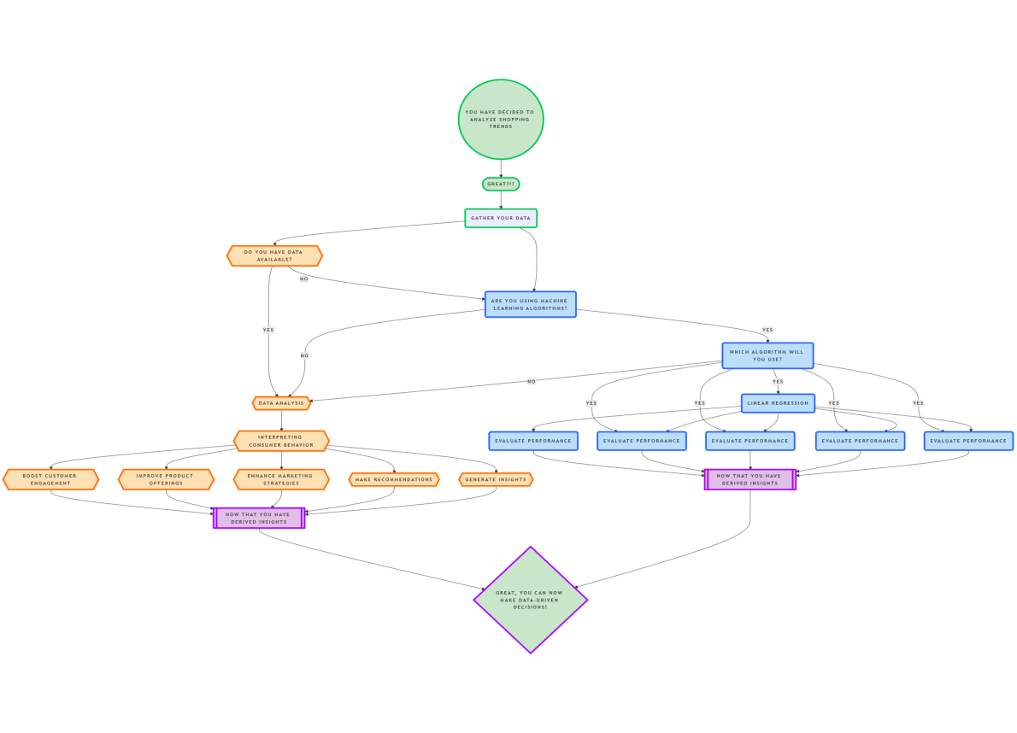

• **Data Collection:** Gather transactional data like purchase history, customer demographics, and product categories from e-commerce platforms or databases.

• **Data Preprocessing:** Clean and organize data by handling missing values, scaling features, and removing inconsistencies to prepare it for analysis.

• **Trend Analysis & Feature Engineering:** Identify key patterns, trends, and relationships in the data. Create additional features (e.g., customer segments or time-based patterns) to enhance analysis.

• **Machine Learning & Predictive Modeling:** Apply machine learning algorithms (e.g., clustering, regression, time-series analysis) to predict customer behavior and shopping trends.

• **Data Visualization:** Present insights using interactive dashboards and charts (e.g., trend lines, bar graphs) for better decision-making.

• **Business Insights:** Deliver actionable insights, such as demand forecasts and customer preferences, to help businesses improve marketing, inventory, and customer engagement.

* 1. **Requirement Specification**

To successfully implement the solution for identifying shopping trends using data analysis, the following tools and technologies are required:

* + 1. **Hardware Requirements:**

• **Processor:** Intel Core i5 or higher (or equivalent)

• **RAM:** Minimum 8 GB (16 GB recommended for large datasets)

• **Storage:** At least 256 GB SSD for faster data access

• **Graphics Card:** Optional, for advanced data visualization tasks

• **Operating System:** Windows 10/11, macOS, or Linux

* + 1. **Software Requirements:**

• **Programming Language:** Python 3.x for data analysis and modeling

• **Libraries:**

* **Pandas:** For data manipulation and analysis
* **NumPy:** For numerical computations
* **Matplotlib/Seaborn/Plotly:** For data visualization
* **Scikit-learn:** For implementing machine learning algorithms
* **Statsmodels:** For time-series analysis

• **Development Environment:**

* Jupyter Notebook or PyCharm for coding and testing

• **Data Storage:**

* MySQL or MongoDB for storing large datasets

• **Visualization Tools:**

* Power BI or Tableau for creating dashboards

• **Version Control:**

* Git for tracking code changes and collaboration

• **Others:**

* IDEs like VS Code for development
* Cloud Platforms (e.g., AWS, Google Cloud, or Azure) for handling large-scale data if required

**CHAPTER 4**

**Implementation and Result**

* 1. **Snap Shots of Result:**

#### Kindly **Snapshot 1: Age Category vs. Frequency of Purchases**

**Description:**  
This bar chart represents the relationship between different age categories (e.g., 18-25, 26-35, etc.) and the frequency of purchases. The graph highlights which age group shops the most frequently. For instance, it may show that customers in the 26-35 age category have the highest purchase frequency, indicating their strong engagement with the platform.

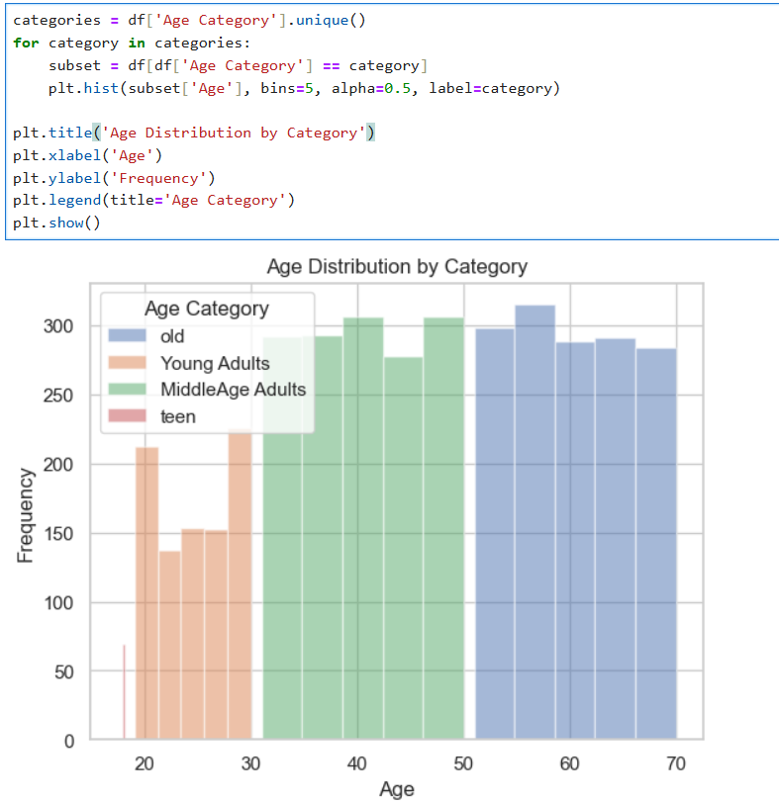

#### **Snapshot 2: Product Category Purchase Distribution**

**Description:**  
This histogram displays the distribution of purchases across various product categories (e.g., electronics, clothing, groceries). It showcases which categories are the most popular. For example, the graph might indicate that electronics account for the majority of purchases, followed by clothing and groceries, which can guide inventory and marketing priorities.

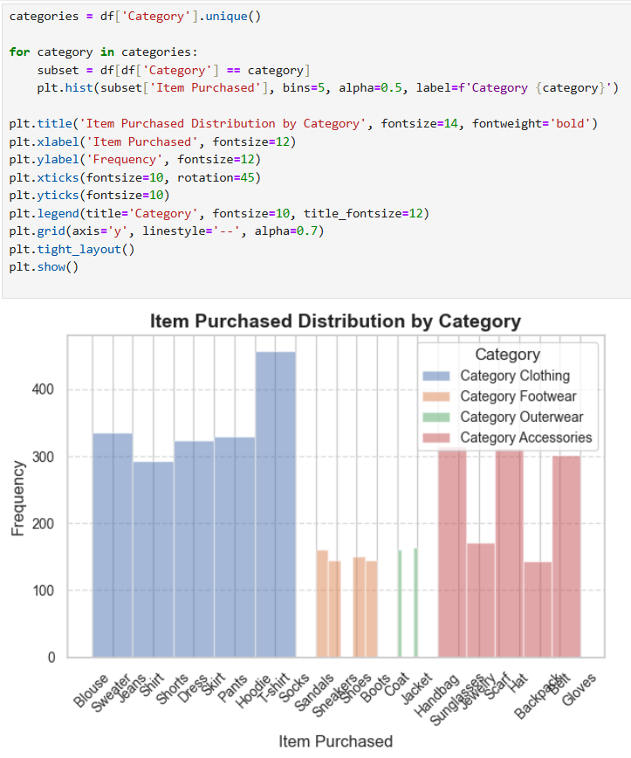

#### **Snapshot 3: Impact of Promo Codes on Purchases**

**Description:**  
This comparison chart (e.g., a bar or pie chart) illustrates how promo codes affect purchasing behavior. It may compare the number of purchases made with and without promo codes. For instance, the graph might show that purchases increase significantly when promo codes are applied, highlighting the importance of promotional campaigns in driving sales.

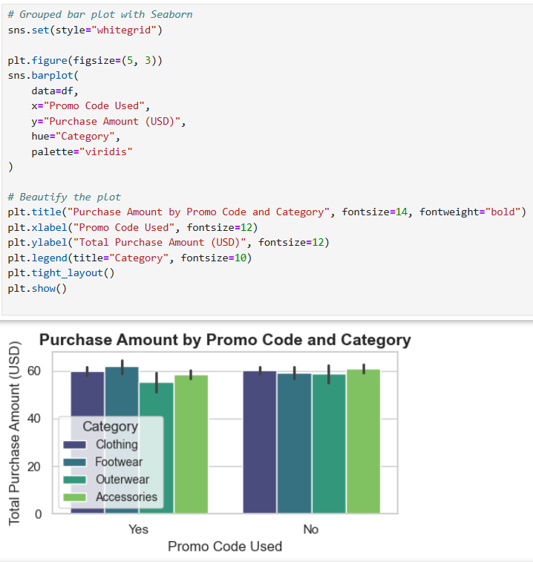

* 1. **GitHub Link for Code:**

**CHAPTER 5**

**Discussion and Conclusion**

* 1. **Future Work:**

The project provides valuable insights into shopping trends, but there are areas where further improvements and extensions can be made:

1. **Enhanced Data Collection:**  
   Incorporate additional data points such as customer reviews, website clickstream data, and social media activity to gain a more comprehensive understanding of customer preferences and behavior.
2. **Real-Time Analysis:**  
   Implement real-time data streaming and processing to analyze shopping trends dynamically, enabling businesses to respond quickly to changing customer needs and market conditions.
3. **Integration of Advanced Machine Learning Models:**  
   Use more advanced models such as deep learning (e.g., LSTM for time-series analysis or CNNs for image-based insights) to improve prediction accuracy and uncover complex patterns.
4. **Personalized Recommendations:**  
   Expand the system to include a recommendation engine tailored to individual customers based on their purchasing history and preferences, improving user engagement and satisfaction.
5. **Geographic and Cultural Trends:**  
   Analyze shopping trends across different geographic regions and cultural contexts to identify location-specific patterns and cater to diverse customer bases.

**Conclusion:**

The project, "Identifying Shopping Trends using Data Analysis," provides a powerful framework for understanding customer behavior and market dynamics. By analyzing purchasing patterns, age demographics, product preferences, and the impact of promotional strategies, the project equips businesses with actionable insights to enhance their decision-making processes.

The key contributions of the project include:

* Identifying high-engagement customer segments based on age and shopping frequency.
* Highlighting popular product categories to optimize inventory management and marketing focus.
* Demonstrating the effectiveness of promotional strategies in driving sales.

The project underscores the significance of data-driven approaches in addressing real-world business challenges. By leveraging advanced tools and methodologies, it helps businesses refine their strategies, improve customer satisfaction, and stay competitive in an evolving marketplace. The insights derived not only facilitate better resource allocation but also pave the way for more personalized and efficient shopping experiences.

.

**REFERENCES**

1. Ming-Hsuan Yang, David J. Kriegman, Narendra Ahuja, “Detecting Faces in Images: A Survey”, IEEE Transactions on Pattern Analysis and Machine Intelligence, Volume. 24, No. 1, 2002.