1. Networking Basis:

A **subnetwork** or **subnet** is a logical subdivision of an [IP network](https://en.wikipedia.org/wiki/IP_network).

Each subnet is served by a designated default router,

Two network interfaces/host in the same subnet has same prefix. Hosts with same network prefixes transfers data locally and if the prefixes differ the data is transferred through a router.

Subnet Mask: It’s a [bitmask](https://en.wikipedia.org/wiki/Bitmask) that when applied by a [bitwise AND](https://en.wikipedia.org/wiki/Bitwise_AND) operation to any IP address in the network.

CIDR Notation: First address of a network/Bit length of prefix. E.g. 192.168.1.0/24

IP Address: Network Prefix + Host Number.

IV4 = 32 bit address. Decimal dot notation (192.168.1.0)

Iv6 = 128 bit address. Hexadecimal separated with:

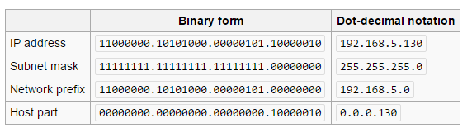

Subnetting: Subnetting is the process of designating some high-order bits from the host part and grouping them with the network mask to form the **subnet mask**. This divides a network into smaller subnets.

**Regions:**

Each region is a separate geographic area.

Each region has multiple, isolated locations known as Availability Zones.

The AWS Cloud operates **38** Availability Zones within **14** geographic Regions around the world, with nine more Availability Zones and four more Regions coming online throughout the next year.

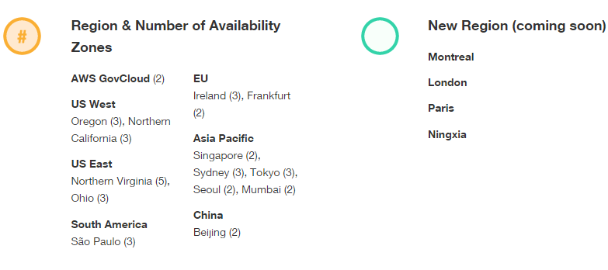

A Region is a physical location in the world where we have multiple Availability Zones. Availability Zones consist of one or more discrete data centers, each with redundant power, networking and connectivity, housed in separate facilities.

Availability Zones are connected to each other with fast, private fiber-optic networking,

You can also choose to increase redundancy and fault tolerance further by replicating data between geographic Regions. You can do so using both private, high speed networking and public internet connections to provide an additional layer of business continuity,

Resources aren't replicated across regions unless you do so specifically.

Each region is completely independent. Each Availability Zone is isolated, but the Availability Zones in a region are connected through low-latency links. The following diagram illustrates the relationship between regions and Availability Zones.

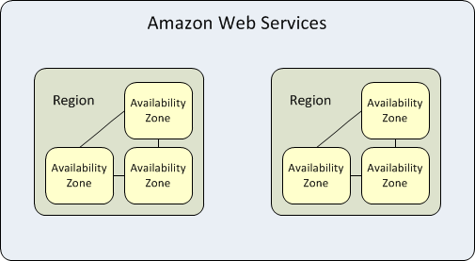

Amazon EC2 resources are either global, tied to a region, or tied to an Availability Zone. When you view your resources, you'll only see the resources tied to the region you've specified.

When you launch an instance, you must select an AMI that's in the same region. If the AMI is in another region, you can copy the AMI to the region you're using.

All communication between regions is across the public Internet. Therefore, you should use the appropriate encryption methods to protect your data.

When you launch an instance, you can select an Availability Zone or let us choose one for you.

You can also use Elastic IP addresses to mask the failure of an instance in one Availability Zone by rapidly remapping the address to an instance in another Availability Zone.

 your Availability Zone us-east-1a might not be the same location as us-east-1a for another account.

As Availability Zones grow over time, our ability to expand them can become constrained. If this happens, we might restrict you from launching an instance in a constrained Availability Zone unless you already have an instance in that Availability Zone. Eventually, we might also remove the constrained Availability Zone from the list of Availability Zones for new customers. Therefore, your account might have a different number of available Availability Zones in a region than another account.

An AWS account:

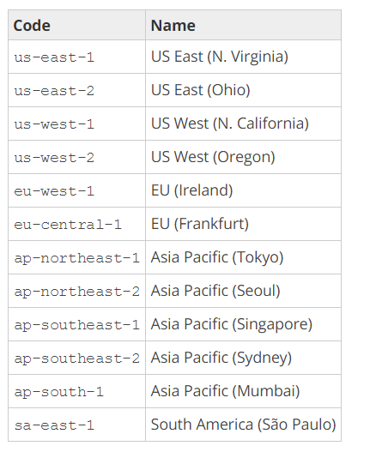

AWS GovCloud (US) account provides access to AWS GovCloud (US) region

Amazon AWS account provides access to the China (Beijing) region.

The number and mapping of Availability Zones per region may vary between AWS accounts.

Some AWS resources might not be available in all regions and Availability Zones. Ensure that you can create the resources you need in the desired regions or Availability Zone before launching an instance in a specific Availability Zone.

When you launch your initial instances, we recommend that you accept the default Availability Zone, because this enables us to select the best Availability Zone for you based on system health and available capacity. If you launch additional instances, only specify an Availability Zone if your new instances must be close to, or separated from, you’re running instances.

**Migrating instance from one AZ to Other**

1. Create an AMI from the instance.
2. Preserve IP Address (if required)
   1. Delete subnet in current AZ
   2. Create new subnet in new AZ with same IP address range

(Note: To delete a subnet, all instances in that subnet needs to be terminated so we require to migrate all the instances)

1. Launch an instance from the AMI that you just created, specifying the new Availability Zone or subnet.
2. If the original instance has an associated Elastic IP address, associate it with the new instance.
3. If the original instance is a Reserved Instance, change the Availability Zone for your reservation.
4. (Optional) Terminate the original instance.

[Launching Instances in an Availability Zone](http://docs.aws.amazon.com/AWSEC2/latest/UserGuide/using-regions-availability-zones.html#using-regions-availability-zones-launching).

[Disassociating an Elastic IP Address and Reassociating it with a Different Instance](http://docs.aws.amazon.com/AWSEC2/latest/UserGuide/elastic-ip-addresses-eip.html#using-instance-addressing-eips-associating-different).

[Terminating an Instance](http://docs.aws.amazon.com/AWSEC2/latest/UserGuide/terminating-instances.html#terminating-instances-console).

**Public IP:**

**Private IP:**

**Elastic IP:**

An **Elastic IP** address is a static **IP** address designed for dynamic cloud computing. An **Elastic IP** address is associated with your AWS account. With an **Elastic IP**address, you can mask the failure of an instance or software by rapidly remapping the address to another instance in your account.

* To use an Elastic IP address, you first allocate one to your account, and then associate it with your instance or a network interface.
* When you associate an Elastic IP address with an instance or its primary network interface, the instance's public IP address (if it had one) is released back into Amazon's pool of public IP addresses. You cannot reuse a public IP address. For more information, see [Public IP Addresses and External DNS Hostnames](http://docs.aws.amazon.com/AWSEC2/latest/UserGuide/using-instance-addressing.html#concepts-public-addresses).
* You can disassociate an Elastic IP address from a resource, and reassociate it with a different resource.
* A disassociated Elastic IP address remains allocated to your account until you explicitly release it.
* To ensure efficient use of Elastic IP addresses, we impose a small hourly charge if an Elastic IP address is not associated with a running instance, or if it is associated with a stopped instance or an unattached network interface. While your instance is running, you are not charged for one Elastic IP address associated with the instance, but you are charged for any additional Elastic IP addresses associated with the instance. For more information, see [Amazon EC2 Pricing](http://aws.amazon.com/ec2/pricing/on-demand/#Elastic_IP_Addresses).
* An Elastic IP address is for use in a specific region only.
* When you associate an Elastic IP address with an instance that previously had a public IP address, the public DNS hostname of the instance changes to match the Elastic IP address.
* We resolve a public DNS hostname to the public IP address or the Elastic IP address of the instance outside the network of the instance, and to the private IP address of the instance from within the network of the instance.

From Internet:

Public DNS 🡪 Elastic IP/Public IP

From Intranet:

Public DNS 🡪 Private IP

If your account supports EC2-Classic, there's one pool of Elastic IP addresses for use with the EC2-Classic platform and another for use with the EC2-VPC platform. You can't associate an Elastic IP address that you allocated for use with a VPC with an instance in EC2-Classic, and vice-versa. However, you can migrate an Elastic IP address you've allocated for use in the EC2-Classic platform to the EC2-VPC platform.  You cannot migrate an Elastic IP address to another region.

## Next:

## <http://docs.aws.amazon.com/AWSEC2/latest/UserGuide/elastic-ip-addresses-eip.html#using-instance-addressing-eips-allocating>

## Elastic IP Address Differences for EC2-Classic and EC2-VPC