MINI PROJECT

**(2021-2022)**

**“SMART E-VECHILE**

End Term Project Report



**Institute of Engneering and Technology**

**Submitted By-**

SAJAL GAUR (191500695)

BHAKTI VARSHNEY(191500209)

RUDRA RAJPOOT (191500780)

MANISH SHARMA (191500437)

**Under the Supervision Of**

**Mr. Piyush Vashistha**

**Technical Trainer**

**Department of Computer Engneering &Applications**

**Department of Computer Engineering and Applications**



**GLA University, 17 km. Stone NH#2, Mathura-Delhi Road,**

**Chaumuhan, Mathura – 281406 U.P (India)**

**Declaration**

I/we hereby declare that the work which is being presented in the Bachelor of technology. Project **“SMART E-VECHILE”**, in partial fulfillment of the requirements for the award of the ***Bachelor of Technology*** in Computer Science and Engineering and submitted to the Department of Computer Engineering and Applications of GLA University, Mathura, is an authentic record of my/our own work carried under the supervision of **Mr. Piyush Vashishtha , Technical Trainer, Dept. of CEA,GLA University.**

The contents of this project report, in full or in parts, have not been submitted to any other Institute or University for the award of any degree.

|  |  |
| --- | --- |
| **Sign**: *Sajal Gaur*    **Name of Candidate**: Sajal Gaur | **Sign**: *Bhakti Varshney*    **Name of Candidate**: Bhakti Varshney |
| **University Roll No**.:191500695 | **University Roll No**.:191500209 |
| **Sign*:*** *Rudra Rajpoot*    **Name of Candidate:** Rudra Rajpoot | **Sign**: *Manish Sharma*    **Name of Candidate**: Manish Sharma |
| **University Roll No**.:191500680 | **University Roll No**.:191500437 |

**Department of Computer Engineering and Applications**

**GLA University, 17 km. Stone NH#2, Mathura-Delhi**

**Road, Chaumuhan, Mathura – 281406 U.P (India)**

**Certificate**

This is to certify that the project entitled “Smart E-Vechile”, carried out in Mini Project – I

, is a bonafide work by Sajal Gaur, Rudra Rajpoot, Bhakti Varshney and Manish Sharma is submitted in partial fulfillment of the requirements for the award of the degree Bachelor of Technology (ComputerScience & Engineering).

**Signature of Supervisor:**

# Name of Supervisor: Mr. Piyush Vashishtha

**Date:** 25 May 2022

**Department of Computer Engineering and Applications**



**GLA University, 17 km. Stone NH#2, Mathura-Delhi**

**Road, Chaumuhan, Mathura – 281406 U.P (India)**

# ACKNOWLEDGEMENT

Presenting the ascribed project paper report in this very simple and official form, we would like to place my deep gratitude to GLA University for providing us the instructor Mr. Piyush Vashishtha, our technical trainer and supervisor.

He has been helping us since Day 1 in this project. He provided us with the roadmap, the basic guidelines explaining on how to work on the project. He has been conducting regular meeting to check the progress of the project and providing us with the resources related to the project. Without his help, we wouldn’t have been able to complete this project.

And at last but not the least we would like to thank our dear parents for helping us to grab this opportunity to get trained and also my colleagues who helped me find resources during the training.

Thanking You

|  |  |
| --- | --- |
| **Sign**: *Sajal Gaur*    **Name of Candidate**: Sajal Gaur | **Sign**: *Bhakti Varshney*    **Name of Candidate**: Bhakti Varshney |
| **University Roll No**.:191500695 | **University Roll No**.:191500209 |
| **Sign:** *Rudra Rajpoot*    **Name of Candidate:** Rudra Rajpoot | **Sign**: *Manish Sharma*    **Name of Candidate**: Manish Sharma |
| **University Roll No**.:191500680 | **University Roll No**.:191500437 |

**ABSTRACT**

The Internet of Things (IoT) is making human life easy in all aspects. The applications it offers are beyond comprehension. IoT is an abstract idea, a notion which interconnects all devices, tools, and gadgets over the Internet to enable these devices to communicate with one another. IoT finds application in various areas, such as intelligent cars and their safety, security, navigation, and efficient fuel consumption. This project puts forth a solution to achieve the desired outcome of saving precious human lives . In this context, we propose to develop a system, we are designing and deploying a system that not only avoids accidents but also to take action accordingly. This research aims at dealing with the issues that cause fatal crashes and also integrates measures to ensure safety. Life without transportation is impossible to imagine; it makes far off places easy to reach and greatly reduces the travel time. But the problems which surface due to the ever-increasing number of vehicles on the road cannot be ignored. The project aims to eradicate a few of the major reasons of car crashes and also aims to integrate post-crash measures.

# CONTENTS

Cover Page ......................................................................................................... i

Declaration ........................................................................................................ ii

Certificate ........................................................................................................... iii

List Of figures ..................................................................................................... xi

List Of tables…………………………………………………………………….xii

Chapter 1Introduction ........................................................................................... 1

* 1.1 Context

•

* 1.2 Motivation

* 1.3 Objective ................................................................................................. 2
* 1.4 Existing System ..................................................................................... 2
* 1.4 Sources .................................................................................................... 3

Chapter 2 Software Requirement Analysis .............................................................4

Chapter 3 Software Design… ................................................................................. 8

* 3.1 Use Case Diagram .................................................................................. 8

Chapter 4 Technology Used… ................................................................................13

* 4.1 Android… ........................................................................................ 13

* 4.2 Version of Android ............................................................................................................. 14

1.1

4.3 Tools and Languages .......................................................................................... 15

* 4.4 Basic Terminology .............................................................................................................. 16

Chapter 5 Implementation and User Interface ...................................................... 19

* 5.1 Implementation of Smart E-Vechile ............................................................................................ 19

Chapter 6 Testing ................................................................................................. 33

Chapter 7 Conclusion…………………………………………………………… .. 40

**References…………………………………………………………………………***41*

# LIST OF FIGURES

1. Existing System .........................................................................................................................2

1. Use Case Diagram ....................................................................................................................9

1. Data Flow Diagram ................................................................................................................. 11

1. Sequence Diagram .................................................................................................................... 12

1. Flow Chart for User ................................................................................................................. 21

1. FAQ Page....................................................................................................................................... 29

1. Description Page ...................................................................................................................... 30

**LIST OF TABLES**

1. Unit testing of Smart E-Vechile......................................................................................................... 34

# CHAPTER-1

**INTRODUCTION**

**CONTEXT**

This Web Application “Smart E-Vechile” has been submitted in partial fulfilment of the requirements for the award of the degree of Bachelor of Technology in Computer Science and Engineering at GLA University, Mathura supervised by Mr. Piyush Vashishtha . This project will be completed soon and will been executed in modules, meetings will be organized to check the progress of the work and for instructions and guidelines.

## MOTIVATION

The Internet of Things (IoT) is making human life easy in all aspects. The applications it offers are beyond comprehension. IoT is an abstract idea, a notion which interconnects all devices, tools, and gadgets over the Internet to enable these devices to communicate with one another. It utilizes information technology, network technology, and embedded technology. Various sensors and tracking devices are coupled to deliver the desired outcome thus making lives easier. IoT finds application in various areas, such as intelligent cars and their safety, security, navigation, and efficient fuel consumption. This project puts forth a solution to achieve the desired outcome of saving precious human lives that are lost . In the proposed system, we are designing and deploying a system that not only avoids accidents but also to take action accordingly.

## OBJECTIVE

The proposed project aims to achieve the following :

* To ensure the driver is not drowsy, eye-blink sensors are deployed in the automobile.

* To circumvent a crash, a proximity sensor is deployed to discover the interruption in front of the

automobile on the path.

* To ensure post-crash safety an alert system is deployed which makes use of a GPS system to attain the geographical location of the crashed vehicle and it is sent to a responsible and authorized individual. The accident is detected with the use of a vibration sensor.

* An RFID can be affixed to an object and used to track tools, equipment, inventory, assets, people, or other objects.

* A Fuel Sensor is affixed to make accurate measurements of fuel level in vehicle tanks.

## EXISTING SYSTEM

The proposed system utilizes an embedded system based on the Internet of Things and the Global System for Mobile Communication (GSM) To avoid an accident, when the system is initiated, the seat belt is checked using a pressure sensor. If the driver is not wearing a seat belt, the engine is turned off. After this, three things – tiredness and obstacles – are checked using the eyeblink sensor and the proximity sensor, respectively. If there is any obstacle present, then the buzzer beeps to tell the driver. If the driver is feeling sleepy or drowsy, the eye blink sensor detects it and switches off the engine.

1. The system utilizes GSM technology for the communication of code pattern to transmit location coordinates.

1. The system is Arduino Uno based.

1. The system should be able to communicate even from physically far off distances.

1. The system uses a proximity sensor, fuel sensor , RFID , eye-blink sensor, buzzer and humidity sensor.

1. To practically put together all the components and execute them, the composition of various sensing devices in our system is as shown in the figure below.

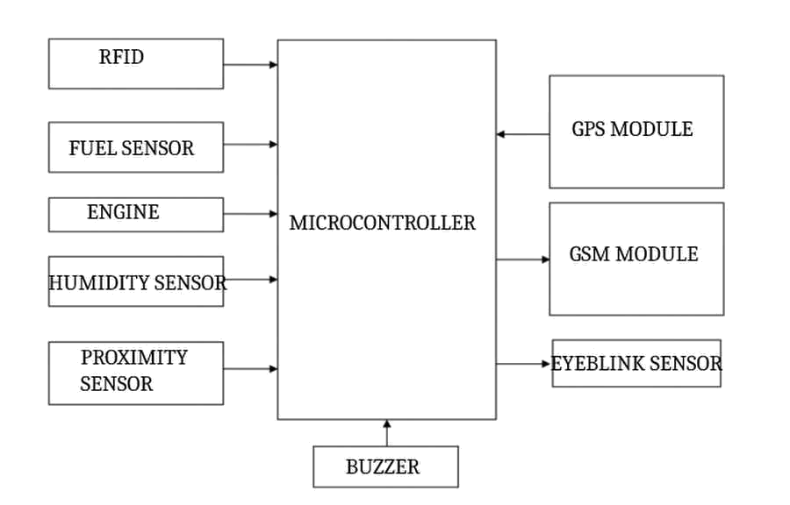

## SOURCES

The source of our project (including all the project work, documentations and presentations) will is available at the following link :

https://github.com/sajal20003/Smart-E-Vechile.git

# CHAPTER -2

**SOFTWARE REQUIREMENT ANALYSIS**

## PROBLEM STATEMENT

The arrangement of the idea to implement the functional requirements is elucidated under the heading system design. The arrangement of the idea to implement the non-functional requirements is elucidated in the system architecture section of this project report. The imperative functional requirements of this project’s objective accomplishment are:

1. The automotive system should have the capability to determine the mental awareness of the driver in terms of if he is feeling sleepy.

1. The automotive system should have the capability to check whether the vehicle is not coming too close to the vehicle in front.

1. The automotive system should have the capability to determine whether an accident has already taken place and thus should have the capability of sending the location coordinates of accident to a responsible person with the help of GSM technology.

The assumptions and dependencies are established in the beginning itself to give us a lucid understanding of the implementation of the product:

* Need of an appropriate GPS module to deliver exact geographical location coordinates.

* The driver should be wearing the spectacles eye gear integrated with the eye-blink sensor.

* The system should always be connected to Internet.

* Proper placement of numerous proximity sensors can be added.

## HARDWARE AND SOFTWARE REQUIREMENTS

### Hardware Requirement

* Processor : Intel i3

* Operating System : Windows 7/8/10

* RAM : 4+GB

* Hardware Devices : Computer System

* Hard disk : 64 GB

* Display : 1366 x 768

### Software Requirement

 

* Technology Implemented : IOT

* Language Used : integrated C

* Database : AWS Cloud

* User Interface Design : HTML , CSS

* Web Browser : Chrome

## MODULES AND FUNCTIONALITIES

This project deals with problems which cause accidents and attempts to ensure safety. This project addresses various reasons that lead to fatal accidents. Roads are unpredictable and at every turn of the road can be fatal accidents present and one cannot rely on the driving sense of other drivers and the pedestrians. One needs to be self-aware of the environment and the vehicles around. The driver should take all the precautions and be mindful of the people on the road as well because every life has value. Common reasons for accidents are the

lack of concentration of the driver on the road because of some distraction or because of lack of sleep of the driver. The product aims to provide the following functions:

* External forces should not result in the damaging of the system.

* The framework must be able to explicitly identify and discover problems related to the

components.

* The issue detected should be reported back to the system.

**About the Sensors**

## GPS Module

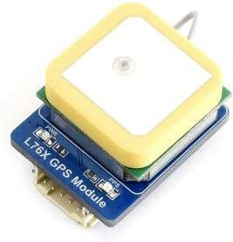

GPS modules contain tiny processors and antennas that directly receive data sent by satellites through dedicated RF frequencies. ... The four well-known Global Navigation Satellite System include GPS, BDS(Beidou), GLONASS and GALILEO four satellite navigation systems.

### GSM MODULE

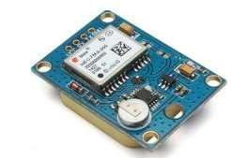

A GSM modem or GSM module is a hardware device that uses GSM mobile telephone technology

to provide a data link to a remote network. From the view of the mobile phone network, they are

essentially identical to an ordinary mobile phone, including the need for a SIM to identify

themselves to the network.

### EYEBLINK SENSOR

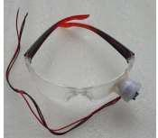

This Eye Blink Sensor is IR based. The Variation Across the eye will vary as per eye blink . If the

eye is closed means the output is high otherwise output is low. This to know the eye is closing or

opening position.

### FUEL SENSOR

Fuel sensor is a device designed to make accurate measurements of fuel level in vehicle tanks. According to these measurements a GPS tracking and telematics platform features the following data: fuel level in the tank of a vehicle. fuel consumption per time period. average fuel consumption.

### HUMIDITY SENSOR

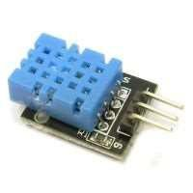

A humidity sensor is an electronic device that measures the humidity in its environment and converts its findings into a corresponding electrical signal. In contrast, absolute humidity is measured without reference to temperature. The two most common RH sensors are the capacitive and resistive humidity sensors

#### RFID sensors

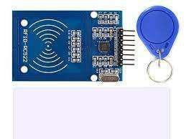

What are RFID Sensors? RFID sensor tags **detect environmental changes and events and**

**communicate the data wirelessly to an RFID reader**. These telemetry products are ideal in

situations where measurements need to be remotely and automatically captured.

## Proximity Sensor

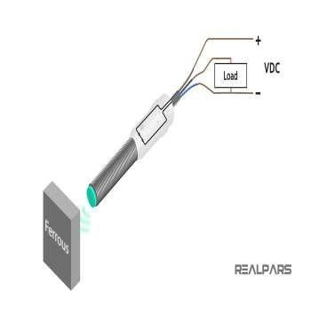

A **proximity sensor** is a sensor able to detect the presence of nearby objects without any physical contact.

## Arduino

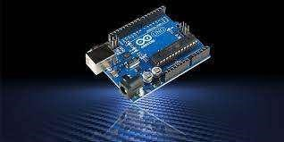

Arduino is an open-source hardware and software company, project, and user community that designs and manufactures single-board microcontrollers and microcontroller kits for building digital devices.

## CHAPTER- 3

**SOFTWARE DESIGN**

**USE-CASE DIAGRAM:**

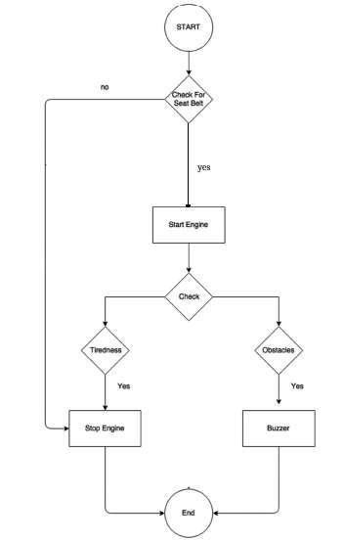

UML Diagram (Activity Diagram)

### Technologies Used

**IOT**

The Internet of Things (IoT) is a system of interrelated computing devices, mechanical and digital machines, objects, animals or people that are provided with unique identifiers and the ability to transfer data over a network without requiring human-to-human or human-to-computer interaction.

**Why Use IOT ?**

With the internet of things, many devices can connect to each other and send information across. Due to their utility and high levels of automation, there has been an increase in the number of devices being connected to the internet.

.

### Languages Used Integrated C

C is a general-purpose, procedural computer programming language supporting structured programming, lexical variable scope, and recursion, with a static type system. By design, C provides constructs that map efficiently to typical machine instructions. It has found lasting use in applications previously coded in assembly language. Such applications include operating systems and various application software for computer architectures that range from supercomputers to PLCs and embedded systems.

#### Applications of C

1. **Operating Systems** - The first operating system to be developed using a high-level programming language was UNIX, which was designed in the C programming language.

Later on, Microsoft Windows and various Android applications were scripted in C.

1. **Embedded Systems** - The C programming language is considered an optimum choice when it comes to scripting applications and drivers of embedded systems, as it is closely related to machine hardware.

### CHAPTER -5

**IMPLEMENTATION TILL DATE**

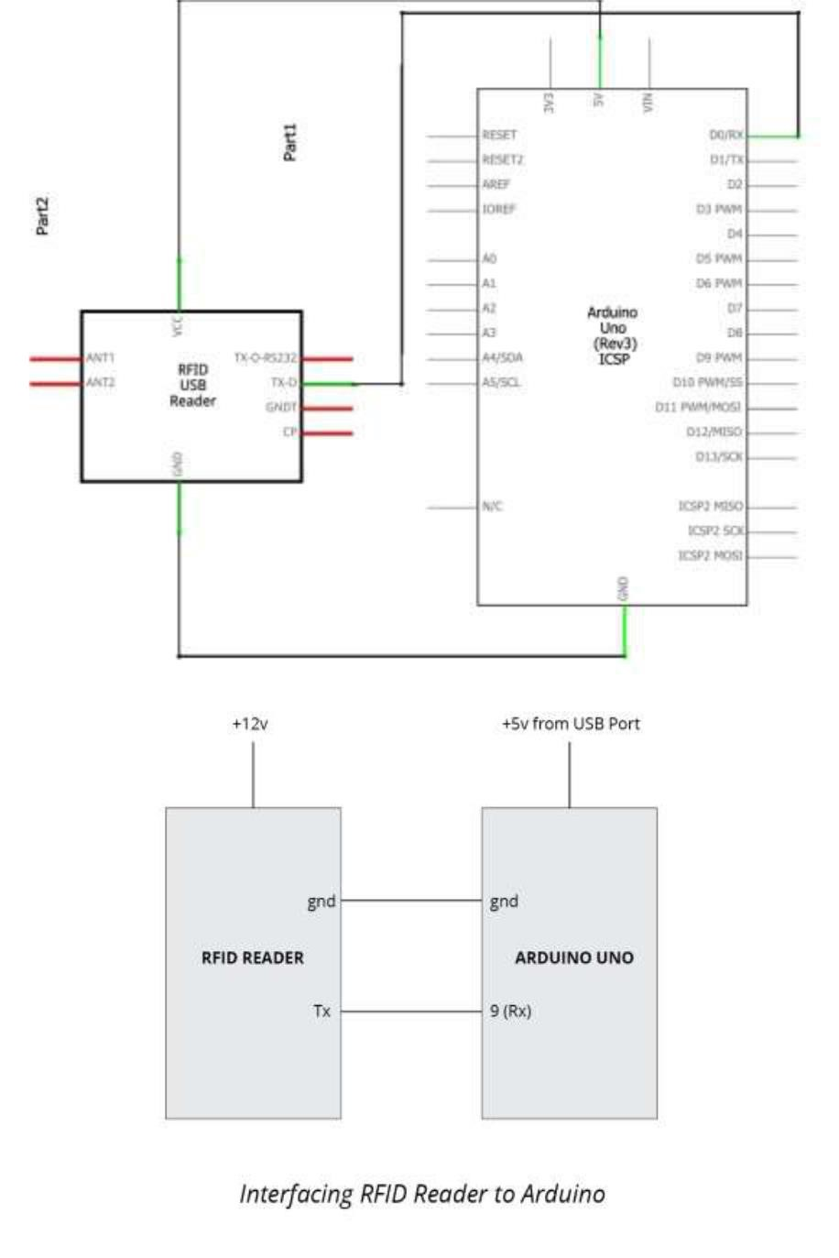 **RFID**

**GSM MODULE:****-**

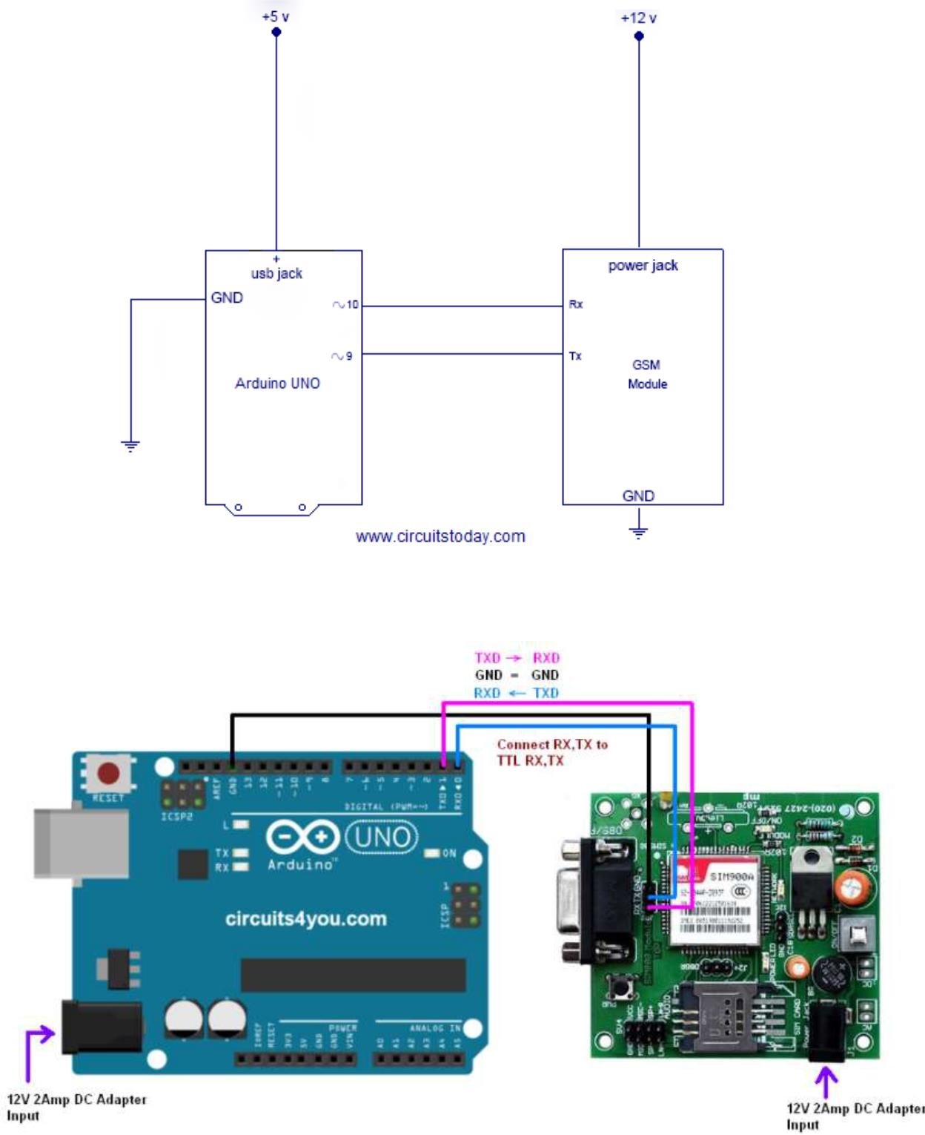

#### GPS MODULE:-

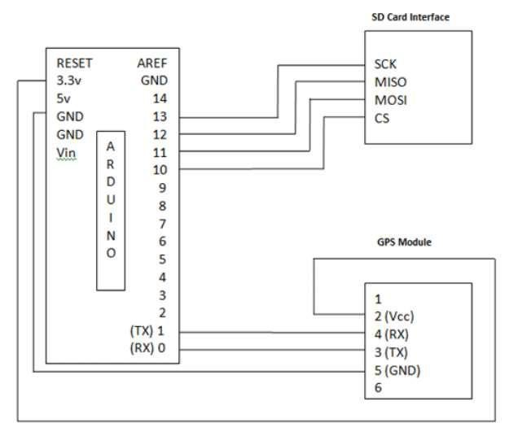

**DHT Sensor**

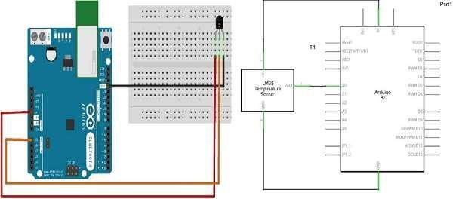

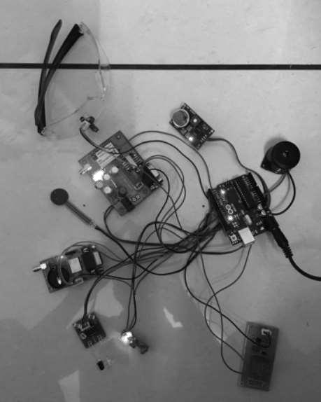

A competent Smart Vehicle Security and Safety System integrated with a humidity sensor, eyeblink sensor, proximity sensor, RFID and fuel sensor using the concept of GPS and GSM has been implemented. The sensors are integrated with the Arduino board. Areas with outreach problems that experience bad network connectivity or in remote areas with no network connectivity available can be an issue.

**CHAPTER - 6**

**TESTIN TILL DATE**

**Unit Testing :**

|  |  |  |  |
| --- | --- | --- | --- |
| **Test cases** | **Description** | **Expected Outcome** | **Result** |
| 1 | Connection with RFID using Relay | Vehicle motor starts | Fail |
| 2 | Dht11 sensor | To check the temperature and humidity | Pass |
| 3 | Proximetre sensor | To check the distance between the vehicle and obstacle | Pass |
| 4 | GPS module | To check the location | Pass |
| 5 | GSM module | To check the connectivity | Fail |
| 6 | Aurdino | Check all pins are working | Pass |



7

8

Eye blink Sensor

To check driver is sleepy

Pass

Module is working

All

module working properly

pass

### CHAPTER -7 CONCLUSION

By the way of concluding this project is good at cost efficient and easy in assembling the circuit also highly efficient in means of practical.

### REFERENCES

[**www.google.com**](http://www.google.com/)

**DCS and IIOT lab**

**THANK YOU**