

**Task-6**

**Web Engineering Lab**

Course Code:CSE415

Submitted To

**Ms.** Sharmin **Akter**

Senior Lecturer, Dept. of CSE

Daffodil International University.

Submitted By

Sajal Das

ID: **191-15-12381**

Section: **“B”**

Semester: Spring-2022

Department of CSE

Task 6

**HTML & CSS code:**



**PHP code:**





**Output:**

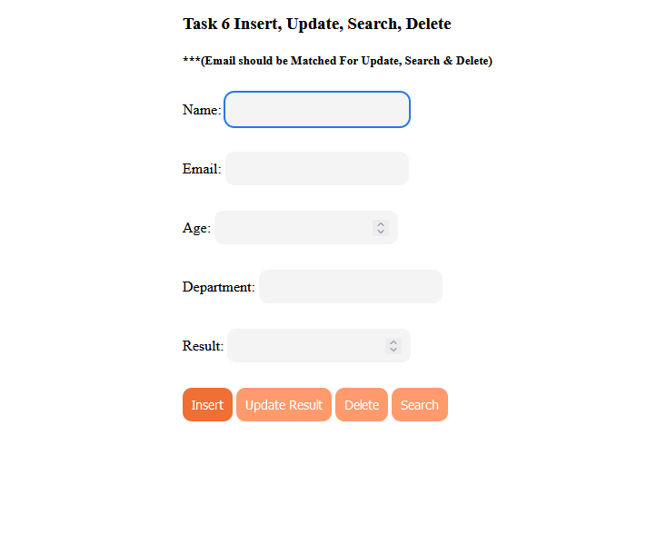

1. Insert:

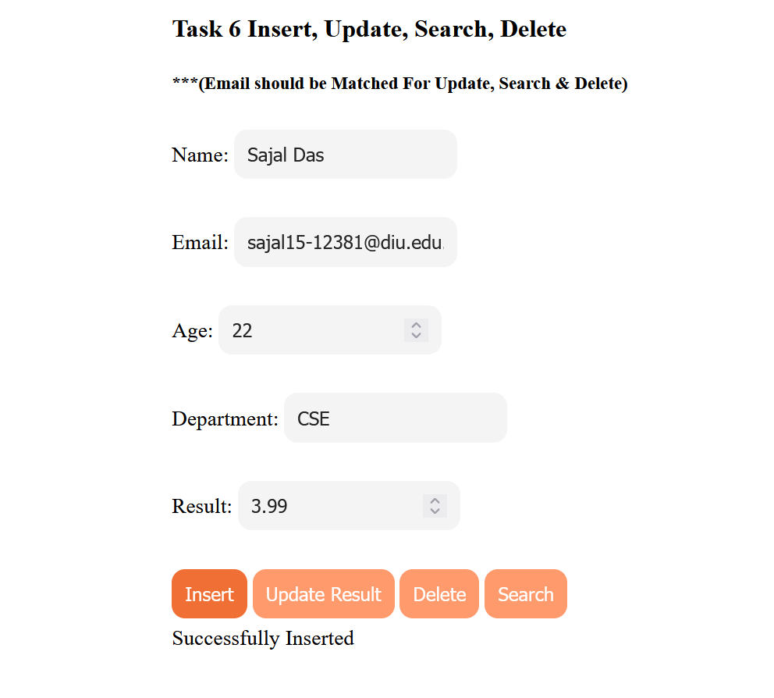

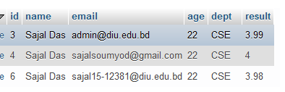

1. Update:

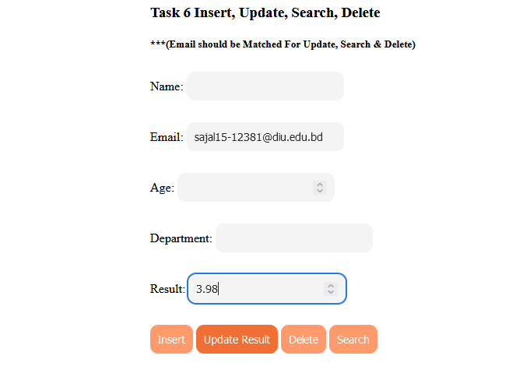

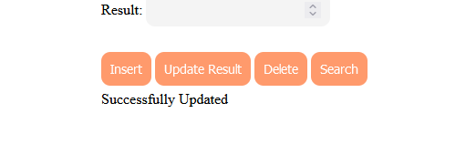 Result Updated



1. Search:

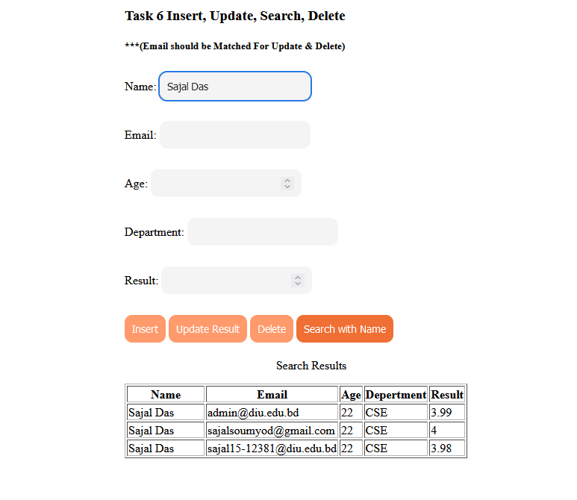

1. 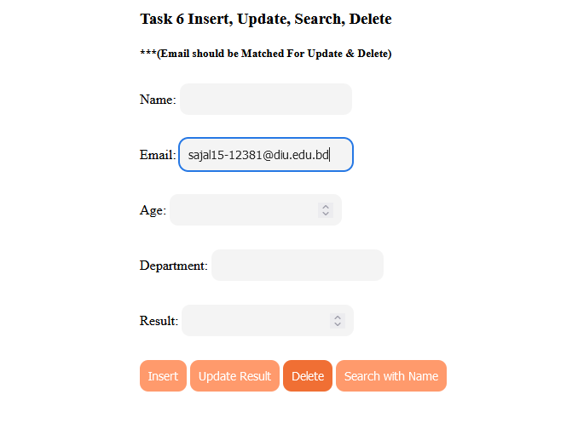Delete:

Email contains [sajal15-12381@diu.edu.bd](mailto:sajal15-12381@diu.edu.bd) deleted.

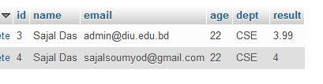

THE END