Spring 2026



Software Requirement Engineering Final Project
Department: BS-SE (Section B)
Submission Date: 10th May,2026
Submitted To: Prof Irfan Ullah
Submitted By
Student Name | Student ID
Musfirah Hamid | 24I-3096
Saliha Noor | 24I-3066
Sajal Ishtiaq | 24I-3041

Classroom Equipment Booking & Fault Tracking System

SE-2001 Software Requirements Engineering
BS Software Engineering — Semester Project

Instructor | Mr. Irfan Ullah
Course | SE 2001 — Software Requirements Engineering
Institution | FAST-NUCES, Islamabad
Program | BS Software Engineering
Submission | May 10, 2026
Version | Final SRS
Document Type | Software Requirements Specification

Executive Summary

This Software Requirements Specification (SRS) document presents the complete Requirements Engineering (RE) process applied to the Classroom Equipment Booking & Fault Tracking System (CEBFTS) — a web-based platform designed to digitise and streamline the booking, management, and maintenance of classroom equipment across FAST-NUCES, Islamabad.
The system addresses a critical gap in the current manual/ad-hoc process where equipment such as projectors, microphones, smart boards, laptops, and multimedia systems are reserved via verbal requests or paper sign-ups, leading to double bookings, unresolved faults, and poor asset visibility.

Scope
CEBFTS covers four primary functional areas: equipment booking, fault reporting & tracking, admin inventory management, and notification services. The system serves five stakeholder groups: Students, Lecturers, Lab Technicians, Department Administrators, and the IT/Facility Manager.

Document Structure
This document is organised into six milestone chapters as follows:
- M1 — Elicitation & Discovery: stakeholder analysis, elicitation techniques, and findings
- M2 — Requirements Specification: 90+ formal functional and non-functional requirements
- M3 — Documentation & Modeling: UML models and quality-assured requirement statements
- M4 — Cross-Group Validation & Negotiation: validation checklist, conflicts, and resolutions
- M5 — Requirements Management: attributes, Wiegers prioritisation, and traceability
- M6 — Effort Estimation: Function Point Analysis and COCOMO calculations.

Table of Contents
Executive Summary 2
Scope 2
Document Structure 3
1- Project Overview & System Description 14
1.1 Purpose 14
1.2 System Scope 14
1.3 Definitions, Acronyms & Abbreviations 14
1.4 References 15
Milestone 1 — Elicitation & Discovery 16
1.1 Elicitation Techniques Used 16
1.2 Stakeholder Analysis 16
1.3 Stakeholder Personas 17
1.4 Elicitation Findings Summary 17
Milestone 2 — Requirements Specification 19
2.1 Requirement Phrase Template 19
2.2 Functional Requirements — Equipment Booking Module 19
2.3 Functional Requirements — Fault Reporting & Tracking Module 20
2.4 Functional Requirements — User Management & Authentication 21
2.5 Functional Requirements — Inventory & Admin Module 22
2.6 Functional Requirements — Notification Module 22
2.7 Non-Functional Requirements 23
2.8 User Stories 24
Booking Module 24
Fault Tracking Module 24
Admin Module 25
Milestone 3 — Documentation & Modeling 26
3.1 Use Case Diagram Description 26
3.2 Fully Dressed Use Case Specifications 27
3.3 Activity Diagram Description — Equipment Booking Process 36
3.4 Class Diagram 3.5 State Machine Diagram for Fault Lifecycle 37
3.6 Sequence Diagram 40
3.7 NL Pitfall Review 46
Milestone 4 — Cross-Group Validation & Negotiation 46
4.1 Validation Checklist 46
4.2 Validation Execution — Perspective-Based Reading 46
4.3 Identified Conflicts 47
4.4 Verifiability Issues Flagged 47
4.5 Conflict Resolution — Decision Matrix 47
4.6 Peer Validation Report Received 48
Milestone 5 — Requirements Management 48
5.1 Requirements Attributes 48
5.2 Wiegers Prioritisation Matrix 49
5.3 Requirements Versioning 50
5.4 Traceability Matrix 50
5.5 Traceability Graph Description 52
Milestone 6 — Effort Estimation (FPA & COCOMO) 52
6.1 Function Point Analysis (FPA) 52
6.1.1 Unadjusted Function Points (UFP) 52
6.1.2 UFP Summary 55
6.1.3 Value Adjustment Factor (VAF) 55
6.1.4 Final Adjusted Function Points 56
6.2 COCOMO Estimation 56
6.2.1 Convert Function Points to Lines of Code (LOC) 56
6.2.2 Basic COCOMO Model — Organic Mode 56
6.2.3 COCOMO Summary 57
6.2.4 Estimation Assumptions & Limitations 57
Document Sign-Off 59

1- Project Overview & System Description

1.1 Purpose
The purpose of this SRS is to formally define and document the requirements for CEBFTS. The system shall provide a centralised, role-based web application that enables authorised users to browse available classroom equipment, make time-slot bookings, receive automated confirmations, report equipment faults with photographic evidence, and track the resolution lifecycle of each fault.

1.2 System Scope
The system is scoped to FAST-NUCES Islamabad campus. It includes:
- Equipment catalogue management (projectors, microphones, smart boards, laptops, laser pointers, speakers)
- Room-based booking calendar with conflict detection
- Fault reporting portal with photo upload and priority tagging
- Technician task assignment and resolution tracking
- Admin dashboard for inventory, utilisation reports, and maintenance scheduling
- Email and in-app notification engine
Out of Scope: procurement management, financial billing, non-campus locations, and physical hardware maintenance procedures.

1.3 Definitions, Acronyms & Abbreviations
CEBFTS | Classroom Equipment Booking & Fault Tracking System
SRS | Software Requirements Specification
FR | Functional Requirement
NFR | Non-Functional Requirement
RE | Requirements Engineering
UC | Use Case
FPA | Function Point Analysis
UFP | Unadjusted Function Points
VAF | Value Adjustment Factor
FP | Adjusted Function Points
LOC | Lines of Code
COCOMO | Constructive Cost Model
RBAC | Role-Based Access Control
UI/UX | User Interface / User Experience
REST | Representational State Transfer
API | Application Programming Interface
SMTP | Simple Mail Transfer Protocol
SLA | Service Level Agreement

1.4 References
- ISO/IEC/IEEE 29148:2018 — Systems and software engineering — Requirements engineering
- IEEE Std 830-1998 — Recommended Practice for SRS
- SE 2001 Course Slides — Mr. Irfan Ullah, FAST-NUCES Islamabad (2026)
- Wiegers, K. & Beatty, J. — Software Requirements, 3rd Edition (Microsoft Press)
- COCOMO II Model Definition Manual — University of Southern California.

Milestone 1 — Elicitation & Discovery

1.1 Elicitation Techniques Used
The following elicitation techniques were applied to gather requirements for CEBFTS:
- Structured Interviews: one-on-one interviews conducted with a lecturer, a lab technician, and a department administrator using a pre-defined question set.
- Focus Group: a 60-minute workshop with five students and two faculty members to surface conflicting priorities and common pain points.
- Observation: the team observed the existing manual equipment request process for two lab sessions to understand the as-is workflow.
- Questionnaire: an online survey of 40 students and 15 faculty members to quantify demand and usage patterns.
- Document Analysis: review of existing room booking registers, equipment fault logs, and maintenance request forms.
- Brainstorming: group sessions to identify features, edge cases, and system boundaries.
- Persona-Based Requirements Generation (AI-assisted brainstorming): five stakeholder personas were generated to surface perspective-specific requirements (see AI Disclosure, Appendix A).

1.2 Stakeholder Analysis
Five primary stakeholder groups were identified for CEBFTS:
Stakeholder | Role | Goals | Pain Points
Student | Books equipment for presentations and lab work | Easy booking, instant confirmation, fault reporting | Double bookings, no confirmation, equipment unavailable
Lecturer / Faculty | Reserves room + equipment for class sessions | Reliable scheduling, advance booking window, status updates | Equipment booked by others, no real-time availability
Lab Technician | Handles fault repairs and equipment maintenance | Clear fault descriptions, photo evidence, priority queue | Verbal-only fault reports, unclear issue descriptions
Dept. Administrator | Manages inventory, approves bookings, generates reports | Full visibility of assets, utilisation analytics, audit trail | No centralised dashboard, manual record-keeping
IT / Facility Mgr | Oversees system health, access control, integrations | Role-based access, security logs, integration with campus systems | Unauthorised access, data inconsistency

1.3 Stakeholder Personas

Persona 1 — Sara Ahmed (Student)
Sara is a 3rd-year BS Software Engineering student who regularly presents group projects. She struggles to find available projectors and often discovers the booked equipment is faulty only on the day of her presentation. She wants a mobile-friendly booking portal with real-time availability.

Persona 2 — Dr. Kamran Iqbal (Lecturer)
Dr. Kamran teaches three courses and requires a laptop and projector every session. He finds the verbal booking process unreliable and wants at least 48-hour advance booking confirmation and email reminders 30 minutes before class.

Persona 3 — Asad Mehmood (Lab Technician)
Asad manages equipment across four labs. He receives fault reports verbally and maintains a paper log. He needs a digital fault queue ordered by severity so he can plan his day and update resolution status in real time.

Persona 4 — Ms. Nadia Khan (Department Administrator)
Nadia oversees asset procurement and usage. She currently produces monthly utilisation reports manually from spreadsheets. She wants automated monthly reports and the ability to deactivate equipment under extended maintenance.

Persona 5 — Mr. Hassan Ali (IT Manager)
Hassan manages network and software infrastructure. He needs role-based access control, audit logs of all bookings and system events, and an API to integrate CEBFTS with the campus identity provider (Active Directory).

1.4 Elicitation Findings Summary
Key findings from the elicitation activities are summarised below:
- 70% of survey respondents reported experiencing at least one double-booking incident per semester.
- Faculty members require a minimum 48-hour advance booking window for planning purposes.
- Technicians need photograph-backed fault reports to diagnose issues before physically attending.
- Administrators require utilisation rate dashboards segmented by room, equipment type, and time period.
- Students prefer a mobile-responsive interface and SMS/email confirmation within 5 minutes of booking.
- The IT Manager mandates integration with FAST-NUCES Active Directory for single-sign-on (SSO).
- Equipment fault resolution must be tracked with a maximum SLA of 48 hours for critical faults and 5 working days for minor faults.

Milestone 2 — Requirements Specification

2.1 Requirement Phrase Template
All functional requirements follow the standard phrase template:
[Condition] [Subject] [Action] [Object]
Example: "When a booking conflict exists, the system shall notify the requesting user with available alternative time slots."

2.2 Functional Requirements — Equipment Booking Module
ID | Requirement Statement | Priority | Source
FR-001 | The system shall allow registered users to view real-time availability of all equipment by date and time slot. | High | Lecturer, Student
FR-002 | The system shall allow a user to submit a booking request specifying equipment type, room number, date, and time slot. | High | Lecturer, Student
FR-003 | When a requested time slot is already booked, the system shall display the next three available slots and reject the conflicting request. | High | Student
FR-004 | Upon successful booking, the system shall send a confirmation email to the user within 5 minutes containing booking ID, equipment details, room, and time. | High | Lecturer
FR-005 | The system shall allow users to cancel a booking at least 2 hours before the scheduled time. | High | Lecturer, Student
FR-006 | When a booking is cancelled, the system shall immediately release the equipment and time slot for other users. | High | Student
FR-007 | The system shall allow lecturers to create recurring weekly bookings for the duration of a semester. | Medium | Lecturer
FR-008 | The system shall prevent a single user from holding more than 3 active bookings simultaneously. | Medium | Admin
FR-009 | The system shall display a booking history list for each authenticated user showing past and upcoming bookings. | Medium | Student, Lecturer
FR-010 | When equipment is marked as under maintenance, the system shall automatically block all new bookings for that equipment until it is marked as available. | High | Admin
FR-011 | The system shall allow administrators to manually override any booking and reassign equipment. | Medium | Admin
FR-012 | The system shall send a reminder notification to the booking user 30 minutes before the scheduled start time. | Medium | Lecturer
FR-013 | The system shall allow users to search for available equipment by type, room, building, or time range. | High | Student, Lecturer
FR-014 | The system shall generate a printable booking receipt in PDF format upon user request. | Low | Lecturer
FR-015 | The system shall allow an administrator to set blackout periods during which no equipment can be booked (e.g., exam weeks). | Medium | Admin

2.3 Functional Requirements — Fault Reporting & Tracking Module
ID | Requirement Statement | Priority | Source
FR-016 | The system shall allow any authenticated user to submit a fault report specifying equipment ID, fault description, and severity level (Critical / Major / Minor). | High | Student, Lecturer
FR-017 | The system shall allow the fault reporter to attach up to three photographs (max 5 MB each) as evidence of the fault. | High | Technician
FR-018 | Upon fault submission, the system shall assign a unique Fault Ticket ID and set the initial status to 'Reported'. | High | Technician
FR-019 | The system shall automatically notify the assigned lab technician via email and in-app notification when a new Critical fault is reported, within 2 minutes. | High | Technician
FR-020 | The system shall allow the technician to update the fault status through the lifecycle: Reported → Assigned → In Progress → Resolved → Closed. | High | Technician
FR-021 | The system shall allow the technician to add resolution notes and time taken when marking a fault as Resolved. | High | Technician
FR-022 | When a fault is resolved, the system shall notify the original reporter via email with the resolution summary. | Medium | Student, Lecturer
FR-023 | The system shall allow administrators to reassign a fault ticket to a different technician. | Medium | Admin
FR-024 | The system shall escalate any fault ticket that remains in 'Assigned' status for more than 48 hours to the administrator automatically. | High | Admin
FR-025 | The system shall display a public fault status tracker where users can view current status of their submitted faults using the Fault Ticket ID. | Medium | Student
FR-026 | The system shall allow administrators to flag equipment as permanently decommissioned after three unresolved critical faults. | Low | Admin
FR-027 | The system shall maintain a complete audit history of all status changes for every fault ticket. | High | Admin, IT Mgr
FR-028 | The system shall generate a monthly fault frequency report per equipment item for the administrator. | Medium | Admin
FR-029 | When a fault report is submitted for equipment that is currently booked, the system shall immediately notify the booking holder and offer rebooking options. | High | Student, Lecturer
FR-030 | The system shall allow a user to reopen a closed fault ticket within 7 days if the issue recurs. | Medium | Student, Lecturer

2.4 Functional Requirements — User Management & Authentication
ID | Requirement Statement | Priority | Source
FR-031 | The system shall authenticate users via FAST-NUCES Active Directory using LDAP-based Single Sign-On (SSO). | High | IT Mgr
FR-032 | The system shall support four user roles: Student, Lecturer, Technician, and Administrator, each with distinct access privileges. | High | IT Mgr
FR-033 | The system shall allow administrators to create, update, deactivate, and delete user accounts. | High | Admin
FR-034 | When a user account is deactivated, the system shall cancel all future bookings by that user and notify affected parties. | High | Admin
FR-035 | The system shall enforce password complexity rules: minimum 8 characters, at least one uppercase letter, one digit, and one special character. | Medium | IT Mgr
FR-036 | The system shall lock a user account after five consecutive failed login attempts and notify the administrator. | High | IT Mgr
FR-037 | The system shall provide administrators with a full audit log of all login events, booking actions, and fault ticket updates. | High | IT Mgr, Admin
FR-038 | The system shall allow users to update their contact email address and notification preferences from their profile. | Low | Student, Lecturer

2.5 Functional Requirements — Inventory & Admin Module
ID | Requirement Statement | Priority | Source
FR-039 | The system shall allow administrators to add new equipment records specifying model, serial number, category, purchase date, and assigned room. | High | Admin
FR-040 | The system shall allow administrators to update equipment status to: Available, Booked, Under Maintenance, Decommissioned. | High | Admin
FR-041 | The system shall generate a real-time equipment utilisation dashboard showing booking rates, fault rates, and downtime by equipment category and room. | High | Admin
FR-042 | The system shall allow administrators to export all reports (utilisation, fault frequency, booking history) in CSV and PDF formats. | Medium | Admin
FR-043 | The system shall allow administrators to schedule preventive maintenance windows for equipment, during which bookings are blocked. | Medium | Admin
FR-044 | The system shall send automated email alerts to the administrator when any equipment has been out of service for more than 5 consecutive working days. | Medium | Admin
FR-045 | The system shall maintain version history for every equipment record update. | Low | Admin

2.6 Functional Requirements — Notification Module
ID | Requirement Statement | Priority | Source
FR-046 | The system shall support email notifications for: booking confirmations, cancellations, reminders, fault alerts, and resolution updates. | High | All
FR-047 | The system shall support in-app push notifications for all events listed in FR-046. | Medium | All
FR-048 | The system shall allow users to configure which notification types they receive via their profile settings. | Low | Student, Lecturer
FR-049 | The system shall queue and retry failed email notifications up to three times before marking delivery as failed. | Medium | IT Mgr

2.7 Non-Functional Requirements
ID | Requirement Statement | Priority | Source
NFR-001 | The system shall respond to all user interface interactions within 2 seconds under normal load (up to 500 concurrent users). | High | IT Mgr
NFR-002 | The system shall achieve 99.5% uptime during semester hours (Monday–Friday, 07:00–22:00 PKT). | High | IT Mgr, Admin
NFR-003 | The system shall support at least 500 concurrent users without performance degradation. | High | IT Mgr
NFR-004 | The system shall encrypt all user passwords using bcrypt with a minimum cost factor of 12. | High | IT Mgr
NFR-005 | The system shall use HTTPS (TLS 1.2 or higher) for all client-server communications. | High | IT Mgr
NFR-006 | All sensitive data at rest shall be encrypted using AES-256 encryption. | High | IT Mgr
NFR-007 | The system shall comply with FAST-NUCES data privacy policies and shall not expose personally identifiable information (PII) to unauthorised roles. | High | IT Mgr, Admin
NFR-008 | The system user interface shall achieve a System Usability Scale (SUS) score of at least 75 in user testing. | Medium | All
NFR-009 | The system shall be fully functional on the latest two versions of Chrome, Firefox, Safari, and Edge browsers. | Medium | IT Mgr
NFR-010 | The system shall provide a responsive mobile interface compatible with screens of 375px width and above. | Medium | Student
NFR-011 | The system shall support internationalisation (i18n) for English and Urdu languages. | Low | Admin
NFR-012 | The system shall be deployable on a Linux-based server environment (Ubuntu 22.04 LTS). | Medium | IT Mgr
NFR-013 | The system database shall support automatic daily backups retained for 30 days. | High | IT Mgr
NFR-014 | The system shall maintain an average page load time of under 3 seconds on a 4G mobile connection. | Medium | Student
NFR-015 | The system codebase shall achieve a minimum 80% unit test coverage measured by the CI/CD pipeline. | Medium | IT Mgr
NFR-016 | The system shall be built using a modular, RESTful API architecture to facilitate future integration with third-party campus systems. | Medium | IT Mgr
NFR-017 | Critical fault notifications (FR-019) shall be delivered within 2 minutes of submission with 99% reliability. | High | Technician
NFR-018 | The system shall complete all database read operations for availability queries in under 500 milliseconds. | High | IT Mgr
NFR-019 | The system shall log all security events (logins, failed attempts, role changes) to an immutable audit log. | High | IT Mgr
NFR-020 | The system shall support horizontal scaling to handle peak loads during exam-period booking surges. | Medium | IT Mgr

2.8 User Stories

Booking Module
- As a lecturer, I want to reserve a projector and microphone 48 hours in advance, so that I can plan my class session without equipment conflicts.
- As a student, I want to receive an email confirmation within 5 minutes of booking, so that I have proof of my reservation.
- As a student, I want to see the next available time slot automatically when my preferred time is taken, so that I can rebook without guessing.
- As a lecturer, I want to set up a recurring weekly booking for my course, so that I do not have to re-book every week.

Fault Tracking Module
- As a student, I want to report a faulty projector with photos attached, so that the technician understands the issue before arriving.
- As a technician, I want to see all open fault tickets ranked by severity, so that I can prioritise critical issues first.
- As a lecturer, I want to be notified when a fault affecting my booking is reported, so that I can arrange a replacement in advance.
- As an administrator, I want to receive automatic escalation alerts for unresolved faults older than 48 hours, so that SLAs are not breached.

Admin Module
- As an administrator, I want to generate a monthly utilisation report in PDF, so that I can report to the head of department.
- As an IT manager, I want all user actions logged in an immutable audit trail, so that I can investigate security incidents.

Milestone 3 — Documentation & Modeling

3.1 Use Case Diagram Description

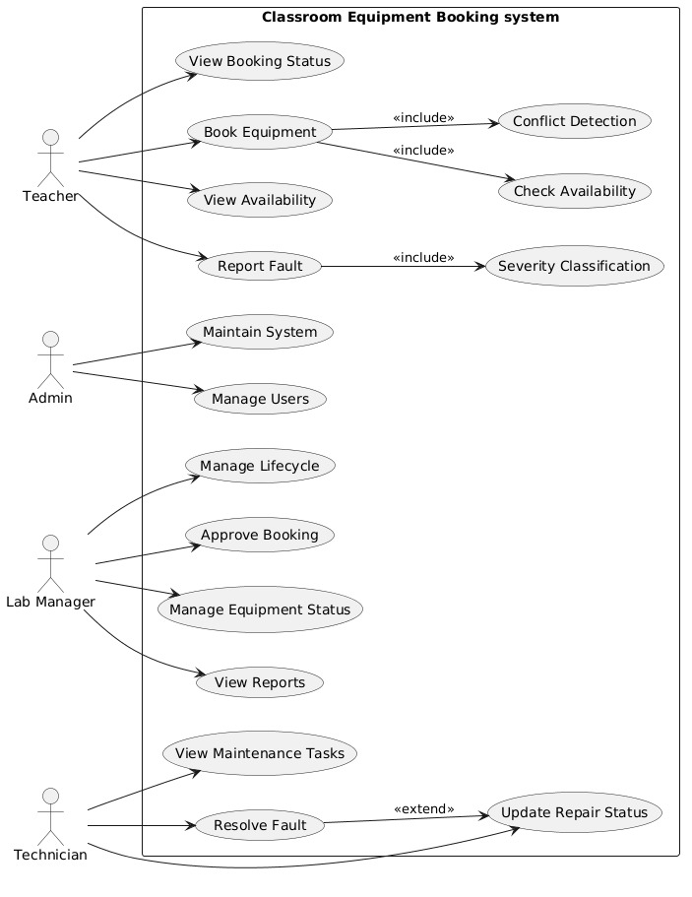

3.2 Fully Dressed Use Case Specifications

Use case 1: Booking Equipments
Extended Use case
- Use Case Name: Booking Equipments
- Scope: Classroom Equipment Booking and fault tracking Management System
- Level: User-goal
- Primary Actor: Teacher
- Stakeholders and Interests:
1-Teacher: Teacher wants to easily search and book required equipment and quickly report faulty equipment to ensure smooth teaching activities.
2-Lab Manager: Lab Manager wants to efficiently manage equipment requests, approve or reject bookings, and ensure faulty equipment is assigned to technicians for timely repair.
3-Technician : Technician wants to receive fault reports and update repair status to ensure equipment is fixed and available for use.

- Preconditions
- Teacher is logged into the system.
- Teacher is registered in the system.
- Equipment data is available in the database.
- Teacher has permission to book equipment
- Success Guarantee (Post Conditions)
Equipment booking is recorded in the system.
Equipment status is updated to “Reserved”.
Teacher receives booking confirmation with equipment details.
Lab Manager is notified of new booking for approval

- Main Success Scenario (two-column format)
Actor Action | System Response
Teacher searches for desired equipment | System displays list of available equipment
Teacher selects equipment and submits booking request | System records the booking request in the database
 | System updates equipment status to “Reserved”
 | System shows confirmation message with equipment details to the teacher
 | System notifies Lab Manager for approval

- Extensions
- If the selected equipment is already booked, then the system displays “Equipment already booked”.
- If the teacher enters invalid input, then the system displays an error message.
- If the system fails to update the database, then the system shows an error message.
- If the session expires, then the system redirects the teacher to the login page.

- Special Requirements
- System must respond within 2 seconds.
- Teacher must have valid login credentials to book equipment.
- Only authorized teachers can book equipment
- Technology and Data Variations List
- System should support desktop and mobile browsers.
- Equipment data may include text, images, or PDF manuals.
- Database may contain hundreds of equipment records

- Frequency of Occurrence
Low
Teachers may book equipment 2–3 times per week for classroom use.

- Miscellaneous
- Booking confirmation should be logged for auditing purposes.
- System should prevent double booking of the same equipment at the same time.
- Lab Manager should be able to approve or reject bookings based on equipment availability.

Use case 2: Report Faulty Equipments
Extended Use case
- Use case Id: 4
- Use Case Name: Report Faulty Equipments
- Scope: Classroom Equipment Booking and fault tracking Management System
- Level: User-goal
- Primary Actor: Teacher
- Stakeholders and Interests:
1-Teacher: Teacher wants to easily search and book required equipment and quickly report faulty equipment to ensure smooth teaching activities.
2-Lab Manager: Lab Manager wants to efficiently manage equipment requests, approve or reject bookings, and ensure faulty equipment is assigned to technicians for timely repair.
3-Technician : Technician wants to receive fault reports and update repair status to ensure equipment is fixed and available for use.
- Preconditions
- Teacher is logged into the system.
- Teacher is registered in the system.
- Equipment data is available in the database.
- Teacher has permission to report faulty equipment
- Success Guarantee (Post Conditions)
1-Fault report is recorded in the system database.
2-Equipment is marked as faulty in the system.
3-Teacher receives a confirmation message for the reported fault.
4-Lab Technician is notified about the faulty equipment

- Main Success Scenario (two-column format)

Actor Action | System Response
Teacher searches and selects the faulty equipment | System displays equipment details
Teacher submits a fault report | System records the fault report in the database
 | System marks the equipment status as “Faulty”
 | System shows a confirmation message to the teacher
 | System notifies Lab Technician for further action

- Extensions
- If the teacher submits a report without selecting equipment, then the system displays “Please select equipment to report”.
- If the system fails to save the fault report, then an error message is displayed.
- If the teacher enters invalid details (e.g., description too short), then the system prompts for valid input.
- If the session expires, then the teacher is redirected to the login page

- Special Requirements

1-System must respond within 2 seconds.
2-Teacher must have valid login credentials to report faulty equipment.
3-Only authorized teachers can submit fault reports

- Technology and Data Variations List
1-System should support desktop and mobile browsers.
2-Fault report may include text description, images, or documents (PDF).
3- Database may contain hundreds of equipment records

- Frequency of Occurrence
1-Teachers may report faulty equipment 1–2 times per month.
2- Lab Technician may receive multiple reports per week

- Miscellaneous
1-All fault reports should be logged for auditing purposes.
2-System should allow Lab Technician to update repair status once completed.
- Faulty equipment should be blocked from booking until repaired

UC03: Approves or Rejects Booking

Use Case ID: UC01

Use Case Name: Approve or Reject Booking

Scope: Classroom Equipment Booking and Fault Tracking System

Level: User Goal

Primary Actor: Lab Manager

Stakeholders and Interests:
- The Lab Manager wants the system to ensure conflict-free scheduling and efficient resource allocation.
- The Teacher wants the system to provide quick approval so that they can plan their classes effectively.
- The Students want the system to ensure uninterrupted classes with the required equipment available.
- The Administration wants the system to optimize resource utilization and reduce wastage.
- The IT Department wants the system to maintain reliability, security, and proper activity logging.

Preconditions:
- The Teacher has submitted a booking request in the system.
- The Lab Manager has successfully authenticated into the system.
- The system has stored the equipment information in the database.

Success Guarantee (Post Conditions):
- The Lab Manager has approved or rejected the booking request.
- The system has updated the booking status in the schedule.
- The system has sent a notification to the Teacher.
- The system has stored the decision in the activity logs.

Main Success Scenario
User Action | System Action
The Lab Manager logs into the system. | The system authenticates the Lab Manager credentials.
The Lab Manager opens the booking requests page. | The system retrieves and displays all pending booking requests.
The Lab Manager filters or searches the booking requests. | The system displays the filtered list of booking requests.
The Lab Manager selects a specific booking request. | The system displays detailed booking information.
The Lab Manager checks equipment availability. | The system performs conflict detection on the selected time slot.
The Lab Manager approves or rejects the booking request. | The system updates the booking status accordingly.
 | The system updates the equipment schedule.
 | The system sends a notification to the Teacher.
 | The system records the action in the system logs.

Extensions:
- If the system detects a time slot conflict, the system blocks the approval action.
- If the equipment is marked as faulty, the system prevents the booking from being approved.
- If the system detects a duplicate booking request, the system displays a warning message.
- If a network failure occurs during the process, the system does not save the action.
- If an unauthorized user attempts access, the system denies the operation.

Special Requirements:
- The system must respond within 2 seconds for booking operations.
- The system must perform real-time conflict detection.
- The system should be responsive 24/7.
- The system must maintain secure authentication and logging mechanisms.

Technology and Data Variations List:
- The system uses a web-based user interface for interaction.
- The system stores booking data in a relational database.
- The system sends notifications through email or in-system alerts.

Frequency of Occurrence:
- The Lab Manager performs this use case multiple times daily.

Open Issues:
- The system may need to support automatic approval for certain bookings.
- The system may need to introduce priority-based booking features.
- The system may need to handle emergency booking scenarios.
- The system may need integration with the institutional timetable system.
- The system may need to decide between email and SMS notifications.

UC04: Mark Fault as Resolved
Use Case ID: UC03
Use Case Name: Mark Fault as Resolved
Scope: Classroom Equipment Booking and Fault Tracking System
Level: User Goal
Primary Actor: Technician
Stakeholders and Interests:
- The Technician wants to close completed tasks.
- The Lab Manager wants equipment to be available again.
- The Teacher wants equipment ready for use.
- The Administration wants reduced downtime.
Preconditions:
- The Technician has completed the repair.
- The Technician is logged into the system.
Success Guarantee (Post Conditions):
- Fault is marked as resolved.
- Equipment status is updated to available.
- The system records the completion.

Main Success Scenario
User Action | System Action
The Technician selects a completed task. | The system displays task details.
The Technician clicks "Mark as Resolved". | The system verifies task completion.
The Technician confirms the action. | The system updates fault status.
 | The system updates equipment availability.
 | The system logs the action.

Extensions:
- If task is incomplete, system blocks resolution.
- If system error occurs, action is not saved.
- If unauthorized access, system denies action.
Special Requirements:
- Confirmation prompt must be shown.
- Data must be saved securely.
Technology and Data Variations List:
- Button-based UI action.
- Database update for fault and equipment.
Frequency of Occurrence:
Occasional (after repairs).
Open Issues:
- Verification mechanism not defined.
- Notification to teacher not specified.

UC05: View Fault Details
Use Case ID: UC04
Use Case Name: View Fault Details
Scope: Classroom Equipment Booking and Fault Tracking System
Level: Sub-function
Primary Actor: Technician
Stakeholders and Interests:
- The Technician wants complete fault information before repair.
- The Lab Manager wants accurate diagnosis.
Preconditions:
- Fault has been reported.
- Technician is logged in.
Success Guarantee (Post Conditions):
Fault details are displayed correctly.
Main Success Scenario
User Action | System Action
The Technician selects a fault report. | The system retrieves fault data.
The Technician opens fault details. | The system displays severity, description, and date.

Extensions:
- If fault not found, system shows error.
- If system fails, data not loaded.
Special Requirements:
Information must be clearly displayed.
Technology and Data Variations List:
Detail view interface.
Frequency of Occurrence:
Frequently before repair.
Open Issues: Image/file attachment support is not defined.

UC06:Monitors Equipment Availability

Use Case ID: UC02

Use Case Name: Monitor Equipment Availability

Scope: Classroom Equipment Booking System

Level: User Goal

Primary Actor: Lab Manager

Stakeholders and Interests:
- The Lab Manager wants the system to provide real-time visibility of equipment status.
- The Teacher wants the system to show accurate availability information.
- The Students want the system to ensure that equipment is ready for use.
- The Administration wants the system to track equipment utilization.
- The IT Department wants the system to perform efficiently.

Preconditions:
- The system has registered equipment in the database.
- The Lab Manager has logged into the system.

Success Guarantee:
- The system displays the current availability status of all equipment.

Main Success Scenario
User Action | System Action
The Lab Manager logs into the system. | The system authenticates the Lab Manager.
The Lab Manager opens the dashboard. | The system retrieves equipment data.
The Lab Manager applies filters such as type or date. | The system filters the equipment list accordingly.
The Lab Manager views equipment availability. | The system displays status such as Available, Booked, or Faulty.
The Lab Manager refreshes the dashboard. | The system updates and displays real-time data.

Extensions:
- If the system fails to load data, the system displays an error message.
- If the server response is delayed, the system shows a loading indicator.
- If the user applies an invalid filter, the system prompts for correction.
- If equipment data is missing, the system flags an inconsistency.
- If unauthorized access occurs, the system denies access.

Special Requirements:
- The system must provide real-time updates.
- The system must ensure fast dashboard rendering.
- The system must provide a user-friendly interface.
- The system should be responsive 24/7.

Technology and Data Variations List:
- The system categorizes equipment status into predefined types.
- The system supports filtering and searching mechanisms.

Frequency of Occurrence:
- The Lab Manager performs this action frequently during daily operations.

Open Issues:
- The system may need to support mobile-friendly dashboards.
- The system may need advanced filtering options.
- The system may need an auto-refresh feature.
- The system may need integration with booking modules.
- The system may need graphical dashboards.

UC07: Updates Equipment Status

Use Case ID: UC03

Use Case Name: Update Equipment Status

Scope: Classroom Equipment Booking and Fault Tracking System

Level: User Goal

Primary Actor: Lab Manager

Stakeholders and Interests:
- The Lab Manager wants the system to maintain accurate and up-to-date equipment status.
- The Technician wants the system to reflect the correct repair status of equipment.
- The Teacher wants the system to ensure that only functional equipment is available for booking.
- The Administration wants the system to track equipment lifecycle and condition.
- The IT Department wants the system to maintain data consistency and integrity.

Preconditions:
- The system has registered the equipment in the database.
- The Lab Manager has successfully authenticated into the system.
- The system has stored the current status of the equipment.

Success Guarantee:
- The Lab Manager has updated the equipment status successfully.
- The system has stored the updated status in the database.
- The system has reflected the updated status across all modules.
- The system has recorded the update action in the logs.

Main Success Scenario
User Action | System Action
The Lab Manager logs into the system. | The system authenticates the Lab Manager.
The Lab Manager selects an equipment item. | The system retrieves equipment details.
The Lab Manager reviews the current status. | The system displays the current status.
The Lab Manager selects a new status. | The system validates the selected status.
The Lab Manager confirms the update. | The system saves the updated status.
 | The system updates the status across all modules.
 | The system logs the update action.

Extensions:
- If the system detects an invalid status, the system displays an error.
- If the system cannot find the equipment, the system shows an alert.
- If concurrent updates occur, the system shows a conflict warning.
- If the system fails, the system rolls back the changes.
- If an unauthorized user attempts access, the system denies the action.

Special Requirements:
- The system must enforce strict data validation rules.
- The system must maintain audit logs.
- The system must ensure data consistency across modules.
- The system should be responsive every time.

Open Issues:
- The system may need to allow multiple roles to update status.
- The system may need approval workflows for status changes.
- The system may need automatic updates from technicians.
- The system may need to maintain status history.
- The system may need to notify users about status changes.

UC08:Views Reports and Analytics

Use Case ID: UC04

Use Case Name: View Reports and Analytics

Scope: Classroom Equipment Booking and Fault Tracking System

Level: User Goal

Primary Actor: Lab Manager

Stakeholders and Interests:
- The Lab Manager wants the system to provide meaningful insights for decision-making.
- The Administration wants the system to generate reports for performance evaluation and planning.
- The IT Department wants the system to ensure report accuracy and data integrity.
- The Finance Department wants the system to analyze cost efficiency and maintenance expenses.
- The Auditors want the system to maintain historical records for auditing purposes.

Preconditions:
- The system has stored sufficient operational data.
- The Lab Manager has successfully logged into the system.
- The reporting module is available and functional.

Success Guarantee :
- The system has generated the requested report successfully.
- The system has displayed the report in a readable format.
- The system has optionally exported the report if requested.
- The system has logged the report generation activity.

Main Success Scenario
User Action | System Action
The Lab Manager logs into the system. | The system authenticates the Lab Manager credentials.
The Lab Manager navigates to the reports section. | The system loads available report options.
The Lab Manager selects a report type. | The system retrieves relevant data from the database.
The Lab Manager applies filters such as date or category. | The system processes the selected filters.
The Lab Manager requests report generation. | The system generates the report based on selected criteria.
The Lab Manager views the generated report. | The system displays the report using charts and tables.
The Lab Manager chooses to export the report. | The system generates a downloadable file (PDF/Excel).
 | The system logs the report generation activity.

Extensions:
- If the system finds no data for the selected filters, the system displays an empty report.
- If the dataset is too large, the system displays a delay message.
- If report generation fails, the system prompts the user to retry.
- If the user enters invalid filters, the system asks for correction.
- If a system error occurs, the system displays an error message.

Special Requirements:
- The system must support graphical visualization such as charts and graphs.
- The system must provide export options such as PDF and Excel formats.
- The system must generate reports efficiently within acceptable response time.
- The system should be responsive 24/7.

Technology and Data Variations List:
- The system uses a database to retrieve historical and real-time data.
- The system supports multiple report types such as usage reports and fault reports.
- The system provides export functionality in different file formats.

Frequency of Occurrence:
- The Lab Manager performs this use case weekly or monthly.

Open Issues:
- The system may need to support real-time analytics.
- The system may need to allow custom report creation.
- The system may need additional export formats.
- The system may need a defined data retention policy.
- The system may need integration with external reporting tools.

UC09: Assigns Maintenance Tasks

Use Case ID: UC05

Use Case Name: Assign Maintenance Tasks

Scope: Classroom Equipment Booking and Fault Tracking System

Level: User Goal

Primary Actor: Lab Manager

Stakeholders and Interests:
- The Lab Manager wants the system to ensure timely and efficient fault resolution.
- The Technician wants the system to provide clear and prioritized task assignments.
- The Teacher wants the system to ensure quick repair of faulty equipment.
- The Students want the system to ensure availability of functional equipment.
- The Administration wants the system to minimize equipment downtime.

Preconditions:
- The system has recorded a fault in the system.
- The Lab Manager has successfully logged into the system.
- The system has registered technicians in the database.

Success Guarantee:
- The system has assigned the maintenance task to a technician.
- The system has set the task priority based on severity.
- The system has notified the assigned technician.
- The system has recorded the assignment in logs.

Main Success Scenario
User Action | System Action
The Lab Manager logs into the system. | The system authenticates the Lab Manager credentials.
The Lab Manager navigates to the fault management section. | The system retrieves and displays all reported faults.
The Lab Manager sorts faults based on severity. | The system organizes faults according to priority levels.
The Lab Manager selects a fault. | The system displays detailed fault information.
The Lab Manager selects a technician. | The system verifies technician availability.
The Lab Manager assigns the maintenance task. | The system creates a maintenance task entry.
 | The system assigns priority based on fault severity.
 | The system notifies the technician.
 | The system logs the task assignment.

Extensions:
- If no technician is available, the system displays a warning message.
- If the fault has high severity, the system automatically assigns high priority.
- If a duplicate assignment is attempted, the system prevents duplication.
- If the system fails during assignment, the system does not save the task.
- If the selected technician is overloaded, the system suggests another technician.

Special Requirements:
- The system must support priority-based task scheduling.
- The system should be responsive 24/7.
- The system must provide real-time notification to technicians.
- The system must track maintenance tasks effectively.

Technology and Data Variations List:
- The system stores fault and task data in a centralized database.
- The system categorizes faults into severity levels such as Low, Medium, and High.
- The system uses notification services such as email or system alerts.

Frequency of Occurrence:
- The Lab Manager performs this use case regularly depending on fault occurrences.

Open Issues:
- The system may need to support automatic task assignment.
- The system may need workload balancing among technicians.
- The system may need escalation rules for unresolved tasks.
- The system may need defined service-level agreements (SLAs).
- The system may need integration with maintenance history logs.

UC10: View Assigned Maintenance Tasks
Use Case ID: UC01
Use Case Name: View Assigned Maintenance Tasks
Scope: Classroom Equipment Booking and Fault Tracking System
Level: User Goal
Primary Actor: Technician
Stakeholders and Interests:
- The Technician wants to view all assigned maintenance tasks clearly to manage workload.
- The Lab Manager wants technicians to complete tasks on time.
- The Teacher wants faulty equipment to be repaired quickly.
- The Administration wants efficient maintenance and reduced downtime.
- The IT Department wants smooth system performance and accurate data retrieval.
Preconditions:
- The Technician has a valid account in the system.
- The Technician has successfully logged into the system.
- Faults have been reported and assigned to the Technician.
Success Guarantee (Post Conditions):
- The Technician can view all assigned maintenance tasks.
- The system displays task details including equipment name, severity, and status.
- No data is altered during this process.

Main Success Scenario
User Action | System Action
The Technician logs into the system. | The system authenticates the Technician credentials.
The Technician navigates to the maintenance dashboard. | The system retrieves assigned tasks from the database.
The Technician selects "View Tasks". | The system displays a list of assigned tasks.
The Technician views task details. | The system shows equipment name, fault severity, and status.

Extensions:
- If login credentials are incorrect, the system denies access.
- If no tasks are assigned, the system displays a "No Tasks Available" message.
- If a network issue occurs, the system fails to load tasks.
- If unauthorized access is attempted, the system blocks access.
Special Requirements:
- The system must respond within 2 seconds.
- The interface should be user-friendly and easy to navigate.
- The system must ensure secure authentication.
Technology and Data Variations List:
- Web-based dashboard interface.
- Data stored in a centralized database.
Frequency of Occurrence:
Performed multiple times daily.
Open Issues:
- Task prioritization visualization not defined.
- Filtering and sorting options may be needed.

UC11:Update Repair Status
Use Case ID: UC02
Use Case Name: Update Repair Status
Scope: Classroom Equipment Booking and Fault Tracking System
Level: User Goal
Primary Actor: Technician
Stakeholders and Interests:
- The Technician wants to update repair progress easily.
- The Lab Manager wants real-time updates on maintenance.
- The Administration wants accurate maintenance records.
- The IT Department wants data consistency and integrity.
Preconditions:
- The Technician is logged into the system.
- A maintenance task is assigned to the Technician.
Success Guarantee (Post Conditions):
- The repair status is successfully updated.
- The system stores updated status in the database.
- The system reflects changes in real-time.

Main Success Scenario
User Action | System Action
The Technician opens the task list. | The system displays assigned tasks.
The Technician selects a task. | The system shows task details.
The Technician selects a new status (Pending/In Progress/Completed). | The system validates the status.
The Technician confirms the update. | The system updates the status in the database.
 | The system reflects the updated status on dashboard.

Extensions:
- If invalid status is selected, the system shows an error.
- If database error occurs, the system does not save changes.
- If network failure occurs, update is not completed.
Special Requirements:
- Status update must be real-time.
- Only valid status transitions should be allowed.
Technology and Data Variations List:
- Dropdown menu for status selection.
- Database update through backend system.
Frequency of Occurrence:
Frequently during maintenance tasks.
Open Issues:
- Automatic notifications after update not defined.
- Audit logs for changes may be required.

3.3 Activity Diagram Description — Equipment Booking Process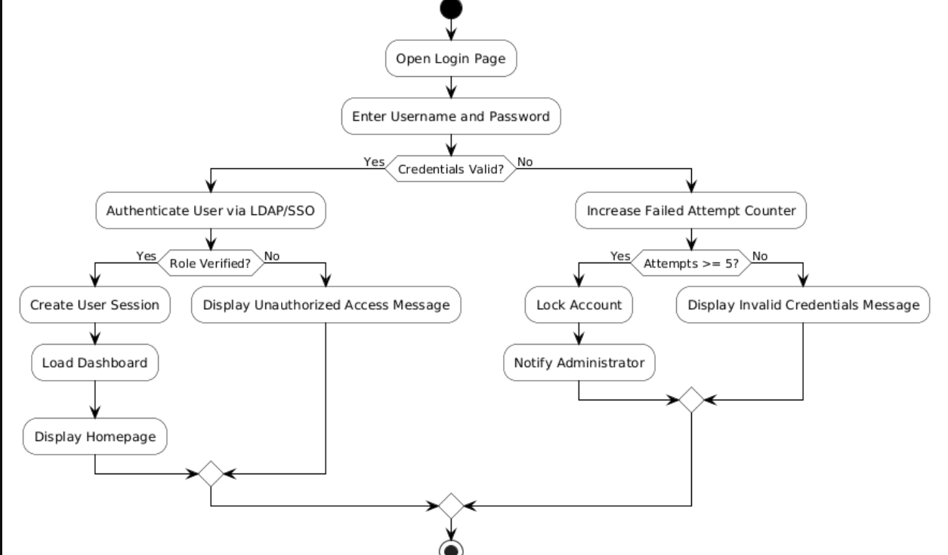

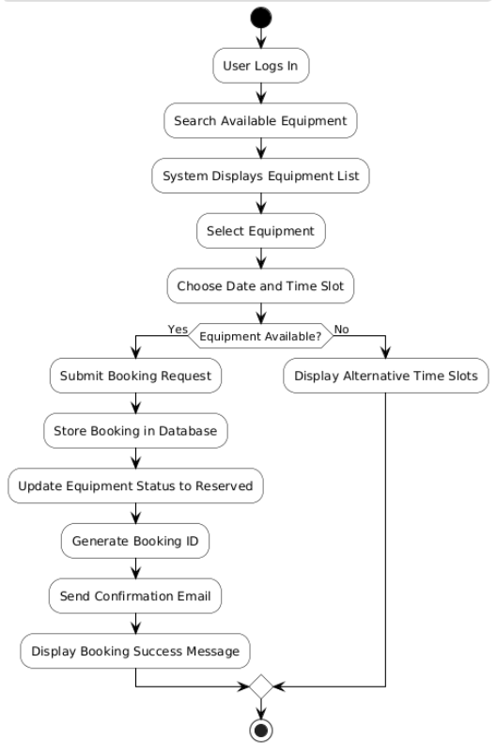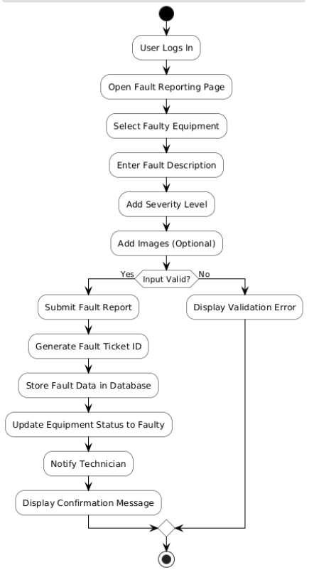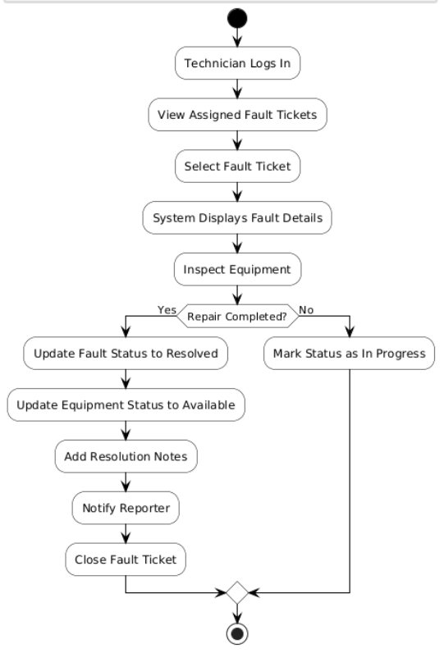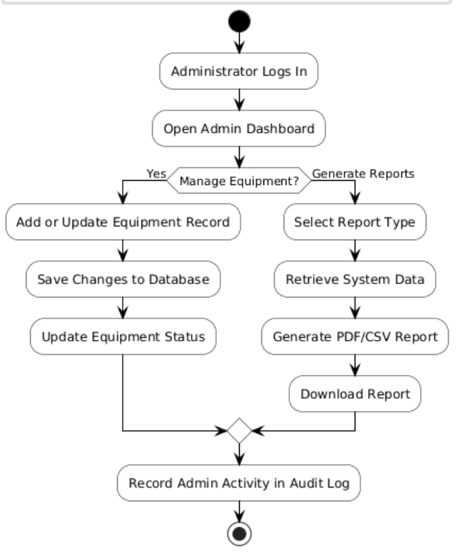

3.4 Class Diagram 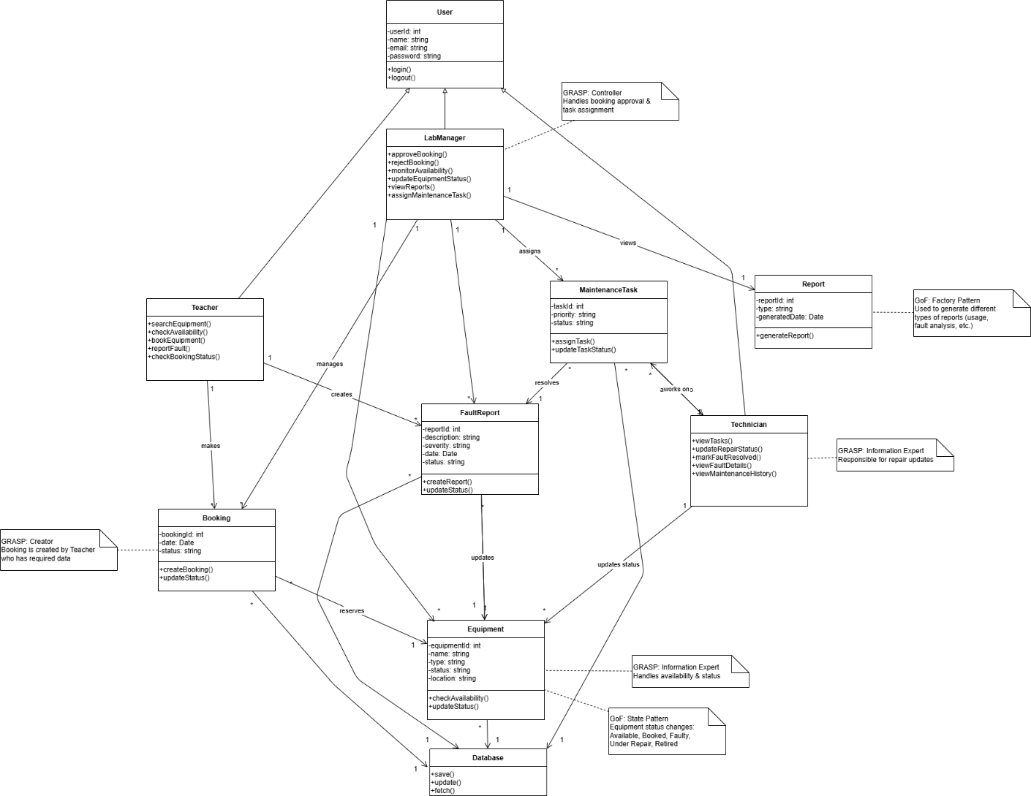3.5 State Machine Diagram for Fault Lifecycle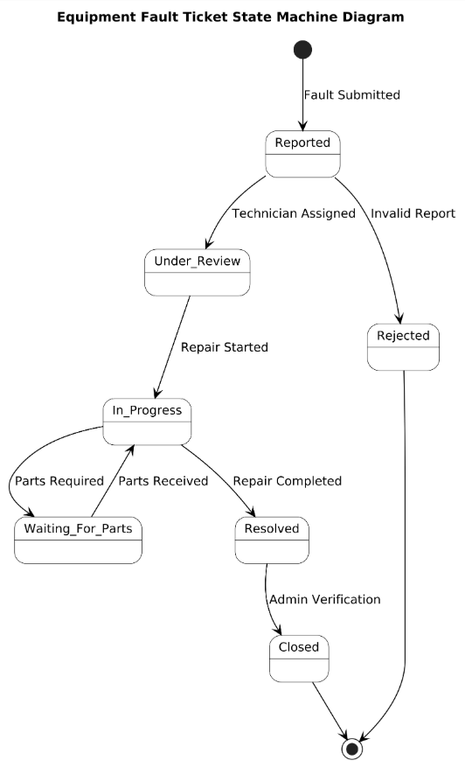

3.6 System Sequence Diagram Use case 1: Booking Equipments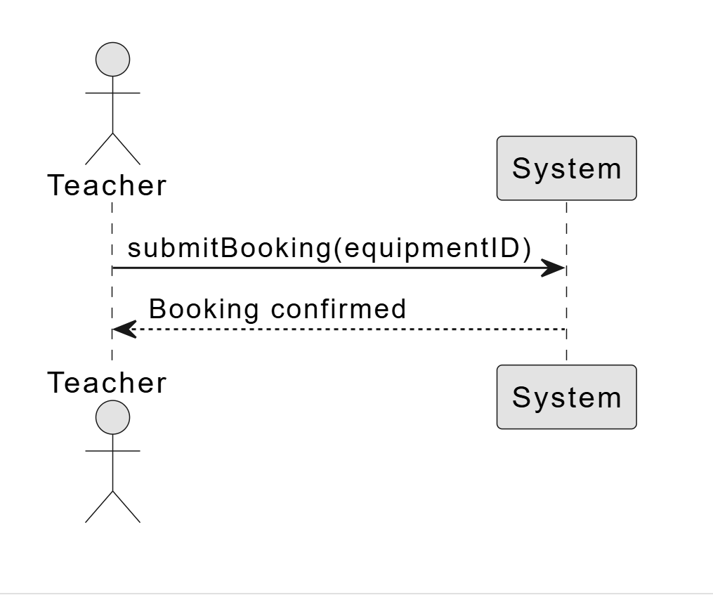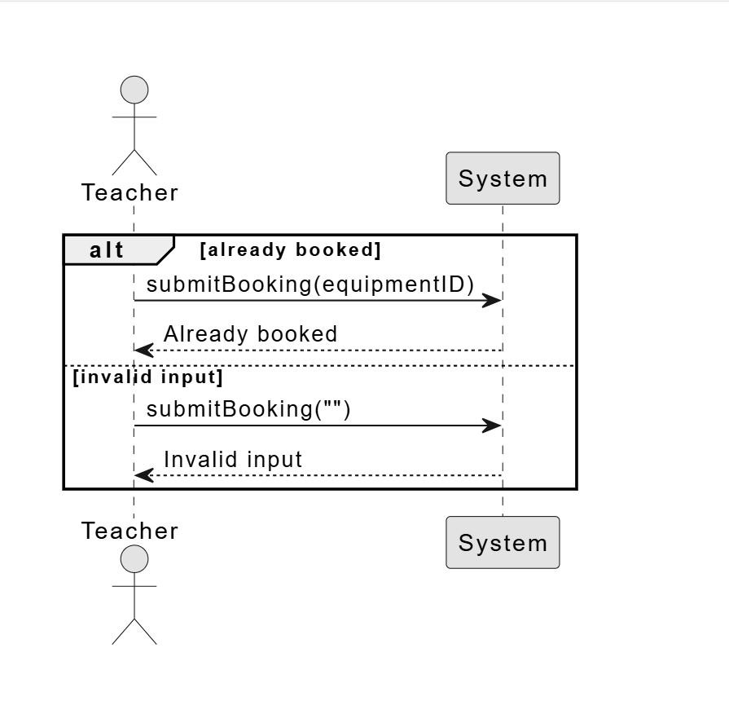

Use case 2: Report Faulty Equipments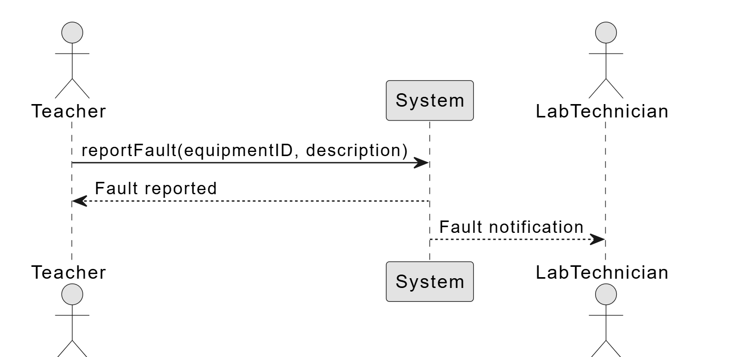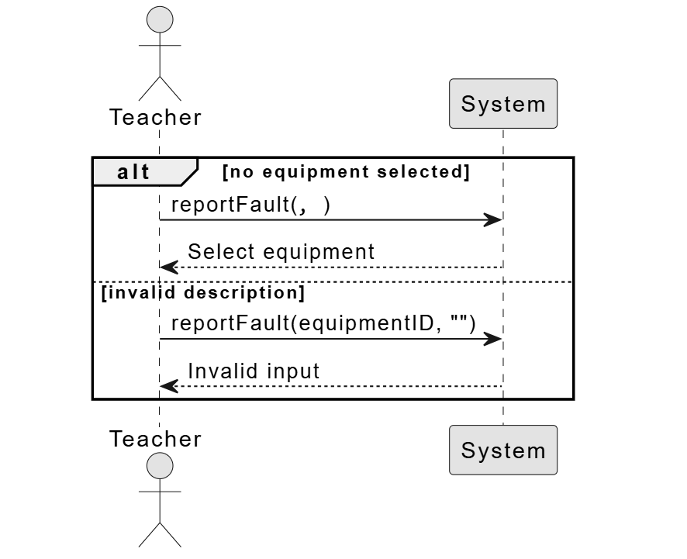

UC03: Approves or Rejects Booking 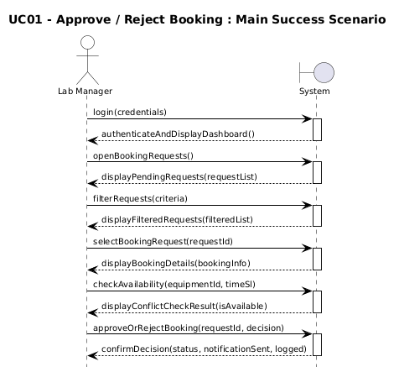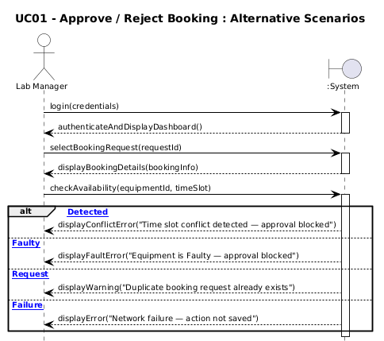

UC04: Mark Fault as Resolved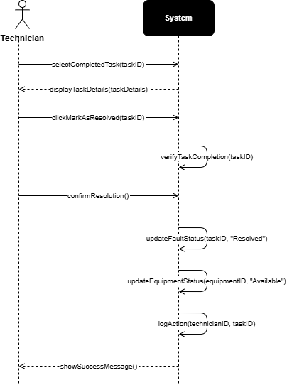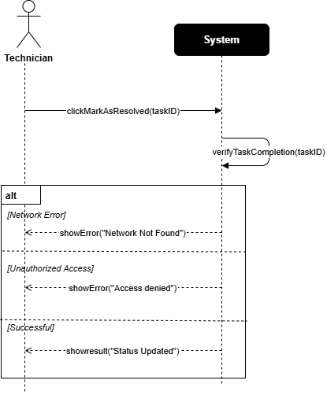
UC05: View Fault Details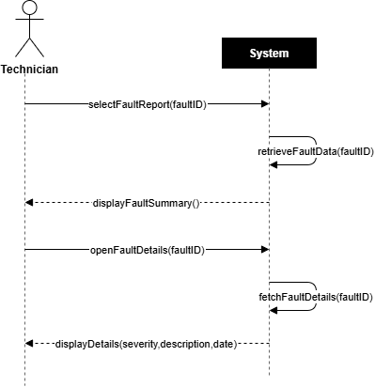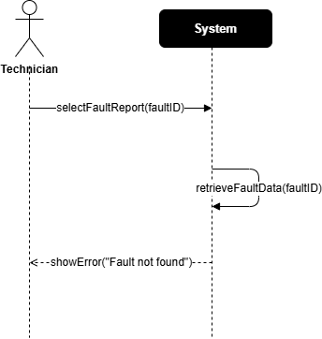

UC06:Monitors Equipment Availability 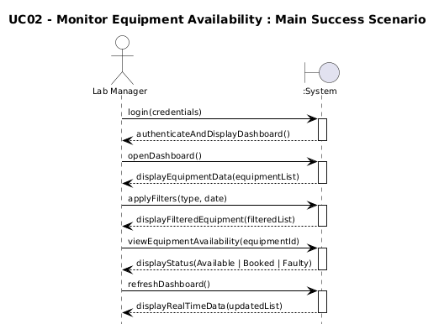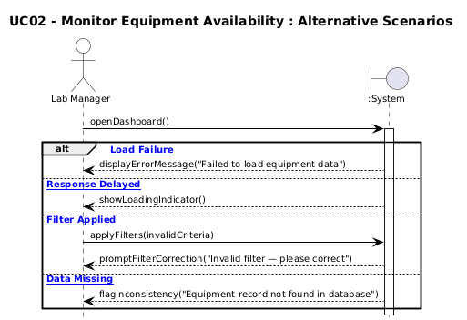

UC07: Updates Equipment Status 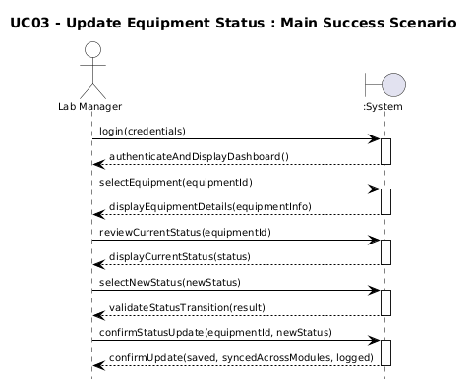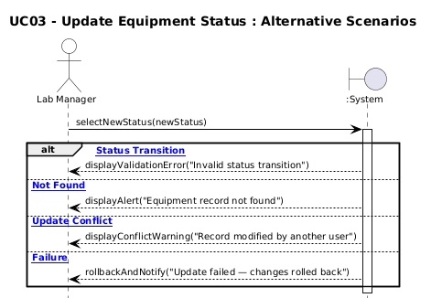

UC08:Views Reports and Analytics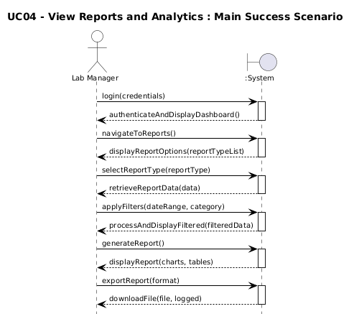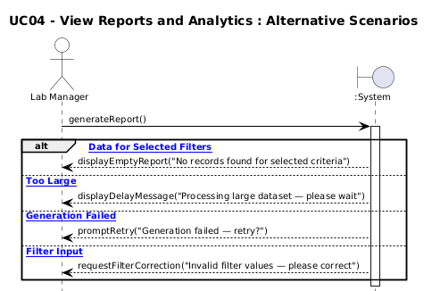
UC09: Assigns Maintenance Tasks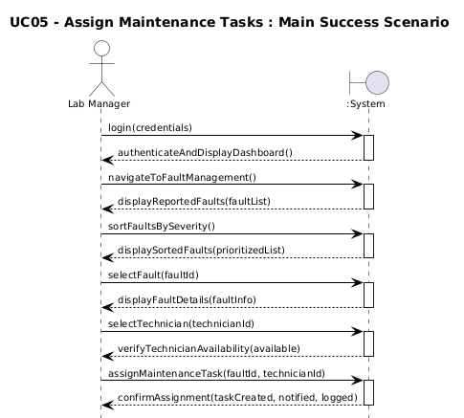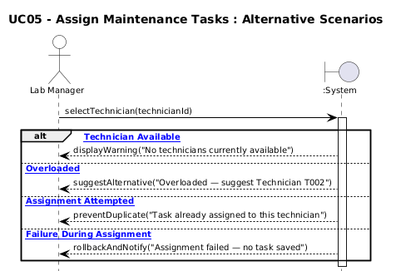
UC10: View Assigned Maintenance Tasks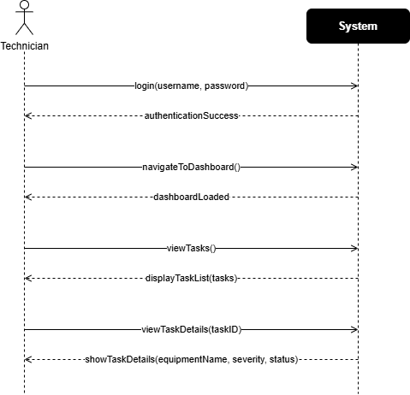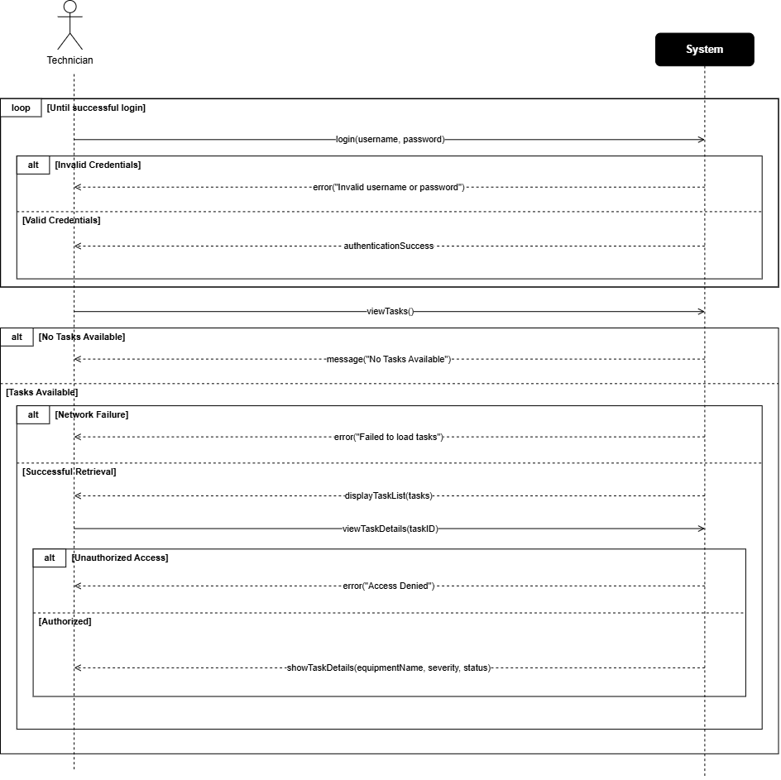
UC11:Update Repair Status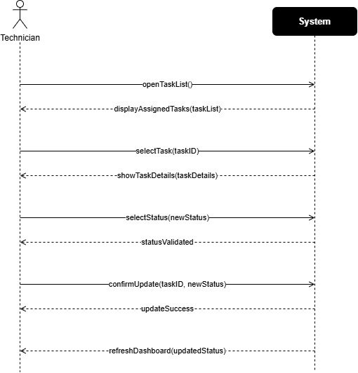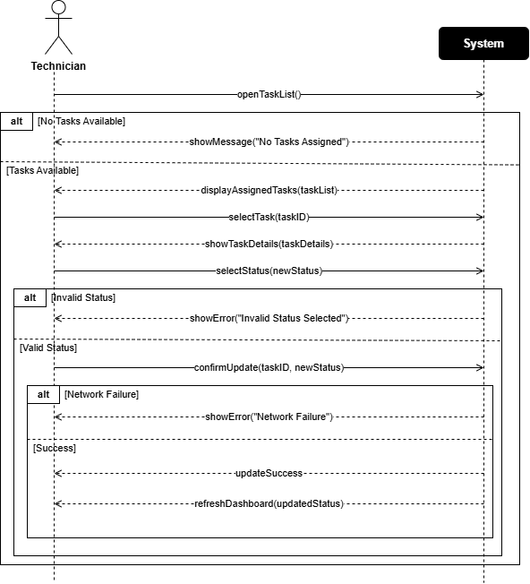

3.7 NL Pitfall Review
All requirements were reviewed against the following Natural Language pitfalls. No requirement in this SRS contains any of the following:
- Passive voice without a clear subject (e.g., replaced 'emails shall be sent' with 'the system shall send emails')
- Universal quantifiers without scope (e.g., 'all users' → replaced with specific roles)
- Unspecific nouns (e.g., 'system information' → specified as 'booking confirmation email containing Booking ID, equipment details, room, and time')
- Incomplete conditions (e.g., 'if available' → replaced with explicit availability check conditions)
- Vague temporal terms (e.g., 'soon' → replaced with '5 minutes', '2 minutes', '30 minutes')
- Ambiguous pronouns (each requirement uses explicit subjects: 'the system', 'the user', 'the technician')

3.8 Context Diagram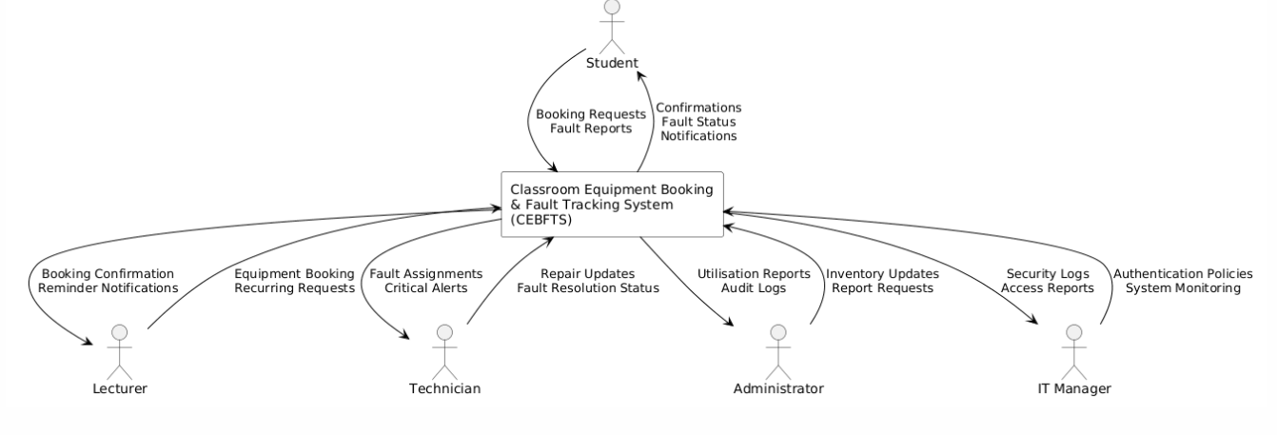

3.9 DFD- Diagram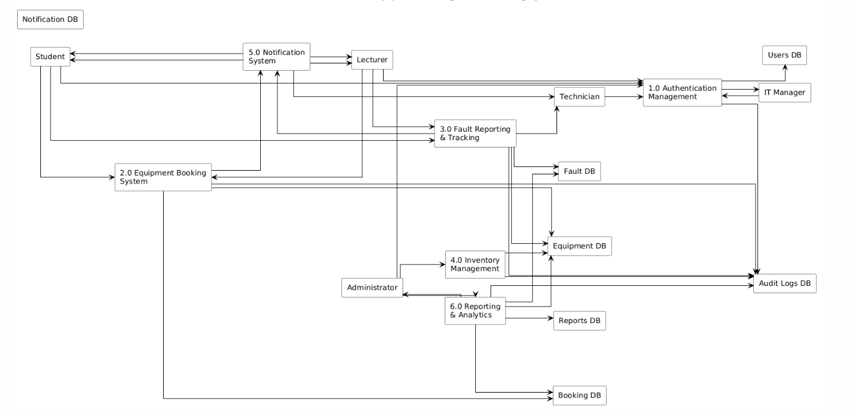

Milestone 4 — Cross-Group Validation & Negotiation

4.1 Validation Checklist
This checklist was applied in Guideline-Based Review mode against the audited group's M1–M3 artifacts. Each requirement was evaluated on four dimensions:
Criterion | Guideline Question | Method | Result
Correctness | Does the requirement accurately reflect stakeholder needs? Is it technically feasible? Is it free from factual errors? | Interview comparison | All 49 FRs: PASS
Consistency | Does the requirement contradict any other requirement? Are terms used uniformly across all requirements? | Cross-reference matrix | 2 conflicts found (see §4.3)
Verifiability | Can a test be designed to verify the requirement? Does it have measurable acceptance criteria? | Test case derivation | 3 requirements flagged (see §4.4)
Necessity | Is the requirement essential for the system's purpose? Would removing it leave a functional gap? | MoSCoW classification check | 1 requirement removed as duplicate

4.2 Validation Execution — Perspective-Based Reading
Each team member adopted a distinct stakeholder perspective during the review:
- Reviewer 1 (Student perspective): checked that all booking flows are complete and that error messages are user-friendly.
- Reviewer 2 (Technician perspective): verified that fault reporting requirements contain sufficient technical detail for implementation.
- Reviewer 3 (Admin perspective): validated that all reporting and inventory management requirements were present and unambiguous.
- Reviewer 4 (IT Manager perspective): audited security, performance, and integration requirements for completeness.

4.3 Identified Conflicts

Conflict C-01: Booking Cancellation Window vs. Reminder Notification Timing
FR-005 states users may cancel a booking at least 2 hours before the scheduled time. FR-012 sends a reminder 30 minutes before. If a user cancels within the 30-minute reminder window the reminder has already been sent for an invalid booking. These two requirements are inconsistent.

Conflict C-02: Concurrent Booking Limit vs. Recurring Bookings
FR-008 limits a user to 3 active bookings simultaneously. FR-007 allows lecturers to create recurring weekly bookings for a full semester (up to 16 weeks), which would generate 16 booking records and violate the FR-008 limit.

4.4 Verifiability Issues Flagged
- FR-008 originally stated 'a reasonable number of bookings'. Revised to 'no more than 3 active bookings' (measurable).
- NFR-008 originally stated 'the system shall be user-friendly'. Revised to 'achieve a SUS score of at least 75' (testable).
- FR-044 originally stated 'equipment out of service for too long'. Revised to 'more than 5 consecutive working days' (measurable).

4.5 Conflict Resolution — Decision Matrix

Resolution of C-01 (Booking Cancellation vs. Reminder)
Option | User Impact (1-5) | Impl. Cost (1-5) | Consistency (1-5) | Score
Change cancellation window to 1 hour | 3 | 2 | 4 | 9
Change reminder to 1 hour before (selected) | 4 | 3 | 5 | 12
Remove reminder feature | 1 | 5 | 5 | 11
Resolution: FR-012 is revised — reminder shall be sent 1 hour (not 30 minutes) before the scheduled start. FR-005 cancellation window remains 2 hours. The conflict is eliminated.

Resolution of C-02 (Booking Limit vs. Recurring Bookings)
Option | Fairness (1-5) | Complexity (1-5) | Stakeholder Acceptance (1-5) | Score
Exempt recurring bookings from the 3-booking limit for Lecturers (selected) | 4 | 3 | 5 | 12
Increase limit to 20 for all users | 2 | 5 | 2 | 9
Remove recurring booking feature | 1 | 5 | 1 | 7
Resolution: FR-008 is revised — the 3-booking limit applies to Students. Lecturers are exempt from the simultaneous limit for recurring bookings created via the semester-schedule feature.

4.6 Peer Validation Report Received
The following issues were raised by the peer auditor group during their review of our M1–M3 artifacts:
- Verifiability Issue: FR-009 ('the system shall display a booking history list') does not specify how many records are shown. Resolution: clarified to 'shall display the most recent 50 bookings by default with pagination'.
- Consistency Issue: FR-031 references LDAP while FR-035 references internal password rules — contradictory for an SSO system. Resolution: FR-035 scoped to internal/fallback accounts only; SSO users bypass local password rules.
- Necessity Issue: FR-014 (printable PDF receipt) was flagged as low priority and potentially redundant with confirmation email. Retained as Low priority based on lecturer stakeholder request.
All peer-raised issues have been reviewed, accepted, and incorporated into the revised requirements in this document.

Milestone 5 — Requirements Management

5.1 Requirements Attributes
Each requirement carries the following management attributes:
ID | Unique identifier (e.g., FR-001, NFR-001)
Title | Short descriptive label
Statement | Full ISO/IEC 29148 phrase template statement
Priority | High / Medium / Low (Wiegers scale)
Status | Proposed / Approved / Implemented / Verified / Deferred
Source | Stakeholder group(s) that originated the requirement
Version | Version number and change date
Rationale | Justification for inclusion
Test Ref | Associated test case ID
UC Ref | Associated use case ID

5.2 Wiegers Prioritisation Matrix
Priority scoring formula: Value % = [(Benefit × 2) + Penalty] / [(Cost + Risk) × Total] × 100
Scale: 1 (lowest) — 9 (highest). Higher Value % = higher priority.
Requirement | Benefit (1-9) | Penalty (1-9) | Cost (1-9) | Risk (1-9) | Value % | Priority
FR-002: Submit Booking Request | 9 | 8 | 3 | 2 | High (51%) | Critical
FR-003: Conflict Detection | 9 | 9 | 4 | 3 | High (49%) | Critical
FR-016: Submit Fault Report | 9 | 8 | 3 | 2 | High (51%) | Critical
FR-019: Critical Fault Notification | 9 | 9 | 2 | 2 | High (55%) | Critical
FR-004: Booking Confirmation Email | 8 | 7 | 2 | 1 | High (52%) | High
FR-031: SSO Authentication | 8 | 9 | 5 | 4 | High (40%) | High
FR-024: Fault Escalation (48h) | 8 | 8 | 3 | 3 | High (46%) | High
FR-041: Utilisation Dashboard | 7 | 6 | 4 | 3 | Medium (38%) | Medium
FR-007: Recurring Bookings | 6 | 5 | 5 | 4 | Medium (31%) | Medium
FR-014: PDF Booking Receipt | 3 | 2 | 3 | 2 | Low (20%) | Low
FR-011: Manual Booking Override | 4 | 3 | 4 | 2 | Low (23%) | Low
NFR-002: 99.5% Uptime | 9 | 9 | 6 | 5 | High (40%) | High
NFR-004: Password Encryption | 9 | 9 | 3 | 2 | High (52%) | Critical
NFR-008: SUS Score ≥ 75 | 7 | 5 | 5 | 3 | Medium (33%) | Medium

5.3 Requirements Versioning
Req ID | Version | Changed By | Change Description | Date
FR-008 | v1.0 → v1.1 | Peer Review (M4) | Added role-based exemption for Lecturer recurring bookings | May 2026
FR-012 | v1.0 → v1.1 | Internal Review (M4) | Changed reminder from 30 min to 1 hour | May 2026
FR-035 | v1.0 → v1.1 | Peer Review (M4) | Scoped to fallback accounts only | May 2026
FR-009 | v1.0 → v1.1 | Peer Review (M4) | Specified 50 records + pagination | May 2026
NFR-008 | v1.0 → v1.1 | Internal Review (M3) | Replaced 'user-friendly' with SUS score ≥ 75 | May 2026
NFR-001 | v1.0 | Elicitation (M1) | Initial version | April 2026

5.4 Traceability Matrix
The traceability matrix maps each requirement to its originating use case, implementing design component, verification test case, and current implementation status.
Req ID | Use Case | Design Component | Test Case | Status
FR-001 | UC-02 Search Equipment | EquipmentRepository.getAvailability() | TC-001 | Approved
FR-002 | UC-03 Create Booking | BookingService.createBooking() | TC-002 | Approved
FR-003 | UC-03 Create Booking | BookingService.checkConflict() | TC-003 | Approved
FR-004 | UC-03 Create Booking | NotificationService.sendConfirmation() | TC-004 | Approved
FR-005 | UC-04 Cancel Booking | BookingService.cancelBooking() | TC-005 | Approved
FR-016 | UC-06 Submit Fault Report | FaultTicketService.createTicket() | TC-006 | Approved
FR-017 | UC-06 / UC-07 Attach Evidence | FaultTicketService.attachPhoto() | TC-007 | Approved
FR-019 | UC-06 Submit Fault Report | NotificationService.sendCriticalAlert() | TC-008 | Approved
FR-020 | UC-08 Manage Fault Ticket | FaultTicketService.updateStatus() | TC-009 | Approved
FR-024 | UC-09 Escalate Fault | EscalationScheduler.run() | TC-010 | Approved
FR-031 | UC-01 Login | AuthService.ldapAuthenticate() | TC-011 | Approved
FR-041 | UC-11 Generate Reports | ReportService.generateUtilisation() | TC-012 | Approved
NFR-001 | All UCs | API Gateway / Load Balancer | TC-P01 | Approved
NFR-002 | All UCs | Infrastructure / Monitoring | TC-P02 | Approved
NFR-004 | UC-01 Login | AuthService.hashPassword() | TC-S01 | Approved
NFR-005 | All UCs | HTTPS/TLS Configuration | TC-S02 | Approved

5.5 Traceability Graph Description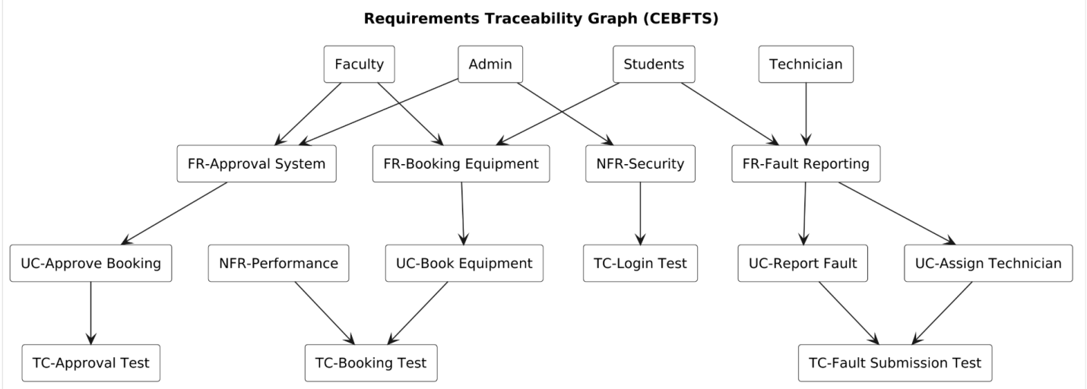

Milestone 6 — Effort Estimation (FPA & COCOMO)

6.1 Function Point Analysis (FPA)

6.1.1 Unadjusted Function Points (UFP)
Function points are counted across five component types using the IFPUG standard complexity weights.
Complexity Weights Reference Table:
Component Type | Simple | Average | Complex
External Input (EI) | 3 | 4 | 6
External Output (EO) | 4 | 5 | 7
External Inquiry (EQ) | 3 | 4 | 6
Internal Logical File (ILF) | 7 | 10 | 15
External Interface File (EIF) | 5 | 7 | 10
External Inputs (EI):
Component | Name | Type | Count | UFP
EI | Login / SSO Authentication | Simple | 1 | 3
EI | Create Booking Form | Average | 1 | 4
EI | Cancel Booking Request | Simple | 1 | 3
EI | Submit Fault Report Form | Average | 1 | 4
EI | Upload Fault Photos | Average | 1 | 4
EI | Update Fault Ticket Status | Simple | 1 | 3
EI | Add Equipment Record | Average | 1 | 4
EI | Update Equipment Status | Simple | 1 | 3
EI | Configure Notification Prefs | Simple | 1 | 3
EI | Update User Profile | Simple | 1 | 3
TOTAL UFP |  |  |  | 34
External Outputs (EO):
Component | Name | Type | Count | UFP
EO | Booking Confirmation Email | Average | 1 | 5
EO | Fault Resolution Email | Average | 1 | 5
EO | Booking Reminder Notification | Simple | 1 | 4
EO | Critical Fault Alert | Average | 1 | 5
EO | Escalation Alert Email | Simple | 1 | 4
EO | Monthly Utilisation Report PDF | Complex | 1 | 7
EO | Monthly Fault Frequency Report | Complex | 1 | 7
EO | PDF Booking Receipt | Average | 1 | 5
TOTAL UFP |  |  |  | 42
External Inquiries (EQ):
Component | Name | Type | Count | UFP
EQ | Search Available Equipment | Average | 1 | 4
EQ | View Booking History | Average | 1 | 4
EQ | View Fault Ticket Status | Simple | 1 | 3
EQ | View Equipment Inventory | Average | 1 | 4
EQ | View Audit Log | Complex | 1 | 6
EQ | View Utilisation Dashboard | Complex | 1 | 6
TOTAL UFP |  |  |  | 27
Internal Logical Files (ILF):
Component | Name | Type | Count | UFP
ILF | Users Table | Simple | 1 | 7
ILF | Equipment Table | Average | 1 | 10
ILF | Bookings Table | Average | 1 | 10
ILF | FaultTickets Table | Average | 1 | 10
ILF | FaultHistory Table | Simple | 1 | 7
ILF | Notifications Table | Simple | 1 | 7
ILF | Rooms Table | Simple | 1 | 7
ILF | AuditLog Table | Average | 1 | 10
TOTAL UFP |  |  |  | 68
External Interface Files (EIF):
Component | Name | Type | Count | UFP
EIF | FAST-NUCES Active Directory (LDAP) | Average | 1 | 7
EIF | SMTP Email Gateway | Simple | 1 | 5
EIF | Campus Calendar System | Average | 1 | 7
TOTAL UFP |  |  |  | 19

6.1.2 UFP Summary
Component Type | Count | UFP Contribution | Subtotal
External Inputs (EI) | 10 | 34 | 34
External Outputs (EO) | 8 | 42 | 42
External Inquiries (EQ) | 6 | 27 | 27
Internal Logical Files (ILF) | 8 | 68 | 68
External Interface Files (EIF) | 3 | 19 | 19
TOTAL UFP |  |  | 190

6.1.3 Value Adjustment Factor (VAF)
The VAF is calculated using 14 General System Characteristics (GSC), each rated 0 (no influence) to 5 (strong influence). VAF = 0.65 + (0.01 × TDI) where TDI = sum of all GSC ratings.
# | General System Characteristic | Rating (0-5) | Justification
1 | Data Communications | 4 | Web-based, LDAP, SMTP integrations
2 | Distributed Data Processing | 3 | Centralised DB with distributed clients
3 | Performance | 4 | 500 concurrent users, <2s response
4 | Heavily Used Configuration | 2 | Standard server infrastructure
5 | Transaction Rate | 3 | Moderate booking/fault transaction load
6 | Online Data Entry | 5 | All user interactions are online
7 | End-User Efficiency | 4 | SUS ≥ 75 usability requirement
8 | Online Update | 4 | Real-time availability and fault status
9 | Complex Processing | 2 | Conflict detection, escalation logic
10 | Reusability | 3 | Modular REST API design
11 | Installation Ease | 2 | Standard Ubuntu deployment
12 | Operational Ease | 3 | Admin dashboard for non-technical users
13 | Multiple Sites | 1 | Single campus deployment
14 | Facilitate Change | 3 | Versioned requirements, modular codebase
TDI Total |  | 43 | VAF = 0.65 + (0.01 × 43) = 1.08

6.1.4 Final Adjusted Function Points
Calculation:
Adjusted FP = UFP × VAF = 190 × 1.08 = 205.2 ≈ 205 FP
UFP | 190
VAF | 1.08 (TDI = 43)
Adjusted FP | 205 FP

6.2 COCOMO Estimation

6.2.1 Convert Function Points to Lines of Code (LOC)
Selected implementation language: Python (Django framework). IFPUG conversion factor for Python: 40 LOC / FP.
LOC = Adjusted FP × Conversion Factor = 205 × 40 = 8,200 LOC = 8.2 KLOC

6.2.2 Basic COCOMO Model — Organic Mode
CEBFTS is classified as an Organic project: small team with good familiarity with the application domain, relatively simple requirements, and a flexible development environment.
Basic COCOMO Formulae (Organic Mode):
- Effort (E) = 2.4 × (KLOC)^1.05 Person-Months
- Development Time (T) = 2.5 × (E)^0.38 Months
- Average Team Size (S) = E ÷ T persons
Step 1 — Effort Calculation:
KLOC = 8.2
(KLOC)^1.05 = (8.2)^1.05
ln(8.2) = 2.1041; 1.05 × 2.1041 = 2.2093; e^2.2093 = 9.108
E = 2.4 × 9.108 = 21.86 ≈ 21.9 Person-Months
Step 2 — Development Time:
(E)^0.38 = (21.9)^0.38
ln(21.9) = 3.0861; 0.38 × 3.0861 = 1.1727; e^1.1727 = 3.229
T = 2.5 × 3.229 = 8.07 ≈ 8.1 Months
Step 3 — Team Size:
S = E ÷ T = 21.9 ÷ 8.1 = 2.70 ≈ 3 Persons

6.2.3 COCOMO Summary
Adjusted FP | 205 FP
Conversion Factor | 40 LOC / FP (Python/Django)
Estimated LOC | 8,200 LOC = 8.2 KLOC
COCOMO Mode | Organic (small team, familiar domain)
Effort | 21.9 Person-Months
Development Time | 8.1 Months
Required Team Size | 3 Persons

6.2.4 Estimation Assumptions & Limitations
- The Python/Django conversion factor of 40 LOC/FP is an industry average; actual LOC may vary by ±25% depending on implementation decisions.
- Basic COCOMO does not account for team experience levels or tool support factors; Intermediate COCOMO with cost drivers is recommended for production-level planning.
- FP counts are based on the approved requirements baseline in this document. Scope changes will require FP recalculation.
- Organic mode is assumed; if the project moves to a semi-detached or embedded context, coefficients must be updated.
Appendix A — AI Usage Disclosure
In accordance with SE 2001 course policy, the group discloses the following use of AI tools in preparing this document:
Tool | Purpose | Scope of Use
Claude (Anthropic) | Brainstorming stakeholder personas and initial feature list | AI suggested persona characteristics; all requirement statements, models, calculations, and decisions were authored and reviewed by the student group.
Claude (Anthropic) | Formatting assistance for document structure | Section headings and table formatting assistance only; all content is original student work.
Claude (Anthropic) | Persona-based requirements generation ideation | AI output used as a starting point; all requirements were revised, verified against elicitation data, and quality-checked by the group.
All UML models, FPA calculations, COCOMO computations, conflict resolutions, and traceability matrices are entirely original student work and can be reproduced or explained during the final viva.
Appendix B — Use Case Diagram
(already done)
Appendix C — Activity Diagram
(already done)
Appendix D — Class Diagram
(already done)
Appendix E — State Machine Diagram
(already done)
Appendix F — Sequence Diagram
(already done)
Appendix G — Traceability Graph
(already done)

Document Sign-Off
This SRS has been reviewed and approved by all group members. The document represents the collective work of the group and is submitted in fulfilment of SE 2001 — Software Requirements Engineering Semester Project requirements at FAST-NUCES, Islamabad.
Member Name | Registration No. | Section
Musfirah Hamid | 24i3096 | SE-B
Saliha Noor | 24i3066 | SE-B
Sajal Ishtiaq | 24i3041 | SE-B

