1. **Following is an employee entry screen idea:**

Employee Entry

|  |  |  |  |  |
| --- | --- | --- | --- | --- |
| Name: | [Textbox] | | | |
| Present Address: | [Textbox] | | | |
| Permanent Address: | [Textbox] | | | |
| Location: | [Dropdown] | | | |
| Position: | [Dropdown] | | | |
| Gender: | [Radiobox] | | | |
| Phone: | [Textbox] | | | |
| Is User of System: | [Checkbox] | | | |
| Date of Birth: | [Textbox] | | | |
| Current Salary: | [Textbox] | | | |
| Joining Date: | [Textbox] | | | |
| Marital Status: | [Dropdown] | | | |
|  | Save | Remove | Show | Clear |

* Location and Position will be loaded from database. Database design is given at Section 2 of this document.
* Phone textbox is number only.
* Current salary will allow two decimal places.
* Date fields must check for valid date format [can use third party date picker].
* Except Marital Status, all fields are must entry.
* Save button click will save the information or update if exists already.
* Remove button click will delete the information
* Show button click will (1) hide the entry block (2) display the following grid. This grid will contain all the employee in the database.

[Back]

|  |  |  |  |
| --- | --- | --- | --- |
| Employee Name | Location | Phone Number |  |
| Somebody Anybody 1 | Dhaka 1 | XXXXXXXXXXX | [Select] |
| . | . | . | [Select] |
| . | . | . | [Select] |
| Somebody Anybody n | Dhaka n | XXXXXXXXXXX | [Select] |
|  |  |  |  |

* Within grid select click will (1) bind the selected employee information to the entry block (2) hide the grid block (3) display the entry block. Clicking on the Back button will (1) show the entry block (2) hide the grid block.
* Click on clear button will clear the entry form.

1. **Database:**

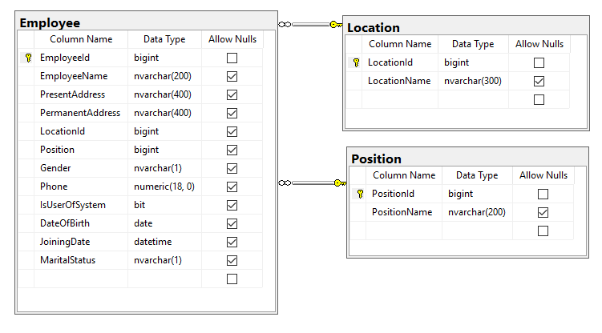

1. **Must use technologies:**
   1. ASP.NET MVC C#
   2. AngulaJS
   3. Entity Framework Core 2
   4. SQL Server
   5. DotNet Core 2
   6. Bootstrap
2. **Markings:**
   1. Business: 10
   2. Client script standard: 10
   3. C# code standard: 10
   4. Dependency Injection: 8
   5. UI Design: 7
   6. Test Case: 5
   7. Who will submit quicker: 5

**Total Marks: 100(50 for the test exercise and 45 interview).**

**Note:** Please visual studio 2017 community edition.