Tab 1

PORTFOLIO

# COMPUTER SCIENCE AND ENGINEERING

SUBMITTED BY : HARSIMRANJEET SINGH MAHLA

REGISTRATION NO: 12406763

ROLL NO : RK24CTB66

SECTION : K24CT

## SUBMITTED TO:

LOVELY PROFESSIONAL UNIVERSITY



**RK24CTB66 RK24C**

**TB6vxfsfag6 RK24**

**CTB66 RK24CTB66 RK24CTB66 RK24CTB66**

Tab 2

## I, harsimran , a student of Bachelor of technology under CSE discipline at Lovely Professional University, Punjab, hereby declare that all the information furnished in this project report is based report is based on my own work and is genuine

## 

## 

## 

## 

## 

## 

## 

## 

## 

## HARSIMRANJEET SINGH MAHLA

## 12406763

## PLATFORMS

| Platforms for profile creation | Link to student profile | Screenshot |
| --- | --- | --- |
| Figma | <https://www.figma.com/files/team/1408360738235497195/user/1408360735989949900?fuid=1408360735989949900> | 1 |
| Quora | <https://www.quora.com/profile/Sajan-Mahla-3> | 1 |
| Stack overflow | <https://stackoverflow.com/users/26949821/harsimranjeet-singh-mahla> | 1 |
| Hacker Rank | <https://www.hackerrank.com/profile/sajanmahla965> | 1 |
| Hacker Earth | <https://www.hackerearth.com/@sajanmahla965/> | 1 |
| Geeks for Geeks | <https://www.geeksforgeeks.org/user/sajanmacxus/> | 1 |
| LinkedIn | <https://www.linkedin.com/in/harsimranjeet-singh-mahla-5359a930b/> | 1 |
| Github | <https://github.com/sajan666-ops> | 1 |
| CV | https://ibb.co/ZSmfzV8 | 1 |

## MOOC’s

| TECHNICAL MOOC’s | — | —--- |
| --- | --- | --- |
| NON-TECHNICAL MOOC’s | TIME MANAGEMENT | 1 |

# 

## FIGMA

## 

# PROFILE AND ACCOMPLISHMENTS

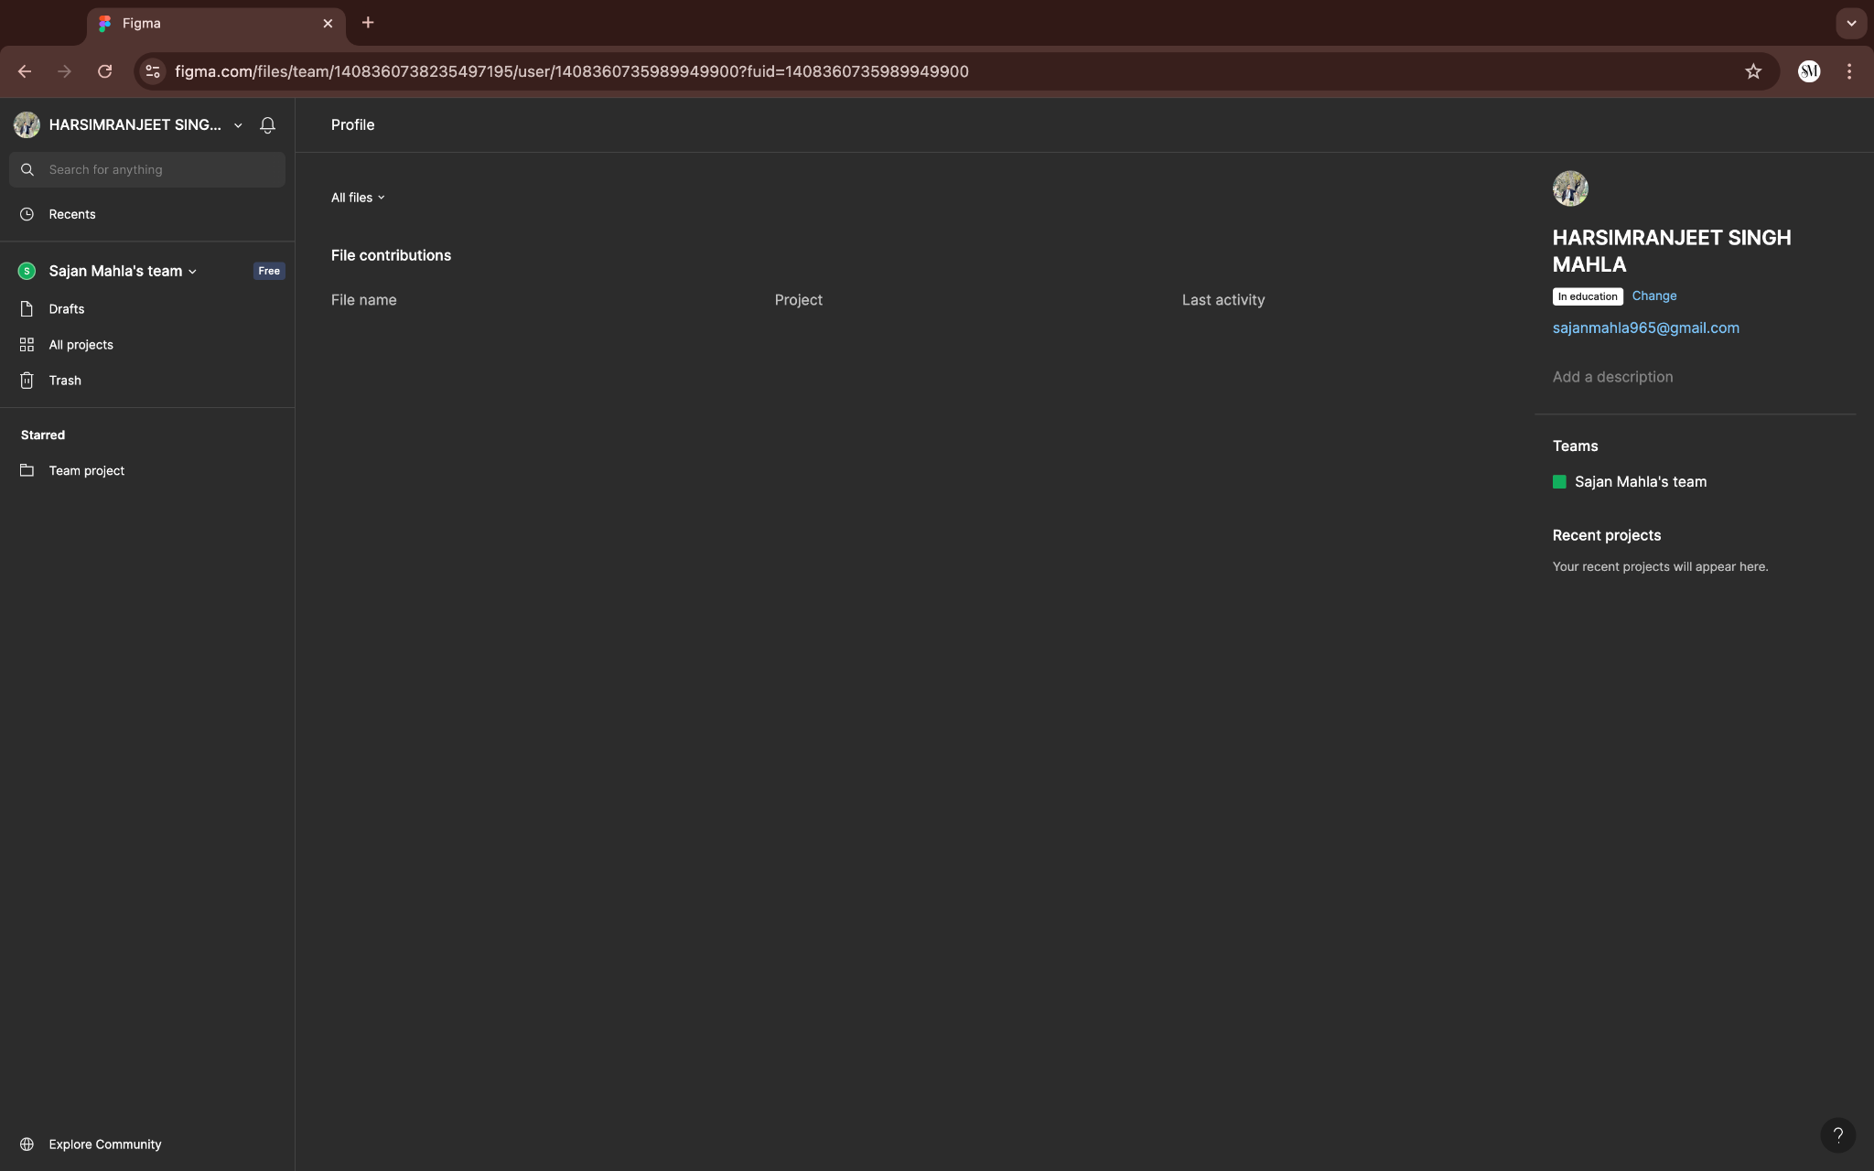

## 

# 

## **RK24CTB66**

Tab 3

# 2. QUORA

# PROFILE AND ACCOMPLISHMENTS

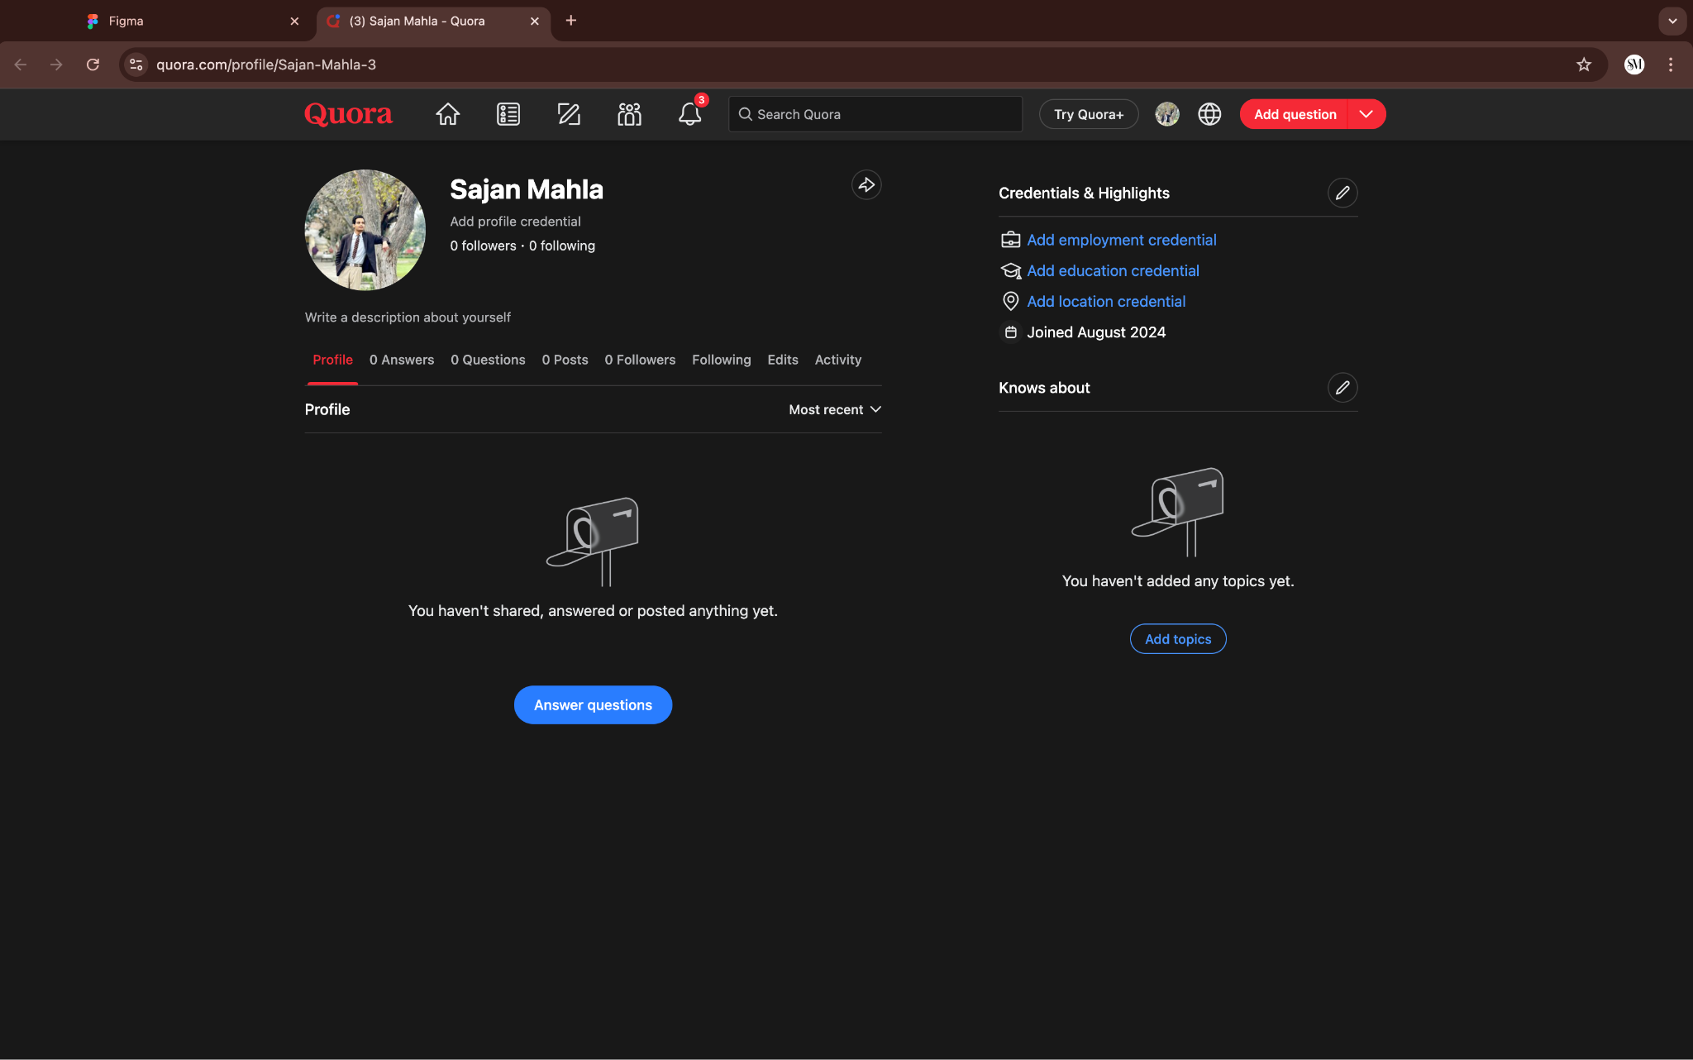

Tab 4

# 3. STACKOVERFLOW

# PROFILE AND ACCOMPLISHMENTS

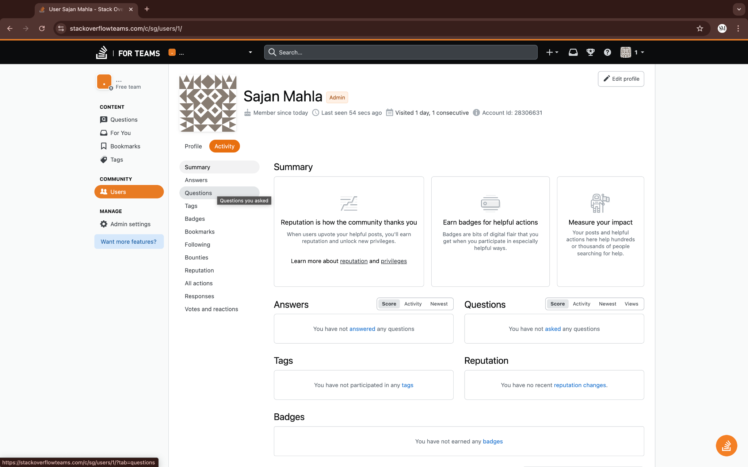

Tab 5

# 4. HACKER RANK

# PROFILE AND ACCOMPLISHMENTS

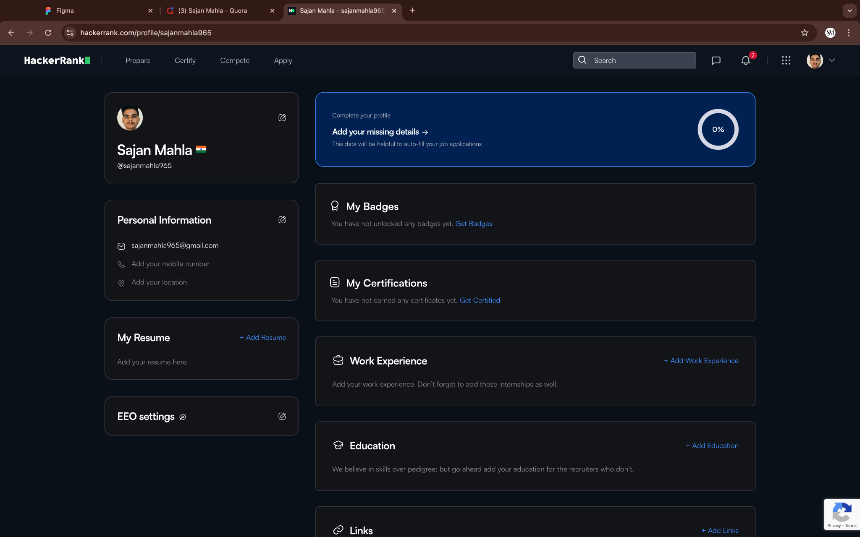

Tab 6

# 5. HACKER EARTH

# PROFILE AND ACCOMPLISHMENTS

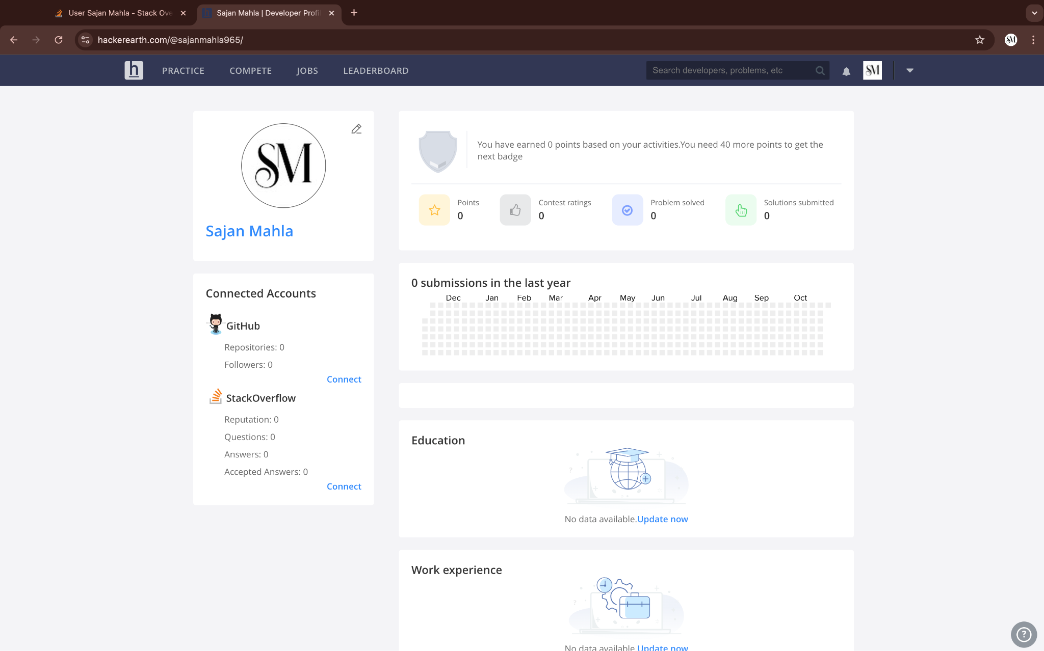

Tab 7

# 6. GEEKS FOR GEEKS

# PROFILE AND ACCOMPLISHMENTS

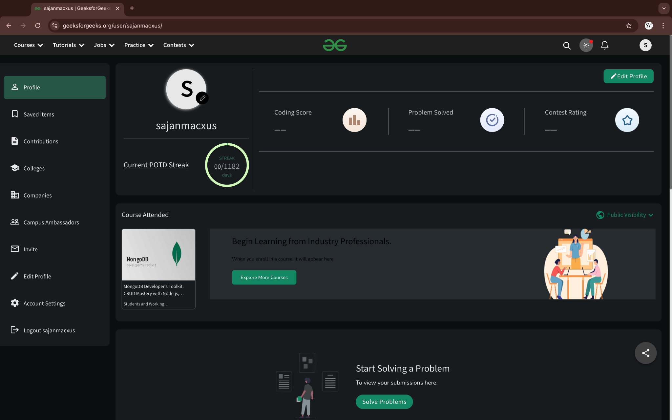

Tab 8

# 7. LINKEDIN

# PROFILE AND ACCOMPLISHMENTS

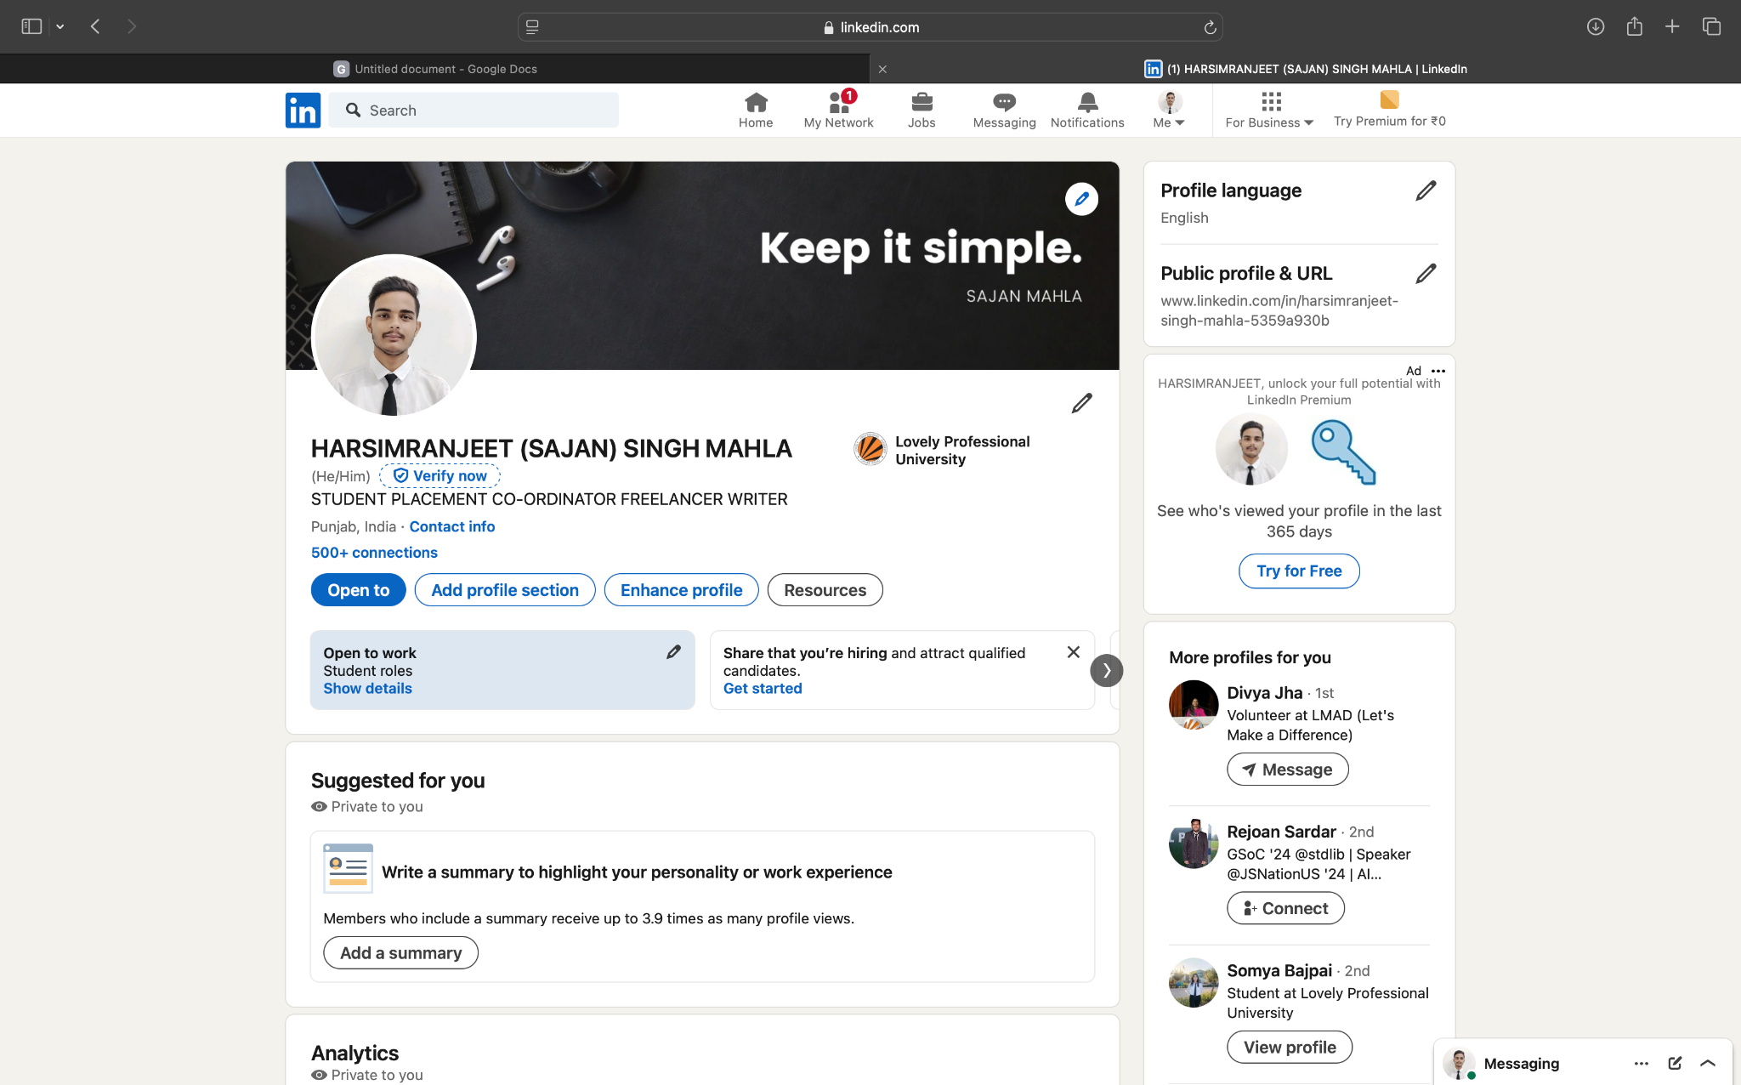

tab 9

# 8. GITHUB

# PROFILE AND ACCOMPLISHMENTS

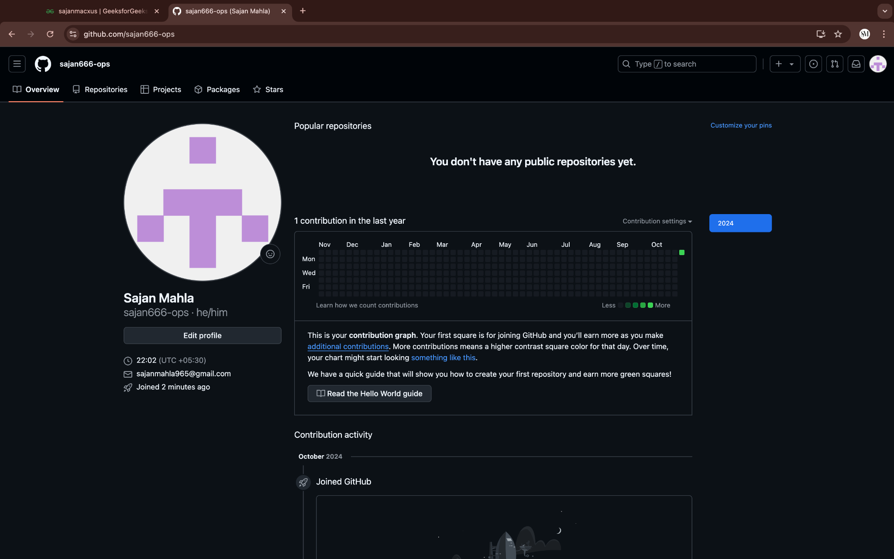

tab 10

# CV

# 



tab 11

# MOOC’S

# PROFILE AND ACCOMPLISHMENTS

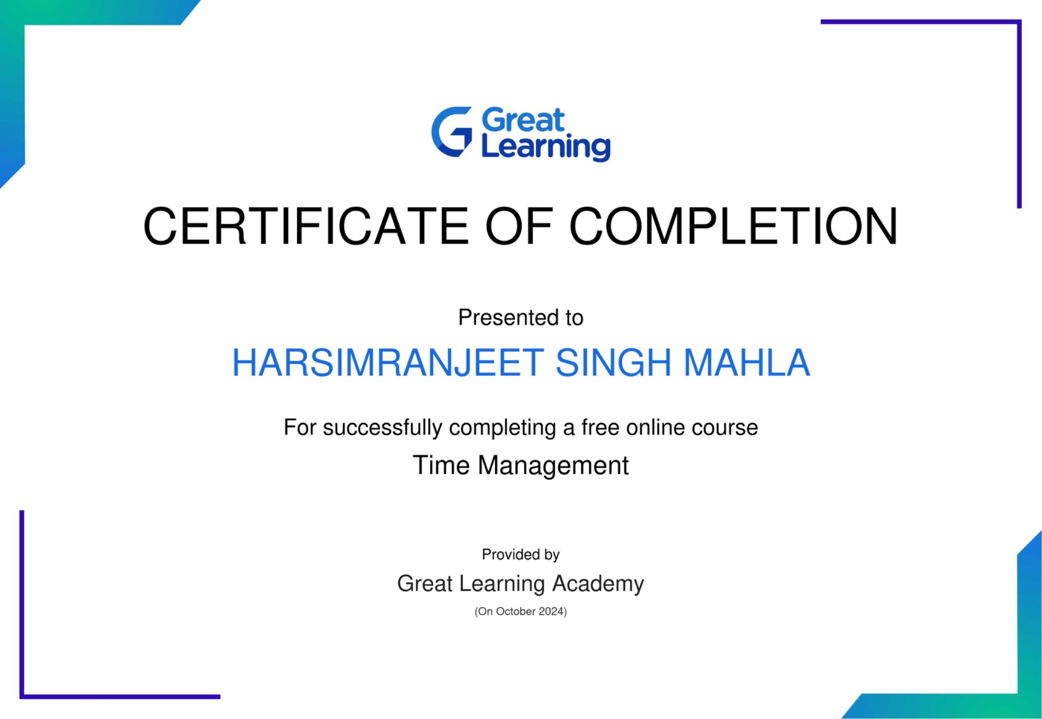

Tab 12

# THANKS ……