PROJECT REPORT

COURSE CODE: 24ADI204
COURSE TITLE: DATA SCIENCE AND VISUALIZATION
DATA VIZ HACK A BIT (2026-2027)

KidneyCare Analytics:
Early Detection of Chronic Kidney Disease Using Clinical Health Indicators

TEAM NO: TEAM 12
SUBMITTED BY
GANESHKUMAR B (25BAD025)
PRAJIT K (25BAD080)
SAJAY SRI S (25BAD094)
SANJAY V (25BAD099)

DEPARTMENT OF ARTIFICIAL INTELLIGENCE AND DATA SCIENCE
KUMARAGURU COLLEGE OF TECHNOLOGY
(Autonomous Institution)
COIMBATORE - 641 049

DOMAIN
Healthcare & Public Health
PROBLEM STATEMENT
KidneyCare Analytics: Early Detection of Chronic Kidney Disease Using Clinical Health Indicators.
PROJECT ABSTRACT
Chronic Kidney Disease (CKD) is a major global health concern that may remain undetected until it reaches advanced stages. This project analyzes clinical health indicators to identify the key factors associated with Chronic Kidney Disease using Data Science and Visualization techniques.
The project begins with raw clinical data and performs a systematic analysis to understand the structure, quality, and characteristics of the dataset. The raw dataset is then preprocessed by handling missing values, cleaning inconsistent data, detecting and treating outliers, and transforming relevant features.
Exploratory Data Analysis (EDA), statistical analysis, Principal Component Analysis (PCA), and interactive visualizations are used to identify hidden patterns and relationships among clinical health indicators. The final objective is to generate meaningful insights that can support the understanding of factors associated with Chronic Kidney Disease and contribute to data-driven healthcare decision-making.
OBJECTIVES
- To understand the structure, features, and quality of the raw clinical dataset.
- To identify data types, missing values, duplicate records, and constant columns in the dataset.
- To clean the dataset by correcting inconsistent values and fixing incorrect data types.
- To handle missing numerical values using the median and missing categorical values using the mode.
- To detect and treat outliers using boxplots and Z-score analysis.
- To perform univariate and bivariate Exploratory Data Analysis (EDA) on clinical health indicators.
- To study relationships between clinical variables and the disease classification using correlation analysis.
- To apply Principal Component Analysis (PCA) for dimensionality reduction of clinical features.
- To generate meaningful, data-driven insights that support early detection of Chronic Kidney Disease.
SDG ALIGNMENT
SDG 3 - Good Health and Well-being. This project is aligned with Sustainable Development Goal 3 by using data-driven analysis to improve the understanding of Chronic Kidney Disease and support better healthcare awareness and decision-making.
DATASET DETAILS
Dataset Name | Chronic Kidney Disease Dataset
Source | Kaggle
Dataset Link | https://www.kaggle.com/datasets/mansoordaku/ckdisease

WEEK 2: UNDERSTANDING THE RAW DATASET
Objective
To understand the raw dataset before performing data cleaning and Exploratory Data Analysis (EDA). The dataset is inspected to understand its size, structure, features, data types, missing values, duplicate records, and overall data quality.
Steps Performed
- Imported required libraries (pandas, numpy, matplotlib, seaborn) and loaded the raw dataset.
- Viewed sample records to get an initial look at the dataset.
- Checked dataset shape and column names.
- Checked dataset information (data types and non-null counts).
- Identified numerical and categorical feature types.
- Checked missing values and assessed data completeness.
- Checked for duplicate records.
- Checked the number of unique values in each feature.
- Generated a statistical summary of numerical features.
- Checked for constant columns (columns with only one unique value).
- Prepared a data quality summary and a first impression report.
Code and Output
Import Libraries and Load Dataset
Code:
import pandas as pd
import numpy as np
import matplotlib.pyplot as plt
import seaborn as sns

df = pd.read_csv(r"C:\Users\monik\Downloads\kidney_disease.csv")

Sample Records (df.head())
Code:
df.head()

Output:
 | id | age | bp | sg | al | su | rbc | pc | pcc
0 | 0 | 48.0 | 80.0 | 1.02 | 1.0 | 0.0 |  | normal | notpresent
1 | 1 | 7.0 | 50.0 | 1.02 | 4.0 | 0.0 |  | normal | notpresent
2 | 2 | 62.0 | 80.0 | 1.01 | 2.0 | 3.0 | normal | normal | notpresent
3 | 3 | 48.0 | 70.0 | 1.005 | 4.0 | 0.0 | normal | abnormal | present
4 | 4 | 51.0 | 80.0 | 1.01 | 2.0 | 0.0 | normal | normal | notpresent

Showing first 10 columns of the output.
Dataset Shape and Column Names
Code:
print("Rows:", df.shape[0])
print("Columns:", df.shape[1])

df.columns.tolist()

Output:
Rows: 400
Columns: 26

Dataset Information (df.info())
Code:
df.info()

Output:
<class 'pandas.DataFrame'>
RangeIndex: 400 entries, 0 to 399
Data columns (total 26 columns):
# Column Non-Null Count Dtype
--- ------ -------------- -----
0 id 400 non-null int64
1 age 391 non-null float64
2 bp 388 non-null float64
3 sg 353 non-null float64
4 al 354 non-null float64
5 su 351 non-null float64
6 rbc 248 non-null str
7 pc 335 non-null str
8 pcc 396 non-null str
9 ba 396 non-null str
10 bgr 356 non-null float64
11 bu 381 non-null float64
12 sc 383 non-null float64
13 sod 313 non-null float64
14 pot 312 non-null float64
15 hemo 348 non-null float64
16 pcv 330 non-null str
17 wc 295 non-null str
18 rc 270 non-null str
19 htn 398 non-null str
20 dm 398 non-null str
21 cad 398 non-null str
22 appet 399 non-null str
23 pe 399 non-null str
24 ane 399 non-null str
25 classification 400 non-null str
dtypes: float64(11), int64(1), str(14)
memory usage: 81.4 KB

Missing Values per Column
Code:
df.isnull().sum()

Output:
id 0
age 9
bp 12
sg 47
al 46
su 49
rbc 152
pc 65
pcc 4
ba 4
bgr 44
bu 19
sc 17
sod 87
pot 88
hemo 52
pcv 70
wc 105
rc 130
htn 2
dm 2
cad 2
appet 1
pe 1
ane 1
classification 0
dtype: int64

Statistical Summary (df.describe())
Code:
df.describe(include="all")

Output:
 | id | age | bp | sg | al | su | rbc
count | 400.0 | 391.0 | 388.0 | 353.0 | 354.0 | 351.0 | 248
unique |  |  |  |  |  |  | 2
top |  |  |  |  |  |  | normal
freq |  |  |  |  |  |  | 201
mean | 199.5 | 51.483376 | 76.469072 | 1.017408 | 1.016949 | 0.450142
std | 115.614301 | 17.169714 | 13.683637 | 0.005717 | 1.352679 | 1.099191
min | 0.0 | 2.0 | 50.0 | 1.005 | 0.0 | 0.0
25% | 99.75 | 42.0 | 70.0 | 1.01 | 0.0 | 0.0
50% | 199.5 | 55.0 | 80.0 | 1.02 | 0.0 | 0.0
75% | 299.25 | 64.5 | 80.0 | 1.02 | 2.0 | 0.0
max | 399.0 | 90.0 | 180.0 | 1.025 | 5.0 | 5.0

Showing first 8 columns of the output.
First Impression Report
Code:
print("=" * 50)
print("FIRST IMPRESSION REPORT")
print("=" * 50)

print("\nDataset Shape:", df.shape)

print("\nNumerical Features:", len(numerical_cols))
print("Categorical Features:", len(categorical_cols))

print("\nTotal Missing Values:", df.isnull().sum().sum())
print("Duplicate Records:", df.duplicated().sum())

print("\nColumns with Missing Values:")
print(df.columns[df.isnull().any()].tolist())

Output:
==================================================
FIRST IMPRESSION REPORT
==================================================

Dataset Shape: (400, 26)

Numerical Features: 12
Categorical Features: 14

Total Missing Values: 1009
Duplicate Records: 0

Columns with Missing Values:
['age', 'bp', 'sg', 'al', 'su', 'rbc', 'pc', 'pcc', 'ba', 'bgr', 'bu', 'sc', 'sod', 'pot', 'hemo', 'pcv', 'wc', 'rc', 'htn', 'dm', 'cad', 'appet', 'pe', 'ane']

Conclusion
The raw dataset was successfully inspected to understand its structure, features, data types, missing values, duplicates, and overall data quality. The next stage focuses on data cleaning and preparation.
WEEK 3: DATA CLEANING
Objective
To clean the dataset by fixing inconsistent values, correcting data types, handling missing values, checking duplicates, and detecting potential outliers.
Steps Performed
- Recorded the initial data quality condition of the dataset before cleaning.
- Cleaned categorical values by removing unnecessary spaces and tab characters.
- Verified that categorical values were consistently formatted.
- Converted numerical values stored as text into correct numeric data types.
- Re-checked missing values after correcting data types.
- Re-identified numerical and categorical feature types for cleaning.
- Handled missing numerical values using the median, since it is less affected by extreme values.
- Handled missing categorical values using the mode, representing the most frequent category.
- Verified that all missing values were handled successfully.
- Updated the feature lists before outlier detection.
- Detected outliers visually using boxplots on numerical clinical features.
- Detected outliers statistically using Z-score analysis (|Z| > 3 considered a potential outlier).
Code and Output
Initial Data Quality Check
Code:
df_cleaned = df.copy()
print("Dataset Shape:", df_cleaned.shape)
print("Total Missing Values:", df_cleaned.isnull().sum().sum())
print("Duplicate Records:", df_cleaned.duplicated().sum())

Output:
Dataset Shape: (400, 26)
Total Missing Values: 1009
Duplicate Records: 0

Convert Incorrect Data Types
Code:
numeric_object_columns = ["pcv", "wc", "rc"]

for col in numeric_object_columns:
df_cleaned[col] = pd.to_numeric(
df_cleaned[col],
errors="coerce"
)

print(df_cleaned[numeric_object_columns].dtypes)

Output:
pcv float64
wc float64
rc float64
dtype: object

Missing Value Summary After Type Correction
Code:
missing_summary = pd.DataFrame({
"Missing Values": df_cleaned.isnull().sum(),
"Missing Percentage": (
df_cleaned.isnull().sum() / len(df_cleaned) * 100
).round(2)
})

missing_summary

Output:
 | Missing Values | Missing Percentage
id | 0 | 0.0
age | 9 | 2.25
bp | 12 | 3.0
sg | 47 | 11.75
al | 46 | 11.5
su | 49 | 12.25
rbc | 152 | 38.0
pc | 65 | 16.25
pcc | 4 | 1.0
ba | 4 | 1.0
bgr | 44 | 11.0
bu | 19 | 4.75
sc | 17 | 4.25
sod | 87 | 21.75
pot | 88 | 22.0
hemo | 52 | 13.0
pcv | 71 | 17.75
wc | 106 | 26.5
rc | 131 | 32.75
htn | 2 | 0.5
dm | 2 | 0.5
cad | 2 | 0.5
appet | 1 | 0.25
pe | 1 | 0.25
ane | 1 | 0.25
classification | 0 | 0.0

Verify Missing Values After Imputation
Code:
print("Total Missing Values:")
print(df_cleaned.isnull().sum().sum())

print("\nMissing Values by Column:")
print(df_cleaned.isnull().sum())

Output:
Total Missing Values:
0

Missing Values by Column:
id 0
age 0
bp 0
sg 0
al 0
su 0
rbc 0
pc 0
pcc 0
ba 0
bgr 0
bu 0
sc 0
sod 0
pot 0
hemo 0
pcv 0
wc 0
rc 0
htn 0
dm 0
cad 0
appet 0
pe 0
ane 0
classification 0
dtype: int64

Outlier Detection Using Boxplots (sample features)
Code:
for col in numerical_cols:
plt.figure(figsize=(8, 4))

df_cleaned.boxplot(column=col)

plt.title(f"Boxplot of {col}")
plt.ylabel(col)

plt.show()

Output:
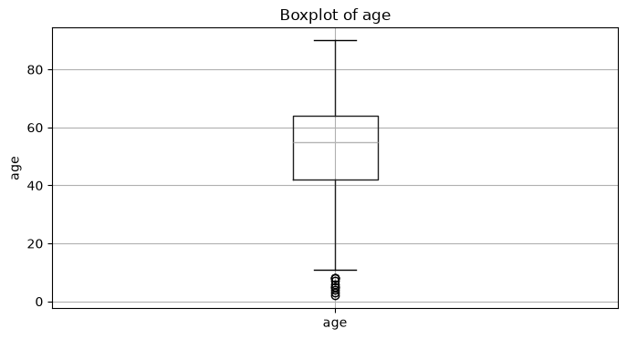
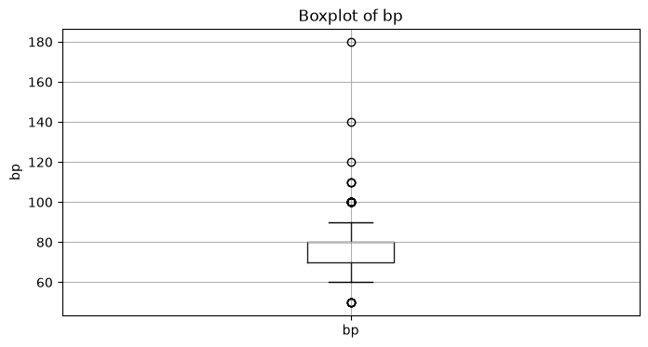
Showing sample plots (age, bp); the notebook generates one boxplot per numerical feature.
Outlier Detection Using Z-Score
Code:
all_numerical_cols = numerical_cols

z_score_df = pd.DataFrame(index=df_cleaned.index)

for col in all_numerical_cols:
mean = df_cleaned[col].mean()
std = df_cleaned[col].std()

z_score_df[col] = (
df_cleaned[col] - mean
) / std

z_outlier_mask = z_score_df.abs() > 3

z_outlier_report = pd.DataFrame({
"Outlier Count": z_outlier_mask.sum(),
"Outlier Percentage": (
z_outlier_mask.sum() / len(df_cleaned)
) * 100
})

z_outlier_report

Output:
 | Outlier Count | Outlier Percentage
age | 0 | 0.0
bp | 3 | 0.75
sg | 0 | 0.0
al | 1 | 0.25
su | 16 | 4.0
bgr | 11 | 2.75
bu | 10 | 2.5
sc | 4 | 1.0
sod | 2 | 0.5
pot | 2 | 0.5
hemo | 1 | 0.25
pcv | 2 | 0.5
wc | 6 | 1.5
rc | 3 | 0.75

Conclusion
Week 3 completed the cleaning of the dataset by correcting inconsistent categorical values, fixing data types, and handling missing values using median and mode imputation. Outliers were identified using boxplots and Z-score analysis. The cleaned dataset is now ready for detailed Exploratory Data Analysis.
WEEK 4: EXPLORATORY DATA ANALYSIS (EDA)
Objective
To explore the cleaned kidney disease dataset using univariate and bivariate analysis, focusing on distributions, category frequencies, relationships between clinical variables, and differences between kidney disease classes. The cleaned dataset from Week 3 is used; no rows are removed at this stage.
Steps Performed
- Checked the distribution of the target variable (classification) to understand class balance.
- Performed univariate analysis of numerical features using histograms with KDE curves.
- Performed univariate analysis of categorical features using count plots.
- Performed bivariate analysis comparing numerical clinical measurements across target classes using boxplots.
- Performed bivariate analysis comparing categorical features with the target using stacked percentage tables and heatmaps.
- Conducted correlation analysis among numerical variables to identify relationships and possible multicollinearity.
- Generated an automated EDA summary table recording descriptive statistics and missing-value status after cleaning.
Code and Output
Target Variable Distribution
Code:
plt.figure(figsize=(7, 4))
sns.countplot(data=eda_df, x='classification')
plt.title('Distribution of Kidney Disease Classification')
plt.xlabel('Classification')
plt.ylabel('Number of Patients')
plt.xticks(rotation=0)
plt.tight_layout()
plt.show()

print(eda_df['classification'].value_counts())
print('\nPercentage distribution:')
print((eda_df['classification'].value_counts(normalize=True) * 100).round(2))

Output:
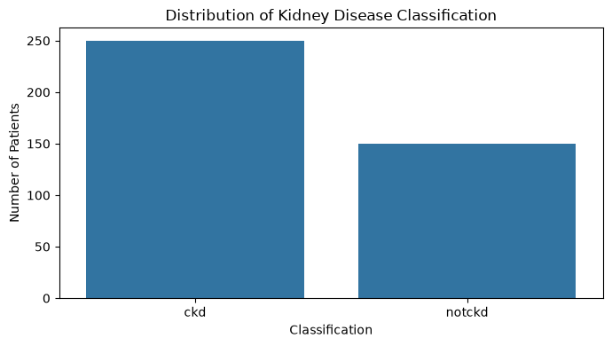
Univariate Analysis: Numerical Features (sample)
Code:
numeric_eda_cols = [col for col in numerical_cols if col != 'id']

for col in numeric_eda_cols:
plt.figure(figsize=(7, 4))
sns.histplot(data=eda_df, x=col, kde=True, bins=20)
plt.title(f'Distribution of {col}')
plt.xlabel(col)
plt.ylabel('Frequency')
plt.tight_layout()
plt.show()

Output:
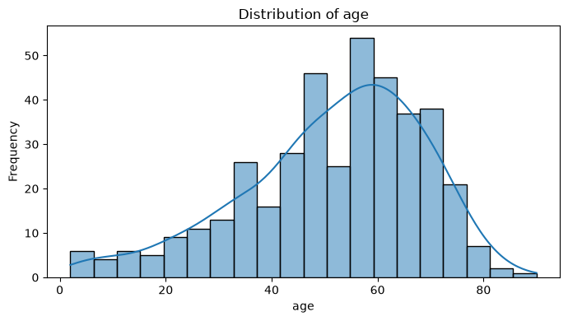
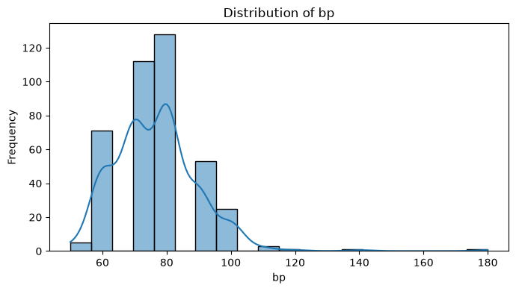
Univariate Analysis: Categorical Features (sample)
Code:
categorical_eda_cols = [col for col in categorical_cols if col != 'classification']

for col in categorical_eda_cols:
plt.figure(figsize=(7, 4))
order = eda_df[col].value_counts().index
sns.countplot(data=eda_df, x=col, order=order)
plt.title(f'Category Distribution of {col}')
plt.xlabel(col)
plt.ylabel('Frequency')
plt.xticks(rotation=45)
plt.tight_layout()
plt.show()

Output:
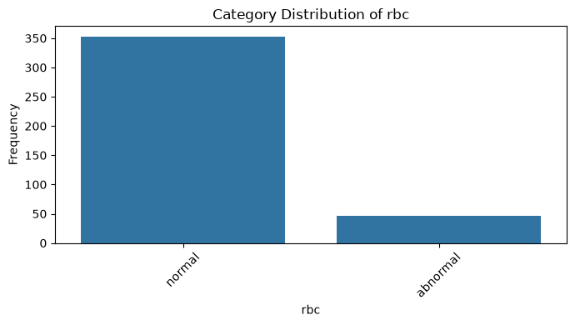
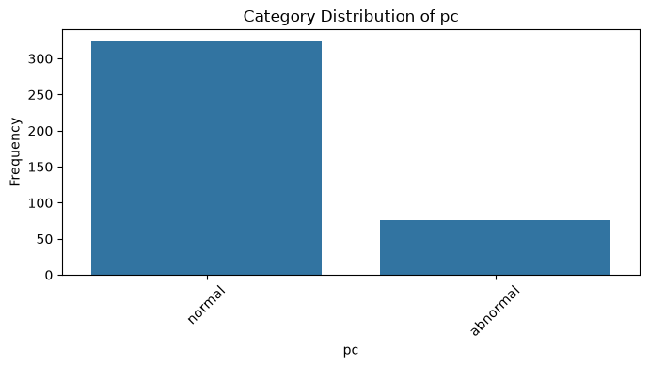
Bivariate Analysis: Numerical Features vs Classification (sample)
Code:
for col in numeric_eda_cols:
plt.figure(figsize=(7, 4))
sns.boxplot(data=eda_df, x='classification', y=col)
plt.title(f'{col} by Kidney Disease Classification')
plt.xlabel('Classification')
plt.ylabel(col)
plt.tight_layout()
plt.show()

Output:
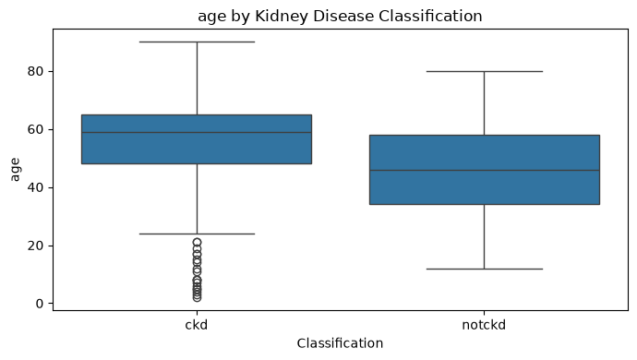
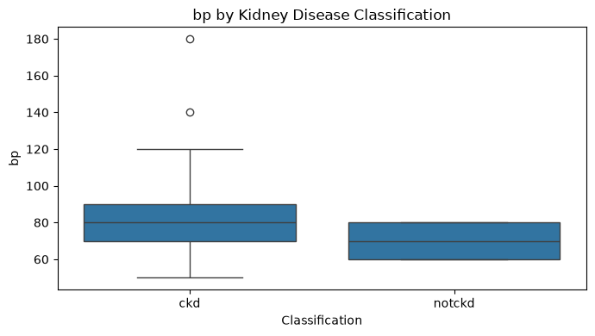
Bivariate Analysis: Categorical Features vs Classification (sample)
Code:
for col in categorical_eda_cols:
crosstab = pd.crosstab(eda_df[col], eda_df['classification'], normalize='index') * 100
print(f'\n{col} vs classification (%)')
display(crosstab.round(2))

crosstab.plot(kind='bar', stacked=True, figsize=(7, 4))
plt.title(f'{col} vs Classification')
plt.xlabel(col)
plt.ylabel('Percentage within category')
plt.xticks(rotation=45)
plt.legend(title='Classification')
plt.tight_layout()
plt.show()

Output:
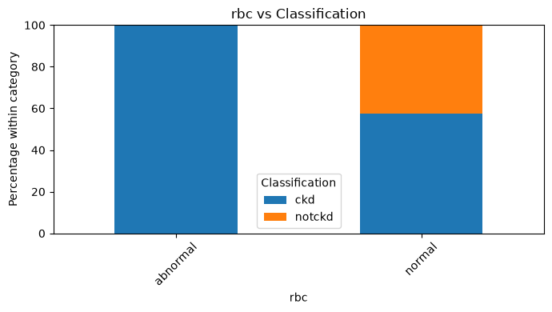
Showing a sample output; the notebook generates one chart per categorical feature.
Correlation Analysis
Code:
corr_cols = [col for col in numeric_eda_cols if eda_df[col].nunique() > 1]
correlation_matrix = eda_df[corr_cols].corr()

plt.figure(figsize=(12, 9))
sns.heatmap(correlation_matrix, annot=True, fmt='.2f', cmap='coolwarm', center=0)
plt.title('Correlation Matrix of Numerical Features')
plt.tight_layout()
plt.show()

Output:
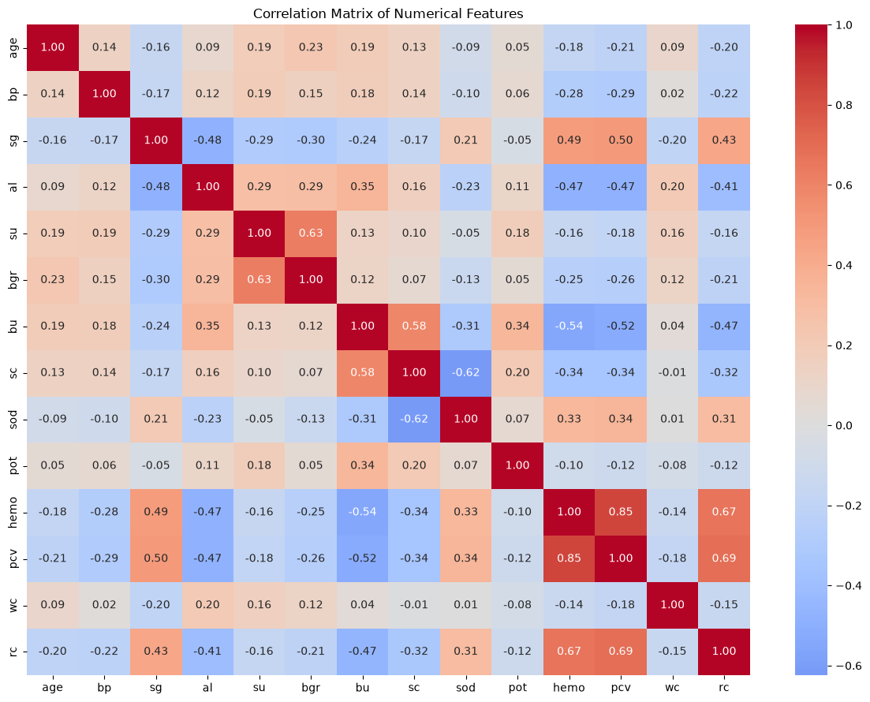
Automated EDA Summary
Code:
eda_summary = pd.DataFrame({
'Data Type': eda_df.dtypes.astype(str),
'Unique Values': eda_df.nunique(),
'Missing Values': eda_df.isnull().sum(),
'Missing %': (eda_df.isnull().sum() / len(eda_df) * 100).round(2)
})

eda_summary

Output:
 | Data Type | Unique Values | Missing Values | Missing %
id | int64 | 400 | 0 | 0.0
age | float64 | 76 | 0 | 0.0
bp | float64 | 10 | 0 | 0.0
sg | float64 | 5 | 0 | 0.0
al | float64 | 6 | 0 | 0.0
su | float64 | 6 | 0 | 0.0
rbc | string | 2 | 0 | 0.0
pc | string | 2 | 0 | 0.0
pcc | string | 2 | 0 | 0.0
ba | string | 2 | 0 | 0.0
bgr | float64 | 146 | 0 | 0.0
bu | float64 | 118 | 0 | 0.0
sc | float64 | 84 | 0 | 0.0
sod | float64 | 34 | 0 | 0.0
pot | float64 | 40 | 0 | 0.0
hemo | float64 | 116 | 0 | 0.0
pcv | float64 | 42 | 0 | 0.0
wc | float64 | 89 | 0 | 0.0
rc | float64 | 45 | 0 | 0.0
htn | string | 2 | 0 | 0.0
dm | string | 2 | 0 | 0.0
cad | string | 2 | 0 | 0.0
appet | string | 2 | 0 | 0.0
pe | string | 2 | 0 | 0.0
ane | string | 2 | 0 | 0.0
classification | str | 2 | 0 | 0.0

Findings
- The target-class distribution should be checked for imbalance before later modelling or comparison.
- Numerical distributions reveal differences in scale, spread, and skewness, guiding later transformations.
- Boxplots and categorical comparisons identify variables that may differ between disease classes and deserve further investigation.
- The correlation heatmap identifies potentially redundant numerical features for later feature selection and PCA.
- These findings are exploratory associations, not medical conclusions or causal claims.
Conclusion
Week 4 completed the required univariate and bivariate EDA on the cleaned dataset. The analysis documented distributions, category frequencies, class-wise comparisons, and numerical correlations. The results establish the evidence base for the mid-review and provide clear next steps for feature engineering, scaling, encoding, and PCA.
GITHUB REPOSITORY LINK
GitHub Link | https://github.com/sajaysri2911/24CSI024L-25BAD094-DSV-Group-Assingment-

WEEKLY WORK DONE
WEEK | TEAM MEMBER | WORK DONE
Week 1 | PRAJIT K | Team formation and finalization of the problem statement; selected the Chronic Kidney Disease dataset from Kaggle for analysis.
Week 2 | GANESHKUMAR B | Understood the raw dataset - checked its size, structure, feature/data types, missing values, duplicate records, and overall data quality.
Week 3 | PRAJIT K  SANJAY V | Cleaned the dataset by fixing inconsistent categorical values, correcting data types, handling missing values (median/mode), and detecting outliers using boxplots and Z-score analysis.
Week 4 | SAJAY SRI S  GANESHKUMAR B | Performed univariate and bivariate Exploratory Data Analysis (EDA), studied correlations among clinical variables, and summarized findings for the mid-review.

