# Project Overview: Stock Management System

* Name of Project:     Stock Management System
* Language used:      PHP
* Used Database:      My SQL
* Design Interface:     HTML, CSS, Bootstrap, JavaScript, Ajax, jQuery
* Browser:                   Opera/Mozilla/Google Chrome/ IE8,
* Software:                 WAMP/ XAMPP/ LAMP/MAMP/Web Hosting

# At a Glance

1. Maintains an optimal stock level
2. Track goods during transport between locations
3. Receive new items
4. Manage warehouse processes such as picking, packing, and shipping
5. Ensure products are never out of stock.
6. Report Publishing: Daily, Weekly, Monthly

## Features of Stock Management System Project

* Add Items
* Update Items
* Insert New Items
* Monitor Stock
* Change Password
* View In/Out items
* Report Publishing

**Database:**

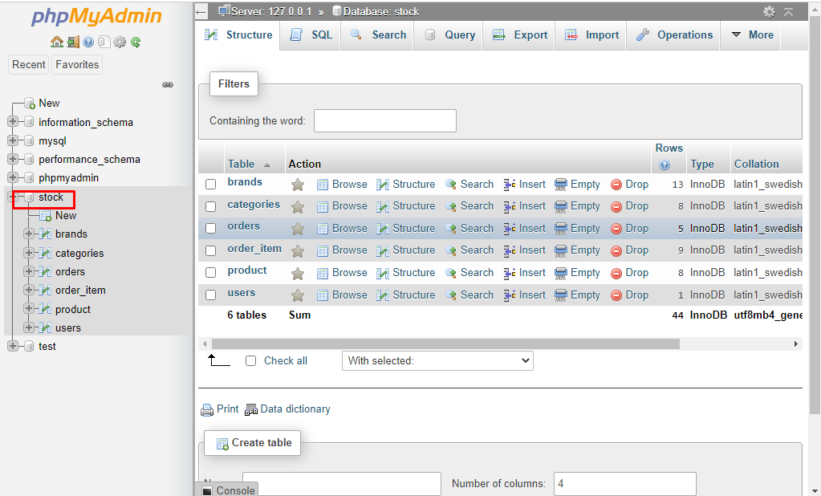

**Admin Page:**

