**Environment**

Friday, 2 September 2022

1:37 AM

# Index

[Approaches to the ecology (5:53 PM)](onenote:#Environment&section-id={DF74AA9E-E2FF-7A46-96BD-36D22F163CE1}&page-id={2BEF7712-7BD7-8C47-82C4-3CB91E73B92C}&object-id={6EB6A996-A50F-7E4C-8A9A-AC121C984217}&D2&base-path=https://d.docs.live.net/9b24b3fb5359b984/Documents/My%20Notebook/GS3%20-%20CORE.one) - interaction between species

[ECOSYSTEM (Explained with a flow chart) (5:53](onenote:#Environment&section-id={DF74AA9E-E2FF-7A46-96BD-36D22F163CE1}&page-id={2BEF7712-7BD7-8C47-82C4-3CB91E73B92C}&object-id={609FC77D-AB1C-2040-96DF-99E09151B216}&8C&base-path=https://d.docs.live.net/9b24b3fb5359b984/Documents/My%20Notebook/GS3%20-%20CORE.one))

[Types of Biogeochemical cycles (5:54 PM)](onenote:#Environment&section-id={DF74AA9E-E2FF-7A46-96BD-36D22F163CE1}&page-id={2BEF7712-7BD7-8C47-82C4-3CB91E73B92C}&object-id={BF2B32EB-3841-C140-9911-CE8F57B71DAE}&9C&base-path=https://d.docs.live.net/9b24b3fb5359b984/Documents/My%20Notebook/GS3%20-%20CORE.one)

[BIODIVERSITY](onenote:#Environment&section-id={DF74AA9E-E2FF-7A46-96BD-36D22F163CE1}&page-id={2BEF7712-7BD7-8C47-82C4-3CB91E73B92C}&object-id={0F36F9BC-3717-CA4A-8ED3-0BF1DE35B27C}&90&base-path=https://d.docs.live.net/9b24b3fb5359b984/Documents/My%20Notebook/GS3%20-%20CORE.one)

[Threatened species of India:](onenote:#Environment&section-id={DF74AA9E-E2FF-7A46-96BD-36D22F163CE1}&page-id={2BEF7712-7BD7-8C47-82C4-3CB91E73B92C}&object-id={EBCFFE69-B1E1-A141-9418-29A1AEF1F6F6}&E6&base-path=https://d.docs.live.net/9b24b3fb5359b984/Documents/My%20Notebook/GS3%20-%20CORE.one)

[International convention](onenote:#Environment&section-id={DF74AA9E-E2FF-7A46-96BD-36D22F163CE1}&page-id={2BEF7712-7BD7-8C47-82C4-3CB91E73B92C}&object-id={7822A747-D570-8741-957D-F8C8BE66B1D1}&1A&base-path=https://d.docs.live.net/9b24b3fb5359b984/Documents/My%20Notebook/GS3%20-%20CORE.one)

Cities

Traffic

Ramsar convention

Convention on Biodiversity

Biodiversity Act

[Global Warming and Climate Change: (5:05 PM)](onenote:#Environment&section-id={DF74AA9E-E2FF-7A46-96BD-36D22F163CE1}&page-id={2BEF7712-7BD7-8C47-82C4-3CB91E73B92C}&object-id={6F705DCB-97E7-2743-B1B0-8CC504C40876}&61&base-path=https://d.docs.live.net/9b24b3fb5359b984/Documents/My%20Notebook/GS3%20-%20CORE.one)

[IPCC FOURTH ASSESSMENT REPORT 2007( 5:15 PM):](onenote:#Environment&section-id={DF74AA9E-E2FF-7A46-96BD-36D22F163CE1}&page-id={2BEF7712-7BD7-8C47-82C4-3CB91E73B92C}&object-id={6A9BD7FE-7F27-4D45-8A91-F2B61A799A61}&1F&base-path=https://d.docs.live.net/9b24b3fb5359b984/Documents/My%20Notebook/GS3%20-%20CORE.one)

[CLIMATE CHANGE IN INDIA (6:30 PM):](onenote:#Environment&section-id={DF74AA9E-E2FF-7A46-96BD-36D22F163CE1}&page-id={2BEF7712-7BD7-8C47-82C4-3CB91E73B92C}&object-id={3297CB34-8396-AE41-B918-72287FDADB52}&34&base-path=https://d.docs.live.net/9b24b3fb5359b984/Documents/My%20Notebook/GS3%20-%20CORE.one)

[POLLUTION ( 5:08 PM):](onenote:#Environment&section-id={DF74AA9E-E2FF-7A46-96BD-36D22F163CE1}&page-id={2BEF7712-7BD7-8C47-82C4-3CB91E73B92C}&object-id={701E1E6C-C825-F549-8B56-38B8A70F446F}&3C&base-path=https://d.docs.live.net/9b24b3fb5359b984/Documents/My%20Notebook/GS3%20-%20CORE.one)

|  |  |
| --- | --- |
| Definitions |  |
| Deforestation | * + - Deforestation is the large-scale removal of trees from land that is then converted to non-forest use like agriculture, mining infrastructure development, urbanization, industrialization. |
| Desertification | * + - The process by which fertile land gradually becomes arid and desert-like due to natural factors like climate change and drought, but is often accelerated by human activities like overgrazing, unsustainable agricultural practices. |
| Eutrophication | * + - Eutrophication is a process occurring in water bodies like lakes, rivers, and estuaries, where excessive nutrients lead to an abnormal overgrowth of algae and plants.       * Types - Natural eutrophication and Cultural eutrophication |
| Algal bloom | * + - An algal bloom is a rapid increase or accumulation in the population of algae in freshwater or marine water systems. It's often identified by the discoloration of the water due to the pigments of the algae.      * + - Harmful algal blooms (HABs): Some algal species produce toxins harmful to humans, animals, and aquatic ecosystems. |
| Wetland | * + - A wetland is a distinct ecosystem that is flooded or saturated by water, either permanently or seasonally. The water in wetlands can be fresh, saltwater, or a mixture of both.       * Benefits : habitat, water quality, flood control, recreation |

## ECOLOGY AND ENVIRONMENT

* + Ecology is defined “as a scientific study of the relationship of the living organisms with each other and with their environment.”
  + Ecosystem is a biological community of interacting organisms and their physical environment.
    - 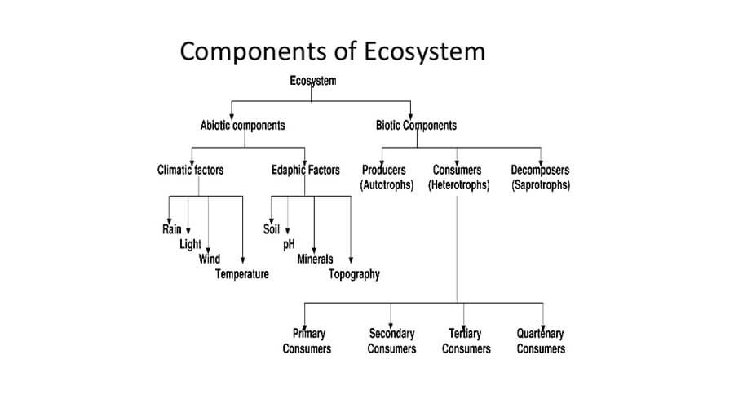
  + The environment is simply defined as everything around, it is made up of all the biotic and abiotic components.
    - Biotic components - living - animals, plants, etc.
    - Abiotic components - non-living - oxygen, land, temperature, etc.
      * Climatic
      * Edaphic
      * Topographic

**Significance of Ecology studies**

* + Understanding human and environmental relations.
  + Environment conservation.
  + Resource allocation as animals and humans are sharing common resources.
  + Energy conservation.
  + Eco-friendliness - it helps to appreciate living among the organisms.

### Basic concepts of ecology

**Environment vs habitat**

* + Many species can survive in more than one environment.
  + But each species has its home or habitat.
  + Fish may be able to live in a water tank, river, and sea also but cannot live in the wild.
  + The basic idea behind the study of ecology is understanding the relation of the interdependence among organisms.
  + Organisms need to survive - air, water, food, and shelter.
  + All organisms survive for these resources which are limited in number.
  + All organisms have the ability to produce a population of unlimited size, but, nature keeps everything in check.
  + Limiting factors are the factors which decide the population size.
  + The limiting factors can be biotic and abiotic.

**CARRYING CAPACITY**

* + When all the limiting factors are considered together, we can determine the carrying capacity of a region.
  + It talks about how many organisms/species an area can hold without depleting or degrading the environment and the resources of the region.

**Gaia Hypothesis**

* + Proposed by James lovelock, a British scientist.
  + Gaia hypothesis refers to "earth has a self-sustenance mechanism with all its resources interacting with the species and being interacted by the species".
  + Just like as compared with the human having immunity, the earth is also having its own carrying capacity.
  + Anything exceeding the carrying capacity leads to disasters.
  + Earth overshoot day marks the date when humanity's demand for ecological resources and services in a given year exceeds what Earth can regenerate in that year.

**Components of the environment**

* + Four major components of the environment include the lithosphere, hydrosphere, atmosphere and biosphere.
  + 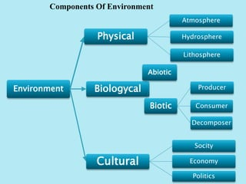

## Ecology

* + Ecology is the scientific study of interaction and interdependencies between the species and its surroundings.
  + The environment components are both biotic and abiotic.

**The laws in Ecology**

* + Everything is connected to everything else.
  + Everything must go somewhere.
  + There is no such thing as free lunch.

**Holism in Ecology**

* + Ecological holism represents the culmination of the view that humans have certain duties toward the preservation of the natural world.
  + Nature itself should be preserved as far as possible rather than any particular component entities.

**Approaches to the ecology**

* + **Autecology (Study of individual organism)**
    - It talks about how an individual interacts with a surrounding and how surroundings impact the individual.
    - Acclimatisation is for a short duration. In this an individual organism adjusts to a change in its environment, allowing it to maintain fitness across a range of environmental conditions
    - Adaptation is of three types - Physiological, Morphological and behavioural.
      * Physiological adaptation is an internal body process to regulate and maintain homeostasis for an organism to survive in the environment in which it exists.
      * Physiological adaptation is of two types - Hibernation and aestivation.

**Allen's rule**

* + In the cold areas, the size of the limbs of the animal and its ears, snout and tail of the animal is shorter when compared to its counterparts in the tropical areas to facilitate the conservation of the heat.

**Morphological adaptation**

* + Morphological adaptation isa structural change that gives an organism a greater chance of survival in its habitat.
  + the people living near to equator have darker colour skin.

**Behavioural adaptation**

* + Behavioural adaptations are the things organisms do to survive.
  + For example, bird calls and migration are behavioural adaptations.
  + Adaptations are the result of evolution.
  + Evolution is a change in a species over long periods of time.

* + **Synecology (Study of whole plant or animal)**
    - How a group of species is interacting with the environment.
    - Biotic Interaction 
      S.No. 
      1. 
      2. 
      3. 
      4. 
      5. 
      6. 
      TYpe 
      Mutualism 
      Commensalism 
      Amensalism 
      Competition 
      Predation 
      Parasitism 
      Spices 1 
      Species 2 
      (o) 
      (o) 
      (+) Benefited (—) Harmed 
      (o) Neither Benefited nor harmed. 

**Mutualism**

* + Mutualism is defined as an interaction between individuals of different species that results in positive (beneficial) effects on per capita reproduction and/or survival of the interacting populations.
  + There are two types of mutualism - symbiosis and proto-co-operation.
    - Symbiosis is compulsory/Obligatory mutualism.
    - Symbiosis takes place only when the two species are physically in the association.
      * Example - coral polyps and zooxanthellae.
    - Proto-co-operation, when two species are getting more benefitted whenever in contact. If they are separated, they can survive on their own.
      * National centre for biological studies Bangalore recently discovered the facultative co-operation between caterpillars and the red ants.

**Commensalism**

* + In this type of interaction, one species is benefitted and the other is neutral.
    - Example - vulture feeding on the dead bodies.

**Negative Inter-actions**

* + Predation = (+/-). It is a plus-minus interaction.
  + Parasitism =  (+/-). It is a plus-minus interaction. One species which is feeding on the host is benefitted and the other is negatively impacted.
    - Parasitism types - brood parasitism, facultative parasitism.
      * Facultative parasitism doesn't have the capacity to kill the host but it can derive nutrients from the host. Ex - lice.

**Amensalism**

* + One species is negatively impacted and the other species is not impacted.
  + There is a unique type of interaction called allelopathy.
    - The chemical inhibition of one plant (or other organism) by another, due to the release into the environment of substances acting as germination or growth inhibitors.
    - Secreting of chemicals that inhibits the growth of other species.
  + Antibiosis - An organism(specially microorganisms) is either damaged or killed by a chemical secretion of another organism.

**Competition**

* + In this type of interaction, both species are negatively impacted.
  + A larger, physically stronger organism deprives a smaller, weaker organism of food or space.
  + Both species have the same niche.

**Gause rule**

* + The principle of competitive exclusion.
  + Two species competing for the same limited resource cannot coexist in a stable equilibrium at constant population sizes.
  + When two species are having the same ecological niche or have the same food, one species will eventually outcompete and exclude the other in the long run.
  + Given a region on a physical space in which two species do persist indefinitely there exists one or more properties of the environment or the species or of both that ensures an ecological distinction between the two species.

**Ecological niche**

* + It refers to a microhabitat.
    - comfortable biological, physical, chemical factors for a species in the environment.
  + It refers to a functional role and a position of a species in its habitat or ecosystem.
    - Habitat niche - it refers to the place where the species lives.
    - Food niche - It means what the species eat and decompose.
    - Reproductive niche - It means when and how the species reproduce.

## ECOSYSTEM

* + Ecosystem is a biological community of interacting organisms and their physical environment.
    - 
  + In 1935, it is Mr Arthur George who define the ecosystem as the unit of the environment.
  + According to AG Tansley " An ecosystem is a functioning and interacting system composed of one or more living organism and their effect to the environment in a biological, chemical and physical sense and is a concept applicable by any scale ranging from planet earth as an ecosystem down to the smallest patch of lichens on a rock surface".

**Types of Ecosystem**

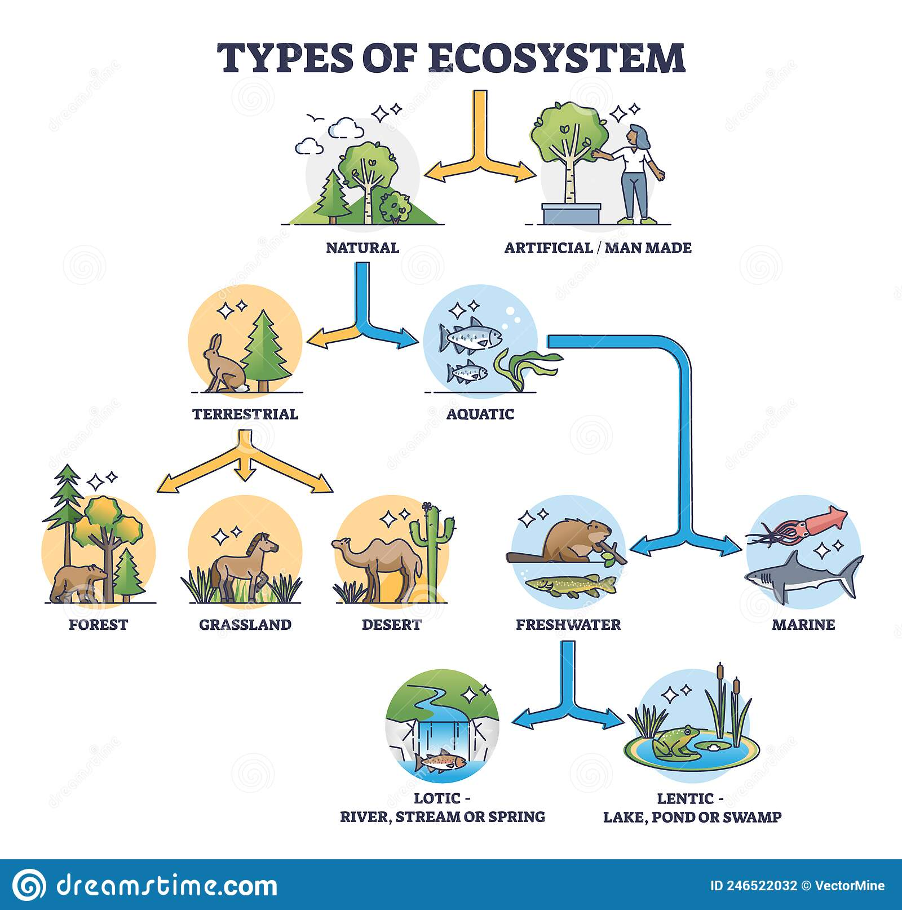

* + Forest Ecosystem - A forest ecosystem is a functional unit or a system that comprises soil, trees, insects, animals, birds, and man as its interacting units.
    - It can be a rainforest or deciduous forest ecosystem.
  + Grassland ecosystem - Grassland Ecosystem is an area where the vegetation is dominated by grasses and other herbaceous (non-woody) plants.
    - It is also called transitional landscape because grassland ecosystems are dominated by the grass with few or no trees in the area where there is not enough for a forest and too much of a forest.
    - It can be temperate grassland and tropical grassland.
  + Desert ecosystem - arid regions that are generally associated with warm temperatures; however, cold deserts also exist.
  + Aquatic ecosystem - An aquatic ecosystem is an ecosystem in and surrounding a body of water.
    - The two main types of aquatic ecosystems are marine ecosystems and freshwater ecosystems.
    - Freshwater ecosystem - river, lake, pond, wetland etc.
    - Saline Ecosystem - Ocean, sea, lake and wetland.

* + Transition ecosystem - also called ecotone
    - Ecotone is a zone of junction between two or more diverse ecosystems. For e.g. the mangrove forests represent an ecotone between marine and terrestrial ecosystem
    - Transition area from freshwater to saline water.

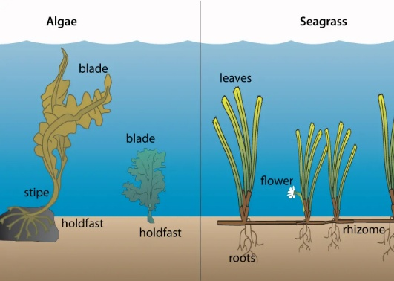

**Edge effect**

* + Edge effect refers to the changes in population or community structures that occur at the boundary of two or more habitats called as ecotone.
  + The life that takes birth in the ecotone should be more than that of the adjacent ecosystem.
  + Diversity of ecotone permits growth of more plants and animals
  + Such an effect is called the edge effect.
  + Species that grow here are called edge species.

**Mangrove vegetation**

* + All the mangroves of the world are protected areas.
  + Mangroves in Andaman and Nicobar are called Andaman mangroves.
  + They are rich biodiversity regions.

**Mangroves in India**

|  |  |
| --- | --- |
| **Area** | **Mangroves** |
| West Bengal | Sunderbans |
| Orissa | Bhitarkanika |
| Andhra Pradesh | CORINGA |
| Tamil Nadu | Pitchavaram |
| Kerala | Myristica swamp |
| Karnataka | Netrani |
| Maharashtra | Sindudurg |
| Goa | Goan mangroves |
| Andaman and Nicobar | Andaman mangroves |

**Important characteristics of mangroves**

* + Salt secreting glands on thick leaves
  + They exhibit viviparity
  + Found between 23.5 degrees north to 23.5 degrees south.
  + High insolation.

**Ecocline**

* + It is a zone of gradual but continuous change from one ecosystem to another ecosystem.
  + When there is no sharp boundary between the two along the hilly slopes.
    - altitudinal gradient on a mountain.

|  |  |  |
| --- | --- | --- |
| **Feature** | **Ecotone** | **Ecocline** |
| Focus | Biotic (living) | Abiotic (non-living) |
| Boundary | Sharp | Diffuse |
| Species change | Distinct at boundary | Gradual along gradient |
| Example | Forest-field edge | Thermocline in ocean |

### Functions of the ecosystem

* + Energy flow
  + Nutrient cycle
  + Homeostasis
  + Ecological succession
  + All the functions are providing services to humankind and these services are termed ecosystem services.

* + **Energy flow**

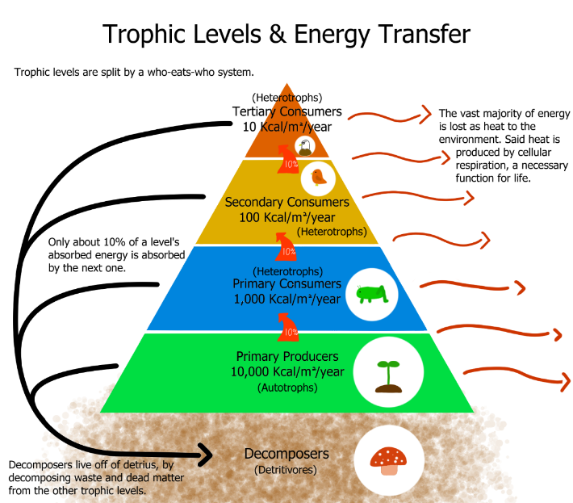

* + Energy flow is happening through the food chain.
  + Energy is cyclical in nature.
  + The sun is the primary source of energy on the surface of the earth.
  + Out of the entire energy of the sun, it is only 50%, absorbed by the earth surface.
  + Out of this 50%, just 2-10% is consumed by the plants for photosynthesis.
  + This energy is called PAR (Photosynthetically active radiation).
  + The trophic level is the position of the species in the food chain.
  + The trophic level is the number of steps an organism is from the start of the food chain.

* + The two main groups of decomposers are fungi and detritivores
    - Decomposers - like bacteria and fungi don’t eat their food, they decompose it externally
    - Detritivores eat large amount of decaying material and excrete nutrients.
      * Example - worms, millipedes, dung flies, woodlice, slugs, sea stars, crabs and sea cucumbers, springtails.

* + **10% Rule**
    - Also called Lindeman's 10% rule.
    - According to Lindeman at every successive trophic level, it is only 10% of the energy is transported.

**Food chain**

* + A food chain is a linear sequence of organisms through which energy and nutrients are transferred. Each organism in the food chain feeds on the one below it, and in turn is eaten by the one above. The arrows in a food chain represent the direction of energy transfer.
  + There are two types of food chains - grazing and detritus food chain.
  + Grazing food chain - It began with the green plants as they are self producers of food material by converting the photon energy into chemical energy.
  + This chemical energy produced by the autotrophs is the primary food for all other species.

**Detritus Food chain**

* + It starts with the dead species either plants or animals.
  + The dead organic matter is broken down by decomposers like bacteria and fungi.
  + These broken simple compounds again enter into the grazing food chain in the form of either hummus or worms.

**Food web**

* + It is a network of interconnected food chains.
  + It denotes the number of feeding relationships among different species.

**Ecological pyramid**

* + An ecological pyramid is a graphical representation of the distribution of energy or biomass at different trophic levels within an ecosystem. These levels represent how organisms obtain their nutrition, starting with producers at the base and progressing to top predators or decomposers at the apex.
  + This concept was propounded by Charles Elton in 1927.
  + The ecological pyramid indicated the health of the ecosystem.
  + The ecological pyramids suggested to the ecologists whether the species needs to be translocated or not.
    - For example, Rhino vision 2020.
      * The rhinos were translocated from Kaziranga national park to the other important protected areas of Assam like Orang national park, Manas wildlife sanctuary and national park and biosphere reserve, Pabitora wildlife sanctuary, Dibru-Saikhowa.

**Types of ecological pyramids**

**Pyramid of Numbers**

* + It represents the number of species at each trophic level based on the size the pyramid of number can be either upright or inverted.
  + Upright - grassland ecosystem.
  + Inverted ecosystem - tree ecosystem.

**Pyramid of Biomass**

* + It represents the organic matter of the species at each trophic level.
  + Based on the weight of the organic matter, the pyramid of biomass can be either upright or inverted.

**Pyramid of energy**

* + It represents the direction of the flow of energy from one trophic level to another trophic level.
  + It majorly emphasises the amount of energy at each trophic level and the loss of energy at each transfer of another trophic level.
  + The pyramid of energy is always upright.

**Ecological Productivity**

* + The rate of biomass production.
  + Ecological productivity is of two types - primary and secondary productivity.

**Primary productivity**

* + Primary productivity refers to the rate at which organic matter is produced by primary producers, such as plants, algae, and some bacteria.
  + Gross primary productivity - the total amount of organic matter produced by primary producers, before accounting for any losses due to respiration.
    - Represents the maximum potential photosynthetic output of an ecosystem.
  + Net primary productivity : GPP minus the amount of organic matter lost through respiration by the primary producers.
    - Represents the net amount of organic matter available to consumers and decomposers in the ecosystem.
    - Net primary productivity - (e.g., grams of carbon per square meter per year).
    - NPP = GPP - respiration.

* + 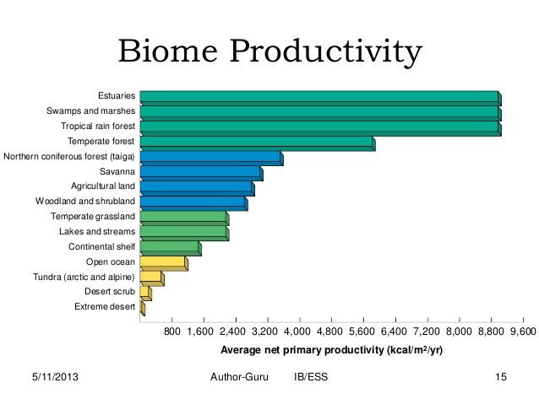

**Secondary productivity**

* + Net secondary productivity is the amount of energy the gain by consumers in energy or biomass per unit area, per unit time, remaining after allowing for respiratory losses.
  + The secondary productivity is confined to the consumers.
  + Therefore net secondary productivity is equal to gross secondary productivity - respiration.

**Primary V/s secondary productivity**

|  |  |
| --- | --- |
| **Primary** | **Secondary** |
| It is the rate of synthesis of organic matter by producers. | It is the rate of synthesis of organic matter by consumers. |
| Comparatively high. | Comparatively low. |
| It is due to the synthesis of fresh organic matter from inorganic raw material. | It is due to the synthesis of organic matter from organic matter. |

### Biogeochemical cycles/Nutrient cycles

* + It refers to the flow of chemical elements and compounds between organisms and the physical environment.
  + The elements that are consumed by the species passes through the food chain from one trophic level to another and finally, come back to the physical environment.
  + Such a cycle of chemicals/elements is called a biogeochemical cycle.
  + They are more or less circular pathways through which the chemical elements including all the essential elements of the matter circulate in the biosphere from the environment to organisms and back to the environment are known as biogeochemical cycles.
  + Focus is given to carbon, nitrogen and water cycles.
  + Typically present in all four parts of the earth's system.
    - Atmosphere
    - Biosphere
    - Hydrosphere
    - Lithosphere
  + There are pools.
  + Transformed chemically or biologically.
  + There are fluxed between pools.
  + Transformation is important.
  + Transformation can lead to negative and positive consequences.

### Types of Biogeochemical cycles

* + There are two types- gaseous and sedimentary.
  + Gaseous - Hydrological cycle, carbon cycle and nitrogen cycle.
  + Sedimentary - Sulphur and phosphorus.

**Hydrological Cycle**

* + Five important processes of the hydrological cycle.
    - Evaporation
    - Transpiration
    - Condensation
    - Precipitation
    - Run-off.
  + 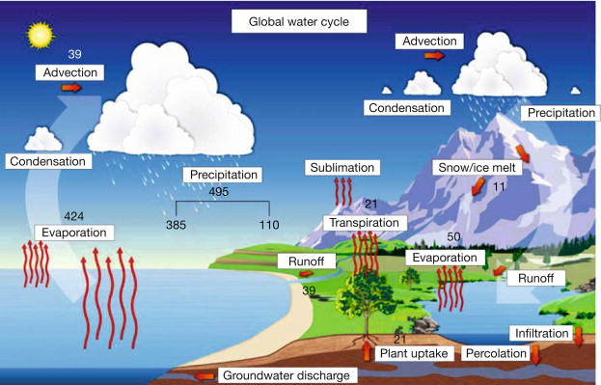

**Carbon cycle**

* + 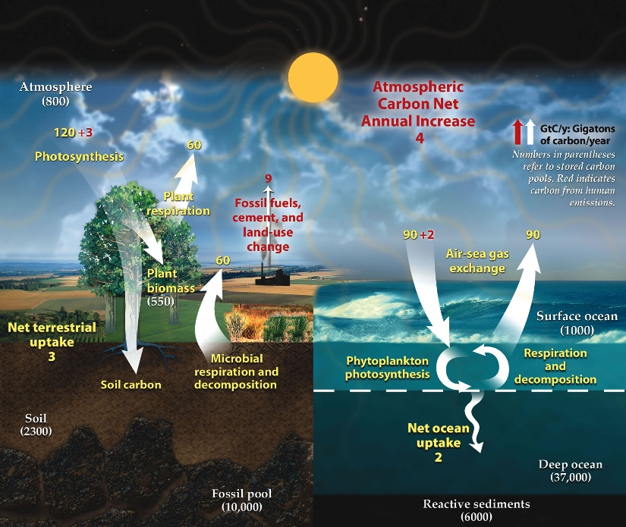

* + The carbon cycle describes the process in which carbon atoms continually travel from the atmosphere to the Earth and then back into the atmosphere.
  + Carbon is released back into the atmosphere when organisms die, volcanoes erupt, fires blaze, fossil fuels are burned, and through a variety of other mechanisms.
  + Carbon moves from the atmosphere to plants.
  + In the atmosphere, carbon is attached to oxygen in a gas called carbon dioxide (CO2).
  + Through the process of photosynthesis, carbon dioxide is pulled from the air to produce food made from carbon for plant growth.
  + Carbon moves from plants to animals.
  + Through food chains, the carbon that is in plants moves to the animals that eat them.
  + Animals that eat other animals get the carbon from their food too.
  + Carbon moves from plants and animals to soils.
  + When plants and animals die, their bodies, wood and leaves decay bringing the carbon into the ground.
  + Some are buried and will become fossil fuels in millions and millions of years.
  + Carbon moves from living things to the atmosphere.
  + Each time you exhale, you are releasing carbon dioxide gas (CO2) into the atmosphere.
  + Animals and plants need to get rid of carbon dioxide gas through a process called respiration.
  + Carbon moves from fossil fuels to the atmosphere when fuels are burned.
  + When humans burn fossil fuels to power factories, power plants, cars and trucks, most of the carbon quickly enters the atmosphere as carbon dioxide gas.
  + Each year, five and a half billion tons of carbon is released by burning fossil fuels.
  + Of this massive amount, 3.3 billion tons stays in the atmosphere.
  + Most of the remainder becomes dissolved in seawater.
  + Carbon moves from the atmosphere to the oceans.
  + The oceans, and other bodies of water, absorb some carbon from the atmosphere.
  + The carbon is dissolved in the water.

**Nitrogen Cycle**

* + 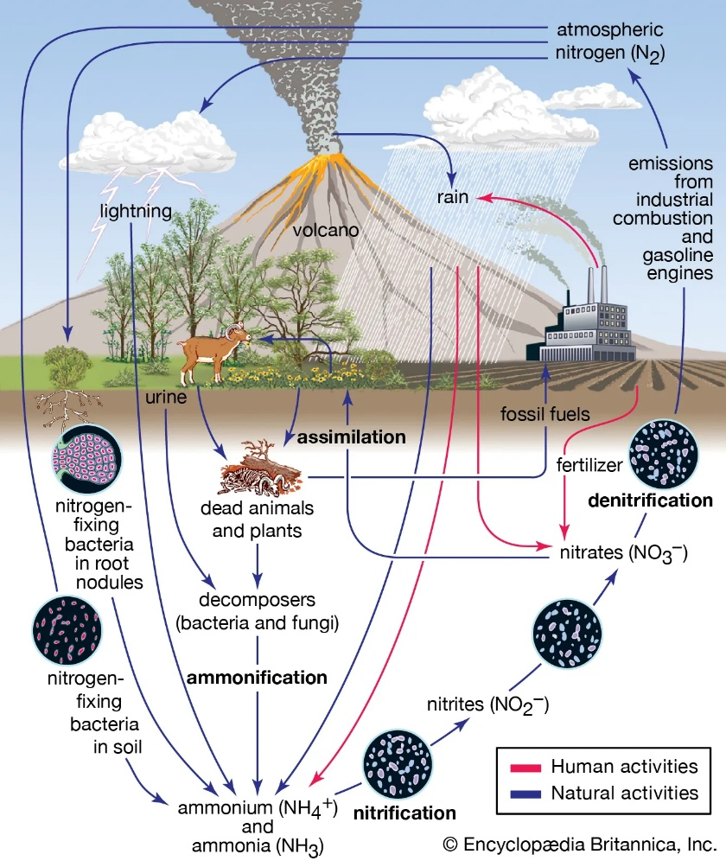
  + ödation 
    N02- 
    Nitrification 
    NOC 
    organic 
    nitrogen 
    hitieation 
    Anammox 
    NOX 
    NO 
    N20 
    Denitrification 
    oxic (oxygen) 
    NH3 
    anoxic (no oxygen) 
    N ogen 
    F ation 
  + The dominant gas of the atmosphere is nitrogen.
  + The nitrogen cycle involves the following important processes- Fixation, Ammonification, Nitrification and denitrification.
    - Fixation **-**During lightning, the high temperatures and pressures created in the air convert nitrogen into oxides of nitrogen.
      * These oxides dissolve in water to give nitric and nitrous acids and fall on land along with rain.
      * These are then utilised by various life forms.
    - Ammonification - Plants generally take up nitrates and nitrites and convert them into amino acids which are used to make proteins.
      * These proteins and other complex compounds are subsequently consumed by animals.
    - Nitrification - Once the animal or the plant dies, other bacteria in the soil(rhizobium) convert the various compounds of nitrogen back into nitrates and nitrites.
      * nitrifying bacteria (e.g. aerobic Azotobacter and anaerobic Clostridium)
      * non leguminous root nodule plants (e.g. Rhizobium) as well as blue green algae (e.g. Anabaena, Spirulina).
    - Denitrification - A different type of bacteria converts nitrates and nitrites into elemental nitrogen.

**Sedimentary cycles**

**Sulphur cycle**

* + 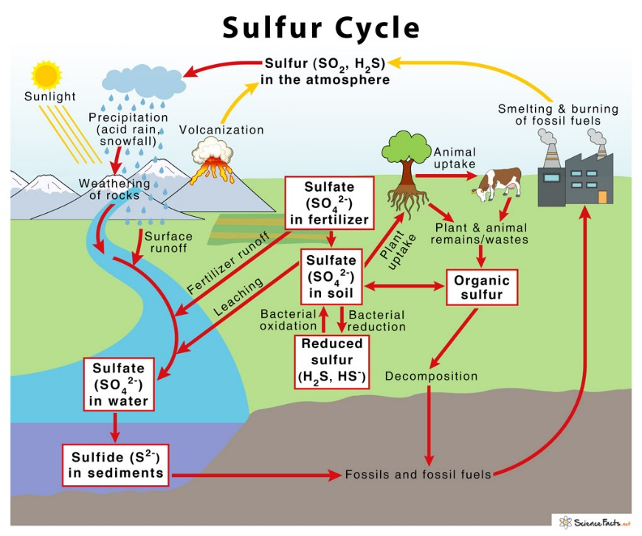
  + The sulphur is one of the most abundant elements on the earth.
  + Sulphur is released into the atmosphere by the burning of fossil fuels volcanic activities, and decomposition of organic molecules.
  + On land, sulphur is stored in underground rocks and minerals.
  + It is released by precipitation, weathering of rocks and geothermal vents.
  + The sulphur is released by the weathering of rocks.
  + Sulphur comes in contact with air and is converted into sulphates.
  + Sulphates are taken up by plants and microbes and are converted into organic forms.
  + The organic form of sulphur is then consumed by the animals through their food and thus sulphur moves in the food chain.
  + When the animals die, some of the sulphur is released by decomposition while some enter the tissues of microbes.
  + There are several natural sources such as volcanic eruptions, evaporation of water, and breakdown of organic matter in swamps, that release sulphur directly into the atmosphere.
  + This sulphur falls on earth with rainfall.

**Phosphorus cycle**

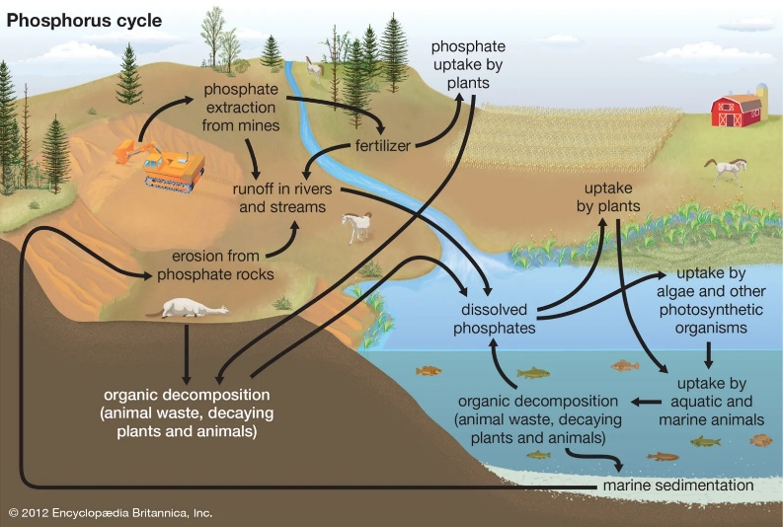

* + Phosphorus plays a central role in aquatic ecosystems and water quality.
  + Unlike carbon and nitrogen, which come primarily from the atmosphere, phosphorus occurs in large amounts as a mineral in phosphate rocks and enters the cycle from erosion and mining activities.
  + The main storage for phosphorus is in the earth’s crust.
  + On land, phosphorus is usually found in the form of phosphates.
  + By the process of weathering and erosion, phosphates enter rivers, streams and finally oceans.
  + In the ocean, phosphorus accumulates on continental shelves in the form of insoluble deposits.
  + After millions of years, the crustal plates rise from the seafloor and expose the phosphates on land.
  + After more time, weathering will release them from rock, and the cycle’s geochemical phase begins again.

### Homeostasis

* + Homeostasis is the ability of ecological systems to maintain stable system properties despite perturbations.
  + It is a self-regulatory system by which the biological systems tend to maintain stability while adjusting to conditions that are optimal for survival.
  + Ecosystems are capable of maintaining their state of equilibrium.
  + They can regulate their own species structure and functional processes.
  + For example, in a pond ecosystem, if the population of zooplankton increases, they consume a large number of the phytoplankton and as a result, food would become scarce for zooplankton.
    - When the number of zooplanktons is reduced because of starvation, the phytoplankton population start increasing.
      * After some time, the population size of zooplankton also increases, and this process continues at all the trophic levels of the food chain.
    - Note that in a homeostatic system, a negative feedback mechanism induced by the limiting resource (here its scarcity of food) is responsible for maintaining stability in an ecosystem.
    - However, the homeostatic capacity of ecosystems is not unlimited as well as not everything in an ecosystem is always well regulated.

* + The stability attained is actually a dynamic equilibrium in which continuous change occurs yet relatively uniform conditions prevail that are optimal for survival.
  + The concept of homeostasis is taken from the Gaia hypothesis by James Lovelock in 1920.
    - Gaia Hypothesis : Living organisms and their inorganic environment on Earth are tightly coupled as a complex self-regulating system, actively maintaining conditions favorable for life.
  + Any ecosystem in dynamic equilibrium tends to reach a steady-state, a balance that resists outside forces of change.
  + When such a system is disturbed built-in regulatory devices respond to the departures to establish a new balance.
  + Such a process is one of feedback control.
    - For example, control of body temperature in humans.
  + The feedback mechanisms are of two types the positive feedback and negative feedback.
  + It is the negative feedback that maintains the stability of the ecosystem.

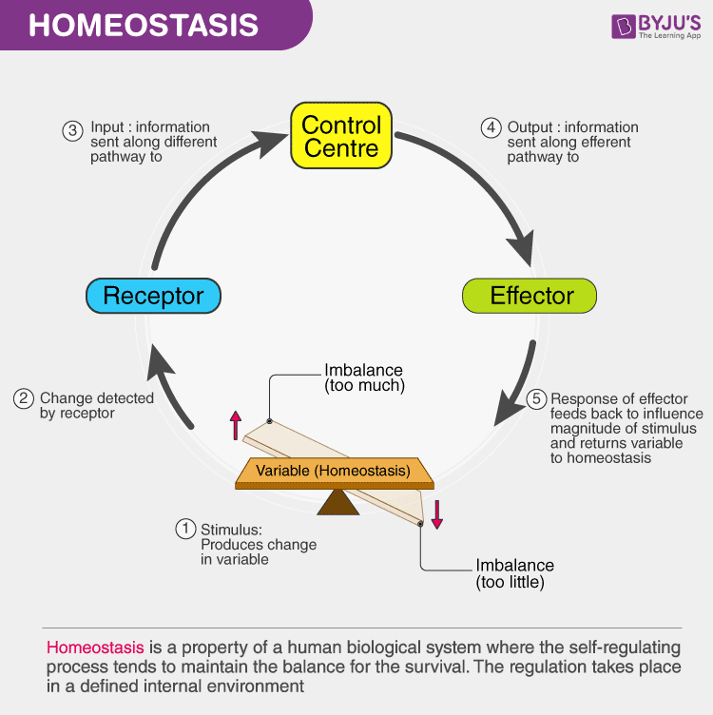

### Ecological Succession

* + The observed process of change in the species structure of an ecological community over a period of time.
  + When lichens die they decompose adding a small amount of organic matter to the soil.
  + These plants add more nutrients to the soil.
  + Shrubs and trees can survive on this soil.
  + Insects, small birds and mammals can now begin to move in.
  + What was earlier only a bare rock, now a lot of varieties can be seen.
  + It is a process of restabilization that follows a disturbance in an area where life has formed an ecosystem.

* + Secondary succession occurs on a surface where an ecosystem has previously existed.
  + It is the process by which one community replaced is by another community, partially or totally due to natural or other factors like earthquakes, floods etc.
  + The existing community will be cleared and the area begins to return to its natural conditions because this habitat previously supported life, secondary succession begins.

|  |  |
| --- | --- |
| **Primary Succession** | **Secondary succession** |
| Begins with no life. | Follows removal of existing biota. |
| No soil present. | Soil is already present. |
| New area (Volcanic Island) | Old area (Bush fire) |
| Lichens and moss come first. | Seeds and roots are already present. |
| Biomass is low. | Biomass is high. |

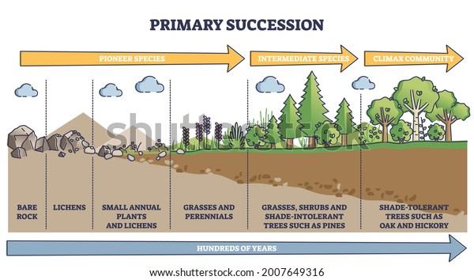

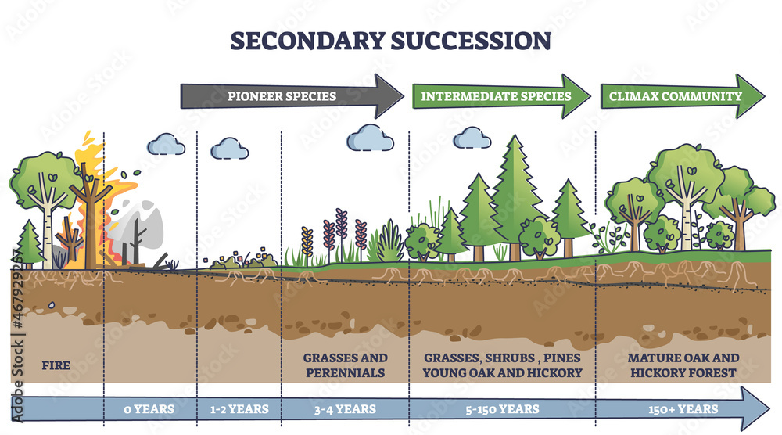

* + **Steps of succession**
    - *Nudation - Invasion - Competition - Reaction - Stabilization.*
      * *Nudation* - Formation of rock because of solidification of lava.
      * *Invasion*- It is by the pioneer species like lichens. Invasion can be of any type like migration, ecesis and aggregation.
      * *Competition* - Due to the aggregation of a large number of the species at a limited place, there develops competition for space and nutrition.
      * Co-action : Individuals of a species affect each other’s life in various ways this is called Coaction
      * *Reaction* - Reaction includes the mechanism of the modification of the environment through the influence of living organisms on it.
        + It is most important stage in ecological succession. Due to this very significant stage, changes take place in the soil, water, light conditions, temperature, etc. of the environment.
        + As a result of the reaction, the environment is modified and become unsuitable for the existing community which sooner or later is replaced by another community (serial community).
      * *Stabilization (climax species)*- The final stage of succession is called the climax community.
    - The final community is not replaced and is known as a climax community and the stage as climax stage.

**Ecosystem Services (RPSC)**

* + Ecosystem services are the many and varied benefits that humans derive from healthy ecosystems.
  + *Provisioning services -*Goods produced by the ecosystem like food, clothing, timber etc.
  + *Regulatory services* - The benefits from the regulation of ecosystem processes like purification of gases, purification of water, controlling of pests and pollination.
    - Climate regulation
    - Air and water purification
    - Flood and erosion control
  + *Supportive services -* Services that are necessary for the production of all other ecosystem services.
    - For example, water cycle, formation of soil, nutrient cycle.
    - Soil formation and nutrient cycling
    - Photosynthesis
    - Habitat provision
  + *Cultural services -*Non-material benefits people obtain from the ecosystem like recreation, aesthetic enjoyment, physical and mental health benefits.

**The Economics of Ecosystems and Biodiversity (TEEB)**

* + The economics of ecosystems and biodiversity (TEEB) is an international initiative focused on bringing the value of nature into economic decision-making.
  + It is a global initiative focused on "making nature's value visible".
  + Its principal objective is to mainstream the values of biodiversity and ecosystem services.
  + It aims to achieve this goal by following a structured approach to valuation that helps decision-makers recognise the wide range of benefits provided by ecosystem and biodiversity, demonstrate their value in economic terms and wherever appropriate capture those values in decision making.
  + *Tyler Prize for environmental achievement 2020*- Gretchen C. Daily, PhD being professor of environmental sciences, Stanford university founder of natural capital project and Pavan Sukhdev, President of WWF international founder and CEO and GIST advisor.

### Ecologically significant species

* + *Keystone species*- Those species which have a disproportionately large impact on the ecosystem. If these species are affected entire ecosystem may collapse, for example sea star which consumes mussels and hence provide space for other species. Other example, dugong, Pigmy-hog.
    - A keystone species is an organism that helps define an entire ecosystem.

* + Flagship species : are chosen to represent and raise awareness for a particular habitat, conservation issue, or environmental cause.
    - They are typically charismatic, easily recognizable, and well-liked by the public.
    - Examples, snow leopards, pandas, olive ridley turtles, swamp dear (Kanha national park) etc.

* + *Indicator species* - They indicate the health of the ecosystem. They represent the changes in the ecosystem and provide early warnings for humans.
    - For example,  Cannery bird detects CO2 and Carbon monoxide in the coalfields, liches indicated sulphur presence.
    - E.g. Frogs for water quality

* + *Umbrella species* - They have large habitats and have migratory character.
    - They occupy the larger geographical areas and the protection of these species automatically protects other species within the same habitat.
    - Examples - Elephants in savannas, polar bears, tiger, cheetah in grassland etc.

* + *Foundation species -*These are usually the primary and pioneer species.
    - They define the ecosystem and control the biological diversity of associated species and modulate critical ecosystem processes and often have important cultural values.

# BIODIVERSITY

* + Definition as given by convention of biodiversity - The variability among living organisms from all sources including territorial, marine and other aquatic ecosystems and the ecological complexes of which they are part, this includes diversity within the species, diversity among the species and the diversity between ecosystems.

**Types of biodiversity**

* + 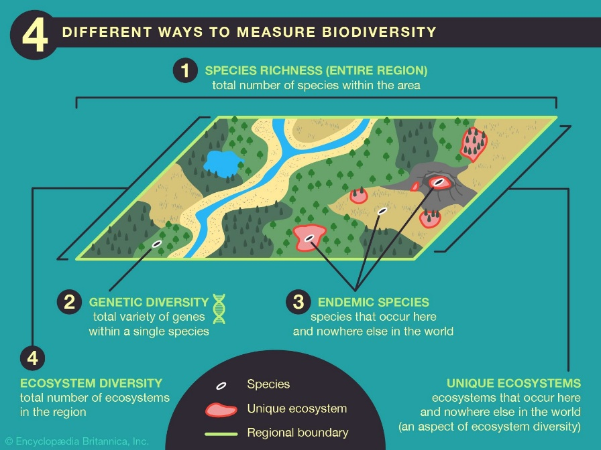

* + Biodiversity is of three types**-**Genetic biodiversity, Species biodiversity and Ecosystem biodiversity.
    - Genetic diversity - The variations within the same species that differ from another in shape, size, colour and taste due to the variation at the gene level.
      * For example, rhinos- one-horned rhinos, two-horned rhinos, Sumatran rhinos, Javan rhinos etc.
    - Species diversity, the variations among species in a given area is called species diversity.
      * For example, in the case of animals, lions, tigers, giraffes, elephants, rhinos etc.
      * For example, in the case of plants, tamarind plants, mango plants, strawberry plants etc.
    - Ecosystem biodiversity - refers to the variability among the species of plants and animals living together and connected by the flow of energy.
      * Examples, tundra ecosystem, aquatic ecosystem etc.

**Importance of Biodiversity**

* + **Ecological benefits:**
    - purification, pollination etc.
    - Life survivability
  + **Economic benefits:**
    - Medical herbs.
    - Food, shelter, clothing.
    - Tourism and recreation
    - Bioprospecting and biotechnology
  + **Social and cultural benefits:**
    - Educational importance.
    - Cultural importance - Aesthetic, worshipping, traditional knowledge (Example, GIAHS).
  + Ethical importance.

**GIAHS Sites**

* + GIAHS stands for globally important agricultural heritage system.
  + There are 3 GIAHS in India -
    - Koraput Traditional Agriculture, Odisha.
    - Kuttanad Below Sea Level Farming System, Kerala.
    - Pampore Saffron Heritage, Jammu & Kashmir.

**Threats to Biodiversity**

* + IPBES - Intergovernmental panel on biodiversity and ecosystem services, gave many reasons for threats to biodiversity.
  + Destruction of habitat
    - In the name of development, mining, construction of dams, an extension of railways and roads are destructing the habitat.
    - Rather than political refugees, environmental refugees are increasing.
    - Habitat destruction can be due to both natural and man-made factors both.
      * Natural factors - Volcanism, forest fires etc.
      * For example, due to the rise in sea level, the Cay island of Australia git submerged leading to the destruction of the great barrier reef extinction of the endemic animals.
  + Climate change and global warming
    - Rise of the sea level due to increase in temperature.
    - Coral bleaching is also an impact of the rising sea levels.
    - Melting of glaciers due to global warming.
      * For example, in place of the Chorabari glacier, we can only find Chorabari lake now.
  + Pollution
    - Excess of heavy metals (industry, roads), manure and pesticides (agriculture) and other pollutants.
  + Overexploitation
  + Invasive alien species
    - Invasive alien spies will take up the resources of all the species and will lead to the destruction of endemic species.
      * Example, PrososIs Juliflora, Cassia Uniflora, Chromolaena Odorata, Eichhornia crassipes, Lantana Camara, Parthenium hysterophorus,

## Biodiversity Conservation

* + Four parts
    - Habitat conservation
    - Species conservation
    - Reducing pollution
    - Sustainable resource use
  + The process of conservation of biodiversity involves sustainable development.
  + Habitat conservation (Two Types)
    - It also involves in situ conservation where conserving and protecting the ecosystem will protect the entire biodiversity.
    - At the same time, it includes ex-situ conservation which involves conservation measures when an organism is endangered.
    - Therefore, this means that the conservation methods of biodiversity aim at preservation, maintenance, recovery, and enhancement of the species population.
  + There are approaches to conserve biodiversity - approaches based on habitat protection & species protection and Institutional mechanism.
    - Habitat and species conservation are further divided into two types - in-situ conservation and ex-situ conservation.
      * In situ conservation means the conservation of ecosystems and natural habitats and the maintenance and recovery of viable populations of species in their natural surroundings and, in the case of domesticated or cultivated species, in the surroundings where they have developed their distinctive properties.
      * Ex-situ conservation literally means, "off-site conservation". It is the process of protecting an endangered species, variety or breed, of plant or animal outside its natural habitat.

**In-situ techniques**

* + Sacred groves.
  + Sanctuaries.
  + National parks.
  + Tiger Reserves.
  + Biosphere Reserves.

**Ex-situ Conservation**

* + Ex-situ conservation can be for both animals and plants.

**Plants**

* + Botanical gardens
  + Seed banks.
  + Cryopreservation by using liquid nitrogen.
  + Gene banks.

**Animals**

* + Zoological Park - It is a place where various living animals are kept within enclosures, displayed to the public and may be used for the study.
  + Captive breeding - Gahirmatha captive breeding centre in Orissa.
  + CCMB - centre for cellular and molecular biology.
  + LACONES - Lab for conservation of endangered species.

**Important Institutions for conservation of biodiversity in the world**

* + International Union for Conservation of Nature (IUCN)
  + Convention on International Trade in Endangered Species of Wild Fauna and Flora (CITES)
  + Convention on Migratory Species (CMS)
  + TRAFFIC
  + Convention on Biological Diversity (CBD).
  + In India, The Centre for Cellular and Molecular Biology (CCMB), India & CBD etc.

**Ecological Civilization:**

* + Ecological civilization, also known as eco-civilization, is a theoretical concept that describes a future society where humans live in harmony with nature.
  + key characteristics
    - Sustainability
    - Harmony with nature
    - Social justice and equity
    - Good governance
  + In a broader sense, ecological civilization involves a synthesis of political, economic, agricultural, educational, and other societal reforms toward sustainability.
  + Ecological Civilization reinforces the symbiosis between economic development and environmental protection.
  + Under the framework of Ecological Civilization, China claims to lead climate change cooperation, push for energy transformation and cultivate China’s renewable energy sector.

**Sacred grooves:**

* + The Sacred Groves comprises patches of forest or natural vegetation that are usually dedicated to local folk deities.
  + Sacred groves are a tract of virgin forest that is protected traditionally by the local communities as a whole and a harbour rich in biodiversity.
    - *Eg: Mal Paharia grooves.*

**Sanctuaries:**

* + Sanctuaries can be of**: a. Bird Sanctuary,**and**b. Wildlife Sanctuary.**
  + In a bird Sanctuary, special birds are taken care of. Eg: Nagaland.

* + **Wildlife Sanctuary (WfS):**
    - In Wildlife Sanctuary, a particular animal or plant is taken care of.
    - It is a natural habitat established by the government to protect a particular species of birds and animals.
    - Not restricted (Restriction is less) and open to the public.
    - Official permission is not required.
    - Boundaries are not fixed.
    - Human activity is allowed but up to a certain extent.
    - People can enter the sanctuary and can collect some forest produce, naturally grown things like honey, grass, etc.
    - It is taken care of by a Wildlife warden (He can restrict the entry of persons or number of persons for protection from damage).
    - A state government can declare a certain area as a wildlife sanctuary.
    - A state government can decide the extent of the areas, how many species can be protected, etc.
    - But information needs to be given to the MoEFCC of the Union government.
    - Can be notified by both centre and state.
    - The state government has larger say in this.
    - Tourism is allowed without any restriction.
    - Example
      * Tunga and Bhadra (Bhadra wildlife sanctuary) rivers in Karnataka.
      * Other important wildlife sanctuaries are Bhitarkanika, Periyar, Sasan Gir, Chinnar, Indian Wild Ass Sanctuary, Parambikulam, etc.

**National Parks (NPs):**

* + Animals and Habitats as a whole are protected under the national park.
  + It is a protected area established by the government to conserve wildlife.
  + Entry is highly restricted.
  + Boundaries are fixed by legislation.
  + Official permission required.
  + The state government can decide the boundary & certain areas of a national park but needs to be done in association with the central government.
  + If two or more states commonly have particular regions/areas then these concerned states in consultation with the central government can declare a national park.
  + Can be notified by both state and centre.
  + A**National park** is divided into**Core**and **Buffer zones.**
    - In**Core:**Controlled tourism.
    - In **Buffer zone:**Tourism with permission.
  + The first National park of India: **Jim Corbett.**
  + Other important national parks are Ranthambore, Bandipur, Keoladeo Ghan, Sariska, Kaziranga, Kanha, Sunderban, Gir, Dudhawa, etc.
  + The first national park of the World: **Yellowstone** National Park (USA).

**Biosphere Reserves (BRs):**

* + Biosphere is the layer of Earth where life exists. It encompasses all living organisms, as well as the air, water, and soil in which they live.
  + **BRs**can be defined as widespread areas of bio-diversity wherein fauna and flora are protected.
  + In the**early 1970s, the UN**established a project called**MAB,**which promotes **sustainable development.**
  + It can include one or moreNational Parks or sanctuaries**.**
  + Protection is granted to all the living organisms flourishing inside the boundaries of the reserve, including flora, fauna as well as the human communities who inhabit those regions.

**Functions of the BR:**

* + **a.**Conservation of Biodiversity.
  + **b.**Sustainable development.
  + **c.**Support for logistics.
  + **Structure of the biosphere:**Divided into**three**parts/zones.
    - **1. Core zone**:
      * It is the most protected area of a biosphere reserve.
      * It may contain endemic plants and animals.
      * It also represents important genetic reservoirs.
      * People and tourism are not allowed.
      * Only scientific persons are allowed for Research purposes.
    - **2. Buffer zone**:
      * Research and Education are allowed.
      * The buffer zone surrounds the core zone.
      * It includes restoration, limited tourism, fishing, grazing, etc; which are permitted to reduce its effect on the core zone
    - **3. Transition zone:**
      * It is the outermost part of the biosphere reserve.
      * Tribal people have to come under the transition zone.
      * Settlements for people and tribes are allowed.
      * Eco-tourism, croplands, and managed forests are allowed.
  + **The Nilgiri**was the**first**biosphere reserve in India.
  + The Democratic Republic of Congo**(**in**Yangambi)**got the**first**biosphere reserve in the world under**UNESCO MAB.**

* + **UNESCO MAB Programme:**
    - Launched in**1971.**
    - **UNESCO's Man and the Biosphere Programme**(MAB) is an intergovernmental scientific program that aims to establish a scientific basis for the improvement of relationships between people and their environments.
    - MAB combines natural & social sciences, economics and education to improve human livelihoods and the equitable sharing of benefits and to safeguard natural and managed ecosystems.
    - There are**18 BRs**in Indiaand out of these,**12 BRs**have been recognised by **UNESCO**under the**UNESCO MAB programme.**

**The Measurement of biodiversity: (at 6.07 PM)**

* + **Two** important parameters to measure biodiversity:
  + **Species Richness**:
    - Several species in a particular area (or NP, WLS, BRs, etc)
    - A number of species in a particular area are called species richness.
    - Species is defined as groups of genetically or functionally related individuals. They can naturally interbreed and produce fertile offspring.
      * E.g.: In a particular NP, if there are five types/species of fauna i.e. Lion, Tiger, Deer, Hyena, and Bison found then it is called species richness of that particular ecosystem.
        + Species evenness may not be maintained here.
  + **Species Evenness**:
    - How evenly species are distributed in a particular area (or NP, WLS, BRs, etc).
    - The proportion of species or functional groups present on a site.
    - A site with a low evenness indicates that a few species dominate the site.
    - The more equal species are in proportion to each other the greater the evenness of the site.

* + Biodiversity is a measure that combines richness and evenness across species.
  + Based on **richness and evenness**,**biodiversity** is measured under **three** types:
    - **Alpha biodiversity:**
      * It talks about the species richness of a habitat.
        + Richness and evenness of individuals within a habitat unit.
        + E.g.: Site A has 5 species, Site B has 7 species and Site C has 7 species.
    - **Beta** **biodiversity:**
      * Expression of biodiversity between the habitats.
      * Comparison between two habitats in biodiversity.
    - **Gamma** **biodiversity**:
      * Landscape diversity or diversity of habitats within a landscape or region.
      * It talks about the overall biodiversity of the large scale of the ecosystem.

**Biosphere Reserves (BRs) in India:**

* + **Nilgiri BR:**
    - It is sandwiched between TN, Kerala and Karnataka.
    - Nilgiri is named because a flower, named **Neelkurinji**, grows **once** in 12 years which appears bluish in colour in the region.
    - It includes the very important protected areas of Wayanad & Sendurni in Kerala, Nagarhole & Bandipur in Karnataka, Mudumalai, Neyyar, Nilambur, Siruvani hills and Silent Valley National Park.
    - **Sholas vegetation** is found here in the region.

* + **Agasthamalaya BR:**
    - It is located between Kerala and Tamilnadu.
    - An important pass is there named the **Shencotta pass**.

* + **Gulf of Mannar BR:**
    - Located between India & Sri Lanka (connected by Palk strait).
    - Adam's Bridge (also known as Ram Setu).
    - The**dugong**is found.

* + **Great Nicobar BR:**
    - This part is located in the extreme south of India.
    - where rich biodiversity is found is a known **Hot spot** in terms of biodiversity.
    - Great Nicobar is also considered a hot spot.

* + **Seshachalam BR:**
    - Situated in part of the Eastern ghat in**Andhra Pradesh.**
    - The only region of India where **Red Sandel** is found.
    - A larger spider is found.

* + **Simplipal BR:**
    - Situated in **Odisha.**
    - Mayurbhunj mining area**: Iron ore-rich**region.

* + **Amarkantak-Achanakmar BR:**
    - Situated in the parts M.P (Dindoli & Anupur) and Chhattisgarh (parts of Bilaspur).
  + **Pachmarhi:**
    - Situated in**M.P**(districts like Betul, Chhindwada, and Hoshangabad).
  + **Penna BR:**
    - It is situated between Ken and Betwa rivers.
  + **Sunderban BR:**
    - A very important species of tiger is named the **Bengal tiger.**
    - Species like Saltwater crocodiles, Rizobora, Sundari flora etc found.
  + **Kutchh BR:**
    - Situated in Gujarat.
    - Endangered species called**Wild Ass**is found here.
    - **Banni Grassland**is found.
      * Maldhari tribes are also here.
      * Indian cheetah is extinct now.
  + **Manas BR:**
    - Located in**Assam.**
    - Districts are Bongaigaon, Kokrajhar, Barpeta, Darak, Kamroop and Nalbari.
  + **Nokrek BR:**
    - Located in the**Garo hills**of Meghalaya.
  + **Dibru-Saikowa:**
    - Located in between Dibrugarh and Tinsukia region.
  + **Dehang-Dibang BR:**
    - Located in Arunachal Pradesh.
    - A valley is named Dibang.
  + **Khangchendzonga or Kanchenjunga BR:**
    - Situated in Sikkim.
    - The third highest peak in the world is found here.
    - Red Panda is found here.
    - Complete organic farming is practised here.
    - Sikkim is the first organic state in India.

* + **Cold Desert BR**:
    - Pink in H.P and Laddakh valley.
    - Chandra Tal is found.
  + **Nanda Devi BR:**
    - Situated in Uttarakhand (Chamoli, Pithoragarh and Bageshwar districts).
    - National park named the Valley of Flowers National park lies in this region.

**Conservation Reserves**

* + These are designated protected areas established under the Wildlife Protection(Amendment) Act of 2002. They typically act as buffer zones, connectors, or migration corridors between established national parks, wildlife sanctuaries, and reserved and protected forests.
  + Such areas are designated as conservation areas if they are uninhabited and completely owned by the Government of India but used for subsistence by communities and community areas if part of the lands is privately owned.
  + These protected area categories were first introduced in the Wildlife (Protection) Amendment Act of 2002 − the amendment to the Wildlife Protection Act of 1972.
  + These categories were added because of reduced protection in and around existing or proposed protected areas due to private ownership of land, and land use.
  + Some of the Conservation Reserves:
    - Beas Wetland, Tungabhadra, Manas Mata (Rajasthan), etc.

**Community Reserves**

* + Community reserves in India are terms denoting protected areas of India which typically act as buffer zones or connectors and migration corridors between established national parks, wildlife sanctuaries, and reserved and protected for subsistence by communities and community areas if part of the lands is privately owned.
  + They are managed by local communities themselves, with the support of the government and NGOs.
  + Community areas are protected area categories were first introduced in the Wildlife (Protection) Amendment Act of 2002 − the amendment to the Wildlife Protection Act of 1972.
  + These categories were added because of reduced protection in and around existing or proposed protected areas due to private ownership of land, and land use.
  + For example: Many community reserves in Meghalaya, e.g. Bandarigre, Chandigre, etc.

**Reserved Forest and Protected Areas/Forest**

* + Protected areas are those in which human occupation or at least the exploitation of resources is limited.
  + Indian Forest Act 1927, defined the Protected.
  + In year 1980, Indian Forest Act was amended.
  + The British termed the equatorial bamboo forests, they did not allow the local people to use bamboo.
  + Bamboo is not a grass product in forests, now it is considered as grass in non-forest areas.
  + It is the warden who can allow entry into the forest areas.
  + As per 2019 Forest Survey Report, 21.67% of the total geographical area is under forest coverage.
  + In the year 1950, JL Nehru said that our goal is to enhance the geographical area to 33%. That time forest cover was 28%, and it kept declining.
  + Madhya Pradesh has 77,000 Sq km of the forest, secondly, Arunachal Pradesh.
  + Percentage-wise Mizoram ranks No. 1. Arunachal Pradesh ranks No. 2 (in the forest).
  + As per the 2019 report:
    - Very Dense Forest has: 3.02%
    - Moderately Dense: 9.39%
    - Open Forest: 9.26%.

**Protected Forests:**

* + Those forests that are declared as protected forests by the government, account for more than 29% of the total forest area of the country.
  + The people are free to enter these forests, they can collect the forest produce, like Honey, timber, tubers, fruits, without degrading the forest ecosystem.
  + The local communities and the tribal people can take their cattle for grazing.

**Reserved Forest:**

* + This forest is under the direct supervision of the Government. The forest department is having a greater vigil, no public entry is allowed.
  + The tribal people are kept outside.
  + Permission is required to enter this forest.

**Village Forest/Communal Forest:**

* + The communal forest also called village forest is governed by local communities for medicinal plantation, recreation, etc.

**Social Audit:**

* + Asking the people who live in the forests about the evidence.
  + Type of citizen participation.

**Eco-Sensitive Zones**

* + In every protected area around the periphery of 10 km, a buffer should be maintained, this was to be called a Buffer Zone.
  + Ecological Sensitive Zones are fragile areas that exist within 10 km of protected areas like National Parks and Wildlife Sanctuaries.
  + The purpose of marking an Eco-sensitive Zone is to create a kind of shock absorber around the protected areas.
  + Banned Activities: Mining, Quarrying is banned, also the construction of heavy infrastructure like Bridge, flyovers, etc. polluting industries like Refineries, etc. are banned.
  + Recent Steps: E.g. Taj Trapezium Zone. Which protects Taj Mahal, Agra Fort, and Fatehpur Sikiri.

**Activities that are allowed in Eco-Sensitive Zones:**

* + Horticulture,
  + Floriculture,
  + Fruits can be grown there,
  + Small agricultural activities allowed, with organic farming, with bio-pesticides and bio-fertilizers.
  + Certain green projects like water harvesting techniques.
  + Construction of foothills, some tourism activities at small scale, like construction of rooms, cottages, with biodegradable materials, also hotels, toilets, biodegradable material.

**Biodiversity Hotspot:**

* + Biodiversity hotspots are regions on Earth that harbor exceptional concentrations of unique and threatened species in a relatively small area.
  + These are the areas that have a very rich biodiversity.
  + Just 2 to 2.5% of areas are holding more than 50% of biological diversity on the earth.
  + The concept was brought by Dr. Norman Myers, in 1988.
  + A biodiversity hotspot is a region with a rich reservoir of biodiversity, that is threatened with destruction, the concept was brought in the year 1988, by Norman Myers.
  + There are two strict criteria used to announce biodiversity hotspots:
    - First criterion: Endemism: 1500 vascular trees should be endemic (Vascular: such a giant tree that has well-developed Xylem and Phloem). This equates to at least 0.5% of the world's total.
      * For E.g. Neem is highly endemic to Monsoon type climate.
    - Second criterion: Threatened. The area has lost 70% of its original vegetation. Meaning not more than 30% of original natural vegetation is remaining.
  + There are 36 Biodiversity Hotspots
    - India is having four biodiversity hotspots.

**These 4 are in India:**

* + The Himalayas,
  + The Western Ghats and Sri Lanka,
  + Indo-Burma Region,
  + Sunda Land.

**Himalayas:**

* + It includes the entire Himalayas of India, Bhutan, Nepal, Tibet area of China, Southern China,

**Indo Burma:**

* + China, Myanmar, Lao, Cambodia, Thailand, Vietnam, etc, and entire North-Eastern India, except Assam, along with Andamans.

**Sunda Land:**

* + Southernmost islands of Nicobar, Malaysia (Malaysian Borneo is called as Sarawak), Singapore, Indonesia (with the region of Kalimantan), Brunei, (Borneo Island), etc.

**The Western Ghats and Sri Lanka:**

* + Gujarat, Maharashtra, Goa, Karnataka, Tamil Nadu, Kerala, Palk Street, Sri Lanka.
  + CEPF: Funds to protect the Biodiversity Hotspots (by Conservation International).

**Mega Biodiverse Countries:**

* + The Mega Biodiverse Countries are the rich biodiversity countries with the greater gene pool.
  + These countries acts as solutions for biodiversity threats.
  + The criteria for announcing any country as a megadiverse country:

**Criteria:**

* + It should be having at least 5000 world plants as endemic.
  + It should have a marine ecosystem within its borders.
  + 17 countries including India.

**Like-Minded Mega Diverse Countries:**

* + Like-Minded Megadiverse Countries (LMMC) is a group of countries that harbour the majority of the Earth's species and are therefore considered extremely biodiverse.
  + They are rich in biological diversity (60-70% of the world’s biodiversity) and associated with traditional knowledge.
  + They are called Like-Minded Mega Diverse Countries (12 Mega diverse + 6 others) India is a member of LMMC.

## Institution-based conservation techniques

### International Union for Conservation of Nature (IUCN):

* + It is a non-governmental organization.
  + 1300 organization, many environmental experts are there.

**Commissions on focus:**

* + CEC: Commission on Education and Communication: Promoting ecosystem-based approach.
  + CEM: Commission on Ecosystem Management: Harmonizing nature conservation, social, cultural issues.
  + CEESP: Commission on Environmental, Economic and Social Policy: influencing, encouraging and assisting societies to conserve biodiversity.
  + SSC: Species Survival Commission: advancing environmental law, sustainable development.
  + WCEL: World Commission on Environmental Law: developing knowledge-based policy.
  + WCPA: World Commission on Protected Areas: mobilizes action in science, conservation, policy, and engagement.

**IUCN World Conservation Congress 2020**

* + It is the world's largest congregation of Scientists
  + More than 10000 scientists all over the world will attend the meeting every four years.

#### *Threatened species of India:*

##### Critically Endangered Species in India:

* + Himalayan Brown Bear:
    - Found in Nepal, Tibet, north India, north Pakistan.
  + Pygmy Hog
    - Assam, it is a keystone species, they construct nests, they are the world’s smallest pigs.
  + Namdapha Flying Squirrel:
    - Unique flying squirrel found only in Namdapha, Arunachal Pradesh (hunted for food).
  + Sumatran Rhinoceros:
    - Smallest and most endangered of the five rhinoceros.
    - Regionally extinct from India
  + Malabar Civet:
    - Found in the Western Ghats, faces the loss of habitat.
  + Kashmir Stag/Hangul:
    - It is a subspecies of Red Deer.
    - Also called as Hangul, was the State animal of Jammu and Kashmir.
  + Peacock Tarantula:
    - Also called as Ornamental Tarantula.
    - Found in Andhra Pradesh, India.
    - Habitation is Nallamala forest area.
  + Jerdon’s Courser (Kalivi Kodi):
    - Endemic to eastern ghat of Andhra Pradesh.
  + White-bellied Heron:
    - Found in five/six states: Assam, Arunachal, etc, and in Bhutan, Myanmar, etc.
    - It is mostly solitary and occurs in undisturbed riversides or wetlands.

##### Endangered Species

* + Indian Wild Ass.
    - Gujarat - Raan of Kutch BR
    - Loss of habitat, due to salt activities, invasive species like Prosopis Juliflora shrub, and encroachment and grazing by the Maldhari community.
    - For reviving the Indian Wild Ass: Captive breeding is done.
    - Captive breeding center at Arignar Anna Zoological Park, Tamil Nadu.
  + Indian Pangolin
    - Pangolin and Chinese Pangolin occur in India.
    - Indian Pangolin is a large anteater.
    - Found in India, Pakistan, Nepal, Sri Lanka.
    - Radio tagging is done on Pangolin to conserve them.
  + Red Panda:
    - Status: Moved from vulnerable to endangered recently.
    - Red Panda is endemic to temperate forests of the Himalayas.
    - Habitat: Sikkim and Assam, northern Arunachal Pradesh.
  + Lion-tailed Macaque:
    - Endemic to the Western Ghat.
    - Avoid human presence and they do not live.
    - Habitat : Evergreen forests in the Western Ghat range.
    - Threat : Habitat fragmentation due to spread of agriculture and tea, coffee, teak and cinchona.
  + Nilgiri Tahr:
    - Nilgiri Tahr is the largest of the three Tahrs (Saudi, Himalayan are the other two).
    - Found in Montane grassland of Western Ghats. It is the state animal of Tamil Nadu.

##### Vulnerable Species:

* + Indian One Horned Rhinoceros
    - Found only in the tall grasslands and forests in the foothills of the Himalayas (Terai regions).
    - National Parks: Kaziranga National Park, Pabitora Wildlife Sanctuary, Manas National Park, Assam.
    - Status: Vulnerable.
    - Threats: Oriental belief that its horn, among other parts, has medicinal properties, habitat loss, habitat fragmentation.

* + Dugong (Sea Cow)
    - Feed on seagrass.
    - Habitat: Gulf of Mannar, Gulf of Kachchh and Andaman and Nicobar Island, Gulf of Mexico, Amazon Basin, West Africa.
    - Threat : Coastal development, red tide, hunting.
    - Red tide: Bloom of algae, and weed, red tide happens when more acidification, increase in temperature occurs.
    - Species are getting threatened.

### CITES

* + Convention on International Trade in Endangered Species of Wild Fauna and Flora, also known as Washington Convention.
  + It was drafted as a result of a resolution adopted in 1963, at the IUCN meeting.
  + To ensure survival of species, avoid smuggling, allow limited trade in protected species.
  + CITES came into force on 1 July, 1975.
  + It has protected 38,000 species of animals and plants.
    - E. g. Veerappan used to smuggle Sandalwood from Sathyamangalam Forest.
  + CITES has Appendix 1, 2, 3.
    - Appendix I: Includes species threatened with extinction. Trade is completely banned.
    - Appendix II: Includes species that are not necessarily threatened with extinction, but may become so if trade is not controlled. Permitted trade is allowed.
    - Appendix III: Includes species that are protected in at least one Party to the Convention, which has requested other Parties to assist in controlling trade. Trade in specimens of these species requires a certificate of origin. Control on the species is very little.

**Functions of CITES:**

* + To distribute information, facilitate identification of specimens of species included in the appendices,
  + Information relevant to several or all parties.
  + Proposal to amend appendices.

**CITES Vision:**

* + Conserves biodiversity and contributes to its sustainable use, by ensuring that there is no wild fauna or flora that becomes or remains subject to unsustainable exploitation through international trade.
  + Hence, contributing to a significant reduction in the rate of loss of biodiversity.
  + CITES COP 18: Held in August 2019 at Geneva Switzerland.
  + Due to Pandemic, COP 19 has been postponed.
  + India has proposed to remove Rosewood (Dalbergia sissoo) VU from Appendix II of CITES.
    - The species grows at a very fast rate and has the capacity to become naturalized outside its native range, it is invasive in other parts of the world as well.
    - India has also proposed to transfer small-clawed otters (Aonyx cinereus), VU smooth-coated otters (Lutrogale perspicillata), VU Indian Star Tortoise (Geochelone Elegans) VU.
      * Indian Star Tortoise is found in Gahirmatha, Odisha (close to Bhitarkanika Mangroves).

### TRAFFIC

* + This is an acronym for Trade Records Analysis of Fauna and Flora in Commerce, a joint program of the World Wildlife Fund (WWF) and the International Union for Conservation of Nature (IUCN).
  + Goal: TRAFFIC works to monitor and analyze illegal wildlife trade and promote sustainable trade in wildlife products.
    - For e.g. trade in medicinal plants.
  + Activities: They conduct research, investigations, and awareness campaigns to combat illegal wildlife trade and support legal and sustainable trade practices.
  + Wildlife Trade Monitoring Network, is the leading non-governmental organization working globally on the trade of wild animals and plants in the context of both biodiversity and sustainable development.
  + It was founded in 1976 as a strategic alliance of the World Wide Fund for Nature (WWF) and the International Union for the Conservation of Nature (IUCN).
  + The organization's aim is to ‘ensure that trade in wild plants and animals is not a threat to the conservation of nature’.
  + It states that through research, analysis, guidance and influence, it promotes sustainable wildlife trade (green stream work) and combats wildlife crime and trafficking (the red stream work).
  + “Don’t Buy Trouble” is one of TRAFFIC India’s first consumer awareness campaigns that advises tourists to be careful of what they buy as souvenirs during their travels.

### RAMSAR Convention

* + It is the only convention that was not under the umbrella of the United Nation.
  + By seeing the participation of the global community, RAMSAR was brought under the United Nations.
  + Until 1970, there was no such formal recognition as ‘wetland’.
  + Wetland was considered as the swamp, marsh, etc.
  + Over 2,400 wetlands have been designated as Ramsar Sites, covering an area of more than 2.5 million square kilometers.
  + Recent estimates show that 64 % or more of the world’s wetlands have disappeared since 1900.

**Montreux Record:**

* + The Montreux Record is a register of listed Ramsar sites where changes in ecological character have occurred, or occurring, or likely to occur as a result of technological developments, pollution or other human interference.
  + Those wetlands which are degrading, degraded, or about to degrade.
  + Two wetlands are still there on Montreux Record
    - Loktak Lake (Keibul Lamjao National Park of Manipur, has Sangai Deer/Dancing Deer)
    - Keoladeo National Park (Bharatpur National Park).
  + Objectives
    - Conservation and sustainable utilization of wetlands
    - Stop the encroachment and loss of wetlands.
  + The Ramsar Convention works closely with six organizations.
    - Birdlife International
    - International Union for Conservation of Nature (IUCN)
    - International Water Management Institute (IWMI)
    - Wetlands International
    - WWF International
    - Wildfowl & Wetlands Trust (WWT)
  + **Key features of the Ramsar Convention:**
    - Recognition to the vital role that wetlands play in maintaining the health of our planet.
    - Wise use: The Convention promotes the wise use of wetlands.

**Wetland Definition:**“Areas of marsh, swamp, peatland or water, whether natural or artificial, permanent or temporary, with water that is static or flowing, fresh, brackish or salt, including areas of marine water the depth of which at low tide does not exceed six meters”

* + The Ramsar Strategic Plan: Three pillars action:
    - Working towards the wise use of their wetlands through a wide range of actions
    - Further identification, designation, and management of a comprehensive suite of sites for the List of Wetlands of International Importance
    - Cooperating internationally in the delivery of wetland conservation.

* + **Why is wetland important?**
    - Biodiversity protection
    - Water management
      * Regulating water flow, reducing flooding and replenishing groundwater.
      * Storage of freshwater.
    - Climate change mitigation
    - Economic and domestic purpose.

**Ramsar Sites of India (Important)**

* + Ashtamudi Lake: One of the Kayals of Kerala.
  + Beas Conservation Reserve, Punjab: Man-Made wetland.
  + Bhitarkanika Mangroves, Odisha: It has Saltwater crocodiles, Olive Ridley Turtles
  + Bhoj Wetland, Madhya Pradesh: Constructed by Raja Bhoj.
  + Chander Tal, Himachal Pradesh.
  + Chilika Lake, Odisha: Largest saltwater/brackish water lake.
  + Deepor Beel: Assam.
  + East Kolkata Wetlands: West Bengal.
  + Harike Wetland: Punjab.
  + Hokera Wetland: UT of Jammu and Kashmir
  + Kanjli Wetland: Punjab
  + Keoladeo National Park: Rajasthan (still a Montreux Record).
  + Keshopur-Miani Community Reserve: Punjab
  + Kolleru Lake: Andhra Pradesh
  + Loktak Lake: Manipur
  + Nalsarovar Bird Sanctuary: Gujarat
  + Nandur Madhmeshwar, Maharashtra
  + Nangal Wildlife Sanctuary, Punjab
  + Nawabganj Bird Sanctuary, Uttar Pradesh
  + Parvati Arga Bird Sanctuary Uttar Pradesh
  + Point Calimere Wildlife and Bird Sanctuary, Tamil Nadu
  + Pong Dam Lake Himachal Pradesh
  + Renuka Lake Himachal Pradesh
  + Ropar Wetland Punjab
  + Rudrasagar Lake Tripura
  + Saman Bird Sanctuary Uttar Pradesh
  + Samaspur Bird Sanctuary Uttar Pradesh
  + Sambhar Lake Rajasthan
  + Sandi Bird Sanctuary Uttar Pradesh
  + Asan Conservation Reserve Uttarakhand
  + Kabarthal Wetland Bihar
  + Lonar Lake, Maharashtra
  + Tso Kar wetland complex Union Territory of Ladakh
  + Sur Sarovar Uttar Pradesh. etc.
  + **Haiderpur of UP was added on 8th December 2021.**

### Convention on Biodiversity (CBD)

* + In 1992, at the Rio Earth Summit, formulated Agenda 21.
    - Protection of Climate, Biodiversity, combating Desertification was decided.

* + Has three additional protocols addressing specific aspects of biodiversity
    - Cartagena Protocol on Biosafety (regulates the transboundary movement of living modified organisms).
    - Nagoya Protocol on Access to Genetic Resources and the Fair and Equitable Sharing of Benefits Arising from their Utilization (establishes a legal framework for fair and equitable sharing of benefits from genetic resources).
    - International Treaty on Plant Genetic Resources for Food and Agriculture (protects the rights of farmers and ensures fair access to plant genetic resources for food and agriculture).

* + The Nairobi Conference adopted and agreed on the text of the Convention on Biological Diversity – CBD
  + The convention was opened for signature on 5th JUN 1992 at ”The United Nations Conference on Environment and Development UNCED popularly called as The Rio “Earth Summit”.
  + The convention entered into force on 29 December 1993.
  + Since then, many countries were working toward saving biodiversity based on the convention.

* + **Objectives of CBD**
    - **Conservation of Bio-diversity -**
      * Ex Situ measures like Gene bank, Artificial seed bank, etc.
      * In Situ measures like National park, Biosphere reserves, etc.
    - **The sustainable use of the components of biodiversity -**
      * Integrate the consideration of the conservation and sustainable use of biological resources into national decision making
      * Encourage cooperation between governmental authorities and its private sector in developing methods for sustainable use of biological resources.

* + **The fair and equitable sharing of the benefits arising out of the utilization of genetic resources -**
    - Appropriate access to genetic resources
    - An appropriate transfer of relevant technologies
    - Appropriate funding, thereby contributing to the conservation of biological diversity.

* + **Convention Bodies**
    - **Conference Of Parties (COP)**
      * The Conference of the Parties is the governing body of the Convention and advances implementation of the Convention through the decisions it takes at its periodic meetings.
    - **Subsidiary Body on Scientific, Technical and Technological Advice (SBSTTA)-**
      * SBSTTA is responsible for providing recommendations to the COP on the technical aspects of the implementation of the Convention.
      * To meet the objectives of CBD there are **two protocols:**
        + Cartagena Protocol on Biosafety and Nagoya Protocol

* + **The Cartagena Protocol**
    - This is an international treaty governing the movements of living modified organisms (LMOs) resulting from modern biotechnology from one country to another.
    - It entered into force on 11 Sept 2003.
    - **Objective**
      * The objective of this Protocol is to contribute to ensuring an adequate level of protection in the field of the safe transfer, handling, and use of living modified organisms resulting from modern biotechnology that may have adverse effects on the conservation and sustainable use of biological diversity, taking also into account risks to human health, and specifically focusing on transboundary movements.
    - The Cartagena protocol assists developing countries in building their capacity for managing modern biotechnology.
    - It creates an **Advanced Informed Agreement (AIA)** procedure that requires exporters to seek consent from importing countries before the first shipment of LMOs meant to be introduced into the environment (e.g. seeds for planting, fish for release, and microorganisms for bioremediation)
    - It establishes an internet-based **“Biosafety Clearing-House”** to help countries exchange scientific, technical, environmental, and legal information about LMOs.
    - It requires bulk shipments of LMO commodities, such as corn or soybeans that are intended to be used as food, feed, or for processing, to be accompanied by documentation stating that such shipments “may contain” LMOs and are “not intended for intentional introduction into the environment”.
    - The Protocol includes a clause that makes clear the Parties’ intent that the agreement does not alter the rights and obligations of governments under the World Trade Organization (WTO) or other existing international agreements.

* + **The Nagoya Protocol**
    - The Nagoya Protocol on Access to Genetic Resources and the Fair and equitable Sharing of Benefits Arising from their Utilization to the Convention on Biological Diversity is an international agreement that aims at sharing the benefits arising from the utilization of genetic resources in a fair and equitable way and contributing to the conservation of biological diversity and the sustainable use of its components.
    - It was adopted by CBD at its tenth meeting on 29 October 2010 in Nagoya, Japan.
    - This protocol came into force on 12 October 2014.
    - The Nagoya Protocol consists of **three elements**:
      * First, the contracting parties may regulate access to biological materials (“genetic resources”) originating from their territories. States that choose to do so, are called “provider countries”.
      * Second, these provider countries may also require that “benefits” from using the biological materials are fairly shared. Together, these requirements are known as **Access and Benefit-Sharing (“ABS”) rules**.
      * Third, all contracting parties must monitor the use of biological material on their territory to ensure that companies comply with the ABS rules where the material originated.

* + **Aichi Biodiversity Targets**
    - Strategic Goal A: Address the underlying causes of biodiversity loss by mainstreaming biodiversity across government and society
    - Strategic Goal B: Reduce the direct pressures on biodiversity and promote sustainable use
    - Strategic Goal C: To improve the status of biodiversity by safeguarding ecosystems, species, and genetic diversity
    - Strategic Goal D: Enhance the benefits to all from biodiversity and ecosystem services
    - Strategic Goal E: Enhance implementation through participatory planning, knowledge management, and capacity building

**Convention on Biodiversity and India**

* + India is one of the first few countries to have enacted appropriate comprehensive legislation to achieve the objectives of the convention.
  + India is one of the 17 mega-diverse countries, which together possess 60-70 percent of the world’s biodiversity.
  + The 17 Mega countries rich in biological diversity and associated traditional knowledge have formed a group known as **Like-Minded Mega diverse Countries (LMMC)**.

* + **The Biological Diversity Act of 2002**
    - This Act provides necessary statutory and administrative mechanisms at the national level.
    - The main intent of the legislation is to protect India’s rich biodiversity and associated knowledge against their use by foreign individuals and organizations without sharing the benefits arising out of such use and to check bio-piracy.
    - The **National Biodiversity Authority (NBA)**, established in Chennai, is the key mechanism at the national level for implementing the provisions of the Biodiversity Act, 2002.

* + **Salient Features**:
    - To regulate access to biological resources of the country equitable share in benefits arising out of the use of biological resources.
    - To conserve and sustainable use of biological diversity.
    - Setting up of **National Biodiversity Authority (NBA)**, **State Biodiversity Board (SBB),** and **Biodiversity Management Committee’s (BMC’s)**.
    - NBA and SBB are required to consult BMCs in decisions relating to bio-resource / related knowledge within their Jurisdiction.
    - To respect and protect the knowledge of local communities’ traditional knowledge related to biodiversity.
    - To secure sharing of benefits with local people as conservers of biological resources and holders of knowledge and information relating to the use of biological resources.
    - All foreign nationals/organizations require prior approval of the NBA for obtaining biological resources and/or associated knowledge for use.
    - Indian scientists/individuals require approval of the NBA for transferring results of research to foreign nationals/organizations.
    - Conservation and development of areas of importance from the standpoint of biological diversity by declaring them as Biological diversity Heritage Sites(BHS).
    - Protection and rehabilitation of threatened species.

* + **People’s Biodiversity Register (PBR)**
    - The main function of the BMC is to prepare Peoples Biodiversity Register in consultation with local people.
    - The Register shall contain comprehensive information on availability and knowledge of local biological resources, their medicinal or any other use or any other traditional knowledge associated with them.

* + **Biopiracy:**
    - To check biopiracy, the proposed legislation provides that access to biological resources and associated knowledge is subject to terms and conditions, which secure equitable sharing of benefits.
    - Further, it would be required to obtain the approval of the National Biodiversity Authority before seeking an IPR based on biological material and associated knowledge obtained from India.

* + **Biodiversity Heritage Sites (BHS):**
    - Biodiversity Heritage Sites” (BHS) are well defined areas that are unique, ecologically fragile ecosystems
    - Biodiversity heritage sites (BHS) should include both wild and domesticated biodiversity and human cultural relations with such biodiversity.
    - It is important to focus while declaring Biodiversity Heritage sites on some aspects like -
      * Local communities would be central to such a process including in identifying and deciding on the potentials of BHS.
      * Both Traditional knowledge and modern scientific knowledge could be used for the process of management of BHS
      * Involvement of marginalized sections of communities including women should be ensured their involvement in BHS.
      * Government Institutions, NGOs, Teachers should facilitate local communities for capacity building for managing BHS.
      * Institutional linkages between and among the existing institutions like panchayats, gram sabhas, village/tribal council, urban wards should be planned for managing the BHS.
    - Without prejudice to any other law for the time being in force, the State Government may, from time to time in consultation with the local bodies, notify in the Official Gazette, areas of biodiversity importance as biodiversity heritage sites under this Act.
    - The State Government, in consultation with the Central Government, may frame rules for the management and conservation of all the heritage sites.
    - The State Government shall frame schemes for compensating or rehabilitating any person or section of people economically affected by such notification.

**India - National Biodiversity Targets**

* + India developed 12 National Biodiversity Targets in line with 20 global Aichi biodiversity targets.
  + The 12 targets were explained with the help of the chart provided in the handout.
  + India submitted its **sixth national report (NR6)** to the Convention on Biological Diversity (CBD) during the inaugural session of the meeting of the State Biodiversity Boards (SBBs) organized by the National Biodiversity Authority (NBA).
  + The NR6 highlights the progress India has made in achieving the 12 National Biodiversity Targets (NBT) set under the convention process.
  + With this India is among the first five countries in the world, the first in Asia, and the first among the biodiversity-rich megadiverse nations, to have submitted Sixth National Report (NR6) to the Convention on Biological Diversity (CBD).
  + The submission of national reports is a mandatory obligation on parties to international treaties, including the CBD.

* + **Highlights of Report**
    - India is one of the few countries where forest cover is on the rise, according to the 15th India State of Forest Report (ISFR) 2017.
    - While India has exceeded/overachieved two NBTs, it is on track to achieve eight NBTs and in respect of the remaining two NBTs also, India is striving to meet the targets by the stipulated time of 2020.
    - More than 20% of India’s total geographical area is under biodiversity conservation, India has exceeded the terrestrial component of 17% of Aichi target 11.
    - India published the first internationally recognized certificate of compliance (IRCC) under the Protocol in 2015, and since then published nearly 75% of the IRCCs. Thereby, achieving targets relating to access and benefit-sharing (ABS) by operationalizing the Nagoya Protocol on ABS.
    - The population of Lion has risen to over 520 in 2015, and elephants to 30,000 in 2015.
    - One-horned Indian Rhino which was on the brink of extinction during the early 20th century is now number 2400.
    - Further, while globally over 0.3 % of total recorded species are critically endangered, in India only 0.08% of the species recorded are in this category.
    - Measures have been adopted for sustainable management of agriculture, fisheries, and forests, with a view to providing food and nutritional security to all without destroying the natural resource base while ensuring intergenerational environmental equity.
    - Programs are in place to maintain the genetic diversity of cultivated plants, farms livestock, and their wild relatives, towards minimizing genetic erosion and safeguarding their genetic diversity.
    - Mechanisms and enabling environments are being created for recognizing and protecting the vast heritage of coded and oral traditional knowledge relating to biodiversity.

### Convention on Migratory Species (CMS)

* + The convention was signed at Bonn in Germany.
  + Includes Avian, terrestrial animals, Sea or marine species.
  + CMS - COP 13 at Gandhinagar Gujarat
  + GIBI - The Great Indian Bustard was the muscat of COP 13.
  + Snow leopard, Irrawaddy dolphins, Great Indian Bustard, Dugong, Bengal Florican, etc. were highlighted at this meeting.
    - The topic was explained in brief using the Website of CMS.

**The Hope Spot**

* + A Hope Spot is any special place that is critical to the health of the ocean.
  + These are the **special areas** that are rich in biodiversity and they **play a vital role** in conserving the health of the water body.
  + They include all the marine-protected areas of the world.
  + **Dr Sylvia Earle brought the concept of Hope Spots.**
  + In**India there are two hope spots**:
    - **Andaman Nicobar Islands:**
      * The GoI through Island Development Agency(IDA) is protecting the marine protected areas along with some developmental activities.
      * The **Home Minister is the Chairman** of IDA.
      * The Secretary of the Home Ministry is overseeing the program and the developmental projects are introduced in a phased manner.
      * The GoI is planning to launch planes that can land on the water for the promotion of tourism.
      * **Three islands of Andaman Nicobar are renamed by GoI:**
        + The Ross Island to Subhash Chandra Bose Island.
        + The Neel Island to Shaheeddweep.
        + The Havlok Isaland to Swaraj Dweep.
    - **Lakshadweep Islands:**
      * It is home to some of the**most diverse reefs**in India.
  + GoI is planning to get recognition for **Blue Flag Certification**.
  + The Blue Flag certification is **awarded by a non-profit organization called the Foundation for Environmental Education (FEE).**
  + As of September 2021, **Ten Beaches in India** have been awarded the prestigious certification, namely:
    - Golden Beach – Odisha
    - Shivrajpur Beach – Gujarat
    - Kappad Beach – Kerala
    - Ghoghla Beach – Diu
    - Radhanagar Beach – Andaman and Nicobar
    - Kasarkod Beach – Karnataka
    - Padubidri Beach – Karnataka
    - Rushikonda Beach – Andhra Pradesh
    - Kovalam Beach – Tamil Nadu
    - Eden Beach – Puducherry

### The Biomes of the World

* + Biomes are the group of ecosystems where **there is similar climatic conditions, vegetation and species composition exists.**
  + They may be composed of different ecosystems.

**Equatorial Biome**

* + **Areas:** Amazon rainforest, Congo-Zaire of Africa, Borneo rainforest of Malaysia & Indonesia, etc.
  + **Species:**
    - **Plants :** Mahogony, Ebony, Cabinet wood, Dyewood, Bamboos, etc.
    - **Animals : Arboreal animals** (those who spend time on the tress for example Chimpanzees, gorillas, apes, orangutans, etc), Anacondas, Varieties of snakes (mainly nonvenomous), Tsetse fly (Causes the sleeping sickness Nagana disorder).

**Savanah Biomes**

* + **Tropical Grasslands** (from 10 to 30 degrees in both N& S)
  + **Areas**: Sudan, Kenya, Tanzania, Uganda, Nigeria , Niger, C. Australia, South America, Brazil/Argentina(**Campos**) and Venezuela(**Llanos**).
  + **Flora**: Elephant grass(10 to 15 ft), Baobabs(critically endangered).
  + **Fauna**:  Lion, tiger, faux, deer's, antelopes, giraffe, rhinos, etc.

**Desert Biome**

* + **Areas**: Sahara, Atacama, the great Australian desert, Thar, Mojave & Sonoran of the USA, Kalahari & Namibia of Africa, the Taklamakan of China, etc.
  + **Plants**: Xerophytic plants (having thorns and spikes on their body (cactus, acacia, bulbous, etc.)
  + **Animals**: Reptiles (rattlesnakes, spiders), Mammals(camel)

**The Mediterranean Biome:**

* + Located **between 30 to 45 degrees in N & S** hemispheres.
  + The countries around the Mediterranean seas, the Western USA(California), Tip of South Africa, Chile(Santiago), South West & Southeast part of Australia.
  + **Flora :**Olive, Cork, oranges, lemons, melons, grapes (this region is also known as wine capital because of great quality 7 variety of grapes).
  + Shrubs like scented varieties like Rosemary, lavenders, laurel, arbutus, myrtle (cosmetic capital of the world).

**The Temperate Biome**

* + **Areas**: the UK, Laurentia region, western Canada(British Colombia).
  + **Flora**: Maple, Birch, Silver, Willows, Beech, Juniper, Oak, Rhododendron, etc.

**The Temperate Grassland Biome (steppe type)**

* + North America: Prairies
  + Europe: Steppe
  + South America: Pampas
  + South Africa: veldts.
  + Australia: Downs.
  + New Zealand: Canterbury plains.
  + Hungary: Pustaz.
  + China: Manchurian grasslands.

**The Taiga Biomes**

* + Found **only in the Northern hemisphere** (because of the absence of land in this latitude in the Southern hemisphere)
    - The area between 65 to 80 degrees of Northern Latitude.
      * Norway & N. Sweden, Finland.
      * Russia: Siberian plains & Kamchatka Plains.
  + **Flora**: Pine, spruce, fir, larch.

**Tundra Biomes**

* + Polar Areas in both North & South hemispheres.
  + **Floras** : Lichens & Mosses.
  + **Fauna** : Polar bear, penguins, Ibex, seal, walrus, reindeer, Arctic fox, etc.
  + **Tribes:**
    - Eskimos: Canada & Greenland
    - Lapps : Norway & Finland.
    - Samoyeds : Northern Russia.
    - Yakuts : N. Russia.
    - Chukchee's : N. Russia.

### The Biogeographical Zones of India

* + Based upon the geographical conditions **every species have a certain range of tolerance** that decides their distribution.
  + The study of the **distribution of species wrt the geographical condition was done by Mr Panwar and Rodgers** of the Wildlife Institute of India and classified India into 10 biogeographical zones.
    - (refer to the Handouts for the classification).
    - 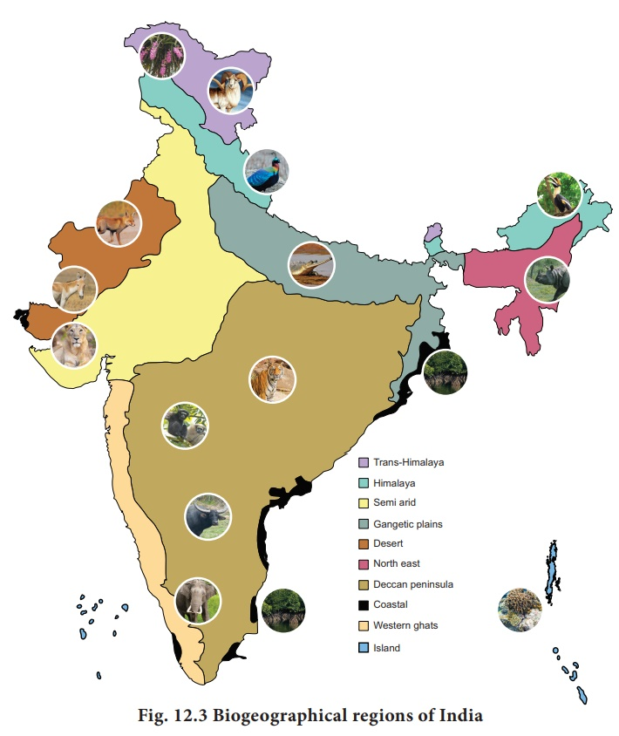

## Global Warming and Climate Change

* + Climate change refers to long-term shift in temperature and weather patterns.
    - Change in temperature patterns
    - Precipitation patterns
    - Extreme weather events
    - Ocean currents
  + The book **Silent Spring** written by **Rachel Carson** highlighted this issue into prominence.
  + **Our Common Future** article by **Brundtland** highlighted the concept of Sustainable Development.
  + After World War II, and the formation of the United Nations, the need for preserving the environment was felt.
  + Environmentalists like **Wangari Mathai etc**. have contributed to the conservation efforts.
  + Silent Spring a book by Rachel Carson created awareness about environment conservation.

* + On 5th June 1972, the Stockholm Convention established the UNEP (United Nations Environment Programme).
  + UNEP is headquartered in Nairobi (Kenya).

**World Meteorological Organization:**

* + WMO is responsible for promoting international cooperation on atmospheric science.
  + It is also concerned with climatology, etc.

**Intergovernmental Panel on Climate Change (IPCC):**

* + It was founded in 1988.
  + It is an intergovernmental body.
  + An organization that can study the changes in the world environment.
  + IPCC is responsible for submitting reports: Assessment Reports (ARs).
    - It has to submit reports regularly.
    - 6 Assessment Reports have been submitted by IPCC.
  + First Assessment Report was published by IPCC in 1990.
    - It was about the degradation of the environment, urgent need for action.
    - Based on this 1990 Report by IPCC, a summit called the United Nations Convention on Environment and Development(UNCED) also called as '**earth summit**' was conducted in 1992.
    - Agenda 21 was charted at the UNCED/Earth Summit.

**Agenda 21:**

* + Type of activities that should be practiced in the 21st century.
  + It relates to sustainable development.
  + It has non-binding targets.
  + Agenda 21 gave birth to 3 important organizations, specifically focusing on climate change.
    - United Nations Framework Convention on Climate Change (UNFCCC):
      * Founded in the year 1992, via Earth Summit/Agenda 21.
    - United Nations Convention on Biodiversity (UN CBD):
      * For conservation of biodiversity.
    - United Nations Convention to Combat Desertification (UNCCD).
      * Established in 1994.
      * It is a legally binding international agreement.

**Impacts of Climate Change**

* + Climate Change : It is the variation and shifts in weather conditions over space and time of different scales and magnitude resulting into changes of Climatic Type is defined as ‘climate change’.
    - In current context - Climate change is attributed directly/indirectly to human activity.
    - Alterations in the global atmosphere and natural climate occur.

**Global Warming**

* + Global warming occurs when CO2 and other air pollutants and greenhouse gases collect in the atmosphere and absorb sunlight and solar radiation that have bounced off the earth’s surface.

* + **Green House Gases:**
    - Both naturally occurring gases and anthropogenic gases. , CO2, Methane, etc.
    - Earth’s atmosphere traps the longwave radiations (reflected from the earth’s surface).
    - Due to an increase in GHGs, absorption increases. Hence, the temperature of the atmosphere increases.

**Major Greenhouse Gases:**

* + Carbon Dioxide,
  + Methane,
  + Nitrous Oxide,
  + Sulphur hexafluoride.

**Global Warming Potential**

* + It is a measure of how much heat a greenhouse gas traps in the atmosphere up to a specific time horizon, relative to CO2.
  + It compares the amount of heat trapped by a certain mass of the gas in question to the amount of heat trapped by a similar mass of Carbon Dioxide is expressed as a factor of CO2.

* + **GWP = Warming caused by a GHG/Warming caused by CO2.**
    - GWP of various gases:
      * CFCs: 12000-16000
      * HFCs: 140 to 11700
      * PFCs: 6500 - 9200
      * SF6: 23000
      * NO2 : 206
      * Methane : 21

**Causes of climate change:**

* + Natural causes include Continental Drift, Plate tectonics, volcanoes, solar variation, etc.
  + Human causes: Greenhouse gases, Deforestation, Coal mining, Burning of fossil fuels, industry, agriculture, etc.

**Effects of Climate Change:**

* + Climate Change is the defining issue of our time and we are a defining moment.
  + From shifting weather patterns that threaten food production, to rising sea levels that increase the risk of catastrophic flooding, impacts of climate change are global in scope.
  + General effects of climate change:
    - Extreme weather events.
    - Sea level changes : due to rise in level, and expansion of the volume of water.
    - Agricultural impacts : E.g. droughts, excessive rain, etc. (prompting climate-resilient agriculture).
    - Forest impacts : Reduction in forest cover, etc.
    - On the Oceans: Microplastic, Great Pacific Garbage, etc.

**Tipping Points (irreversible changes), highlighted by IPCC:**

* + The shutdown of the Atlantic Meridional Overturning Circulation (AMOC)
    - 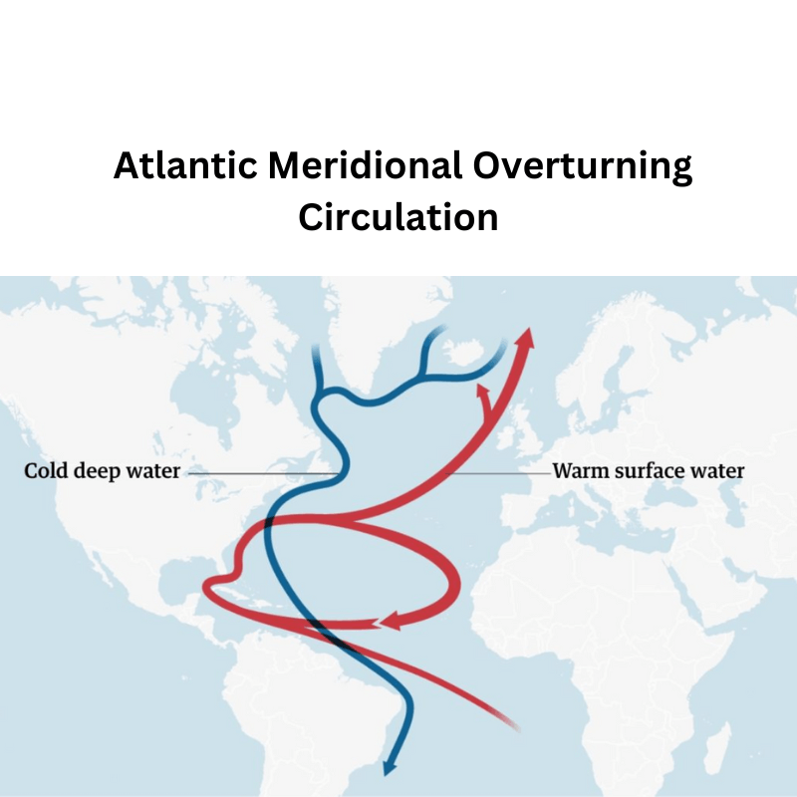
  + West Antarctic ice sheet disintegration.
  + Amazon Rainforest dieback.
  + West Africa monsoon shift.
  + Permafrost and methane hydrates.
  + Coral reef die-off.
  + Indian monsoon shift.
  + Greenland ice sheet disintegration.
  + Boreal forest shift and Other tipping points.

**Global warming and rise of sea levels:**

* + Melting of Glaciers (45%)
  + Thermal expansion (38%)
  + Melting of Antarctica Ice sheet (13%)
  + Ice loss from Greenland (4%).
  + Climate change: Triple threat for oceans: Oceans will become warmer, less oxygen, more acidic, increase in toxic algae, loss of fisheries, etc.

**The nine planetary boundaries (by Stockholm Resilience Centre):**

* + Estimates of how the different control variables for seven planetary boundaries have changed from 1950 to the present. These are:
    - Stratospheric ozone depletion.
    - Loss of biosphere integrity (biodiversity loss and extinctions).
    - Chemical pollution and the release of novel entities
    - Climate Change
    - Ocean acidification
    - Freshwater consumption and the global hydrological cycle
    - Land system change
    - Nitrogen and phosphorus flows to the biosphere and oceans
    - Atmospheric aerosol loading.
  + 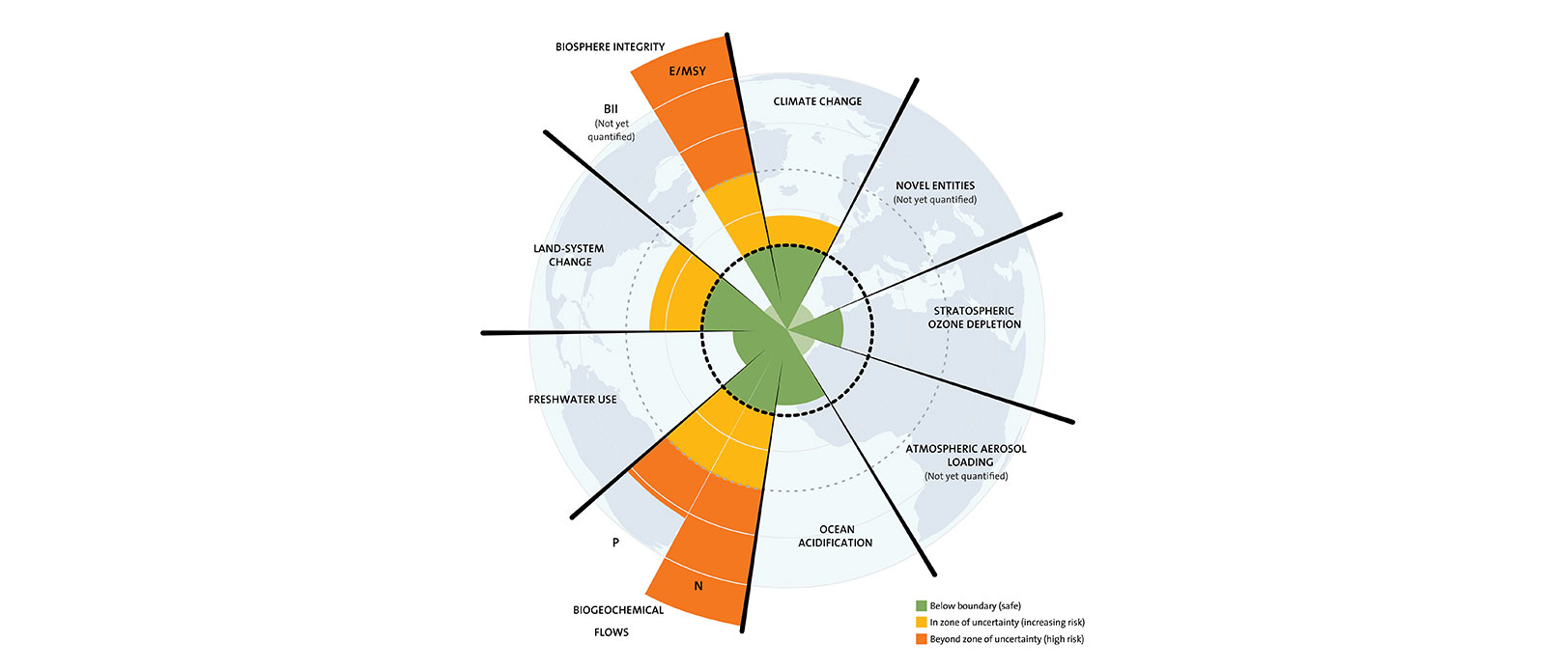

**Assessment Report II (1995) by IPCC:**

* + The 2nd report: There must be a certain protocol.
  + This means implementation has to be done through the protocol.
  + In the year 1997: the Conference of Parties-05 adopted the Kyoto Protocol.
    - Kyoto Protocol highlighted a temperature rise of 1.1 degrees since the 1750s.

### Kyoto Protocol:

* + Believes in development vs. destruction.
  + It called for the Principle of Equality.
  + Hence, it called for **Common but Differentiated Responsibility (CBDR).**
  + Kyoto Protocol evolved the polluter has to pay principle in the climate arena.
  + Key Features:
    - Differentiated responsibilities: Developed countries, considered primarily responsible for historical emissions, had binding reduction targets, while developing countries had voluntary commitments.
    - Flexible mechanisms: The Protocol included market-based mechanisms like emissions trading and clean development mechanisms to allow countries to meet their targets in a cost-effective way.

* + **Kyoto Protocol divided countries into:**
    - **Annex countries:**
      * Responsible countries: (First world and Second world countries).
        + Annex I Parties include the industrialized countries that were members of the OECD.
        + Annex II Parties consist of the OECD members of Annex I, but not the EIT Parties.

Developed countries with additional obligations: A subset of Annex I countries with specific financial support obligations for developing countries.

Providing grants and technology transfer to assist developing countries

Same as Annex I, plus Norway, Iceland, New Zealand, Switzerland.

* + **Non-Annex countries:**
    - Non-responsible countries: Non-Annex countries (Third world and fourth world communities are included in this).
    - Non-Annex I Parties are mostly developing countries.
      * The 49 Parties classified as least developed countries (LDCs) by the United Nations are given special consideration.
    - Under the Convention on account of their limited capacity to respond to climate change and adapt to its adverse effects.
    - They had no binding emission reduction targets but could adopt voluntary actions

* + The rationale behind this division:
    - Historical responsibility
    - Capacity differences
    - Promoting collaboration

* + **Flexible Market Mechanism (Kyoto Protocol)**
    - They are the mutually agreed market mechanism to help countries meet their emission reduction targets.
    - This includes:
      * **Joint implementation :** It is between the Annexed countries.
        + Concept: Annex I countries could invest in emission reduction projects in other Annex I countries and earn Emission Reduction Units (ERUs) equivalent to the emissions reduced. These ERUs could then be used to meet their own reduction targets.

For example : Denmark and Czech Republic undertook the Joint mechanism. Denmark had a burden of controlling 50 tonnes, Czech Republic had a burden of 30 tonnes. Denmark traded 50 certificates (given by Czech Republic to Denmark) of 1 ton equivalent of CO2.

The certificate has to be certified by UNFCCC.

* + - * + Challenges: Less utilized than the CDM due to complexities and limited cost-effectiveness opportunities compared to emissions trading.
      * **Clean Development Mechanism**: it is between Annex and Non-Annex countries.
        + Concept: Annex I countries could invest in emission reduction projects in developing countries (Non-Annex I) and earn Certified Emission Reductions (CERs) equivalent to the emissions reduced. These CERs could then be used to meet their own reduction targets
        + Annex parties can earn some carbon credits (certified emission reduction credits) by financing some environmental project in a non-annex party.

For example, in India, in Jaisalmer (there is an industry Dahanu Solar Power Plant), the people wanted to attract the finance from the developed world, Sweden implemented Clean Development Mechanism.

Sweden approached Asian Development Bank: on the guarantee of Sweden, ADB gave funds to India, especially to Dahanu Solar Power Plant.

India gave 100 Certified Emission Units (CEU) to Sweden.

* + **Emission Trading :**Kyoto Protocol made the Carbon Certificates as tradeable, hence they can be sold or purchased.
    - One carbon credit is a tradable carbon offset certificate that is believed equivalent to one ton of Carbon dioxide. They can be acquired through green actions like afforestation, Carbon Dioxide sequestration, Methane capture, etc.
    - They were carried forward under Paris Agreement.
    - Concept: Annex I countries with surplus emission allowances could sell them to countries with deficits, allowing them to meet their targets more cheaply.
    - Implementation: A quota of tradable emission permits was established for each Annex I country based on their target. Countries could trade permits directly or through intermediaries.

**KYOTO PROTOCOL RATIFICATION**

* + The 1997 Kyoto Protocol divided the world into Annex Countries (which had emission caps), and Non-Annex countries (which had no emission cap).
  + It was to come to force after 55 countries that contribute at least 55% of the Green House Gases emissions ratified the protocol.
  + The USA withdrew from Kyoto protocol in 20001, and Canada left the protocol in 2012.
  + It took 8 years to enter into force in 2005.
  + The Annex members (41 countries and European Union) raised objections over the exclusion of major greenhouse gases emitters like China and India from emission cuts obligations.
  + After coming into force, the 2008-2012 period was decided as a commitment period during which the annex countries must decrease their emissions by 5.2% as per 1990 levels.

* + IPCC Third Assessment Report 2001 pointed out that the lack of enthusiasm of annexing countries can be problematic in the efforts.

* + It's important to remember that the Kyoto Protocol has been superseded by the Paris Agreement, which aims for more ambitious global action on climate change. As of today, 197 countries have ratified the Paris Agreement, including the United States and Canada.

**IPCC FOURTH ASSESSMENT REPORT 2007**

* + IPCC was hopeful that the change of regime in the USA would see the USA ratifying the Kyoto Protocol.
  + At **COP 15 Copenhagen 2009**, President Obama gave no commitment for ratifying Kyoto Protocol, and also flagged the lenient conditions meted out to India and China.
  + At **COP 17 Durban 2011,**just one year after the end of the first commitment period, it was agreed that –
    - The commitment period shall be extended to 2020, and in the meantime, a new agreement (not protocol) will be drafted.
    - This extension was termed Ad-Hoc Durban Platform (ADP).
  + This ADP was accepted at COP 18 Doha 2012, and it later paved way for the Paris Agreement, COP 21 in 2015.
  + The annexed nations which do not meet their targets were to be penalized, and their emission reduction targets were compounded until 2020.

### Paris Agreement

* + aims to:
    - Limit global warming to well below 2 degrees Celsius, preferably to 1.5 degrees Celsius, compared to pre-industrial levels
    - Increase the ability of countries to adapt to the impacts of climate change and build resilience.
  + Key Features:
    - **Nationally Determined Contributions (NDCs):** Each country submits its own plan outlining its intended emissions reductions and adaptation actions. This allows for flexibility and recognizes that countries have different capabilities and circumstances.
    - **Common but Differentiated Responsibilities and Respective Capabilities (CBDR-RC):** Acknowledges that all countries have a responsibility to act on climate change, but developed countries have a greater historical responsibility and should provide support to developing countries.
    - **Transparency Framework**: A system for monitoring and reporting progress on NDC implementation, ensuring accountability and transparency.
    - **Global Stocktake**: Regular assessments of collective progress towards the Paris Agreement goals, starting in 2023, to inform further action.

**Differences between Kyoto Protocol and Paris Agreement:**

|  |  |
| --- | --- |
| **Kyoto Protocol** | **Paris Agreement** |
| Only the annex countries were given binding targets | All the members must contribute, but binding targets were not laid on anyone. |
| Countries were not free to choose their emissions targets | Countries were invited to come up with their own emission cuts targets, called Intended Nationally Determined Contributions (INDCs). After the countries disclosed their voluntary targets, the targets became legally binding and were called Nationally Determined Contributions (NDC). |

**GREEN CLIMATE FUND**

* + Under the Kyoto Protocol, the developing countries had demanded contributions from the developed nations to help the developing world transition into sustainable practices.
    - $100 billion was demanded in 2001, and by 2021, only $ 10.8 billion can be raised.
    - The GCF is accountable to the United Nations, and its principles are guided by UNFCCC.
    - World Bank serves as the trustee of the GCF.
    - The GCF was carried forward up to 2025 under Paris Agreement.

**IPCC FIFTH ASSESSMENT REPORT 2013-2014**

* + Recommended the ratification of the agreement decided in Durban.
  + After getting signed in COP 21, in 2015, the Paris Agreement got ratified by 55 countries contributing at least 55% of the emissions and entered into force in 2016.

**IPCC Special Report 2016:**

* + Notwithstanding the target to limit the temperature rise by 2 degrees Celsius till 2100, even if the temperature rises by 1.5 degrees Celsius by 2100, we would be experiencing the same catastrophe.

**TALANOA DIALOGUE**

* + It took place in 2019, at Bonn, Germany, but it was headed by the president of Fiji.
  + The Small Island Developing States (SIDS) raised the demand to adopt the **“Loss and Damage**” concept.
  + As per the concept, the SIDS faced much threat of climate-changing actions which were being done by the developed states.
  + The Emission Gap Report was released. It measured the gap between the funding needed to meet the Paris targets, and the actual contributions received.
  + It was agreed that in the next session, global “stock-taking“ will be done. Under which, the actions taken by the nations would be evaluated against their commitments.

**COP 26 GLASGOW SCOTLAND 2020**

* + The call was given to achieve global carbon-free status by 2050 so that the temperature rise can be limited to 1.5 degrees Celsius till 2100.
  + The carbon-free status would mean that all carbon emitted is properly absorbed, and compensated.
  + USA, EU, announced to achieve net carbon-free status by 2050.
  + China announced the target of 2060.
  + Nepal pledged to achieve the status in 2045 itself.

**INDIA PRESENTED THE PANCHAMRITAS-FIVE POINT CLIMATE ACTION PLAN**

* + Increase non-fossil fuel energy capacity to 500 Gigawatts by 2030.
  + To meet 50% of energy requirements from renewable energy by 2030.
  + Reduce carbon emissions by 1 billion tons by 2030.
  + Bring down the economy’s carbon intensity below 45% by 2030.
  + India pledged to achieve the target of net zero emissions by 2070.
    - It is estimated that India would need $ 1 trillion for net zero emission status.

* + The Global Climate Action tracker, popularly called as CAT, under UNFCCC, opined that –
    - India’s 40% non-fossil fuel electricity capacity target is “critically insufficient”, and its emission intensity targets as “highly insufficient”.
    - This review leaves much scope for improvement if it is to be consistent with the 1.5 degrees centigrade global warming limit under the Paris Agreement.

* + The government submitted to UNFCCC that-
    - India was able to reduce its GDP emissions intensity by 24% between 2015 and 2016.
    - India’s per capita emissions are very low at 1.94-ton carbon dioxide (tco2), less than half of the global average of 4.2 tco2. While USA and Russia have 15.5 and 12.5 tco2 respectively.
    - These statistics are ascertained by the emission database by Global Atmospheric Research.

|  |  |  |
| --- | --- | --- |
| **Country** | **Net Emissions (in million tons)** | **Per capita emission** |
| China | 11535 | 8.1 |
| USA | 5107 | 15.5 |
| EU | 3304 | 6.5 |
| India | 2594 | 1.9 |
| Russia | 1792 | 12.5 |

### CLIMATE CHANGE IN INDIA

* + National Action Plan on Climate Change (NAPCC) 2008, under which 8 projects were launched in Mission Mode:
    - National Solar Mission: Now the target is 175 Gigawatts of installed Solar energy.
    - National Mission on Sustainable Habitat: It is implemented through programs like AMRIT.
    - National Green Mission: Afforestation and reforestation to increase forest cover.
    - National Mission in Energy Efficiency: Star ratings by Bureau of Energy Efficiency (BEE).
    - National Water Mission.
    - National Mission on Sustaining the Himalayan Ecosystem.
    - National Mission for Sustainable Agriculture: Climate-smart agricultural practices.
    - National Mission on Strategic Knowledge on Climate Change: Indigenous R&D infrastructure.

* + India and France jointly setup **International Solar Alliance** in the backdrop of COP 21 Paris:
    - It aims to achieve global solar power utilization.
    - It is headquartered in Gurugram, Haryana.
    - It now has 121 members, with the USA joining in 2021.
    - Other Indian initiatives in this regard include:
      * Missions for utilizing wind energy.
      * Coastal Area Management
      * Biomass management: through initiatives the Biodiesel blended Petrol, diesel, and even aviation turbine fuel.
      * Waste-To-Energy program.
      * Green-Credit scheme: NGOs involved in reforestation.

**OZONE**

* + The Ozone layer is present in the Stratosphere (12km-25 km) high from the earth.
  + It acts as a biological shield against the ultraviolet rays from the sun.
  + During the presence of sunlight (photoperiod), the atomic oxygen meets the molecular oxygen to form ozone - O2 + O= O3.
  + Chapman observed that during the Non-Photo period, the larger Ozone molecule got split into atomic oxygen and molecular oxygen- O3 = O2+ O, and this is known as Chapman’s reaction.
  + The thickness of the ozone layer decreases as we go from the equator to the poles, due to differences in insolation. The thickness of the ozone layer is measured in Dobson units.

* + Brewer-Dobson circulations: They are the circulations that transmit Ozone Depleting Substances (ODS) towards the poles.
  + The issue of Ozone holes was first raised at Vienna Convention in 1972.
  + The chlorofluorocarbons (CFCs) were first used to replace ammonia as refrigerant, as ammonia was explosive.
  + These CFCs were later found as the main culprits for the Ozone holes.
    - The chlorine present in the CFCs splits the Ozone into Chlorine Oxide and molecular oxygen.
    - Cl + O3= Cl-O + O2.
    - The resultant Cl-O is not stable and it keeps interacting with other ozone molecules.
    - Cl-O + O3 = CL02 +O2
    - Even this chlorine dioxide is not stable, and it rapidly breaks down into a free chlorine atom and oxygen molecule.
    - The free chlorine obtained here starts the chain reaction.
  + It is estimated that a single chlorine-free atom can deplete 1 lakh ozone molecules.
  + International conventions on Ozone hole reduction have been the most successful of environmental conventions.

**Montreal Protocol 1989** called for shifting to Hydrofluorocarbons (HFCs).

* + Though HFCs are not ozone-depleting, they have much higher greenhouse potential than CFCs.
  + To address this issue, an amendment was brought in the Montreal Protocol at Kigali 2016.
  + Kigali Agreement agreed to phase out HFCs.

**KIGALI AGREEMENT: TARGETS FOR PHASING OUT HFCs**

|  |  |  |  |
| --- | --- | --- | --- |
| **Groups** | **Base Year** | **Percentage Reduction** | **Target Year** |
| Group 1: Developed nations | 2012 | 85 | 2036 |
| Group 2: Developing nations | 2021 | 80 | 2045 |
| Group 3: Rest nations(India is in group 3) | 2024-2026 | 80 | 2047 |

### ENVIRONMENTAL IMPACT ASSESSMENT (EIA)

* + It is the process through which we try to assess the present and future environmental impacts of any developmental project on any area, and even adjoining areas are estimated.
  + The exercise is very useful to predict and reduce pollution, and even for the penalization of the defaulters.
  + The Environmental Impact Assessment Act was first brought in 1994.
  + Later in 2006, a new EIA act was brought. This act is still in practice.
  + In 2020, the government brought out a new draft EIA 2020 for public consultation.

* + Four steps for EIA- (SSPA)
    - Screening - Preliminary observations.
    - Scoping - 60-day time limit
    - Public consultation - 45-day time limit
    - Appraisal and environmental clearance - 105-day time limit.
  + As we can see that in this manner, EIA would take almost 1 year. To take care of this and balance developmental and environmental benefits, the new draft is brought.

## POLLUTION

* + Environmental pollution can be defined as any undesirable change in any form - physical, chemical, or biological characteristics of any component of the environment i.e. air, water, or soil which can cause harmful effects to the life of humans and even animals.
  + A pollutant is any substance causing nuisance or harmful effects or uneasiness to the organisms.
  + Major types of pollution are pollution of air, water, land, noise, nuclear, etc.
  + Major types of polluting wastes are e-waste, solid waste, biomedical waste, nuclear waste, plastic waste, etc.

**AIR POLLUTION**

* + Causes of air pollution:
    - Natural causes- Forest fires, volcanic eruptions, wind erosion, pollen dispersal, evaporation of organic compounds, natural radioactivity, etc.
    - Man-made causes- Emissions due to various activities like transport, energy, manufacturing, etc.
    - Natural forest fires are very common in some regions which experience very dry weather as California (Santa Ana winds), and Australia (Brick fielder winds).
  + The six major air pollutants - *Carbon Monoxide, Ozone (at tropospheric level), nitrogen dioxide, sulphur oxides, Carbon dioxide, and lead.*
  + The ground-level Ozone (Tropospheric ozone) causes the formation of *Photochemical Smog* (Los Angeles smog).
    - Smog refers to the phenomena where smoke and fog combine together, and their combination can cause great damage to the environment and human health.
    - Smog affects plant capacity for photosynthesis and reduces their productivity.
    - Smog can also cause various respiratory diseases and other ailments such as rickets due to obstructing sunlight which helps in the synthesis of vitamin D.
  + When volatile materials like nitrogen dioxide, tropospheric ozone, and some volatile organic compounds (which can get evaporated at room temperature) react together in presence of sunlight, we get **PAN- Peroxyl Acetyl Nitrate**, which is a very major pollutant.
    - PAN exists in form of tiny particles whose size ranges in the order of millimicrons.
    - PAN particles can enter our respiratory system and interfere with the functions of the bronchi.

* + **Marpol convention** is with respect to the health of air and water over high seas.
    - As per the convention, the fossil fuel used in ships traveling on high seas cannot have more than 0.005% of sulphur. Similar limits exist for all major pollutants.
    - India is also a party to the convention and has taken appropriate steps in this regard, like treating the ship fuel before usage.

**TYPES OF POLLUTANTS**

* + **Primary pollutants:**They are those gases or particles that are pumped directly into the atmosphere and which pollute the air directly with their presence.
    - Major examples include Carbon Monoxide, Sulphur dioxide, etc.
  + **Secondary pollutants:** They are formed by the chemical intermingling of primary pollutants.
    - A major example includes Photochemical smog.

**CAUSES OF AIR POLLUTION**

* + Industrial emissions:
    - It can be reduced with interventions like using scrubbers at chimney tops so that the exhaust causes less harm.
  + Combustion of fossil fuels:
    - Even the fossil fuels can be treated before use, as the sour crude oil can be converted into sweet crude oil by reducing the H2S(hydrogen sulphide quantity).
  + Agricultural activities:
    - The use of chemical fertilizers, pesticides releases harmful substances into the atmosphere.
    - The chemicals can also pollute water and land through surface runoffs.
    - Some major pollutants are ammonia and methane.
  + Mining Operations:
    - The entire area around the mines gets polluted.
    - Not only the ambient air but land, surface water, and even groundwater can get polluted.
  + Indoor pollution:
    - The major sources include smoking, using fossil fuels or wood for cooking, paints, and varnishes, etc.

**CONSEQUENCES OF AIR POLLUTION**

* + **Acid rain:**
    - Chemical reactions involving pollutants can create acidic compounds which can harm vegetation and buildings.
    - Pollutants like nitrogen dioxide, sulphur dioxide can combine with rainwater to form diluted nitric acid and sulphuric acid respectively.
    - It can also result in the discoloration of marble monuments like the Taj Mahal.
    - It can also harm the soil and underground water.

* + **Eutrophication**:
    - It refers to the increase in the number of plant nutrients like nitrogen, phosphorus, potassium in the water body.
    - It will increase the Biological Oxygen Demand (BOD) of the water body.
    - The eutrophic water would see much growth of plants and algae on its surface.
    - It affects the light penetration and oxygen absorption necessary for sustaining underwater life.
    - It can be pollution from both air and water.

* + Particulate matter:
    - They are the solid remnants of burning fossil fuel. They can be of three types as per their size- PM 1, PM 2.5, and PM 10, where 1, 2.5, and 10 is the diameter of the pollutant in micrometres.
    - World Health Organisation, the Global Burden of Disease Study 2017, and the review paper by scientists from the Forum of International Respiratory Societies have studied the air quality of India and released their report in June 2019 with the title “At the Cross-Roads”, published by Centre for Science and Environment.
    - The report said that the life expectancy in India has gone down by 2.6 years due to diseases caused by air pollution.

* + **Fly Ash:**
    - It is a kind of particulate matter and the end product in the combustion of fossil fuels, especially in thermal power plants where the fuel is coal.
    - Fly ash can also be used in various sectors like road making, bricks-production, building construction, etc.
    - The government has taken various steps for its promotion -
      * National Thermal Power Corporations, use at least 20% of fly ash generated to be used for making fly ash bricks/blocks/tiles.
      * Fly ash is kept at the lowest GST bracket.
      * Ministry of Power developed the app Ash Track to connect fly ash producers(thermal power plants) with the potential users (road contractors, cement plants, etc.)
      * Exhibitions like Ash Park are held so as to showcase the various things possible with using fly ash.
  + The major legislation against air pollution is the Air Pollution (Prevention and Control Act) 1981.

**WATER POLLUTION**

**Causes of water pollution**:

* + Discharge of untreated effluents from the industries.
  + Discharge of untreated thermally polluted water by thermal and nuclear plants.
  + Agricultural runoff.
  + Contamination of heavy metals in the groundwater.
  + Mining discharge.

**Impacts of water pollution:**

* + Health hazards as Black foot disease (Arsenic contamination), Blue Baby syndrome(nitrate pollution, Minamata disease(mercury pollution), Bone and tooth decay due to fluorine pollution.
  + Biomagnification: Due to the toxication of soil.

**Solutions for water pollution:**

* + Construction of Sewerage treatment plants, effluent treatment plants,
  + Conscious use of chemical fertilizers through methods like fertigation.
  + Stringent laws like Water pollution (Prevention and Control ) Act 1974.
  + Putative actions like heavy fines.
  + Water metering.
  + Bio-remediation.
  + Programs like **Namami Gange**, under which all the villages along the Ganga (Ganga Grams) are made Open Defecation Free.
    - Beautification of river banks in form of riverfronts.
    - Continuous and clean flow: Aviral Dhara, Nirmal Dhara.
    - The act Water pollution (Prevention and Control) Act 1974, had provisions of formation of Statutory Pollution Control boards.

**Land Pollution**

* + United Nations  Convention to Combat Desertification(UNCCD) 1994
  + At COP 14 of UNCCD held in New Delhi 2019.
    - Delhi Declaration: The government emphasized ecosystem restoration, private sector engagement in the reclamation of desertified land.
    - India pledged to reclaim 26 million hectares of land by 2030. It is a part of the Bonn Challenge under which 500 million hectares of degraded land are to be reclaimed by 2030.
    - Peace Forest Initiative:  An initiative of South Korea as a peace-building process. It aims to address the issues of land degradation in the conflict border zones.
    - Drought Tool Box: UNCCD launched a one-stop shop for all actions on drought.
      * All countries pledged for land degradation neutrality by 2030, which will satisfy the Sustainable Development Goal 15: Life on Land

**NUCLEAR POLLUTION**

* + It is the pollution due to improper handling of wastes of nuclear power plants.
  + The by-products of nuclear power production continue to have radioactive properties for a very long time.
  + In 2010, there was an incident in Mayapuri Delhi where there was cobalt-60 radiation leak out of a defunct machine of Delhi University.

**HAZARDOUS WASTE HANDLING**

* + Basel convention 1989- Regulating the transboundary movement of hazardous waste
  + Rotterdam convention 1998- It talked about the shared responsibilities for international trade of hazardous chemicals.
    - It had the Prior Informed Consent procedure under which the importing parties must formally disseminate if they wish to receive future shipments of the annex 3 chemicals mentioned in the convention.
  + Stockholm Convention 2001- It covers the Persistent Organic Pollutants, like DDT, diclofenac, etc. which are called Dirty Dozen.

**IMPORTANT LEGISLATIONS REGARDING HAZARDOUS WASTE**

* + Solid waste management (SWM) rules 2016, amended in 2019:
  + Solid Waste Management emphasized segregation at the source.
  + Emphasized reuse, recycle and recovery.
  + Gave more authority to the local bodies to collect fees and levy charges.
  + SWM brought rural areas under its jurisdiction.
  + The emphasis is on treating and disposal of sanitary napkins and diapers.
  + SWM emphasized not just city compost management, also bulk generators to have composting.
  + SWM emphasized generating energy from the waste: Waste to Energy program.
  + All the Special Economic Zones in the country have to allocate at least five plots or five percent of the total area for recovery and recycling facilities.

**Biomedical Waste Management Rules 2019:**

* + It emphasized segregation as:
    - Four separate chambers or containers for segregation-
      * Blue-Broken glass, metallic body implants, etc.
      * Red-plastic gloves, pipes, etc.
      * Yellow - Human body parts, body fluids and clinical waste, expired medicines, and chemical wastes.
      * White (all sharp metals like needles, syringes, scalps, etc)
      * It covers all healthcare facilities(Primary, Secondary, Tertiary)

* + Barcoding for packaging and labelling of medical waste.
    - Instead of incineration, modern disposal of medical waste by converting waste to energy.
    - Biomedical waste management mandates phasing out of chlorinated plastic bags, gloves, and blood bags by 2021.
    - Safe disposal of bio-waste in non-residential areas.

**E-WASTE MANAGEMENT RULES 2019**

* + E-Waste management rules brought stringent action on non-compliances parties.
  + It has issued comprehensive guidelines and Standard Operation Procedures (SOPs) for licensing and permissions.
  + E-waste management rules 2019 is a target-based approach.
  + It introduced Extended Producer Responsibility (EPR), which forms the crux of the E-waste management rules. It emphasizes the mechanism of collection and recycling.
  + Flexibility for implementation of EPR through E-waste Exchange, E- Retailer, and deposit refund.
  + All the ERP authorization procedures are framed by CPCB.
  + New mechanism for the collection of e-waste; introduced door-to-door collection.

**PLASTIC WASTE MANAGEMENT RULES 2019**

* + It phased out the use of single-use plastic.
  + Scope for reuse and recycle enhanced.
  + Collection of plastic waste management fee through pre-registration of shopkeepers and vendors.
  + The jurisdiction extended even to rural areas.
  + The polythene bags thickness increased from 40 microns to 50 microns.
  + It mandated collection - back system on lines of Extended Producer Responsibility (EPR).
  + Use of plastic waste in the construction of roads and other infrastructural projects.

**NATIONAL GREEN TRIBUNAL**

* + It is a quasi-judicial body headed by a retired Supreme Court judge.
  + Its principal bench is in New Delhi and has regional benches in Bhopal, Kolkata, Chennai, and Pune.
  + It is also a statutory body as per National Green Tribunal Act 2010.
  + Its main objective is the speedy disposal of environmental issues.
  + Appeals of the awards can be done in Supreme Court.
  + It can also take the environmental cases on a Suo-motu basis.

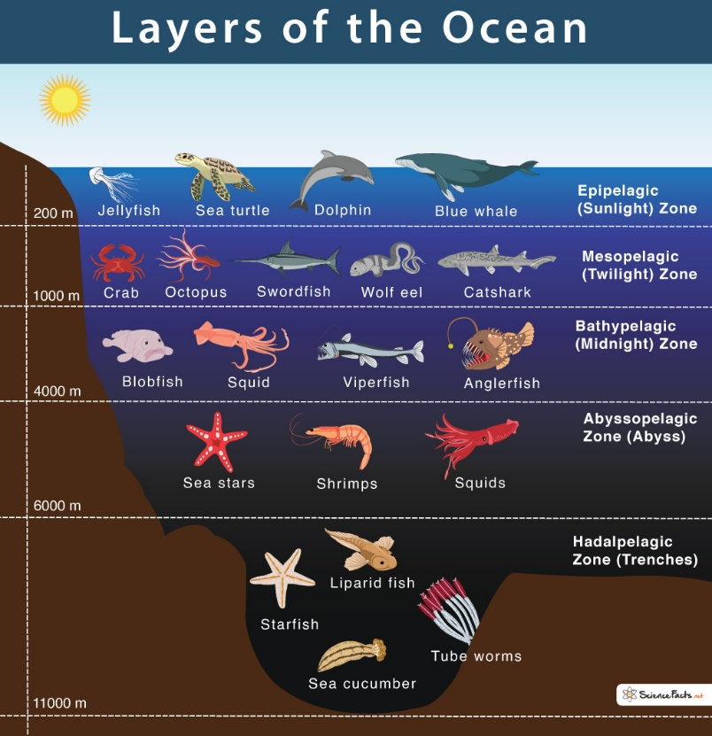

# Legislations

### Wildlife Protection Act (WPA), 1972

* + Key Features:
    - Scheduled Species
      * Schedule I containing animal species enjoying the highest level of protection.
      * Schedule II for animal species subject to a lesser degree of protection.
      * Schedule III for protected plant species, and.
      * Schedule IV for scheduled specimens under CITES.
    - Protected Areas
      * Sanctuaries
      * National Parks
      * Conservation Reserves
      * Community Reserves
    - Enforcement Mechanisms
    - Permits and Licenses
    - Central Zoo Authority

* + Recent amendment
    - Rationalising schedules - It seeks to reduce the number of schedules from VI to IV whereby Schedule V for vermin or animals that destroy food crops will be done away with.
    - Obligations under CITES- The Act provides for the Central government to designate a
      * Management Authority- The authority grants export or import permits for trade of specimens,
      * Scientific Authority- The authority gives advice on aspects related to impact on the survival of the specimens being traded
    - Control of sanctuaries- The Act entrusts the Chief Wild Life Warden to control, manage and maintain all sanctuaries in a state. They are appointed by respective State government.
  + Issues
    - Listing of species- Spotted deer which is common throughout India are listed in Schedule 1.
      * However, these are invasive in the Andaman Islands. But the spotted deer cannot be legally culled or removed because of the WLPA.
    - Co-existence factor : various Schedule 1 species pose enormous physical, mental and economic harm to people.
      * leopards in certain pockets, and elephants everywhere kill people, destroy their livelihoods, and leave lasting psychological impacts.

### Environment Protection Act (EPA) of 1986

* + Background
    - Response to Bhopal Gas leaks

* + Comprehensive : covers air, water, soil, and noise pollution.
  + Preventive approach : provides for environmental impact assessment (EIA)