**Pattern Name: Artificial Intelligence and Automation**

**Intent:**

Provide intelligent, adaptive, and automated functionalities that enhance user experience, optimize system performance, and support decision-making in modern mobile devices.

**Motivation:**

Modern smartphones and smart devices are expected to operate efficiently with minimal manual intervention.  
Artificial Intelligence (AI) enables the system to learn user behavior, predict user needs, and automate actions such as screen brightness adjustment, voice-based assistance, and battery optimization.

This pattern ensures the device can analyze data, adapt to usage patterns, and make real-time adjustments for better usability and personalization.  
For example, the phone might automatically switch to dark mode in low light, or the voice assistant may proactively remind the user about upcoming meetings.

**Constraints:**

* Each AI feature must be trained or configured to operate without compromising user privacy and data security.
* Automated actions must always have an option for user override or confirmation.
* AI models should consume minimal power and resources to avoid performance degradation.
* The system should be able to function normally even if AI features are disabled.
* Data collected for automation must be processed ethically and according to privacy regulations.
* The device must provide transparency (explainable AI) when making automated decisions affecting the user.

**Applicability:**

Useful in any intelligent system where user behavior, preferences, or environmental context can be leveraged to improve performance or automation.  
Common examples include mobile phones, smart TVs, wearable devices, and home automation systems.

**Structure:**

The **AI and Automation** pattern consists of multiple logical components that interact with sensors, the operating system, and user interfaces.  
A conceptual UML-like structure may include:

* **AIEngine (abstract):** Defines core AI operations such as data collection, pattern recognition, and learning.
* **UserBehaviorModel:** Learns from user actions (e.g., app usage, screen time).
* **SystemOptimizer:** Uses learned patterns to adjust performance settings dynamically.
* **ContextSensor:** Collects contextual data such as light level, sound, or location.
* **AutomationController:** Executes automated tasks (e.g., adjusting brightness, scheduling updates).
* **PrivacyManager:** Ensures all AI actions comply with user consent and data protection policies.

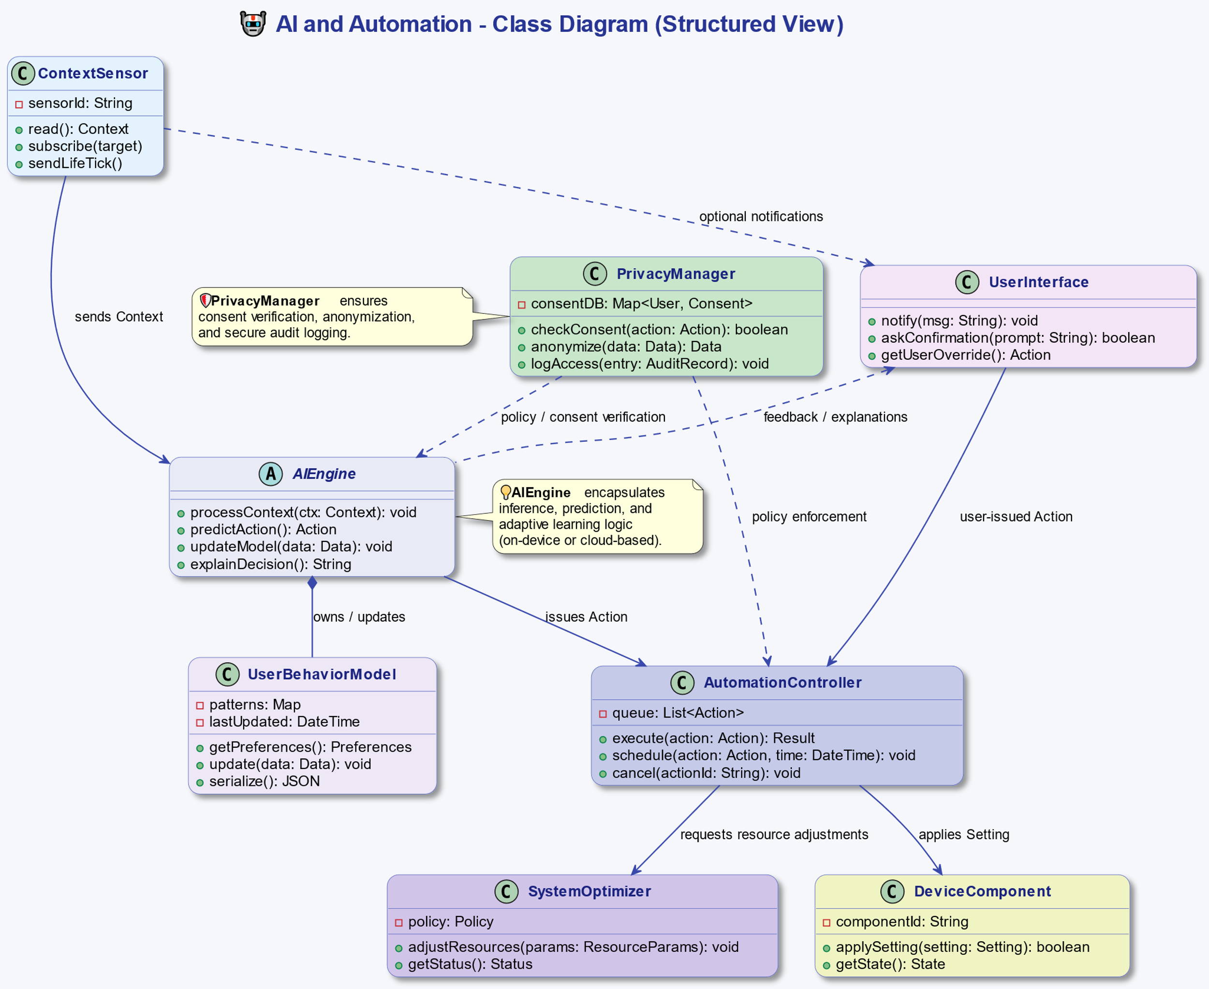

**Behavior:**

The behavior of the **Artificial Intelligence and Automation** pattern can be illustrated as follows:

1. **ContextSensor** gathers input data (light, temperature, time, app usage).
2. **AIEngine** processes the data and updates the **UserBehaviorModel**.
3. The **AIEngine** makes a prediction or decision (e.g., “reduce brightness”).
4. The **AutomationController** executes the corresponding action on the device.
5. The **PrivacyManager** verifies whether the action adheres to user consent rules.
6. If the user overrides the AI’s decision, feedback is sent back to the **AIEngine** to improve future predictions.

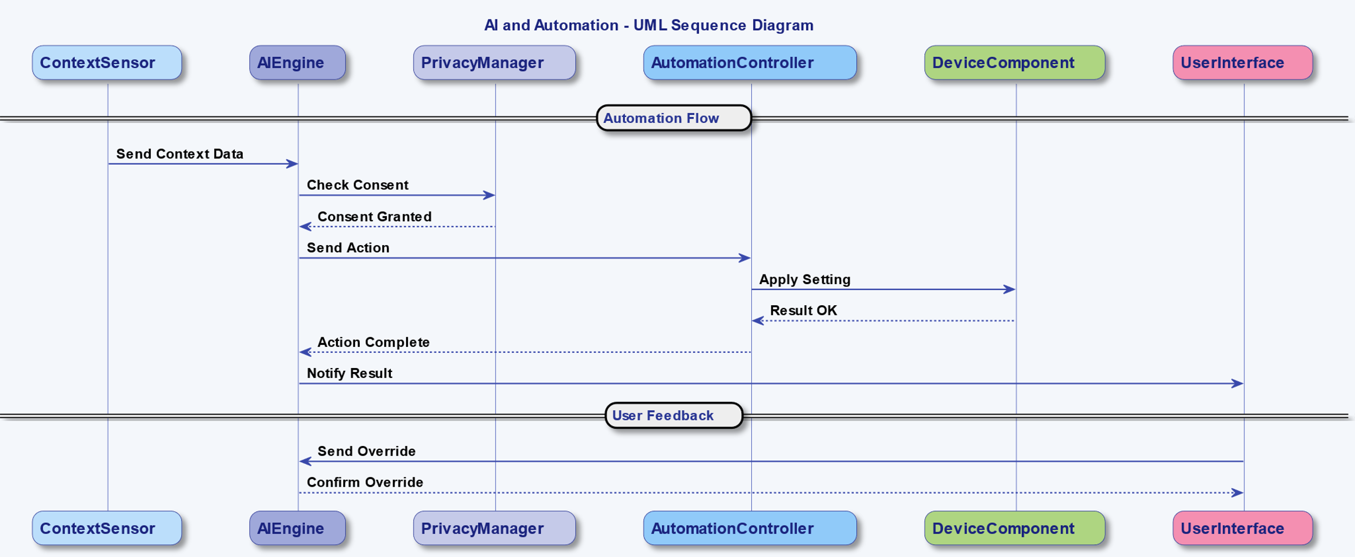

**Participants:**

* **AIEngine (abstract):** Core component responsible for learning, inference, and decision-making.
* **UserBehaviorModel:** Stores learned preferences and habits of the user.
* **SystemOptimizer:** Controls device resources (CPU, battery, memory) for efficiency.
* **AutomationController:** Implements automated responses or adjustments.
* **ContextSensor:** Gathers environmental and system data inputs.
* **PrivacyManager:** Validates ethical and permission-based constraints.
* **UserInterface:** Communicates AI-driven recommendations or actions to the user.

**Collaborations:**

* The **ContextSensor** continuously monitors the environment and sends data to the **AIEngine**.
* The **AIEngine** updates the **UserBehaviorModel** based on detected usage patterns.
* When a pattern is recognized, the **AIEngine** sends a command to the **AutomationController**.
* The **AutomationController** interacts with the **SystemOptimizer** to apply necessary changes (e.g., reduce power use).
* **PrivacyManager** ensures no sensitive user data is shared or misused during this process.
* **UserInterface** provides notifications or requests confirmation for specific automated actions.

**Consequences:**

1. Enables smarter, more adaptive mobile devices that provide personalized experiences.
2. Reduces manual user interaction by automating repetitive tasks.
3. Improves energy efficiency and system performance through intelligent optimization.
4. Enhances accessibility for users with different needs.
5. However, increases complexity of system design and potential privacy concerns.
6. Requires regular updates and retraining of AI models for accuracy and fairness.