Getting Started.

This document provides a guideline for using the annotation tool once the instructions mentioned in ReadME.md are successfully completed.

Log in & Account creation

The landing page contains a component to authenticate the user such as the one below. Before we can proceed, a user account needs to be created. Hence proceed to click “Register Instead”.

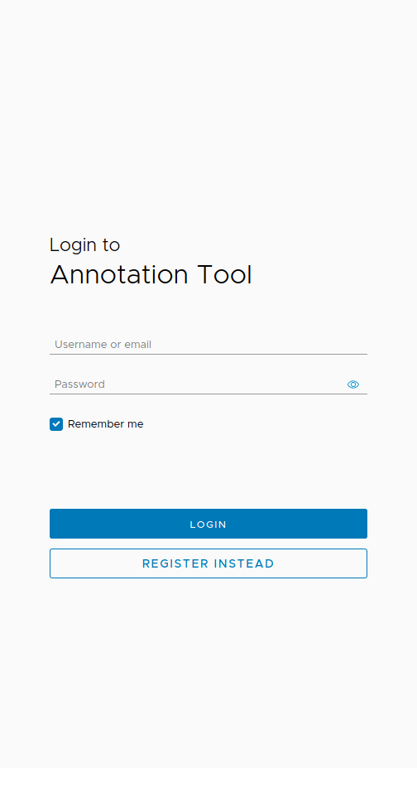

This should bring you to a screen where you can enter the queried details and click register to create a new user. Once that is completed, these credentials can be used to log into the system.

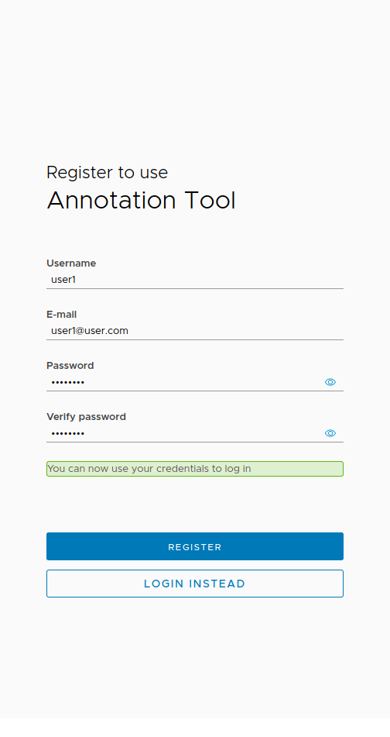

Project Creation

A successful login takes you to the Project landing page, where you can see all the projects that you have created, are a supervisor or a contributor of.

A new project can be created by clicking the “New Project” icon, and filling in the following form.

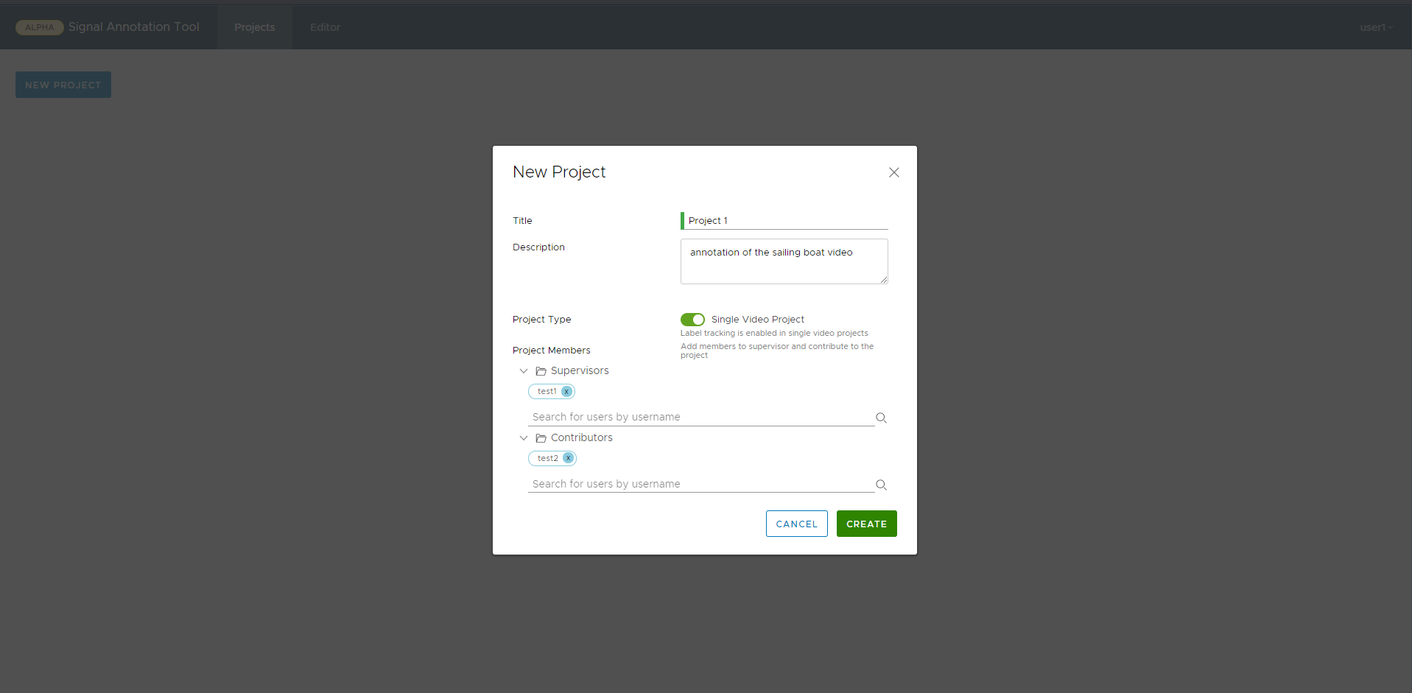

Here a single video Project is turned on by default, which the user can choose to turn off. Enabling single video mode turns on tracking features for labels within the uploaded video. If tracking of objects is not required, this can be turned off.

Additionally, users can be added as supervisors and contributors by searching for them by their usernames.

NOTE: Only users that are either the contributor or the supervisor can see this project apart from the original creator.

Video Upload

Click the upload icon shown below and select the video you wish to upload.

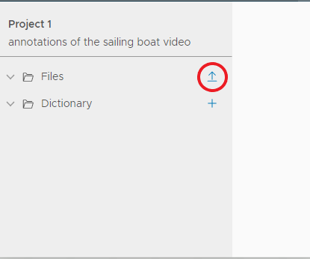

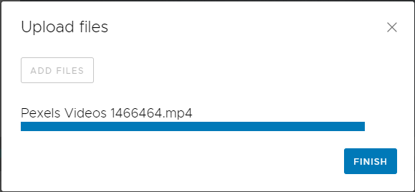

Once completed the player should initialise itself as seen in the following figure.

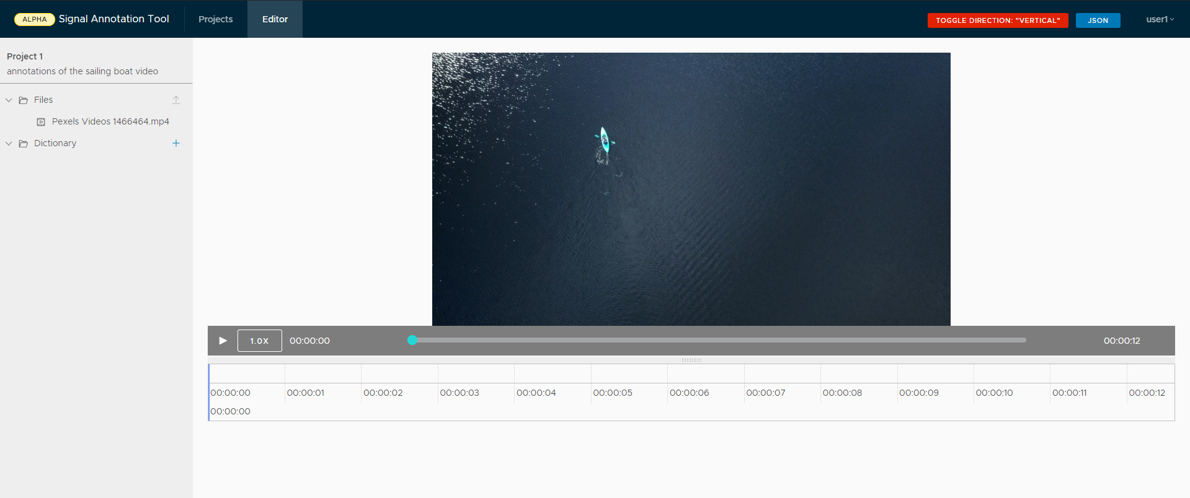

Annotations

Annotations occurs in two major steps. Label categories and Labels. A category may contain many labels which are instances of the category.

To create a category click on the icon shown below.

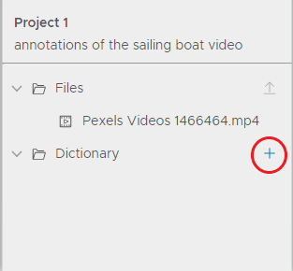

Fill in the details in the modal displayed below:

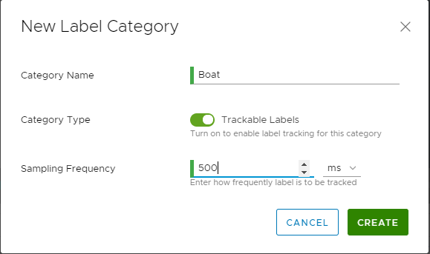

Setting trackable labels as on, helps us specify the frequency with which tracking data is to be provided for this category. Here, tracking will be queried every 500ms for the occurence of this category.

If the category does not need to be tracked, simply leave the tracking labels switch turned off.

Creating a category automatically creates one label for the same as seen below.

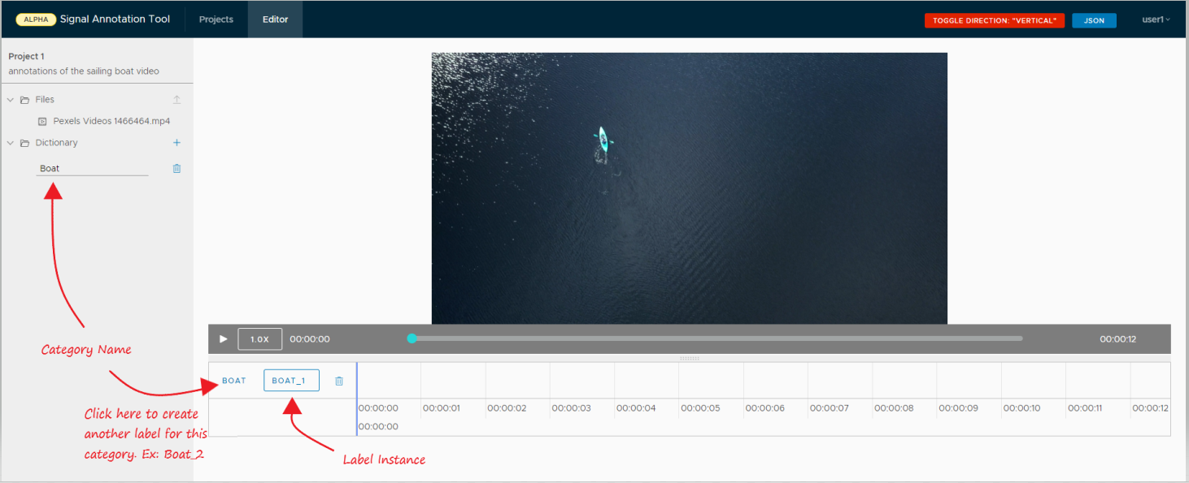

Click the label instance to start marking a time frame with the occurrence of the selected label. You can play the video to continue extending the time frame marked as the label that was selected.

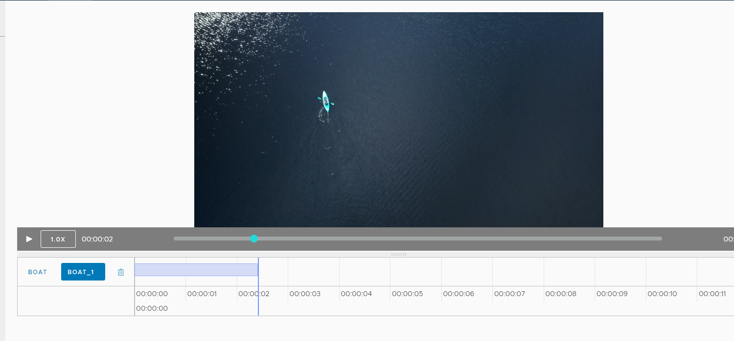

Deselect the label instance to complete marking a segment of the occurrence of the label. Since the category of this label had been selected as trackable (while creating the category) markers will show up on the timeline indicating the time instances where tracking data needs to be added.

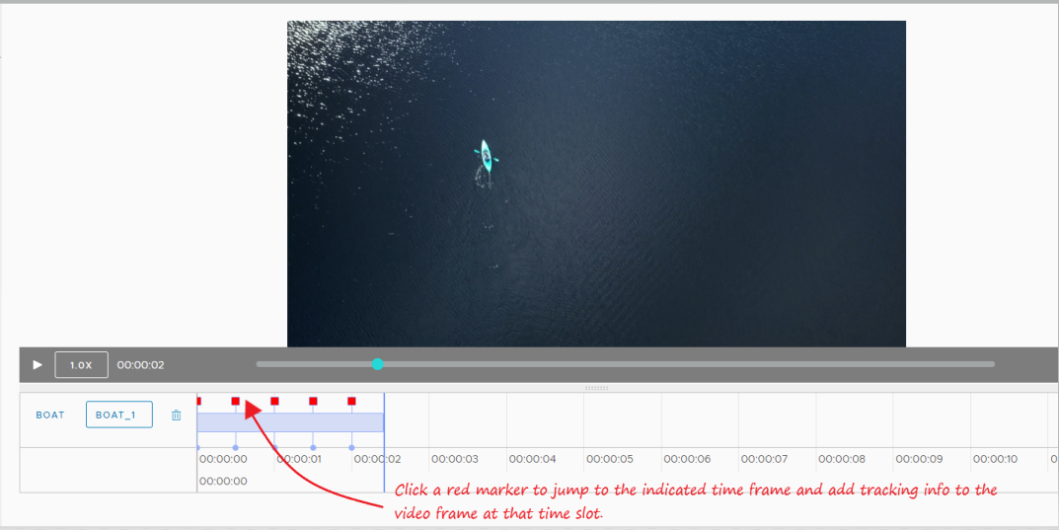

Clicking on the marker, loads the video frame at the timeslot of the marker and opens up a tool box where we can add rectangles/circles/ polygons to indicate the area represented by the label.

The toolbox contains the following tools:

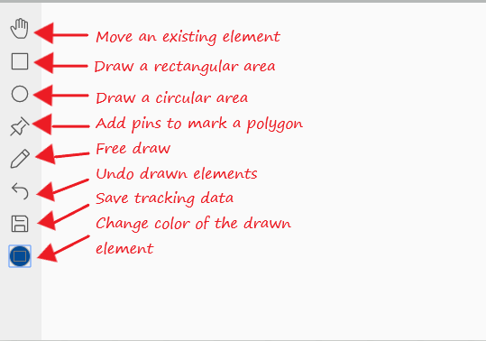

Simply select the required tool, move the mouse over the video, and start drawing to add tracking information. An example for the rectangular tool is shown below. Simply save the tracking by clicking the save icon from the tool box. This copies this configuration onto all the markers so the user has to only move the trackables in the remaining frames instead of having to recreate them.

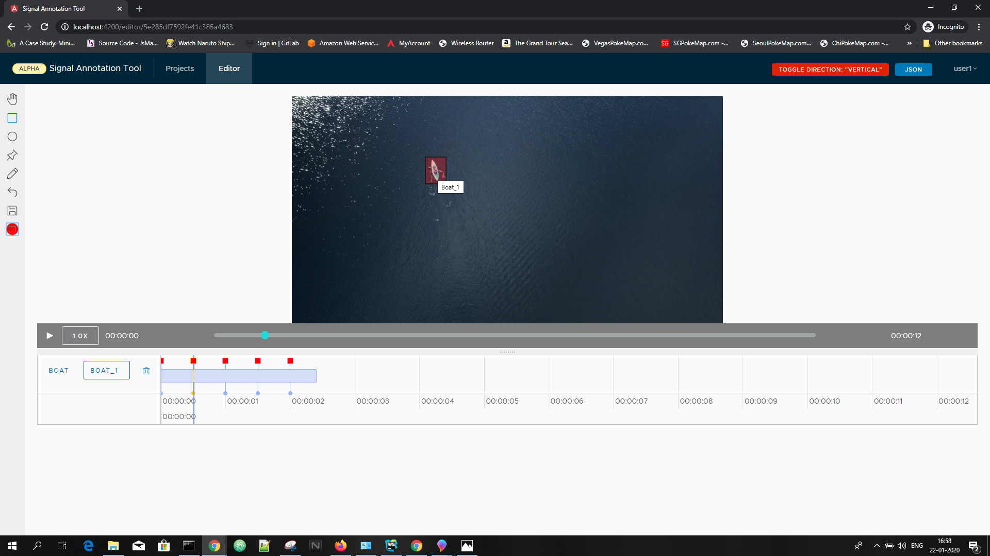

Once saved, all the markers show up as green to indicate the presence of tracking information.

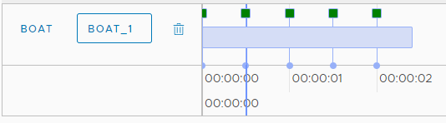

Exporting video annotations

At any point, the annotations marked so far, can be exported as JSON file by clicking on the JSON button at the top right corner of the screen.

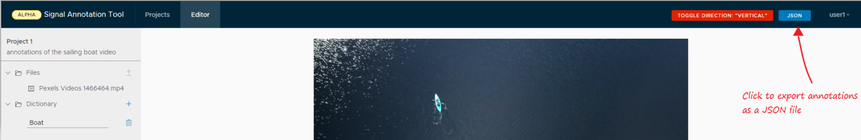

This generates a JSON with all labelling as well tracking data, an example of which is provided below:

