MVL Supply Chain
Intelligence Hub
V8 Dashboard — Technical Documentation

━━━━━━━━━━━━━━━━━━━━━━━━━━━━━━━━━━━━━━━━━━━━━━━━━━

Data Sources • Calculation Logic • Display Reference
February 2026 | Version 8.0
https://sajeshvs.github.io/mvl/v8/

Table of Contents

1. Executive Summary
2. Architecture Overview
3. Data Pipeline (9 Stages)
4. Currency Conversion
5. Change Order Classification Logic
6. Tab 1 — Supplier Marketplace (SM)
7. Tab 2 — Global Spend Analysis (GSA)
8. Tab 3 — Materials & Disciplines (M&D)
9. Data File Reference
10. Material Code Classification
11. Country Normalization

1. Executive Summary
The MVL Supply Chain Intelligence Hub is a browser-based, three-tab analytics dashboard that provides end-to-end visibility into procurement operations — from initial Request for Quotation (RFQ) through Purchase Order (PO) execution and Change Order (CO) tracking.

Dashboard Tabs at a Glance
Tab | Theme | Focus Area | Primary Data
Supplier Marketplace | Blue #004578 | RFQ pipeline, quotation tracking, supplier discovery | Quotation records (RFQs)
Global Spend Analysis | Orange #D96F3C | PO spend, change orders, entity & project analysis | Purchase Orders
Materials & Disciplines | Dark Blue #0F3D5E | Material categorization, discipline spend, conversions | Combined RFQs + POs

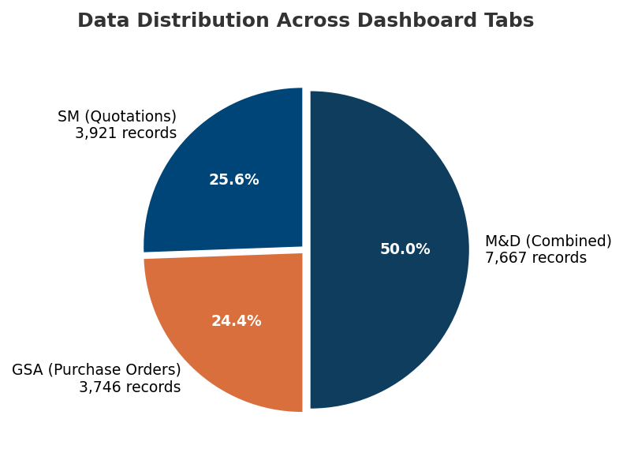

Key Metrics Summary
Metric | Value | Source
Total RFQ Records | 3,921 | Quotation Excel export
Total Purchase Orders | 3,746 | PO CSV export
Total PO Spend (USD) | ~$481M | Converted via FX rates
Change Orders | 296 (192 groups) | PO/RFPO rev 2–6
Master Supplier Count | 2,189 | suppliers.json
Active Suppliers (in POs) | 1,133 | Derived from PO data
Material Categories | 12 | Code-based classification
Raw Materials | 33 | Distinct material names

2. Architecture Overview

Technology Stack
Layer | Technology | Purpose
Frontend | HTML5, CSS3, Vanilla JavaScript | Single-page application
Charts | Chart.js 4.x | Bar, line, doughnut, radar charts
Maps | Leaflet.js 1.9.4 | Interactive supplier location map
Data Pipeline | Python 3.12 | Excel/CSV → JSON transformation
Hosting | GitHub Pages | Static file deployment

Data Flow Architecture
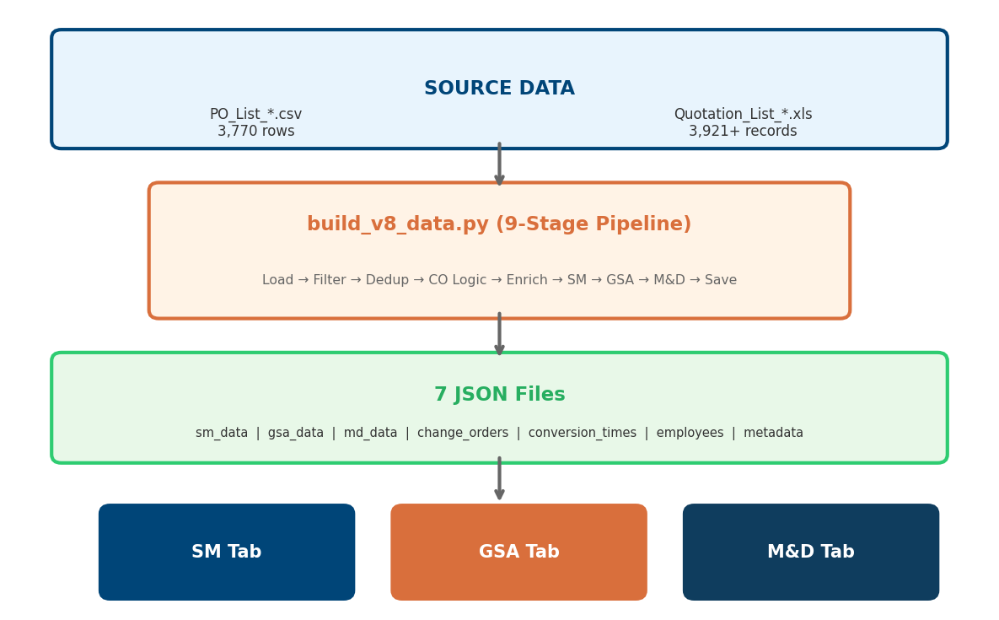

File Structure
File | Purpose
v8/index.html | Single-page app with 3 tabs (~1,063 lines)
v8/shared/scripts.js | All dashboard logic (~5,928 lines)
v8/shared/styles.css | Complete CSS with design tokens (~2,820 lines)
v8/data/build_v8_data.py | Python pipeline — 9 stages (~1,508 lines)
v8/data/sm_data.json | Supplier Marketplace data
v8/data/gsa_data.json | Global Spend Analysis data
v8/data/md_data.json | Materials & Disciplines data
v8/data/suppliers.json | Master supplier directory (2,189 entries)
v8/data/change_orders.json | CO group details (192 groups)
v8/data/conversion_times.json | RFQ→PO linkage & timing (180 links)
v8/data/client_country_map.json | Client→Country mapping (1,098 entries)
v8/data/entity_code_map.json | Entity code→name lookup (~20 entries)

3. Data Pipeline (9 Stages)
The Python pipeline (build_v8_data.py) is the single source of truth for all dashboard data. It reads raw Excel/CSV files and transforms them into optimized JSON through 9 sequential stages.

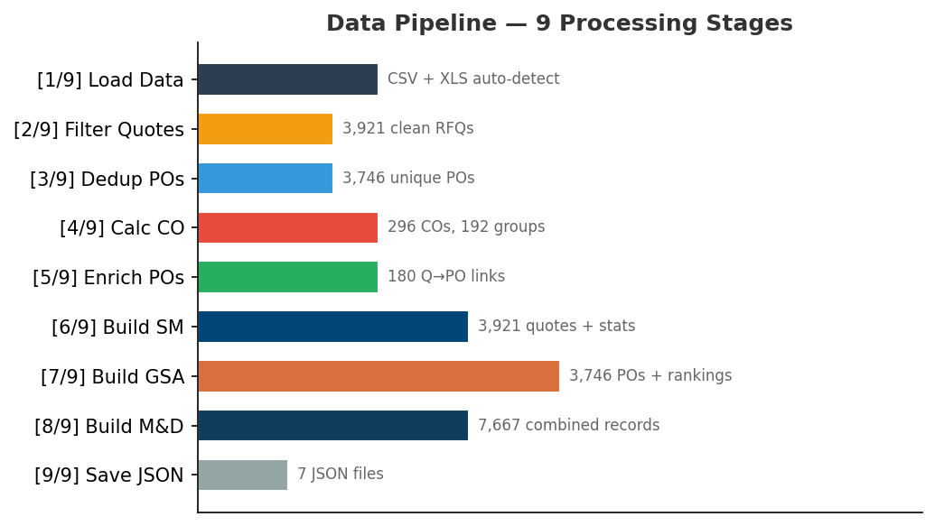

Stage | Name | Description | Output
[1/9] | Load Data Files | Auto-detects CSV from Data-New/ folder; falls back to legacy XLS via xlrd | 3,770 PO rows + 3,921+ quotation rows
[2/9] | Filter Quotations | Keeps RFQ only (removes Internal Quotations), deduplicates, removes empties | 3,921 clean quotation records
[3/9] | Deduplicate POs | Removes 24 duplicate PO numbers, converts all values to USD | 3,746 unique POs
[4/9] | Calculate Change Orders | 3-tier CO logic: PO/RFPO rev 2–6 = CO, rev 7+ = standalone | 296 COs in 192 groups
[5/9] | Enrich POs | Matches POs to quotations by orderId — fills material, project, entity | 180 Q→PO links, avg 29.5 days
[6/9] | Build SM Data | Quotation stats, status counts, employee records, entity aggregations | sm_data.json
[7/9] | Build GSA Data | PO spend summaries, supplier rankings, CO deduction logic, trends | gsa_data.json
[8/9] | Build M&D Data | Combined RFQ + PO by material code, discipline breakdown | md_data.json
[9/9] | Save All JSON | Conversion times, change order groups, metadata, all files saved | 7 JSON output files

4. Currency Conversion
Formula: USD Value = Original Amount ÷ Exchange Rate

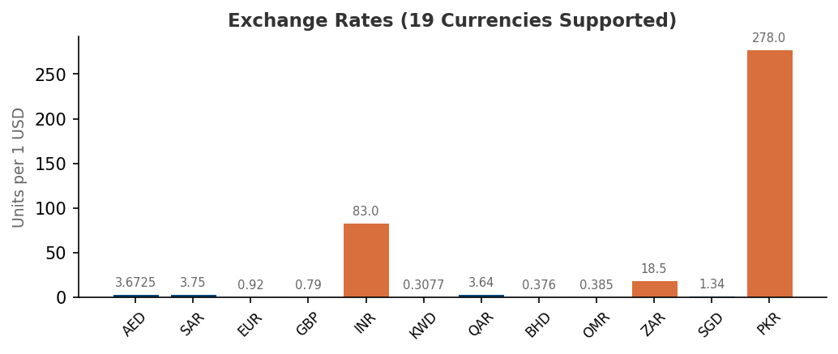

Currency | Rate (per 1 USD) | Notes
USD | 1.0000 | Base currency
AED | 3.6725 | UAE Dirham
SAR | 3.7500 | Saudi Riyal
EUR / EURO | 0.9200 | Euro (both codes mapped)
GBP | 0.7900 | British Pound
INR | 83.0000 | Indian Rupee
KWD | 0.3077 | Kuwaiti Dinar
QAR | 3.6400 | Qatari Riyal
BHD | 0.3760 | Bahraini Dinar
OMR | 0.3850 | Omani Rial
NPR | 133.5000 | Nepalese Rupee (PO override: 1:1)
JPY | 149.5000 | Japanese Yen (PO override: 1:1)
ZAR | 18.5000 | South African Rand
SGD | 1.3400 | Singapore Dollar
PKR | 278.0000 | Pakistani Rupee
EGP | 30.9000 | Egyptian Pound
JOD | 0.7090 | Jordanian Dinar
LKR | 320.0000 | Sri Lankan Rupee
PO-specific overrides: NPR and JPY are treated as 1:1 with USD for PO values — these appear to be data-entry artifacts where USD values were entered under NPR/JPY currencies.

5. Change Order Classification Logic

PO Number Structure
PO-1234-M4004-3
PO = Prefix (PO, RFPO, SPO, RFSPO, etc.)
1234 = Sequential Number
M4004 = Entity Code (maps to entity name)
3 = Revision Number

3-Tier Classification Rules

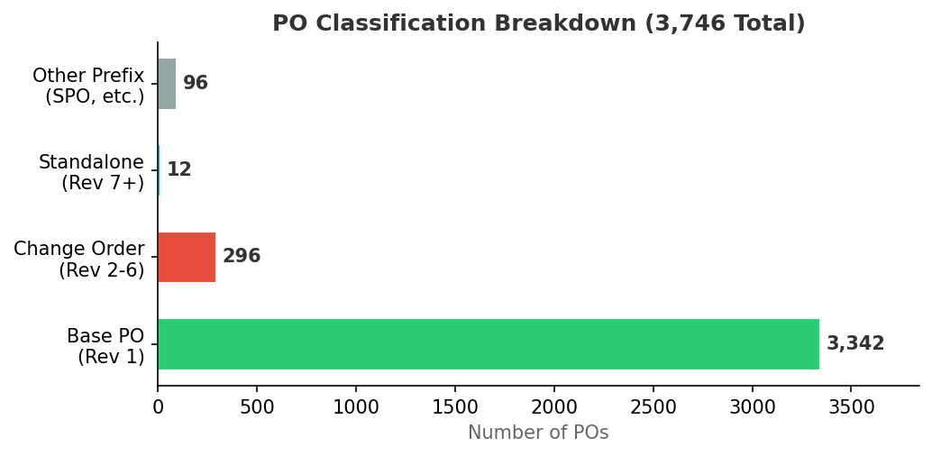

Tier | Prefix | Revision | Classification | Grouping
1 | PO / RFPO | 1 | Base PO | Shared baseGroupKey
2 | PO / RFPO | 2–6 | Change Order | Shared baseGroupKey with rev 1
3 | PO / RFPO | 7+ | Independent Standalone | Own baseGroupKey (self)
4 | All others | Any | Standalone | Own baseGroupKey (self)

CO Value Calculation (Incremental Deduction)
Change Order values represent the incremental cost difference, not the absolute PO value:
Scenario | CO Value Formula
First CO in group (or orphan) | Full CO amount
Same value as previous version | $0 (count only)
Non-consecutive revision gap | Full CO amount
Normal consecutive revision | CO amount − Previous version amount

6. Tab 1 — Supplier Marketplace (SM)
Theme: Blue (#004578) | Focus: RFQ pipeline and supplier discovery

6.1 Data Sources
File | Variable | Content
sm_data.json | smData | Quotation workbench, status/entity/material summaries, MVL employee records, filter lists
gsa_data.json | gsaData | PO counts, CO counts/values, supplier rankings, entity spend (for PO-related KPIs)
suppliers.json | suppliersData | Master supplier directory — name, contact, email, phone, rating, address, country
conversion_times.json | _conversionTimes | RFQ→PO monthly conversion averages
client_country_map.json | clientCountryMap | Client name → country mapping (1,098 entries)

6.2 Filters (10 Controls)
# | Filter | HTML ID | Options Source | Matches Field
1 | Entity | filterEntity | smData.entities[].Entity | q.Entity
2 | Project | filterProject | smData.workbench[] (2+ quotations) | q.ProjectName
3 | Supplier | filterSupplier | gsaData.filters.suppliers | q.Client
4 | Status | filterStatus | Hardcoded: Order, Quotation, Waiting, Cancelled, Closed | q.Status
5 | Material | filterMaterial | smData.filters.materials (30 names) | q.Material
6 | Material Code | filterMaterialCode | smData.filters.materialCodes (12 categories) | q.materialCode
7 | Date From | filterDateFrom | User-selected | q.Date >= fromDate
8 | Date To | filterDateTo | User-selected | q.Date <= toDate
9 | Search | searchInput | Free text | QuotationNumber, Entity, ProjectName, Description, Client
10 | Clear All | Button | — | Resets all filters
Filter Pipeline: applyFilters() filters smData.workbench[] array, then updates ALL visual components from the filtered result set.

6.3 KPI Cards (7 Metrics)
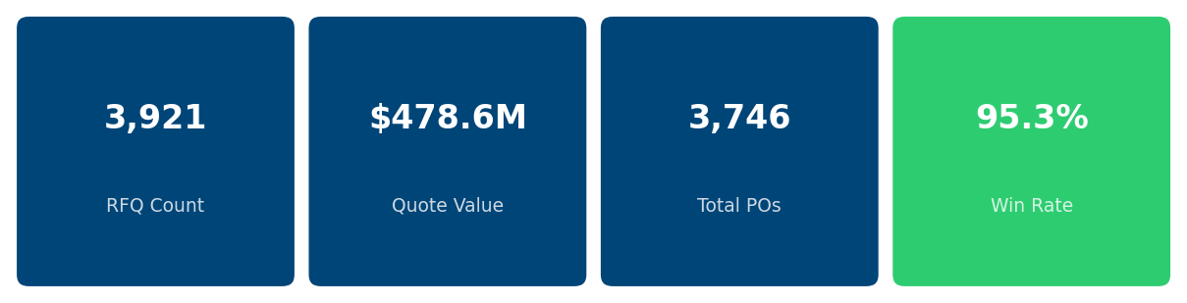

# | KPI Title | Formula | Refilters?
1 | Request for Quotation | COUNT(smData.workbench) | Yes
2 | Quote Value | SUM(convertToUSD(q.QuotationValue, q.Currency)) | Yes
3 | Total Purchase Orders | COUNT(non_spo_pos) from pipeline | No — pre-calculated
4 | PO Values | SUM(po.poSpendUSD) for non-SPO POs | No — pre-calculated
5 | Win Rate | totalPOs / totalQuotations × 100 | Yes
6 | Change Orders | COUNT(gsaData WHERE poType="Change Order") | No — from GSA data
7 | CO Value | Incremental deduction logic (Section 5) | No — from GSA data
Note: KPIs 3, 4, 6, 7 are sourced from PO/GSA data and remain constant regardless of SM quotation filters. Only KPIs 1, 2, 5 respond to filter changes.

6.4 Charts and Visualizations
Chart Name | Type | Canvas/Container | Data Source | Styling | Interaction & Notes
Status Chart | Custom HTML bar list | statusChart | smData.statusSummary[] — {Status, Count, TotalValueUSD} | Order=#4CAF50, Quotation=#2196F3, Waiting=#FFC107, Cancelled=#F44336, Closed=#9E9E9E | Click bar → filters by that status. Sub-KPIs: Conversion Rate, Open Quotes (Quotation + Waiting)
Entity Comparison | Chart.js horizontal bar | entityChartCanvas | quote view: smData.entities[].TotalValueUSD; spend view: gsaData.entityBreakdown[].valueUSD | Toggle: "By Quote" / "By PO Spend". Frozen x-axis, scrollable. | Click bar → filters by entity. Dynamic 28px per entity bar height.
Top 10 Suppliers | Custom HTML ranked list | topSuppliers | gsaData.supplierRankings.top[] (first 10) | Gold/silver/bronze rank circles, proportional bar widths | Click row → updates Supplier Profile + sets Supplier filter
Supplier Map | Leaflet.js interactive map | supplierMap | suppliersData.suppliers[] grouped by country via normalizeCountry() | CircleMarker radius 8–25px, 5-color intensity scale (green→red) | Popup: country, count, value, top 5 clients. Uses clientCountryMap + entityCountryMap fallback.
Material Distribution | Chart.js (Bar/Pie/Line/Radar) | materialChartCanvas | smData.materialsByDiscipline[] (top 8 by value) | 4-way toggle: Bar, Pie, Line, Radar views | Click segment → filters by material
Quotation to PO Time | Chart.js vertical bar | quotationTimeChart | conversion_times.json → monthlyAverage[] | Labels show "Nd" (days) above bars. Tooltip: X days (Y POs) | Date-range filtered by month (YYYY-MM comparison)
Submit & Order Trend | Chart.js multi-line (3 datasets) | trendChart | Quotes from submission_date, Orders from po_date, COs from GSA workbench | Quotes (#0066CC), Orders (#339933), COs (#FF9900) | NOT refiltered — rendered once at initial load

6.5 Supplier Profile Card
Field | HTML ID | Data Source
Avatar | supplierAvatar | First character of supplier name
Name | supplierName | Selected supplier name
Location | supplierLocation | suppliersData → normalizeCountry(address.country_standardized)
Contact | supplierContact | suppliersData → contact.primary_contact
Email | supplierEmail | suppliersData → contact.email
Phone | supplierPhone | suppliersData → contact.phone
Rating | supplierRating | suppliersData → rating.score → rendered as ★/☆

6.6 Responsible MVL Employee
Data source: smData.suppliers[] — these are MVL procurement contacts (e.g., "Lince M.", "Marman I."), NOT vendor companies. Ranked list with gold/silver/bronze circles, togglable "By Spend" / "By Count" sort.

6.7 Bottom Tables
Quotation Details Table (default tab) — Columns: Quotation Number, Status (color badge), Material, Project, Value (USD), Contact. Pagination: 25/50/100/200 rows per page.
Supplier List Table — Columns: Supplier Name, Contact, Email, Phone, Country, Category. Source: suppliers.json (2,189 suppliers). Click row → updates Supplier Profile.

7. Tab 2 — Global Spend Analysis (GSA)
Theme: Orange (#D96F3C) | Focus: PO spend analysis and change order tracking

7.1 Data Sources
File | Variable | Content
gsa_data.json | gsaData | PO workbench (3,746 records), spend summary, supplier rankings, entity/material breakdown, monthly trends, CO details
suppliers.json | suppliersData | Supplier details for supplier card (name, contact, rating, location)

7.2 Filters (10 Controls)
# | Filter | HTML ID | Options Source | Matches Field
1 | Entity | gsaFilterEntity | gsaData.filters.entities | po.entity
2 | Supplier | gsaFilterSupplier | gsaData.filters.suppliers | po.supplier
3 | Project | gsaFilterProject | Derived unique po.project values | po.project
4 | Material | gsaFilterMaterial | gsaData.filters.materials | po.material
5 | Material Code | gsaFilterMaterialCode | gsaData.filters.materialCodes | po.materialCode
6 | PO Type | gsaFilterDiscipline | gsaData.filters.poTypes | po.poType
7 | Year | gsaFilterYear | gsaData.filters.years | po.year
8 | Date From | gsaFilterFrom | Date input | po.poDate >= fromDate
9 | Date To | gsaFilterTo | Date input | po.poDate <= toDate
10 | Search | gsaSearchInput | Free text (debounced 300ms) | poNumber, poName, project, supplier, material, entity, orderId

7.3 KPI Cards (6 Metrics)
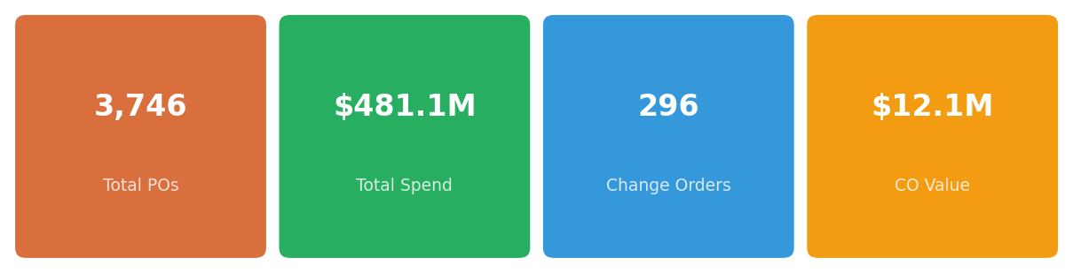

# | KPI Title | Unfiltered Source | Filtered Calculation
1 | Total No. of Purchase Orders | gsaData.summary.totalPOs | filteredPOs.length
2 | Total Spend | gsaData.summary.totalSpendUSD | SUM(convertToUSD(po.valueUSD, po.currency))
3 | Total No. of Change Orders | gsaData.summary.changeOrders | COUNT(po WHERE poType="Change Order")
4 | Total Amount of Change Orders | gsaData.summary.changeOrderValue | SUM(convertToUSD(co.valueUSD, co.currency))
5 | No. of Suppliers | gsaData.summary.supplierCount (2,189) | COUNT(DISTINCT po.supplier)
6 | No. of Entities | gsaData.summary.entityCount | COUNT(DISTINCT po.entity)
Sub-labels: KPI 3 shows "N groups" count. KPI 4 shows "X% of total spend" = (CO Value / Total Spend) × 100.

7.4 Charts and Visualizations
Chart Name | Type | Canvas ID | Datasets & Interaction | Data Source
Annual Spend Trend | Stacked bar + line combo | gsaSpendTrendChart | Base Spend (bar, orange #FF8C00) + Change Orders (bar, gold #FFD700) + Running Total (line, blue #0066CC) | Unfiltered: gsaData.monthlyTrend[]. Filtered: grouped from filteredData by po.yearMonth
Spend by Entity | Horizontal bar | gsaEntityChart | Top 8 Entities by PO Value. Click → cross-filters to that entity | Unfiltered: gsaData.entityBreakdown[]. Filtered: grouped by po.entity
Spend by Projects | Horizontal bar | gsaProjectChart | Top 8 Projects by PO Value. Click → cross-filters to that project | Always calculated from filteredData by po.project, top 8
Top Suppliers | Horizontal bar | gsaTopSuppliersChart | Top 10 Suppliers by Spend. Click → updates supplier card + cross-filters | Unfiltered: gsaData.supplierRankings.top[]. Filtered: grouped by po.supplier
Most Inactive Suppliers | Horizontal bar | gsaBottomSuppliersChart | Bottom 10 Suppliers by Spend. Click → updates supplier card + cross-filters | Same aggregation, sorted ascending, bottom 10

7.5 Supplier Details Card
Field | HTML ID | Data Source
Name | gsaSupplierName | Selected supplier name
Location | gsaSupplierLocation | suppliersData → normalizeCountry()
Stars | gsaSupplierStars | suppliersData → rating.score
Rating | gsaSupplierRating | rating.toFixed(2) + "/5"
Email | gsaSupplierEmail | suppliersData → contact.email
Contact | gsaSupplierContact | suppliersData → contact.primary_contact
Fallback: If supplier not found in suppliersData, shows entity from first PO, PO count + total spend, default 4-star rating.

7.6 PO Details Table
Column | Sort Key | Field | Format
PO No. | po_no | po.poNumber | Link
Type | type | po.poType | Badge: "CO" (red) / "Base" (green) + group badge
Order ID | order_id | po.orderId | Integer sort
Project | project | po.project | Truncated 40 chars
PO Date | po_date | po.poDate | Date sort (default desc)
Supplier | supplier | po.supplier | Text
Material | material | po.material | Text
PO Value (US$) | po_value | convertToUSD(po.valueUSD, po.currency) | formatCurrency()
Pagination: 25/50/100 rows per page. Default sort: PO Date descending. Searchable by PO number, name, project, supplier, material, entity, orderId.

7.7 Cross-Filter Behavior
Click Target | What Happens
Entity bar | Filters all components to that entity
Project bar | Filters all components to that project
Top/Bottom supplier bar | Updates supplier card + filters to that supplier
Trend bar | Console log only (no cross-filter)

8. Tab 3 — Materials & Disciplines (M&D)
Theme: Dark Blue (#0F3D5E) | Focus: Material categorization, discipline spend, and conversion analysis

8.1 Data Sources
File | Variable | Content
md_data.json | mdData | Combined quotations (3,921) + POs (3,746), discipline breakdown, entity breakdown, trend, filters
suppliers.json | suppliersData | Supplier details for profile card and overview table

8.2 Filters (8 Controls + Search)
# | Filter | HTML ID | Options Source | Matches
1 | Material Code | filterMdDiscipline | mdData.filters.materialCodes | po.materialCode / q.materialCode
2 | Material | filterMdMaterial | mdData.filters.materials | po.material / q.material
3 | Entity | filterMdEntity | mdData.filters.entities | po.entity / q.entity
4 | Project | filterMdProject | mdData.filters.projects (max 200) | po.project / q.project
5 | Supplier | filterMdSupplier | mdData.filters.suppliers | po.supplier / q.supplier
6 | Year | filterMdYear | Derived from PO years | po.year
7 | Date From | filterMdFrom | Date input | poDate / q.date >= fromDate
8 | Date To | filterMdTo | Date input | poDate / q.date <= toDate
9 | Search | mdSearchInput | Free text (debounced 300ms) | Multiple fields
Important: M&D filters apply to both POs and quotations simultaneously.

8.3 KPI Cards (5 Metrics)
# | KPI Title | Unfiltered Formula | Filtered Formula
1 | Materials | Unique raw material names (excl. Blank) | DISTINCT(po.material + q.material) count
2 | Material Codes | Unique consolidated codes | DISTINCT(po.materialCode + q.materialCode) count
3 | Total Material Spend | SUM(md_pos[].value) in USD | SUM(po.value) from filtered POs
4 | Total Material Code Spend | Same as #3 (totalOrdered) | Same as #3
5 | Active Projects | Unique projects from POs | DISTINCT(po.project) count
Sub-labels: KPIs 3 & 4 show conversion %: (totalOrdered / totalQuoted × 100)%. KPI 5 shows supplier count: 2,189 from master list.

8.4 Charts
Chart Name | Type | Canvas ID | Datasets & Interaction | Data Source
Total Spend by Material Code | Horizontal grouped bar | disciplineSpendChart | Dataset 1: "Quoted" (#9CB3C9), Dataset 2: "Ordered" (#2B4257). Top 12 by orderedValue. | Unfiltered: mdData.disciplines[]. Filtered: aggregated from filtered POs + quotations by materialCode.
Material Distribution | Doughnut (55% cutout) | materialDistributionChart | Top 10 slices. Click slice → filters by that material. | Unfiltered: mdData.disciplines[] (top 10). Filtered: aggregated from filtered POs by po.material.

8.5 Supplier Profile Card
Field | HTML ID | Source
Name | mdSupplierName | supplier.name
Location | mdSupplierLocation | normalizeCountry() on address data
Stars | mdSupplierStars | rating.score → ⭐/☆
Rating | mdSupplierRatingVal | rating.toFixed(2) + "/5"
Email | mdSupplierEmail | supplier.contact.email
Contact | mdSupplierContact | supplier.contact.primary_contact

8.6 Supplier Overview Table
Column | Sort | Field
Supplier Name ↕ | name | supplier.name (clickable → profile)
Location ↕ | country | normalizeCountry(address.country_standardized)
Rating ↕ | rating | ⭐ rating.toFixed(1) from suppliers.json
Email | — | contact.email
Contact | — | contact.primary_contact
Pagination: 10/25/50 per page with search and page navigation buttons. Unfiltered: all suppliers from suppliersData. Filtered: unique suppliers from filtered POs.

8.7 PO/Material Details Table
Column | Field | Format
PO Number | po.poNumber | Text
PO Date | po.poDate | Text
Material | po.material | Text
Material Code | po.materialCode | Text
PO Value (USD) | convertToUSD(po.value, po.currency) | formatCurrencyShort()
Currency | po.currency | Text
Project | po.project | Truncated 40 chars
Pagination: 20 rows/page with prev/next navigation.

8.8 Approved Materials
Status: 🚧 Coming Soon — Placeholder in current UI. JavaScript functions exist but the HTML tbody is hidden by the "Coming Soon" overlay. Will display: Material, Spec No, Supplier, Discipline.

9. Data File Reference

Pipeline-Generated Files (7)
File | Records | Key Fields
sm_data.json | 3,921 quotations | .summary, .workbench[], .statusSummary[], .entities[], .materialsByDiscipline[], .suppliers[] (employees), .filters, .funnel
gsa_data.json | 3,746 POs | .summary, .workbench[], .supplierRankings, .entityBreakdown[], .materialBreakdown[], .monthlyTrend[], .poTypeBreakdown, .changeOrderDetails[], .filters
md_data.json | 3,921 Q + 3,746 PO | .summary, .quotations[], .pos[], .disciplines[], .entityBreakdown[], .trend[], .filters
employees.json | ~50 employees | Employee quotation/order counts, win rates, spend values
conversion_times.json | 180 links | .monthlyAverage[], .totalLinked, .averageDays
change_orders.json | 192 groups | .totalGroups, .totalCOPOs, .totalCOValue, .groups[]
data_metadata.json | 1 record | Build date, source files, record counts

Pre-existing Reference Files (3)
File | Entries | Purpose
suppliers.json | 2,189 suppliers | Master supplier directory with contact, address, rating, material category
client_country_map.json | 1,098 entries | Client name → country mapping (4-source priority)
entity_code_map.json | ~20 entries | Entity code → entity name lookup

10. Material Code Classification
The pipeline classifies ~35 raw material names into 12 standardized material categories:

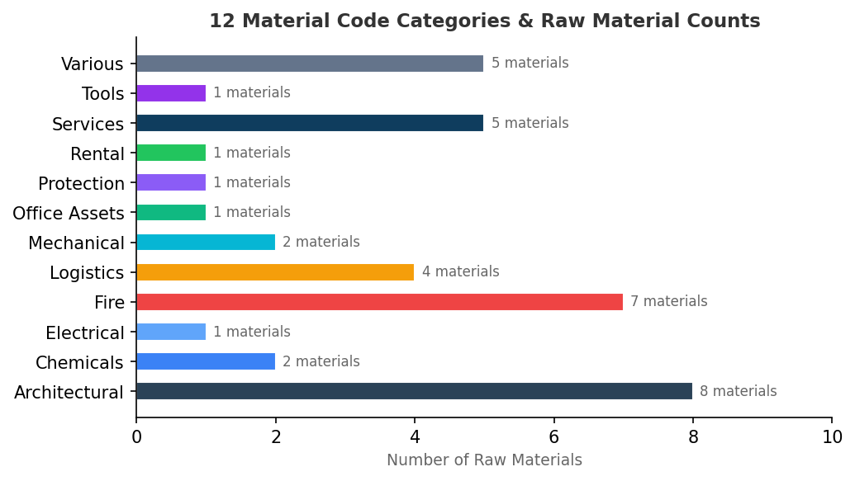

Material Code | Raw Materials | PO Prefix
Architectural | Sandwich Panel, Steel Coil, Doors, Windows, Fit Out Project, Paints, Sanitary Accessories | A
Chemicals | Polyurethane Foam, Chemicals | C
Electrical | Electrical | E
Fire | Firestop/DC 315, Firestop, Fire Alarm, Fire Fighting, Fire Suppression, Fire Protection | F
Logistics | Transportation, Discount, MHE, Logistics | L
Mechanical | Machine/Equipments, Mechanical Items | M
Office Assets | Computer Peripherals | O
Protection | PPE | P
Rental | Rental | R
Services | Design, Construction, LSA - Life Support Area, Subcontract, Services | S
Tools | Tools | T
Various | Containers, Building Materials, Graco Spares, Misc., General | V
PO-based detection: When material info is not available from quotation linkage, the pipeline infers material from the PO entity code prefix letter (e.g., "M" → Mechanical).

11. Country Normalization

Multi-Source Country Resolution
Priority | Source | Description
1 | Address | Physical address country field
2 | Phone Validation | Country from validated phone number
3 | Phone Prefix | Country inferred from phone number prefix
4 | Email TLD | Country from email domain extension

Entity-Based Fallback
For clients not in the country map, 29 entity→country mappings provide defaults:
Entity | Default Country
MVL INDUSTRIAL SOLUTIONS | United Arab Emirates
MVL VENTURES LLC | United Arab Emirates
MVL ENERGY | United Arab Emirates
MVL SOLUTIONS | United Arab Emirates
CENTRICO | United Arab Emirates
MVL INDUSTRIAL EST | Saudi Arabia
MVL ARABIA | Saudi Arabia
MVL PROJECTS | United Arab Emirates
MVL TRADING | United Arab Emirates
MVL FACILITIES | United Arab Emirates

normalizeCountry() Function
The frontend normalizeCountry() function standardizes ~150 country name variants:
Input Variants | Normalized Output
"United Arab Emirates" / "UAE" / "U.A.E." / "Uae" | United Arab Emirates
"Kingdom of Saudi Arabia" / "KSA" / "Saudi" | Saudi Arabia
"USA" / "United States of America" / "US" | United States
"UK" / "United Kingdom of Great Britain..." | United Kingdom
"Peoples Republic of China" / "PRC" | China

Appendix — Design Tokens & Formatting

Currency Display Functions
Context | Function | Example
KPI cards | formatCurrencyShort() | $478.6M, $12.1K, $1.2B
Table cells | formatCurrency() | $1.2M, $478.6K, $12
Number only | formatNumber() | 3,746

Status Badge Colors
Status | Color | Hex
Order | Green | #2ECC71
Quotation | Blue | #3498DB
Waiting | Orange | #F39C12
Cancelled | Red | #E74C3C
Closed | Gray | #95A5A6

Change Order Badges
Badge | Color | Meaning
CO | Red #E74C3C | Change Order
Base | Green #2ECC71 | Base PO
N of M | Gold #F39C12 | Group indicator (e.g., "2 of 3")

━━━━━━━━━━━━━━━━━━━━━━━━━━━━━━━━━━━━━━━━━━━━━━━━━━
Document generated from codebase analysis of v8/shared/scripts.js (~5,928 lines),
v8/data/build_v8_data.py (~1,508 lines), and v8/index.html (~1,063 lines).
MVL Supply Chain Intelligence Hub — V8 — February 2026

