MVL Supply Chain
Intelligence Hub
V8 Dashboard — Technical Documentation

━━━━━━━━━━━━━━━━━━━━━━━━━━━━━━━━━━━━━━━━━━━━━━━━━━

Data Sources • Calculation Logic • Display Reference
February 2026 | Version 8.0
https://sajeshvs.github.io/mvl/v8/

Table of Contents
1. Executive Summary
2. Architecture Overview
3. Data Pipeline (9 Stages)
4. Currency Conversion
5. Change Order Classification Logic
6. Tax Data Processing (V9 New)
7. Tab 1 — Supplier Marketplace (SM)
8. Tab 2 — Global Spend Analysis (GSA)
9. Tab 3 — Materials & Disciplines (M&D)
10. Data File Reference
11. Material Code Classification
12. Country Normalization

1. Executive Summary
The MVL Supply Chain Intelligence Hub is a browser-based, three-tab analytics dashboard that provides end-to-end visibility into procurement operations — from initial Request for Quotation (RFQ) through Purchase Order (PO) execution and Change Order (CO) tracking.

Dashboard Tabs at a Glance
Tab | Theme | Focus Area | Primary Data
Supplier Marketplace | Blue #004578 | RFQ pipeline, quotation tracking, supplier discovery | Quotation records (RFQs)
Global Spend Analysis | Orange #D96F3C | PO spend, change orders, entity & project analysis | Purchase Orders
Materials & Disciplines | Dark Blue #0F3D5E | Material categorization, discipline spend, conversions | Combined RFQs + POs

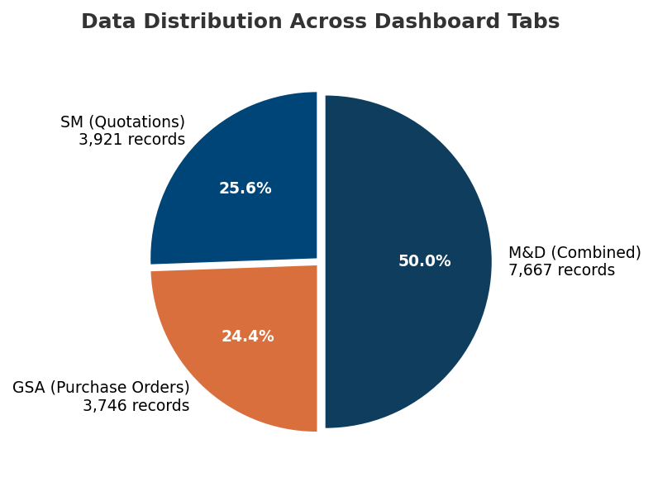

Key Metrics Summary
Metric | Value | Source
Total RFQ Records | 3,941 | Quotation XLS export (5 files, 12,276 raw rows)
Total Purchase Orders | 3,620 | PO XLS export (3,637 raw rows, 9 columns)
Total PO Spend (USD) | ~$481M | Converted via FX rates
Total PO Tax (USD) | ~$1.69M | 870 POs with tax data (V9 New)
Total Quotation Tax (USD) | ~$1.58M | 872 quotations with tax data (V9 New)
Change Orders | 296 (192 groups) | PO/RFPO rev 2–6
Master Supplier Count | 2,189 | suppliers.json
Active Suppliers (in POs) | ~1,133 | Derived from PO data
Material Categories | 12 | Code-based classification
Raw Materials | 33 | Distinct material names

2. Architecture Overview

Technology Stack
Layer | Technology | Purpose
Frontend | HTML5, CSS3, Vanilla JavaScript | Single-page application
Charts | Chart.js 4.x | Bar, line, doughnut, radar charts
Maps | Leaflet.js 1.9.4 | Interactive supplier location map
Data Pipeline | Python 3.12 | Excel/CSV → JSON transformation
Hosting | GitHub Pages | Static file deployment

Data Flow Architecture
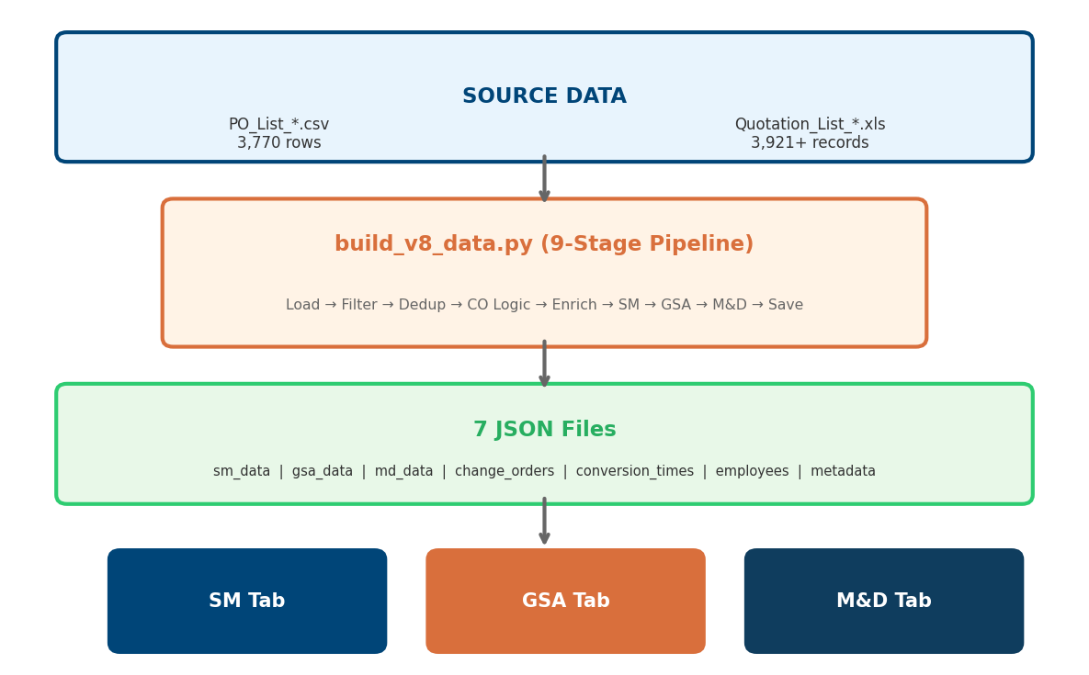

File Structure
File | Purpose
v8/index.html | Single-page app with 3 tabs (~1,063 lines)
v8/shared/scripts.js | All dashboard logic (~5,928 lines)
v8/shared/styles.css | Complete CSS with design tokens (~2,820 lines)
v8/data/build_v8_data.py | Python pipeline — 9 stages (~1,508 lines)
v8/data/sm_data.json | Supplier Marketplace data
v8/data/gsa_data.json | Global Spend Analysis data
v8/data/md_data.json | Materials & Disciplines data
v8/data/suppliers.json | Master supplier directory (2,189 entries)
v8/data/change_orders.json | CO group details (192 groups)
v8/data/conversion_times.json | RFQ→PO linkage & timing (180 links)
v8/data/client_country_map.json | Client→Country mapping (1,098 entries)
v8/data/entity_code_map.json | Entity code→name lookup (~20 entries)

3. Data Pipeline (9 Stages)
The Python pipeline (build_v8_data.py) is the single source of truth for all dashboard data. It reads raw Excel/CSV files and transforms them into optimized JSON through 9 sequential stages.

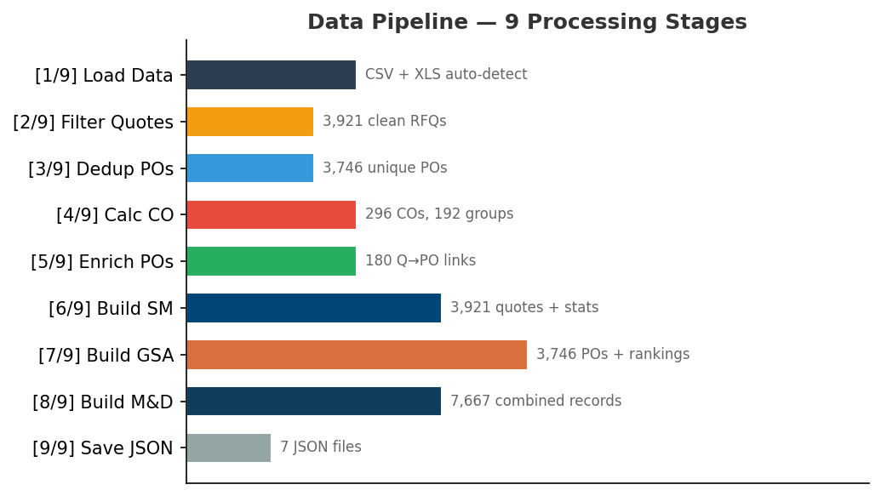

Stage | Name | Description | Output
[1/9] | Load Data Files | Auto-detects CSV from Data-New/ folder; falls back to legacy XLS via xlrd | 3,770 PO rows + 3,921+ quotation rows
[2/9] | Filter Quotations | Keeps RFQ only (removes Internal Quotations), deduplicates, removes empties | 3,921 clean quotation records
[3/9] | Deduplicate POs | Removes 24 duplicate PO numbers, converts all values to USD | 3,746 unique POs
[4/9] | Calculate Change Orders | 3-tier CO logic: PO/RFPO rev 2–6 = CO, rev 7+ = standalone | 296 COs in 192 groups
[5/9] | Enrich POs | Matches POs to quotations by orderId — fills material, project, entity | 180 Q→PO links, avg 29.5 days
[6/9] | Build SM Data | Quotation stats, status counts, employee records, entity aggregations | sm_data.json
[7/9] | Build GSA Data | PO spend summaries, supplier rankings, CO deduction logic, trends | gsa_data.json
[8/9] | Build M&D Data | Combined RFQ + PO by material code, discipline breakdown | md_data.json
[9/9] | Save All JSON | Conversion times, change order groups, metadata, all files saved | 7 JSON output files

4. Currency Conversion
Formula: USD Value = Original Amount ÷ Exchange Rate

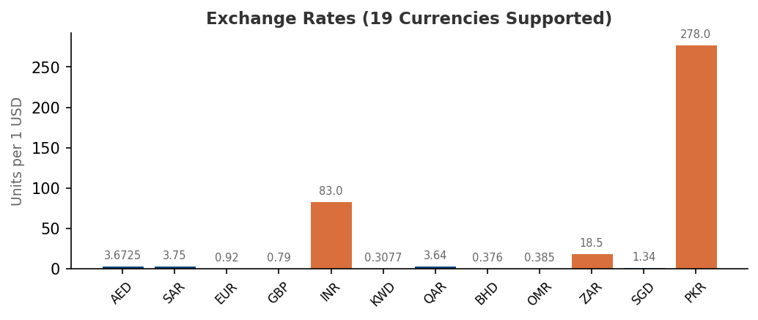

Currency | Rate (per 1 USD) | Notes
USD | 1.0000 | Base currency
AED | 3.6725 | UAE Dirham
SAR | 3.7500 | Saudi Riyal
EUR / EURO | 0.9200 | Euro (both codes mapped)
GBP | 0.7900 | British Pound
INR | 83.0000 | Indian Rupee
KWD | 0.3077 | Kuwaiti Dinar
QAR | 3.6400 | Qatari Riyal
BHD | 0.3760 | Bahraini Dinar
OMR | 0.3850 | Omani Rial
NPR | 133.5000 | Nepalese Rupee (PO override: 1:1)
JPY | 149.5000 | Japanese Yen (PO override: 1:1)
ZAR | 18.5000 | South African Rand
SGD | 1.3400 | Singapore Dollar
PKR | 278.0000 | Pakistani Rupee
EGP | 30.9000 | Egyptian Pound
JOD | 0.7090 | Jordanian Dinar
LKR | 320.0000 | Sri Lankan Rupee
PO-specific overrides: NPR and JPY are treated as 1:1 with USD for PO values — these appear to be data-entry artifacts where USD values were entered under NPR/JPY currencies.

5. Change Order Classification Logic

PO Number Structure
PO-1234-M4004-3
PO = Prefix (PO, RFPO, SPO, RFSPO, etc.)
1234 = Sequential Number
M4004 = Entity Code (maps to entity name)
3 = Revision Number

3-Tier Classification Rules

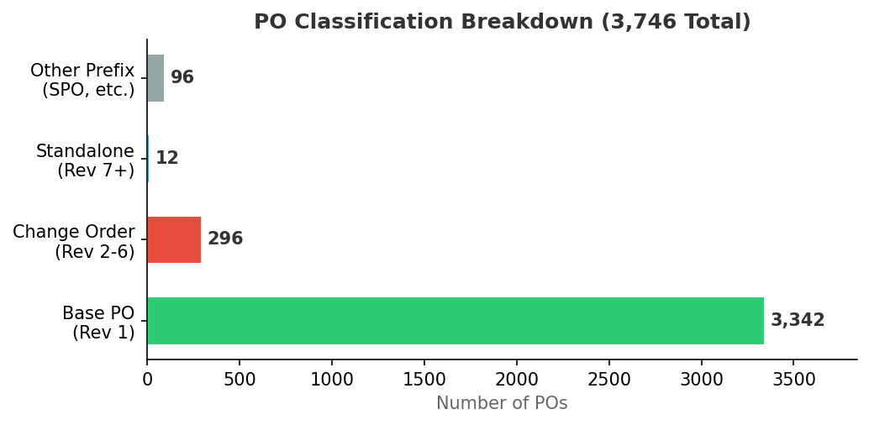

Tier | Prefix | Revision | Classification | Grouping
1 | PO / RFPO | 1 | Base PO | Shared baseGroupKey
2 | PO / RFPO | 2–6 | Change Order | Shared baseGroupKey with rev 1
3 | PO / RFPO | 7+ | Independent Standalone | Own baseGroupKey (self)
4 | All others | Any | Standalone | Own baseGroupKey (self)

CO Value Calculation (Incremental Deduction)
Change Order values represent the incremental cost difference, not the absolute PO value:
Scenario | CO Value Formula
First CO in group (or orphan) | Full CO amount
Same value as previous version | $0 (count only)
Non-consecutive revision gap | Full CO amount
Normal consecutive revision | CO amount − Previous version amount

6. Tax Data Processing (V9 New)
Version 9 introduces tax data processing for both Purchase Orders and Quotations. Tax amounts are extracted from source Excel files, converted to USD, and displayed across multiple dashboard tabs as KPI subtexts and table columns.

6.1 Source Data
Tax data is extracted from two source Excel (XLS) files:
Source | File Pattern | Tax Column | Records with Tax
Purchase Orders | PO_List_*.xls | Tax (column 9) | 870 of 3,620 POs
Quotations | quotation_*.xls (5 files) | Tax (column 14) | 872 of 3,941 quotations

6.2 Pipeline Processing
The build_v8_data.py pipeline processes tax data in two functions:
load_po_xls_tax(): Reads PO XLS → extracts Tax column → converts to USD via FX rates → writes taxUSD and netTotalUSD fields to each PO record in gsa_data.json
load_quotation_xls_tax(): Reads Quotation XLS files → extracts Tax and Net Total columns → converts to USD → writes Tax and NetTotal fields to each quotation record in sm_data.json and md_data.json

6.3 Tax KPIs — GSA Tab
JSON Field | Value | Description
summary.totalTaxUSD | ~$1,689,813 | Sum of all PO tax amounts in USD
summary.posWithTax | 870 | Count of POs that have non-zero tax
summary.totalNetSpendUSD | ~$479M | Total spend minus tax (netTotalUSD)

6.4 Tax KPIs — SM Tab
JSON Field | Value | Description
summary.totalQuotationTaxUSD | ~$1,578,990 | Sum of all quotation tax amounts in USD
summary.quotationsWithTax | 872 | Count of quotations that have non-zero tax
summary.totalQuotationNetUSD | ~$118M | Total quotation value minus tax

6.5 Frontend Display
Tax data appears in the dashboard in three ways:
KPI Subtext (GSA): Total Spend KPI shows "Tax: $X.XM" below the main value
KPI Subtext (SM): Quote Value KPI shows "Tax: $X.XM" below the main value
Table Columns: GSA PO Details table includes "Tax US$" column; SM Quotation Details table includes "TAX" column

7. Tab 1 — Supplier Marketplace (SM)
Theme: Blue (#004578) | Focus: RFQ pipeline and supplier discovery

7.1 Data Sources
File | Variable | Content
sm_data.json | smData | Quotation workbench, status/entity/material summaries, MVL employee records, filter lists
gsa_data.json | gsaData | PO counts, CO counts/values, supplier rankings, entity spend (for PO-related KPIs)
suppliers.json | suppliersData | Master supplier directory — name, contact, email, phone, rating, address, country
conversion_times.json | _conversionTimes | RFQ→PO monthly conversion averages
client_country_map.json | clientCountryMap | Client name → country mapping (1,098 entries)

7.2 Filters (10 Controls)
# | Filter | HTML ID | Options Source | Matches Field
1 | Entity | filterEntity | smData.entities[].Entity | q.Entity
2 | Project | filterProject | smData.workbench[] (2+ quotations) | q.ProjectName
3 | Supplier | filterSupplier | gsaData.filters.suppliers | q.Client
4 | Status | filterStatus | Hardcoded: Order, Quotation, Waiting, Cancelled, Closed | q.Status
5 | Material | filterMaterial | smData.filters.materials (30 names) | q.Material
6 | Material Code | filterMaterialCode | smData.filters.materialCodes (12 categories) | q.materialCode
7 | Date From | filterDateFrom | User-selected | q.Date >= fromDate
8 | Date To | filterDateTo | User-selected | q.Date <= toDate
9 | Search | searchInput | Free text | QuotationNumber, Entity, ProjectName, Description, Client
10 | Clear All | Button | — | Resets all filters
Filter Pipeline: applyFilters() filters smData.workbench[] array, then updates ALL visual components from the filtered result set.

7.3 KPI Cards (7 Metrics + Tax Subtext)
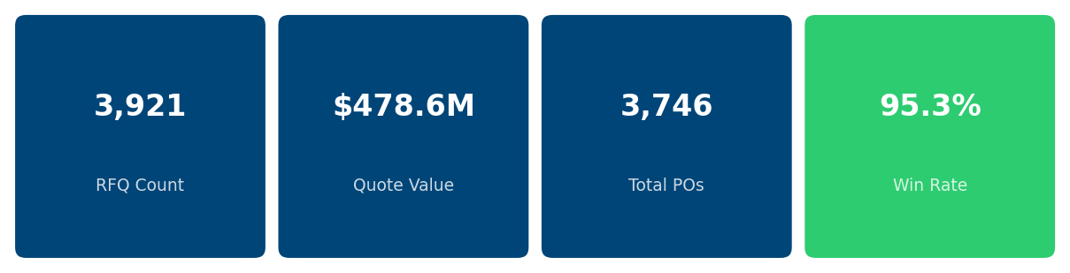

# | KPI Title | Formula | Refilters?
1 | Request for Quotation | COUNT(smData.workbench) | Yes
2 | Quote Value | SUM(convertToUSD(q.QuotationValue, q.Currency)) | Yes
2a | Tax subtext (V9 New) | SUM(convertToUSD(q.Tax, q.Currency)) | Yes
3 | Total Purchase Orders | COUNT(non_spo_pos) from pipeline | No — pre-calculated
4 | PO Values | SUM(po.poSpendUSD) for non-SPO POs | No — pre-calculated
5 | Win Rate | totalPOs / totalQuotations × 100 | Yes
6 | Change Orders | COUNT(gsaData WHERE poType="Change Order") | No — from GSA data
7 | CO Value | Incremental deduction logic (Section 5) | No — from GSA data
Note: KPIs 3, 4, 6, 7 are sourced from PO/GSA data and remain constant regardless of SM quotation filters. Only KPIs 1, 2, 2a, 5 respond to filter changes.

7.4 Charts and Visualizations
Chart Name | Type | Canvas/Container | Data Source | Styling | Interaction & Notes
Status Chart | Custom HTML bar list | statusChart | smData.statusSummary[] — {Status, Count, TotalValueUSD} | Order=#4CAF50, Quotation=#2196F3, Waiting=#FFC107, Cancelled=#F44336, Closed=#9E9E9E | Click bar → filters by that status. Sub-KPIs: Conversion Rate, Open Quotes (Quotation + Waiting)
Entity Comparison | Chart.js horizontal bar | entityChartCanvas | quote view: smData.entities[].TotalValueUSD; spend view: gsaData.entityBreakdown[].valueUSD | Toggle: "By Quote" / "By PO Spend". Frozen x-axis, scrollable. | Click bar → filters by entity. Dynamic 28px per entity bar height.
Top 10 Suppliers | Custom HTML ranked list | topSuppliers | gsaData.supplierRankings.top[] (first 10) | Gold/silver/bronze rank circles, proportional bar widths | Click row → updates Supplier Profile + sets Supplier filter
Supplier Map | Leaflet.js interactive map | supplierMap | suppliersData.suppliers[] grouped by country via normalizeCountry() | CircleMarker radius 8–25px, 5-color intensity scale (green→red) | Popup: country, count, value, top 5 clients. Uses clientCountryMap + entityCountryMap fallback.
Material Distribution | Chart.js (Bar/Pie/Line/Radar) | materialChartCanvas | smData.materialsByDiscipline[] (top 8 by value) | 4-way toggle: Bar, Pie, Line, Radar views | Click segment → filters by material
Quotation to PO Time | Chart.js vertical bar | quotationTimeChart | conversion_times.json → monthlyAverage[] | Labels show "Nd" (days) above bars. Tooltip: X days (Y POs) | Date-range filtered by month (YYYY-MM comparison)
Submit & Order Trend | Chart.js multi-line (3 datasets) | trendChart | Quotes from submission_date, Orders from po_date, COs from GSA workbench | Quotes (#0066CC), Orders (#339933), COs (#FF9900) | NOT refiltered — rendered once at initial load

7.5 Supplier Profile Card
Field | HTML ID | Data Source
Avatar | supplierAvatar | First character of supplier name
Name | supplierName | Selected supplier name
Location | supplierLocation | suppliersData → normalizeCountry(address.country_standardized)
Contact | supplierContact | suppliersData → contact.primary_contact
Email | supplierEmail | suppliersData → contact.email
Phone | supplierPhone | suppliersData → contact.phone
Rating | supplierRating | suppliersData → rating.score → rendered as ★/☆

7.6 Responsible MVL Employee
Data source: smData.suppliers[] — these are MVL procurement contacts (e.g., "Lince M.", "Marman I."), NOT vendor companies. Ranked list with gold/silver/bronze circles, togglable "By Spend" / "By Count" sort.

7.7 Bottom Tables
Quotation Details Table (default tab) — Columns: Quotation Number, Status (color badge), Material, Project, Value (USD), TAX (V9 New), Contact. Pagination: 25/50/100/200 rows per page.
Supplier List Table — Columns: Supplier Name, Contact, Email, Phone, Country, Category. Source: suppliers.json (2,189 suppliers). Click row → updates Supplier Profile.

8. Tab 2 — Global Spend Analysis (GSA)
Theme: Orange (#D96F3C) | Focus: PO spend analysis and change order tracking

8.1 Data Sources
File | Variable | Content
gsa_data.json | gsaData | PO workbench (3,746 records), spend summary, supplier rankings, entity/material breakdown, monthly trends, CO details
suppliers.json | suppliersData | Supplier details for supplier card (name, contact, rating, location)

8.2 Filters (10 Controls)
# | Filter | HTML ID | Options Source | Matches Field
1 | Entity | gsaFilterEntity | gsaData.filters.entities | po.entity
2 | Supplier | gsaFilterSupplier | gsaData.filters.suppliers | po.supplier
3 | Project | gsaFilterProject | Derived unique po.project values | po.project
4 | Material | gsaFilterMaterial | gsaData.filters.materials | po.material
5 | Material Code | gsaFilterMaterialCode | gsaData.filters.materialCodes | po.materialCode
6 | PO Type | gsaFilterDiscipline | gsaData.filters.poTypes | po.poType
7 | Year | gsaFilterYear | gsaData.filters.years | po.year
8 | Date From | gsaFilterFrom | Date input | po.poDate >= fromDate
9 | Date To | gsaFilterTo | Date input | po.poDate <= toDate
10 | Search | gsaSearchInput | Free text (debounced 300ms) | poNumber, poName, project, supplier, material, entity, orderId

8.3 KPI Cards (6 Metrics + Tax Subtext)
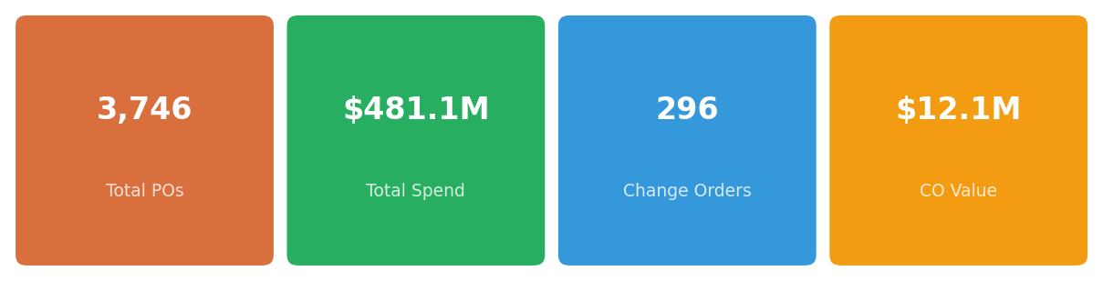

# | KPI Title | Unfiltered Source | Filtered Calculation
1 | Total No. of Purchase Orders | gsaData.summary.totalPOs | filteredPOs.length
2 | Total Spend | gsaData.summary.totalSpendUSD | SUM(convertToUSD(po.valueUSD, po.currency))
2a | Tax subtext (V9 New) | gsaData.summary.totalTaxUSD | SUM(po.taxUSD)
3 | Total No. of Change Orders | gsaData.summary.changeOrders | COUNT(po WHERE poType="Change Order")
4 | Total Amount of Change Orders | gsaData.summary.changeOrderValue | SUM(convertToUSD(co.valueUSD, co.currency))
5 | No. of Suppliers | gsaData.summary.supplierCount (2,189) | COUNT(DISTINCT po.supplier)
6 | No. of Entities | gsaData.summary.entityCount | COUNT(DISTINCT po.entity)
Sub-labels: KPI 3 shows "N groups" count. KPI 4 shows "X% of total spend" = (CO Value / Total Spend) × 100. KPI 2 shows Tax subtext: "Tax: $X.XM" (V9 New).

8.4 Charts and Visualizations
Chart Name | Type | Canvas ID | Datasets & Interaction | Data Source
Annual Spend Trend | Stacked bar + line combo | gsaSpendTrendChart | Base Spend (bar, orange #FF8C00) + Change Orders (bar, gold #FFD700) + Running Total (line, blue #0066CC) | Unfiltered: gsaData.monthlyTrend[]. Filtered: grouped from filteredData by po.yearMonth
Spend by Entity | Horizontal bar | gsaEntityChart | Top 8 Entities by PO Value. Click → cross-filters to that entity | Unfiltered: gsaData.entityBreakdown[]. Filtered: grouped by po.entity
Spend by Projects | Horizontal bar | gsaProjectChart | Top 8 Projects by PO Value. Click → cross-filters to that project | Always calculated from filteredData by po.project, top 8
Top Suppliers | Horizontal bar | gsaTopSuppliersChart | Top 10 Suppliers by Spend. Click → updates supplier card + cross-filters | Unfiltered: gsaData.supplierRankings.top[]. Filtered: grouped by po.supplier
Most Inactive Suppliers | Horizontal bar | gsaBottomSuppliersChart | Bottom 10 Suppliers by Spend. Click → updates supplier card + cross-filters | Same aggregation, sorted ascending, bottom 10

8.5 Supplier Details Card
Field | HTML ID | Data Source
Name | gsaSupplierName | Selected supplier name
Location | gsaSupplierLocation | suppliersData → normalizeCountry()
Stars | gsaSupplierStars | suppliersData → rating.score
Rating | gsaSupplierRating | rating.toFixed(2) + "/5"
Email | gsaSupplierEmail | suppliersData → contact.email
Contact | gsaSupplierContact | suppliersData → contact.primary_contact
Fallback: If supplier not found in suppliersData, shows entity from first PO, PO count + total spend, default 4-star rating.

8.6 PO Details Table
Column | Sort Key | Field | Format
PO No. | po_no | po.poNumber | Link
Type | type | po.poType | Badge: "CO" (red) / "Base" (green) + group badge
Order ID | order_id | po.orderId | Integer sort
Project | project | po.project | Truncated 40 chars
PO Date | po_date | po.poDate | Date sort (default desc)
Supplier | supplier | po.supplier | Text
Material | material | po.material | Text
PO Value (US$) | po_value | convertToUSD(po.valueUSD, po.currency) | formatCurrency()
Tax US$ (V9 New) | tax | po.taxUSD | formatCurrency()
Pagination: 25/50/100 rows per page. Default sort: PO Date descending. Searchable by PO number, name, project, supplier, material, entity, orderId.

8.7 Cross-Filter Behavior
Click Target | What Happens
Entity bar | Filters all components to that entity
Project bar | Filters all components to that project
Top/Bottom supplier bar | Updates supplier card + filters to that supplier
Trend bar | Console log only (no cross-filter)

9. Tab 3 — Materials & Disciplines (M&D)
Theme: Dark Blue (#0F3D5E) | Focus: Material categorization, discipline spend, and conversion analysis

9.1 Data Sources
File | Variable | Content
md_data.json | mdData | Combined quotations (3,921) + POs (3,746), discipline breakdown, entity breakdown, trend, filters
suppliers.json | suppliersData | Supplier details for profile card and overview table

9.2 Filters (8 Controls + Search)
# | Filter | HTML ID | Options Source | Matches
1 | Material Code | filterMdDiscipline | mdData.filters.materialCodes | po.materialCode / q.materialCode
2 | Material | filterMdMaterial | mdData.filters.materials | po.material / q.material
3 | Entity | filterMdEntity | mdData.filters.entities | po.entity / q.entity
4 | Project | filterMdProject | mdData.filters.projects (max 200) | po.project / q.project
5 | Supplier | filterMdSupplier | mdData.filters.suppliers | po.supplier / q.supplier
6 | Year | filterMdYear | Derived from PO years | po.year
7 | Date From | filterMdFrom | Date input | poDate / q.date >= fromDate
8 | Date To | filterMdTo | Date input | poDate / q.date <= toDate
9 | Search | mdSearchInput | Free text (debounced 300ms) | Multiple fields
Important: M&D filters apply to both POs and quotations simultaneously.

9.3 KPI Cards (5 Metrics)
# | KPI Title | Unfiltered Formula | Filtered Formula
1 | Materials | Unique raw material names (excl. Blank) | DISTINCT(po.material + q.material) count
2 | Material Codes | Unique consolidated codes | DISTINCT(po.materialCode + q.materialCode) count
3 | Total Material Spend | SUM(md_pos[].value) in USD | SUM(po.value) from filtered POs
4 | Total Material Code Spend | Same as #3 (totalOrdered) | Same as #3
5 | Active Projects | Unique projects from POs | DISTINCT(po.project) count
Sub-labels: KPIs 3 & 4 show conversion %: (totalOrdered / totalQuoted × 100)%. KPI 5 shows supplier count: 2,189 from master list.

9.4 Charts
Chart Name | Type | Canvas ID | Datasets & Interaction | Data Source
Total Spend by Material Code | Horizontal grouped bar | disciplineSpendChart | Dataset 1: "Quoted" (#9CB3C9), Dataset 2: "Ordered" (#2B4257). Top 12 by orderedValue. | Unfiltered: mdData.disciplines[]. Filtered: aggregated from filtered POs + quotations by materialCode.
Material Distribution | Doughnut (55% cutout) | materialDistributionChart | Top 10 slices. Click slice → filters by that material. | Unfiltered: mdData.disciplines[] (top 10). Filtered: aggregated from filtered POs by po.material.

9.5 Supplier Profile Card
Field | HTML ID | Source
Name | mdSupplierName | supplier.name
Location | mdSupplierLocation | normalizeCountry() on address data
Stars | mdSupplierStars | rating.score → ⭐/☆
Rating | mdSupplierRatingVal | rating.toFixed(2) + "/5"
Email | mdSupplierEmail | supplier.contact.email
Contact | mdSupplierContact | supplier.contact.primary_contact

9.6 Supplier Overview Table
Column | Sort | Field
Supplier Name ↕ | name | supplier.name (clickable → profile)
Location ↕ | country | normalizeCountry(address.country_standardized)
Rating ↕ | rating | ⭐ rating.toFixed(1) from suppliers.json
Email | — | contact.email
Contact | — | contact.primary_contact
Pagination: 10/25/50 per page with search and page navigation buttons. Unfiltered: all suppliers from suppliersData. Filtered: unique suppliers from filtered POs.

9.7 PO/Material Details Table
Column | Field | Format
PO Number | po.poNumber | Text
PO Date | po.poDate | Text
Material | po.material | Text
Material Code | po.materialCode | Text
PO Value (USD) | convertToUSD(po.value, po.currency) | formatCurrencyShort()
Currency | po.currency | Text
Project | po.project | Truncated 40 chars
Pagination: 20 rows/page with prev/next navigation.

9.8 Approved Materials
Status: 🚧 Coming Soon — Placeholder in current UI. JavaScript functions exist but the HTML tbody is hidden by the "Coming Soon" overlay. Will display: Material, Spec No, Supplier, Discipline.

10. Data File Reference

Pipeline-Generated Files (7)
File | Records | Key Fields
sm_data.json | 3,921 quotations | .summary, .workbench[], .statusSummary[], .entities[], .materialsByDiscipline[], .suppliers[] (employees), .filters, .funnel
gsa_data.json | 3,746 POs | .summary, .workbench[], .supplierRankings, .entityBreakdown[], .materialBreakdown[], .monthlyTrend[], .poTypeBreakdown, .changeOrderDetails[], .filters
md_data.json | 3,921 Q + 3,746 PO | .summary, .quotations[], .pos[], .disciplines[], .entityBreakdown[], .trend[], .filters
employees.json | ~50 employees | Employee quotation/order counts, win rates, spend values
conversion_times.json | 180 links | .monthlyAverage[], .totalLinked, .averageDays
change_orders.json | 192 groups | .totalGroups, .totalCOPOs, .totalCOValue, .groups[]
data_metadata.json | 1 record | Build date, source files, record counts

Pre-existing Reference Files (3)
File | Entries | Purpose
suppliers.json | 2,189 suppliers | Master supplier directory with contact, address, rating, material category
client_country_map.json | 1,098 entries | Client name → country mapping (4-source priority)
entity_code_map.json | ~20 entries | Entity code → entity name lookup

11. Material Code Classification
The pipeline classifies ~35 raw material names into 12 standardized material categories:

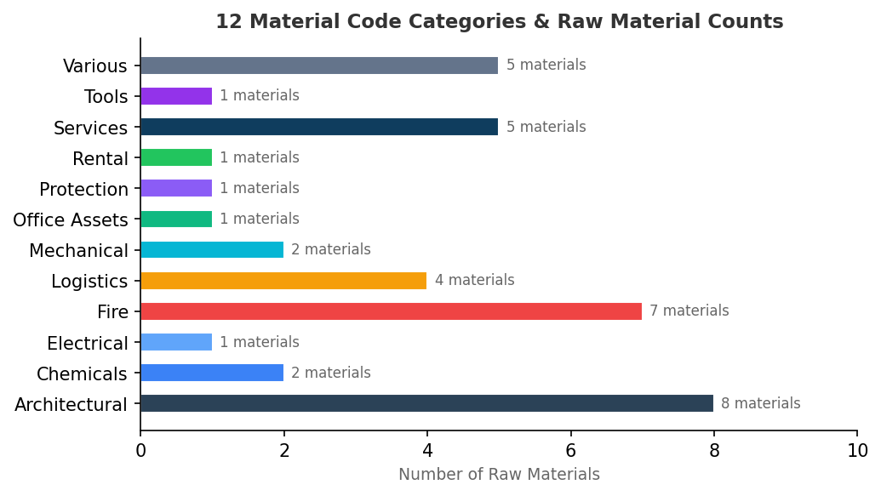

Material Code | Raw Materials | PO Prefix
Architectural | Sandwich Panel, Steel Coil, Doors, Windows, Fit Out Project, Paints, Sanitary Accessories | A
Chemicals | Polyurethane Foam, Chemicals | C
Electrical | Electrical | E
Fire | Firestop/DC 315, Firestop, Fire Alarm, Fire Fighting, Fire Suppression, Fire Protection | F
Logistics | Transportation, Discount, MHE, Logistics | L
Mechanical | Machine/Equipments, Mechanical Items | M
Office Assets | Computer Peripherals | O
Protection | PPE | P
Rental | Rental | R
Services | Design, Construction, LSA - Life Support Area, Subcontract, Services | S
Tools | Tools | T
Various | Containers, Building Materials, Graco Spares, Misc., General | V
PO-based detection: When material info is not available from quotation linkage, the pipeline infers material from the PO entity code prefix letter (e.g., "M" → Mechanical).

12. Country Normalization

Multi-Source Country Resolution
Priority | Source | Description
1 | Address | Physical address country field
2 | Phone Validation | Country from validated phone number
3 | Phone Prefix | Country inferred from phone number prefix
4 | Email TLD | Country from email domain extension

Entity-Based Fallback
For clients not in the country map, 29 entity→country mappings provide defaults:
Entity | Default Country
MVL INDUSTRIAL SOLUTIONS | United Arab Emirates
MVL VENTURES LLC | United Arab Emirates
MVL ENERGY | United Arab Emirates
MVL SOLUTIONS | United Arab Emirates
CENTRICO | United Arab Emirates
MVL INDUSTRIAL EST | Saudi Arabia
MVL ARABIA | Saudi Arabia
MVL PROJECTS | United Arab Emirates
MVL TRADING | United Arab Emirates
MVL FACILITIES | United Arab Emirates

normalizeCountry() Function
The frontend normalizeCountry() function standardizes ~150 country name variants:
Input Variants | Normalized Output
"United Arab Emirates" / "UAE" / "U.A.E." / "Uae" | United Arab Emirates
"Kingdom of Saudi Arabia" / "KSA" / "Saudi" | Saudi Arabia
"USA" / "United States of America" / "US" | United States
"UK" / "United Kingdom of Great Britain..." | United Kingdom
"Peoples Republic of China" / "PRC" | China

Appendix — Design Tokens & Formatting

Currency Display Functions
Context | Function | Example
KPI cards | formatCurrencyShort() | $478.6M, $12.1K, $1.2B
Table cells | formatCurrency() | $1.2M, $478.6K, $12
Number only | formatNumber() | 3,746

Status Badge Colors
Status | Color | Hex
Order | Green | #2ECC71
Quotation | Blue | #3498DB
Waiting | Orange | #F39C12
Cancelled | Red | #E74C3C
Closed | Gray | #95A5A6

Change Order Badges
Badge | Color | Meaning
CO | Red #E74C3C | Change Order
Base | Green #2ECC71 | Base PO
N of M | Gold #F39C12 | Group indicator (e.g., "2 of 3")

━━━━━━━━━━━━━━━━━━━━━━━━━━━━━━━━━━━━━━━━━━━━━━━━━━
Document generated from codebase analysis of v8/shared/scripts.js (~5,928 lines),
v8/data/build_v8_data.py (~1,508 lines), and v8/index.html (~1,063 lines).
MVL Supply Chain Intelligence Hub — V8 — February 2026

