

**BUSINESS DEVELOPMENT SERVICE**

**Submitted by**

**Md Golam Mostofa**

**ID: 143-35-815**

15th Batch

**Kazi Kaysar**

**ID: 143-35-785**

15th Batch

This project is partial

Fulfillment of the requirements for the degree of **Bachelor in Software Engineering**

September 2018

# DECLARATION

We hereby declare that, this project has been done by me under the supervision of **Md. Anwar Hossen, Senior Lecturer, Department of SWE** at Daffodil International University. We also declare that neither this project nor any part of this project has been submitted elsewhere for award of any degree.

**Supervised by:**

**________________**  
**Md. Anwar Hossen**  
**Senior Lecturer**  
Department of Software Engineering  
Daffodil International University

**Submitted by:**

**________________**  
**Kazi Kaysar**  
**ID: 143-35-785**  
Department of Software Engineering  
Daffodil International University

**________________**  
**Md. Golam Mostofa**  
**ID: 143-35-815**  
Department of Software Engineering  
Daffodil International University

**Acknowledgement**

At first we are very grateful to Almighty that he have given us a chance to walk through final year. In our previous year of university life we have learnt politeness, morality and etc. For this we are thankful to all of our teachers.

I am very grateful to my supervisor, **Md. Anwar Hossen** for giving a chance to work with this project. In the time of working with this project sometimes I got some obstacles. For overcoming from this obstacles, some of my friends are always there besides us.

Finally, we must acknowledge with due respect the constant support and patients of our parents.

Table of Contents

**INTRODUCTION -----------------------------------------------------------------------------------------------------------------9**

* 1. **Project Overview-----------------------------------------------------------------------------------------------------9**
  2. **Problem----------------------------------------------------------------------------------------------------------------9**
  3. **Why the project necessary-----------------------------------------------------------------------------------------9**
  4. **The Purpose of the Project----------------------------------------------------------------------------------------10**
  5. **Current situation----------------------------------------------------------------------------------------------------11**
  6. **The context of the work--------------------------------------------------------------------------------------------11**
  7. **Work Partitioning--------------------------------------------------------------------------------------------------11**
  8. **Benefits----------------------------------------------------------------------------------------------------------------11**
  9. **Water fall model-----------------------------------------------------------------------------------------------------11**

**PROJECT PLANNING-----------------------------------------------------------------------------------------------------------12**

**2.1 Project Scenario------------------------------------------------------------------------------------------------------12**

**2.2 Project Scenario List------------------------------------------------------------------------------------------------12**

**2.3 Propose System Model----------------------------------------------------------------------------------------------12**

**2.4 Clint--------------------------------------------------------------------------------------------------------------------12**

**2.5 The Customer--------------------------------------------------------------------------------------------------------13**

**2.6 Hands on Users of the project------------------------------------------------------------------------------------13**

**2.7 Priorities Assigned to Users---------------------------------------------------------------------------------------13**

**2.8 User Participation---------------------------------------------------------------------------------------------------13**

**2.9 Maintenance Users and Service Technicians------------------------------------------------------------------13**

**2.10 Other Stake Holders-----------------------------------------------------------------------------------------------13**

**2.11 Solution Constraints----------------------------------------------------------------------------------------------14**

**2.12 Implementation Environment of the current System------------------------------------------------------14**

**2.13 Anticipated Workplace Environment-------------------------------------------------------------------------14**

**2.14 Budget Constraints-----------------------------------------------------------------------------------------------14**

**2.15 Project Schedule---------------------------------------------------------------------------------------------------14**

**2.16 Project Timeline----------------------------------------------------------------------------------------------------15**

**2.16.1 Project Timeline Figure----------------------------------------------------------------------------------------15**

**2.17 HR planning--------------------------------------------------------------------------------------------------------15**

**2.17.1Risk Analysis -----------------------------------------------------------------------------------------------------16**

**2.17.2 Risk Assessment-------------------------------------------------------------------------------------------------16**

**2.17.3 SWOT Analysis--------------------------------------------------------------------------------------------------16**

**REQUIREMENTS SPECIFICATIONS-------------------------------------------------------------------------------------18**

**3.1 Functional Requirement ------------------------------------------------------------------------------------------18**

**3.2 data requirements --------------------------------------------------------------------------------------------------18**

**3.3 Performance requirements ---------------------------------------------------------------------------------------19**

**3.3.1 Speed and Latency Requirements ----------------------------------------------------------------------------19**

**3.3.2 Precession or Accuracy Requirements ----------------------------------------------------------------------19**

**3.3.3 Capacity Requirements-----------------------------------------------------------------------------------------19**

**3.4 Reliability Requirements -----------------------------------------------------------------------------------------20**

**3.5 Availability Requirements----------------------------------------------------------------------------------------20**

**3.6 Robustness or Fault Tolerance Requirements----------------------------------------------------------------20**

**3.7. Maintenance Requirements--------------------------------------------------------------------------------------20**

**3.8. Supportability Requirements ----------------------------------------------------------------------------------20**

**3.9 .Adaptability Requirements-------------------------------------------------------------------------------------21**

**3.10. Scalability or Extensibility Requirements------------------------------------------------------------------21**

**3.11. Longevity Requirements---------------------------------------------------------------------------------------21**

**3.12. Usability and human Interaction Requirements----------------------------------------------------------21**

**3.13. Ease of use Requirements--------------------------------------------------------------------------------------21**

**3.14. Personalization and Internationalization Requirements------------------------------------------------21**

**3.15. Understand ability and politeness Requirements---------------------------------------------------------21**

**3.15.1 Accessibility Requirements---------------------------------------------------------------------------------22**

**3.15.2 User documentation Requirements-------------------------------------------------------------------------22**

**3.15.3 Training Requirements---------------------------------------------------------------------------------------22**

**3.16. Look and fell Requirements-----------------------------------------------------------------------------------22**

**3.16.1 Appearance Requirements-----------------------------------------------------------------------------------22**

**3.16.2 Elements Requirements---------------------------------------------------------------------------------------22**

**3.17. Operational and environmental Requirements------------------------------------------------------------22**

**3.17.1 Accepted physical Environment Requirements----------------------------------------------------------22**

**3.17.2 Requirements for interfacing with Adjacent System ---------------------------------------------------23**

**3.17.3 Project in action Requirements------------------------------------------------------------------------------23**

**3.17.4 Release Requirements-----------------------------------------------------------------------------------------23**

**3.18. Security Requirements--------------------------------------------------------------------------------------------------23**

**3.18.1. Access Requirements-------------------------------------------------------------------------------------------------24**

**3.18.2 .Integrity Requirements- ---------------------------------------------------------------------------------------------24**

**3.18.3. Privacy Requirements ------------------------------------------------------------------------------------------------24**

**SYSTEM ANAYSIS-------------------------------------------------------------------------------------------------------------25**

**4.1 Use case------------------------------------------------------------------------------------------------------------25**

**4.1.1 Figure of Use case diagram------------------------------------------------------------------------------------26**

**4.1.2 Figure of Admin------------------------------------------------------------------------------------------------- 26**

**4.1.3 Figure of User----------------------------------------------------------------------------------------------------27**

**4.1.4 Figure of Sector--------------------------------------------------------------------------------------------------27**

**4.2 Use case Description-----------------------------------------------------------------------------------------------28**

**4.2.1 Admin Registration--------------------------------------------------------------------------------------------- 28**

**4.2.2 User Registration------------------------------------------------------------------------------------------------29**

**4.2.3 Order --------------------------------------------------------------------------------------------------------------30**

**4.2.4 Cost ----------------------------------------------------------------------------------------------------------------31**

**4.2.5 Application and Approve--------------------------------------------------------------------------------------31**

**4.3 Structural Functionality -----------------------------------------------------------------------------------------33**

**4.4 User----------------------------------------------------------------------------------------------------------------------------33**

**4.5 Employee/Admin-----------------------------------------------------------------------------------------------------------33**

**4.6 Sector--------------------------------------------------------------------------------------------------------------------------33**

**4.7 Activity Diagram------------------------------------------------------------------------------------------------------------34**

**4.7.1 Figure of Activity Diagram---------------------------------------------------------------------------------------------35**

**4.8 Sequence Diagram---------------------------------------------------------------------------------------------------------36**

**4.8.1 Figure of System Sequence Diagram --------------------------------------------------------------------37**

**4.8.1.1 Registration -------------------------------------------------------------------------------------------------38**

**4.8.1.1.1 Figure of Success Scenario-----------------------------------------------------------------------------38**

**4.8.1.1.2 Figure of Failure Scenario------------------------------------------------------------------------------38**

**4.8.1.2 Login ---------------------------------------------------------------------------------------------------------------------39**

**4.8.1.2.1Figure of Success Scenario----------------------------------------------------------------------------------------39**

**4.8.1.2.2 Figure of Failure Scenario----------------------------------------------------------------------------------------39**

**4.8.1.3 Order----------------------------------------------------------------------------------------------------------40**

**4.8.1.3.1 Success Scenario-------------------------------------------------------------------------------------------------40**

**4.8.1.3.2 Failure Scenario--------------------------------------------------------------------------------------------------40**

**4.8.1.4 Application Approve ----------------------------------------------------------------------------------------------41**

**4.8.1.4.1 Figure of Success Scenario-------------------------------------------------------------------------------------44**

**4 .8.1.4.2 Figure of Failure Scenario-------------------------------------------------------------------------------------44**

**4.9. Dataflow Diagram -------------------------------------------------------------------------------------------42**

**4.10 Context Diagram--------------------------------------------------------------------------------------------42**

**4.10.1 Figure of DFD-0 -------------------------------------------------------------------------------------------43**

**4.10.2 Figure of DFD-1-------------------------------------------------------------------------------------------43**

**DESIGN & DEVELOPMENT---------------------------------------------------------------------------------------------44**

**5.1. Figure of Class Diagram -----------------------------------------------------------------------------------44**

**5.2. Database Designee -----------------------------------------------------------------------------------------45**

**5.3 Figure of ERD---------------------------------------------------------------------------------------------------46**

**USER INTERFACE AND MANUAL-------------------------------------------------------------------------------**

**6.1 Home-------------------------------------------------------------------------------------------------50**

**6.2. Sector------------------------------------------------------------------------------------------------50**

**6.3. Registration----------------------------------------------------------------------------------------51**

**6.4 Login -------------------------------------------------------------------------------------------------51**

**6.5 Order------------------------------------------------------------------------------------------------52**

**7. TEST PLANS**

**7.1 Testing Features------------------------------------------------------------------------------------53**

**7.2 Features not be tasted----------------------------------------------------------------------------53**

**7.3 Testing Strategies --------------------------------------------------------------------------------53**

**7.4 Pass Fail Criteria ---------------------------------------------------------------------------------53**

**7.5 Testing schedule-----------------------------------------------------------------------------------54**

**7.6 Testing environment-----------------------------------------------------------------------------54**

**7.7 Testing deliverables------------------------------------------------------------------------------55**

**7.7.1 Project status report----------------------------------------------------------------------55**

**8. CONCLUSION**

**8.1 Critical Evolution and team Attainment --------------------------------------------------------56**

**8.2 Limitations--------------------------------------------------------------------------------------------56**

**8.3 Obstacles and Achievements----------------------------------------------------------------------56**

**INTRODUCTION**

**1.1 Project overview:**

Business development service is an online service provider platform for investor, entrepreneur and service provider organization. Entrepreneur from around the world who wants to invest in business, start a business in our country need to complete a lots of process and procedure. These processes take long time to complete because he needs to take permission from government offices like Land, Gas, and power supply authority. The aim of this project is to reduce the complexity and time of the existing hard copy documents. In your system, an entrepreneur can apply for government permission in different area like Land permission, gas connection, and power connection. Our system will takecare rest of the procedure. This system will send the documents to the government an office for permission and they verify the application with the necessary documents and give a response either it is acceptable or need to modify the documents. After greeting all the response system will send the response to the applicant entrepreneur.

**1.2 Problem**

People from other countries when they want to invest in business, start a business in our country the process take long time because he need to go to the sectors to approve his all applications. Also there will take many time because many people’s there with their application to approve. There have many sectors for this he need to stay in our country and need to go from one sector to other sector some time he need to give a huge amount of money to approve his applications.

**1.3 Why the Project Necessary:**

The project is necessary to help the people from other countries want to invest in business, start a business in the country.

**1.4 The Purpose of the Project:**

1. **The User Background of the Project Effort :**

Its main purpose is complete development work easily in a short time. When they want to invest in business, start a business in our country the process take long time. We will help them to complete the full process in a short time. From that problem I think about the business development service by which the problem may solve.

1. **Goals of the Project :**

Business development service goal is to help the foreigner people and save their time to make any kind of industry in our country.

1. **Measurement :**

**Direct measure**: Its need a cost of taka fifty thousand. Our team members are working eight month continuously to develop the project. We collected our requirements by last four years.

**Indirect measures**: It will provide a solution for save time from making industry.

**1.5 The current situation**

In the current situation there have many website or company like this but in our country there have no website or company like this and the website and company not so trusted that’s why we make the website to help the people.

**1.6. The context of the work**

Our application design is ready. We take all information from online website and the government sectors. We have completed our most of the work. We trust that our work will be finish in time.

**1.7. Work Partitioning**

A user can use the website from any where of any country. Our work procedure is some one like admin or an employee will control the whole system .An user can use the system when he is registered. Then when he is ready for order then he will select the sectors from where he needs the permission and then confirm us for the work. Then we will do it by our employee.

**1.8. Benefits:**

1. Foreigners have no need to go their work place for permission.
2. Employee can complete the full system online.
3. All data secure.
4. Time save, money save.
5. Friendly for use.

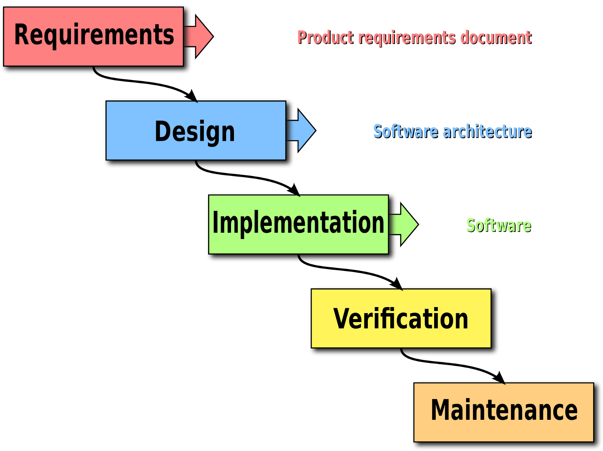

**Figure 1.9 Water fall model**

**PROJECT PLANNING**

**2.1. Project scenario**

**2.2. Project scenario list**

Many people from other countries they want to buy land/ make industry/house in this country. They need to take many type of permission from government like soil test, gas, water, electricity etc. The full Process take a long time they need to stay a long time for permission and need to stay here for the permission. Our website for that people to complete their work Online.

1. Foreigner can complete their work without stay the work place.
2. Anyone can join our website by registration and only registered people can give order for their work.
3. Time save and money save.
4. The total system and transactions are secure.

**2.3. Proposed system model**

When anyone need to give order in our website firstly he need to register. Then from the order section he can order for his work .the when system confirms the order data will save to database then our employee send the data and application to the sectors what user give to us. Then when the sectors give confirmation about the application then we give it to user the order complete.

**2.4. Clint**

The person who will use this system those are the client. ”BUSINESS DEVELOPMENT SERVICE” is an online website. A client can use this on his/her Computer. This is a time saving application. A client project is defined by the development, deployment, and, under the control of a project leader. This definition depends on the client actual methodology, on what application means for him, on how he organizes to realize it, and possibly on implementation or deployment choices.

**2.5. The Customer**

Customers are all time an important for a system. In this system the person who will purchase the product those are the customers of this system. In agile software development, a customer is a person with an understanding of both the business needs and operational constraints for a project. The customer provides guidance during development on what priorities should be emphasized.

**2.6**. **Hands-On Users of the Project**

In the project the user can access the website and he can find out the total information about work. If he/she find any trouble in the project he/she can contract with the developer .The user can provide any types of suggestion.

**2.7. Priorities Assigned to Users**

If needed any types of contract with the developer. They can do that by the mail or text or phone call.

**2.8. User Participation:**

User can give any kind of suggestion or complain to the developer.

**2.9. Maintenance Users and Service Technicians:**

The user can maintain the website. He/she cannot change the website. If any problem occur in the system user can give mail or send.

**2.10. Other Stakeholders:**

A person or group or organization that has interest or concern in an organization. Stakeholders can affect or be affected by the organization's actions, objectives and policies. Some examples of key stakeholders are creditors, directors, employees, government (and its agencies), owners (shareholders), suppliers, unions, and the community from which the business draws its resources.

● **Tester:** This person is responsible for testing the project.

● **System Designer**: This person is responsible for designing the project.

● **Legal Expert**: This person is responsible for taking care of the legal issues of the project

**2.11. Solution Constraints:**

This project is on industrial development service .so we help them by approve all application what the need to approve to make him industry.

**2.12. Implementation Environment of the Current System:**

We use Xamp free database and html,css for design php,laraval for the develop .

**2.13. Anticipated Workplace Environment:**

We use netbeans 8.1 (IDE),Sublime text 3 for our work.

**2.14. Budget Constraints:**

The total budget for this website is 50000.00 taka. Because of the developers are working for eight month. So all the steps of this project worked very carefully. At first step of this project is requirement collection and analysis. It is the more important step. Because of a project is run by requirement. Then the designing face and coding. The developers of this project take extra care of this part. The testing and maintaining part. All the part of this project is more important that’s why its takes this budget.

**2.15. Project Schedule:**

Project Timelines:

A timeline is a way of displaying a list of events in chronological order, sometimes described as a "project artifact". It is typically a graphic design showing a long bar labeled with dates alongside itself and usually events.

**Project Timeline**

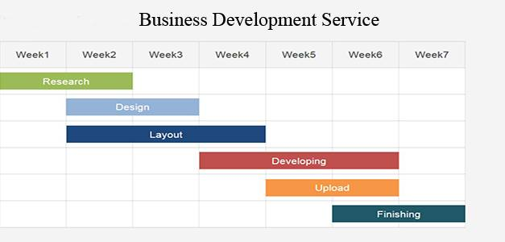

**Figure 2.16 Project TimeLine**

**2.16. HR planning and development phase:**

|  |  |  |
| --- | --- | --- |
| **SYSTEM** | **DISCRIPTION** | **ORGANIZATIONAL LEVEL** |
| Development | Developer skills, and performance appraisals | Operational |
| Application Analysis | It can tell a third party worker website | Management |
| Project planning | This project for safe time and cost for customer satisfaction. | Strategic |

**2.17.1. Risk Analysis:**

**2.17.2 Risk assessment:**

Completing the whole task in time is a risk. It also hard to provide the service according to user expectation. Limited appropriate information is available and a complete set of probabilities is not available. In such problems, where the analysis is highly subjective and related to vague, incomplete, uncertain or inexact information.

|  |  |  |  |  |
| --- | --- | --- | --- | --- |
| **Risk name** | **Impact** | **Probability** | **Our priority** | **Mitigation plan** |
| Misunderstand ing user Requirement | High | Medium | 1 | Feedback analysis |
| Exceeding schedules and budgets | Medium | Low | 3 | Make effective plan |
| Scarcity of arranged information | High | Medium | 2 | Collecting information carefully |
| Team’s lack of general expertise | High | Medium | 2 | Recruit skilled & experienced team members |
| Reliable information source | Low | High | 4 | Verify collecting information |

**2.17.3 SWOT Analysis**

SWOT analysis an acronym for strengths, weaknesses, opportunities, and threats and is a structured planning method that evaluates those four elements of an organization, project or business venture. A SWOT analysis can be carried out for a company, product, place, industry, or person. It involves specifying the objective of the business venture or project and identifying the internal and external factors that are favorable and unfavorable to achieve that objective.

● **Strengths:** characteristics of the business or project that give it an advantage over others

● **Weaknesses:** characteristics of the business that place the business or project at a disadvantage relative to others

● **Opportunities:** elements in the environment that the business or project could exploit toits advantage

● **Threats:** elements in the environment that could cause trouble for the business or project.

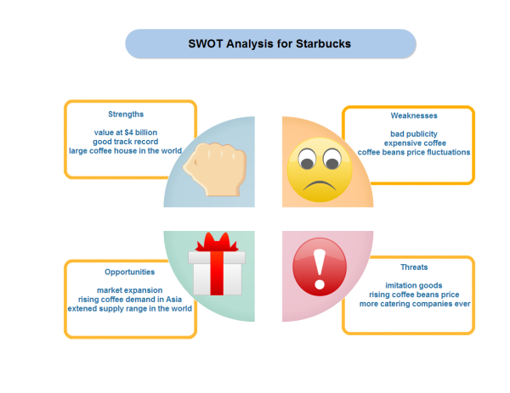

**Figure 2.17.3 Water fall model**

|  |  |
| --- | --- |
| **Strength**  Innovative idea.  Very essential for everyone.  Exceptional service.  There have much type of sectors here. | **Weakness**  All people are not well known about this service.  There have corruption most of the places that’s why people cannot trust . |
| **Opportunities**  Work have done in short time .  Owner have no need to stay outside for his work.  Save money . | **Threat**  It may take long time to take permission from the sectors that time our process ma take long time . |

**REQUIREMENTS SPECIFICATIONS**

**3.1. Functional Requirements:**

In Software engineering and systems engineering, a functional requirement defines a function of a system or its component. A function is described as a set of inputs, the behavior, and outputs. Functional requirements may be calculations, technical details, data manipulation and processing and other specific functionality that define what a system is supposed to accomplish. Behavioral requirements describing all the cases where the system uses the functional Requirements are captured in use cases. Functional requirements are supported by non-functional requirements (also known as quality requirements), which impose constraints on the design or implementation (such as performance requirements, security, or reliability). Generally, functional requirements are expressed in the form "system must do. While nonfunctional requirements are "system shall be. The plan for implementing functional requirements is detailed in the system design. The plan for implementing non-functional requirements is detailed in the system architecture

1. Take data by a form from the users.

2. Approve application from the sectors.

3. Assure that only registered people use the system.

4. Processing the query.

5. Replay with related message.

6. Provide the details.

**3.2**. **Data Requirements:**

we will get data from the users then work on it .on his application all details about his sectors for which he need permission.

A data warehouse requirements specification states the project objectives and goals and related data storage, data integration, information delivery, security, quality, usage, functional and nonfunctional requirements that must be delivered in order to achieve the project objectives. The requirements specification provides a means of specifying all requirements and the criteria that will be used to accept that the requirements have been met. It helps ensure that the technical team does not design and build something that is not specified.

**3.3. Performance Requirements:**

**3.3.1. Speed and Latency Requirements:**

It is very responsive. It will provide the result within a few seconds with the correct ans. And it will take only that time which time sector need to approve.

**3.3.2. Precision or Accuracy Requirements:**

There is no one standard definition of an accuracy non-functional requirement. It will be defined for each project where it needs to be specified. This principle is true of all non-functional requirements.

For the purposes of this article an accuracy non-functional requirement is any requirement that is not a functional, data or process requirement concerned with defining the precision which the solution will record or produce data.

**3.3.3. Capacity Requirements:**

It is an online application so at a time any number of user can use this app. Internal resources required to carry out a project at a particular time. The system calculates the capacity requirements for networks using the formula that you have entered in the capacity detail screen of the work center. Generally, the system uses the value you entered for work in the network activity in the formula; however, you can specify other formula parameters.

**3.4. Reliability Requirements:**

Our website is a new website for this kind of work for this there has no enough resource to us about the system.

The concept of reliability is one which can prove to be of paramount importance to the project management team and or the project management team leader, as errors in reliability can cause productivity to decline significantly. Specifically speaking, reliability refers to the probability and or the likelihood that a given product will perform in the way and or manner it was intended to perform in the efforts that have been deemed required of that given product within or under a specific period of time required.

**3.5. Availability Requirements:**

Project will run in a short time, when the user needs to use this project he/she can use that from Online. For using this website the user can save the time and he/she can easily find out their specific order from the website .Also when the full work complete he will get a confirmation for his work.

**3.6. Robustness or Fault-Tolerance Requirements:**

Our system is robust. So it will helpful for the user because he/she can find their topic in a short time. It will work smoothly.

**3.7. Maintenance Requirements:**

The user cannot edit or change anything in his choice .He/she can only change the application interface by his/her choice. If they find any problem in the time of using he/she can give the information or the suggestion to the developer.

**3.8. Supportability Requirements:**

The developer of this website will all time ready for solving any types of problem about this application. If the user gives the information or any types of suggestion about the application the developer will try to solve the problem.

**3.9. Adaptability Requirements:**

The developer will solve the problem as soon as possible, to take the information. Ability of an entity or organism to alter itself or its responses to the changed circumstances or environment. Adaptability shows the ability to learn from experience, and improves the fitness of the learner as a competitor.

**3.10. Scalability or Extensibility Requirement:**

All the feature of this website willfix in the time of published. All the right by the developer. In some organizations, project management is considered overhead. It is sometimes referred to as a “necessary evil”. The Ten Step philosophy for project management is that it is a value-adding process. The value is added in a number of ways as stated in A.1 The Value of Project Management.

**3.11. Longevity Requirements:**

The user can use this website unlimited time. There is no time limit. The Longevity Project shows you how you can live longer by analyzing the results from one of the world’s longest lasting studies and drawing surprising conclusions about the work ethic, happiness, love, marriage and religion of people who have lived to old age.

**3.12 Usability and human Interaction Requirements**

These Requirements define how to meet the physical and cognitive needs of the intended users of your website or application

**3.13. Ease of Use Requirements:**

This website is totally user friendly. Anyone can use this without facing any difficulties. The entire component of the app is good looking, easy to understanding and operating. Here we also provide user guideline which will help the user to use comfortably.

**3.14. Personalization and Internationalization Requirements:**

There have no b. Personalization and Internationalization Requirements for this website. That means user cannot change all as his/her own wish.

**3.15**. **Understand ability and Politeness Requirements:**

All the feature of this website is easily designed. So the user can easily understand.

**3.15.1. Accessibility Requirements:**

The website is easily accessible because the features are designed for all types of user.

**3.15.2. User Documentation Requirements:**

We take all documents from to user by a form or a ptf or a text file. Outwork depends on his document.

**2.15.3. Training Requirements:**

Training is very important for every project. Training helps every project or application user to use that project. But our project is easily designed for all classes of user.

Because this application can use all types of user. All the feature of this project is well designed. A user can easily use the search and other option of this project.

**3.16. Look and Feel Requirements:**

**3.16.1. Appearance Requirements:**

The website is totally designed for the all types of user. So it will be simply and easy understood for everyone. The website will help the new user for use the application. And all the feature of the website is well decorated. So hopefully it will be helpful for all.

**3.16.2. Style Requirements:**

All the feature of the application is simply designed. So all user can use easily I hope so.

**3.17. Operational and environmental Requirements:**

**3.17.1Expected Physical Environment:**

It is online website and responsive that’s why anyone can use it from mobile and computer with access internet.

**3.17.2. Requirements for Interfacing with Adjacent Systems:**

As the system's overall footprint is significant we need to find an architecture that allows us to change the number of modules and how they interact without a total redesign. While it's impossible to achieve this under all thinkable circumstances the architecture must consider this fact the system must be designed in a way that supports the addition and removal of modules without a major redesign.

With this feature the user can easily access the application and can save the time.

**3.17.3. Project inaction Requirements:**

An exploitation of the results including product inaction is planned for the late stages of this project, but it’s impossible to provide any information that would be more specific than that already listed in the Description of Work and in the Grant Agreement.

**3.17.4. Release Requirements:**

By this version any one can use it by mobile and computer next if any update need developer will take steps for that.

### 3.18. Security Requirements:

There are no access requirements beside those that have been outlined in the below:

* + - The software must validate all user input to ensure it does not exceed the size specified for that type of input
    - The server must authenticate every request accessing the restricted WebPages
    - After authenticating the browser, the server must determine whether that browser is authorized to access the requested restricted WebPages
    - The system must have security controls to protect against denial-of-service attacks
    - The system must encrypt sensitive data transmitted over the Internet between the server and the browser

To get access to this system or a specific module the system must provide a central authentication mechanism. In order to prevent anyone to exploit stolen all users password must be encrypted in hash process.

#### 3.18.1. Access Requirements:

To get access to the system, the system provides authorization/authentication way. This system uses various modules.

|  |  |
| --- | --- |
| **SR-01** | The system provides security strategies. |
| **Description** | The system is designed in way that allows all modules to access a  mechanism that provides security services. |
| **Stakeholders** | Admin, User and Sectors |

#### 3.18.2. Integrity Requirements:

To protect credentials of user from being stolen, all passwords are stored in encrypted form. The Requirements significantly reduces the value of stolen user credentials, it’s not easy to decrypt the password.

#### 3.18.3. Privacy Requirements:

The system provides a protection of the database in the server. However, the system will have to increment this level of protection because of the personal data mode available on the system & the larger share of people that will be having access to it through the system’s registration. The user’s privacy will be granted by the limited access that the log in process is going to the database.

|  |  |
| --- | --- |
| **SR-02** | All data will be protected |
| **Description** | The main requirement in the context is the generation of Alumni  member’s data for analysis. |
| **Stakeholders** | Admin, User and sectors |

**SYSTEM ANALYSIS**

**4.1. Use case:**

**System Environment (use case):**

In software and systems engineering, a use case is a list of actions or event steps, typically defining the interactions between a role (known in the Unified Modeling Language as an actor) and a system, to achieve a goal. The actor can be a human or other external system. In systems engineering, use cases are used at a higher level than within software engineering, often representing missions or stakeholder goals. The detailed requirements may then be captured in the Systems Modeling Language (SysML) or as contractual statements. While a use case itself might drill into a lot of detail about every possibility, a use-case diagram can help provide a higher-level view of the system. It has been said before that "Use case diagrams are the blueprints for your system". They provide the simplified and graphical representation of what the system must actually do. Due to their simplistic nature, use case diagrams can be a good communication tool for stakeholders. The drawings attempt to mimic the real world and provide a view for the stakeholder to understand how the system is going to be designed.

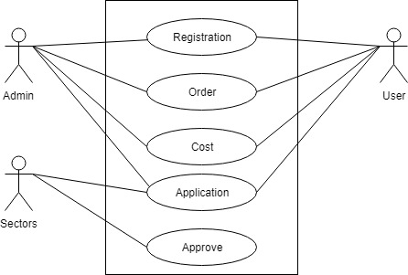

**Figure: 4.1.1 Use Case**

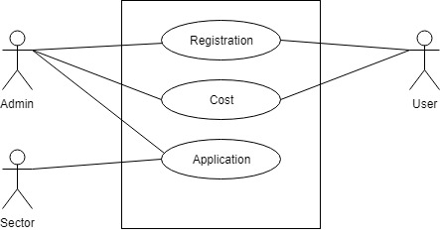

**Figure: 4.1.2 Use Case for Admin**

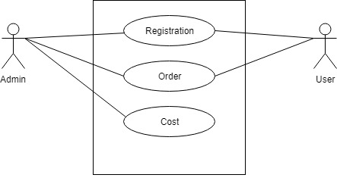

**Figure 4.1.3 Use Case for User**

**4.1.4 Sector:**

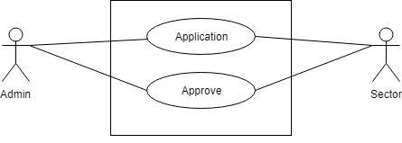

**Figure: 4.1.4 Use Case for Sector**

**4.2 Use Case Description**

**4.2.1. Admin Registration:**

|  |  |  |
| --- | --- | --- |
| Use case id | 1 | |
| Name | Admin Registration | |
| Primary Actor | Admin | |
| Secondary Actor | User | |
| Goal | Register Accounts for different Admin of system. | |
| Precondition | Relevant data to enter in database for registration is available. | |
| Post condition | Register sergeant accounts for all the Admin. | |
| Main Success scenario | Actor | System |
|  | 1. Admin selects register option to register an account for new Admin.  2. Admin will enter the relevant data about user e.g. Admin basic information.  3. Admin will assign roles to the account that what a user do in the system respective to Admin designation.  4. Admin submits the required description about user to the system.  5. System will save the record in the database and will show the success message. | 2.1. System create registration form  3.1. system will show a roles category list  5.1. Submit all data to database. |
| Scenario Extensions | 1. If any Admin all information repeats system will back a error massage. 2. Without admin registration not possible. | |

**4.2.2. User Registration:**

|  |  |  |
| --- | --- | --- |
| Use case id | 2 | |
| Name | User Registration | |
| Primary Actor | Admin | |
| Secondary Actor | User | |
| Goal | Register Accounts for different users of system. | |
| Precondition | Relevant data to enter in database for registration is available. | |
| Post condition | Register sergeant accounts for all the users. | |
| Main Success scenario | Actor | System |
|  | 1. Admin selects register option to register an account for user.  2. Admin will enter the relevant data about user e.g. user basic information.  3. Admin will assign roles to the account that what a user do in the system respective to user designation.  4. Admin submits the required description about user to the system.  5. System will save the record in the database and will show the success message. | 2.1. System create registration form  3.1. system will show a roles category list  5.1.Submit all data to database. |
| Scenario Extensions | 1. If any users all information repeat system will back a error massage. 2. Without admin registration not possible. | |

**4.2.3. Order:**

|  |  |  |
| --- | --- | --- |
| Use case id | 3 | |
| Name | order | |
| Primary Actor | User | |
| Secondary Actor | Admin | |
| Goal | Hire for a work | |
| Precondition | User must be registered without registration they can not order. | |
| Post condition | System will return a successful massage. | |
| Employee | Actor | System |
| 3.employee will check all and confirm the order. | 1. user go to service and then select order option.  2 . user send all information and details about his work  3. get a confirmation sms from system | 1.1. System create a form.  2.1.system check the statement.  3.system take work details and update to database. |
| Scenario Extensions | 1.if transaction not complete successfully system will return the massage that transaction fail. | |

**4.2.4. Cost:**

|  |  |  |
| --- | --- | --- |
| Use case id | 4 | |
| Name | cost | |
| Primary Actor | Admin | |
| Secondary Actor | user | |
| Goal | Cost calculation | |
| Precondition | Only admin can select a cost for the work. | |
| Post condition | cost calculate | |
|  | Employee | System |
|  | 2.select a cost for the work | 1.take order from user and details about work  2. Update cost. |
| Scenario Extensions | 1. If account empty system will return An error massage.  2. Successful. | |

**4.2.5. Application and approve:**

|  |  |  |
| --- | --- | --- |
| Use case id | 3 | |
| Name | Application approve | |
| Primary Actor | User | |
| Secondary Actor | Admin | |
| Goal | Approve application | |
| Precondition | All required data must be valuable | |
| Post condition | approve application and ready for work | |
| Employee | user | System |
| 3. Admin check database take the information then send other sectors for approve. | 1 .Go to order  2.fell the form and submit | 1.system give a form  2. check validation add to database  3. Send all data to approve.   1. Confirmation about all approve. |
| Scenario Extensions | 1.if information not valid system will return an error message | |

**4.3. Structural Functionalities:**

An organization can be arranged according to a variety of structures, which determine how the organization will operate and perform. In a functional structure, a common configuration, an organization is divided into smaller groups by areas of specialty (such as IT, finance, operations, and marketing).

Some refer to these functional areas as "silos"—entities that are vertical and disconnected from each other. Correspondingly, the company's top management team typically consists of several functional heads (such as the chief financial officer and the chief operating officer). Communication generally occurs within each functional department and is transmitted across departments through the department heads.

**4.4. User:**

User registration in this system then order and at last he/she receive the confirmation.

**4.5. Employee/admin:**

Employee or admin must be registered .confirm any Oder from the user and then select a cost for the order .then send the application form to the government then well all are approve they send the confirmation to the user .

**4.6. Sectors:**

Just approve all files.

**4.7**. **Activity Diagram**

Activity diagrams are graphical representations of workflows of stepwise activities and actions with support for choice, iteration and concurrency. In the Unified Modeling Language, activity diagrams are intended to model both computational and organizational processes (i.e. workflows). Activity diagrams show the overall flow of control.

Activity diagram is another important diagram in UML to describe the dynamic aspects of the system.

Activity diagram is basically a flowchart to represent the flow from one activity to another activity. The activity can be described as an operation of the system.

The control flow is drawn from one operation to another. This flow can be sequential, branched, or concurrent. Activity diagrams deal with all type of flow control by using different elements such as fork, join, etc.

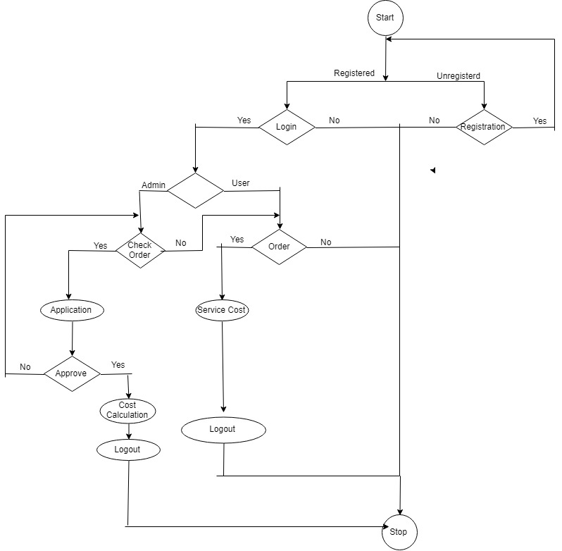

**Figure: 4.7.1 Activity Diagram**

4.8. **Sequence Diagram**

**Model:**

A sequence diagram is an interaction diagram that shows how objects operate with one another and in what order. It is a construct of a message sequence chart. A sequence diagram shows object interactions arranged in time sequence. It depicts the objects and classes involved in the scenario and the sequence of messages exchanged between the objects needed to carry out the functionality of the scenario. Sequence diagrams are typically associated with use case realizations in the Logical View of the system under development. Sequence diagrams are sometimes called event diagrams or event scenarios. A sequence diagram shows, as parallel vertical lines (lifelines), different processes or objects that live simultaneously, and, as horizontal arrows, the messages exchanged between them, in the order in which they occur. This allows the specification of simple runtime scenarios in a graphical manner.

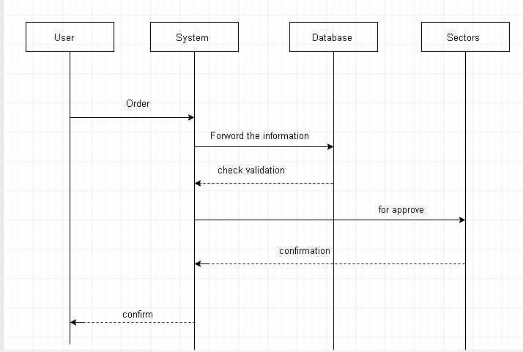

**Figure: 4.8.1 System Sequence Diagram**

**4.8.1.1 Registration:**

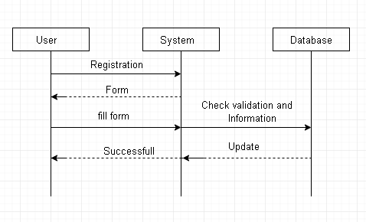

**Figure: 4.8.1.1.1 Success scenario for Registration**

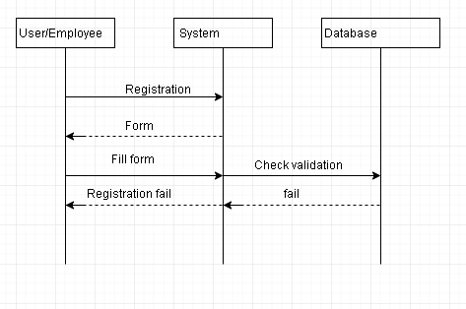

**Figure: 4.8.1.1.2 Failure scenario for Registration**

**4.8.1.2: Login:**

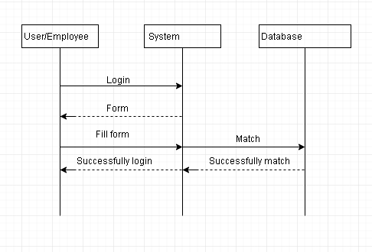

**Figure 4.8.1.2.1 Success scenario for Login**

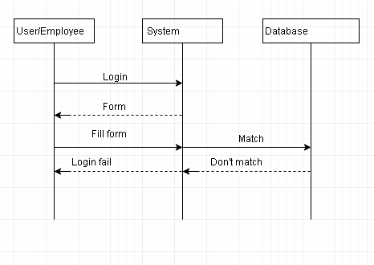

**Figure: 4.8.1.2.2 Failure scenario for Login**

**4.8.1.3. Order:**

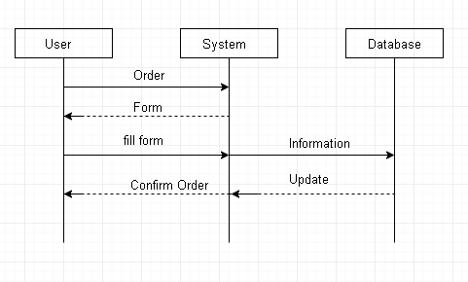

**Figure 4.8.1.3.1 Success scenario for Order**

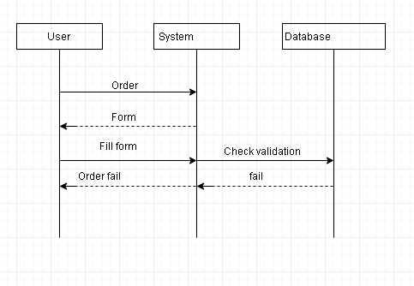

**Figure: 4.8.1.3.1 Failure scenario for Order**

**4.8.1.4. Application Approve:**

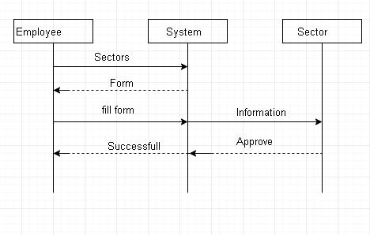

**Figure: 4.8.1.4.1. Success scenario for Application Approve**

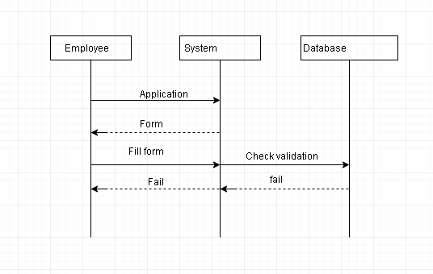

**Figure 4.8.1.4.2 Failure scenario for Application Approve**

**4.9. Data Flow Diagram (DFD)**

**4.9.1. Context Diagram (Level-0 DFD):**

A data flow diagram (DFD) is a graphical representation of the "flow" of data through an information system, modeling its process aspects. A DFD is often used as a preliminary step to create an overview of the system without going into great detail, which can later be elaborated. DFDs can also be used for the visualization of data processing (structured design). A DFD shows what kind of information will be input to and output from the system, how the data will advance through the system, and where the data will be stored. It does not show information about the timing of process or information about whether processes will operate in sequence or in parallel unlike a flowchart which also shows this information.

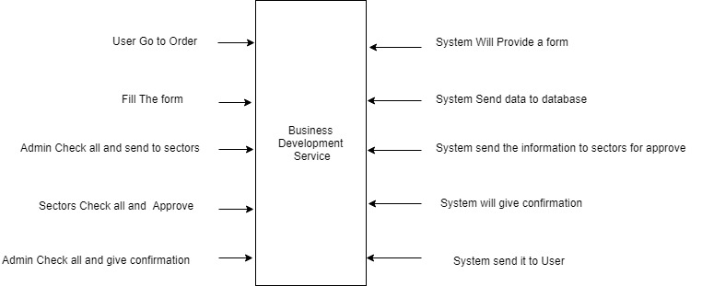

**Figure: 4.9.1 DFD-0**

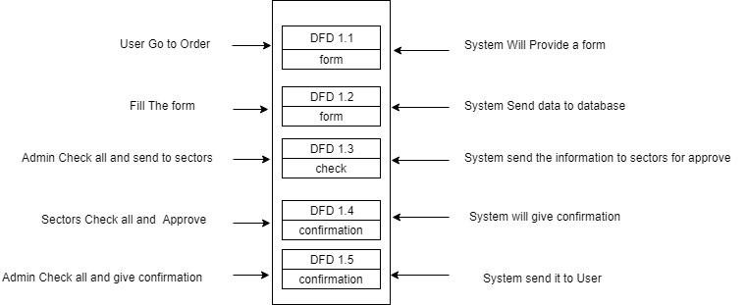

**Figure: 4.9.2 DFD-1**

**DESIGN AND DEVELOPMENT**

**5.1. Class Diagram:**

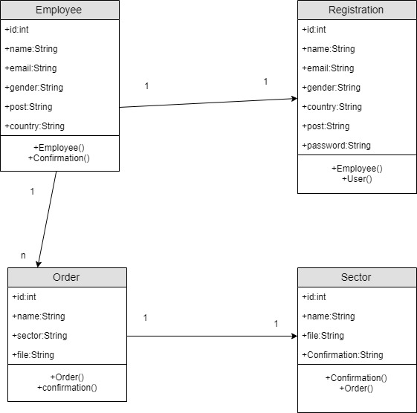

**Figure: 5.1 Class Diagram**

**5.2. Database design**

Database design is the process of producing a detailed data model of database. This data model contains all the needed logical and physical design choices and physical storage parameters needed to generate a design in a data definition language, which can then be used to create a database. A fully attributed data model contains detailed attributes for each entity. The term database design can be used to describe many different parts of the design of an overall database system. Principally, and most correctly, it can be thought of as the logical design of the base data structures used to store the data. In the relational model these are the tables and views.

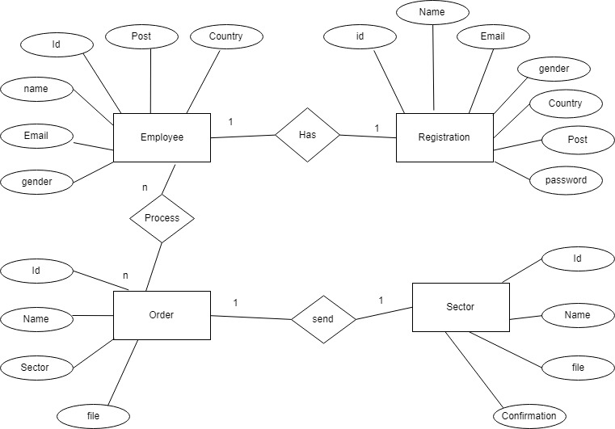

**Figure: 5.3 Entity Relationship Diagram (ERD)**

**USER INTERFACE AND MENUAL**

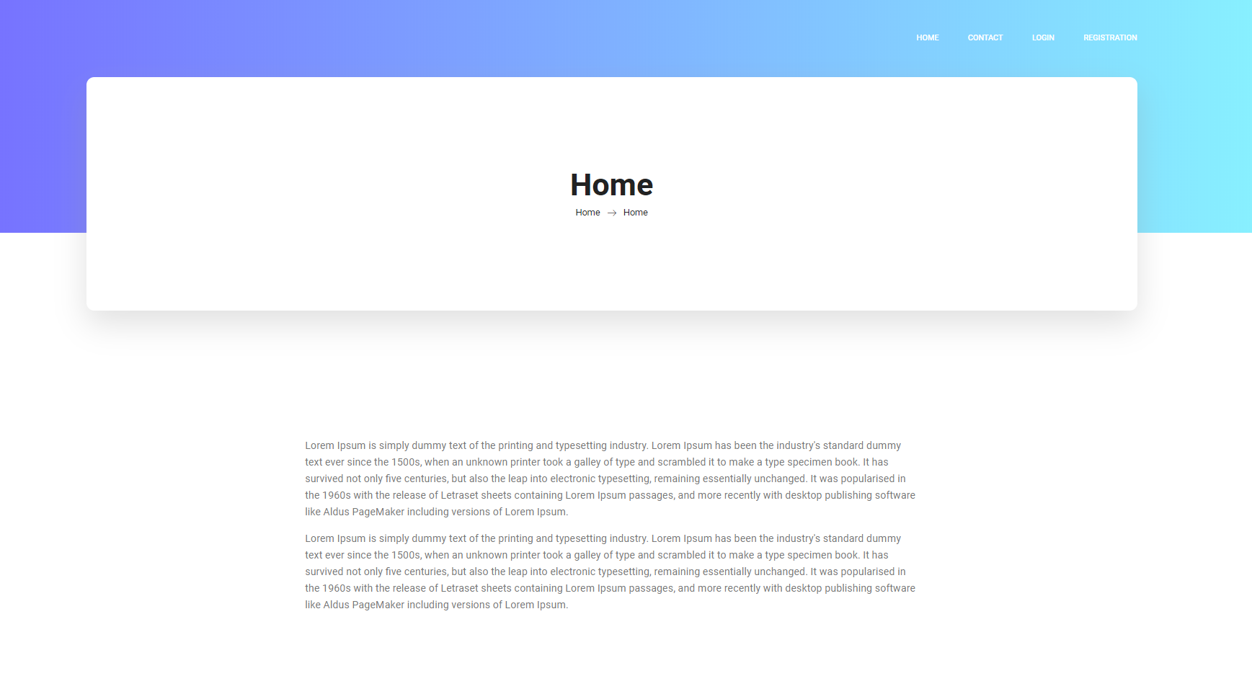

**Figure: 6.1 Home**

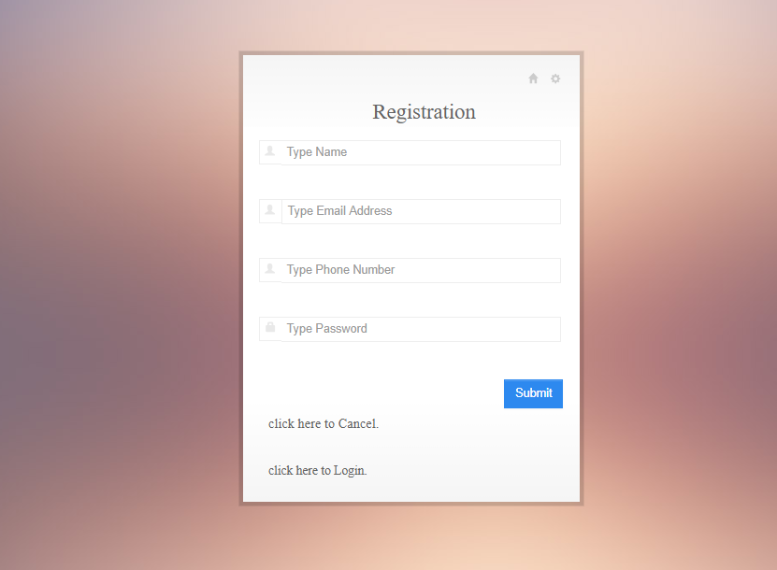

**Figure: 6.2 Registrations**

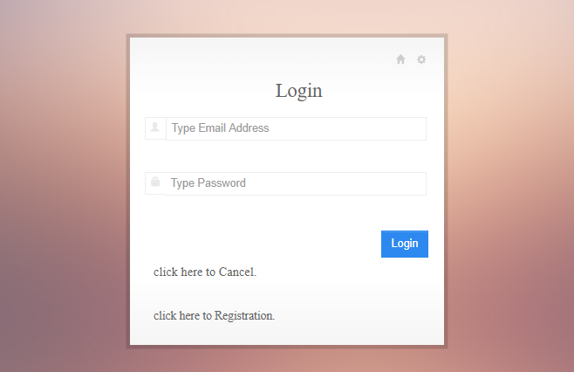

**Figure: 6.3 Login**

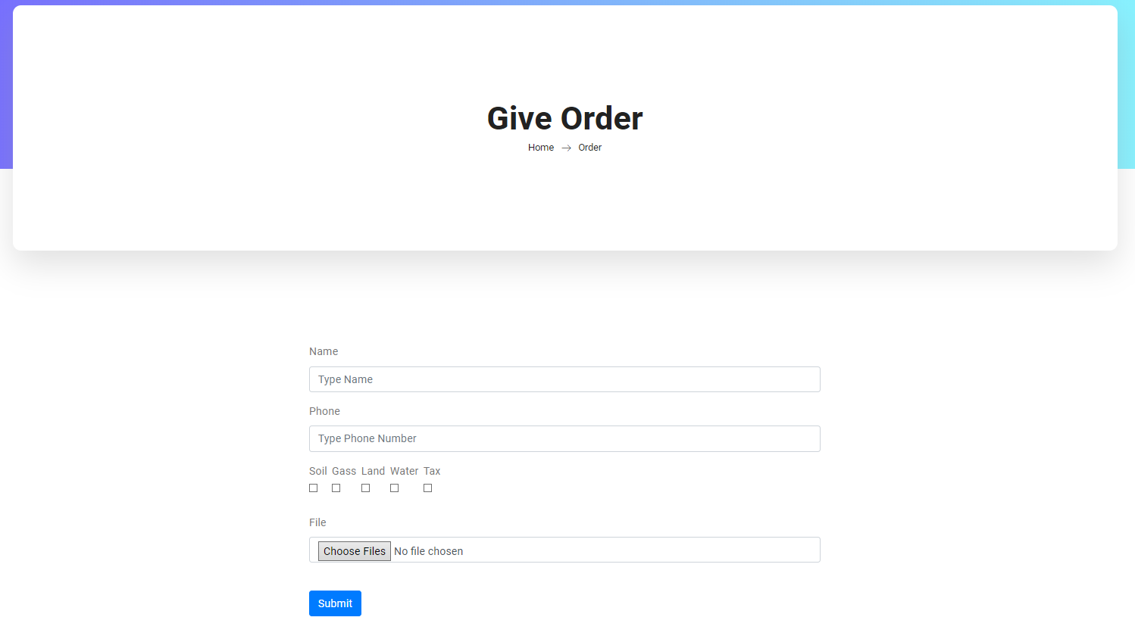

**Figure: 6.4 Orders**

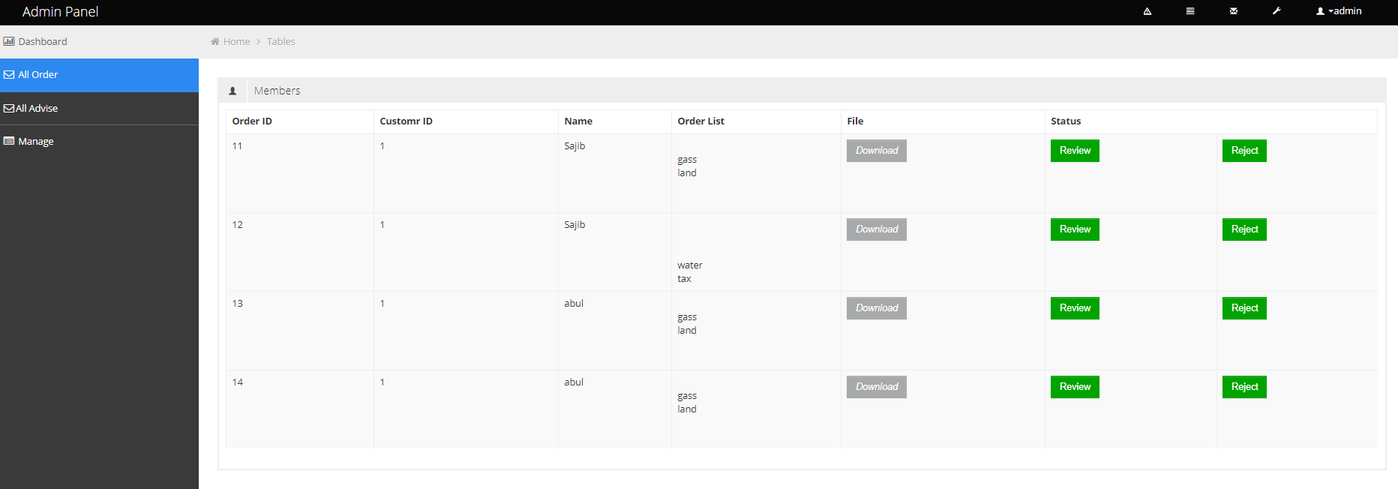

**Figure: 6.5 Order List**

**TEST PLANS**

**7.1. Testing Features:**

1. Valid information for registration.
2. Valid information for order properly working.
3. Transaction working properly.

**7.2. Features not to be tested:**

It is very hard to tell which function is not to be checked which will save our time. In the testing section we will check function to meet our requirement and others function will be left as unchecked

**7.3. Testing Strategies:**

A small individual unit of the project is tested here separately to find out whether that unit is functional as expected or not. The crucial units of the project are only tested here.

**7.4. Pass/Fail Criteria:**

1. Login system – pass.

2. Registration part –pass.

3. Order confirmation –pass.

4. If not confirm (show error)-pass.

6. Exit –pass.

**7.5. Testing schedule:**

|  |  |  |  |
| --- | --- | --- | --- |
| Id | Action | Start date | End date |
| 1 | Login System | 1/9/2018 | 2/9/2018 |
| 2 | Registration form | 3/9/2018 | 4/9/2018 |
| 3 | Order form | 5/9/2018 | 6/9/2018 |
| 4 | Showing error | 7/9/2018 | 8/9/2018 |
| 5 | Exit | 9/9/2018 | 10/9/2018 |

**7.6. Testing Environment (hardware/software requirements)**

|  |  |  |  |  |  |  |
| --- | --- | --- | --- | --- | --- | --- |
| Id | Action | Input | Expected Result | Actual Result | Pass/  Fail | Code module |
| 1 | Login System | User name Password | Login the system | Login the system | pass | Login.php |
| 2 | Check Registration | User name, password, email, country. | Successfully registered | Successfully registered | pass | Registratiuon.php |
| 3 | Check order | Company name, company details, employee name | Successfully order | Successfully order | pass | Order.php |
| 4 | error | anything | error | error | pass | Any where |
| 5 | exit | Click on exit | exit | exit | pass | ExitSystem.php |

**7.7. Testing Deliverables:**

**7.7.1. Project Status Report:**

All type of test has done successfully. There were some errors. All of them are now fixed. Now it is working without making any error or bug. All features are working correctly and showing the expected results.

Database is responding very well. All the buttons are performing their action correctly. All text is showing at the right position, right font and color. It is totally usable for all users now. So project is deliverable now.

**CONCLUSION**

**8.1. Critical Evolution and Team Attainment:**

The project was really fantastic. There are many challenge in our project “BUSINESS DEVELOPMENT SERVICE” .main challenge was how to send data to sectors and take permission from there for this we use a file upload system by which employee can easily send an application to every sectors. We manage order from outside by this website. We release the short version of our project; in this short version we think we are success.

**8.2. Limitations:**

The main limitation is time maintaining .this time is really short for doing this project. Another problem time maintaining problem with teammate. Main thing is communication problem for the project.

**8.3. Obstacles &Achievements:**

For this project development we faced some obstacles.

1. Lack of agreement on initial goals and objectives

2. Lack of stakeholder support or understanding

3. Lack of required resources

4. Lack of use of final outcome

5. Personality conflicts

6. Poor leadership style

7. Weak communication between project team members or management

We also gained achievement throughout the project.

1. Learned how to work with team

2. Learned how to deal pressure situation