Github link: https://github.com/sajid-karim/su21-lab-starter/tree/main
Exercise 1
Part 1 and Part 2

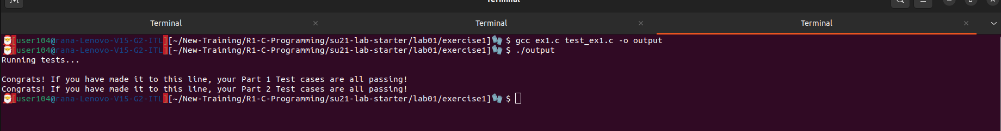

Exercise 2

Part 1
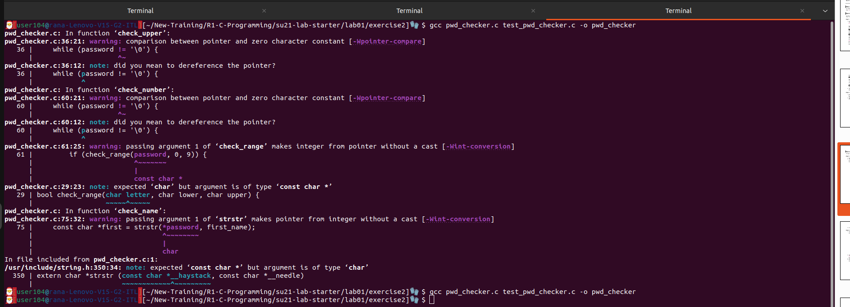
Part 2

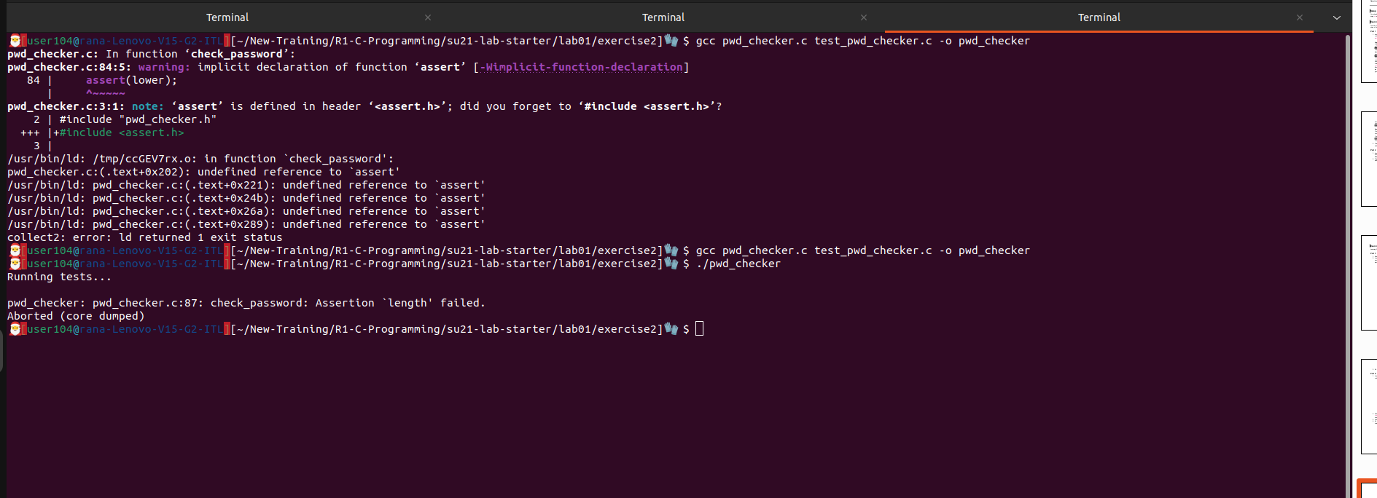

Part 3

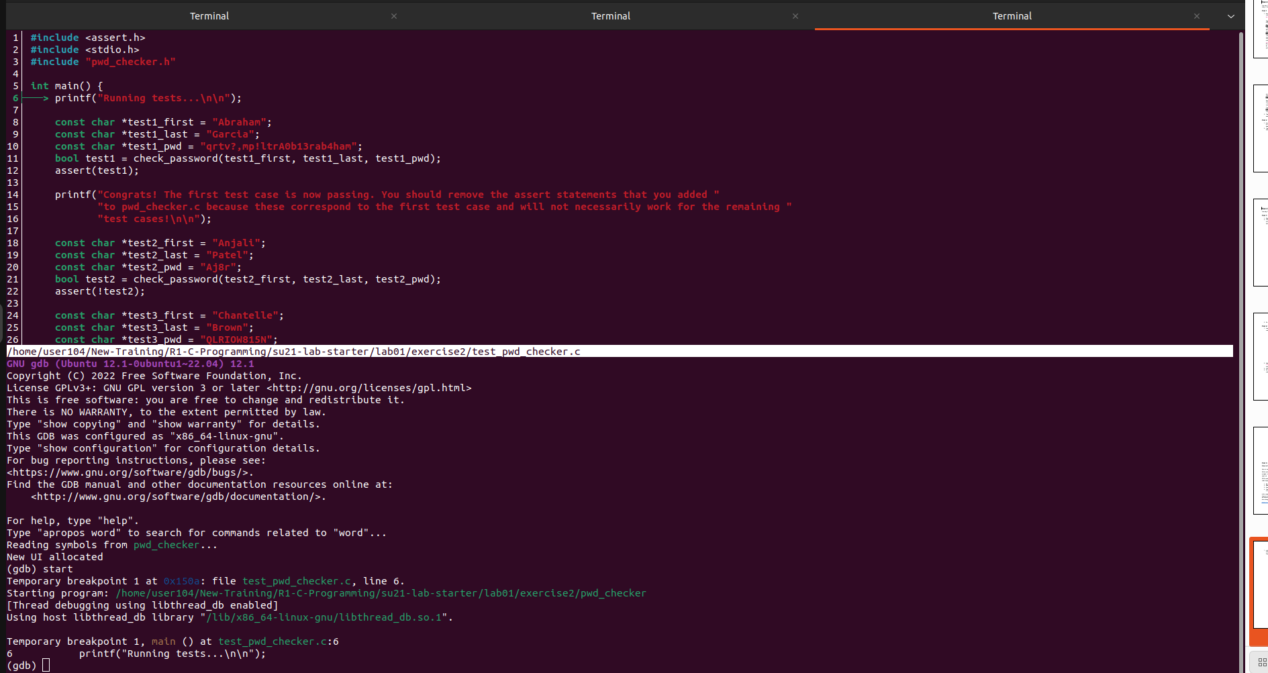
We found the error in check_length function using cgdb

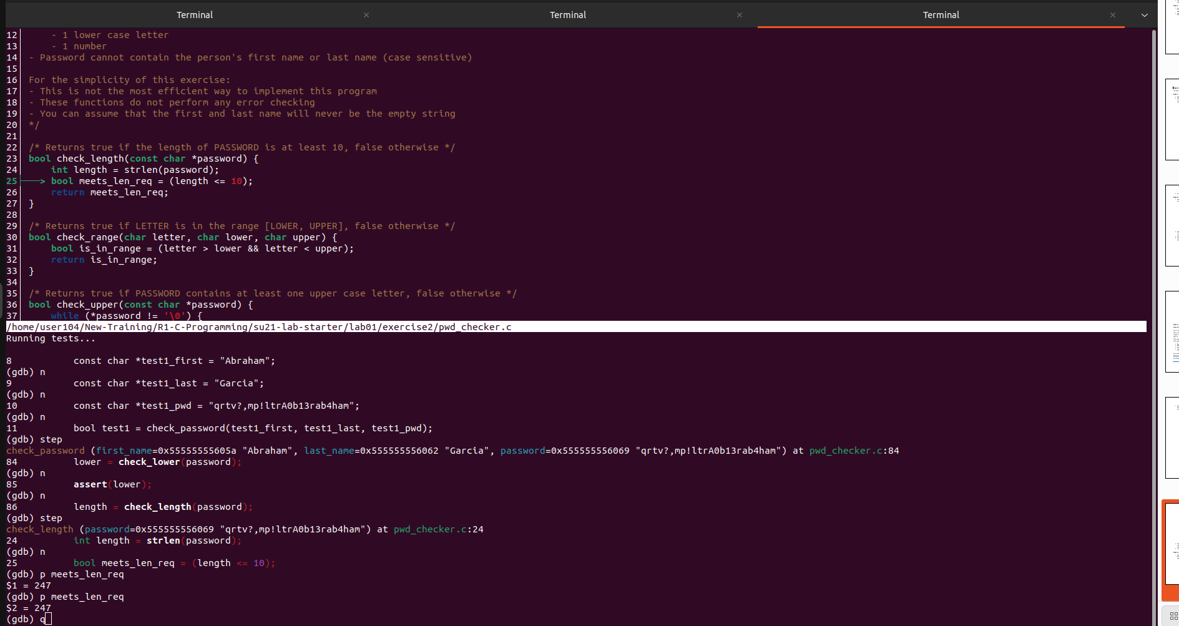

Now check_name function is failing. We will debug it using cgdb.
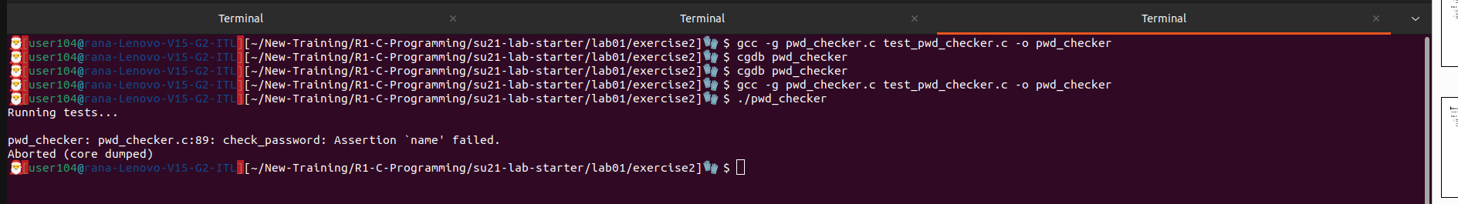

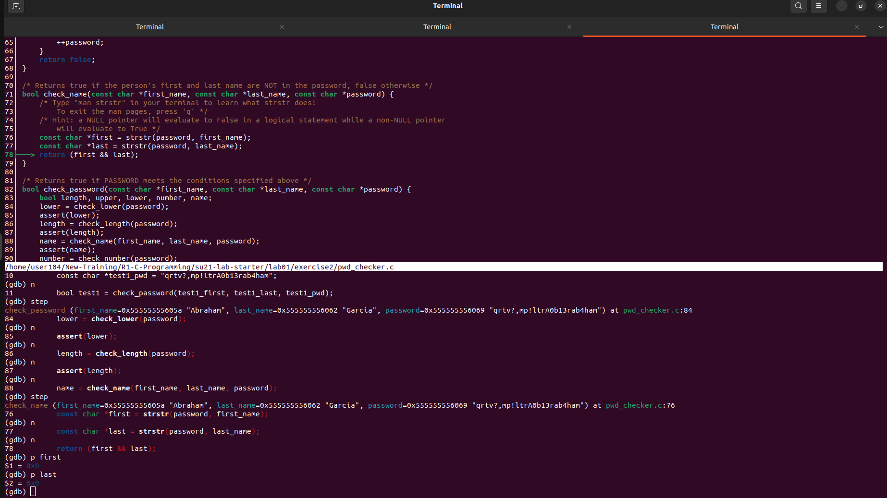
We have fixed the check_name , however , check_number is failing now.
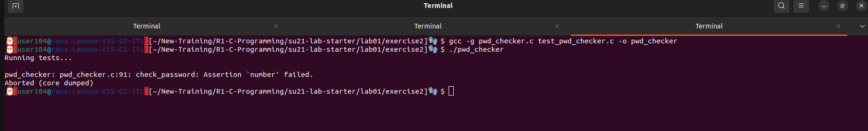

Part 4

We will debug check_number failing now. We have found the error using conditional breaks in cgdb.

It was taking a wrong range because we had passed 0 and 9 as int , not char.

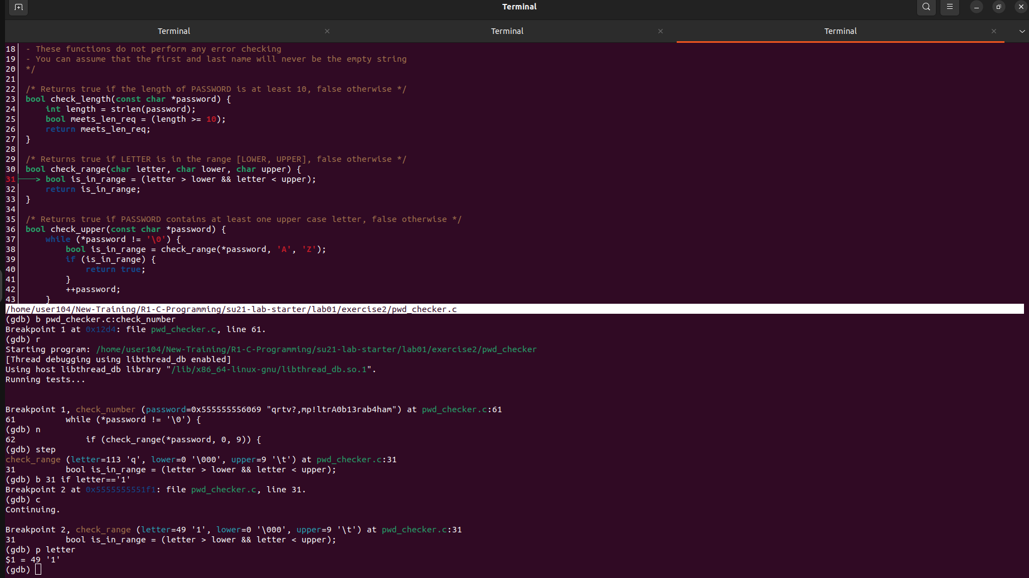
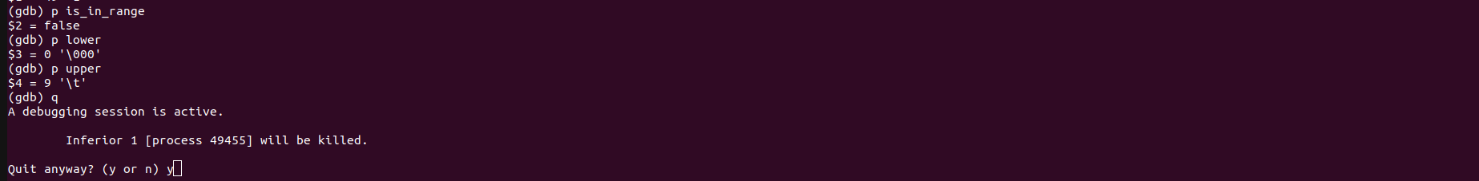
Now we can see that check_upper is failing. Let’s debug it.
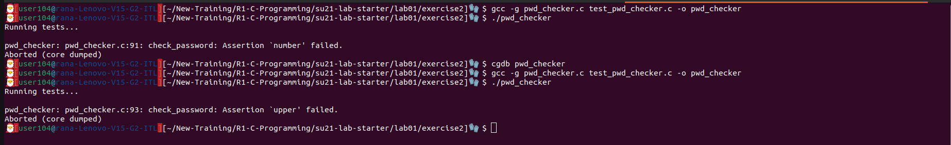

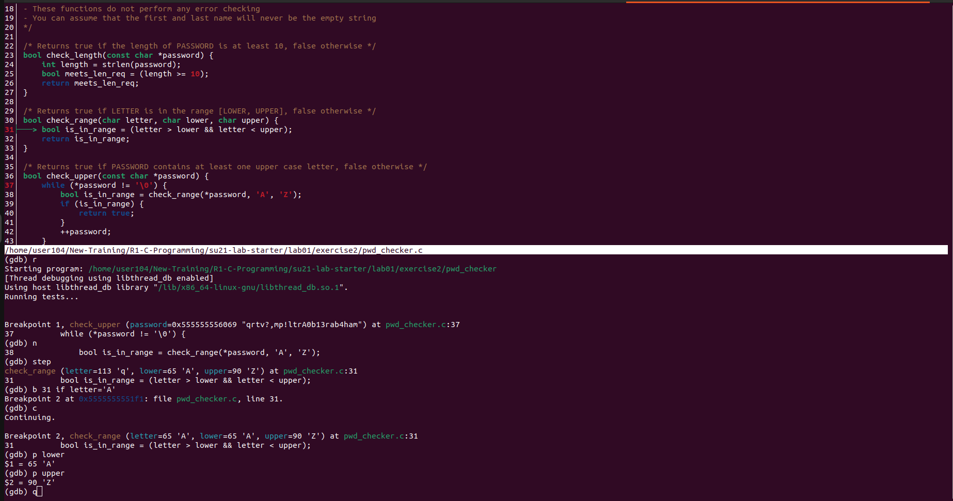

The screenshot shows that it was failing because we were not including 65 in our range. The ASCII value for A is 65 , so the characters range should be inclusive of 65 and 95.

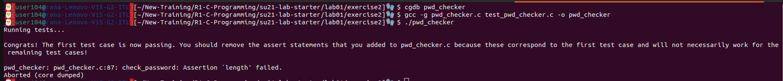

We have passed all the test cases...

Exercise 3

Part 3 let’s fix the Seg Fault which we all hate (:|

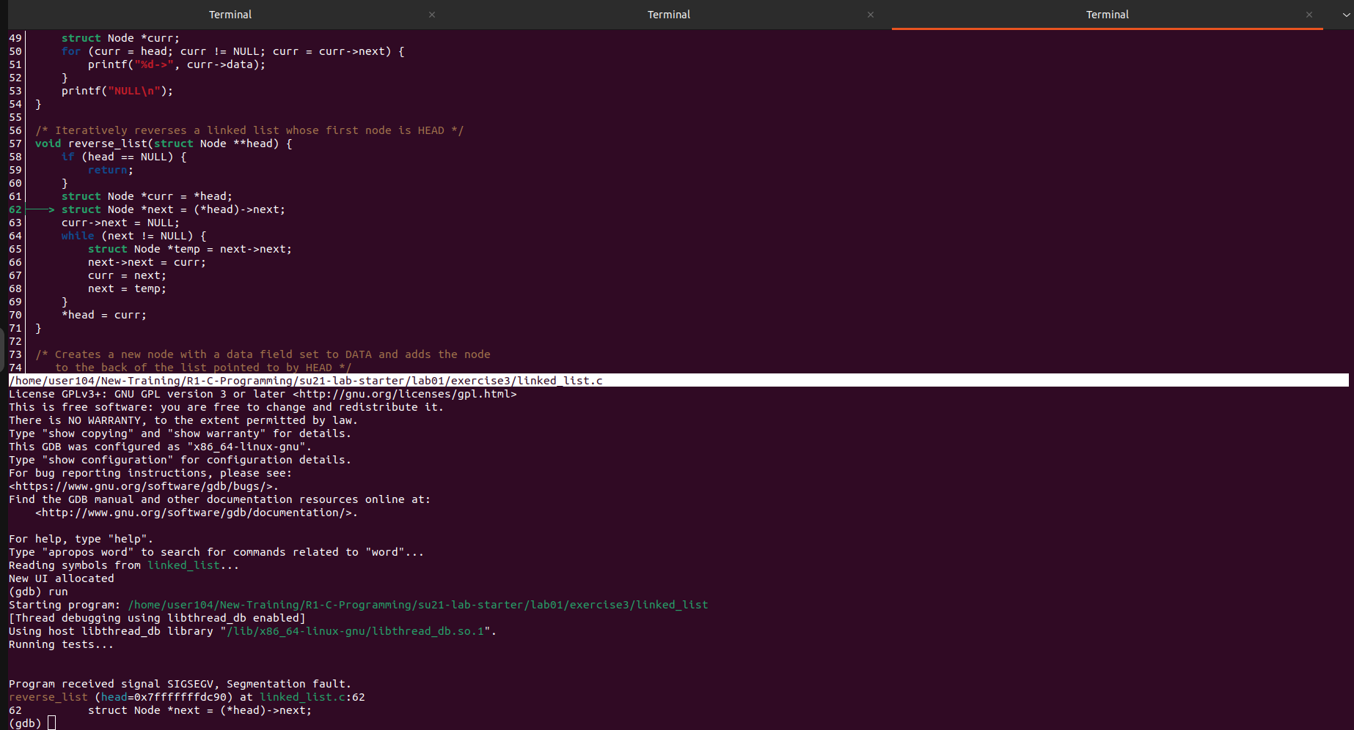

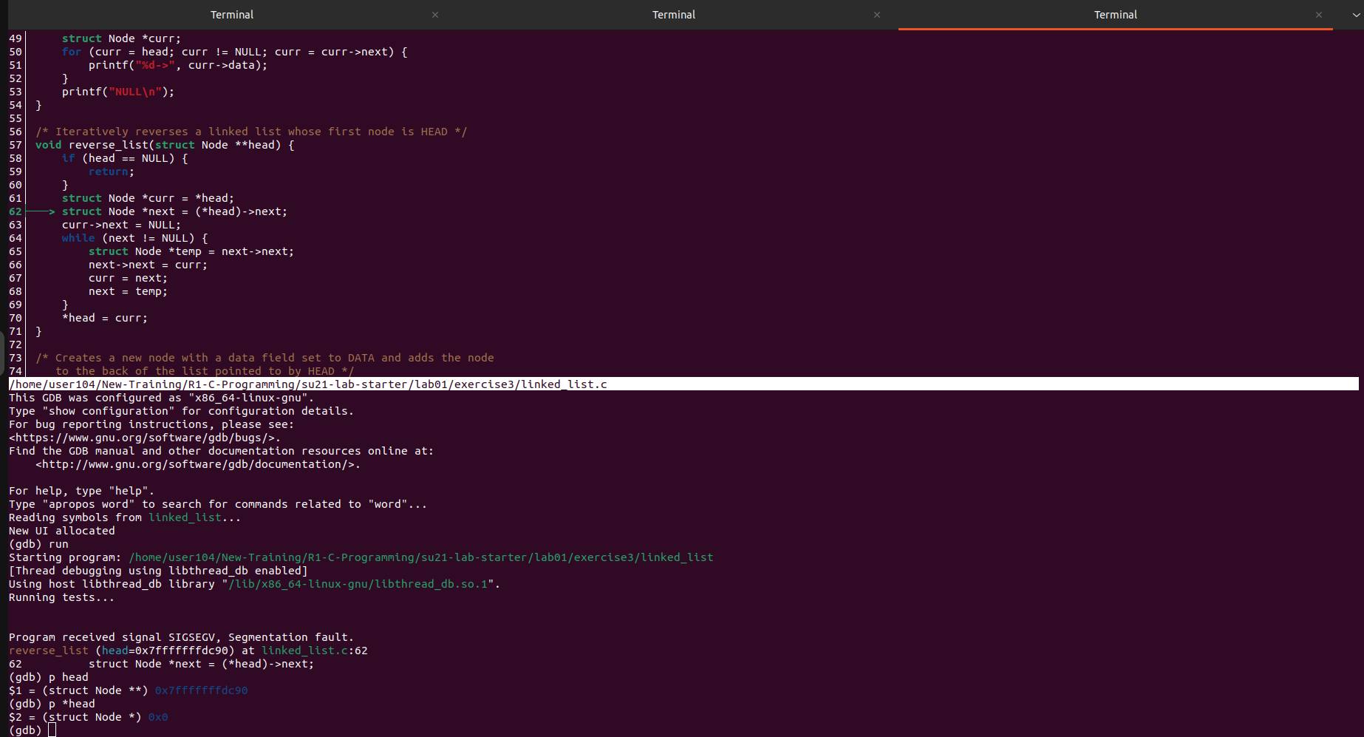
As we can see that our friend cgdb is showing we are trying to reverse an empty linked list. So, it is not a good idea. Let’s fix this by adding a condition if list is empty do nothing and return.

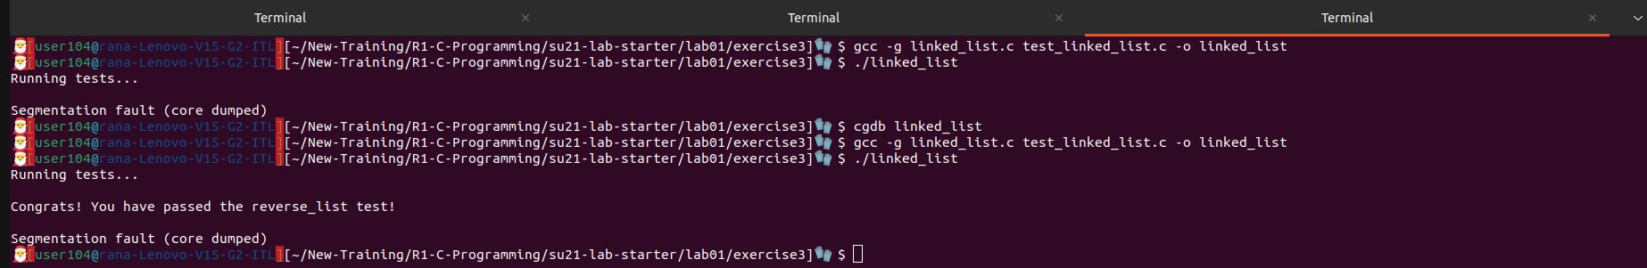
We have passed reverse list. But we are still getting SEG Fault. Not so good. Let’s redo the debugging process.
We are getting SEG fault in add_to_back. Let’s fix it by adding a breakpoint there and see what’s happening inside. As the below screenshot is showing we are doing the same thing like the previous one, add to back of an empty list.
We will fix this by adding a conditional after we created a node that if list is empty , then add the
node to the head of the linked list.

Hurrahhh!!! the last screenshot shows that our program is running without any SEG faults.

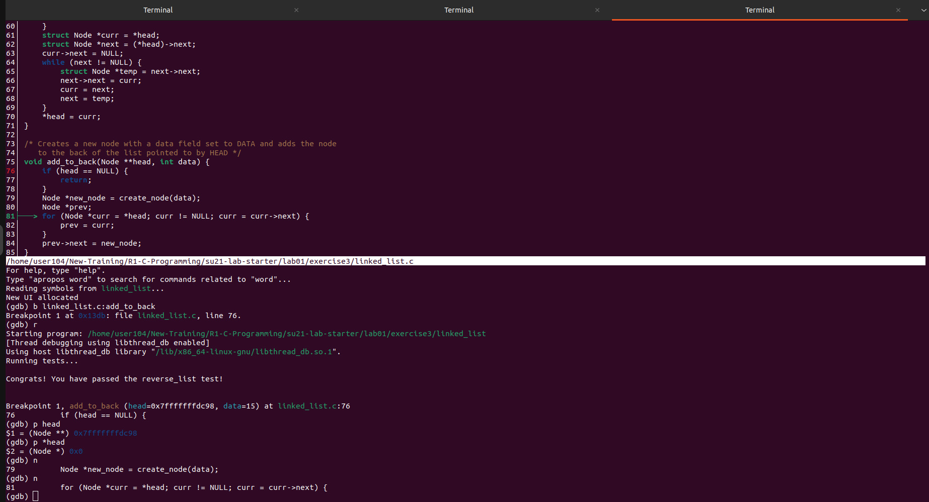

Exercise 4 Finding if a singly linked list has a cycle or not.

