Task 2

Exercise 1:

Add the make targets for vector.c and bit_ops.c.

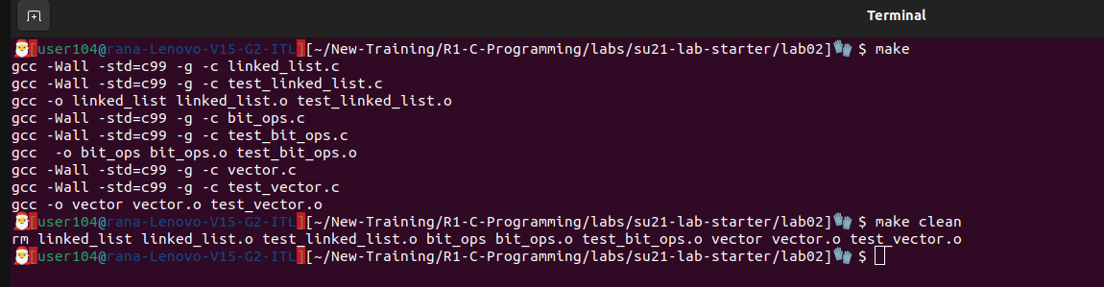

Exercise 2: Install and run valgrind

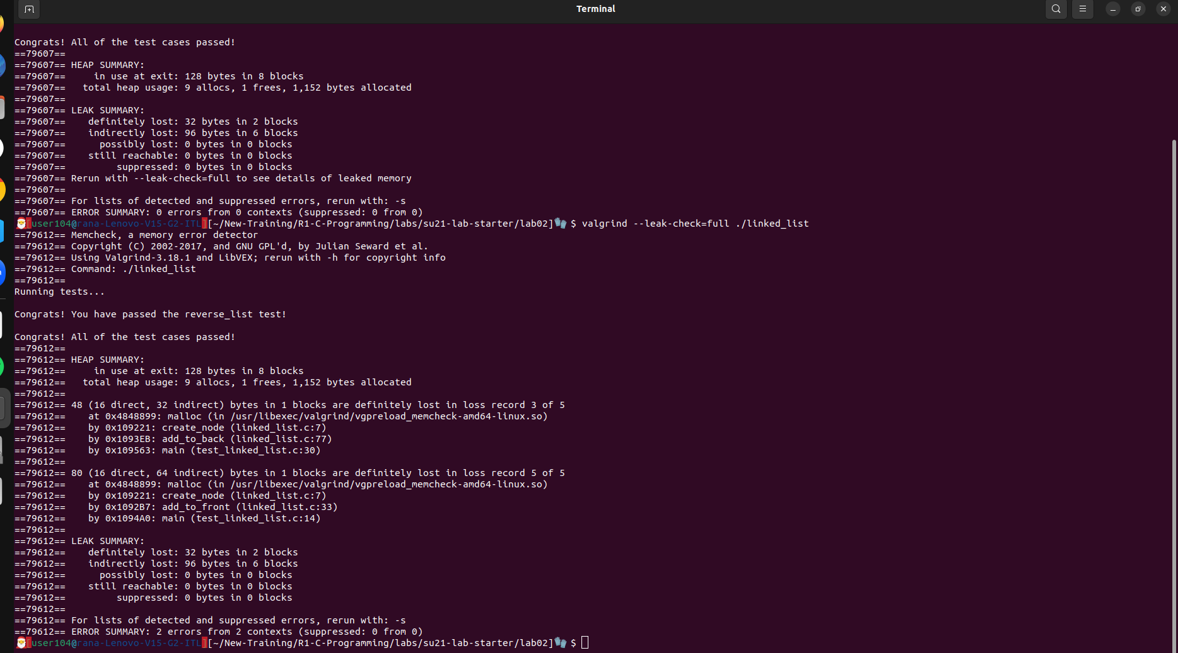

Exercise 3: Bit operations

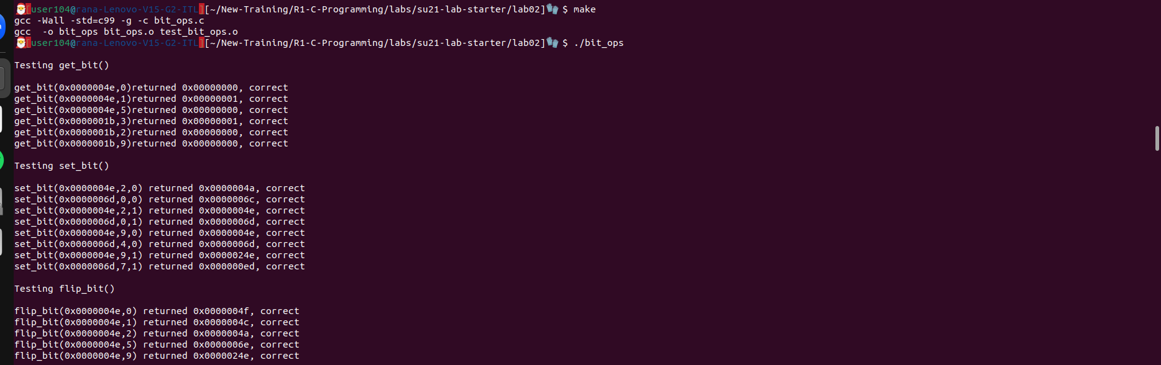
Exercise 4:

1. explain why bad_vector_new() and also_bad_vector_new() are bad

bad_vector_new(): The local variable v will be lost after the function returns from the stack
and the pointer will be a we would not be able to free the memory used by the inner members of the struct. It should be allocated on heap.

also_bad_vector_new(): The local variable is on stack and it will be lost and will not have
access to it. It should allocate the struct on heap or we need to make a pointer in our caller function and store the address and then it will work.

2.



