Q1 structure for student details

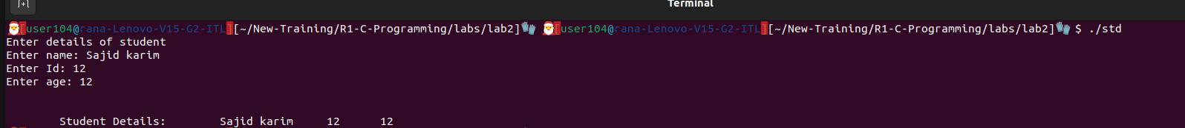

Q2 Inline function

