**Product Detail**

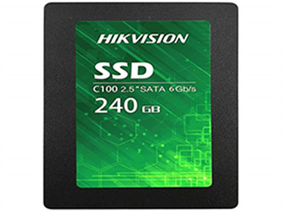

**HIKVISION SSD**

The C100 series solid state drive is developed from years of experience and expertise on storage technology and flash memory management.

Price: Rs:3000