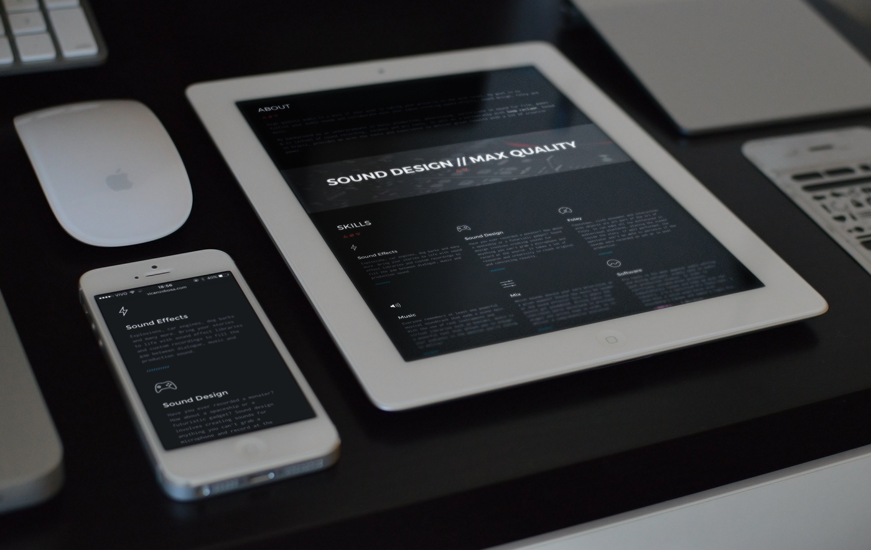

**SOUND WEBSITE**

CONTENTS

Introduction …………………………………………………………………………………………

Acknowledgment………………………………………………………………………………….

Requirements……………………………………………………………………………………….

E-Project Analysis…………………………………………………………………………………..

User Guide……………………………………………………………………………………………

Coding………………………………………………………………………………………………….

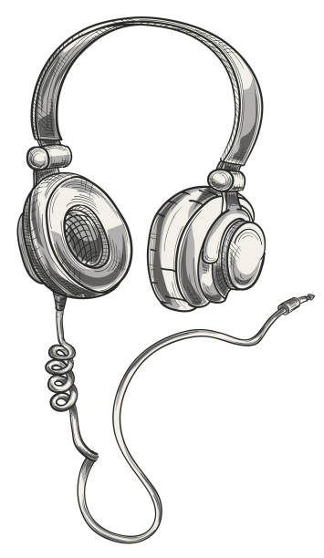

**SUBMITED BY**

* **HAMZA AHMED**
* **KHANSA ABID**
* **MUHAMMAD FAIZAN**
* **SAJID ALI**
* **SIDRA MUGHAL**

Of batch **PR2-202310C** have successfully completed the given task for the topic

**FACULTY: MISS FASAHAT**

SEMESTER DISM

APTECH LEARNING SHAHRAH-E-FAISAL

**INTRODUCTION**

Welcome to our website! This platform is dedicated to the exploration and creation of sound, offering a diverse array of audio resources for musicians, sound designers, and enthusiasts alike. Here, you can discover, share, and create sounds ranging from music and sound effects to ambient noise.

Our mission is to celebrate the art of sound and provide users with the tools and knowledge to enhance their auditory experiences. This documentation will guide you through our features, helping you make the most of what our website has to offer. Dive in and unleash your creativity!

**ACKNOWLEDGE**

We would like to extend our heartfelt thanks to everyone who contributed to the creation and development of our website.

First and foremost, we are grateful to our talented team of developers, designers, and sound engineers whose hard work and dedication brought this project to life. Your creativity and expertise have been invaluable.

We also appreciate the support of our beta testers and early users for their feedback and insights, which have helped us improve the platform. Thank you for your enthusiasm and encouragement.

Lastly, we acknowledge the broader community of sound artists and enthusiasts whose passion for sound inspires us every day. Your contributions to the field continue to shape our journey.

Thank you for being part of our website!



**WHAT IS THIS E-PROJECT?**

Our website is an innovative online platform designed to explore, create, and share sound in its various forms. This e-project serves as a comprehensive resource for individuals interested in sound design, music production, and audio exploration.

Key features of the project include:

* **Sound Library:** A diverse collection of audio samples, sound effects, and music tracks for users to explore and utilize in their projects.
* **Creation Tools:** User-friendly tools that allow users to create, edit, and manipulate sound, fostering creativity and experimentation.
* **Community Engagement:** A space for users to share their creations, collaborate with others, and participate in discussions about sound and audio production.
* **Educational Resources:** Tutorials, articles, and guides designed to enhance understanding of sound theory and practical applications.

This e-project aims to empower users to unleash their creativity, deepen their understanding of sound, and connect with a community of like-minded individuals.

**OBJECTIVE OF THIS EPROJECT**

The primary objectives of our website are:

1. **Sound Exploration:** To provide users with an extensive library of audio resources that encourages exploration and discovery of diverse soundscapes.
2. **Creative Tools:** To offer intuitive sound creation and editing tools that enable users to produce, manipulate, and innovate their own audio content.
3. **Community Building:** To foster a vibrant community of sound enthusiasts, musicians, and sound designers where users can collaborate, share their work, and exchange ideas.
4. **Educational Advancement:** To enhance users’ knowledge of sound theory and practical applications through accessible tutorials, guides, and resources.
5. **Inspiration and Innovation:** To inspire creativity by showcasing unique sound projects, trends, and techniques that push the boundaries of sound design and music production.

By achieving these objectives, our website aims to be a go-to destination for anyone interested in the art and science of sound.

**REQUIRMENTS**

Music and Video's are the most common source of entertainment today.

SOUND Group wants to host a WEBSITE for Entertainment. Company is looking on hosting new and old Video's and Songs in both REGIONAL and ENGLISH language.

WEBSITE should have proper menu structure and Music and Video should be arranged as per ALBUM, ARTIST, YEAR, GENRE, LANGUAGE etc.

Users should have option of reviewing and rating the Music and Video's available.

Home Page should have information about the site and a section for latest music and video with 5-5 listing in each.

Customer Specifications:

Website will host information about songs and videos with images and description and "New" image/icon should flash along with the new additions to Music and Video's.

The website will have three users/roles:

1) Administrator

2) USER

The Administrator should be able to do the following:

a) Add Music files with information.

b) Add Video files with information.

c) Create Categories viz. YEAR, ARTIST, ALBUM etc.

d) Delete Music files

e) Delete Video files.

f) Create/Manage Users/Logins

g) Manage information/details on the WEBSITE

The USER should be able to do the following:

a) Register/Create Account [USERID should be unique].

b) Search for MUSIC/Video based on Name, ARTIST, YEAR, ALBUM etc.

c) ADD/Modify Reviews

d) ADD/Modify Ratings

Note: Name, Address, Phone Numbers, Email-ids should be mandatory to be provided. Proper Validations should be applied on all Data Fields.

**PROJECT ANALYSIS**

|  |  |
| --- | --- |
| NAME | ENROLLMENT NO |
| HAMZA AHMED | Student 1525950 |
| KHANSA ABID | Student 1525476 |
| MUHAMMAD FAIZAN | Student 1518575 |
| SAJID ALI | Student 1518578 |
| SIDRA MUGHAL | Student 1525474 |
| TEACHER: MISS FASAHAT | BATCH CODE:PR2-202310C |

|  |  |  |  |  |  |  |  |
| --- | --- | --- | --- | --- | --- | --- | --- |
| NAME | HOME  PAGE | FRONT-END CODING | BACK-END  CODING | MY  SQL | LOG- IN FORM | REGIST  RATION FORM | DOCUME  NTATION |
| HAMZA |  |  |  |  |  |  |  |
| KHANSA |  |  |  |  |  |  |  |
| FAIZAN |  |  |  |  |  |  |  |
| SAJID |  |  |  |  |  |  |  |
| SIDRA |  |  |  |  |  |  |  |

**Home Page Source Code:**

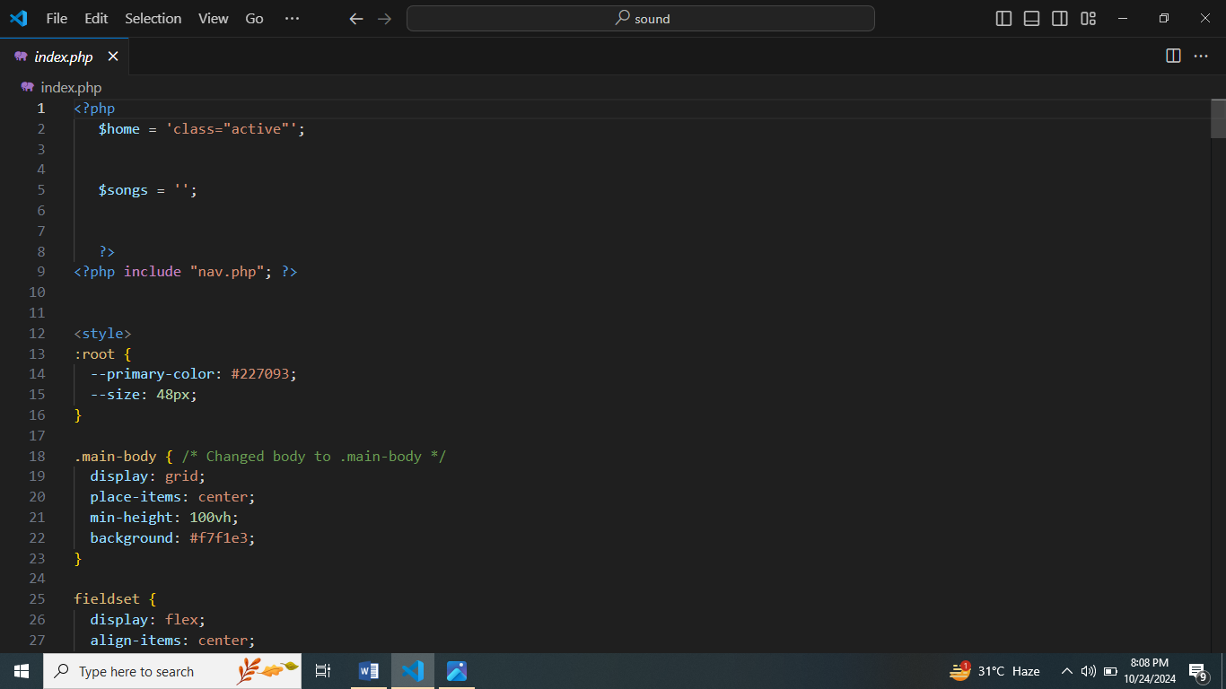

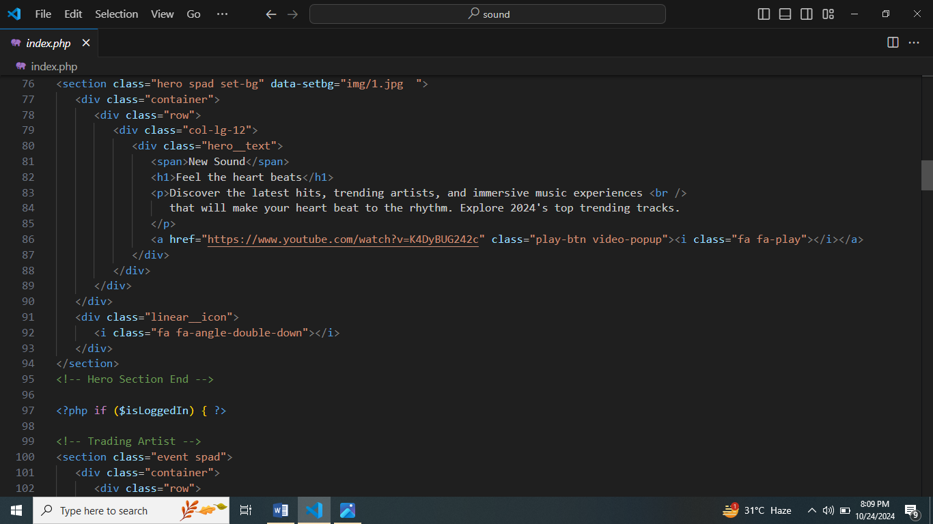

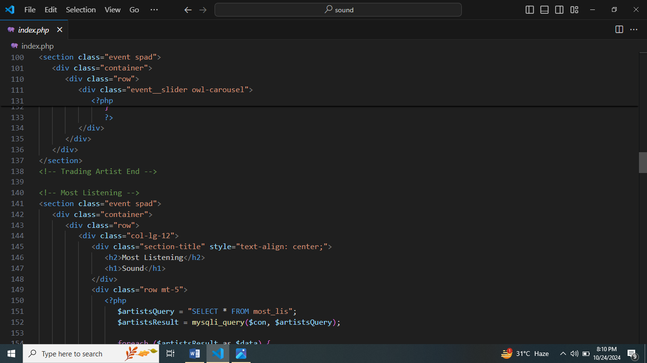

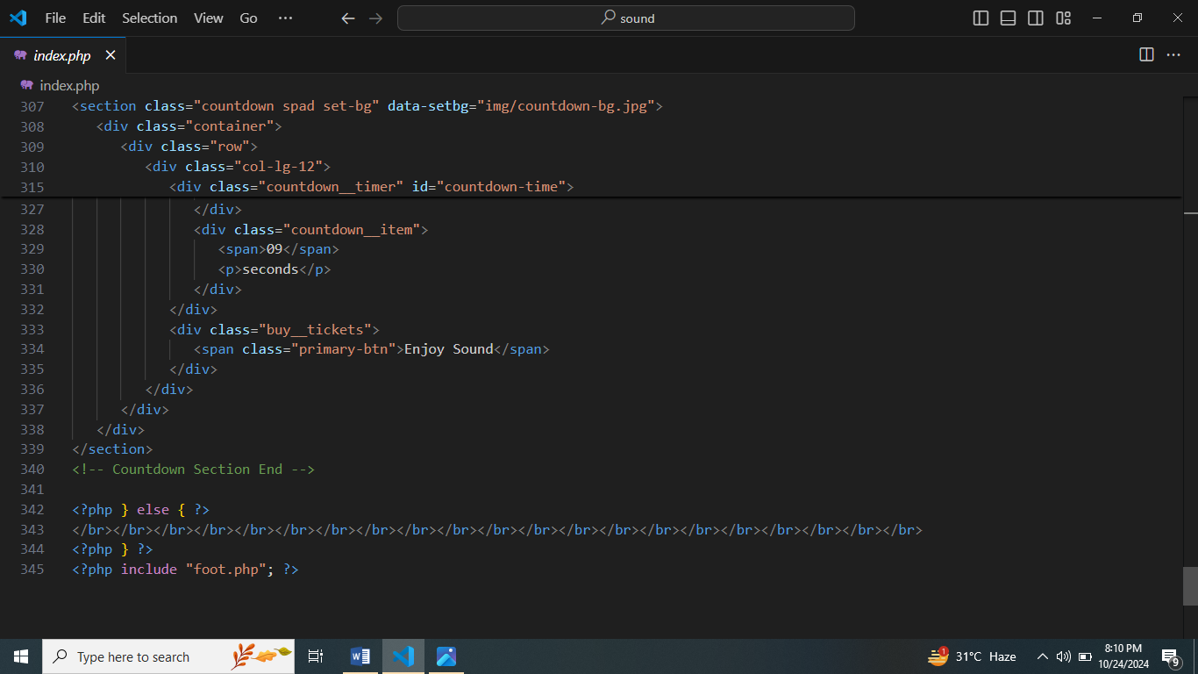

**Backend Source Code:**

