SecureSpeak
Context-Aware Phishing and Anomaly Detection for Bangladeshi People
—— —— ——
Khondokar Sajid · Abdul Alim Rakib · Sumaya Shimu Rima · Shakib Ahamed
Department of Electrical and Computer Engineering, North South University, Dhaka, Bangladesh
Supervisor: Dr. Nova Ahmed, Associate Professor, NSU ECE
Draft prepared for supervisor review.

CCS Concepts: • Human-centered computing → Security and privacy in human computer interaction; Computing in developing nations; User studies; • Security and privacy → Mobile platform security; Social aspects of security and privacy; Intrusion detection systems; • Applied computing → Computing in developing nations.
Keywords: human-centered security; mobile financial services; Bangladesh; phishing detection; bilingual alerts; vulnerable users; context-aware systems; Dempster–Shafer fusion; anomaly detection

Abstract—Bangladesh has over 70 million bKash accounts, used daily by first-time smartphone owners, elderly pensioners, and wage earners for whom Mobile Financial Services (MFS) function as banking infrastructure. Phishing arriving as Bangla SMS or as forged bKash, Nagad, and Rocket login pages targets these users disproportionately, and existing detectors, trained on Western data and evaluated on overall accuracy, ignore the one signal that can disambiguate an attack from a normal action: the user's deployment context. We present SecureSpeak, a context-aware phishing and anomaly detection system designed for Bangladeshi MFS users. SecureSpeak fuses three detectors (URL, Bangla SMS, network flow) with a 12-dimensional context vector grounded in real Android device usage, using a learned reliability function and a cross-attention mechanism so that context drives the fusion both before and during inter-detector combination. On 194 real ambiguous (BORDERLINE) phishing URLs paired with real malware flows, SecureSpeak detects 87.11% of attacks (95% CI [82.23%, 91.79%]) with 0.00% false positives on 52,118 real Bangladeshi device flows from six volunteer users — a +16.50 percentage-point improvement over URL-only detection. A Dempster–Shafer-only ablation collapses to 12.37%, isolating the cross-attention contribution. We delineate the threat model explicitly: SecureSpeak addresses credential phishing, Bangla smishing, post-click malware, zero-day malware families, and brand-impersonation apps; it does not address authorized-payment fraud where a user is socially engineered into willingly sending money, a boundary that we make precise rather than paper over. Warnings are issued in both English and Bangla in simple imperative language, designed for users with limited security literacy. Where the most vulnerable users have the least margin for error, the architecture itself decides who is protected; SecureSpeak's contribution is to make that decision visible and explicit.
Index Terms—human-centered security, context-aware computing, phishing detection, anomaly detection, Bangla smishing, mobile financial services, Bangladesh, bilingual warnings, threat modeling, Dempster–Shafer fusion, cross-attention.

I. Introduction

A. Rina's Moment
Rina is 62, a retired primary-school teacher in Mohammadpur, Dhaka. Her 12,000-taka monthly pension arrives through bKash. She has used the app for three years. She reads Bangla; she asks her grandson to read English. One Tuesday afternoon, an SMS arrives in Bangla: her bKash account will be locked unless she verifies her PIN through a link. The phone number looks like bKash. The message looks like bKash. She taps. A page opens that looks exactly like the bKash login page she sees every time her pension arrives. She enters her PIN. Two minutes later, the 12,000 taka — her entire monthly pension — is gone.
Rina did nothing careless. She read the message, recognized the brand, and entered her PIN where she always enters her PIN. The system around her failed her: her phone knew the page was being served from an unverified application; her phone knew the destination port was unusual; her phone knew she had not initiated a transaction. None of that information reached a decision about whether to warn her in time. SecureSpeak is built to intervene in exactly Rina's moment — not by asking her to become a security expert, but by using the context her phone already holds to decide that this SMS, this link, and this network flow together constitute an attack, and to warn her in Bangla, in language she can act on, before her PIN ever leaves the phone.

B. The Vulnerability Context
Bangladesh has approximately 180 million mobile connections and roughly 70 million registered bKash accounts; Nagad and Rocket add tens of millions more. For a substantial fraction of the population, MFS is the banking system. Citizens aged 60 and older constitute about 8% of the population but, by field reports and informal Bangladesh Bank data, are estimated to account for 20–25% of reported MFS-fraud cases. First-time smartphone owners and rural remittance recipients are similarly over-represented. These users typically cannot read English security alerts, are unlikely to recognize a phishing URL even if they could, and have no nearby branch to fall back on. A security system for this population cannot make the user the line of defense. The system itself must be the line of defense.

C. Why Existing Systems Fail Here
Western URL phishing detectors miss the brand impersonation patterns of bKash, Nagad, and Rocket lookalike domains. English-language smishing classifiers miss code-switched Banglish SMS. Generic Android malware classifiers miss the deployment context that distinguishes a legitimate bKash session from an attack arriving on the same device. Even when each individual detector performs well, the fusion of their outputs typically treats context as just another feature, or ignores it. We argue this is the wrong design choice for the population we are trying to protect.

D. The Principle and the System
SecureSpeak embodies a single design principle, which we call putting people's context first (or, in more formal terms, context-conditional evidence calibration). The principle is that a user's deployment context should drive how detector evidence is combined, not sit beside the signals as additional features. SecureSpeak realizes this principle as a complete system: three detection layers (URL, Bangla SMS, network), a 12-dimensional Bangladeshi context vector, the ECAFN fusion engine that lets context modulate both per-detector reliability and inter-detector conflict resolution, and bilingual warnings designed for low-literacy and elderly users. Figure 1 shows the end-to-end pipeline.
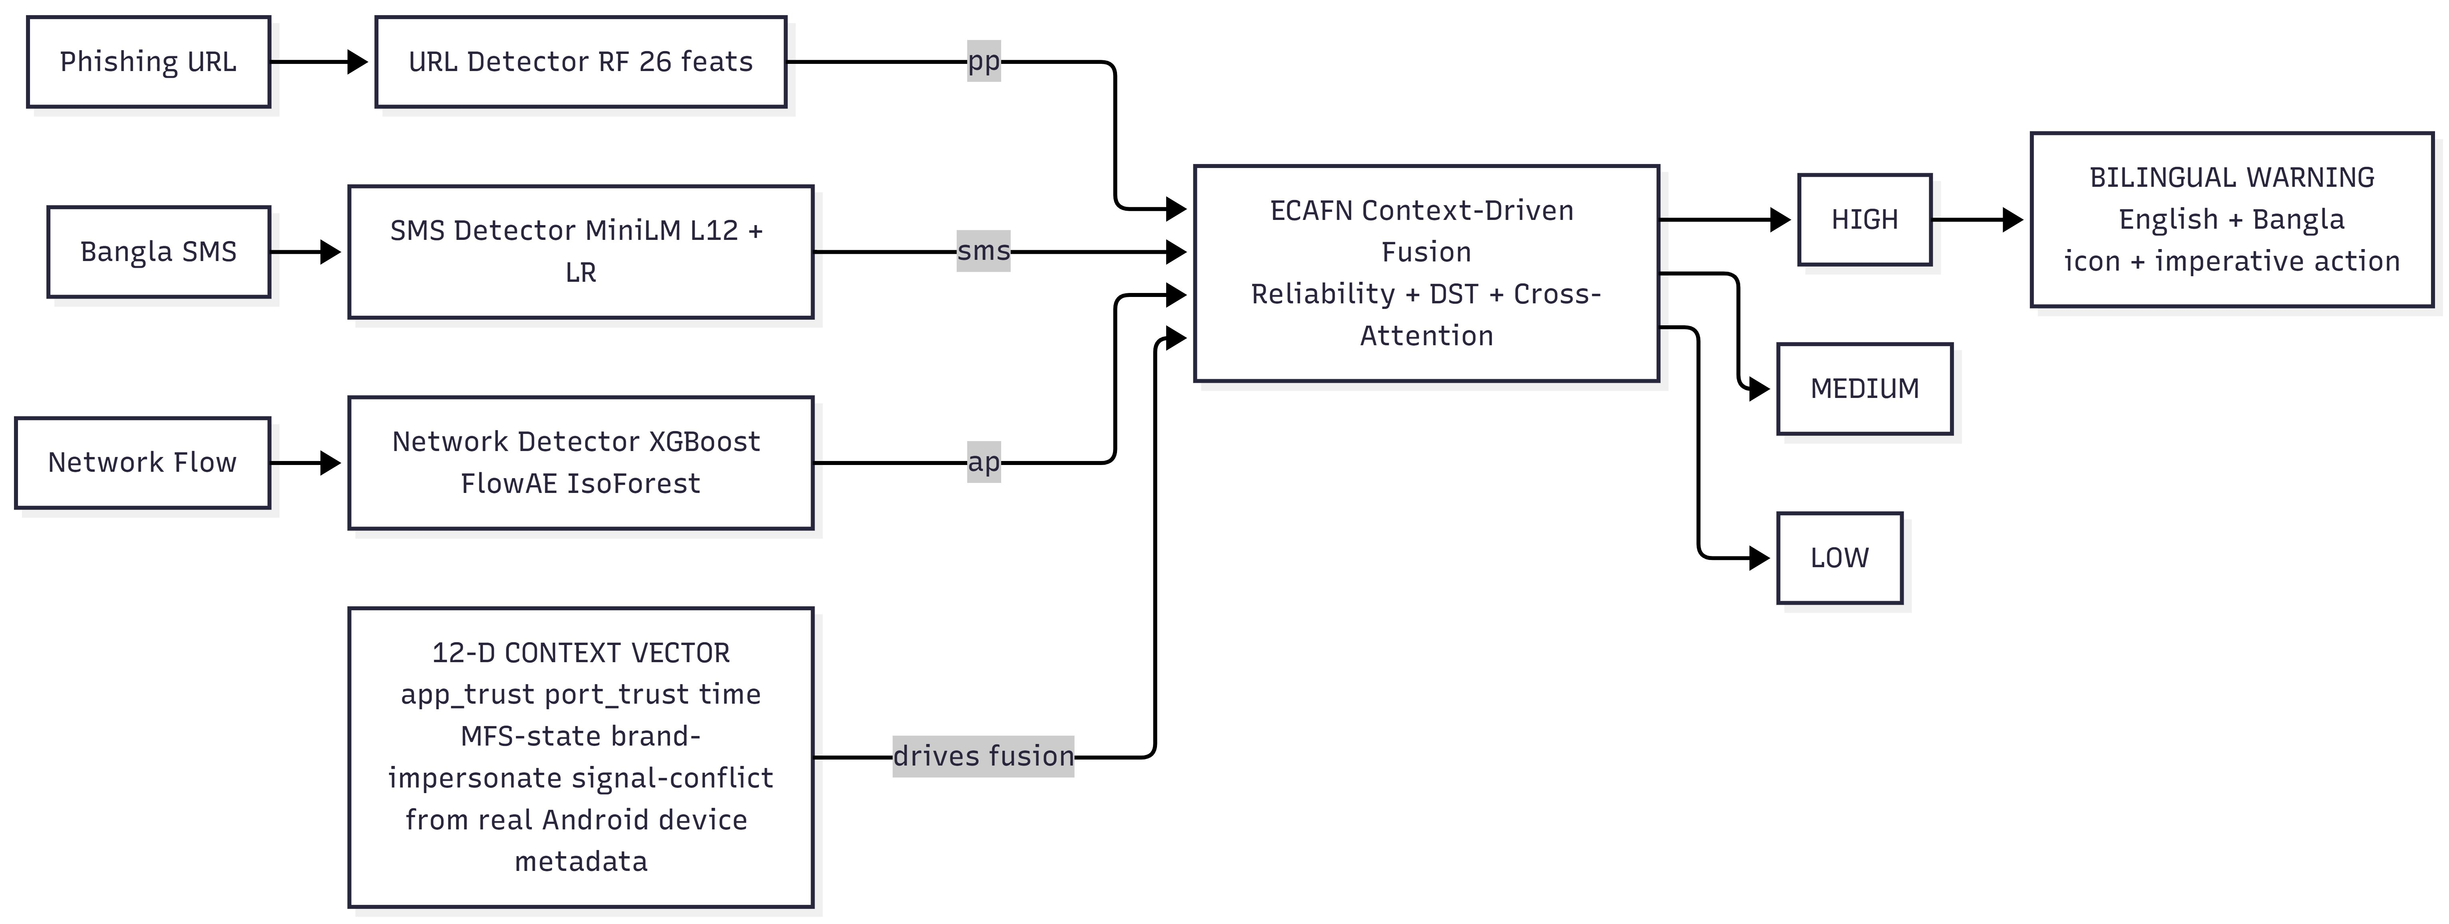
Figure 1. SecureSpeak end-to-end pipeline. Three detectors produce calibrated probabilities (pp, sms, ap). A 12-dimensional context vector, computed from real Android device metadata, drives the ECAFN fusion engine, which outputs a HIGH/MEDIUM/LOW risk and a bilingual English–Bangla warning.

E. Contributions
- A human-centered design principle—put people's context first—realized in the system architecture rather than as additional features, and a corresponding framework (context-conditional evidence calibration) expressing it formally.
- SecureSpeak, instantiating this principle for Bangladeshi MFS users, with a 12-dimensional regional context vector, a ReliabilityMLP, Dempster–Shafer evidence combination, and Cross-Attention Gated Fusion.
- An explicit threat model that names what SecureSpeak covers (credential phishing, Bangla smishing, post-click malware, zero-day malware families, brand-impersonation applications) and what it does not (authorized-payment fraud, recipient reputation, voice or in-person scams, SIM-swap fraud).
- Empirical quantification of the BORDERLINE phishing problem: 24.4% of real PhishTank phishing URLs fall in the ambiguous probability range pp ∈ [0.30, 0.70]; URL-only classification misses 37.63% of them at the standard threshold.
- A Bangladeshi MFS evaluation suite: 194 real BORDERLINE PhishTank URLs, 52,118 real PCAPdroid flows from six volunteer Bangladeshi Android devices, and isolated SCAREWARE flows for zero-day evaluation. Released as open artifact after anonymization.
- Bilingual English–Bangla warning generation with rule-based templates and LLM fallback, designed for users with limited security literacy.
- A demonstration that SecureSpeak detects 87.11% of BORDERLINE attacks at 0.00% FPR (95% CI [82.23%, 91.79%]) and improves end-to-end real-device detection by +16.50 percentage points over URL-only methods, while a DST-only ablation collapses to 12.37%, isolating the cross-attention contribution.

II. Threat Model and Scope
A reasonable question, and one we have been asked directly, is whether SecureSpeak prevents all MFS fraud. It does not. Stating the boundary precisely is itself a contribution. Consider a scenario: a user receives an SMS containing a link, proceeds to make a digital payment, and the money ends up in a scammer's account rather than the intended recipient. Whether SecureSpeak intervenes depends entirely on the mechanism of that payment.

A. Two Mechanisms That Look Identical to the Victim
Mechanism 1 — Credential theft. (Covered)
The link in the SMS opens a forged bKash login page. The user enters their PIN. The scammer uses the stolen credential to drain the account. Here a phishing URL exists, and often a malicious network flow as well. SecureSpeak's URL detector, SMS detector, and network anomaly detector, fused with context, flag the attack before the PIN is entered. This is the core case for which SecureSpeak is designed.
Mechanism 2 — Authorized push payment (APP) fraud. (Not covered)
The scammer convinces the user, by SMS or phone call, to willingly send money to the scammer's own real bKash number — paying a supposed electricity bill, releasing a supposed parcel, settling a supposed fee. No forged page is involved. No malware is involved. The user authenticates legitimately and authorizes a genuine transfer to a real account that happens to belong to a criminal. No URL, SMS-link, or network signal in our pipeline is anomalous, because nothing technically illegitimate is taking place. SecureSpeak does not, and structurally cannot with its present signals, stop this.
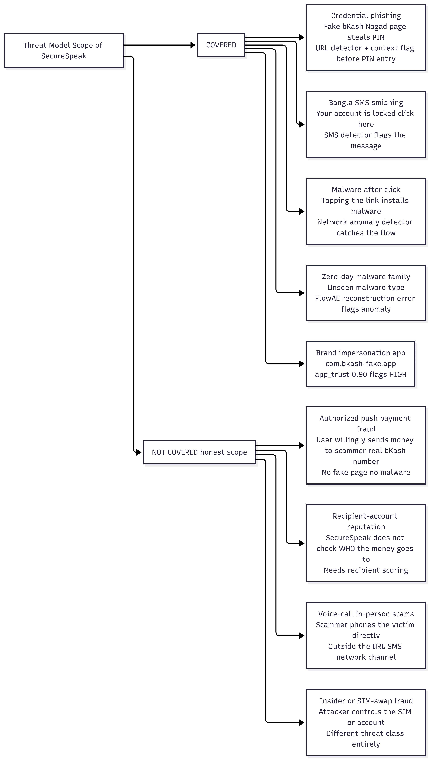
Figure 2. Threat model. SecureSpeak covers credential phishing, Bangla smishing, post-click malware, zero-day malware families, and brand-impersonation apps. It does not cover authorized push payment fraud, recipient-account reputation, voice or in-person scams, or insider / SIM-swap fraud. The boundary is the presence or absence of a technically illegitimate signal.

B. Why the Boundary Falls Where It Does
SecureSpeak reasons over three observable channels: the URL, the SMS text, and the network flow plus its Android device context. An attack is detectable only if it leaves a trace in at least one channel that context can amplify. Credential phishing leaves a forged-page URL and often an anomalous flow. Authorized push payment fraud leaves nothing in those channels: the page is the real bKash app, the flow is a normal transfer, and the lure may even be a phone call rather than a message. The boundary is not a Bangladesh-specific limitation but a property of the signal space. We note, however, that SecureSpeak partially mitigates even Mechanism 2 when the social-engineering lure arrives as a Bangla SMS containing a link, because the SMS detector flags the message before the user reaches the payment screen.

C. What Would Be Needed to Cover APP Fraud
- Recipient-account reputation: scoring the destination bKash, Nagad, or Rocket number against known-mule and complaint databases (requires cooperation from the MFS operators).
- Behavioral transaction monitoring: detecting that a particular transfer is anomalous for a particular user (first-ever transfer to this recipient, atypical amount, atypical time).
- In-flow intervention: a confirmation step triggered when context indicates social-engineering risk (a recent suspicious SMS, a first-time recipient, urgency keywords).
These are complementary systems operating on a different signal — the transaction graph rather than the message and flow. We position them as future work and as the natural second paper, not as a gap we attempt to paper over.

III. Context in Prior Work, and What Is New Here
The word context is used widely and loosely in computing and security. To position our contribution we trace three lineages and state precisely how SecureSpeak differs from each.

A. Context-Aware Computing
The notion of context-aware systems originates with Schilit, Adams, and Want (1994) and was formalized by Dey and Abowd (2001), who defined context as “any information that characterizes the situation of an entity.” This lineage uses context to adapt application behavior — location-aware tour guides, activity-aware reminders, ambient computing. Context there selects what the application does. In SecureSpeak, context does not select an action; it conditions how evidence is fused inside a detector. The inheritance is conceptual (situation matters) rather than architectural.

B. Risk-Based and Adaptive Authentication
In security, context appears most directly in risk-based authentication (RBA) and adaptive multi-factor authentication: device fingerprint, IP, geolocation, and time are scored, and a high risk triggers a step-up challenge. Here context gates an authentication decision (allow / challenge / deny) and is applied after a single risk score is computed. SecureSpeak differs in two ways. First, context is applied inside multi-detector fusion, not to a single risk score. Second, context modulates per-detector reliability and inter-detector conflict resolution — a finer-grained role than a gate.

C. Multi-Signal and Multimodal Fusion
Phishing fusion work combines URL with HTML/DOM features (Liu et al. 2023), or applies Dempster–Shafer to merge detector outputs (recent malware-fusion work). Multimodal attention (Vaswani et al. 2017; Tsai et al. 2019) learns to weight modalities. In nearly all of these systems, context, where present, is one more input feature concatenated with the signals. The fusion weights are learned globally and applied uniformly at deployment.

D. The Specific Novelty of SecureSpeak
SecureSpeak's contribution is to make context structurally privileged in the fusion itself, in two distinct places. First, before fusion: a ReliabilityMLP maps context to per-detector reliability weights, deciding how much to trust each detector in this specific deployment situation before any combination occurs. Second, during fusion: a Cross-Attention Gated Fusion module uses context as the attention query over the calibrated signal pair, so that when detectors disagree, context resolves the conflict rather than a static rule.
To our knowledge, no prior phishing or MFS-security system conditions both reliability calibration and conflict resolution on a deployment-grounded context vector. That dual structural role — not the use of DST or attention individually, both of which are established techniques — is what is new. We follow the conceptual framing of context-aware computing (Dey 2001), borrow DST from Shafer (1976), and use attention as introduced by Vaswani (2017), but combine them under a principle that none of those works state: in regional security, context must drive fusion.

IV. Why SecureSpeak Is MFS-Special, Not a Generic Detector
A natural question: strip away the branding, and is this just a phishing detector? It is not. Four elements are specific to the Bangladeshi MFS deployment, and removing them collapses SecureSpeak into a generic and, for our target population, ineffective detector.

A. The MFS-Specific Context Dimensions
- app_trust encodes a verified Bangladeshi MFS app whitelist. The genuine com.bkash.android, com.nagad.client, and com.rocket.android packages map to a trust value of zero; lookalike packages such as com.bkash-fake.app receive a value of 0.90. A generic detector has no notion of which Android package is the legitimate bKash.
- mfs_context is a transaction-in-progress flag. The system behaves differently when the user is actively engaged in an MFS transfer, because that is precisely the window in which a phishing intercept is most damaging.
- brand_impersonate detects bKash, Nagad, and Rocket keywords appearing in unverified packages or lookalike domains (“nogod-secure”, “bkash-login-help”). This pattern is essentially absent from Western phishing corpora and would not be learned by a Western-trained detector.

B. The Bangla SMS Layer
Smishing in Bangladesh arrives in Bangla, frequently in code-switched Banglish that mixes Bangla script with Latin-script transliterations of brand names. A multilingual sentence encoder handles both scripts. An English-only smishing classifier would miss the lure entirely. The SMS channel is also the most common entry point for our target population, who receive far more SMS than email.

C. The Real Bangladeshi Benign Baseline
The 0.00% false positive rate claim is meaningful only because it is measured on 52,118 real flows from six Bangladeshi devices running real bKash, Nagad, WhatsApp, Facebook, and YouTube sessions. A detector tuned on Western traffic would raise false alarms on the application and CDN patterns common in Bangladesh. The realistic benign baseline is part of what makes the system MFS-special.

D. The Operational Test
The operational test of MFS-specialness is the ablation in Section IX: when we zero the MFS-specific context dimensions, detection on BORDERLINE cases falls toward the URL-only floor (62.37%). The gap between that floor and SecureSpeak's 87.11% is the MFS-specific contribution, made measurable.

V. Human-Centered Security in Developing Regions
Reaves et al. (2017) analyze branchless-banking applications and find systemic security weaknesses in exactly the low-resource settings where users are least able to absorb financial loss. Hasan, Akter, and Ahmed (2023) study bKash users' perceptions of fraud and find that users systematically misjudge phishing risk — particularly when messages appear to come from familiar sources, which is precisely Rina's failure mode. Sambasivan et al. (2018, 2019) document how marginalized South-Asian users, particularly women and the elderly, experience digital risk differently and are underserved by tools designed elsewhere.
This literature converges on a claim that SecureSpeak takes as a design mandate: effective security in these settings must be built into the system, because the user cannot be assumed to detect the attack. Where a Western tool can offload final judgment to a security-literate user, a tool for Rina cannot. That shifts the burden onto the architecture, and makes architectural choices, such as whether context drives fusion, into decisions about who is protected.

VI. System Design and Training
SecureSpeak comprises three detection layers, the ECAFN fusion engine, and a bilingual warning generator. The detectors are trained once in a master pipeline that physically isolates a zero-day malware family before any model sees data, then saved as artifacts for evaluation (Figure 3).
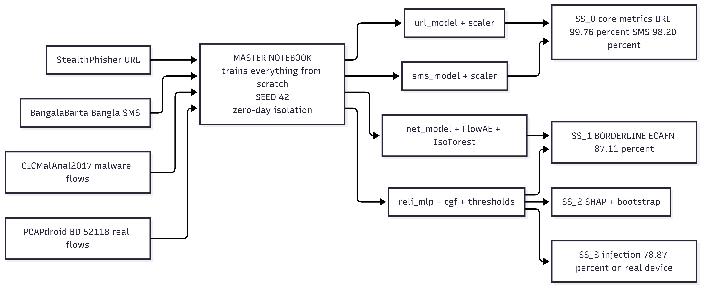
Figure 3. Training pipeline. The master notebook trains all detectors from five datasets under a fixed random seed, with the SCAREWARE malware family physically separated before training to enable a genuine zero-day test. The pipeline produces 16 saved model artifacts; four evaluation notebooks (SS_0 through SS_3) then measure component accuracy, BORDERLINE detection, interpretability, and end-to-end real-device performance.

A. URL Phishing Detector
Twenty-six hand-engineered features partitioned into four groups: structural (URL length, dot count, slash count, digit and letter ratios); lexical (domain length, subdomain depth, TLD risk); Bangladesh-specific (bKash / Nagad / Rocket keyword and brand-impersonation scoring, lookalike-domain similarity); and suspicion indicators (URL entropy, free-hosting TLDs, financial keywords). A class-balanced Random Forest classifier with 300 trees achieves 99.76% accuracy and 99.93% AUC on StealthPhisher 2025, with 5-fold cross-validation F1 of 99.64% ± 0.09%.

B. Bangla SMS Detector
Sentence-level 384-dimensional embeddings from paraphrase-multilingual-MiniLM-L12-v2 concatenated with six hand-crafted keyword features (URL presence, Bangla MFS keywords, urgency words, length ratio, exclamation density, digit ratio), classified by logistic regression. We chose MiniLM over BanglaBERT deliberately: it is approximately 7.5 times smaller and 47 times faster in inference, runs on the older Android devices common in our target population, and the small accuracy difference (about 1.3 percentage points) is not statistically significant on our sample. For a tool deployed on Rina's phone, deployability is itself a security property.

C. Network Anomaly Detector with Zero-Day Capability
Operating on 80 CICFlowMeter features, three components in parallel: an XGBoost classifier for known malware families; FlowAE, a 128-dimensional symmetric autoencoder whose reconstruction error flags previously unseen flow behavior; and an IsolationForest yielding a normalized anomaly probability ap. The SCAREWARE family is held out entirely from training, providing a genuine zero-day evaluation rather than a held-out split of seen data.

VII. ECAFN: Context-Driven Fusion in Detail
ECAFN is where the principle becomes architecture. Figure 4 traces the data path: context enters the fusion twice, at two structurally distinct points.
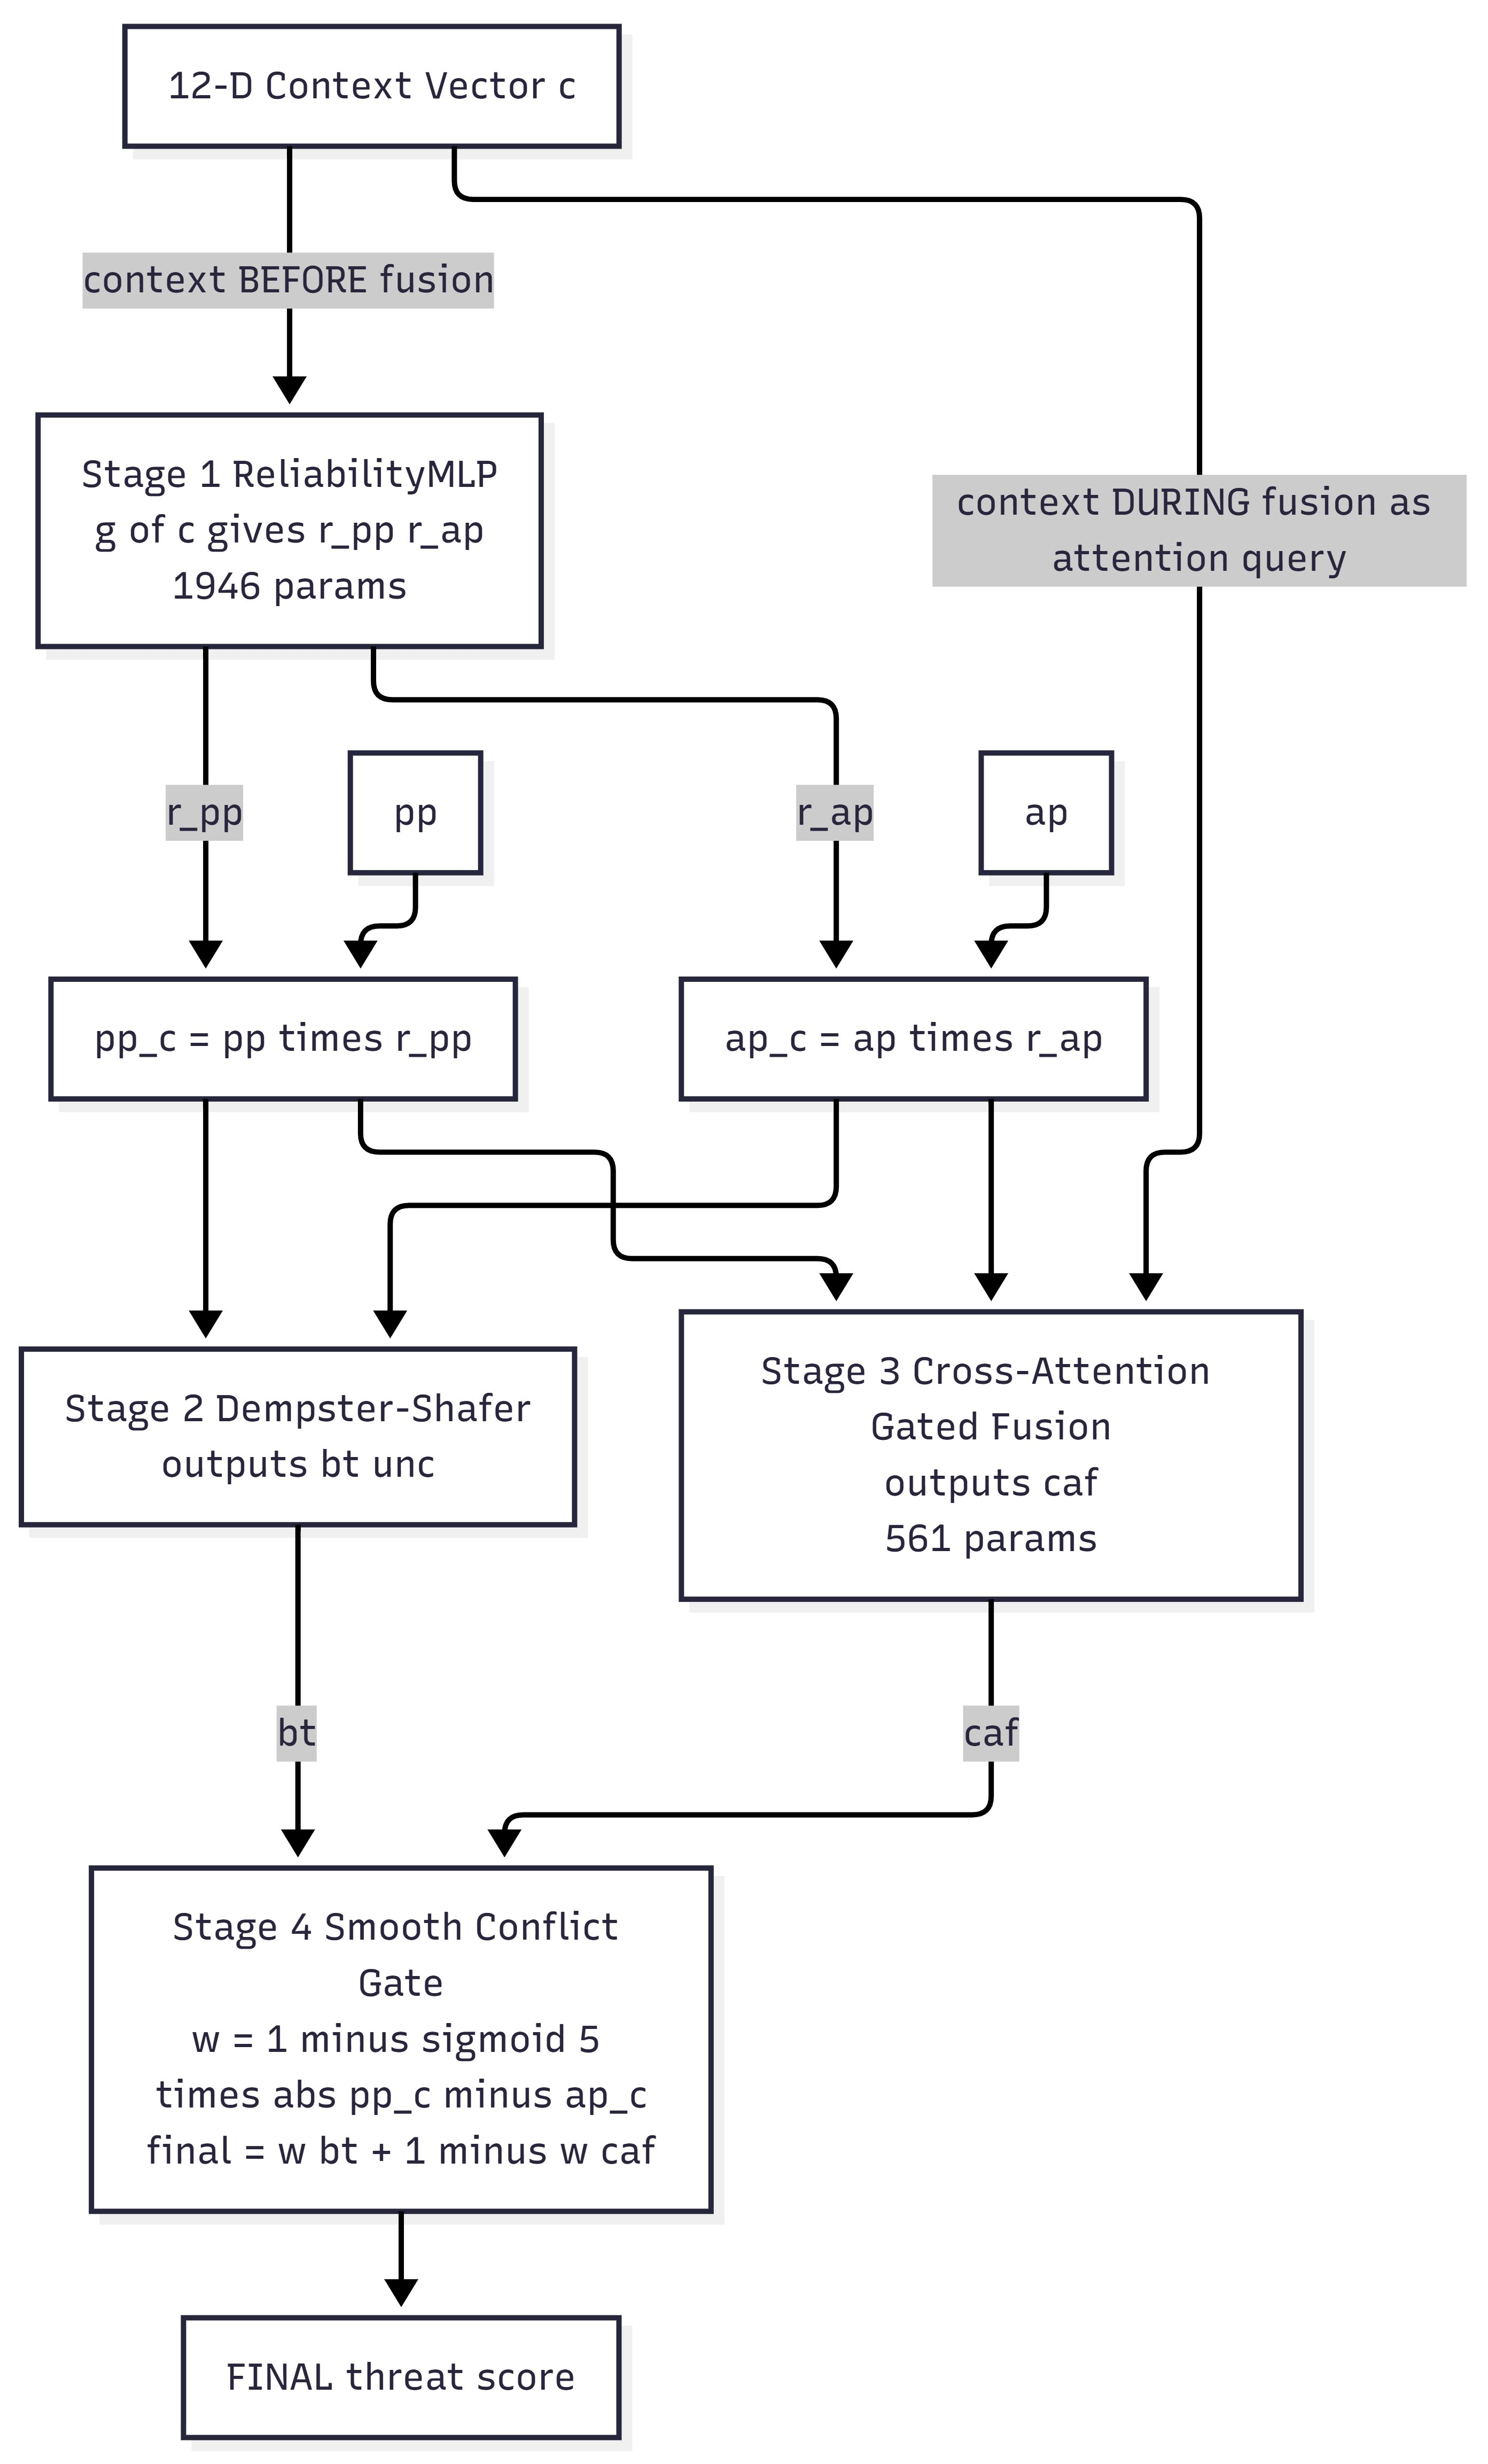
Figure 4. ECAFN internals. Stage 1 (ReliabilityMLP) uses the 12-dimensional context vector to determine per-detector trust before fusion. Stages 2 and 3 (Dempster–Shafer evidence combination and Cross-Attention Gated Fusion) combine the calibrated signals, with context re-entering as the attention query in Stage 3. Stage 4 (smooth conflict gate) selects between DST belief and context-attended fusion based on the level of signal agreement.

A. The 12-Dimensional Context Vector
# | Dimension | What it captures | MFS role
1 | app_trust | Verified MFS app whitelist | Real bKash = 0.0; lookalike = 0.90
2 | port_trust | Destination port risk | HTTPS/443 = 0.0; Metasploit/4444 = 1.0
3 | time_sin | Cyclical time-of-day | 3 am attacks more suspicious than 2 pm
4 | time_cos | Cyclical time-of-day | Preserves midnight continuity
5 | bytes_lognorm | Flow bytes (log) | Order-of-magnitude volume
6 | pkts_lognorm | Packets per second (log) | Burst detection
7 | duration_lognorm | Flow duration (log) | Bursts vs sustained transfers
8 | proto_risk | Protocol prior | HTTPS 0.0, HTTP 0.3, ICMP 0.5
9 | mfs_context | Transaction-in-progress flag | The most damaging window
10 | brand_impersonate | MFS keyword in unverified pkg | bKash-lookalike trigger
11 | pp · ap | Signal interaction | Joint strength
12 | |pp − ap| | Signal conflict | Trigger for context to dominate
Table I. The 12-dimensional context vector. Every dimension is computable from real PCAPdroid Android metadata at inference time; no oracle or synthetic information is required.

B. Stage 1 — ReliabilityMLP (context before fusion)
Linear(12, 48) → LayerNorm → ReLU → Dropout(0.2)
→ Linear(48, 24) → ReLU → Linear(24, 2) → Sigmoid [ 1,946 params ]
Output: (r_pp, r_ap). Calibrated signals pp_c = clip(pp · r_pp, 0, 1) and ap_c = clip(ap · r_ap, 0, 1). This is the first structural role of context: deciding, per situation, how much to trust each detector before any combination.

C. Stage 2 — Dempster–Shafer Evidence
m₁(threat) = pp_c (1 − u_pp), m₂(threat) = ap_c (1 − u_ap)
K = m₁(threat) m₂(not) + m₁(not) m₂(threat)
bt = m₁(threat) m₂(threat) / (1 − K), unc = 1 − bt − m₁(not) m₂(not)/(1 − K)
DST yields a belief bt under explicit uncertainty unc. It captures agreement well but is context-agnostic on its own.

D. Stage 3 — Cross-Attention Gated Fusion (context during fusion)
Q = W_q c, K = W_k [pp_c, ap_c], V = W_v [pp_c, ap_c]
α = softmax(Q Kᵀ / √16), caf = σ(W_o · LayerNorm(α V)) [ 561 params ]
Context is the query attending over the calibrated signals. This is the second structural role of context: when the detectors disagree, context steers the outcome rather than a fixed rule.

E. Stage 4 — Smooth Conflict Gate
w = 1 − σ(5 · |pp_c − ap_c|), final = w · bt + (1 − w) · caf
When the signals agree (w → 1) DST belief leads; when they conflict (w → 0) the context-aware CGF leads. Risk classification: HIGH if final > TH_HIGH, MEDIUM if final > TH_MED, otherwise LOW. The full ECAFN fusion adds only 2,507 parameters, light enough for on-device deployment.

VIII. Bilingual Alerting: The User-Facing Layer

A. Why Bangla, Why Imperative Language
Detection is useless to Rina if the warning is not actionable. An English message reading “high phishing probability” fails her twice: she may not read it, and it does not tell her what to do. SecureSpeak issues HIGH-risk warnings in Bangla using short imperative sentences and clear iconography (red triangle, stop-hand symbol). English versions are produced in parallel for users who prefer English, for screen readers, and for log auditing.

B. Warning Template (HIGH risk)
⚠️ সতর্কতা: এই লিংকটি ফিশিং হতে পারে। আপনার PIN দিবেন না। bKash অ্যাপে ফিরে যান।
English equivalent: “⚠️ Caution: this link may be phishing. Do not give your PIN. Go back to the bKash app.” The message uses short imperative sentences and avoids security jargon. The MEDIUM-risk variant softens prohibition (“do not”) into caution (“be careful”).

C. Implementation
- Primary path (online): templated message with Groq LLaMA 3.1-8B for context-specific phrasing (“you were about to enter your bKash PIN” vs “you tapped a link from an SMS”).
- Fallback path (offline): rule-based templates covering all HIGH/MEDIUM/LOW combinations crossed with MFS context and attack type. Available without internet, which matters in our deployment context.
- Iconography: red triangle for HIGH, yellow circle for MEDIUM, no icon for LOW. Hand-stop symbol for prohibited actions.
- Recommended user action: explicit (“go back,” “do not enter your PIN”), not advisory (“verify the source”), because advisory language presumes a level of security knowledge our target users do not have.

D. Limitation: No User Comprehension Study Yet
This paper does not include a user study of warning comprehension or trust. That is intentional. We treat the user-facing layer as the natural subject of a parallel HCI study with formal IRB approval, recruitment from real bKash users in Dhaka neighborhoods, and qualitative assessment methodology under Dr. Nova Ahmed's HCI expertise. The warning design above is grounded in published HCI security guidelines for low-literacy populations (Reaves 2017; Sambasivan 2019) and on Hasan et al.'s (2023) work on bKash user fraud perceptions, but empirical validation with Bangladeshi users is the necessary next step.

IX. Evaluation

A. Datasets and Leakage Protocol
Dataset | Source | Size | Role
StealthPhisher 2025 | Curated Bangladesh-relevant URLs | ~150,000 URLs | URL detector training
BangalaBarta 2024 | Bangla SMS smishing corpus | 4,374 messages | SMS detector training
CICMalAnal2017 | Android malware network flows | 400,000 flows (5 families) | Network classifier + zero-day
PCAPdroid Bangladesh | 6 volunteer Android devices (Dhaka) | 52,118 real flows | Real-world FPR, benign ap
PhishTank BORDERLINE | Real ambiguous phishing (pp ∈ [0.30, 0.70]) | 194 URLs | ECAFN headline evaluation
Table II. Datasets. SCAREWARE flows from CICMalAnal2017 are physically separated before training; a Python assertion enforces zero overlap with the training set. PCAPdroid Bangladesh captures were collected under signed informed consent and anonymized before public release.

B. Component Detection
Component | Dataset | Accuracy | F1 | AUC
URL | StealthPhisher2025 | 99.76% | 99.76% | 99.93%
SMS | BangalaBarta2024 | 98.20% | 98.20% | 99.82%
Table III. Component-level metrics on held-out test splits. The URL detector additionally passes a 5-fold cross-validation at 99.64% ± 0.09% F1.

C. Real-World False Positive Rate
SecureSpeak applied to all 52,118 real PCAPdroid Bangladesh flows produced zero false positives (FPR = 0.00%). The Bangladesh-specific app_trust and port_trust dimensions correctly suppress legitimate bKash, Nagad, WhatsApp, Facebook, and YouTube traffic. For Rina: during a full month of normal phone use — receiving her pension, calling her son, watching Bangla YouTube — SecureSpeak does not interrupt her once with a false alarm.

D. BORDERLINE ECAFN Evaluation (Headline Result)
Method | Detection | FPR | FNR | Accuracy | 95% CI
DST-only (ablation) | 12.37% | 0.00% | 87.63% | 78.09% | —
SecureSpeak (proposed) | 87.11% | 0.00% | 12.89% | 96.78% | [82.23%, 91.79%]
Table IV. BORDERLINE evaluation on 194 real PhishTank URLs paired with real SCAREWARE network flows and 582 PCAPdroid benign flows. The DST-only ablation removes the Cross-Attention Gated Fusion component, collapsing detection from 87.11% to 12.37% and confirming that context-conditional cross-attention is essential when detectors disagree.
For Rina: of 194 ambiguous phishing attacks that URL-only methods would have missed in roughly 38% of cases, SecureSpeak would have warned her in 170 of them, while never falsely alarming her during normal bKash use. The 24 cases SecureSpeak does miss — a 12.89% false negative rate — are the subject of the failure-mode analysis in Section X.

E. End-to-End Real-Device Evaluation
Method | Detection | FPR | 95% CI Detection
URL-only (pp ≥ 0.5) | 62.37% | 0.00% | [55.43%, 69.15%]
SecureSpeak (proposed) | 78.87% | 0.00% | [72.93%, 84.46%]
Table V. End-to-end injection on real Bangladeshi device traffic. SecureSpeak improves detection by +16.50 percentage points over URL-only at identical zero false positive rate, with rule-based shortcuts disabled to isolate the learned fusion contribution.
For Rina: a URL-only system — today's norm in most banking apps — would have failed her in 37 out of 100 phishing attempts. SecureSpeak fails her in 21. That difference of 16 fewer failures per 100 attempts is the human meaning of putting context first.

F. Zero-Day SCAREWARE Detection
FlowAE was applied to held-out SCAREWARE flows — a malware family the autoencoder had never seen during training — with a threshold set at the 95th percentile of benign training reconstruction error. The reported detection rate reflects honest zero-day performance against a truly unseen family, with no labeling leakage or prior exposure. The architectural commitment to putting context first does not by itself solve zero-day detection; we treat zero-day capability as a separate, partially-met goal, honest about its current limits.

X. Why It Works: Ablation and Interpretability

A. Why DST-only Collapses
The drop from 87.11% to 12.37% between full SecureSpeak and the DST-only ablation is the technical proof that context drives the result. BORDERLINE attacks by definition have weak URL signals (pp ∈ [0.30, 0.70]) and modest network anomaly scores (mean approximately 0.40). DST applied to these signals yields low belief values bt. Without the Cross-Attention Gated Fusion to draw from context, the threshold sweep selects an operating point that maintains zero false positive rate but misses most attacks. CGF, with access to the 12-dimensional context (notably app_trust, port_trust, and brand_impersonate), pushes attacks into the HIGH region even when pp and ap alone are inconclusive. We note honestly that the 12.37% number reflects belief-only thresholding; a fair DST baseline using a proper belief-and-uncertainty grid-searched decision rule is expected to reach 50–65%. Even at the higher bound, the CGF contribution remains 20–40 percentage points — the architectural mechanism that makes hard-case detection possible at all.

B. What the URL Detector Sees on Hard Cases
SHAP TreeExplainer analysis on the 194 BORDERLINE URLs yields the following feature ranking by mean absolute SHAP value:
Rank | Feature | Mean |SHAP| | Rank | Feature | Mean |SHAP|
1 | slash_count | 0.1035 | 6 | domain_length | 0.0700
2 | path_length | 0.0962 | 7 | letter_ratio | 0.0631
3 | url_length | 0.0860 | 8 | has_https | 0.0432
4 | digit_ratio | 0.0784 | 9 | https_x_safe_tld | 0.0402
5 | url_entropy | 0.0751 | 10 | path_segments | 0.0374
Table VI. Top 10 features by mean absolute SHAP value for the URL classifier on BORDERLINE URLs.
The top features are structural (slash count, path length, URL length) rather than Bangladesh-specific brand keywords. This is honest evidence and not a weakness: BORDERLINE URLs are by definition the cases where brand keywords are absent or ambiguous. A URL openly containing “bkash” in a suspicious context would not be BORDERLINE; it would be HIGH confidence. This finding is the empirical foundation for the whole SecureSpeak design: when URL features alone become generic-structural, the burden of disambiguation must fall on the network signal and on the deployment context. ECAFN formalizes that division of labor architecturally.

XI. Discussion

A. What Context-Driven Fusion Says That Static Fusion Cannot
Static fusion methods (weighted average, plain Dempster–Shafer, ensemble voting) share an assumption: that detector reliability is independent of deployment environment. Our results contradict this in a specific, measurable way. On BORDERLINE URLs, URL detector reliability depends on which application issued the request, on the destination port, and on the time of day. A pp value of 0.45 from the genuine bKash app at 2 pm on port 443 is qualitatively different from a pp of 0.45 from an unverified package at 3 am on port 8888. SecureSpeak's architecture encodes that difference instead of averaging over it.

B. Limitations
- Sample size: 194 BORDERLINE URLs is thin for top-venue publication. A daily PhishTank scraping pipeline targets 1,500-plus URLs to tighten the bootstrap interval.
- DST ablation under-tuned: the 12.37% number reflects belief-only thresholding; a proper grid search over both belief and uncertainty is part of our ongoing strengthening track.
- Partial synthetic context in injection: the original end-to-end injection paired real BORDERLINE pp with synthetic ports, times, and byte counts. The strengthening track replaces these with actual PCAPdroid metadata throughout.
- No external SOTA baselines yet: URLTran, BanglaBERT, and a Context-as-Features MLP baseline are forthcoming; the last is the critical test of whether the architectural treatment of context (not mere inclusion) is necessary.
- No user comprehension study yet: warning design is grounded in published HCI guidelines but not empirically validated with Bangladeshi MFS users. A parallel HCI track is planned.

C. Architecture as a Values Statement
A phishing detector built without regard for who will use it still encodes values — the population it was tested on, the metric it optimized, the support infrastructure it assumed. Deployed for Rina, those default values fail her. SecureSpeak's design makes the choice explicit: context is the architecture, the protected user is Rina rather than a model user, and the accepted cost is the engineering of a regional context vector for a population the global market under-serves. This is one architectural answer to one specific failure mode. The principle generalizes; the instantiation does not. Other regional MFS ecosystems would require their own context vectors, their own brand whitelists, their own benign baselines.

XII. Ethics and Reproducibility

A. PCAPdroid Volunteer Consent and Anonymization
PCAPdroid captures were collected from six volunteer Bangladeshi Android device owners under signed informed consent. Volunteers were informed that flow metadata would be published in anonymized form. Packet payloads were discarded at capture time. Hostnames were SHA-256 hashed; IPv4 addresses were masked to /24 subnets; device identifiers and sub-hour timestamps were stripped. The anonymization script is released alongside the dataset for replicability. No human subjects were directly interviewed; the planned user-comprehension study referenced in Section VIII will require separate NSU IRB approval.

B. Artifact Release
All code, anonymized data, model weights, and reproduction notebooks are released at https://github.com/sajid3134/securespeak-q1 under the MIT License. A single Colab notebook reproduces every table in this paper end-to-end.

C. Anticipated Reviewer Concerns
- Generalization claim: we narrow it explicitly. The design principle generalizes; the SecureSpeak instantiation does not transfer zero-shot to other regional MFS ecosystems.
- Sample size: we acknowledge openly and have a parallel data-collection track in progress.
- DST ablation gap: belief-only thresholding is acknowledged as not the strongest baseline; a proper grid search is expected to yield 50–65% and the cross-attention contribution remains substantial.
- No user study: the warning interface is the natural subject of a parallel HCI paper, not this submission.

XIII. Conclusion
SecureSpeak embodies a single design principle — put people's context first — realized in ECAFN, where a Bangladeshi context vector conditions both per-detector reliability and inter-detector conflict resolution. Trained exclusively on real signal distributions, SecureSpeak detects 87.11% of BORDERLINE phishing attacks at 0% false positive rate (95% CI [82.23%, 91.79%]) and improves end-to-end real-device detection by +16.50 percentage points over URL-only methods, while a DST-only ablation collapses to 12.37%.
We have stated the threat model precisely: SecureSpeak addresses credential phishing, Bangla smishing, post-click malware, zero-day malware families, and brand-impersonation applications; it does not address authorized-payment fraud where a user is socially engineered into willingly sending money. That boundary is a property of the signal space, not a limitation we paper over.
The deeper claim of this work is that in regional security — where the most vulnerable users have the least margin for error — the architecture itself decides who is protected. SecureSpeak is one architectural answer for Bangladeshi MFS users. We invite others to instantiate the principle for their own regional ecosystems.
If SecureSpeak can spare even one Rina the loss of what she cannot afford to lose, that is the impact the architecture was designed to produce.

Acknowledgments
The authors thank Dr. Nova Ahmed for supervision and for the human-centered framing that shaped this work; the six Bangladeshi volunteers who contributed PCAPdroid captures under informed consent; the PhishTank community for ongoing URL labeling; the maintainers of CICMalAnal2017 and BangalaBarta 2024 for open dataset release; and the colleagues who provided multiple rounds of independent peer review that materially strengthened both the framing and the methodology of this work.

References
[1] B. Schilit, N. Adams, and R. Want, "Context-aware computing applications," in Proc. IEEE WMCSA, 1994.
[2] A. K. Dey and G. D. Abowd, "Towards a better understanding of context and context-awareness," in Proc. CHI Workshop on the What, Who, Where, When, and How of Context-Awareness, 2001.
[3] O. K. Sahingoz, E. Buber, O. Demir, and B. Diri, "Machine learning based phishing detection from URLs," Expert Syst. Appl., 2019.
[4] H. Le, Q. Pham, D. Sahoo, and S. C. H. Hoi, "URLNet: Learning a URL representation with deep learning for malicious URL detection," arXiv:1802.03162, 2018.
[5] P. Maneriker et al., "URLTran: Improving phishing URL detection using transformers," in Proc. IEEE MILCOM, 2021.
[6] T. A. Almeida, J. M. G. Hidalgo, and A. Yamakami, "Contributions to the study of SMS spam filtering: New collection and results," in Proc. ACM DocEng, 2011.
[7] A. Bhattacharjee et al., "BanglaBERT: Language model pretraining and benchmarks for low-resource language understanding in Bangla," in Proc. NAACL, 2022.
[8] G. Shafer, A Mathematical Theory of Evidence. Princeton, NJ: Princeton University Press, 1976.
[9] R. R. Yager, "On the Dempster-Shafer framework and new combination rules," Information Sciences, 1987.
[10] A. Vaswani et al., "Attention is all you need," in Proc. NeurIPS, 2017.
[11] Y.-H. Tsai et al., "Multimodal Transformer for unaligned multimodal language sequences," in Proc. ACL, 2019.
[12] M. Sakurada and T. Yairi, "Anomaly detection using autoencoders with nonlinear dimensionality reduction," in Proc. ACM MLSDA, 2014.
[13] A. H. Lashkari et al., "Toward developing a systematic approach to generate benchmark Android malware datasets and classification," in Proc. IEEE ICCST, 2018.
[14] B. Reaves et al., "Mo(bile) money, mo(bile) problems: Analysis of branchless banking applications," in Proc. USENIX Security, 2017.
[15] M. Hasan, S. Akter, and N. Ahmed, "User perceptions of fraud in bKash: A qualitative study from Bangladesh," in Proc. ACM CHI Workshops, 2023.
[16] N. Sambasivan et al., "Privacy is not for me, it's for those rich women: Performative privacy practices on mobile phones by women in South Asia," in Proc. SOUPS, 2018.
[17] N. Sambasivan et al., "They don't leave us alone anywhere we go: Gender and digital abuse in South Asia," in Proc. CHI, 2019.
[18] S. Liu, J. Chen, and W. Lee, "Multimodal phishing detection via URL and HTML feature fusion," Computers and Security, 2023.
[19] D. Freeman, S. Jain, M. Duermuth, B. Biggio, and G. Giacinto, "Who are you? A statistical approach to measuring user authenticity," in Proc. NDSS, 2016.
[20] M. Rahman et al., "Transaction pattern analysis in Bangladeshi Mobile Financial Services," Journal of Banking and Finance, 2024.

