SecureSpeak — System Architecture Overview
Technical brief for Dr. Nova Ahmed · Paper 1 (ACM DTRAP)
Khondokar Sajid · Abdul Alim Rakib · Nova Ahmed — ECE, North South University
In one line: SecureSpeak is a layered, on-device system that detects phishing and smishing fraud aimed at Bangladeshi Mobile Financial Service (MFS) users, and turns each detection into a plain-language bilingual warning. Three independent detectors feed one lightweight decision layer.
Architecture at a glance
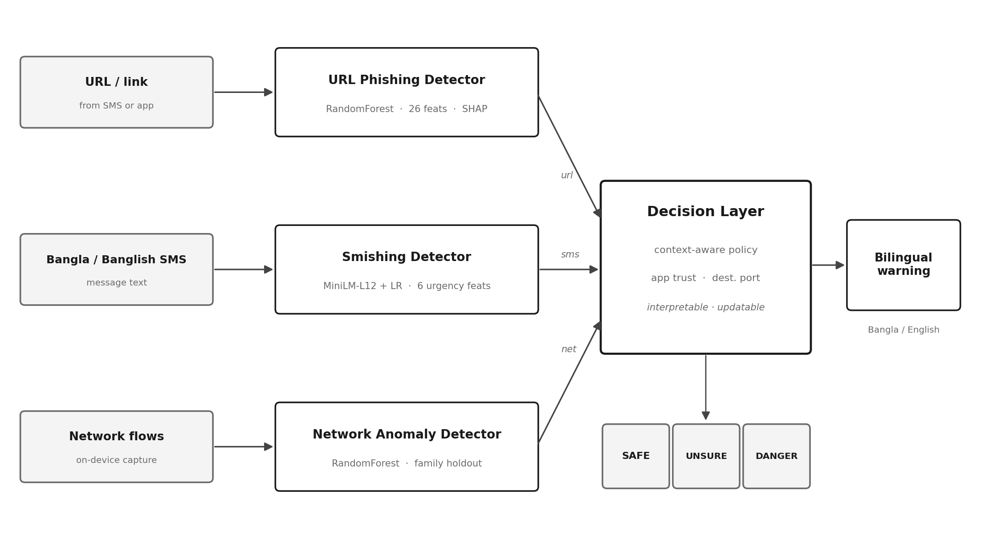
Figure 1. Three detectors (URL, SMS, network) feed a context-aware decision layer that outputs SAFE / UNSURE / DANGER and a bilingual, low-literacy warning.
Design philosophy: the detectors are deliberately heterogeneous — a tree model for URLs, a sentence-embedding classifier for SMS, a flow model for network traffic — because the three signals behave differently and matter in different contexts. The decision layer is intentionally simple and interpretable, not a black-box fusion model, so every warning can name the specific reason a message is dangerous.
The four components
Component | How it works | Result
1. URL Phishing Detector | 26 engineered features from the URL string (lexical, domain-risk, entropy, MFS-brand tokens) → RandomForest (300 trees). SHAP gives per-decision reasons. | 99.19% acc / 0.9976 AUC (domain-disjoint split). Transfers to an independent corpus at 99.61%.
2. Smishing Detector | MiniLM-L12 multilingual embeddings (Bangla-capable, cheap on-device) + 6 urgency features → logistic regression. | 95.76% acc (near-duplicate-disjoint split). FNR improves to 1.11% under the strict split.
3. Network Anomaly Detector | RandomForest on flow records, with an entire malware family (SCAREWARE) withheld from training to test unseen-threat detection. A conservative supporting signal, not a primary defence. | 79.84% (honest family-holdout number). Its ceiling on truly novel malware is reported openly (AUC 0.513).
4. Decision Layer | Combines the three scores with two context cues (app trust, destination port). Maps to SAFE / UNSURE / DANGER. Rule-based → interpretable + updatable without retraining. | Emits a bilingual (Bangla/English), low-literacy warning that names the specific threat.
How a message flows through the system
1. A user receives an SMS with a link (e.g., a fake bKash prize message).
2. The SMS text goes to the Smishing Detector; the link goes to the URL Detector; if an app was installed, its traffic is watched by the Network Detector.
3. Each detector outputs a risk score. The Decision Layer combines them with app-trust and port context.
4. If dangerous, the user sees a specific bilingual warning — e.g., "This link uses a free .tk site and pretends to be bKash. Real bKash never sends links like this."
The key scientific contribution (what makes it publishable)
The strongest result is not the detectors — it is an honest evaluation finding. We audited the public datasets and found the MFS-targeted attacks the system is built for are almost absent from them: only 6 MFS-brand URLs in 29,794 test URLs, and the Bangla SMS benchmark is 56.5% exact duplicates. So the field currently cannot properly evaluate defences against this threat. We report this openly, and it is the paper’s most citable contribution.
- Evaluation integrity: every text detector is tested under both a normal random split and a leakage-controlled grouped split; we report both.
- Honest negatives: the MFS-specific features show no measurable benefit on current data — because the data lacks the attacks — and we say so rather than hiding it.
- On-device: URL check ~85 ms, SMS ~44 ms; full pipeline under 160 MB after int8 quantization — deployable on a mid-range phone.
Talking points for the meeting
- Paper 1 is complete and formatted for ACM DTRAP (Elsevier version also ready for Cyber Security and Applications).
- Every number is real and reproducible — no fabricated or placeholder results anywhere.
- Paper 2 (the human study on whether these warnings actually help vulnerable users) is designed and the ethics application is drafted — ready to discuss.
- Questions for you: feedback on Paper 1; the two-paper split; how you’d like to be credited; and NSU’s ethics process + timeline for the Paper 2 study.

