SecureSpeak — How the System Works
Detailed technical walkthrough for Dr. Nova Ahmed · Paper 1 (ACM DTRAP)
Khondokar Sajid · Abdul Alim Rakib · Nova Ahmed — ECE, North South University
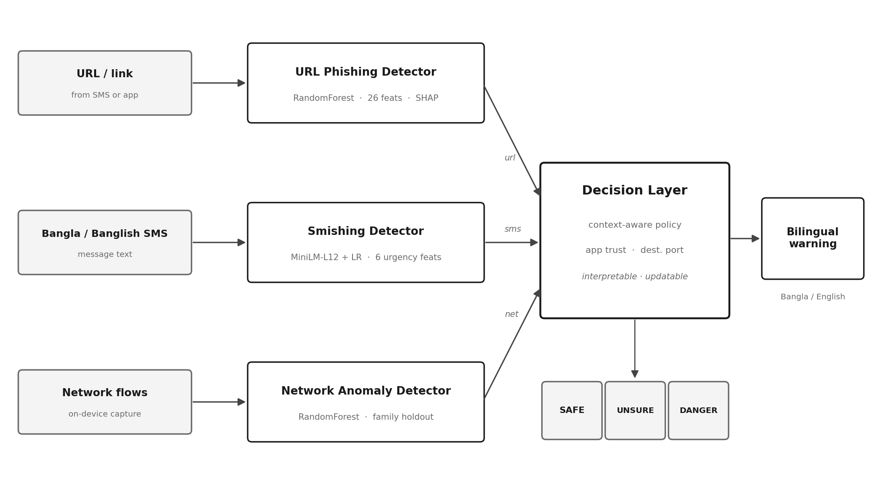
Figure 1. Three detectors feed one decision layer, which outputs a single zone (SAFE / UNSURE / DANGER) and, if needed, one warning.
Important clarification up front: the system does NOT show three warnings. SAFE / UNSURE / DANGER are three possible outcomes. For any one message the decision layer picks exactly one zone, and shows at most one warning (SAFE shows nothing, UNSURE shows a soft caution, DANGER shows a strong specific warning). This document explains each detector step by step, then exactly how the decision layer chooses that one outcome.
1. URL Phishing Detector — step by step
Job: decide whether a link (from an SMS or app) is phishing. It works purely on the URL text — it never visits the link, so it is safe and instant.
Step 1. Input: a raw URL string, e.g. http://bkash-bonus.tk/win.
Step 2. Feature engineering: 26 numbers are computed from the URL, in five groups — lexical structure (length, dots, slashes, special characters), domain risk (high-risk and free-hosting TLDs like .tk/.ml/.ga), entropy (randomness of the string), Bangladesh/MFS-specific signals, and structural patterns. Four of the 26 are MFS-specific: a brand-impersonation count (bKash/Nagad/Rocket + global brands appearing in the domain), a financial-keyword density, a free-hosting-TLD flag, and a high-risk-TLD flag.
Step 3. Classification: the 26 features go into a Random Forest (300 decision trees, balanced class weights). Each tree votes; the forest outputs a phishing probability from 0 to 1.
Step 4. Explanation: SHAP is run on the result to find which features drove the decision (e.g. "free .tk TLD" + "contains bKash"). These top features are what the warning message will later name.
Output: a phishing probability + the list of reasons. Accuracy 99.19% on a domain-disjoint split; still 99.61% on a completely different corpus (proves it generalizes).
2. Smishing (Bangla/Banglish SMS) Detector — step by step
Job: decide whether an SMS message is a scam, even in Bangla or mixed Bangla-English (Banglish).
Step 1. Input: the SMS text, e.g. "আপনার বিকাশে ৫০০০ টাকা বোনাস! এখনি ক্লিক করুন..." (a fake bKash bonus message).
Step 2. Embedding: the message is passed through MiniLM-L12 (a multilingual model that understands 50+ languages including Bangla). It turns the sentence into 384 numbers capturing its meaning — cheaply enough to run on a phone, unlike a full BERT.
Step 3. Extra features: 6 handcrafted signals are added — does it contain a URL, an MFS keyword, an urgency word ("now", "urgent", "win"), message length, exclamation density, and digit ratio. Total: 390 numbers.
Step 4. Classification: a logistic-regression classifier maps those 390 numbers to a scam probability.
Output: a smishing probability. Accuracy 95.76% under the strict near-duplicate-disjoint split, and it misses fewer real attacks (1.11% false-negative rate) than the naive version.
3. Network Anomaly Detector — step by step
Job: catch malware that a user may have installed — apps that look fine but send suspicious network traffic afterward. This is the supporting layer, deliberately conservative, not the main defence.
Step 1. Input: network flow records captured on the device (packet timing, sizes, ports — not the content).
Step 2. Classification: a Random Forest trained on malware flow data scores each flow. Critically, one entire malware family (SCAREWARE) was held out of training, so the score reflects how well it catches unseen threats, not memorized ones.
Step 3. Honest limit: on the truly unseen family it performs near chance (79.84% overall; AUC 0.513 on SCAREWARE). Malware that mimics normal HTTPS is nearly invisible on flow statistics. We report this openly and therefore treat the network score only as supporting evidence.
Output: a network-risk score, used cautiously — and only for untrusted apps (see the decision layer).
4. The Decision Layer — how the three become ONE outcome
This is the brain. It takes the three detector scores + two context cues and produces a single zone and (at most) one warning. It is a set of explicit rules — not a black box — so every outcome can be explained and updated without retraining.
The two context cues it adds
- App trust: is the traffic from a trusted app (bKash, WhatsApp, system services) or an unknown/untrusted one? The network score is down-weighted for trusted apps, so a shaky network score cannot raise a false alarm on a known-good app. (In real data, 67.8% of traffic was from trusted apps.)
- Destination port: unusual ports add suspicion; normal web ports do not.
How it decides the zone (the logic)
The layer combines the signals and maps them to one of three zones:
Zone | When | What the user sees
SAFE | All detectors say low risk, and context is normal. | Nothing. The message passes silently — no interruption.
UNSURE | Signals are mixed or borderline — not clearly safe, not clearly an attack. | A soft, cautious prompt (protect-by-default): "We are not sure about this — be careful before tapping."
DANGER | Detector(s) clearly flag phishing/smishing, confirmed by context. | A strong, specific bilingual warning that NAMES the threat (see below).
So: one message → one zone → at most one warning. Never three warnings at once.
How the DANGER warning is written
The warning is not generated by an AI model (too heavy for a cheap phone). Instead, rule-based bilingual templates are filled using the top SHAP features from the detector. So the warning names the specific reason, which is what a low-literacy user can act on:
"⚠ This link uses a free .tk site and pretends to be bKash. Real bKash never sends links like this."
(shown in both Bangla and English)
Why this matters: a generic "this may be dangerous" tells the user nothing they can learn from. Naming the threat ("free .tk site pretending to be bKash") is recognition-based — the user can spot the same trick next time. Whether this actually helps vulnerable users is the question Paper 2 will test.
5. Full example: one fake bKash SMS, start to finish
Step 1. User receives: "আপনার বিকাশে ৫০০০ টাকা বোনাস! http://bkash-bonus.tk/win এখনি ক্লিক করুন"
Step 2. SMS Detector: embeds the Bangla text, sees urgency ("এখনি/now") + MFS keyword ("বিকাশ") + a link → high smishing probability.
Step 3. URL Detector: analyzes bkash-bonus.tk → free .tk TLD + contains "bkash" in a non-official domain → high phishing probability. SHAP reasons: free-hosting TLD, brand token.
Step 4. Decision Layer: both text detectors flag it; context confirms (link, not a trusted app) → zone = DANGER.
Step 5. Warning shown (one, bilingual): "⚠ This link uses a free .tk site and pretends to be bKash. Real bKash never sends links like this." / "⚠ এই লিংকটি একটি ফ্রি .tk সাইট এবং বিকাশ সেজে আছে। আসল বিকাশ এমন লিংক পাঠায় না।"
6. Points to raise with you
- The decision layer is rule-based on purpose — interpretable (every warning traces to a reason) and updatable (add a new bad port/package without retraining).
- The network detector is honestly the weakest part; we present it as a conservative supporting signal, not a primary defence, and report its ceiling openly.
- Whether the DANGER warnings actually help elderly/low-literacy users is exactly what Paper 2 (the user study) will measure — this architecture is what that study evaluates.

