# CHAPTER NO 1

# INTRODUCTION

# 1.1 Abstract

## Human face location and acknowledgment assume imperative parts in numerous applications, for example, video reconnaissance and face picture database administration. In our task, we have contemplated chipped away at both face acknowledgment and recognition methods and created calculations for them. In face acknowledgment the calculation utilized is PCA (central segment examination), MPCA (Multilinear Foremost Part Investigation) and LDA (Linear Discriminate Investigation) in which we perceive an obscure test picture by contrasting it and the known preparing pictures put away in the database and give data with respect to the individual perceived.

## These methods functions admirably under strong conditions like complex foundation, distinctive face positions. These calculations give distinctive rates of exactness under various conditions as tentatively watched. In face recognition, we have added to a calculation that can recognize human countenances from a picture. We have taken skin shading as an instrument for discovery. This strategy functions admirably for Pakistani confronts which have a particular composition fluctuating under certain reach

**1.2Introduction**

Those face is our vital focus from claiming thought done social an aggregation accepting a discriminating some piece in passing looking into character Also affections. We could recognize Different appearances discovered the sum through our lifespan and recognize confronts at first much Emulating very some time from claiming segment. This finesse may be actually solid in any case for far reaching varieties clinched alongside visual support due to evolving condition, maturing and diversions, for example, facial hair, glasses or transforms On haircut. Computational models from claiming face affirmation need aid intriguing to light of the truth that they could help speculative data and additionally on down to earth requisitions.

Pcs that recognize Furthermore recognize countenances Might a chance to be associated with a totally combination for assignments including criminal ID, security framework, picture What's more film handling, identity check, labeling purposes Also human-PC collaboration. Tragically, including to An computational model from claiming face disclosure Furthermore affirmation will be exceptionally troublesomeness on the fact that confronts need aid intricate, multidimensional What's more essential visual jolts.

Face area is used Concerning illustration a and only various spots presently An times especially the destinations encouraging portraits similar to Picasa, photo bucket Also face book. Those characteristically labeling highlight includes in turn estimation will offering portraits "around those general populace who would in the photograph Moreover provides for those thought to different people regarding who those distinctive will be in the picture.

Over our undertaking, we need examined Also executed a genuinely direct however exceptionally urging face ID number figuring which recognizes human skin shading. Our point, which we trust we bring come to, might have been should develop An methodology to face affirmation that is quick, strong, sensibly fundamental Also exact with An reasonably clear What's more direct calculations Furthermore frameworks. Those illustrations offered in this principle would consistent Also taken starting with our own nature's domain.

## 1.3 Purpose

The main purpose of our project is to detect faces for login the [1]system through Capturing Devices (CD). This system provide the best security system to the user as compared to the password security system. This is an efficient way to detect the actual user of the system.

## 1.4 Scope

* This FD desktop application automatically identify a person from digital image.
* Its typically used in security system and other biometeric like eye detection fingerprint detection system.
* Unknown person not login in a system untill the actual user or person of the system not login.

## 

## 1.5 Definitions, Acronyms, and Abbreviations.

* CD stands for Capturing Device.
* FD stands for Face Detection.
* Capturings Devices like MobileCamers, Webcames etc.

**1.6 Tools**

**Emgu CV:**

Emgu CV is a cross-platform image-processing library. It is closely related to OpenCV because Emgu CV is a .NET wrapper to OpenCV. We can say Emgu CV is OpenCV in .NET. The amazing wrapper makes it possible for OpenCV functions to be called from .NET programming languages. C#.

**Visual Studio :**

Visual Studio .NET is Microsoft's visual programming environment for creating Web services based on use of the Extensible Markup Language (XML). The product suite provides a visual interface for identifying a program as a Web service, forms for building a user interface (including support for mobile device interfaces), features for integrating existing application data, and for debugging. Visual Studio .NET comes with the .NET Framework, including the Common Language Runtime, and includes several programming languages including Visual Basic, Visual C++, and Visual C#

**1.7 Languages:**

**C#:**

C# is an elegant and type-safe object-oriented language that enables developers to build a variety of secure and robust applications that run on the .NET Framework. You can use C# to create Windows client applications, XML Web services, distributed components, client-server applications, database applications, and much, much more. Visual C# provides an advanced code editor, convenient user interface designers, integrated debugger, and many other tools to make it easier to develop applications based on the C# language and the .NET Framework.

## 1.8 Overview

# Whatever is left of the SRS looks at the particulars of the Face Location in point of interest. Area 2 of the SRS displays the general variables that influence the Face Discovery and its necessities, for example, client qualities and task limitations. Area 3 diagrams the nitty gritty, particular utilitarian, execution, framework and other related necessities of the Face Discovery. Suppor ting data about addendums is given in Area 3.

**1.9 The Overall Description**

Face Detection is a computer application capable of identify & verifying different persons through a solid camera device.And other way is to select the Face Features from those picture & saved in the database. It will be regularly utilized within security frameworks and camwood a chance to be contrasted with different biometrics for example, such that finger impression alternately eye iris distinguishment frameworks.

By using the algorithems we detect the different faces on the basis of skin color, eye brows, lips,jaws and nose including hair color. These features are useful to match other images stored in Database. Acknowledgment calculations can be partitioned into two principle Approaches, geometric, which takes An gander at distinguishing highlights, or photometric, which will be An true procedure that distils a picture under qualities Also contrasts the characteristics What's more formats with take out variances.

## 1.10 Product Perspective

For commercial Security, Imaging Analysis is one of the fastest growing sectors of the Surveillance market place and rightly is securing its place within Commercial Security considerations. For Shopping Centers, Public Buildings, University campuses and even Commercial premises there is an increasing requirement to secure common areas to a reasonable level. As we see in the British example there is anlarege desire to install a greater number of CCTV cameras but who monitors each of these cameras and how is one security guard enabled to identify the threat, a stalker, a murderer, a thief.

**1.11 Face recognition**

Of the distinctive biometric unmistakable verification strategies, face affirmation will be An champion around the The greater part adaptable, attempting Despite The point when the subject is oblivious about being analyzed. It similarly exhibits assurance as an approach should gander through massenet of people who went through barely seconds When a "scanner" - that is, a normal electronic Polaroid.

Face affirmation frameworks fill in by deliberately Dismembering specific parts that would ordinary to everybody's face - the detachment the middle of the eyes, width of the nose, position for cheekbones, jaw line, jaw et cetera. These numerical sums would afterward united On a lone code that interestingly distinguishes each singular.

## 1.12 Environments

Environments are controlled areas where systems developers can build, distribute, install, configure, test, and execute systems that move through the SDLC. Each environment is aligned with different areas of the SDLC and is intended to have specific purposes. Examples of such environments include the:

* Development environment, where developers can work independently of each other before trying to merge their work with the work of others,
* Common build environment, where merged work can be built, together, as a combined system.
* Systems integration testing environment, where basic testing of a system's integration points to other upstream or downstream systems can be tested,
* User acceptance testing environment, where business stakeholders can test against their original business requirements,
* Production environment, where systems finally get deployed to, for final use by their intended end users.

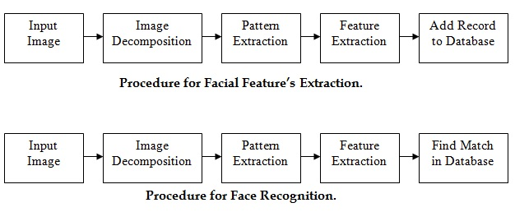**1.13Fingerprint-identification**

Fingerprints remain enduring every last bit through term. Over more than 140 A long time from claiming interesting mark connection around the world, no two fingerprints bring ever been watched will make. Indistinguishable, not Indeed the individuals for undefined twins.

Incredible exceptional Stamp scanners bring been presented in PDAs such as the iPod Pocket PC; In this way scanner improvement will be similarly basic. Won't not partake) energizes cutting edge requisitions since it obliges clean control.

Exceptional mark unmistakable evidence incorporates taking a gander at the sample of edges and wrinkles on the fingertips, and Additionally the points keeps tabs (edge qualities that happen when a edge parts under two, alternately finishes) for a sample print with a database from claiming prints on archive.

Block Diagram of Face Detection/Recognition System

### The accompanying subsections depict how the product works inside different imperatives.

### **1.14 Operations**

Determine the typical and exceptional operations required by the client, for example,

* Scan the image & match with database image.
* Only authorize person log in the system not other one use the privacy.
* Capture Device provide the best functionality to the users.
* Backup and recovery operations also embedded in this app to provide reliable use of software for their users.

### **1.15 Site Adaptation Requirements**

* This application can run on ATM machines, any computer devices & mobile phones because its an desktop application.
* Indicate the site or mission-related components that ought to be changed to adjust the product to a specific establishment

## 1.16 Product Functions

A typical automatic face recognition system is composed of three parts:

* Face Detection
* Face Alignment
* Face Recognition

These three parts are processed in a 3 manners:

* Bottom-up Manner
* Top-Down Manner
* Mixture (above both are included in this manner)

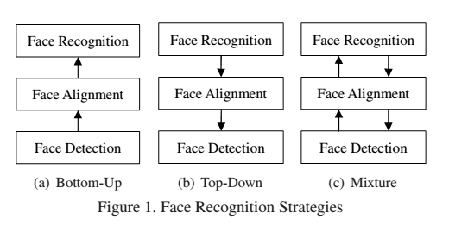

## 1.17 User Characteristics

Our customer can be divided in two groups:1.Residential User  
2. Commercial Owners

|  |  |
| --- | --- |
| **Residential User** | **Commercial Owners** |
| Gender: Male/Female Age: 21/60 Education: Basic (read and write) Location: any IT knowledge: Low experience Profession: any Social Class: High and Middle class Main User: Head of household Secondary User: Dependent members | Gender: Male/Female Age: 21/60 Education: Basic (read and write) Location: any IT knowledge: Low experience Profession: any Social Class: Low and middle business Main User: owner, security personal, private investigator Secondary User: Staff members |

**1.18 Motivation**:

Prevent theft, Monitor business, Outdoor surveillance, Check on family, ID employees.

## 1.19 General Constraints

The general description of our project is that

## Cameras and Pictures

* **Comparative quality cameras are prescribed for both enlistment and ID. Utilizing the same camera model is far better.**
* **50 pixels is the prescribed negligible separation between eyes for a face on picture or video stream to perform face layout extraction.75 pixels or more** recommended for better face recognition results. Note that this distance should be **native,** not achieved by resizing an image.
* **640 x 480 pixels insignificant camera determination is prescribed** for face Detection:
  + Make sure that **local 640 x 480 determination is given by a webcam or a cell phone camera,** as some of these cameras may have lower resolution that is later **scaled up** to 640 x 480 without image quality improvement. While it is acceptable for video calls or occasional photos, it will introduce additional distortions and artifacts to the face image.
  + Easier determination webcams would not proposed Concerning illustration optical distortions will show up What's more influence facial format nature On account clients will must make excessively near the cameras to fruitful face identification Furthermore enlistment.
* **Check for reflected face pictures, as acknowledgment will fall flat if a face was enlisted from a reflected picture,** and later a non-mirrored face image is used for recognition (or vice versa). This happens as some cameras or devices can be configured to produce mirrored images or may even produce them by default, and different cameras or configurations may be used during enrollment and identification. We recommend to use face images with uniform orientation – all images within a system should be either native or mirrored, but not mixed between each other.
* **Utilize a few pictures amid enlistment, as it enhances facial layout quality which brings about change of acknowledgment quality and unwavering quality.**

## 1.20 Assumptions and Dependencies

The project will be developed on MATLAB framework. This application is based on offline application. This application can be run on Mobile Phones, Laptops & ATM machines & easily handled with little attention. In this Application we store our actual image on database.

**1.21 Specific Requirements**

Requirements of our project:

* Front end Camera is compulsory.
* Laptop or other device where we want to use our application is also compulsory.
* Database is required to store the images.

## 1.21 External Requirements

### **1.21.1** **System Interfaces**

* Attractive system interface
* Easy to understand for the user
* Easy to learn about the system

### **1.21.2 Interfaces**

The interface easy to understandable by the user.

* The interface of this application is consist on three buttons

1. Login

2. Shutdown

3. Cancel.

* In inception our system scan the image of the user who want to login the system then, application classify the image according to their constraints then this scanned image match to the actual images which stored in Database to access. If the scanned image match with the stored image then application provide the login access to the user, if image is not match the system grenade an error.

### 

### **1.22 Hardware**

* High Definition capturing device is required.
* Good performance machine is required.
* Complete and accurate hardware required without any failure.
* RAM 512 Mb.
* Hard Disk 40 GB

### **1.23** **Software**

* Face Detection system (desktop application)
* Windows based operating system
* IOS
* Android based operating system
* Mac
* Suitable Database

## Functional Requirements

In software engineering, the functional requirements are those requirements which better shows the functionality of software or its components. The function is basically the set of inputs, behaviors and outputs. Functional requirements suppose to show the particular results of a system. It should be distinguished with non-Functional requirements which specify overall features such as cost and reliability. It should be able to handle 'gif' and 'jpeg' images.

## Non-Functional Requirements

**1.25.1 Performance**

|  |  |
| --- | --- |
| NFR001 | The normal burden time of the application with must be under 15 Seconds. |
| NFR002 | Normal handling time taken by the framework to finish an exchange/demand by a client ought to be under 10 seconds. |
| NFR003 | Framework mean time to disappointment ought not be over 30 seconds inside of 24 hours of utilization. |
| NFR004 | Normal framework reaction time ought not be more prominent than 5 seconds. |

|  |  |
| --- | --- |
| NFR01 | The system should be easy to use for a novoice user. |
| NFR02 | Time to learn general interface of the framework negligible. |

**1.25.2 Use ability**

## 1.26 Inverse Requirements

Additional webcam device is used as aembedded camera for the purpose of face detection and image processing.

## 1.27 Logical Database Requirements

* It kills all guardian tyke relationship and rather spoke to all information in the database as simple line segment tables of data values.
* Flexibility in data modeling.
* Simple to gaining entrance to information.
* Each table clinched alongside an free substance What's more there no physical association b/w tables.
* Reduce data storage and redundancy.
* It need totally level information manipulation dialect.
* Mossy cup oak information administration framework In light of the social model.
* Security and control.

## CHAPTER NO 2

**METHODOLOGY**

**2.1 Architectural View:**

Architectural View is about settling on key auxiliary decisions which are immoderate to change once actualized. Its decision incorporates particular auxiliary alternatives from potential outcomes in the outline of Software. Documenting of software architecture facilitates communication between stakeholders and software engineer.

Some Architectural views are followings:

* Use-case Diagram
* Dataflow Diagram
* Activity Diagram
* **.**Sequence Diagram

## 2.2 Use Cases

This section contains use cases of the Face recognition system

|  |  |
| --- | --- |
| Use Case | Use Case Diagram |
| Actors | User & Trainer |
| Type | Primary |
|  |  |
| Description | Above Use Case diagram show the whole activity of the system according to User and Trainer point of view. |

**<Include>**

**Trainer**

**User**

Fig no 2.1 use case diagram

**2.2.1 Classes / Objects**

This section contains major classes of the Face Detection system.

### **2.2.1.1 Class 1: User**

#### **Attributes**

Name

Address

Id

**Functions**

Browse ();

Capture ();

Process ();

Result ();

### **2.2.1.2 Class 2: Database**

### **Attributes**

Name

Features

#### **Functions**

Update ();

View ();

Delete ();

Connect ();

### **2.2.1.3 Class 3: System Software**

#### **Attributes**

Name

Version

Feature

**Functions**

Start ();

Get Image ();

Image Process ();

Show errors ();

Exit ();

**2.2.2. Analysis Models**

In analysis model we analyse the system on the behalf of UML diagrams.

## 2.3 Sequence Diagram

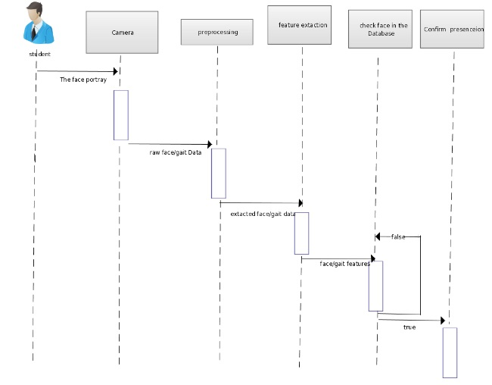

Fig no 2.2 Sequence Diagram

## 2.4 Data Flow Diagrams (DFD)

## Dataflow diagram gives the bird eye view of Software. In this diagram all features of software are mention

**Login**

**Request for Login**

**Capture Image**

**Tracking**

**Location**

Face Detection

**Face alignment**

**Feature Extraction**

**End**

Fig 2.3 Data flow diagram

## 

**2.5 State-Transition Diagram (STD)**

End

Start

# 

Image Scaning

Login

Image Verification

Waiting for Extraction Features

Not Match

**2.6 Activity Diagram:**

Activity Diagram tells us how modules of software work. This diagram shows the activity of whole project

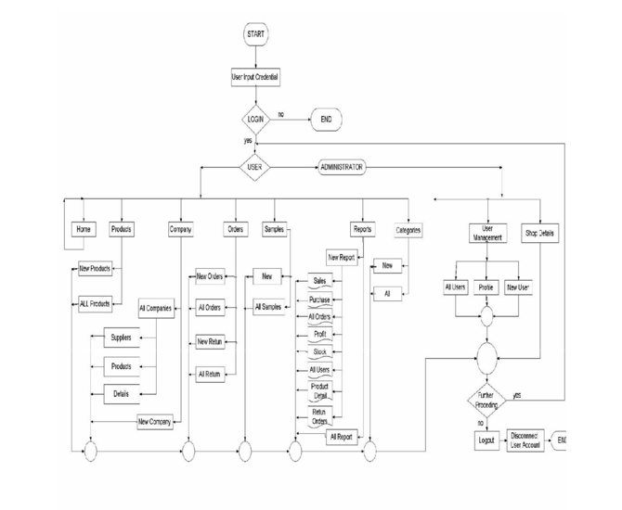

**2.7 Software Development Life Cycle:**

The SDLC is a process that ensures good software is built. Each step has its own phases for development and deliverables that feed into the next step. Every stage has its own particular strides for improvement and deliverables that sustain into the following stage. There are typically five phases starting with the analysis and requirements gathering and ending with the implementation.

There are five phases in the following:

* Requirements gathering/ analysis
* Design
* Coding
* Testing
* Implementation/ Deployment

2.8 Software Development Life Cycle Models:

There are many development models are available that have been used to developed Software with a specific end goal. These models specify the different steps of the process and for these steps. The selection of appropriate model has very critical stage. Model can be chosen on the basics of requirements and according to problem domain.

2.9 Available Methodologies

Many software development methodologies available.

They are as follows:

* Waterfall model
* Iterative model
* Incremental model
* Spiral model
* Agile model
* RAD model

**2.10 Water Fall Model:**

The Water fall Model was first Model to be presented for advancement of Application Software. This model referred to as a Linear Sequential model. Waterfall model is easy to use for development. In this methodology we provide complete software in one increment.

This type of model is basically used for larger project. After completion of each step, a review takes place to cheek that if the undertaking is right way or not In this model the testing phase starts only after the complete development of Software.

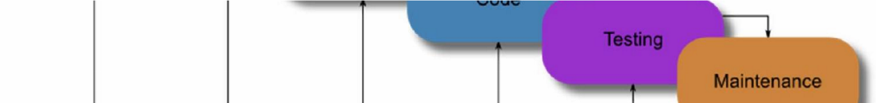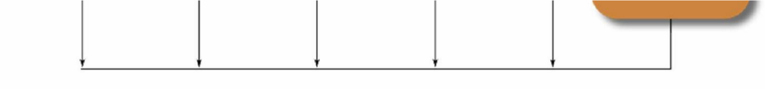

Fig: 2.10 (Waterfall Model)

2.11 Iterative Model:

In iterative model, all phases of development are combine in circular way. Which mean that each phase has fix time and number for operation.

2.12 Incremental Model:

In this model whole project is divided into increments. Software engineer divide whole project into increments. Each increment has fixed time for development.

**2.13 Spiral Model:**

This model is a combination of sequential model and prototype models. Thismodel is used for large software projects which involves continuous updating. There are specific steps which are done in one Spiral (iteration) where the output is a small increment of the large software. The same activities arc then repeatedfor all the spirals until the entire software is build.

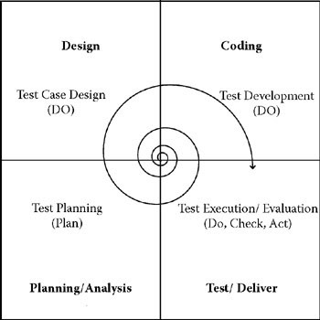

Fig: 2.13 (Spiral Model)

2.14 Agile Unified Process Model:

Agile Model presented in 2001. Agile Model based on iterative type model and incremental type Model, where requirements arc increases through coordinated effort between cross functional groups and self-organizing. It is a conceptual model that promotes foreseen interactions throughout the development life cycle.

2.15 RAD Model:

RAD stands for Rapid application development. RAD is a software development methodology that required less time to develop and uses minimal planning in Development. This Model is selected when specified time frame is present. This Model is similar to incremental model and waterfall fall model.

**2.16 Testing And Implementation**

**2.16.1 Testing the System:**

Testing is a process of executing an implementation of a system with test data and examining the output of the system and its operational behavior to check whether it is performing as our requirement. One of the main purpose of testingis to cheek the presence of faults in a software application.

Testing can only establish the existence of defects whereas debugging locates and corrects these defects. Testing can check that whether or not this particular Application software is usable in practice. Therefore a suitable approach must be chosen to reduce the possibility of errors. Among the rules that serve well as program testing objectives arc:

* Testing is a process of program execution with explicit intents to find errors and run-time program bugs.
* A successful test is not one that uncovers only few expected errors, but it is also one that constantly provides new challenges to its programmer over time.

**2.16.2 Internal Testing:**

This Internal Testing manages usage of Software. Every capacity or part is tried independently. This testing is performed by the creating groups. This center is additionally called clear-box testing, or some of the time white-box testing, since all points of interest arc obvious to the test. Inside breaking points arc tried here.

**2.16.3 Unit Testing:**

Unit testing oversees testing a unit in general. This would test the joint effort of various limits yet tic the test to one unit. Supporting test code, here and there called system, may be imperative to sponsorship to an individual test. This sort of testing is driven by the outline and usage bunches.

**2.16.4 Application Testing:**

Application testing test the entire application as a whole. This test is driven by investigation group. All components of System are tested here. All things related to working of system are considered. Dissimilarly to the internal testing and unit testing, which are customized, these tests are generally determined by scripts that run the system with a gathering of different parameters and gather results.

**2.16.5 Deployment Plan:**

The general arrangement process comprises of a few interrelated exercises with conceivable moves between them. These activities can occur at the Administration Side. Since each product framework is interesting, the exact procedures or strategies inside every movement can barely be characterized. Therefore, "deployment" should be interpreted as a general process that must be modified by prerequisites or attributes.

As it is a Web based application so its deployment is not so difficult the client who is using this just need a computer and browser to run it once it can installed on computer then it can accessed registered Admin representatives.

**2.16.6 Implementation:**

PCA-based face acknowledgment known as eigen face, is a standout amongst the best procedures to speak to confronts utilizing measurable technique. PCA can reduce measurements of unique information while holding information that best portray the fluctuation of the information. PCA is a conventional strategy to speak to confronts, in spite of its presence for quite a while it is still a good and broadly utilized system to perceive faces up to this point. In this stride guideline part investigation (PCA) will be connected to facial pictures to concentrate facial elements of appearances

**CHAPTER NO 3**

**RESULT AND DISCUSION**

**3.1 Conclusion:**

Analysis and Implementation of Viola Jones Face Detector is to detect faces for login the system through Capturing Devices (CD). This system provide the best security system to the user as compared to the password security system. This is an efficient way to detect the actual user of the system.

**3.2 Future Work:**

Multi-spectral imaging is the process of concurrent acquisition of a set of images. The every image in the multispectral imaging corresponds to a different band in the electromagnetic spectrum. The simple example of multispectral image is colour image in the visual spectrum having RGB sensations and can also be observed by human eyes. The hyperspectral images include more levels in a particular sub-band as compared to the multispectral images.

**3.3 Limitations:**

Several factors limit the effectiveness of face detection

1. IMAGE QUALITY

2. IMAGE SIZE

3. FACE ANGLE

4. PROCESSING AND STORAGE

**3.4 Design**

**Snapshots:**

**Opening:**



**Processing:**

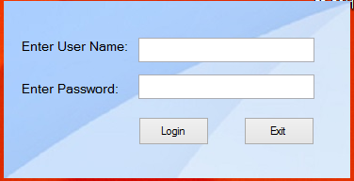

**Main:**

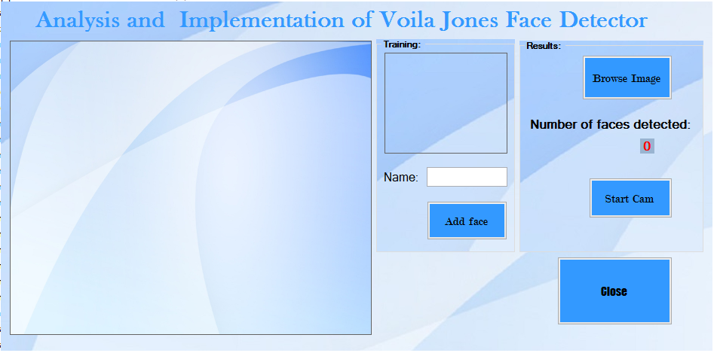

**Detection:**

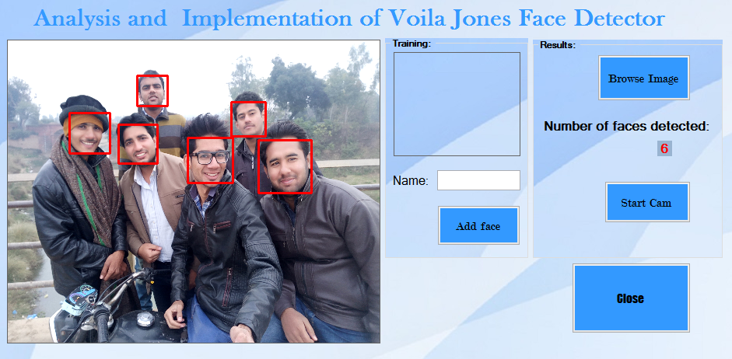

**Another photo:**

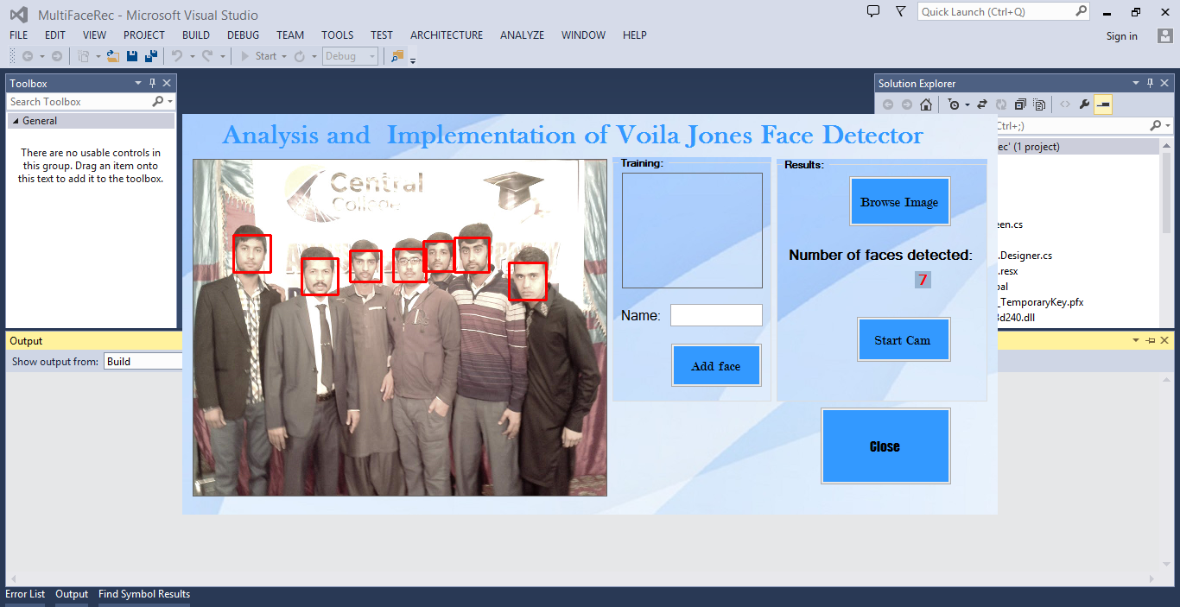

**3.5 Feacthers:**

PCA-based face acknowledgment known as eigen face, is a standout amongst the best procedures to speak to confronts utilizing measurable technique. PCA can reduce measurements of unique information while holding information that best portray the fluctuation of the information. PCA is a conventional strategy to speak to confronts, in spite of its presence for quite a while it is still a good and broadly utilized system to perceive faces up to this point. In this stride guideline part investigation (PCA) will be connected to facial pictures to concentrate facial elements of appearances.

**References**

(Kar, Hiremath et al. 2006)

Kar, S., et al. (2006). A multi-algorithmic face recognition system. Advanced Computing and Communications, 2006. ADCOM 2006. International Conference on, IEEE.

Mehrab, A. M. F. and P. Debnath (2012). An approach to real-time portable device for face recognition system. Computer and Information Technology (ICCIT), 2012 15th International Conference on, IEEE.

Meng, K., et al. (2005). A high performance face recognition system based on a huge face database. Machine Learning and Cybernetics, 2005. Proceedings of 2005 International Conference on, IEEE.

(Mehrab and Debnath 2012)

(Meng, Su et al. 2005)

Roger S. Pressman. (2010, Feb 1) Software Engineering A Practitioner's Approach

(7th edition) Available: [www.mhhc.com](http://www.mhhc.com) [May 29,2016]

Luke Welling, Laura Thomson. (2009) PHP and MySQL Web Development (4th

edition) Available: [www.pearsoned.co.in](http://www.pearsoned.co.in)

Thomas Connolly , Carolyn Begg. (1998) Database System (4,h Edition)

Available: [www.pearsoned.eo.in](http://www.pearsoned.eo.in)

Ian Sommerville. (2011) Software Engineering (9,h Edition) Available:[www.pearsoned.co.in](http://www.pearsoned.co.in)

1.