# Introduction

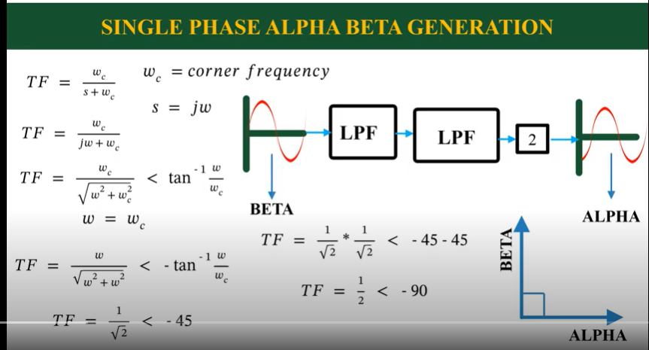

To create a sinusoid that is 90 phase shift two low pass filters have been used

# Use

# References

https://www.youtube.com/watch?v=3Q-pIKNLvUE