1. **Write a shell script that determines the period for which a specified user is working on the system.**
   * echo “Enter the desired username: “
   * read a
   * last Sa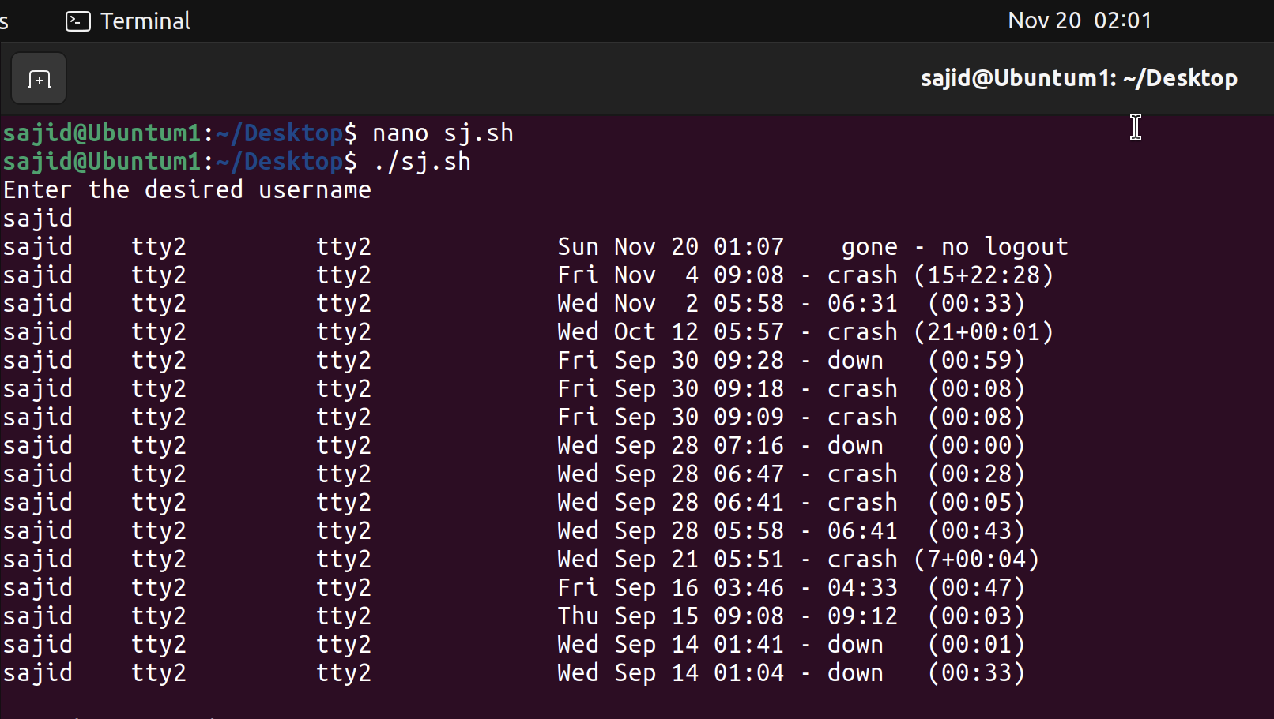
2. **Write a shell script that displays all the lines between start and end line numbers passed as argument.**
   * echo “Enter filename:”
   * read a
   * echo “Enter the starting line:”
   * read sl
   * echo “Enter the ending line”
   * read el
   * sed -n $sl,$el\p $a

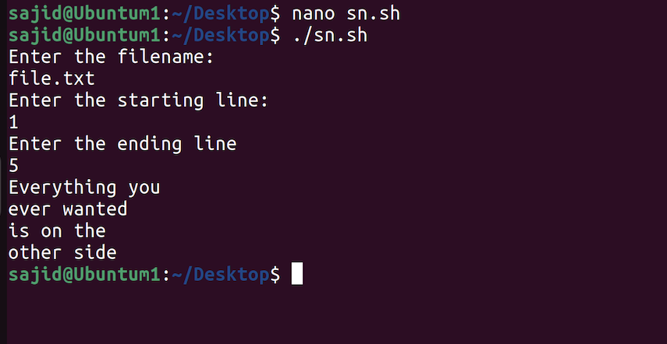

1. **Write a shell script that deletes all lines containing a specified word in one or more files supplied as arguments to it.**
   * if [ $# -eq 0 ]
   * then
   * echo NO ARGUMENT
   * else
   * pattern=$1
   * shift
   * for fname in $*
   * do
   * if [ -f $fname ]
   * then
   * echo DELETING: $pattern FROM : $fname
   * sed ’/’$pattern’/d’ $fname
   * else
   * echo $fname : FILENMAE NOT FOUND
   * fi
   * done
   * fi

