**East West University**

**Mini Project Report**

Computer Networks **CSE405**

**Submitted by:**

Md Alfaz Zaman Akash

ID: 2020-1-60-255

**Submitted to:**

Dr. Anisur Rahman

Associate Professor

Department of Computer Science and Engineering

East West University

**Submission Date:** 21/05/2022

Table of Contents

Preface: 3

Objective: 3

Requirements 3

Design Specifications: 3

Physical Diagram: 4

Design Issues: 4

Number of Hosts: 4

Number of Networks: 4

Limitations: 5

Lines of Code: 5

Router Configuration Code: 5

Routing Table Code: 9

Conclusion: 10

# Preface:

The motive of this project was to get a comprehensive idea about how a complex mesh of networks work. Knowledge about how a complex network design can be practically implemented was also gained through doing this project. The network design implemented will hopefully satisfy all the necessary requirements and it will be as close of a real-life implementation as possible.

# Objective:

The primary objective was to design a complete model of a complex network by discovering the interconnectivity of the systems and sub-networks, which will reflect a university named the University of Professionals’ structure and facilities.

On top of that, a webpage for University of Professionals was to be made and it would be located through the address <http://www.professionals.edu>. Some campuses were given a wireless access point to access the network. All the 6 campuses of the university were encompassed in the complex network along with sub-nets inside each campus.

# Requirements

* Must make sure that web page of the university will reflect University of Professionals’ web page.
* A DNS sever needs to be installed to locate webserver - meaning people will browse University’s web site with the following address: http://www.professionals.edu
* Must configure the whole network in such a way that IP for the hosts of different campuses will be automatically assigned by a single DHCP server.
* Among the hosts must make sure wireless links to the networks are available.
* University’s full network must cover its six campuses with six routers.
* Connectivity between all the hosts needs to be established.

# Design Specifications:

In the network design there are only 6 routers for 6 campuses, meaning 1 router per campus. A DHCP server is used to distribute IP addresses automatically to each host. In the DHCP server, there are 6 pools for 6 campus networks. A web server is also deployed. There is a DNS for accessing websites with a domain name. The networks also include switches, wireless access points, wireless hosts, LAN hosts.

# Physical Diagram:

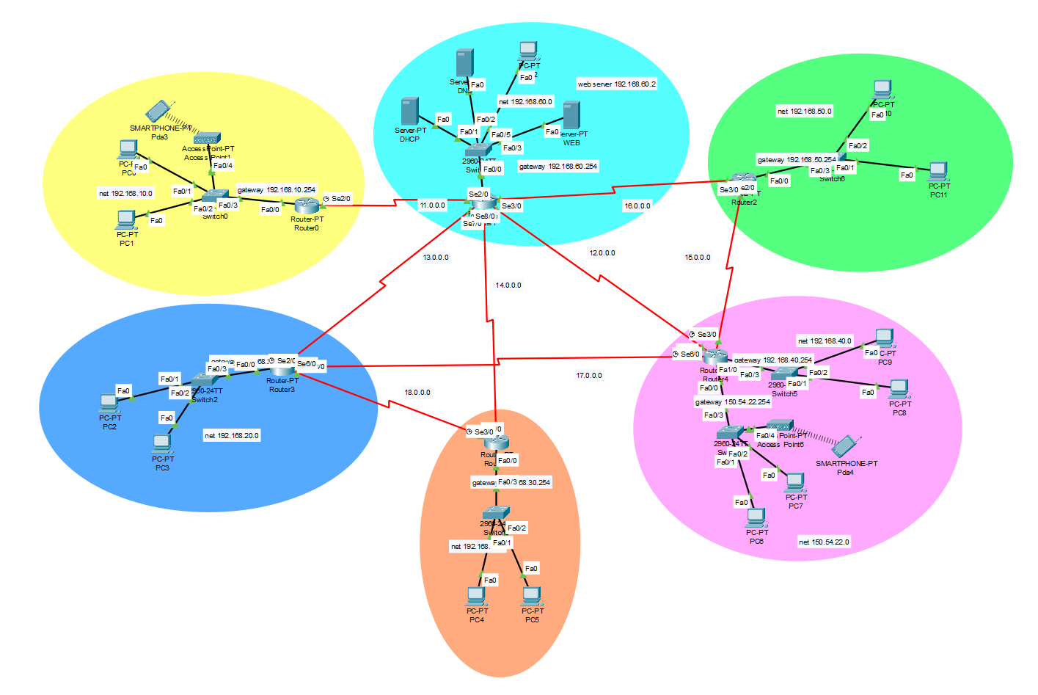

# Design Issues:

* Routers must be manually configured. In future if the University decides to add another campus, the new router the new network must be configured manually, which is not that easy.
* In some networks, only a limited number of hosts can be added. If more hosts are needed, then the IP addresses must be changed to an IP address class with m more hosts allowed.

# Number of Hosts:

18

# Number of Networks:

6

# Limitations:

The implemented design is not as efficient as other advanced routing algorithms and techniques. The network is very complex. Maintaining this network can create problems. More campus networks cannot be added very easily. To add more networks, manual configuration is needed. The network can support a limited number of hosts.

# Lines of Code:

## Router Configuration Code:

**Campus 1/Router 1**

interface fa0/0

ip address 192.168.20.254 255.255.0.0

no shut

do wr

exit

interface se2/0

ip address 17.0.0.1 255.0.0.0

clock rate 64000

no shut

do wr

exit

interface se3/0

ip address 18.0.0.1 255.0.0.0

clock rate 64000

no shut

do wr

exit

interface se6/0

ip address 13.0.0.2 255.0.0.0

no shut

do wr

exit

**Campus 2/Router 2**

interface fa0/0

ip address 150.54.22.254 255.255.0.0

no shut

do wr

exit

interface fa1/0

ip address 192.168.40.254 255.255.255.0

no shut

do wr

exit

interface se2/0

ip address 17.0.0.2 255.0.0.0

no shut

do wr

exit

interface se3/0

ip address 16.0.0.1 255.0.0.0

clock rate 64000

no shut

do wr

exit

interface se6/0

ip address 15.0.0.1 255.0.0.0

no shut

do wr

exit

**Campus 3/Router 3**

interface fa0/0

ip address 163.146.30.254 255.255.0.0

no shut

do wr

exit

interface se2/0

ip address 15.0.0.2 255.0.0.0

no shut

do wr

exit

interface se3/0

ip address 12.0.0.1 255.0.0.0

clock rate 64000

no shut

do wr

exit

interface se6/0

ip address 13.0.0.1 255.0.0.0

no shut

do wr

exit

**Campus 4/Router 4**

interface fa0/0

ip address 163.146.40.254 255.255.0.0

no shut

do wr

exit

interface se2/0

ip address 14.0.0.1 255.0.0.0

clock rate 64000

no shut

do wr

exit

**Campus 5/Router 5**

interface fa0/0

ip address 163.146.50.254 255.255.0.0

no shut

do wr

exit

interface se2/0

ip address 18.0.0.1 255.0.0.0

clock rate 64000

no shut

do wr

exit

**Campus 6/Router 6**

interface fa0/0

ip address 163.146.60.254 255.255.0.0

no shut

do wr

exit

interface se2/0

ip address 17.0.0.2 255.0.0.0

clock rate 64000

no shut

do wr

exit

## Routing Table Code:

**Campus 1 OSPF**

router OSPF 1

network 13.0.0.0 0.0.0.255 area 1

network 18.0.0.0 0.0.0.255 area 1

network 17.0.0.0 0.0.0.255 area 1

exit

**Campus 2 OSPF**

router OSPF 2

network 17.0.0.0 0.0.0.255 area 1

network 12.0.0.0 0.0.0.255 area 1

network 15.0.0.0 0.0.0.255 area 1

exit

**Campus 3 OSPF**

router OSPF 3

network 13.0.0.0 0.0.0.255 area 1

network 14.0.0.0 0.0.0.255 area 1

network 12.0.0.0 0.0.0.255 area 1

exit

**Campus 4 OSPF**

router OSPF 4

network 18.0.0.0 0.0.0.255 area 1

network 14.0.0.0 0.0.0.255 area 1

exit

**Campus 5 OSPF**

router OSPF 5

network 16.0.0.0 0.0.0.255 area 1

network 15.0.0.0 0.0.0.255 area 1

exit

**Campus 6 OSPF**

router OSPF 6

network 11.0.0.0 0.0.0.255 area 1

exit

# Conclusion:

The project is about creating a full-fledged network for University of Professionals with multiple subnets. The network is fully operational and was designed to be as close as possible to real life network implementations.