OpenSCG Python Scripts for the Deployment of Database Objects

Objective:

This document explains in detail the execution of the python scripts for deploying the database objects into the PG Server.

It contains the overview of the scripts, the pre-requisites involved and the deployment steps.

Overview:

These scripts will help in deploying the database objects in the postgresql server of the client.

It is configurable as per the client's requirement, i.e. It gives the user the option for creating the database and load all the objects.

The database objects, we are referring to ( 'Database', 'Tables', 'Types', 'PackageSchema', 'Sequences', 'Views', 'Trigger', 'Functions', 'Procedures')

All the .SQL files are stored in a specific folder structure and it is uniform for all the schemas.

For instance:
The base folder is TR_New and its path is :

base_folder = "/home/openscg/TR_New"
and all the schemas are present in these folders in alphabetical order .

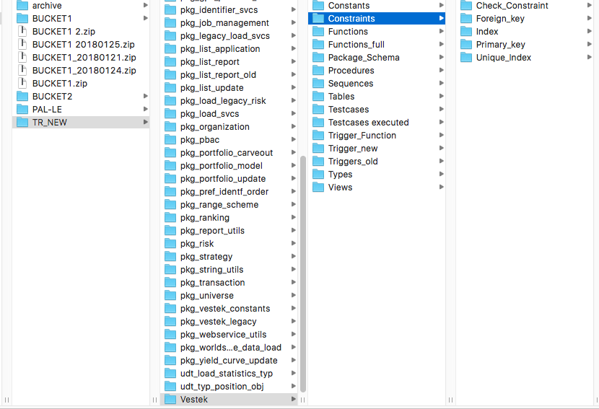
Snapshot of the base folder structure

Each folder has one or more of these schema objects:

Configuration File:

We have specified the parameters in the configuration file with all the details which looks like below:

PKG_ERROR_LOG = /Users/THOMSON_REUTERS/package_schema_types_error_log.log
TB_ERROR_LOG = /Users/THOMSON_REUTERS/table_creation_error_log.log
OC_ERROR_LOG = /Users/THOMSON_REUTERS/object_creation_error_log.log
BASE_FOLDER = /Users/THOMSON_REUTERS
PGHOST = portfolio-qa-cluster.cluster-c6mxreiwpdjf.us-east-1.rds.amazonaws.com
PGPORT = 5432
PGDATABASE_EXT = postgres
PGDATABASE = portfolio
PGUSER = vestek
PGPASSWORD = vestekqa
PSQL = /Library/PostgreSQL/9.6/bin/psql
schema_objects = ['Tables', 'Types', 'PackageSchema', 'Sequences', 'Views', 'Triggers', 'Functions', 'Procedures','constants']

The order in which we specify the schema_object list is case sensitive in linux server and has to be taken into consideration.

The execution will start with the creation of the major schema i.e. Vestek, along with their objects and dependent schemas.

For this we have created a schema list which has the list of the above mentioned schemas ( in the particular order which is due to the dependencies of each schema on the other one)

schema list looks something like this:

schemas_list = [pkg_attribute,pkg_cache_invalidator,pkg_date_utils,pkg_gps_portfolio_feed,pkg_list_application,pkg_list_report,pkg_list_update,pkg_load_svcs,pkg_organization,pkg_portfolio_carveout,pkg_portfolio_update,pkg_string_utils,pkg_transaction,pkg_vestek_legacy]

The entire process is saved in the log file , for tracing the errors which may occur during the deployment and once it is completed, we can go back to the log and check the errors and rectify them easily.

Pre-requisites:

For running the scripts on the server we have the following pre-requisites.

1- Python 2.7.13
2- Latest GIT code should be available in the EC2 instance (in the base folder).
3- Vestek User and Role should be created.
4- Portfolio Database should be created with Vestek user.

We have created 3 python scripts which are being used for the creation of the database, tables and the objects.

1- schema_creation.py
2- table_creation.py
3- object_creation.py

Execution Steps:

1- schema_creation python script:

This script creates the all the packageschemas and types with the vestek user login.

(i) The sql folder contains the create-database.sql (to be used only when we want to create a new database) and create-type.sql files.
Place the sql folder in the base folder and specify the name of the database in the create-database.sql file.
(ii) Execute the schema_creation.py (command to execute – python schema_creation.py)

(iii) Required database with vestek user login and the extensions with super user login will be created.

2- Table Creation python script:

This script creates the major schema vestek and there corresponding tables along with partition tables.

(i) Execute the table_creation.py

(ii) An inline message will appear “"Enter A - For ALL”.
Select A for creating the tables for the vestek mains schema and the partition tables

Select Q to quit the process.

Once the tables are created then the data loading process will kickoff using the shell scripts. Please refer to README.txt documents for execution of shell scripts.

3- Object Creation python script:

This script creates all the objects

(i)- Execute the object_creation.py

(ii) An inline message will appear “"Enter A - For ALL”.

Select A to create all the objects across all the schemas.
(iii) The entire database is created with all the data and objects.

