Mumtahid Akash

Professor Zheng Peng

CSC34300

17/04/2022

**Task1:**

**Introduction:**

The lab deals with the implementation and understanding of Instruction decoder and ALU Control unit. These are the sub module or sub functions of Mips 32. Basic task was to understand the concept of decoder and alu control unit. Below is the vhdl code of Instruction decoder and ALU control unit:

**VHDL CODE of Decoder:**

----------------------------------------------------------------------------------

----------------------------------------------------------------------------------

library IEEE;

use IEEE.STD_LOGIC_1164.ALL;

entity DEC is

port(

I_DEC_EN : in STD_LOGIC;

I_DEC_OPCODE: in STD_LOGIC_VECTOR(5 downto 0);

O_DEC_REGDST : out STD_LOGIC;

O_DEC_JUMP : out STD_LOGIC;

O_DEC_BEQ : out STD_LOGIC;

O_DEC_BNE : out STD_LOGIC;

O_DEC_MEMREAD : out STD_LOGIC;

O_DEC_MEMTOREG : out STD_LOGIC;

O_DEC_ALUOP : out STD_LOGIC_VECTOR(1 downto 0);

O_DEC_MEMWRITE : out STD_LOGIC;

O_DEC_ALUSRC: out STD_LOGIC;

O_DEC_REGWRITE: out STD_LOGIC

);

end DEC;

architecture Behavioral of DEC is

begin

O_DEC_REGDST <= '1' when (I_DEC_OPCODE="000000" and I_DEC_EN='1') else

'0' when (I_DEC_OPCODE="001000" and I_DEC_EN='1') else

'0' when (I_DEC_OPCODE="000100" and I_DEC_EN='1') else

'0' when (I_DEC_OPCODE="000101" and I_DEC_EN='1') else

'0' when (I_DEC_OPCODE="000010" and I_DEC_EN='1') else

'0' when (I_DEC_OPCODE="100011" and I_DEC_EN='1') else

'0' when (I_DEC_OPCODE="101011" and I_DEC_EN='1') else '0';

O_DEC_JUMP <= '0' when (I_DEC_OPCODE="000000" and I_DEC_EN='1') else

'0' when (I_DEC_OPCODE="001000" and I_DEC_EN='1') else

'0' when (I_DEC_OPCODE="000100" and I_DEC_EN='1') else

'0' when (I_DEC_OPCODE="000101" and I_DEC_EN='1') else

'1' when (I_DEC_OPCODE="000010" and I_DEC_EN='1') else

'0' when (I_DEC_OPCODE="100011" and I_DEC_EN='1') else

'0' when (I_DEC_OPCODE="101011" and I_DEC_EN='1') else '0';

O_DEC_BEQ <= '0' when (I_DEC_OPCODE="000000" and I_DEC_EN='1') else

'1' when (I_DEC_OPCODE="001000" and I_DEC_EN='1') else

'0' when (I_DEC_OPCODE="000100" and I_DEC_EN='1') else

'1' when (I_DEC_OPCODE="000101" and I_DEC_EN='1') else

'0' when (I_DEC_OPCODE="000010" and I_DEC_EN='1') else

'0' when (I_DEC_OPCODE="100011" and I_DEC_EN='1') else

'0' when (I_DEC_OPCODE="101011" and I_DEC_EN='1') else '0';

O_DEC_BNE <= '0' when (I_DEC_OPCODE="000000" and I_DEC_EN='1') else

'0' when (I_DEC_OPCODE="001000" and I_DEC_EN='1') else

'1' when (I_DEC_OPCODE="000100" and I_DEC_EN='1') else

'1' when (I_DEC_OPCODE="000101" and I_DEC_EN='1') else

'0' when (I_DEC_OPCODE="000010" and I_DEC_EN='1') else

'0' when (I_DEC_OPCODE="100011" and I_DEC_EN='1') else

'0' when (I_DEC_OPCODE="101011" and I_DEC_EN='1') else '0';

O_DEC_MEMREAD <= '0' when (I_DEC_OPCODE="000000" and I_DEC_EN='1') else

'0' when (I_DEC_OPCODE="001000" and I_DEC_EN='1') else

'0' when (I_DEC_OPCODE="000100" and I_DEC_EN='1') else

'0' when (I_DEC_OPCODE="000101" and I_DEC_EN='1') else

'0' when (I_DEC_OPCODE="000010" and I_DEC_EN='1') else

'1' when (I_DEC_OPCODE="100011" and I_DEC_EN='1') else

'0' when (I_DEC_OPCODE="101011" and I_DEC_EN='1') else '0';

O_DEC_MEMTOREG <= '0' when (I_DEC_OPCODE="000000" and I_DEC_EN='1') else

'0' when (I_DEC_OPCODE="001000" and I_DEC_EN='1') else

'0' when (I_DEC_OPCODE="000100" and I_DEC_EN='1') else

'0' when (I_DEC_OPCODE="000101" and I_DEC_EN='1') else

'0' when (I_DEC_OPCODE="000010" and I_DEC_EN='1') else

'1' when (I_DEC_OPCODE="100011" and I_DEC_EN='1') else

'0' when (I_DEC_OPCODE="101011" and I_DEC_EN='1') else '0';

O_DEC_MEMWRITE <= '0' when (I_DEC_OPCODE="000000" and I_DEC_EN='1') else

'0' when (I_DEC_OPCODE="001000" and I_DEC_EN='1') else

'0' when (I_DEC_OPCODE="000100" and I_DEC_EN='1') else

'0' when (I_DEC_OPCODE="000101" and I_DEC_EN='1') else

'0' when (I_DEC_OPCODE="000010" and I_DEC_EN='1') else

'0' when (I_DEC_OPCODE="100011" and I_DEC_EN='1') else

'1' when (I_DEC_OPCODE="101011" and I_DEC_EN='1') else '0';

O_DEC_ALUSRC <= '0' when (I_DEC_OPCODE="000000" and I_DEC_EN='1') else

'1' when (I_DEC_OPCODE="001000" and I_DEC_EN='1') else

'0' when (I_DEC_OPCODE="000100" and I_DEC_EN='1') else

'0' when (I_DEC_OPCODE="000101" and I_DEC_EN='1') else

'0' when (I_DEC_OPCODE="000010" and I_DEC_EN='1') else

'1' when (I_DEC_OPCODE="100011" and I_DEC_EN='1') else

'1' when (I_DEC_OPCODE="101011" and I_DEC_EN='1') else '0';

O_DEC_REGWRITE <= '1' when (I_DEC_OPCODE="000000" and I_DEC_EN='1') else

'1' when (I_DEC_OPCODE="001000" and I_DEC_EN='1') else

'0' when (I_DEC_OPCODE="000100" and I_DEC_EN='1') else

'0' when (I_DEC_OPCODE="000101" and I_DEC_EN='1') else

'0' when (I_DEC_OPCODE="000010" and I_DEC_EN='1') else

'1' when (I_DEC_OPCODE="100011" and I_DEC_EN='1') else

'0' when (I_DEC_OPCODE="101011" and I_DEC_EN='1') else '0';

O_DEC_ALUOP <= "10" when (I_DEC_OPCODE="000000" and I_DEC_EN='1')else

"00" when (I_DEC_OPCODE="001000" and I_DEC_EN='1')else

"01" when (I_DEC_OPCODE="000100" and I_DEC_EN='1')else

"11" when (I_DEC_OPCODE="000101" and I_DEC_EN='1')else

"00" when (I_DEC_OPCODE="000010" and I_DEC_EN='1')else

"00" when (I_DEC_OPCODE="100011" and I_DEC_EN='1') else

"00" when (I_DEC_OPCODE="101011" and I_DEC_EN='1') else "00";

end Behavioral;

**VHDL CODE of ALU CONTROL UNIT (ACU):**

----------------------------------------------------------------------------------

----------------------------------------------------------------------------------

library IEEE;

use IEEE.STD_LOGIC_1164.ALL;

entity ACU is

Port ( I_ACU_ALUOp : in STD_LOGIC_VECTOR (1 downto 0);

I_ACU_Funct : in STD_LOGIC_VECTOR (5 downto 0);

O_ACUCTL : out STD_LOGIC_VECTOR (3 downto 0));

end ACU;

architecture Behavioral of ACU is

begin

process(I_ACU_ALUOp,I_ACU_Funct)

begin

case I_ACU_ALUOp is

when "00" => O_ACUCTL <="0010";

when "01" => O_ACUCTL <="0110";

when others =>

case I_ACU_Funct is

when "100000" => O_ACUCTL <=

"0010";

when "100010" => O_ACUCTL<=

"0110";

when "100100" => O_ACUCTL <=

"0000";

when "100101" => O_ACUCTL <=

"0001";

when "101010" => O_ACUCTL<=

"0111";

when others => O_ACUCTL <=

"----";

end case;

end case;

end process;

end Behavioral;

**Test Bench:**

--------------------------------------------------------------------------------

--------------------------------------------------------------------------------

LIBRARY ieee;

USE ieee.std_logic_1164.ALL;

ENTITY TEST_MODULE IS

PORT (

O_REGDST : OUT std_logic;

O_JUMP : OUT std_logic;

O_BEQ : OUT std_logic;

O_BNE : OUT std_logic;

O_MEMREAD : OUT std_logic;

O_MEMTOREG : OUT std_logic;

O_MEMWRITE : OUT std_logic;

O_ALUSRC : OUT std_logic;

O_REGWRITE : OUT std_logic;

O_ALUCTL : OUT std_logic_vector(3 downto 0)

);

END TEST_MODULE;

ARCHITECTURE behavior OF TEST_MODULE IS

-- Component Declaration for the Unit Under Test (UUT)

COMPONENT DEC

PORT(

I_DEC_EN : IN std_logic;

I_DEC_OPCODE : IN std_logic_vector(5 downto 0);

O_DEC_REGDST : OUT std_logic;

O_DEC_JUMP : OUT std_logic;

O_DEC_BEQ : OUT std_logic;

O_DEC_BNE : OUT std_logic;

O_DEC_MEMREAD : OUT std_logic;

O_DEC_MEMTOREG : OUT std_logic;

O_DEC_ALUOP : OUT std_logic_vector(1 downto 0);

O_DEC_MEMWRITE : OUT std_logic;

O_DEC_ALUSRC : OUT std_logic;

O_DEC_REGWRITE : OUT std_logic

);

END COMPONENT;

COMPONENT ACU

PORT(

I_ACU_ALUOp : in STD_LOGIC_VECTOR (1 downto 0);

I_ACU_Funct : in STD_LOGIC_VECTOR (5 downto 0);

O_ACUCTL : out STD_LOGIC_VECTOR (3 downto 0)

);

END COMPONENT;

--Inputs

signal I_DEC_EN : std_logic := '0';

signal I_EN : std_logic:= '0';

signal I_INSTR : std_logic_vector(31 downto 0):=(others=>'0');

--Outputs

signal O_DEC_ALUOP : std_logic_vector(1 downto 0);

-- No clocks detected in port list. Replace <clock> below with

-- appropriate port name

BEGIN

-- Instantiate the Unit Under Test (UUT)

uut_DEC: DEC PORT MAP (

I_DEC_EN => I_EN,

I_DEC_OPCODE => I_INSTR(31 downto 26),

O_DEC_REGDST => O_REGDST,

O_DEC_JUMP => O_JUMP,

O_DEC_BEQ => O_BEQ,

O_DEC_BNE => O_BNE,

O_DEC_MEMREAD => O_MEMREAD,

O_DEC_MEMTOREG => O_MEMTOREG,

O_DEC_ALUOP => O_DEC_ALUOP,

O_DEC_MEMWRITE => O_MEMWRITE,

O_DEC_ALUSRC => O_ALUSRC,

O_DEC_REGWRITE => O_REGWRITE

);

uut_ACU: ACU PORT MAP (

I_ACU_ALUOp => O_DEC_ALUOP,

I_ACU_Funct => I_INSTR(5 downto 0),

O_ACUCTL => O_ALUCTL

);

-- Stimulus process

stim_proc: process

begin

-- hold reset state for 100 ns.

I_INSTR<=X"00123A00";

wait for 100 ns;

I_EN<='1';

wait for 100 ns;

I_INSTR<=X"00123A00";

wait for 100 ns;

I_INSTR<=X"20123A00";

wait for 100 ns;

I_INSTR<=X"10123A00";

wait for 100 ns;

I_INSTR<=X"14123A00";

wait for 100 ns;

I_INSTR<=X"08123A00";

wait for 100 ns;

I_INSTR<=X"8C123A00";

wait for 100 ns;

I_INSTR<=X"AC123A00";

wait for 100 ns;

I_INSTR<=X"20123A00";

wait for 100 ns;

I_INSTR<=X"00123A20";

wait for 100 ns;

I_INSTR<=X"20123A22";

wait for 100 ns;

I_INSTR<=X"10123A24";

wait for 100 ns;

I_INSTR<=X"14123A25";

wait for 100 ns;

I_INSTR<=X"08123A2A";

wait for 100 ns;

I_INSTR<=X"8C123A20";

wait for 100 ns;

I_INSTR<=X"AC123A22";

wait for 100 ns;

I_INSTR<=X"20123A2A";

-- insert stimulus here

wait;

end process;

END;

**Simulation Waveform:**

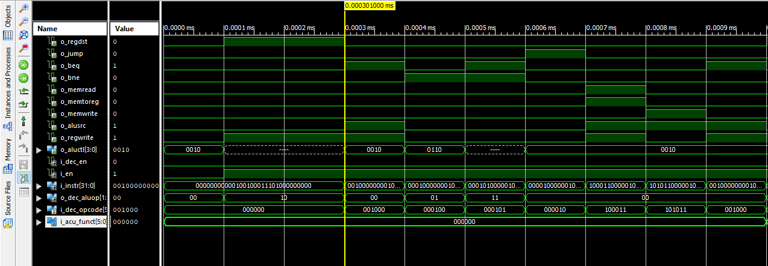

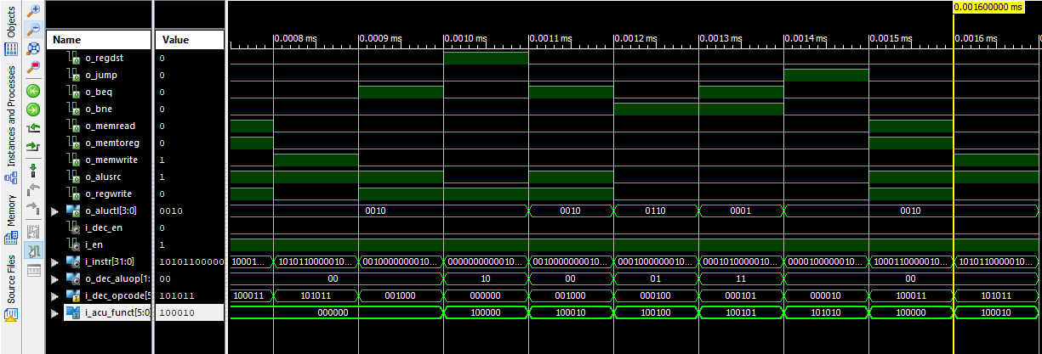

Rushdi, A. M. and Al-Yahya, H. A., "A Boolean minimization procedure using the variable-

entered Karnaugh map and the generalized consensus concept", International Journal of

Electronics, Vol. 87, No. 7, (2000), pp. 769-794.

Rushdi, A. M. and Al-Yahya, H. A., "A Boolean minimization procedure using the variable-

entered Karnaugh map and the generalized consensus concept", International Journal of

Electronics, Vol. 87, No. 7, (2000), pp. 769-794.

Rushdi, A. M. and Al-Yahya, H. A., "A Boolean minimization procedure using the variable-

entered Karnaugh map and the generalized consensus concept", International Journal of

Electronics, Vol. 87, No. 7, (2000), pp. 769-794.