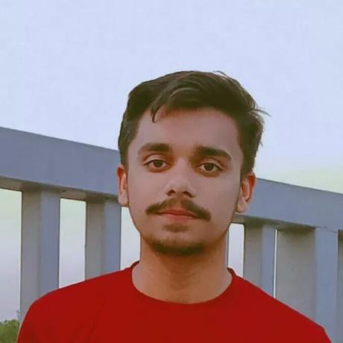SAJID MEHMOOD

[GitHub](https://github.com/sajidmehmoodtariq30) [Gmail](mailto:sajidmehmoodtariq5@gmail.com) [LinkedIn](https://www.linkedin.com/in/sajid-mehmood-tariq)

I am an aspiring Computer Science student and a web developer. My future goal includes becoming a Mern Stack Developer. I am doing my CS form KSK and web development from Punjab University.

|  |  |
| --- | --- |
| **Skills: -**   1. HTML 2. CSS 3. JS 4. Bootstrap 5. Tailwind CSS 6. GitHub Pages | **Education: -**  **Matriculation**  From Govt. Muslim High School  **Intermediate**  From Punjab College  **BSCS**  From UET KSK |

|  |
| --- |
| **Projects: -**  **Todo List:**  A simple Todo list made by using HTML, CSS and JS.  **Stopwatch:**  A simple stopwatch list made by using HTML, CSS and JS.  **Weather App:**  A simple weather app made by using HTML, CSS and JS that uses open weather API |