**Department of Computer Sciences National University of Computer & Emerging Sciences**

**Deliverable - 7**



**Section: A**

**Subject Name: Object Oriented Analysis and Design**

**Course Code: CS-309**

**Submission Date: 26th October 2020, Sunday**

**Submitted to: Ma'am Javaria Imtiaz**

**Company Name:**

“Handy Home services”

**Company Logo:**

**Team members:**

* Sajid Shah i170472
* Ayesha Khan i170313

**Member roles:**

* **Team Manager:** Ayesha Khan
* **Requirement Analyst:** Sajid Shah
* **Manager QA & Testing:** Sajid Shah
* **Manager UI Designer:** Ayesha Khan
* **Developers/SW Engineers:** Sajid Shah & Ayesha Khan

**Table of Contents**

1. Introduction
   1. Title
   2. Product Scope
   3. Objectives
   4. Problem Statement
2. Overall Description
   1. Product Perspective
   2. Product Functions
   3. List of Use Cases
   4. Extended Use Cases
   5. Use Case Diagram
3. Other Nonfunctional Requirements
   1. Performance Requirements
   2. Safety Requirements
   3. Security Requirements
   4. Software Quality Attributes
   5. Business Rules
   6. Operating Environment
   7. User Interfaces
4. Domain Model
5. System Sequence Diagram
6. Operation Contracts
7. Sequence Diagram
8. Class Diagram
9. Package Diagram
10. Deployment Diagram
11. **Introduction**

1.1 PROJECT TITLE

## “HANDY HOME SERVICES”

1.2 Scope

From home repair, maintenance to minor renovation jobs, a home maintenance service will fit the bill. There are a lot of different technicians and labors on the market, and they’ll all offer a broader – or narrower – range of services. But Handy Home Services provides you Cleaning and maintenance (upholstery, carpet, outdoor, windows etc.), Home renovations such as bathrooms, kitchens, and floorboards; Tiling and painting of exteriors and interiors; Roofing, skylights and gutters; Carpentry of decks and pergolas, furniture assembly and carports; Fencing; Plastering; Concreting and paving; Excavation, ground leveling and clearing for creative landscaping; Household repairs.

## 1.3 Objectives

1. **Professional & Trained Technicians:**

All our handymen are well trained and skilled. They are further background checked and are honest & reliable.

1. **Quick Response:**

Our handymen use motor bikes to minimize delays and reach the Client on time.

1. **Wide Availability:**

We provide services both on weekdays and weekends. We also provide a late night service for emergencies (at a higher rate).

1. **Well Equipped:**

We provide our employees with the best tools and make sure that they are smartly uniformed. This ensures that the technician does not waste time to run back and forth looking for parts and tools.

1. **Capability:**

We have the capability to do both small and large jobs. From fixing something as small as a Muslim shower to large commercial & residential projects such as Water Distribution Networks and Building Works, you can count on Handy home services to do the job for you. No job is too small or big for us!

1. **Affordable Pricing:**

We charge sensible prices that are really competitive even when compared to contractors or freelance technicians. The clients are further given invoices professionally and don’t have to go through the worry of over-pricing.

1. **One Window Solution:**

We offer one window solutions for all your construction and maintenance & repair needs. You don't even have to worry about the purchasing and transportation of parts as The Handyman can arrange those for you. We also offer complete facility management services (also known as facilities management or FM services).

1. **Customer Helpline:**

We offer a convenient Toll-Free 0800 helpline so our clients can get in touch with us at any time.

## 1.4 Description and Problem Statement

The motivation behind the Handy Home services was the challenges one would face of finding an expert technician. One would need to discover these handymen through verbal exchange or from a hardware store close by. The undeniable issue with this was that most of these handymen needed polished methodology, and/or skills. Besides they were regularly just not available or reliable, or essentially charged way over what is viewed as reasonable. Clearly there was a requirement for a professional handyman service and we seized the thought!

## 2.1 Product Requirements:

* 1. Every new user must register with a new email ID to login into an account.
  2. User must be able to see a list of handyman services.
  3. User must be able to select multiple choices from the given handyman services as per requirement.
  4. User must provide the location where to provide the selected service.
  5. User must be able to see the name, number, CNIC# and picture of the handyman who will provide the service.
  6. User must be able to reserve the selected service.
  7. User must be able to cancel the selected service.
  8. User must provide feedback once the service is provided.
  9. App Developers must manage the services required for the use.

1. **Use case Register User**

* **High Level or Brief Use Case**

|  |  |
| --- | --- |
| **Use Case Section** | **Comment** |
| Use case name | Register User |
| Actors | Handyman , Customer , Admin |
| Type | Primary |
| Description | To avail the Handyman Home Services , customer and handyman both have to register themselves first. They will open signup page and enter the valid credentials. Customer will only enter his/her name , email , password and near by location while handyman have to provide his/her complete personal information , work experience , ID details and services he/she can provide. Admin will simply create an service account for customer while for handyman he will verify all data given by handyman and then create his/her work account. |

* **Expended or Fully Dressed Used Case**

|  |  |
| --- | --- |
| **Use Case Section** | **Comment** |
| Use case name | Register User |
| Scope | Online System to hire house maintainance services |
| Level | Primary |
| Primary Actors | Customer, Admin, Handyman |
| Stakeholders / Interests | Customer want to use this platform to book services.  Handyman wants register himself/herself to provide services and make money.  Admin wants to provide a bridge between customer and handyman to provide services to customer and an opportunity for a handyman to earn money and both parties can do the business smoothly. |
| Preconditions | Customer must have valid email address.  Handyman must have valid email address and work experience. He also must have valid identification documents to get himself/herself register with system.  Admin must have access to system to register the users. |
| Success Guarantee / Postcondition | On correct entry of credentials, user (customer or handyman) will be register in Handyman Home Services System and can login to hire or provide services. |
| Main Success Scenario | 1. If user is customer,    * he/she will enter his/her email and password twice to avoid mistakes.    * After that on next step he will provide his/her name and near by location where he/she might request for services in future.    * on completion, admin will create a service account for user and user can login his/her account to book services. 2. If user is handyman,  * He/she will provide full personal information like name, email , phone number , work experience , identification details etc. * On the system side , admin will be verifying all the data provided by the handyman to see if there is any legal incompatibility by law to hire such user. * After successful verification, handyman can login into the account and add or update his/her profile according to his/her expertise. |
| Extensions | 1. If customer enter wrong email address or enter mismatch password, he/she will repeat the entry process again with correction credentials. 2. At any stage , user can enter wrong format of name , number and email address. User can always correct the specific field while retaining the other field information. 3. At any stage, handyman signup request can be cancel if he/she provide any wrong personal or work data or he/she have any criminal background. |
| Spatial Requirements | * User should have internet connection and a web brower on PC. * He/she should have website of Handyman Home Services System. * Admin should have web portal access to manage accounts. * All content on website or online portal should be clearly visible. * . NADRA database will be required to verify user’s data. |
| Technology and Data Variation List | Online web-based portal will be use to register the user. Domain server servcies will be hired to provide 24/7 services on portal online.  Customer will need PC with internet connection and custom keyboard and mouse to enter data. |
| Frequency of Occurrence | User will come and get register as they heard about the Company. So this will be frequent. |
| Miscellaneous | At some stage, domain service provider’s servers get down and website might unavaible to access. |

1. **Use case Book Services**

* **High Level or Brief Use Case**

|  |  |
| --- | --- |
| **Use Case Section** | **Comment** |
| Use case name | Book Servcies |
| Actors | Customer , System |
| Type | Primary |
| Description | To book servcies, customer will login in his/her account, select service type (gardening, carpenter, electrician etc) he wants to hire, then select the location where he wants to get service and then the date and time of service and finally detail note of service type or maintainance type for which he is hiring the service(optional). After pressing the Book Now button, he will be displayed with a service token # and details of the handyman like contact number , name and picture, which is hired for customer. |

* **Expended or Fully Dressed Used Case**

|  |  |
| --- | --- |
| **Use Case Section** | **Comment** |
| Use case name | Book Services |
| Scope | Online System to hire house maintainance services |
| Level | Primary |
| Primary Actors | Customer, System |
| Stakeholders / Interests | Customer want to use this platform to book services.  Handyman wants register himself/herself to provide services and make money.  Admin wants to provide a bridge between customer and handyman to provide services to customer and an opportunity for a handyman to earn money and both parties can do the business smoothly. |
| Preconditions | Customer must have logged in with service account to book services.  System should be available to reponse the request of customer and provide him/her a handyman for required services. |
| Success Guarantee / Postcondition | On correct selection or insertion in each field of process for booking service, customer will be successfully hired the handyman for required services if there are any handymen available near-by in customer’s required location. He/she will get the service token number and details of hired handyman on display. |
| Main Success Scenario | To book servcies, customer will login in his/her account, select service type (gardening, carpenter, electrician etc) he wants to hire, then select the location where he wants to get service and then the date and time of service and finally detail note of service type or maintainance type for which he is hiring the service(optional). After pressing the Book Now button, he will be displayed with a service token # and details of the handyman like contact number , name and picture, which is hired for customer. |
| Extensions | 1. Customer might did not find the required type of service in list which means limited services are available only. User can also select the most relavant service type like carpenter for any wood work etc. 2. User can might select inconsistent options like wrong selection of service, wrong time (a.m/p.m confusion), wrong address etc which may he realises later. He can always edit the select after booking by service token number within the web portal or call helpline and provide them the service token number. 3. At any stage, customer can cancel the booking. Moreover he can cancel the booking even after booking is complete. |
| Spatial Requirements | * User should have internet connection and a web brower on PC. * He/she should have website of Handyman Home Services System. * All content on website or online portal should be clearly visible. * Details of handyman which is hired for the customer should copyable and shareable across various platforms such as Whatsapp. |
| Technology and Data Variation List | Customer will need PC with internet connection and custom keyboard and mouse to enter data.  Domain server servcies will be hired to provide 24/7 services on portal online from domain server providers. |
| Frequency of Occurrence | User will hire the services once in a while.  Users will hire the services quite frequently. |
| Miscellaneous | At some stage, domain service provider’s servers get down and website might unavaible to access.  User’s request might get expire due to data traffic on website. |

1. **Use case Display Services**

* **High Level or Brief Use Case**

|  |  |
| --- | --- |
| **Use Case Section** | **Comment** |
| Use case name | Display Services |
| Actors | Customer , System |
| Type | Primary |
| Description | To display servcies, customer will login in into his/her service account. After viewing home page, user will select ‘display service’ from menu bar. A list of all available services will be displayed from which user can proceed further. |

* **Expended or Fully Dressed Used Case**

|  |  |
| --- | --- |
| **Use Case Section** | **Comment** |
| Use case name | Display Services |
| Scope | Online System to hire house maintainance services |
| Level | Primary |
| Primary Actors | Customer, System |
| Stakeholders / Interests | Customer want to use this platform to book services.  Handyman wants register himself/herself to provide services and make money.  Admin wants to provide a bridge between customer and handyman to provide services to customer and an opportunity for a handyman to earn money and both parties can do the business smoothly. |
| Preconditions | Customer must have login to his/her service account to display services for booking.  System should be available to reponse the request of customer. |
| Success Guarantee / Postcondition | After successful login into service account, customer will be able to display the services which are offered by the company. |
| Main Success Scenario | To book servcies, customer will login in his/her account, select service type (gardening, carpenter, electrician etc) he wants to hire, then select the location where he wants to get service and then the date and time of service and finally detail note of service type or maintainance type for which he is hiring the service(optional). After pressing the Book Now button, he will be displayed with a service token # and details of the handyman like contact number , name and picture, which is hired for customer. |
| Extensions | 1. Customer might did not find the required type of service in list which means limited services are available only. User can also select the most relavant service type like carpenter for any wood work etc. 2. User can might select inconsistent options like wrong selection of service, wrong time (a.m/p.m confusion), wrong address etc which may he realises later. He can always edit the select after booking by service token number within the web portal or call helpline and provide them the service token number. 3. At any stage, customer can cancel the booking. Moreover he can cancel the booking even after booking is complete. |
| Spatial Requirements | * User should have internet connection and a web brower on PC. * He/she should have website of Handyman Home Services System. * All content on website or online portal should be clearly visible. * Details of handyman which is hired for the customer should copyable and shareable across various platforms such as Whatsapp. |
| Technology and Data Variation List | Customer will need PC with internet connection and custom keyboard and mouse to enter data.  Domain server servcies will be hired to provide 24/7 services on portal online from domain server providers. |
| Frequency of Occurrence | User will hire the services once in a while.  Users will hire the services quite frequently. |
| Miscellaneous | At some stage, domain service provider’s servers get down and website might unavaible to access.  User’s request might get expire due to data traffic on website. |

1. **Use case Update Account**

* **High Level or Brief Use Case**

|  |  |
| --- | --- |
| **Use Case Section** | **Comment** |
| Use case name | Update Account |
| Actors | Customer , System |
| Type | Primary |
| Description | To update account, customer will login in his/her account, select “Change Account Details” then selects from the following options:   1. Change Username 2. Change Email 3. Change Password   For Case#1 (username):  Customer enters current password. Customer enters new username. Customer enters a username which is non-empty unique and within defined length. Customer receives confirmation of the new username and returns back to previous page.  For Case#2 (email):  Customer enters current password. Customer enters new email. Customer enters a valid email. Customer receives confirmation of the new email and returns back to previous page.  For Case#3 (password):  Customer enters current password. Customer enters new password. Customer enters a valid password. Customer receives confirmation of the new password and returns back to previous page. |

* **Expended or Fully Dressed Used Case**

|  |  |
| --- | --- |
| **Use Case Section** | **Comment** |
| Use case name | Update Account |
| Scope | Online System to hire house maintainance services |
| Level | Primary |
| Primary Actors | Customer, System |
| Stakeholders / Interests | Customer want to use this platform to book services.  Handyman wants register himself/herself to provide services and make money.  Admin wants to provide a bridge between customer and handyman to provide services to customer and an opportunity for a handyman to earn money and both parties can do the business smoothly. |
| Preconditions | Customer must have logged in with service account to book services.  System should be available to reponse the request of customer and provide him/her a handyman for required services. |
| Success Guarantee / Postcondition | On correct selection or insertion in each field of process for updating account, customer will successfully be able to update  His/her account details. |
| Main Success Scenario | To update account, customer will login in his/her account, select “Change Account Details” then selects from the following options:   1. Change Username 2. Change Email 3. Change Password   For Case#1 (username):  Customer enters current password. Customer enters new username. Customer enters a username which is non-empty unique and within defined length. Customer receives confirmation of the new username and returns back to previous page.  For Case#2 (email):  Customer enters current password. Customer enters new email. Customer enters a valid email. Customer receives confirmation of the new email and returns back to previous page.  For Case#3 (password):  Customer enters current password. Customer enters new password. Customer enters a valid password. Customer receives confirmation of the new password and returns back to previous page. |
| Extensions | User might forget current password and in that case will not be able to update any detail unless contact our support system. |
| Spatial Requirements | * User should have internet connection and a web brower on PC. * He/she should have website of Handyman Home Services System. * All content on website or online portal should be clearly visible. * Details of handyman which is hired for the customer should copyable and shareable across various platforms such as Whatsapp. |
| Technology and Data Variation List | Customer will need PC with internet connection and custom keyboard and mouse to enter data.  Domain server servcies will be hired to provide 24/7 services on portal online from domain server providers. |
| Frequency of Occurrence | User will hire the services once in a while.  Users will hire the services quite frequently. |
| Miscellaneous | At some stage, domain service provider’s servers get down and website might unavaible to access.  User’s request might get expire due to data traffic on website. |

2.5 Use Case Diagram:

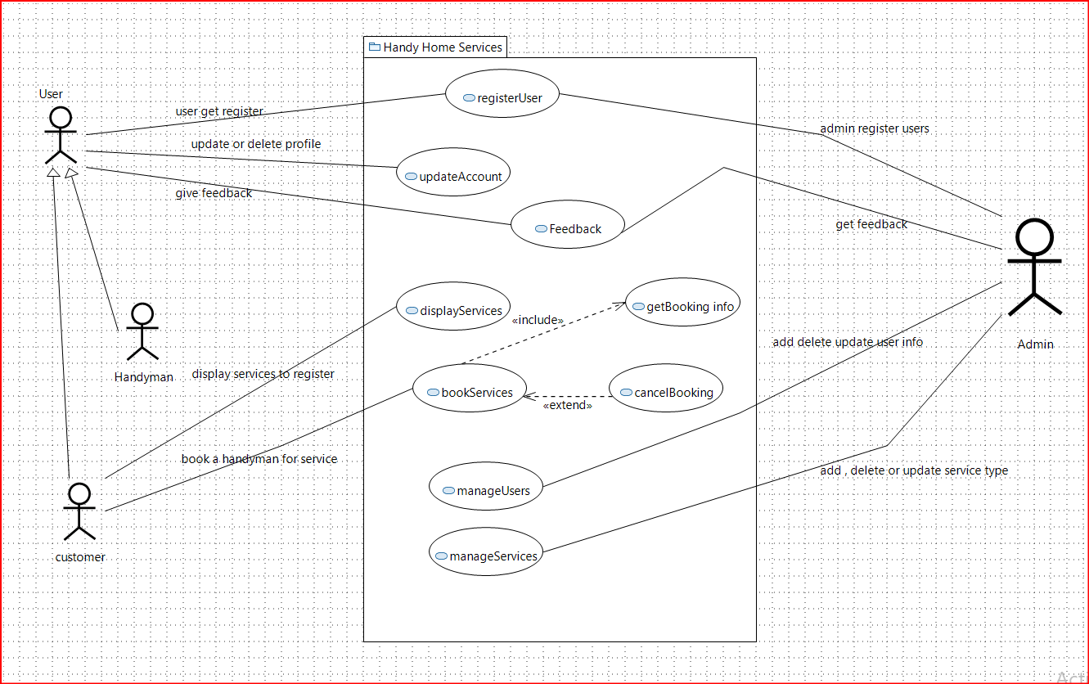

1. **Domain Model:**

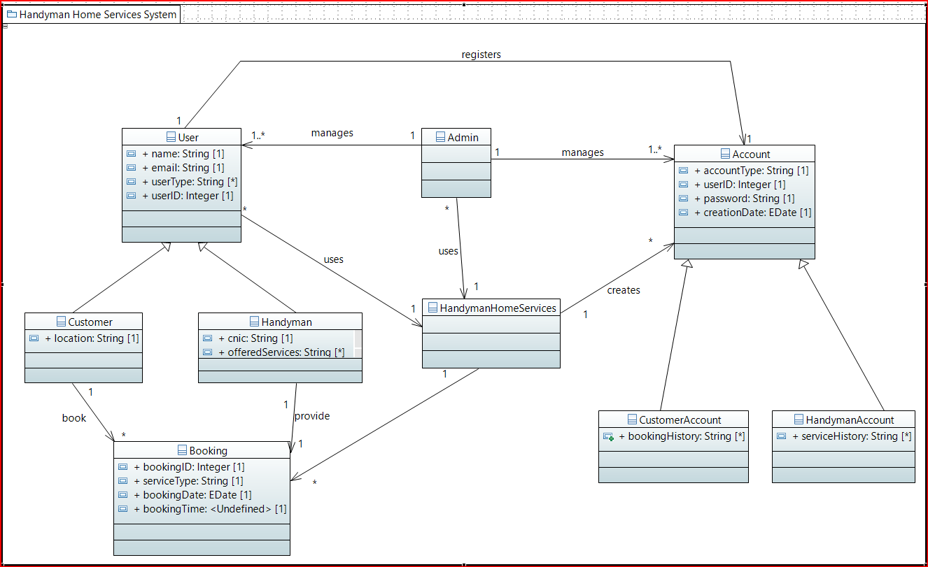**5. System Sequence Diagram:**

* 1. Register User:

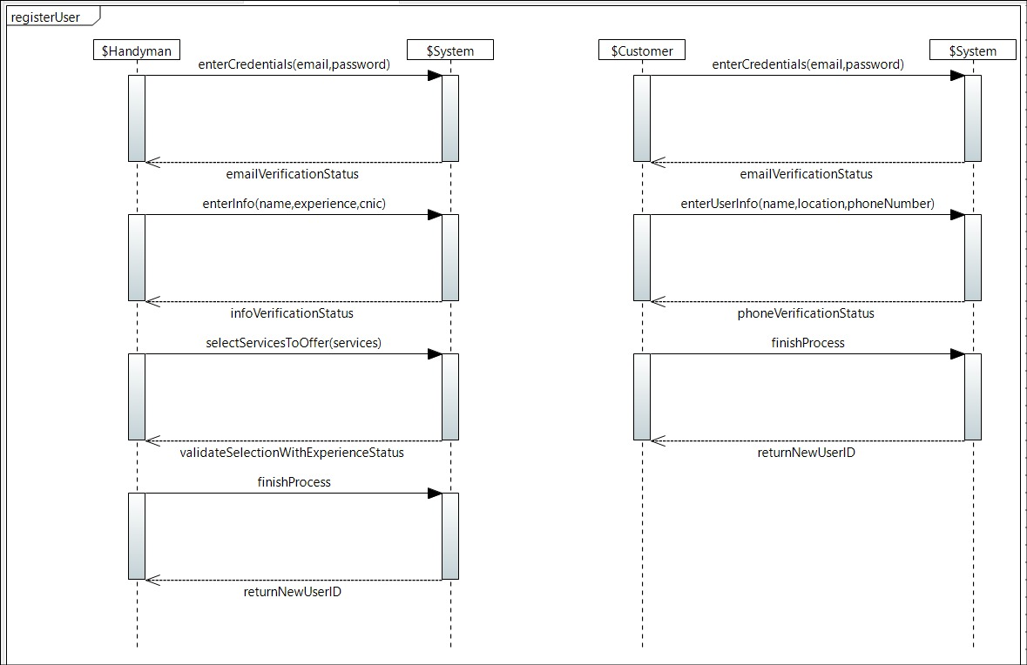

* 1. Update Account:

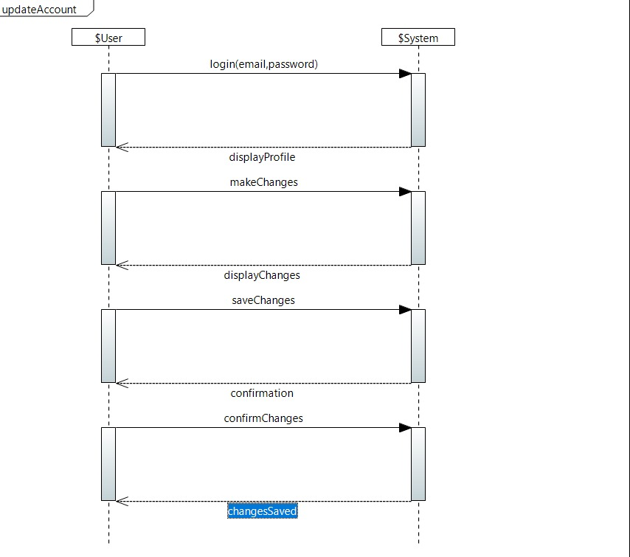

* 1. Display Services:

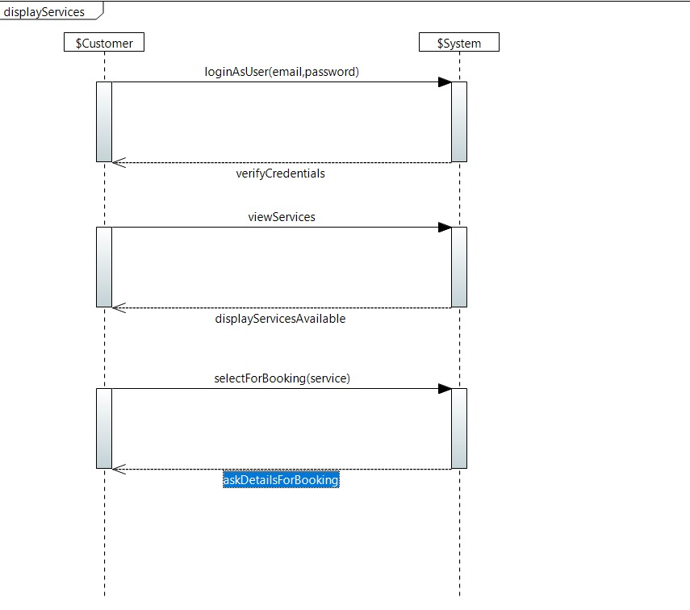

* 1. Book Services:

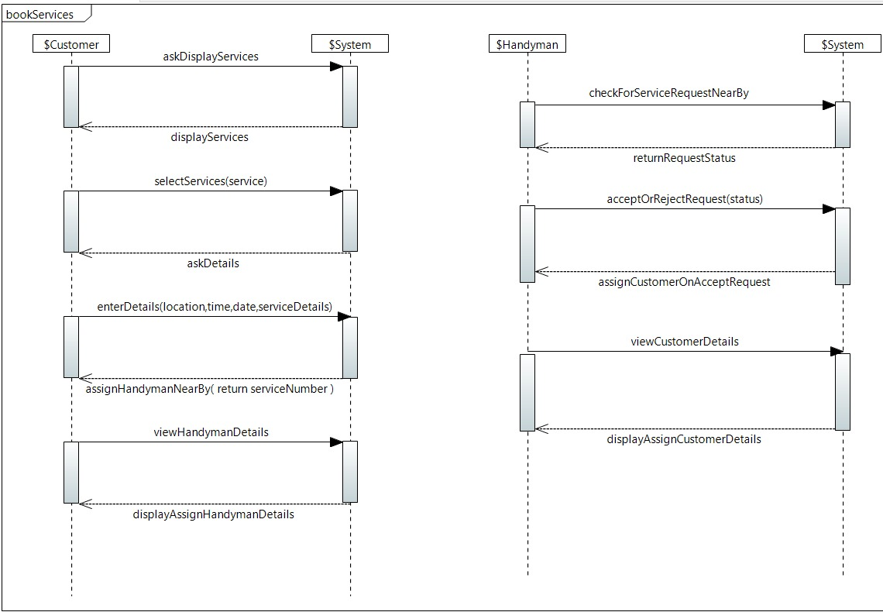

1. **Sequence Diagram:**
   1. Add a User

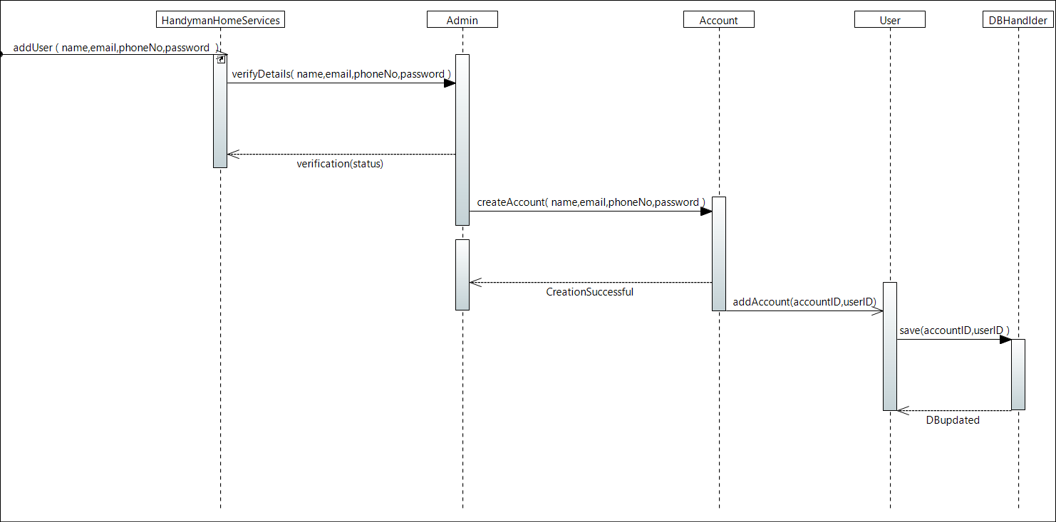

* 1. Book Services:

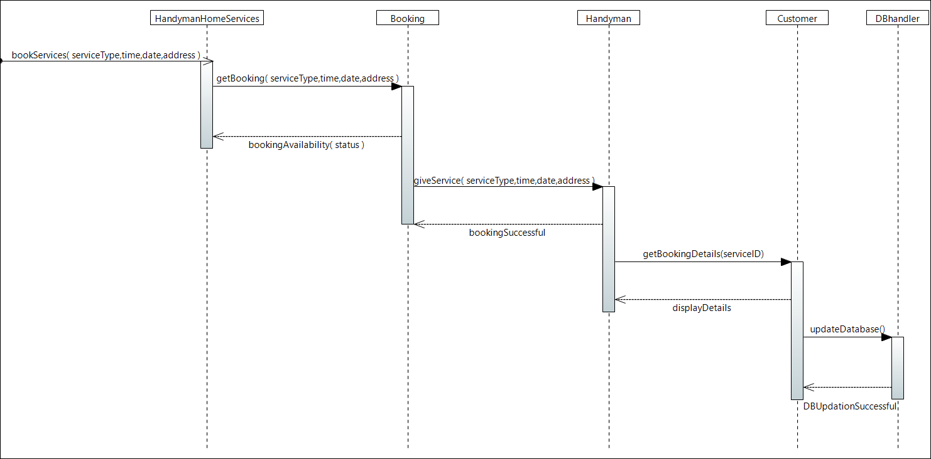

* 1. Update Account:

