

Lawyer Finding System
Software Requirement Specification, Design and Testing



Software Requirement Specification, Design and Testing on
“Lawyer Finding System”

Software Project Lab III
Course: SE 801

Supervised by
Rezvi Shahariar
Assistant Professor
Institute of Information Technology
University of Dhaka

Submitted by
Sazidul Islam
Roll: BSSE 0633
4th Year, 8th Semester
BSSE 06th Batch
Session: 2013-2014
Institute of Information Technology
University of Dhaka

Submission Date:
14th December, 2017

Document Authentication
This document is verified by the following individuals

…………………………………………………………. | ………………………………………….................
Rezvi Shahariar  Assistant Professor  Institute of Information Technology  University of Dhaka | Sazidul Islam  BSSE 0633  Institute of Information Technology  University of Dhaka

Letter of Transmittal

14th December, 2017
4th Year Program Committee
Institute of Information Technology
University of Dhaka

Subject: Submission of project report on “Lawyer Finding System”.

Sir, I, the student who selected “Lawyer Finding System” for Software Project Lab III, am submitting my report with due respect. I have tried my best for the report. However, it might lack perfection. So, may I therefore, hope that you would be kind enough to accept my report and oblige thereby.

Yours sincerely
Sazidul Islam
Roll: BSSE 0633
4th Year, 8th Semester
BSSE 06th Batch
Session: 2013-2014
Institute of Information Technology
University of Dhaka

Executive Summary
In our country many people are facing problems of finding legal advice from legal advisor or lawyer. Considering these problems, I want to implement the “lawyer finding system” which will reduce the problem of people. Lawyers can get registered into this system with their information. Normal user can search for any type of legal question. Lawyer can give answers to these questions. User can send appointment request to the lawyers. If the lawyers accept the request then user can get the personal information of that lawyer and communicate with the lawyer.

Acknowledgement
I respect and thank Rezvi Shahariar Sir, for giving me an opportunity to do the project under him and providing me all support and guidance which made me complete the project on time. I am extremely grateful to him for providing such a nice accompany though he had busy schedule managing the classes in university.

Table of Contents
Chapter 1: Introduction 6
1.1 Purpose 6
1.2 Intendment Audience 6
Chapter 2: Inception 7
2.1 Introduction 7
2.2 Identifying Stakeholders 7
2.3 Recognizing multiple viewpoints 8
2.4 Working towards Collaboration 9
2.5 Asking the First Question 10
2.6 Conclusion 10
Chapter 3: Elicitation 11
3.1 Introduction 11
3.2 Eliciting Requirements 11
3.2.1 Collaborative Requirement Gathering 11
3.2.2 Quality Function Deployment 12
3.3 Usage Scenarios 14
Chapter 4: Scenario Based Modeling 15
4.1 Definition of Use case 15
4.2 Use Case Diagrams 16
4.2.1 System Description from Level-0 use case: 16
4.2.2 System description from level-1 use case diagram: 17
4.3 Activity & Swim lane Diagrams 23
4.3.1 Activity Diagram 23
4.3.2 Swim Lane Diagram 30
Chapter 5: Data Model 37
5.1 Data modeling concepts 37
5.2 Data objects identification 37
5.3 Selected data objects 41
5.4 Relationship between data objects 42
5.5 Entity-Relationship diagram: 43
Chapter 6: Class Base Model 45
6.1 Class Based Modeling Concept 45
6.2 Identifying Analysis Classes 45
6.2.1 Accepted Classes: 47
6.2.2 Attribute Identification: 47
6.2.3 Method Identification: 48
6.2.4 Class Card 49
6.3 Class Responsibility Collaboration (CRC) 51
Chapter 7: Flow Oriented Model 52
7.1 Introduction 52
7.2 Data Flow Diagram (DFD) 52
7.2.1 Data Flow Diagram (DFD) for level 1.1 53
7.2.2 Data Flow Diagram (DFD) for level 1.2 54
Chapter 8: Behavioral Model 55
8.1 Introduction 55
8.2 Sequence Diagram 55
Chapter 9: Architectural Design 56
9.1 Architectural Design for OOP 56
9.1.1 Representing the System in Context: 56
9.1.2 Defining Archetypes’: 57
9.1.3 Refining Architecture into Components: 57
9.1.4 Classes: 57
9.1.5 Describing Instantiation of the System: 58
Chapter 10: Component-Level Design 59
10.1. Identify all design classes that correspond to the problem domain 59
10.2. Identify all design classes that correspond to the infrastructure domain 59
10.3. Elaborate all design classes that are not acquired as reusable components 59
10.3.1. Specify message details when classes or components collaborate 61
10.3.2 Identify appropriate interfaces for each component 62
10.3.3 Elaborate attributes and define data types and data structures required to implement them 62
10.4. Describe persistent data sources (databases and files) and identify the classes required to manage them 63
10.5. Develop and elaborate behavioral representations for a class or component 64
10.6. Elaborate deployment diagrams to provide additional implementation detail 66
Chapter 11: User Interface Design 67
11.1 User Profile 67
11.1.1 User profile model for Normal Users: 67
11.1.2 User profile model for Lawyers: 67
11.2 Event Transition Diagrams 68
11.3 User Interface 70
Index page: 70
Add Question Page: 70
Search question page: 71
Search Lawyer Page: 71
Question Add Confirmation Page: 72
Normal User Registration Page: 72
Lawyer Registration Page: 73
Login page: 73
Lawyer Profile Page: 73
Question List Page: 74
Answer Add page: 75
Answer Add Confirmation Page: 75
Appointment List Page: 76
Appointment Confirmation Page: 76
Lawyer Profile Update Page: 77
Lawyer Profile Delete Page: 77
Forget Password Page: 78
Reset Password Page: 78
Normal User Profile Page: 79
Normal User Profile Update Page: 79
Normal User Profile Delete Page: 80
Answer Edit Page: 80
Appointment List for Normal User: 81
Appointment Confirmation by Normal User: 81
Lawyer Public Profile for Accepted user: 82
Lawyer Public Profile for user: 82
Chapter 12: Testing Components 83
12.1 Test Plan Identifier 83
12.2 Introduction 83
12.2.1 Summary of items and features to be tested 83
12.2.2 High level description of testing goals 84
12.2.3 Reference to related documents 84
12.3 Test-Item to be Tested 85
12.4 Features to be Tested 85
12.5 Features not to be Tested 85
12.6 Approach 85
12.7 Item Pass/Fail Criteria 85
12.8 Suspension Criteria and Resumption Requirements 85
12.9 Test Deliverables 86
12.10 Environmental Needs 86
12.11 Staffing and Training Needs 86
12.12 Responsibilities 86
12.13 Risks and Contingencies 87
12.14 Testing Cost 87
12.15 Approval 87
12.16 Test Cases 88
Test cases for home page: 88
Test cases for Log in page: 93
Test cases for Registration: 94
Test cases for Forgot Password Page: 96
Test cases for Reset password: 97
Test cases for Question Add page: 97
Test cases for Searching Result page: 98
Test cases for Question List page: 98
Test cases for Create answer page: 99
Test cases for Answer List page: 99
Test cases for Appointment List for User page: 100
Test cases for Appointment confirmation page for Lawyer: 100
Test cases for Lawyer Profile page: 101
Test cases for Answer Delete page: 102
Test cases for Answer Edit page 102
Test cases for Lawyer update profile page: 103
Test cases for Lawyer Delete profile page: 104
Test cases for Lawyer Profile For others page: 104
Test cases for Appointment Create page: 105
Test cases for Appointment List for Lawyer page: 105
Chapter 13 106
Conclusion 106
References 107

Chapter 1: Introduction

This chapter is intended to specify the purpose of this document and the intended audiences of it.

1.1 Purpose
This document is the Software Requirement Specification (SRS) for an online legal advice and advisor finding system named “Lawyer Finding System”. It contains functional, non-functional and support requirements and establishes a requirements baseline for the development of the system. The requirements contained in the SRS are independent, uniquely identified, numbered, and organized by topic. The SRS serves as official means of communicating user requirements to the developer and provides a common reference point for both the developer team and stakeholder community. The SRS will evolve over time as users and developers work together to validate, clarify and expand its contents.

1.2 Intendment Audience
This SRS is intended for several audiences including the customers as well as the project managers, designers, developers, and testers.

- The customer will use this SRS to verify that the developer team has created a product that is acceptable to the customer.
- The project managers of the developer team will use this SRS to plan milestones and a delivery date, and ensure that the developing teams on track during development of the system.
- The designers will use this SRS as a basis for creating the system’s design. The designers will continually refer back to this SRS tonsure that the system they are designing will fulfill the customer’s needs.
- The developers will use this SRS as a basis for developing the system’s functionality. The developers will link the requirements defined in this SRS to the software they create to ensure that they have created software that will fulfill all of the customer’s documented requirements.
- The testers will use this SRS to derive test plans and test cases for each documented requirement. When portions of the software are complete, the testers will run their tests on that software to ensure that the software fulfills the requirements documented in this SRS. The testers will again run their tests on the entire system when it is complete and ensure that all requirements documented in this SRS have been fulfilled.

Chapter 2: Inception

2.1 Introduction
At project inception, we establish a basic understanding of the problem, the people who want a solution, the nature of the solution that is desired, and the effectiveness of preliminary communication and collaboration between the other stakeholders and the software team. To establish the groundwork, we have worked with the following factors related to the inception phases:

  - Identifying Stakeholders
  - Recognizing multiple viewpoints
  - Working towards collaboration
  - Asking the First Questions

2.2 Identifying Stakeholders

Anyone who gets benefited in a direct or indirect way from the system which is being developed is the stockholders. To identify the stakeholders, we consulted with several normal people and several lawyers, asked those following questions:

- What is the current process of finding legal advice from legal advisor or lawyer?
- Who will be using the project outcomes?
- From whom we can get the resource to get the project done?
- Whose work will affect our project (During the project and also once the project is (completed)?
- Whom else do you think I should talk to?

We gather all information about the Lawyer Finding System and identified the following stakeholders-

Lawyer: Lawyers can get registered into this system with Lawyer ID, Membership ID, Career Goal, Career summary, Professional Experience, Address, Email, Phone Number and later log in with their credentials. There will be a lawyer profile page which contains lawyer’s carrier info, professional’s details, skills and membership details. They can add additional information and edit and delete their info’s. Lawyers will get appointment notification from normal users and accept them to provide their contact information.

Normal User: The normal users need not to be registered into the system. They can search for any type of legal question. If they don’t find any question they can add this as a question which can be notified to lawyers. If they find the question then they can get their answers. User can go through the lawyer profile page by clicking on the appropriate answers which was given by this lawyer.
After visiting the profile page, the user can send appointment request to the lawyers. If the lawyers accept the request then user can get the personal information of that lawyer and communicate with the lawyer.

2.3 Recognizing multiple viewpoints
After discussing with several normal people and several lawyers, we have collected these viewpoints:

Lawyer’s viewpoints:
- Get notification in case of any changes or updates
- Less costly
- Less time consuming
- Get notification via mail
- Want to edit information any time

Normal user’s viewpoints:
- Allow the system to be accessed via internet
- Can be accessible from any computer that has an active internet connection
- Less time consuming
- Want a help corner where they can find general information of the system

2.4 Working towards Collaboration
We found different requirements from the different stakeholders. So, we follow some rules to identify the final requirements. Rules are:

- Identify the common and conflicting requirements
- Categorize the requirements
- Take priority points from the stakeholders for conflicting requirements
- Take final decision

Common requirements: We found the following requirements which are required by all the stakeholders:

- Easy to use and Well secure
- Less time consuming
- Web based interface
- Can be accessible from any computer that has an active internet connection
- Get notification for any changes and updates
- Want to search

Conflicting requirements: We also found some requirements those are conflicting each other’s.
- Easy to access and strong security
- Want fixed data and want to change data at any time
- Less costly but rich functionality

Final requirements: We select the final requirements for the system by categorizing and prioritizing them. The finalized requirements are:

- Easy to use and maintain
- Web based interface and no need to install
- Accessible through internet
- The Lawyers will go through the login and logout process to use their account after being registered.
- Searching module should be implemented.
- Different types of legal rights should be stored.
- Appointment Request for Lawyer must be implemented.
- The system shall able to send password reset link to e-mail of the Lawyers.
- Restrict access to functionality of the system based upon user roles.

2.5 Asking the First Question
We asked three set of context-free question
- We set our first set of context-free questions focuses on the customer and other stakeholders, overall project goals and benefits. This set of context-free question is explained above. These questions helped us to identify all stakeholders, measurable benefit of the successful implementation and possible alternatives to custom software development.
- Next set of question helped us to gain a better understanding of problem and allows the customer to voice his or her perception about the solution.
- The final set of question focused on the effectiveness of the communication activity itself.

2.6 Conclusion
In this chapter we identify the stakeholders and established a basis understanding of the whole system. We also found all the requirements that need to perform in this system.

Chapter 3: Elicitation

The purpose of this chapter is to specify the elicitation part.

3.1 Introduction
To complete the elicitation step, we have faced many problems like problems of scope, problems of volatility and problems of understanding. However, this is not an easy task. To help overcome these problems, we have worked with the Eliciting requirements activity in an organized and systematic manner.

3.2 Eliciting Requirements
Inception where Question and Answer approach is used; elicitation makes use of a requirements elicitation format that combines the elements of problem solving, elaboration, negotiation, and specification. It requires the cooperation of a group of end-users and developers to elicit requirements (1). To elicit requirements, we completed following four works.

- Collaborative Requirements Gathering
- Quality Function Deployment
- Usage Scenarios
- Elicitation work products

3.2.1 Collaborative Requirement Gathering
Many different approaches to collaborative requirements gathering have been proposed. Each makes use of a slightly different scenario. We completed following steps

- The meetings were conducted with several normal users and several lawyers. They were questioned about their requirements and expectations from the automated “Lawyer Finding System”.
- They were asked about the problems they are facing with the current manual system.
- At last we selected our final requirement list from the meetings.

3.2.2 Quality Function Deployment
Quality function deployment (QFD) known as a way to represent the “voice of the customer,” is a process for capturing customer requirements and translating them into requirements that can be used by designers, producers, and suppliers. It concentrates on maximizing customer satisfaction from the Software engineering process. With respect to our project the following requirements are identified by a QFD.

3.2.2.1 Normal Requirements
Normal requirements consist of objectives and goals that are stated during the meeting with the customers. Normal requirements of our project are: -

- Accessible via the Internet
- Allow System to check items for valid users.
- Allow valid users to login and logout.
- Restrict access to functionality of the system based upon user roles.
- Help feature to explain what they are looking for.
- A product reference manual describing how to use this automated software.

3.2.2.2 Expected Requirement
These requirements are implicit to the system and may be so fundamental that the customer does not explicitly state them. Their absence will be a cause for dissatisfaction. These are

  - Maintain a database of all items in the Lawyer Finding System.
  - The system shall enable the Administrator to change user passwords.
  - The system shall allow the user to log in based upon an assigned login id and password.
  - The Lawyers can add, change and delete their information any time.
  - Searching module should be implemented.
  - Different types of legal rights should be stored.
  - Appointment Request for Lawyer must be implemented.
  - The system shall able to send password reset lint to e-mail of the Lawyers.
  - The user interface of the system shall be easy to use and shall make use of drop-down boxes, radio buttons, and other selectable fields wherever possible instead of fields that require the user to type in data.

3.2.2.3 Exciting Requirements
These requirements are for features that go beyond the customer's expectations and prove to be very satisfying when present. These are-

- The user interface should provide appropriate error messages for invalid input as well as tool-tips and online help
- The user interface should follow standard web practices such that the web interface is consistent with typical internet applications.
- Offer log in with mobile phone.
- The system’s configuration shall be documented and updated as changes to the system are made due to patches, new releases, etc.

3.3 Usage Scenarios

Lawyer Finding System

In our country many people are facing problems of finding legal advice from legal advisor or lawyer. Considering these problems, I want to implement the “lawyer finding system” which will reduce the problem of people. The system's homepage contains, login, registration and searching module.
Lawyers can get registered into this system with Lawyer ID, Membership ID, Career Goal, Career summary, Professional Experience, Address, Email, Phone Number and later log in with their credentials. There will be a lawyer profile page which contains lawyer’s carrier info, professional’s details, skills and membership details. They can add additional information and edit and delete their info’s. Lawyers will get appointment notification from normal users and accept them to provide their contact information.
The normal users need not to be registered into the system. They can search for any type of legal question. If they don’t find any question they can add this as a question which can be notified to lawyers. If they find the question then they can get their answers. They can go through the lawyer profile page by clicking on the appropriate answers which was given by this lawyer. They can also search lawyer by nearby area.
After visiting the profile page, the user can send appointment request to the lawyers. If the lawyers accept the request then user can get the personal information of that lawyer and communicate with the lawyer.

Chapter 4: Scenario Based Modeling

Scenario-based modeling depicts how the user interacts with the system and the specific sequence of activities that occur as the software is used. This chapter describes the scenario-based modeling for the Lawyer Finding System. (1)

4.1 Definition of Use case
A use case is a series of related interactions between a user and a system that enables the user to achieve a goal. A use case diagram simply describes a story using corresponding actors, who perform important role in the story and makes the story understandable for the users.

The first step in writing a use case is to define that set of “actors” that will be involved in the story. Actors are the different people that use the system or product within the context of the function and behavior that is to be described. Actors represent the roles that people play as the system operators. Every user has one or more goals when using system.

Primary Actor:

Primary actors interact directly to achieve required system function and derive the intended benefit from the system. They work directly and frequently with the software.

Secondary Actor:

Secondary actors support the system so that primary actors can do their work. They either produce or consume information.

4.2 Use Case Diagrams
Use case diagrams give the non-technical view of overall system.

4.2.1 System Description from Level-0 use case:
After analyzing the user story, we found five actors who will directly use the system as a system operator. Primary actors are those who will play action and get a reply from the system whereas secondary actors only produce or consume information. (2)

Following are the actors of registration system –
- Lawyer
- Normal User

4.2.1.1 Level-0 Use Case Diagram

In this level of use case diagram describes the overall system and the actors interacting with the system. Here in our system we have two actors interacting with the system.

Figure 01: Level 0

4.2.2 System description from level-1 use case diagram:

The actors of Lawyer finding system have to play different actions and system will reply according to these actions –

Lawyer:

Action1: Enters signup.
Reply1: Please fill up the require information.
Action2: Enters the information.
Reply2: Registration successful. Action3: Enters username and password.
Reply3: Login successful.
Action4: Changing lawyer information Reply4: Information changed.
Action5: Viewing the request of Normal User
Reply5: Request viewed.
Action6: Receiving notification from email.
Reply6: Notification received.

Normal User:

Action1: Enters question for searching.
Reply1: Searching result displayed.
Action2: Enters question to be added.
Reply2: Question added successfully.
Action3: Searching Lawyer by area.
Reply3: Searching result displayed.
Action4: Send appointment request.
Reply4: request sent.

4.2.2.1 Level-1 use case diagram for Lawyer Finding System:

Figure 02: Level 1
Subsystems of Authentication: If any lawyer wants to perform any task then he needs to go through the authentication process. At first the lawyer need to have an account if they want to interact with the system. If they have not any account, then they need to sign up.

Figure 03: Level 1.1
Subsystems of Profile management: Lawyers can get registered into this system with Lawyer ID, Membership ID, Career Goal, Career summary, Professional Experience, Address, Email, Phone Number and later log in with their credentials. There will be a lawyer profile page which contains lawyer’s carrier info, professional’s details, skills and membership details. They can add additional information and edit and delete their info’s.

Figure 04: Level 1.2
Subsystems of Asking Question: The normal users need not to be registered into the system. They can search for any type of legal question. If they don’t find any question they can add this as a question which can be notified to lawyers. If they find the question then they can get their answers

Figure 05: Level 1.3
Subsystems of Search Lawyer to get appointment: If Normal user find the question then they can get their answers. They can go through the lawyer profile page by clicking on the appropriate answers which was given by this lawyer. They can also search lawyer by nearby area. They can send appointment request to the lawyers. If the lawyers accept the request then user can get the personal information of that lawyer and communicate with the lawyer.

Figure 06: Level 1.4

4.3 Activity & Swim lane Diagrams
Activity diagrams and swim lane diagrams for the Lawyer finding system are given below-

4.3.1 Activity Diagram
An activity diagram represents the actions and decisions that occur as some function is performed. (1)

4.3.1.1Activity Diagram for user registration

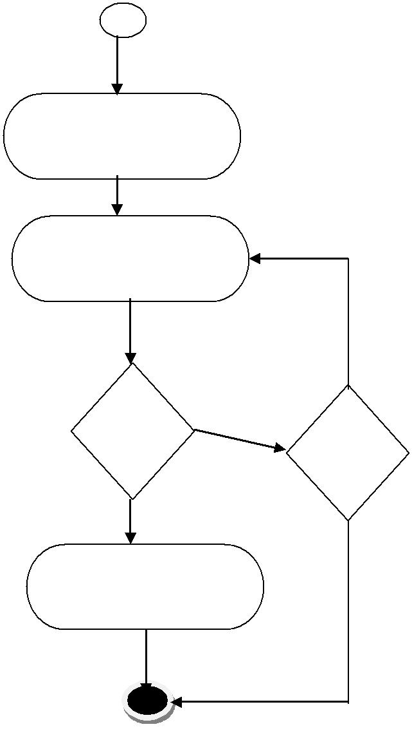
Yes
No
Yes
No
Registration Complete
If retry
If valid
Enter information
Click Registration

Figure 07: Activity diagram of user registration

4.3.1.2 Activity Diagram for user login

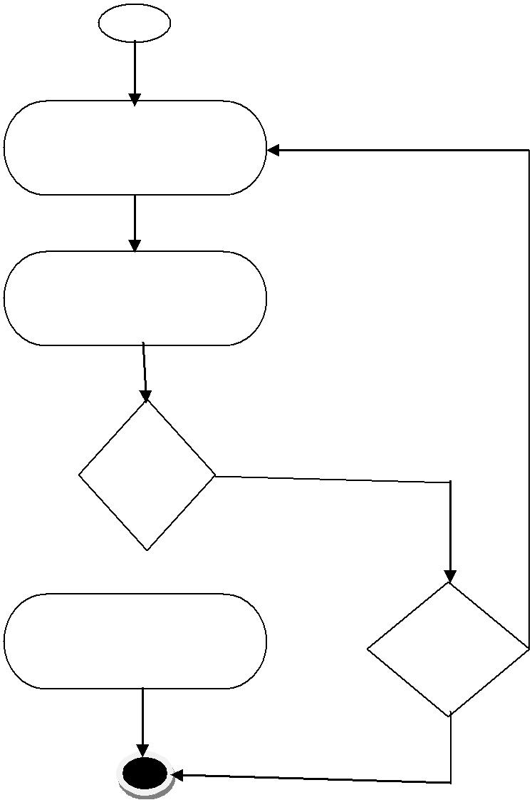

Enter Email

Enter Password
Yes

No
If valid

Yes

Login Successful
If retry
No

Figure 08: Activity diagram of user login

4.3.1.3 Activity Diagram for logged out

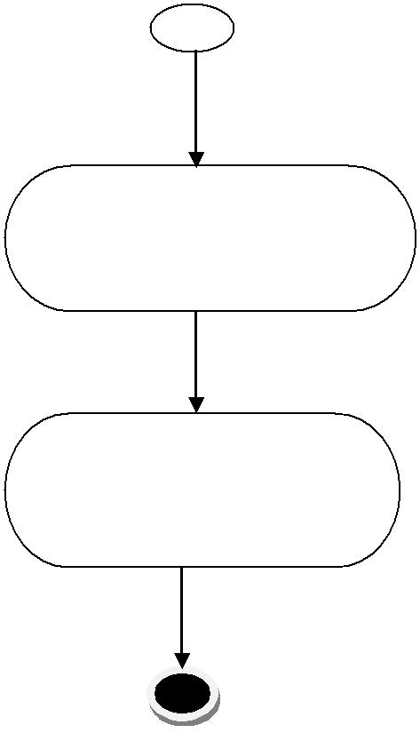

Click log out

Logged out

Figure 09: Activity diagram of user logout

4.3.1.4 Activity Diagram for changing password

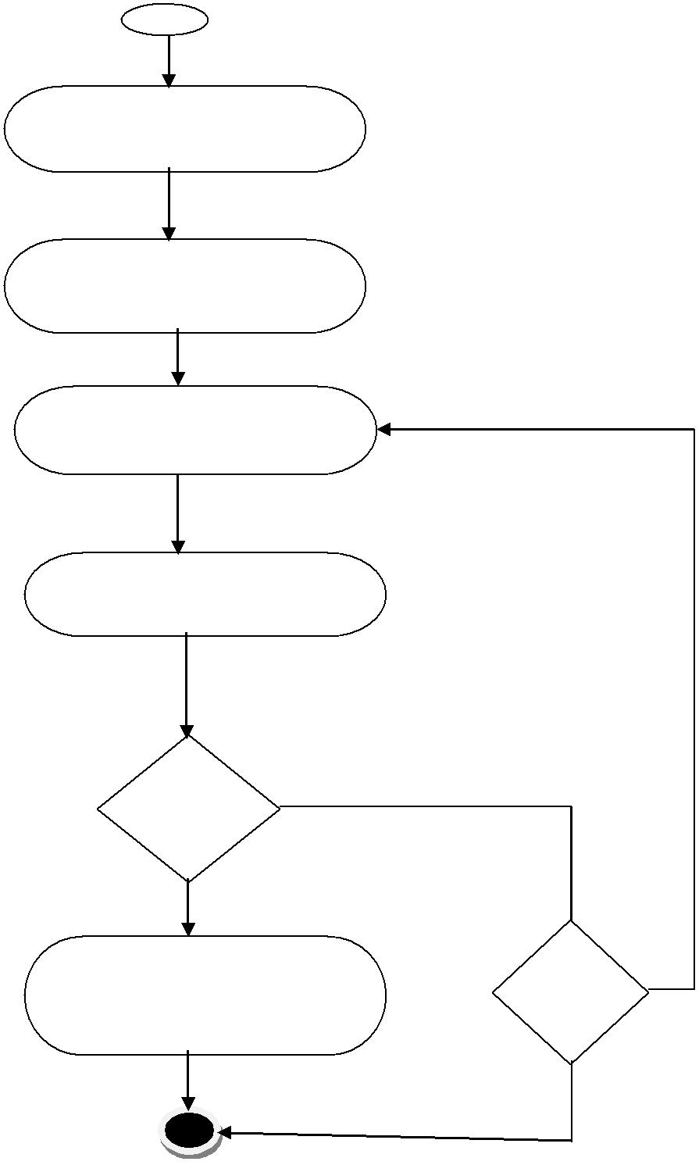

Click password change

Enter Old password

Enter new password

Yes
Re-enter new password

If match
No

Yes

Password changed successfully
If retry
No

Figure 10: Activity diagram of changing password

4.3.1.5 Activity Diagram for Profile Management

Figure 11: Activity Diagram for Profile Management

4.3.1.6 Activity Diagram for Asking Question

Figure 12: Activity Diagram for Asking Question

4.3.1.7 Activity Diagram for Searching Lawyer to get appointment

Figure 13: Activity Diagram for Searching Lawyer to get appointment

4.3.2 Swim Lane Diagram

Swim lane diagram is a useful variation of the activity diagram and allows representing the flow of activities described by the use case and at the same time indicate which actor by an activity rectangle. (1)

4.3.2.1 Swim lane Diagram for User registration

Figure 14 : Swim lane Diagram for User registration

4.3.2.2 Swim lane Diagram for User Logged in

Figure 15: Swim lane Diagram for User Logged in

4.3.2.3 Swim lane Diagram for User Logged out

Figure 16: Swim lane Diagram for User Logged out

4.3.2.3 Swim lane Diagram for Password change

Figure 17: Swim lane Diagram for User Password Change

4.3.2.5 Swim lane Diagram for Profile Management

Figure 18: Swim lane Diagram for Profile Management

4.3.2.6 Swim lane Diagram for Asking Question

Figure 19: Swim lane Diagram for Asking Question

4.3.2.7 Swim lane Diagram for Searching Lawyer to get appointment

Figure 20: Swim lane Diagram for Searching Lawyer to get appointment

Chapter 5: Data Model

5.1 Data modeling concepts

If software requirements include the need to create, extend, or interface with a database or if complex data structures must be constructed and manipulated, the software team may choose to create a data model as part of overall requirements modeling (3).

5.2 Data objects identification

A data object is a representation of composite information. Composite information means the data objects will have multiple attributes. We need to identify those data objects. We used the “grammar parsing” method for this purpose, that is, we selected nouns from the scenario and searched which one has multiple attributes in our context. (1)

A table in this regard is given below-

 | Noun |  | Problem space / |  | Attributes |  | Decision
 |  |  | Solution space
 | country |  | Problem space
 | people |  | Problem space
 | problems |  | Problem space
 | advice |  | Problem space
 | advisor |  | Problem space
lawyer |  | Solution space |  | Lawyer ID, Membership ID, Career Goal, Career summary, Professional Experience, Address, Email, Phone ,userID |  | Potential data object

Noun | Problem space / |  | Attributes |  |  | Decision
 | Solution space
system | Problem space
homepage | Problem space
login | Problem space
registration | Problem space
searching | Problem space
module
Answer ID | Solution space |  |  |  |  | Attribute of another data object
Question ID | Solution space |  |  |  |  | Attribute of another data object
Answer Content | Solution space |  |  |  |  | Attribute of another data object
Question Content | Solution space |  |  |  |  | Attribute of another data object
Lawyer ID | Solution space |  |  |  |  | Attribute of another data object
Membership ID | Solution space |  |  |  |  | Attribute of another data object
Career Goal | Solution space |  |  |  |  | Attribute of another data object
Career summary | Solution space |  |  |  |  | Attribute of another data object

Noun | Problem space / | Attributes | Decision
 | Solution space
Email | Solution space |  | Attribute | of
 |  |  | another | data
 |  |  | object
Contact | Solution space |  | Attribute | of
number |  |  | another | data
 |  |  | object
Professional Experience | Solution space |  | Attribute | of
 |  |  | another | data
 |  |  | object
Address | Solution space |  | Attribute | of
 |  |  | another | data
 |  |  | object
carrier info | Solution space
  Attribute | of
  another | data
  object
Profile page | Problem space
professional’s details | Solution space |  | Attribute of
 |  |  | another data
 |  |  | object
Credentials
  Problem space
skills | Solution space |  | Attribute | of
 |  |  | another | data
 |  |  | object

Noun | Problem space/ | Attributes | Decision
 | Solution space
membership details | Solution space |  | Attribute | of
 |  |  | another | data
 |  |  | object
contact information | Solution space |  | Attribute of another data
 |  |  | object
notification | problem space
normal users | Solution space | Name, Address, userID, Lawyer ID, Password | Potential Data Object
information | problem space
question | Solution space | Question ID, Question Content | Potential data object
answers | Solution space | Answer ID, Answer Content, Question ID, Lawyer ID | Potential data object
appointment | Problem space
Name | Solution space |  | Attribute of another
Address | Solution space |  | Attribute of another
personal information | Problem space

Table no: 01

5.3 Selected data objects

We found following data objects in Lawyer Finding System–

Lawyer:

- Lawyer ID,
- Password
- Membership ID
- Career Goal
- Career summary
- Professional Experience
- Address
- Email
- Phone Number

Question:

- Question ID
- Question Content

Answer:

- Answer ID
- Answer Content
- Lawyer ID
- Question ID

Normal User:

- User ID
- Name
- Password
- Address
- Lawyer ID

5.4 Relationship between data objects

Provides
Normal User
Lawyer
Stored for
Answer

Answer

Question

Send request
Lawyer

Question
Add
Normal User

5.5 Entity-Relationship diagram:

Figure 21: Entity Relationship Diagram

Final Data Objects are:
Lawyer:
- Lawyer ID,
- Password
- Membership ID
- Career Goal
- Career summary
- Professional Experience
- Address
- Email
- Phone Number

Question:
- Question ID
- Question Content

Answer:
- Answer ID
- Answer Content
- Lawyer ID
- Question ID

Normal User:
- User ID
- Name
- Password
- Address
- Lawyer ID

Request for Appointment:
- Appointment ID
- Normal User ID
- Lawyer ID
- Normal User Confirm
- Lawyer Confirm

Chapter 6: Class Base Model

6.1 Class Based Modeling Concept

Class-based modeling represents the objects that the system will manipulate, the operations that will applied to the objects, relationships between the objects and the collaborations that occur between the classes that are defined. (4)

6.2 Identifying Analysis Classes

Identifying and categorize all nouns and Selection of potential class. (1)

General classification criteria:

- External entities
- Things
- Occurrence or events
- Roles
- Organizational units
- Places
- Structures

Selection characteristics:

- Retained information
- Needed services
- Multiple attributes
- Common attributes
- Common operations
- Essential requirements

Identifying potential classes based on their general classification and select as classes by applying selection criteria upon potential classes.

Potential | General | Characteristics that | Accepted/Rejected
Classes | classification criteria | can be applied
Username | Things | 1, 2, 6 | Rejected
Password | Things | 1, 2,6 | Rejected
Lawyer | Roles, structures | 1, 2, 3, 4, 5, 6 | Accepted
Lawyer ID | Things | 1,6 | Rejected
Membership ID | Things | 1,6 | Rejected
Career Goal | Things | 1,6 | Rejected
Career summary | Things | 1,6 | Rejected
Email | Things | 1,6 | Rejected
Contact number | Things | 1,6 | Rejected
Gender | Things | 1,6 | Rejected
Professional Experience | Things | 1,6 | Rejected
Residential | Things | 1,6 | Rejected
Address
Blood group | Things | 1,6 | Rejected
Normal User | Roles, structures | 1, 2, 3, 4, 5, 6 | Accepted
Database | Things, Roles | 1, 2, 3, 4, 5, 6 | Accepted
Question | Things, Roles | 1, 2, 3, 4, 5, 6 | Accepted
Answers | Things, Roles | 1, 2, 3, 4, 5, 6 | Accepted

Table no: 02

6.2.1 Accepted Classes:
- Lawyer
- Normal User
- answers
- question
- Database

6.2.2 Attribute Identification:

Class Name | Attributes
Lawyer | Username, Password, Name, Lawyer ID, , Membership ID, Career Goal, Career summary, Professional Experience,
 | Address, Email, Phone Number
Normal User | Username, Password, Address, Name
Answers | Answer, Question ID, Answer ID, Lawyer ID
question | Question ID, Question
Database

Table no: 03

6.2.3 Method Identification:

Verb |  | Remark
Login |  | Yes
Register |  | Yes
Add |  | Yes
Edit |  | Yes
Delete |  | Yes
Logout |  | yes
Get |  | Yes
Provide |  | Yes
Need |  | Out of scope
Search |  | Out of scope
Find |  | Yes
Notify |  | Yes
Go |  | Out of scope
Click |  | Out of scope
Give |  | Out of scope
Visit |  | Out of scope
Send |  | Out of scope
Accept |  | Yes
communicate |  | Yes

Table no: 04
A table for representing different class and their methods are given below:

Class Name | Methods
Lawyer | Register ()
 | Login ()
 | Logout ()
 | provide ()
Edit()
Delete()
Add()
Normal User | Search()
 | Request()
Get()
Add()
Database | Insert()
 | Update()
 | Delete()
Question | Add()
Answers | Add()
 | Edit()
 | Delete()

Table no: 05

6.2.4 Class Card

Lawyer
Attributes | Methods
Username, Password, Name, Lawyer ID, Membership ID, Career Goal, Career summary, Professional Experience, Address, Email, Phone Number | Register (), Add (), Login (), logout (), Get (), Change ()
Responsibilities | Collaborative Classes
View question | Question
Changing information | Database
Add Answer | Answer
Provide information | Normal User
Normal User
Attributes | Methods
Username, Password, Address, Name | Register (), Add (), Login (), logout(), Change()
Responsibilities | Collaborative Classes
Search Lawyer | Lawyer
Changing information | Database
Add Question | Question

answers
Attributes | Methods
Answer, Question ID, Answer ID, Lawyer ID | Add (), Edit (), Delete (), Get (), store ()
Responsibilities | Collaborative Classes
Being added | Lawyer
Being stored | Database
Being got | Normal User

Question
Attributes | Methods
Question ID, Question | Add (), store ()
Responsibilities | Collaborative Classes
Being added | Normal User
Being stored | Database

Database
Attributes | Methods
 | store (), Update (), Delete ()
Responsibilities | Collaborative Classes
Being stored | Normal User, Lawyer
Being updated | Lawyer
Being deleted | Lawyer

Table no: 06

6.3 Class Responsibility Collaboration (CRC)

Normal User
Searching info, Question
Search (), Request (), Get (), Add ()

Lawyer
Username, Password, Name, Lawyer ID, Membership ID, Career Goal, Career summary, Professional Experience, Address, Email, Phone Number
Register (), Login (), logout (), Get (), Change (), Add (), Provide ()

Provide

Database
store (), Update (), Delete ()
Question
Question ID, Question

Add (), store ()
Answer
Answer, Question ID, Answer ID, Lawyer ID
Add (), Edit (), Delete (), Get (), store ()
Add
Add
change
store
store
Add

Figure 22: Class Responsibility Collaboration Diagram

Chapter 7: Flow Oriented Model

7.1 Introduction

Although data flow-oriented modeling is perceived as an outdated technique by some software engineers, it continues to be one of the most widely used requirements analysis notations in use today. (5)

7.2 Data Flow Diagram (DFD)

The Data Flow Diagram (DFD) takes an input-process-output view of a system. Data objects flow into the software, are transformed by processing elements and resultant data objects flow out of the software. Data objects are represented by labeled arrows and transformations are represented by circles. (1)

Figure 23: Data Flow Diagram (DFD) for level 0

7.2.1 Data Flow Diagram (DFD) for level 1.1

Figure 24: Data Flow Diagram (DFD) for level 1.1

7.2.2 Data Flow Diagram (DFD) for level 1.2

Figure 25: Data Flow Diagram (DFD) for level 1.2

Chapter 8: Behavioral Model

8.1 Introduction
Behavior modeling is also referred to as State modeling, State machines and State transition matrix. Behavior modeling is when one thinks of his ideas in terms of states and transitions. This requires both identifying all of the interesting states of being that software or its components are likely to be in. And also, at a high level, abstracting what events are likely to cause software or its components to change between states of being. (1)

8.2 Sequence Diagram
Sequence diagram indicates how events cause transitions from object to object. (6)

Figure 26: Sequence Diagram

Chapter 9: Architectural Design

9.1 Architectural Design for OOP

9.1.1 Representing the System in Context:

Figure 27: ACD of Lawyer Finding system

9.1.2 Defining Archetypes’:
- Authentication
- Profile Management
- Asking Question
- Adding Answer
- Searching Lawyer
- Appointment

9.1.3 Refining Architecture into Components:
  - Sign in, Sign up, change password
  - Add Lawyer info, Update Lawyer info, Delete Lawyer info
  - Searching Question, Adding Question
  - Add answer according to questions
  - Search Lawyer by address
  - Send appointment request, accept appointment request

9.1.4 Classes:
- Lawyer
- Lawyer
- Question, Normal User
- Answer, Lawyer
- Lawyer, Normal User
- Lawyer, Normal User

9.1.5 Describing Instantiation of the System:

Figure 28: Instantiation of the System

Chapter 10: Component-Level Design

10.1. Identify all design classes that correspond to the problem domain
Using the requirements and architectural model, we found- (1)
- Lawyer
- Question
- Normal User
- Answer

10.2. Identify all design classes that correspond to the infrastructure domain
From given requirements, we found following this as an infrastructure for data management.
- Database (DB)

10.3. Elaborate all design classes that are not acquired as reusable components

Lawyer
Email, Password, Name, Lawyer ID, Membership ID, Career Goal, Career summary, Professional Experience, Address, Phone Number
Register (), Login (), logout (), Get (), Change (), Add (), AcceptRequest ()
Normal User
Username, Password, User ID, Name
Register (), Login (), logout (), Search (), Request (), Get (), Add ()

Database
insert (), Update (), Delete ()
Answer
Answer, Question ID, Answer ID, Lawyer ID
Add (), Edit (), Delete (), Get (), store ()

Question
Question ID, Question

Add (), store ()

Figure 29: Class Elaboration

10.3.1. Specify message details when classes or components collaborate

Figure 30: Class collaboration diagram

10.3.2 Identify appropriate interfaces for each component
There is no necessity to divide the classes in subclasses as they exhibit sufficient cohesion. So, there is no need to define appropriate interfaces.

10.3.3 Elaborate attributes and define data types and data structures required to implement them
Lawyer
UserID: number = null {All positive integers}
Password: string = null {All characters from A-Z and digits}
Name: string = null {All characters from A-Z and digits}
Lawyer ID: string = null {All characters from A-Z and digits}
Membership ID: string = null {All characters from A-Z and digits}
Career Goal: string = null {All characters from A-Z and digits}
Career summary: string = null {All characters from A-Z and digits}
Professional Experience: string = null {All characters from A-Z and digits}
Address: string = null {All characters from A-Z and digits}
Email: string = null {All characters from A-Z and digits}
Phone Number: number = null {All positive integers}
Normal User
UserID: number = null {All positive integers}
Password: string = null {All characters from A-Z and digits}
Name: string = null {All characters from A-Z and digits}
Address: string = null {All characters from A-Z and digits}
Answer
Answer: string = null {All characters from A-Z and digits}
Question ID: number = null {All positive integers}
Answer ID: number = null {All positive integers}
Lawyer ID: number = null {All positive integers}
Question
Question ID: number = null {All positive integers}
Question: string = null {All characters from A-Z and digits}

10.4. Describe persistent data sources (databases and files) and identify the classes required to manage them
Persistent Data Source:
Microsoft SQL Server is a powerful and reliable free data management system that delivers a rich and reliable data store for lightweight Web Sites and desktop applications.
Classes required to manage:
Database

10.5. Develop and elaborate behavioral representations for a class or component

Figure 31: Behavior diagram of Lawyer Class

Figure 32: Behavior diagram of Normal User Class

10.6. Elaborate deployment diagrams to provide additional implementation detail

Figure 33: Deployment diagram

Chapter 11: User Interface Design

11.1 User Profile
These questions are related to user profile selection- (1)

11.1.1 User profile model for Normal Users:
Q - Are users trained professionals, technicians, clerical, or manufacturing workers?
A – All of them.
Q - What is the primary spoken language among users?
A – Bengali.
Q - What is the age range of the user community?
A – any age.
Q - What level of formal education does the average user have?
A – Basic English knowledge, basic computer knowledge and Internet browsing.
Q - Are the users capable of learning from written materials?
A – Yes.
Q - Will the users be represented predominantly by one gender?
A – No.
Q - Do users want to know about the technology that sits behind the interface?
A – No.

11.1.2 User profile model for Lawyers:
Q - Are users trained professionals, technicians, clerical, or manufacturing workers?
A – All of them.
Q - What is the primary spoken language among users?
A – Bengali.
Q - What is the age range of the user community?
A – 24 to any.
Q - What level of formal education does the average user have?
A – Basic English knowledge, basic computer knowledge and Internet browsing.
Q - Are the users capable of learning from written materials?
A – Yes.
Q - Will the users be represented predominantly by one gender?
A – No.
Q - Do users want to know about the technology that sits behind the interface?
A – No.

11.2 Event Transition Diagrams

Figure 34: Event Transition Diagrams

11.3 User Interface

Index page:
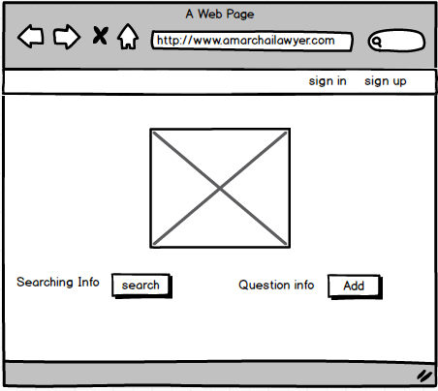
Figure 35: User Interface for Index page

Add Question Page:
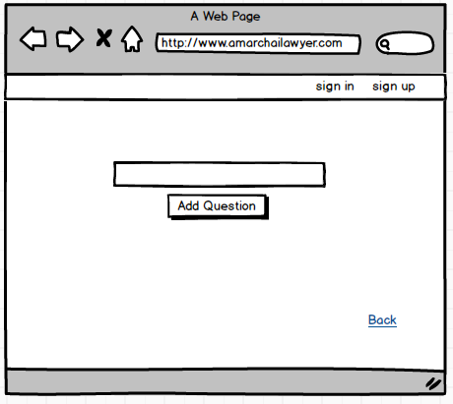
Figure 36: User Interface for Add Question Page

Search question page:
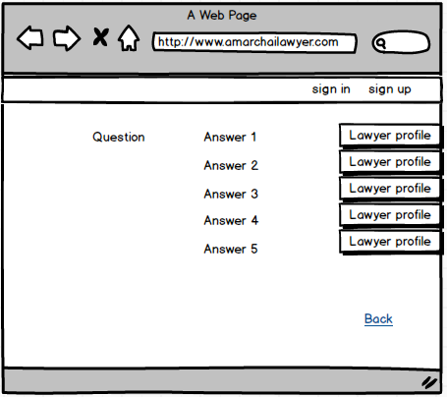
Figure 37: User Interface for Search question page

Search Lawyer Page:

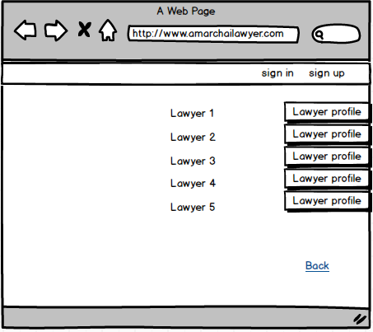

Figure 38: User Interface for Search Lawyer Page

Question Add Confirmation Page:
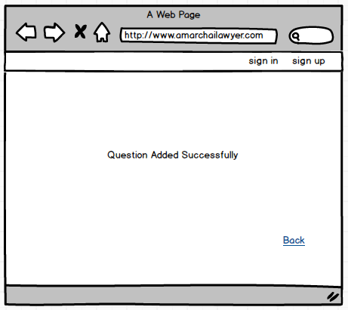
Figure 39: User Interface for Question Add Confirmation Page

Normal User Registration Page:
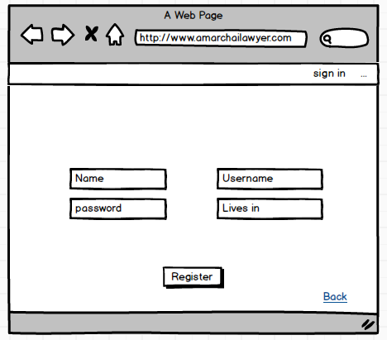

Figure 40: User Interface for Normal User Registration Page

Lawyer Registration Page:
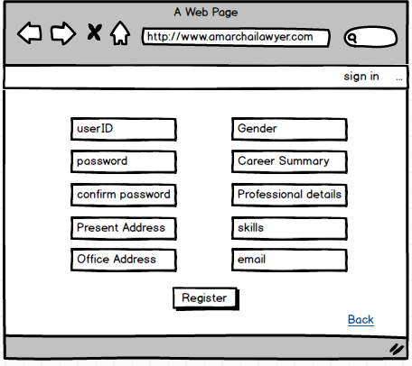
Figure 41: User Interface for Lawyer Registration Page

Login page:
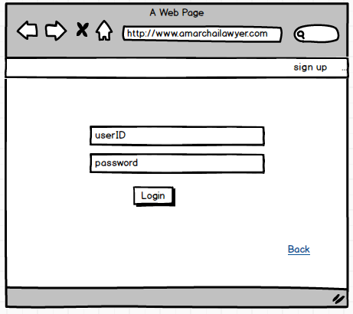
Figure 42: User Interface for Login page
Lawyer Profile Page:

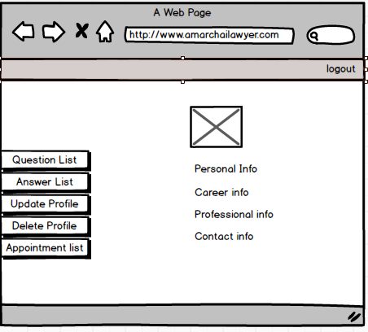
Figure 43: User Interface for Lawyer Profile Page

Question List Page:
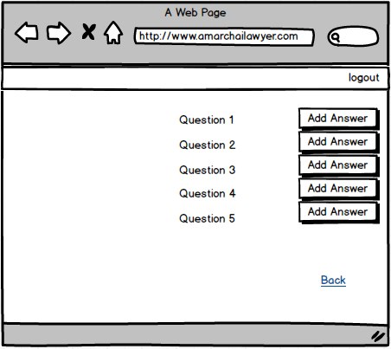
Figure 44: User Interface for Question List Page

Answer Add page:
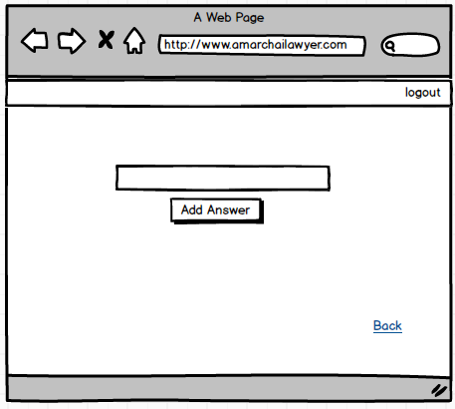
Figure 45: User Interface for Answer Add page

Answer Add Confirmation Page:
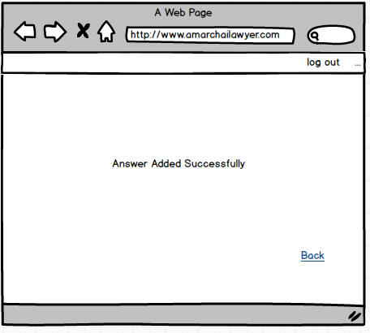
Figure 46: User Interface for Answer Add Confirmation Page

Appointment List Page:
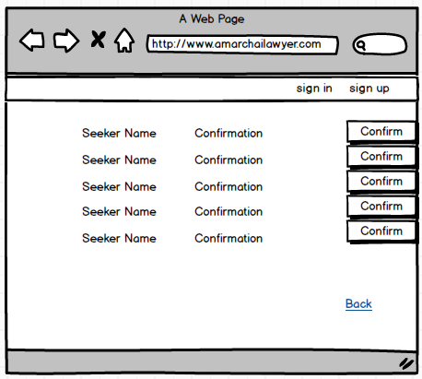
Figure 47: User Interface for Appointment List Page

Appointment Confirmation Page:
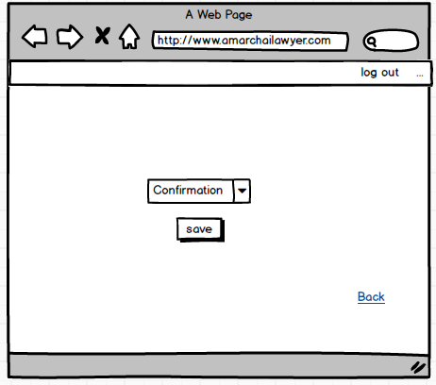
Figure 48: User Interface for Appointment Confirmation Page

Lawyer Profile Update Page:
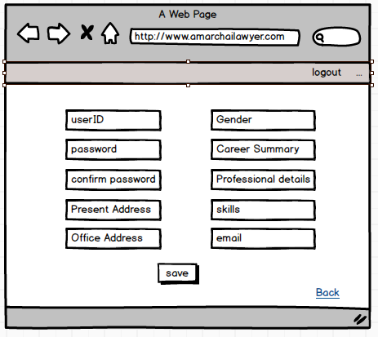
Figure 49: User Interface for Lawyer Profile Update Page

Lawyer Profile Delete Page:
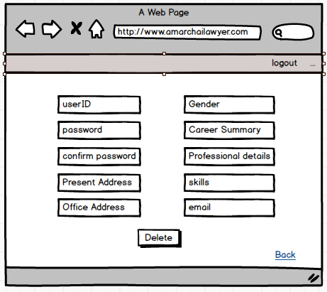
Figure 50: User Interface for Lawyer Profile Delete Page

Forget Password Page:
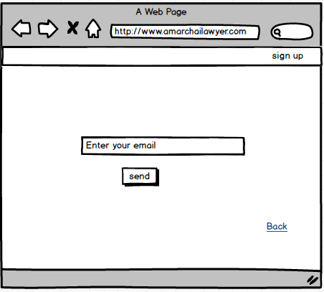
Figure 51: User Interface for Forget Password Page

Reset Password Page:
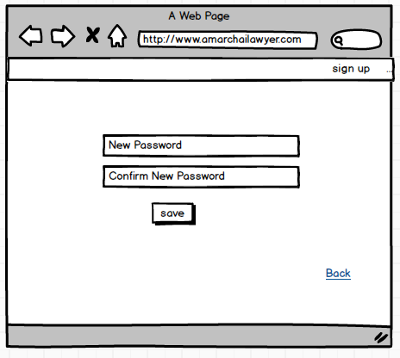
Figure 52: User Interface for Reset Password Page

Normal User Profile Page:
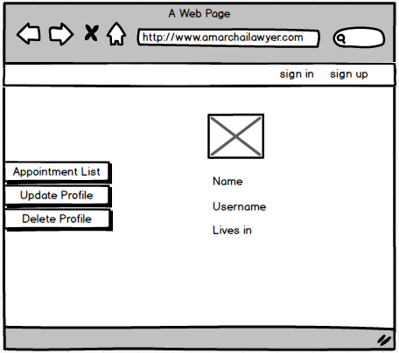
Figure 53: User Interface for Normal User Profile Page

Normal User Profile Update Page:
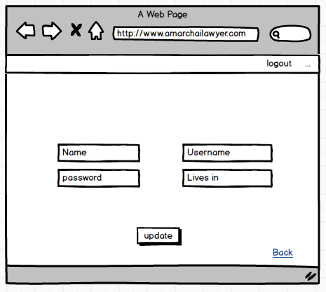
Figure 54: User Interface for Normal User Profile Update Page

Normal User Profile Delete Page:
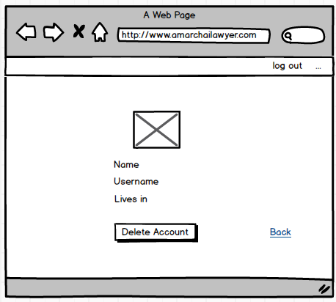
Figure 55: User Interface for Normal User Profile Delete Page

Answer Edit Page:
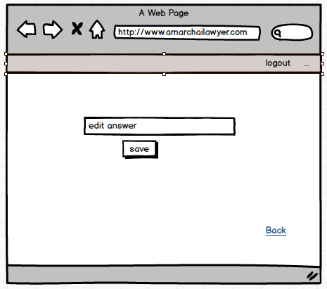
Figure 56: User Interface for Answer Edit Page

Appointment List for Normal User:
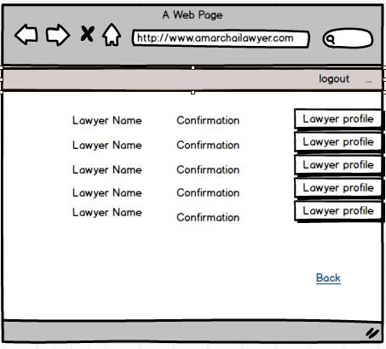
Figure 57: User Interface for Appointment List for Normal User

Appointment Confirmation by Normal User:
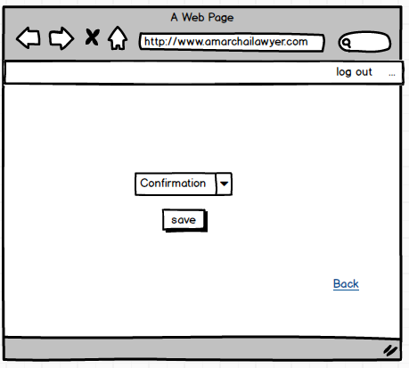
Figure 58: User Interface for Appointment Confirmation by Normal User

Lawyer Public Profile for Accepted user:
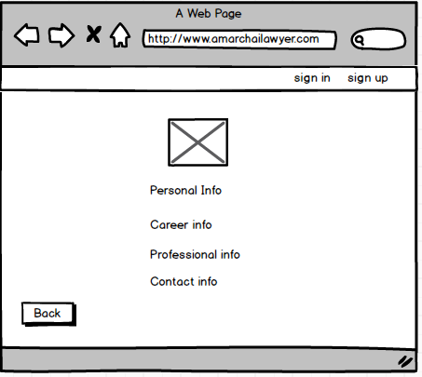
Figure 59: User Interface for Lawyer Public Profile for Accepted user

Lawyer Public Profile for user:
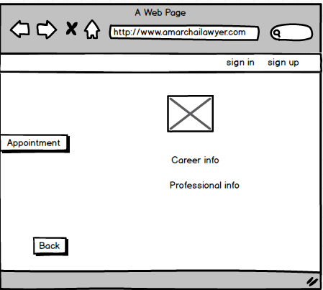
Figure 60: User Interface for Lawyer Public Profile for user

Chapter 12: Testing Components

Version | Date | Document name
1.0 | 14-12-2017 | Test plan outline

12.1 Test Plan Identifier
The Test Plan has been created to communicate the test approach to readers. This is the Master Test Plan of my project. As the software will be released once I will stick to the master test plan (7). The id of this test plan is LawyerFindingSystem-v1.0

12.2 Introduction
In our country many people are facing problems of finding legal advice from legal advisor or lawyer. Considering these problems, I want to implement the “lawyer finding system” which will reduce the problem of people. Lawyers can get registered into this system with their information. They can search for any type of legal question. User can send appointment request to the lawyers. If the lawyers accept the request then user can get the personal information of that lawyer and communicate with the lawyer. This test plan describes the testing approach and overall framework that will drive the testing of the LawyerFindingSystem-v1.0.

12.2.1 Summary of items and features to be tested
- Authentication: The Lawyers will go through the login and logout process to use their account after being registered.
- Profile Management: The Lawyers can add, change and delete their information any time.
- Career Info: The registered lawyers can add, change and delete their Career related info’s after signing in.
- Professional Info: The registered lawyers can add, change and delete their Career related info’s after signing in.
- Searching questions: The search results for questions should be relevant to the search keywords.
- Add questions: If Normal user don’t find any search question result then they can add questions easily.
- Searching Lawyer: The search results for Lawyers should be relevant to the search keywords. Only registered lawyer list should be displayed.
- Send request: Normal user must be able to send appointment request to lawyer.
- Notification: When a Normal user send an appointment request to a Lawyer, he should be notified.
- Accept request: Lawyer must be able to accept or reject appointment request of normal user and this will notify the normal user.

12.2.2 High level description of testing goals
Software testing is the mechanism of knowing that what’s the expected result and what the actual result a software project or product has given. The high-level goals of testing are given below.
- Bug discovery: Software testing immediate goal is to find errors at any stage of software development.
- Bug prevention: It is the consequent action of bug discovery. From the behavior and analysis of bugs discovered, I will get to learn how to code so that bugs discovered should not be repeated in later stages.
- Quality: Testing ensures superior quality. Testing will help me to improve the quality of Intelligent Career Portal.

12.2.3 Reference to related documents
I have used some of my project documents for my test plan. These are listed below as part of reference:
- Requirement Specification document
- Design document

12.3 Test-Item to be Tested
- The Lawyer Finding System itself is the test item that is to be tested

12.4 Features to be Tested
- Authentication
- Profile Management
- Asking Question
- Adding Answer
- Searching Lawyer
- Appointment

12.5 Features not to be Tested
There is no such feature. All the features have to be tested.

12.6 Approach
- I will use an online bug tracking tool called BUG track for posting bug.
- Before starting posting bug, training for using this tool will be available.
- I will test the functionality of the application as I will cover the black box testing for my project.
- I will test all modules in Google Chrome and Mozilla Firefox browser only.
- One level of regression testing will be possible for the project.
- Integration testing will be performed.

12.7 Item Pass/Fail Criteria
Stipulating the criteria that I will use to determine whether each test item of my project has passed or failed. The planning criteria gives the framework for how the project will be assessed and under what circumstances it will be released. At unit test level all test cases of the corresponding modules of Lawyer Finding System project will be tested with the specified percentage of number of minor defects. Although it is dependent on the number and strictness of the defects which may cause a failure or system crashes.

12.8 Suspension Criteria and Resumption Requirements
Suspension criteria will be used when it is needed to suspend all or a percentage of the testing activities when the testing has no value and the build is not working properly which is overall a wasting of resources. On the other hand, resumption criteria specify when testing can resume after it has been suspended. These will be applied in such situations. (8)
Suspension when,
- Unavailability of external dependent systems during execution.
- A defect is introduced that cannot allow any further testing.
Resumption when,
- When the external dependent systems become available again.
- When a fix is successfully implement.

12.9 Test Deliverables
I will provide some deliverables after testing the application at the end of the project. These are given below:
- Test plan document
- Test cases

12.10 Environmental Needs
- Test data which will be provided is an environmental need as I need data to test. Except provided data I cannot perform any phase of testing.
- I will perform a manual unit test, one phase of regression test on each module. After testing these phases I will start integration test for the whole application.

12.11 Staffing and Training Needs
In my testing phase, previously mention that I will use BUG track as bug reporting software. But I don’t know anything about this tool. So, I will take a short training on this tool before starting testing.

12.12 Responsibilities
Responsibility for different functionality of the project-
Number | Functionality | Responsible person | Roll
01 | Authentication | Sazidul Islam | BSSE0633
02 | Profile Management | Sazidul Islam | BSSE0633
03 | Ask Question | Sazidul Islam | BSSE0633
04 | Searching Lawyer | Sazidul Islam | BSSE0633
05 | Appointment | Sazidul Islam | BSSE0633

Table no: 07

12.13 Risks and Contingencies
- After development, testing will start. If development finish lately, there is a risk of late delivery of the software.
- In every software project there is a chance of changing of modification on the requirement. If this happens I may need to redesign or modify my plan and test cases.
- There is a risk of getting original data to test.
Requirements definition is completed. If the requirements change further, the following actions will be taken:
- As I am promised to deliver my product in due time, if requirement changes I will reschedule my working period and enhance my working time to complete my testing.
- I may reduce the number of performed test.
- Number of acceptable defects may be increased. These defects will be resolved in further release.
- The scope of the plan may be changed.

12.14 Testing Cost
- As this is an academic project, so no need to estimate any testing cost.

12.15 Approval
Name | Role | Approver/Reviewer | Approval/Review Date
Rezvi Shahariar | Project Supervisor

Table no: 08

12.16 Test Cases

Test cases for home page:
Id | Test cases | Preconditions | Input test data | Steps to be executed | Expected results | Actual results | Pass/Fail
01 | Test “Sign up” link | Users are not logged in |  | 1)Click “Sign up” Link | Redirected To Sign up page | Redirected To Sign up page | Pass
02 | Test “Sign in” link | Users are not logged in |  | 1)Click “Sign in” Link | Redirected To Sign in page | Redirected To Sign in page | Pass
03 | Test without giving any text into searching question text box | Users are not logged in |  | 1)Click “search Question” button | Giving an alert message | Giving an alert message | Pass
04 | Test giving some text into searching question text box | Users are not logged in | Some text | 1)Input some text  2)Click “search Question” button | Redirected To Search Result page | Redirected To Search Result page | Pass
05 | Test without giving any text into adding question text box | Users are not logged in |  | 1)Click “adding question” button | Giving an alert message | Giving an alert message | Pass
06 | Test giving some text into adding question text box | Users are not logged in | Some text | 1)Input some text  2)Click “adding question” button | Redirected To adding question page | Redirected To adding question page | Pass
07 | Test “searching question” button | Users are not logged in |  | 1)Click “searching question” button | Redirected To Search Result page | Redirected To Search Result page | Pass
08 | Test “adding question” button | Users are not logged in |  | 1)Click “adding question” button | Redirected To adding question Confirmation page | Redirected To adding question Confirmation Page | Pass
09 | Test “Category” button | Users are not logged in |  | 1)Click “Category” button | Opening a modal | Opening a modal | Pass
10 | Test “Banking Law” button | Users are not logged in |  | 1)Click “Banking Law” button | Redirected To Searching Lawyer By Category page | Redirected To Searching Lawyer By Category page | Pass
11 | Test “Company Law” button | Users are not logged in |  | 1)Click “Company Law” button | Redirected To Searching Lawyer By Category page | Redirected To Searching Lawyer By Category page | Pass
12 | Test “Consumer Law” button | Users are not logged in |  | 1)Click “Consumer Law” button | Redirected To Searching Lawyer By Category page | Redirected To Searching Lawyer By Category page | Pass
13 | Test “Copyright Law” button | Users are not logged in |  | 1)Click “Copyright Law” button | Redirected To Searching Lawyer By Category page | Redirected To Searching Lawyer By Category page | Pass
14 | Test “Corporate Law” button | Users are not logged in |  | 1)Click “Corporate Law” button | Redirected To Searching Lawyer By Category page | Redirected To Searching Lawyer By Category page | Pass
15 | Test “Criminal Law” button | Users are not logged in |  | 1)Click “Criminal Law” button | Redirected To Searching Lawyer By Category page | Redirected To Searching Lawyer By Category page | Pass
16 | Test “Divorce Law” button | Users are not logged in |  | 1)Click “Divorce Law” button | Redirected to Searching Lawyer by Category page | Redirected to Searching Lawyer by Category page | Pass
17 | Test “Environmental Law” button | Users are not logged in |  | 1)Click “Environmental Law” button | Redirected To Searching Lawyer By Category page | Redirected To Searching Lawyer By Category page | Pass
18 | Test “Family Law” button | Users are not logged in |  | 1)Click “Family Law” button | Redirected To Searching Lawyer By Category page | Redirected To Searching Lawyer By Category page | Pass
19 | Test “Health & Safety Law” button | Users are not logged in |  | 1)Click “Health & Safety Law” button | Redirected To Searching Lawyer By Category page | Redirected To Searching Lawyer By Category page | Pass
20 | Test “Immigration Law” button | Users are not logged in |  | 1)Click “Immigration Law” button | Redirected To Searching Lawyer By Category page | Redirected To Searching Lawyer By Category page | Pass
21 | Test “Islamic Law” button | Users are not logged in |  | 1)Click “Islamic Law” button | Redirected To Searching Lawyer By Category page | Redirected To Searching Lawyer By Category page | Pass
22 | Test “Labor Law” button | Users are not logged in |  | 1)Click “Labor Law” button | Redirected To Searching Lawyer By Category page | Redirected To Searching Lawyer By Category page | Pass
23 | Test “Land Law” button | Users are not logged in |  | 1)Click “Land Law” button | Redirected To Searching Lawyer By Category page | Redirected To Searching Lawyer By Category page | Pass
24 | Test “Property Law” button | Users are not logged in |  | 1)Click “Property Law” button | Redirected To Searching Lawyer By Category page | Redirected To Searching Lawyer By Category page | Pass
25 | Test “Tax Law” button | Users are not logged in |  | 1)Click “Tax Law” button | Redirected To Searching Lawyer By Category page | Redirected To Searching Lawyer By Category page | Pass
26 | Test “Trademark Law” button | Users are not logged in |  | 1)Click “Trademark Law” button | Redirected To Searching Lawyer By Category page | Redirected To Searching Lawyer By Category page | Pass
27 | Test “Trusts & Estates Law” button | Users are not logged in |  | 1)Click “Trusts & Estates Law” button | Redirected To Searching Lawyer By Category page | Redirected To Searching Lawyer By Category page | Pass
28 | Test “Barisal” button | Users are not logged in |  | 1)Click “Barisal” button | Redirected To Searching Lawyer By City page | Redirected To Searching Lawyer By City page | Pass
29 | Test “Dhaka” button | Users are not logged in |  | 1)Click “Dhaka” button | Redirected To Searching Lawyer By City page | Redirected To Searching Lawyer By City page | Pass
30 | Test “Chittagong” button | Users are not logged in |  | 1)Click “Chittagong” button | Redirected To Searching Lawyer By City page | Redirected To Searching Lawyer By City page | Pass
31 | Test “Khulna” button | Users are not logged in |  | 1)Click “Khulna” button | Redirected To Searching Lawyer By City page | Redirected To Searching Lawyer By City page | Pass
32 | Test “Mymensing” button | Users are not logged in |  | 1)Click “Mymensing” button | Redirected To Searching Lawyer By City page | Redirected To Searching Lawyer By City page | Pass
33 | Test “Rajshahi” button | Users are not logged in |  | 1)Click “Rajshahi” button | Redirected To Searching Lawyer By City page | Redirected To Searching Lawyer By City page | Pass
34 | Test “Rangpur” button | Users are not logged in |  | 1)Click “Rangpur” button | Redirected To Searching Lawyer By City page | Redirected To Searching Lawyer By City page | Pass
35 | Test “Sylhet” button | Users are not logged in |  | 1)Click “Sylhet” button | Redirected To Searching Lawyer By City page | Redirected To Searching Lawyer By City page | Pass
36 | Test “Let’s Have a Look” button | Users are not logged in |  | 1)Click “Let’s Have a Look” button | Opening a modal | Opening a modal | Pass
37 | Test “Banking Law” button | Users are not logged in |  | 1)Click “Banking Law” button | Redirected To Searching Lawyer By Category page | Redirected To Searching Lawyer By Category page | Pass
38 | Test “Banking Law” button | Users are not logged in |  | 1)Click “Banking Law” button | Redirected To Searching Lawyer By Category page | Redirected To Searching Lawyer By Category page | Pass
39 | Test “Banking Law” button | Users are not logged in |  | 1)Click “Banking Law” button | Redirected To Searching Lawyer By Category page | Redirected To Searching Lawyer By Category page | Pass
40 | Test “Banking Law” button | Users are not logged in |  | 1)Click “Banking Law” button | Redirected To Searching Lawyer By Category page | Redirected To Searching Lawyer By Category page | Pass
41 | Test “Banking Law” button | Users are not logged in |  | 1)Click “Banking Law” button | Redirected To Searching Lawyer By Category page | Redirected To Searching Lawyer By Category page | Pass

Table no: 08

Test cases for Log in page:
Id | Test cases | Preconditions | Input test data | Steps to be executed | Expected results | Actual results | Pass/Fail
01 | Test with empty user name and empty password | Users are not logged in |  | 1)leave username and password empty  2) Click login. | Shows validation errors and prompt login again | Shows validation errors and prompt login again | Pass
02 | Test with filled user name and empty password | Users are not logged in |  | 1)leave password empty  2)Enter username  3) Click login. | Shows validation errors and prompt login again | Shows validation errors and prompt login again | Pass
03 | Test with empty user name and filled password | Users are not logged in |  | 1) Leave username empty.  2)Enter password  2) Click login. | Shows validation errors and prompt login again | Shows validation errors and prompt login again | Pass
04 | Test Successful login | Users are not logged in | Correct username, correct password | 1)Enter correct username  2)Enter Correct password  3)Click login | Redirected to authenticated users Profile page. | Redirected to authenticated users Profile page. | Pass
05 | Test if password field is masked | Users are not logged in | Any input | 1)Any input is given in password field | Displays characters in asterisks and bullets | Displays characters in asterisks and bullets | Pass
06 | Test login functions Case sensitivity | Users are not logged in | Correct Email,password but upper cases are lowered and vice versa | 1) Enter username  2)Enter password  3)Click login | Login fails | Login doesn’t fail | Fail
07 | Test Login condition | Users are logged in | Correct username and correct password | 1)Enter correct username  2)Enter Correct password  3)Click login  4) Click back | Login option doesn’t come as user is logged in. | Login option doesn’t come as user is logged in. | Pass
08 | Test copying from password field | Users are not logged in | Any Input | 1)Enter any input  2)Copy input by ctrl +C  3)Paste copied in any place | Nothing is pasted. | Nothing is pasted. | Pass
09 | Test “Forgot  Password” link | Users are not logged in |  | 1)Click “Forgot  Password” link | Redirected To “Forgot  Password” page | Redirected To “Forgot  Password” page | Pass

Table no: 09

Test cases for Registration:
Id | Test cases | Preconditions | Input test data | Steps to be executed | Expected results | Actual results | Pass/Fail
01 | Test with empty one field with other fields filled up validly | Users are not logged in | All Field with text except one field | 1)Leave one field and filled other fields  2) Click Sign up. | Provide a warning message mentioning to add this field | Provide a warning message mentioning to add this field | Pass
02 | Test with filled one field with other fields empty | Users are not logged in | All Field empty except one field filled with text | 1)Leave all fields and filled one field  2) Click Sign up. | Provide a warning message mentioning to add these field | Provide a warning message mentioning to add these field | Pass
03 | Test with filled some fields with other fields empty | Users are not logged in | some Fields empty and some fields filled with text | 1)Leave some fields and filled some fields  2) Click Sign up. | Provide a warning message mentioning to add these field | Provide a warning message mentioning to add these field | Pass
04 | Test with existing username | Users are not logged in | Any input to other fields but username same | 1)Enter all fields text  2)Click Sign up | Provide a warning message mentioning to add valid/unique Username. | Provide a warning message mentioning to add valid/unique Username | Pass
05 | Test with all valid info | Users are not logged in | Any input | 1)Enter all fields text  2)Click Sign up | Successfully registered in the system and redirected to login page | Successfully registered in the system and redirected to login page | Pass
06 | Test “Sign up" button | Users are not logged in |  | 1)Click Sign up | redirected to login page | redirected to login page | Pass

Table no: 10

Test cases for Forgot Password Page:
Id | Test cases | Preconditions | Input test data | Steps to be executed | Expected results | Actual results | Pass/Fail
01 | Test with empty Email Field | Users are not logged in |  | 1)Leave Email field empty  2) Click submit. | Provide a warning message mentioning to add this field | Provide a warning message mentioning to add this field | Pass
02 | Test with valid email field | Users are not logged in | Valid email address | 1)Filled Email field validly  2) Click submit. | Reset Password link sending notification send | Reset Password link sending notification send | Pass
03 | Test with invalid email field | Users are not logged in | invalid email address | 1)Filled with invalid Email  2) Click submit. | Provide a warning message | Provide a warning message | Pass
04 | Test “submit" button | Users are not logged in |  | 1)Click submit | Reset Password link sending notification send | Reset Password link sending notification send | Pass
05 | Test “Back" button | Users are not logged in |  | 1)Click Back | redirected to login page | redirected to login page | Pass

Table no: 11

Test cases for Reset password:
Id | Test cases | Preconditions | Input test data | Steps to be executed | Expected results | Actual results | Pass/Fail
01 | Test “submit" button | Users are not logged in |  | 1)enter new password  2)enter confirm password  3)Click submit | New password Updated notification showed | New password Updated notification showed | Pass
02 | Test “Back" button | Users are not logged in |  | 1)Click Back | redirected to login page | redirected to login page | Pass

Table no: 12

Test cases for Question Add page:
Id | Test cases | Preconditions | Input test data | Steps to be executed | Expected results | Actual results | Pass/Fail
01 | Test “Back" button | Users are not logged in |  | 1)Click Back | redirected to Index page | redirected to Index page | Pass
Table no: 13

Test cases for Searching Result page:
Id | Test cases | Preconditions | Input test data | Steps to be executed | Expected results | Actual results | Pass/Fail
01 | Test “Back" button | Users are not logged in |  | 1)Click Back | redirected to Index page | redirected to Index page | Pass
02 | Test “Go to Lawyer Profile" Link | Users are not logged in |  | 1)Click Go to Lawyer Profile Link | redirected to ProfileForOthers page | redirected to ProfileForOthers page | Pass

Table no: 14

Test cases for Question List page:
Id | Test cases | Preconditions | Input test data | Steps to be executed | Expected results | Actual results | Pass/Fail
01 | Test “Back" button | Users are not logged in |  | 1)Click Back | redirected to Profile page | redirected to Profile page | Pass
02 | Test “Add Answer" Link | Users are logged in |  | 1)Click Add Answer Link | redirected to Answer Create page | redirected to Answer Create page | Pass

Table no: 15

Test cases for Create answer page:
Id | Test cases | Preconditions | Input test data | Steps to be executed | Expected results | Actual results | Pass/Fail
01 | Test “Back" button | Users are logged in |  | 1)Click Back | redirected to QuestionList page | redirected to QuestionList page | Pass
02 | Test “Create Answer" Button | Users are logged in |  | 1)Click “Create Answer" Button | redirected to AnswerList page | redirected to AnswerList page | Pass

Table no: 16

Test cases for Answer List page:
Id | Test cases | Preconditions | Input test data | Steps to be executed | Expected results | Actual results | Pass/Fail
01 | Test “Back" button | Users are logged in |  | 1)Click Back | redirected to Profile page | redirected to Profile page | Pass
02 | Test “Edit Answer" Button | Users are logged in |  | 1)Click “Edit Answer " Button | redirected to Answer Edit page | redirected to Answer Edit page | Pass
03 | Test “Delete Answer" Link | Users are logged in |  | 1)Click Delete Answer Link | redirected to Answer Delete page | redirected to Answer Delete page | Pass
Table no: 17

Test cases for Appointment List for User page:
Id | Test cases | Preconditions | Input test data | Steps to be executed | Expected results | Actual results | Pass/Fail
01 | Test “cancel appointment" link | Users are logged in |  | 1)Click cancel appointment | redirected to Appointment delete page | redirected to Appointment delete page | Pass
02 | Test “Back" link | Users are logged in |  | 1)Click back | redirected to Profile page | redirected to Profile page | Pass
03 | Test “go to lawyer profile" link | Users are logged in |  | 1)Click go to lawyer profile | redirected to Lawyer Public Profile page | redirected to Lawyer Public Profile page | Pass

Table no: 18

Test cases for Appointment confirmation page for Lawyer:
Id | Test cases | Preconditions | Input test data | Steps to be executed | Expected results | Actual results | Pass/Fail
01 | Test “Confirm" button | Users are logged in |  | 1)Click Confirm | redirected to Appointment List page | redirected to Appointment List page | Pass
02 | Test “Back" link | Users are logged in |  | 1)Click back | redirected to Appointment List page | redirected to Appointment List page | Pass

Table no: 19

Test cases for Lawyer Profile page:
Id | Test cases | Preconditions | Input test data | Steps to be executed | Expected results | Actual results | Pass/Fail
01 | Test “Logout" button | Users are logged in |  | 1)Click Logout | redirected to Login page | redirected to Login page | Pass
02 | Test “Question List" Link | Users are logged in |  | 1)Click “Question List " Link | redirected to QuestionList page | redirected to QuestionList page | Pass
03 | Test “Answer List" Link | Users are logged in |  | 1)Click “Answer List " Link | redirected to AnswerList page | redirected to AnswerList page | Pass
04 | Test “Update Profile" Link | Users are logged in |  | 1)Click “Update Profile t " Link | redirected to Update Profile page | redirected to Update Profile page | Pass
05 | Test “Delete Profile " Link | Users are logged in |  | 1)Click “Delete Profile " Link | redirected to Delete Profile page | redirected to Delete Profile page | Pass
06 | Test “Appointment List " Link | Users are logged in |  | 1)Click “Appointment List " Link | redirected to Appointment List page | redirected to Appointment List page | Pass

Table no: 20

Test cases for Answer Delete page:
Id | Test cases | Preconditions | Input test data | Steps to be executed | Expected results | Actual results | Pass/Fail
01 | Test “Back" button | Users are logged in |  | 1)Click Back | redirected to AnswerList page | redirected to AnswerList page | Pass
02 | Test “Delete" Button | Users are logged in |  | 1)Click “Delete " Button | redirected to AnswerList page | redirected to AnswerList page | Pass

Table no: 21
Id | Test cases | Preconditions | Input test data | Steps to be executed | Expected results | Actual results | Pass/Fail
01 | Test “Back" button | Users are logged in |  | 1)Click Back | redirected to AnswerList page | redirected to AnswerList page | Pass
02 | Test Saver" Button | Users are logged in |  | 1)Click “Save " Button | redirected to AnswerList page | redirected to AnswerList page | Pass

Test cases for Answer Edit page

Table no: 22

Test cases for Lawyer update profile page:
Id | Test cases | Preconditions | Input test data | Steps to be executed | Expected results | Actual results | Pass/Fail
01 | Test “Logout" button | Users are logged in |  | 1)Click Logout | redirected to Login page | redirected to Login page | Pass
02 | Test if edited value is saved | Users are logged in |  | 1)filled with some text  2)click update Profile | redirected to Profile page | redirected to Profile page page | Pass
03 | Test “Back" button | Users are logged in |  | 1)Click back | redirected to profile page | redirected to profile page | Pass
02 | Test if edited value is saved | Users are logged in |  | 1)filled with some text  2)click update Profile | redirected to Profile page | redirected to Profile page page | Pass
04 | Test “Update Profile" Button | Users are log-ged in |  | 1)Click “Update Profile “Button | redirected to Profile page | redirected to Profile page | Pass

Table no: 23

Test cases for Lawyer Delete profile page:
Id | Test cases | Preconditions | Input test data | Steps to be executed | Expected results | Actual results | Pass/Fail
01 | Test “Logout" button | Users are logged in |  | 1)Click Logout | redirected to Login page | redirected to Login page | Pass
02 | Test “Back" button | Users are logged in |  | 1)Click back | redirected to profile page | redirected to profile page | Pass
04 | Test “Delete Profile" Button | Users are log-ged in |  | 1)Click “Delete Profile “Button | redirected to Login page | redirected to Login page | Pass

Table no: 24

Test cases for Lawyer Profile For others page:
Id | Test cases | Preconditions | Input test data | Steps to be executed | Expected results | Actual results | Pass/Fail
01 | Test “Appointment" link | Users are not logged in |  | 1)Click Appointment | redirected to Normal User Login page | redirected to Normal User Login page | Pass
02 | Test “Back" link | Users are not logged in |  | 1)Click back | redirected to AnswerList page | redirected to AnswerList page | Pass

Table no: 25

Test cases for Appointment Create page:
Id | Test cases | Preconditions | Input test data | Steps to be executed | Expected results | Actual results | Pass/Fail
01 | Test “cancel" button | Users are logged in |  | 1)Click cancel | redirected to profile page | redirected to profile page | Pass
02 | Test “confirm" button | Users are logged in |  | 1)Click confirm | redirected to Appointment list page | redirected to Appointment list page | Pass

Table no: 26

Test cases for Appointment List for Lawyer page:
Id | Test cases | Preconditions | Input test data | Steps to be executed | Expected results | Actual results | Pass/Fail
01 | Test “Confirm appointment" link | Users are logged in |  | 1)Click Confirm appointment | redirected to Appointment Confirmation page | redirected to Appointment Confirmation page | Pass
02 | Test “Back" link | Users are logged in |  | 1)Click back | redirected to Lawyer Profile page | redirected to Lawyer Profile page | Pass

Table no: 27

Chapter 13

Conclusion
It is a pleasure to submit the final SRS report on “Lawyer Finding System”. From this, a user will get massive information in emergency legal advice needed condition. This SRS document can be used effectively to maintain software development cycle. It will be very easy to conduct the whole project using this SRS. Hopefully, this document can also help our junior BSSE batch students. I tried my best to remove all dependencies and make effective and fully designed SRS. I believe that reader will find it in order.

References

1. Roger , S. Pressman. Software engineering : a practitioner's approach.
2. Scott , W. Ambler. Use Case Diagrams: An Agile Introduction. [Online] October 20, 2010. [Cited: October 06, 2017.] http://www.agilemodeling.com/artifacts/useCaseDiagram.htm.
3. SmartDraw, LLC. Entity Relationship Diagram. [Online] [Cited: October 17, 2017.] https://www.smartdraw.com/entity-relationship-diagram/.
4. Kirill , Fakhroutdinov. UML Class Diagrams. [Online] [Cited: October 10, 2017.] http://www.uml-diagrams.org/class-diagrams-examples.html.
5. Data Flow Diagram. [Online] [Cited: October 10, 2017.] https://www.visual-paradigm.com/tutorials/data-flow-diagram-example-cs-system.jsp.
6. The sequence diagram. [Online] September 02, 2008. [Cited: October 15, 2017.] https://www.ibm.com/developerworks/rational/library/3101.html.
7. STF. Test Plan. [Online] [Cited: October 13, 2017.] http://softwaretestingfundamentals.com/test-plan/.
8. Inc, Lucid Software. Activity Diagram Tutorial. lucidchart. [Online] January 28, 2011. [Cited: October 12, 2017.] https://www.lucidchart.com/pages/uml/activity-diagram.
9. [Online] http://www.uml-diagrams.org/class-diagrams-examples.html.
10. Naresh, Chauhan. Software Testing Principles and Practices. 2010.

