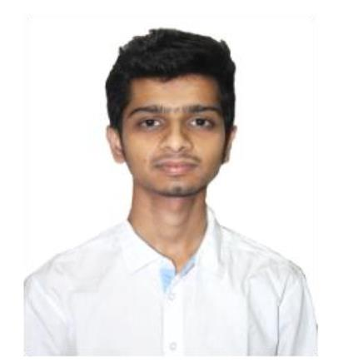
Evaluation Only. Created with Aspose.PDF. Copyright 2002-2018 Aspose Pty Ltd.
Curriculum Vitae
Of
MD. ZAHID HASAN
R/A Road-13, House No-9
Mirpur-6, Dhaka-1216 Contact: +8801773-333963
E-mail: zahid.cse07@gmail.com
CAREER OBJECTIVE
I would like to build up my career as an IT professional. To gain a challenging position in a
well-reputed organization that will utilize my talent properly and provide me with the
opportunity of enhancing my skill.
KEY SKILLS
• Experience building a variety of different web applications and sites using PHP and
MYSQL.
• Good knowledge and understanding of Object Oriented Programming (OOP).
• Good knowledge of Database.
• Experience in working with MYSQL and SQL Server.
• Good analytical, logical and programming skills.
• Basic knowledge of MVC framework.
• Ability to learn & develop using new technologies quickly.
TECHNICAL SKILLS
• Programming Language : C++, C#, JAVA, PHP.
• Database : MS SQL Server, MySQL.
• Client-side : Html, CSS, Bootstrap, JavaScript, jQuery, Ajax.
• Development Tools : NetBeans, PHPStorm, Eclipse, Visual Studio.
• Microsoft Technologies : ASP.Net, C#.Net, ADO.Net
• Application Servers : Apache
• Version Control : Familiar with Git.
INTERNSHIP
• Course Name : Web Development Using PHP.
Training Institute : IBCS-PRIMAX
: Dhanmondi, Dhaka-1209
Duration : 2 months

Evaluation Only. Created with Aspose.PDF. Copyright 2002-2018 Aspose Pty Ltd.
PROJECTS
• Project Title : E-commerce Site using PHP
Description : an E-commerce website for online shopping, include shopping
cart, product search.
Technologies used : PHP, MySQL, Html, JavaScript, JQuery
Source Code link : https://github.com/zahid99/ecommerce/
• Project Title : Online Doctor Appointment System
Description : Online Doctor appointment booking system that provides
patients or any user an easy way of booking a doctor's
appointment online, include doctor search.
Technologies used : PHP, MySQL, Html, JavaScript, JQuery
Source Code link : https://gitlab.com/zahid99/doctor-appointment
• Project Title : TV site Using PHP
Technologies used : PHP, MySQL, Html, JavaScript
Live Demo : https://gitlab.com/zahid99/tv-7unity
• Project Title : Blog Site using PHP
Technologies used : PHP, Html, JavaScript, Bootstrap, MySQL
Source Code link : https://gitlab.com/zahid99/blog
• Project Title : Online Courier Management System
Technologies used : PHP, Html, JavaScript, Bootstrap, MySQL
Source Code link : https://gitlab.com/zahid99/courier
• Project Title : Online Event Information
Technologies used : C#, ASP.Net, Html, JavaScript, Bootstrap, SQL Server
Source Code link : https://github.com/zahid99/event-information-system
EDUCATION
• Bachelor of Science in Computer Science Engineering
Institution : Bangladesh University of Business & Technology (BUBT).
Result : 3.30 Duration : 2014-2018
• Higher Secondary Certificate (H.S.C)
Institution : Govt. Azizul Haque College.
Result : 4.60 Duration : 2011-2012
• Secondary School Certificate (S.S.C)
Institution : Police Lines High School and College.
Result : 5.00 Duration : 2010



Evaluation Only. Created with Aspose.PDF. Copyright 2002-2018 Aspose Pty Ltd.
EXTRA-CURRICULAR ACTIVITIES
• Participation in Programming contest.
• Member at Microsoft Student Partnership (MSP) from Feb 2017-Feb 2018.
PORTFOLIO
My Portfolio is available on https://zahid99.github.io/zahid/
PERSONAL PROFILE
• Father’s Name : MD. ZAHURUL ISLAM
• Mother’s Name : MST. ZAHERA BEGUM
• Date of Birth : DECEMBER 18, 1995
• Gender : Male
• Marital Status : Unmarried
• Nationality : Bangladeshi
• Religion : Islam
• Permanent address : Village: Lotifpur, Post-office: Bogura sadar, District: Bogura
• Current Location : Dhaka
REFERENCES
Md. Fahad Md. Fazle Rabbi
Assistant Database Administrator Lecturer
Sonali Bank Ltd Department of Computer Science
IT Division (BUBT)
Head Office, Motijheel, Dhaka-1000. Phone: +8801913446575
Phone: +8801913242961 E-mail: rabbi102@gmail.com
E-mail: fahad.cse.cu@gmail.com
I am undersigned, hereby declare that I will be responsible for any wrong information
provided here.
(ZAHID)
Date: 16-09-2018

Evaluation Only. Created with Aspose.PDF. Copyright 2002-2018 Aspose Pty Ltd.

