FORMAT FOR PREPARATION OF PROJECT REPORT
FOR
Foundations of Artificial Intelligence

AI-BASED LEGAL ASSISTANT

A PROJECT REPORT

Submitted by
2116240701459 – SAJINE SANTHAKUMAR
2116240701442 – ROSHINI S


October, 2025

BONAFIDE CERTIFICATE

Certified that this project report “AI-BASED LEGAL ASSISTANT” is the bonafide work of “SAJINE SANTHAKUMAR and ROSHINI S” who carried out the project work under my supervision.

SIGNATURE OF THE FACULTY INCHARGE

Submitted for the Practical Examination held on _________________

SIGNATURE OF THE INTERNAL EXAMINER

TABLE OF CONTENTS
CHAPTER NO. TITLE PAGE NO.
ABSTRACT
- INTRODUCTION
- LITERATURE REVIEW
3 PROPOSED SYSTEM
3.1 ARCHITECTURE DIAGRAM
4 MODULES DESCRIPTION
4.1 MODULE 1
4.2 MODULE 2
5 IMPLEMENTATION AND RESULTS
5.1 EXPERIMENTAL SETUP
5.2 RESULTS
6 CONCLUSION AND FUTURE WORK
7 REFERENCES

ABSTRACT
Ordinary citizens find it difficult to obtain reliable legal information because provisions are spread across many Acts and government portals, and people describe the same problem in different words. This project develops an AI-Based Legal Assistant that answers general legal questions on eight common areas of Indian law. A TF-IDF and Logistic Regression classifier estimates the probability of each legal category. Retrieval is formulated as a search problem over START → CATEGORY → ENTRY and solved with the A* algorithm, where the classifier probability and a text-match score form the path cost g(n) and an admissible heuristic h(n) guarantees the best entry while pruning other categories. A reliability threshold rejects weak matches, every answer cites the relevant Act and an official source, and the complete search trace is shown to the user. On 40 held-out test questions the classifier achieved 100% category accuracy, every question was answered in the correct category, and A* reached each answer after expanding only 3 of 90 nodes, in about 1.3 ms per question on an ordinary laptop.
Keywords: A* search, admissible heuristic, legal information retrieval, question classification, explainable AI, intelligent agent.

CHAPTER 1

INTRODUCTION

Introduction to Artificial Intelligence
Artificial Intelligence (AI) is a field of computer science concerned with building systems that perform tasks which normally require human intelligence, such as understanding information, classifying it, searching for solutions and responding to a user. AI is particularly useful in information-based applications because it lets a computer analyse a user’s input, identify the nature of the request and search a knowledge source for the most suitable answer. The AI-Based Legal Assistant developed in this project applies two core AI techniques, supervised machine learning for question classification and A* informed search for knowledge retrieval, to give general legal information about common issues in India.

Background of the Project
Legal information affects everyday situations involving consumers, employees, tenants, vehicle users, online fraud, government procedures and fundamental rights. However, many users do not know which law, section or portal applies to their question, and the traditional routes of reading legal documents, browsing government websites or consulting a lawyer are slow for someone who needs only basic information. This project therefore builds an assistant on a structured knowledge base in which every entry stores a representative question, its category, keywords, an answer, the legal reference, the official source and a verification date. The eight categories covered are listed in Table 1.1.
Table 1.1 Legal categories covered by the system
Category | Examples of topics
Consumer Rights | Defective products, refunds, MRP overcharging, e-commerce complaints
Traffic & Driving | Driving licence, helmet, insurance, drunk driving, accidents
Cybercrime & Online Fraud | Hacked accounts, UPI fraud, fake profiles, phishing
Employment | Minimum wages, salary delay, working hours, PF, gratuity, maternity leave
Rental / Tenant Issues | Security deposit, eviction, rent agreement, repairs
Fundamental & Civic Rights | Fundamental rights, rights on arrest, FIR, free legal aid
Women’s Legal Rights | Workplace harassment (POSH), domestic violence, dowry
Government Procedures | Passport, Aadhaar, voter ID, RTI, PAN, birth certificate

Problem Statement
Reliable and understandable legal information is hard to find because it is spread across laws, portals and official documents, and users describe the same issue in different words. A user may type “Someone hacked my account” while the knowledge base holds the formal question “What should I do if someone hacks my online account or steals my password?”. A system that searches for an exact sentence misses the match, and a system that always returns the closest result may return an unrelated legal answer. The problem addressed here is to develop an AI-based assistant that estimates the legal category of a question with machine learning, retrieves the best entry from a curated knowledge base using A* search, and answers with its legal reference and source, while refusing to answer when no reliable match exists.

Objectives of the Project
- To provide general legal information through a simple web interface.
- To identify the legal category of a question using a supervised machine-learning classifier.
- To formulate legal retrieval as a state-space search problem and solve it with A* using an admissible heuristic.
- To show the legal reference and official source link for every answer.
- To reject unreliable matches using a reliability threshold.
- To make the system explainable by displaying the A* trace (path, g(n), h(n), f(n), expanded and pruned nodes).
- To evaluate the classifier and the search component on a held-out test set.

Scope and Applications
The scope is limited to general legal information on the eight categories in Table 1.1. The system is informational only: it does not replace professional legal advice and does not make case-specific decisions. Its applications include general legal awareness, guidance on government procedures such as passport, Aadhaar, voter registration and RTI applications, awareness of cybercrime reporting through the National Cyber Crime Reporting Portal (Ministry of Home Affairs, 2026), consumer awareness through the e-Daakhil complaint portal (Department of Consumer Affairs, 2026), and student learning of how A* search works on a real problem.

Existing System and Its Limitations
Legal information is traditionally obtained from lawyers, legal books, government websites and search engines, or through FAQ pages. These sources are detailed but require the user to locate the relevant provision, and FAQ systems fail when a question is worded differently. Existing AI-based legal assistants understand a question, identify its topic, search a knowledge source and answer conversationally, but they have the following limitations:
- Dependence on exact search terms, so differently worded questions fail.
- Lack of source visibility, which makes answers hard to verify.
- Black-box behaviour, because deep-learning assistants rarely explain why an answer was chosen.
- Risk of irrelevant answers, since systems that always return the closest result present weak matches as answers.
- High computational cost, because large language models need GPUs.
- Need for updated information, because laws and procedures change.
These limitations call for a lightweight system that accepts questions in the user’s own words, retrieves the best match with an efficient and explainable search, shows its legal reference and source, and declines to answer when no reliable match exists. The proposed assistant is designed to meet these requirements on an ordinary laptop.

Organisation of the Report
Chapter 2 reviews the literature, Chapter 3 describes the proposed system and its architecture, Chapter 4 describes the modules, Chapter 5 presents the implementation and results, Chapter 6 concludes the report with limitations and future work, and Chapter 7 lists the references.
CHAPTER 2

LITERATURE REVIEW
Artificial Intelligence has been applied in the legal domain to information retrieval, question answering, document analysis and user assistance. Because an incorrect or irrelevant response can mislead users, the quality of the knowledge source, the display of references and a clear statement of limitations are essential. Natural language processing lets a system treat “Can I drive without a licence?” and “Is a licence required to drive a car?” as the same issue, and heuristic search lets it find the best answer efficiently. This chapter reviews five research papers closely related to this project.

Review of Related Research Papers
A Formal Basis for the Heuristic Determination of Minimum Cost Paths – Hart, Nilsson and Raphael (1968), IEEE Transactions on Systems Science and Cybernetics.
Methodology: introduces the A* algorithm, a best-first graph search that orders nodes by f(n) = g(n) + h(n), and proves that it finds a minimum-cost path whenever h(n) never over-estimates the remaining cost. Merits: guaranteed optimal solutions, far fewer expansions than uninformed search. Demerits: depends on the quality of the heuristic and is not designed for text retrieval. This project: applies A* to legal retrieval with an admissible word-coverage heuristic over a small 90-node tree.
How Does NLP Benefit Legal System: A Summary of Legal Artificial Intelligence – Zhong et al. (2020), Proceedings of the 58th Annual Meeting of the ACL.
Methodology: a survey that divides legal AI into embedding-based and symbol-based methods and studies judgment prediction, similar-case matching and legal question answering on Chinese datasets. Merits: clear taxonomy; stresses interpretability. Demerits: Chinese law only; question-answering accuracy is far below human level; most models are black boxes. This project: is explainable, showing the A* path, g, h and f values, the legal reference and the source.
LEGAL-BERT: The Muppets Straight out of Law School – Chalkidis et al. (2020), Findings of the ACL: EMNLP 2020.
Methodology: adapts BERT to legal text by further pre-training and pre-training from scratch on about 12 GB of English legislation, cases and contracts. Merits: understands legal language better than generic BERT. Demerits: needs GPU resources, targets EU and US law and cites no sources. This project: uses a lightweight TF-IDF and Logistic Regression model on a laptop CPU with a curated Indian knowledge base that cites its sources.
Improving Access to Justice with Legal Chatbots – Queudot, Charton and Meurs (2020), Stats, Vol.3, No.3.
Methodology: builds retrieval-based legal chatbots for Canadian immigration questions and for bank employees, comparing StarSpace intent classifiers with a fine-tuned BERT model. Merits: shows that FAQ-based chatbots improve access to legal information. Demerits: unseen vocabulary hurts retrieval, BERT is costly at inference and the domain is Canadian. This project: handles new wording with synonyms and keywords, rejects weak matches with a threshold and targets Indian law.
Pre-trained Language Models for the Legal Domain: A Case Study on Indian Law – Paul et al. (2023), Proceedings of ICAIL 2023.
Methodology: continues pre-training LegalBERT on about 5.4 million Indian legal documents to create InLegalBERT and InCaseLawBERT, evaluated on statute identification and judgment prediction. Merits: the first pre-trained models for Indian law. Demerits: built for legal professionals, GPU-heavy and gives no plain-language answers. This project: is citizen-facing and gives plain-language answers with the Act, section and official portal.
Table 2.1 Summary of the literature survey
Authors (year) | Technique | Limitation | How this project addresses it
Hart, Nilsson & Raphael (1968) | A* search, admissible heuristic | Heuristic-dependent; not for text | Admissible word-coverage heuristic
Zhong et al. (2020) | Survey of legal AI | Chinese data; black-box models | Explainable A* trace with sources
Chalkidis et al. (2020) | LEGAL-BERT | GPU-heavy; EU/US law | Lightweight CPU model; Indian law
Queudot et al. (2020) | Retrieval chatbots | Unseen vocabulary; costly BERT | Synonyms, keywords, threshold
Paul et al. (2023) | InLegalBERT | For professionals, not citizens | Plain-language, citizen-facing answers

Research Gap
Existing work shows the potential of AI for legal information, but most systems rely on large, compute-heavy models that behave as black boxes, focus on legal professionals or non-Indian law, and rarely refuse to answer when unsure. There is a need for a simple, explainable system for Indian citizens that combines question classification, an optimal search strategy, source references and reliability checking. This project fills that gap.
CHAPTER 3

PROPOSED SYSTEM

Overview of the AI Legal Assistant
The proposed system is implemented as an intelligent agent (Russell and Norvig, 2020). It perceives a legal question typed into a web interface, classifies it with a learned model, searches the knowledge base with A* and acts by displaying either an answer or a refusal message. It covers the eight categories of Table 1.1 and is intended only for general legal information and awareness.

Proposed Approach
- User query – the user enters a question, for example “Can I drive a car without a licence?”, and may restrict the search to one category.
- Text processing – the question is lower-cased, synonyms are normalised (“license” → “licence”, “hacked” → “hack”), stop words are removed and words are lightly stemmed.
- Category classification – TF-IDF and Logistic Regression give P(category | question) for all eight categories.
- A* search – the knowledge base is searched as a tree START → CATEGORY → ENTRY; the classifier probability forms part of the path cost and an admissible heuristic guides the search.
- Reliability check – the best entry is accepted only if its match score reaches the 45% threshold and a specific word matched.
- Response – the category, answer, legal reference, source, confidence values, related questions and A* trace are displayed, or the question is refused.

Requirements and Features
The functional requirements are: accept a question through the web interface; process it and estimate the category probabilities; search the knowledge base with A*; calculate a match score; answer only when the score reaches the threshold; display the legal reference, source, related questions and A* trace; inform the user when no reliable match exists; and allow a category filter and feedback. The non-functional requirements are usability (a simple chat interface for non-experts), reliability (no weakly related answers), performance (about 1.3 ms per question), maintainability (a CSV knowledge base that can be edited without changing code), scalability (new entries and categories can be added) and transparency (reference, source and trace with every answer).

Advantages of the Proposed System
- Optimal retrieval, because A* with an admissible heuristic returns the lowest-cost entry.
- Efficiency, since on average only 6.2 of 90 nodes are expanded and 6.8 of 8 categories are pruned.
- Robustness to classifier errors, because the probability is a cost and not a hard filter.
- Source-backed and explainable answers that cite the law and show how they were found.
- Protection against weak matches through the reliability threshold, on a lightweight CPU-only system.

3.1 ARCHITECTURE DIAGRAM

System Architecture
The system consists of a web interface, a Flask web application, the legal assistant agent, a text processing module, an AI classification module, an A* search module, a reliability check, the legal knowledge base and a response handling module. Figure 3.1 shows how information flows between them. The classification module estimates the probability of every category, the A* module uses these probabilities with the knowledge base to find the best entry, and the reliability check decides whether the entry is shown as an answer or the user receives a refusal.
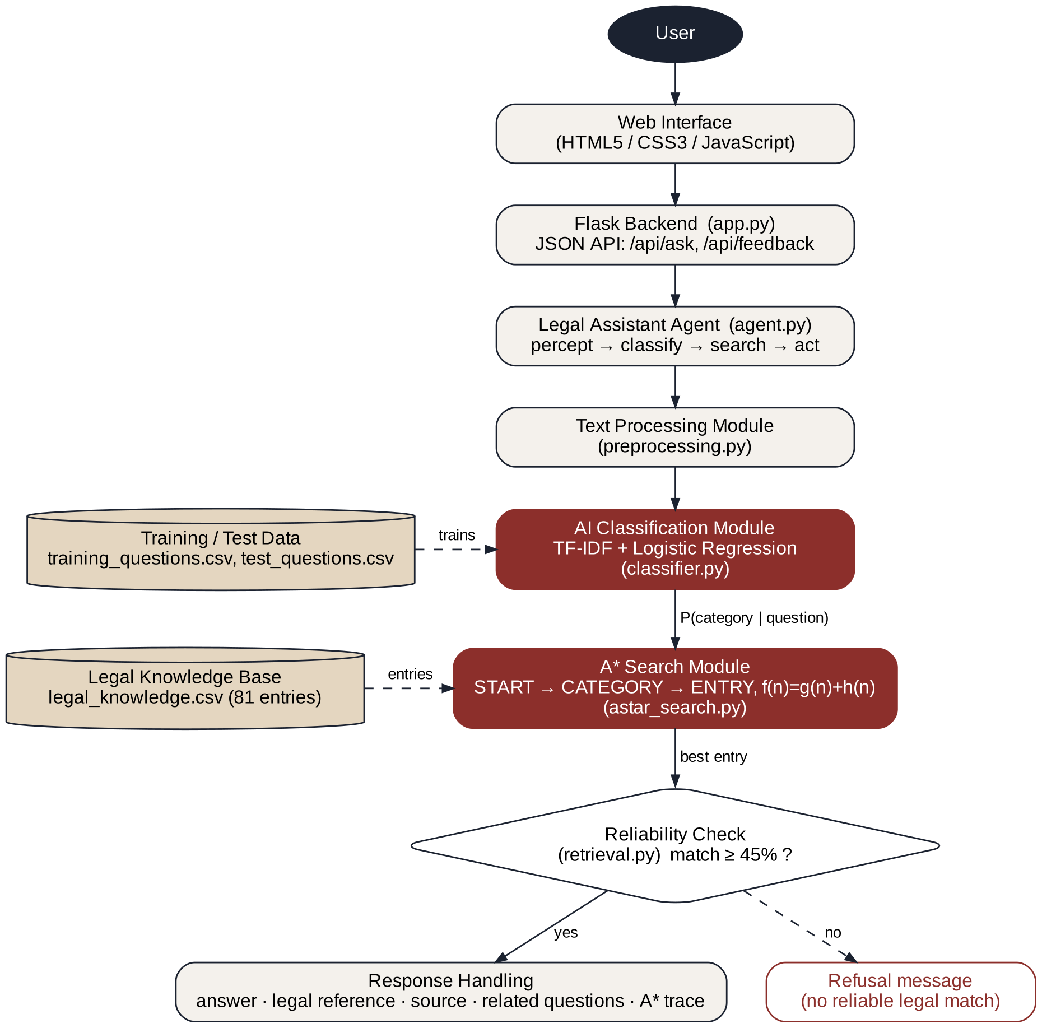
Figure 3.1 System architecture of the AI Legal Assistant

A* Search Problem Formulation
Legal retrieval is formulated as a search problem (Table 3.1). The state space has 1 START node, 8 CATEGORY nodes and 81 ENTRY nodes, 90 nodes in total. The step cost from START to a category C is α × (1 − P(C | question)) with α = 0.6, and the step cost from C to an entry E is 1 − match(question, E).
Table 3.1 Formulation of the legal retrieval search problem
Component | Definition in this project
Initial state | START – the user’s question with nothing yet decided
Actions | From START choose one of 8 categories; from a CATEGORY choose one entry of that category
Goal test | The node is a knowledge-base ENTRY
Path cost g(n) | Sum of step costs from START to n
Heuristic h(n) | h(C) = 1 − coverage(question, vocabulary of C); h(E) = 0
Evaluation function | f(n) = g(n) + h(n); the lowest f(n) is expanded first

The match score is the IDF-weighted fraction of the question’s terms that appear in an entry’s question and keywords. Rare terms weigh more, generic legal words such as “punishment” or “complaint” weigh less, and unknown words weigh most, so out-of-scope questions score low.
Admissibility. An entry in category C cannot contain more of the question’s terms than the whole vocabulary of C, so match(question, E) ≤ coverage(question, C). Hence h(C) = 1 − coverage(C) ≤ 1 − match(E), the true remaining cost, and the heuristic never over-estimates. A* therefore returns the lowest-cost entry, and any category whose f(n) already exceeds that cost is never expanded. Figure 3.2 shows the tree for “Someone hacked my account”: the Cybercrime category has the lowest f(n) = 0.21 and is expanded first, its best entry reaches the goal with the same cost, and six of the eight categories are pruned.
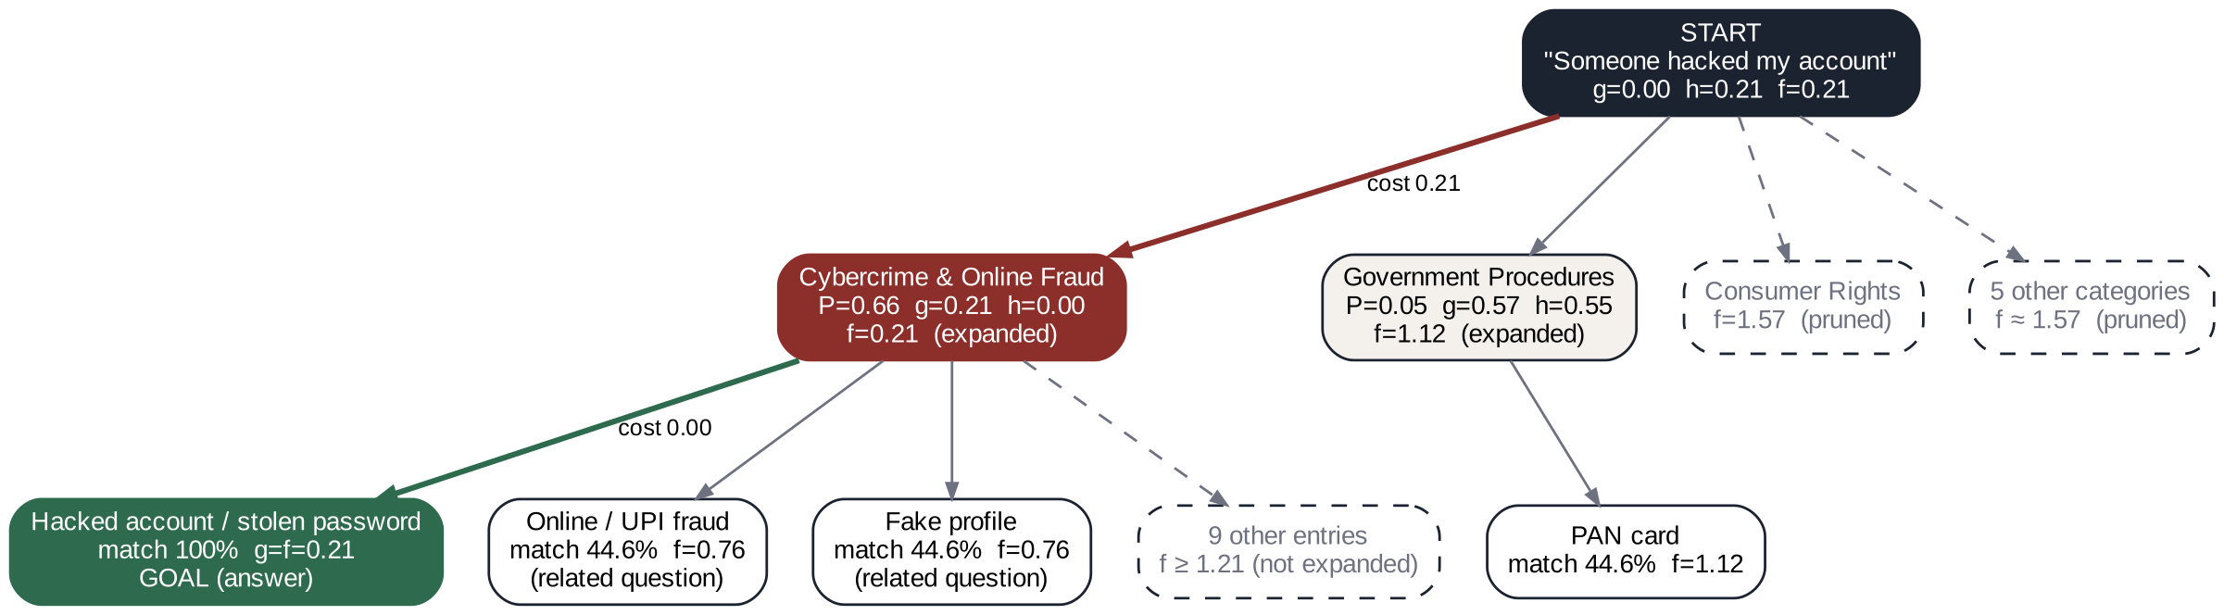
Figure 3.2 A* search tree for “Someone hacked my account”

Use Case, Data Flow and Activity Diagrams
The main actor is the user. Figure 3.3 shows the use cases available to the user, while the internal AI and search components process each request.
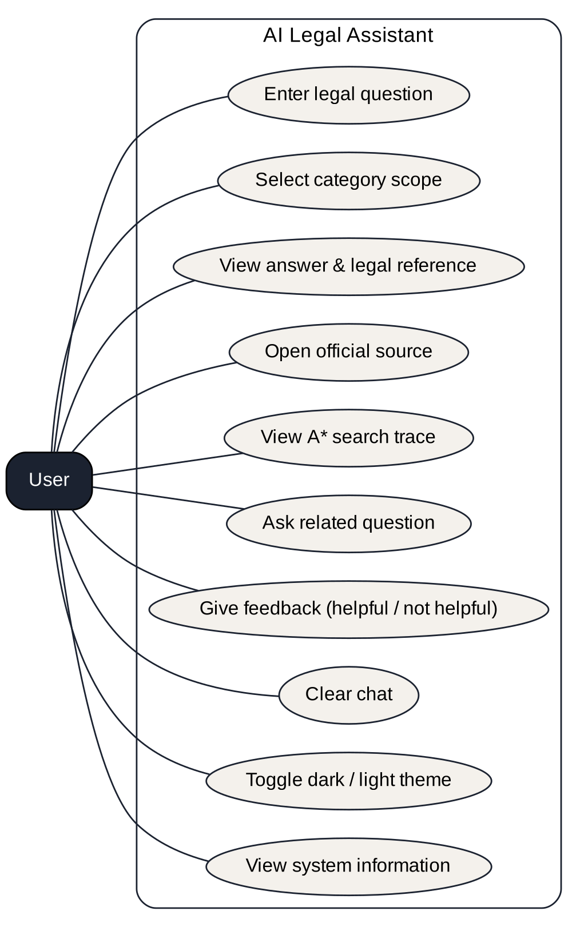
Figure 3.3 Use case diagram
At Level 0 (Figure 3.4) the whole system is one process that receives a legal question and returns legal information. Level 1 (Figure 3.5) shows the internal processes and data stores.
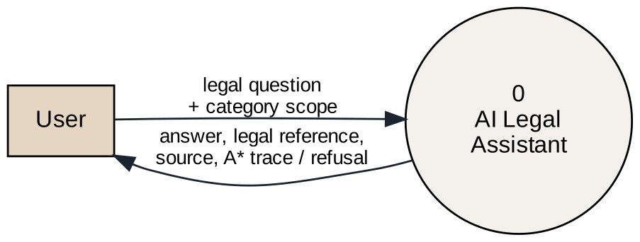
Figure 3.4 Data flow diagram – Level 0
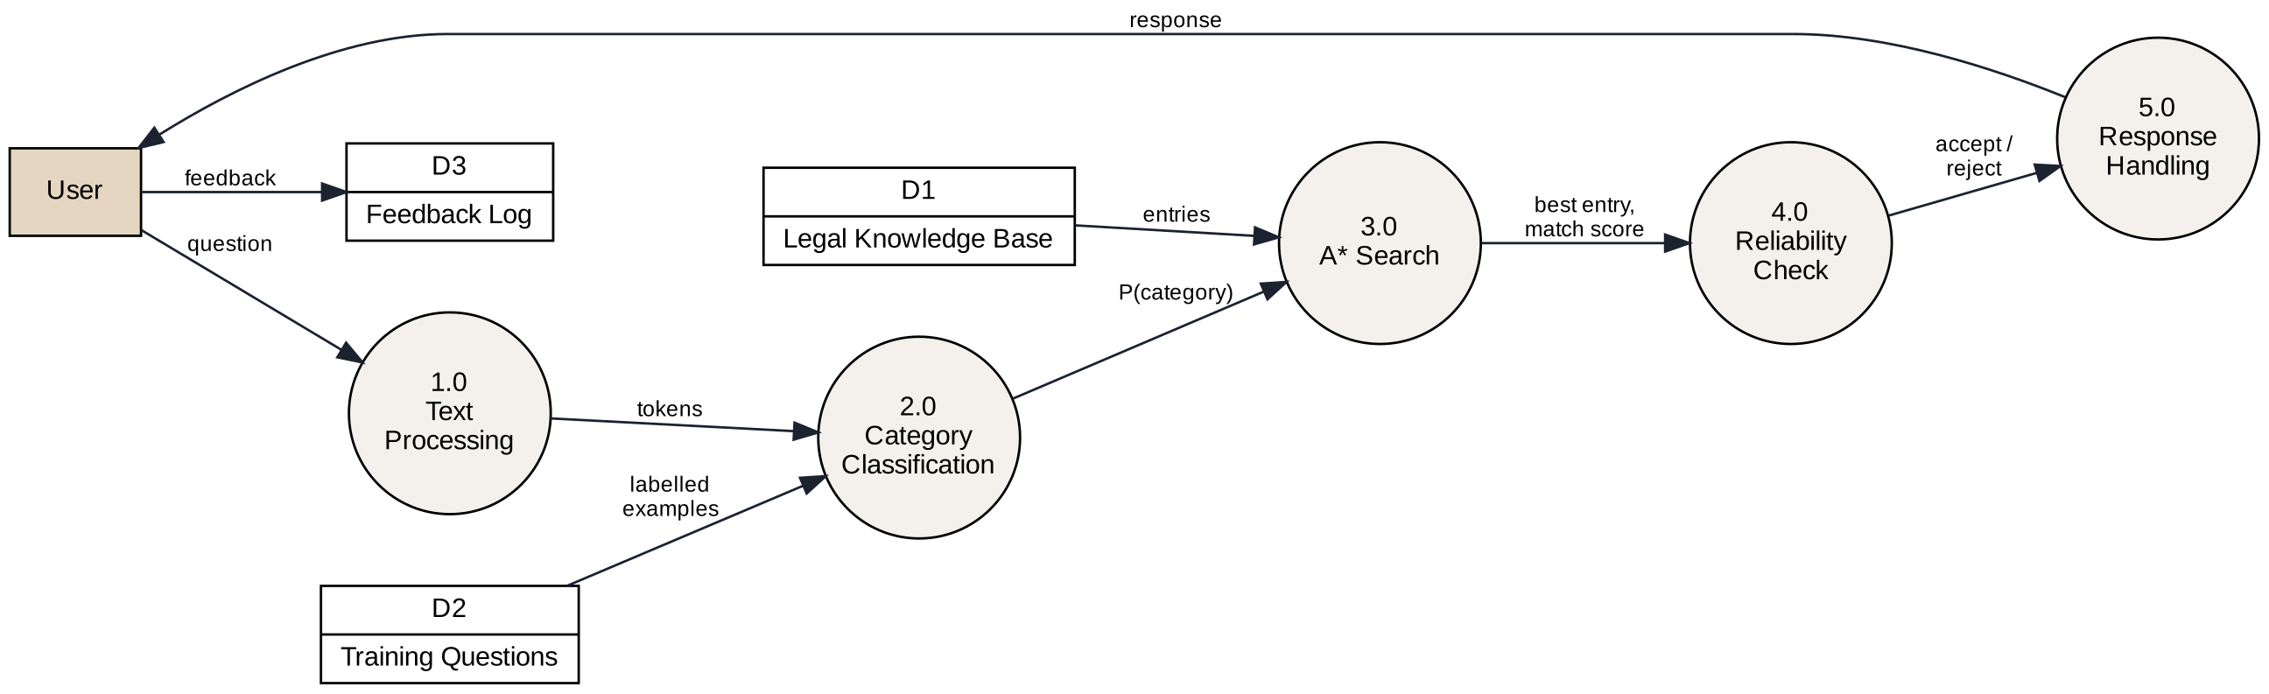
Figure 3.5 Data flow diagram – Level 1
Figure 3.6 shows the activity of the system from the moment a question is entered until an answer or a refusal is displayed. The loop in the middle is the A* search, in which nodes are removed from the open list in order of f(n) until a goal entry is reached.
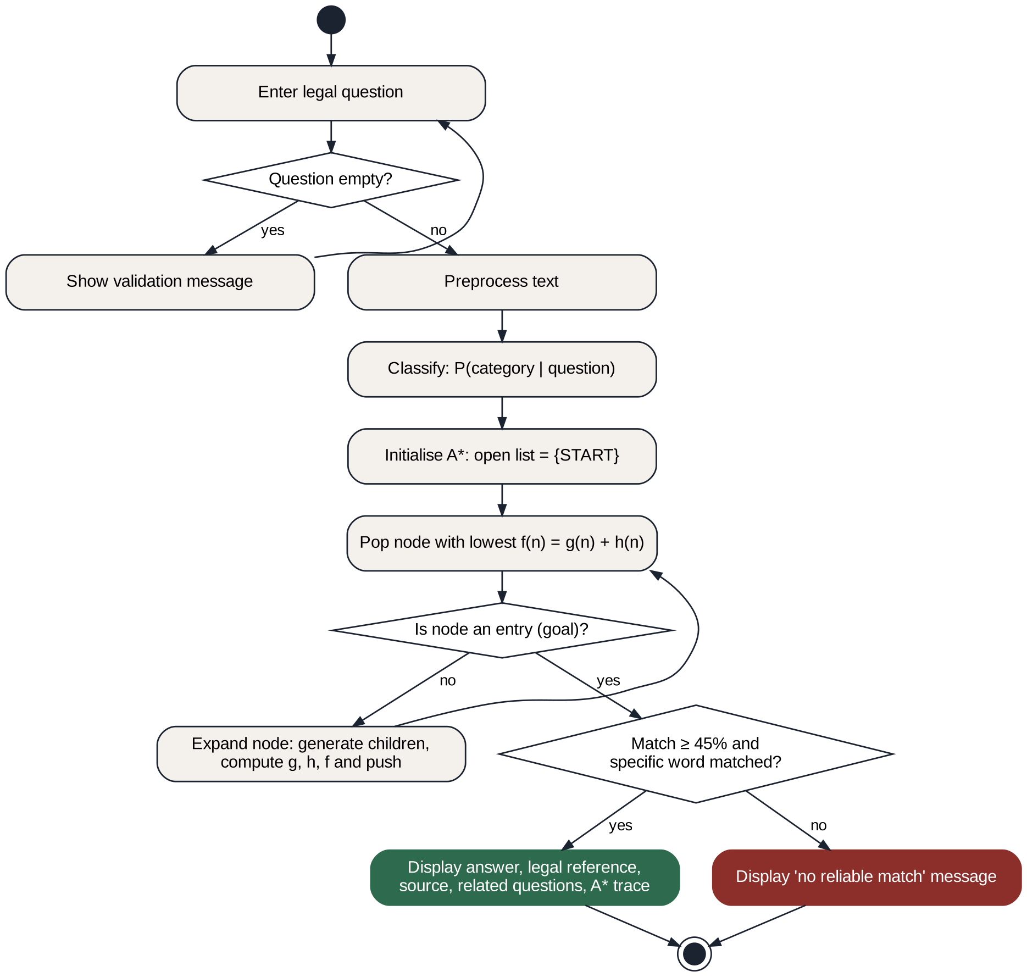
Figure 3.6 Activity diagram of the system

Knowledge Base Design
The knowledge base is stored in a CSV file with the fields listed in Table 3.2. The keywords field holds alternative phrasings, for example “hacked account; password stolen; account compromised”, which help match differently worded questions. It has 81 entries: Consumer Rights (10), Traffic & Driving (11), Cybercrime & Online Fraud (11), Employment (10), Rental / Tenant Issues (9), Fundamental & Civic Rights (10), Women’s Legal Rights (10) and Government Procedures (10). The entries cite official sources such as India Code (Legislative Department, 2026) and reflect the criminal laws in force from 1 July 2024 (Bharatiya Nyaya Sanhita and Bharatiya Nagarik Suraksha Sanhita) and the Labour Codes in force from 21 November 2025.
Table 3.2 Fields of the legal knowledge base
Field | Description
id | Unique identifier of the entry (e.g. L022)
category | One of the eight legal categories
question | Representative legal question
keywords | Alternative words and phrases used during matching
answer | General legal information in plain language
source | Official source (government portal or legislation website)
legal_reference | Relevant Act, section or authority
last_verified | Date on which the entry was last reviewed

CHAPTER 4

MODULES DESCRIPTION
The system is divided into two modules. Module 1 converts the question into terms and estimates the probability of each legal category. Module 2 performs the A* search over the knowledge base and checks the reliability of the result before it is delivered through the web application. Table 4.1 lists the software components that make up these modules.
Table 4.1 Description of modules
Component | Module | Description
Text processing | 1 | Normalisation, synonyms, stop words, stemming
AI classifier | 1 | TF-IDF + Logistic Regression; P(category | question)
A* search | 2 | Optimal retrieval over START → CATEGORY → ENTRY with an admissible heuristic
Retrieval & reliability | 2 | Knowledge base, IDF weights, threshold and too-general check
Agent and Flask application | 2 | Percept → classify → search → act cycle; JSON API
Frontend | 2 | Chat interface, category filter, A* trace view, feedback, theme

4.1 MODULE 1 – TEXT PROCESSING AND AI CLASSIFICATION
The text processing component lower-cases the question, applies synonym rules (“license” → “licence”, “hacked” → “hack”, “house owner” → “landlord”), removes stop words and generic words, ignores pure numbers and applies light suffix stemming. The result is a set of meaningful terms used by both the classifier and the A* search.
The classification component trains a TF-IDF vectoriser (unigrams and bigrams) and a multinomial Logistic Regression model (Pedregosa et al., 2011) on 160 labelled training questions together with the questions and keywords of the knowledge base. For any question it returns the probability of all eight categories. These probabilities are not used as a hard filter; they become the cost of the START → CATEGORY edges in the A* search:
cost(START → C) = 0.6 × (1 − P(C | question)) (4.1)

4.2 MODULE 2 – A* SEARCH AND RELIABILITY CHECK
The A* component contains a generic A* function and the legal search problem. The open list is a priority queue ordered by f(n), a counter breaks ties, a closed set prevents re-expansion and each node stores its parent so that the optimal path can be rebuilt. Algorithm 4.1 gives the pseudocode.
Algorithm 4.1 A* search for legal retrieval
function A_STAR(question, k):
P ← CLASSIFIER.probabilities(question)
open ← priority queue containing START with f = h(START)
closed ← empty set; goals ← empty list
while open is not empty:
n ← node in open with the lowest f(n) = g(n) + h(n)
if n in closed: continue; otherwise add n to closed
if n is an ENTRY: // goal test
append n to goals; if |goals| = k: break // k = 4 (answer + 3 related)
continue
for each child c of n:
if n = START: g(c) ← 0.6 × (1 − P[c]); h(c) ← 1 − coverage(question, c)
else: g(c) ← g(n) + (1 − match(question, c)); h(c) ← 0
push c into open with f(c) = g(c) + h(c)
return goals, expansion trace

Because the first goal removed from the open list has the lowest f(n), it is the optimal answer. The search then continues until three more goals are found, which are shown as related questions. If the user selects a category scope, the successors of START are restricted to that category, so only one branch of the tree is searched.
The best entry is accepted only if its match score is at least the threshold of 45% and at least one specific (non-generic) word of the question matched; otherwise a question such as “How do I file a complaint?” is reported as too general. The legal assistant agent implements the agent cycle of Table 4.2: it perceives the question, obtains the category probabilities, runs the A* search and acts by returning an answer or a refusal. Empty questions, questions longer than 500 characters and unknown category scopes are validated, and server errors return a JSON error message that the interface reports.
Table 4.2 PEAS description of the legal assistant agent
PEAS element | Description
Performance measure | Correct category, relevant answer with law and source, no unreliable answers, fast response
Environment | Questions typed by users; curated knowledge base of Indian legal information
Actuators | Answer card, refusal message, related questions, A* trace on the screen
Sensors | Text of the user’s question and the selected category scope

CHAPTER 5

IMPLEMENTATION AND RESULTS
This chapter describes the setup used to implement and evaluate the AI Legal Assistant and presents the results obtained.

5.1 EXPERIMENTAL SETUP

Technologies Used
The system is written in Python 3.12, which provides the text processing, the classifier, the A* search and the glue to the web application. The user interface uses HTML5, CSS3 and JavaScript: a single-page chat with answer cards, a light and dark theme and a responsive layout, which sends questions to the backend with the Fetch API and renders the answer and the A* trace. Flask (Pallets Projects, 2026) serves the pages and exposes a JSON API (/api/ask and /api/feedback) that passes each question to the agent. The knowledge base and the datasets are CSV files: legal_knowledge.csv (81 entries), training_questions.csv (160 questions) and test_questions.csv (40 questions). Development was done on Windows in a virtual environment using Visual Studio Code, with the Flask development server and Google Chrome for testing.
Table 5.1 Libraries and frameworks used
Library / framework | Purpose
Flask | Web application framework and JSON API
scikit-learn | TF-IDF vectoriser, Logistic Regression, evaluation metrics
pandas, NumPy | Reading CSV datasets; numerical operations
heapq (standard library) | Priority queue used as the A* open list
re, math, collections | Text processing, IDF computation, counting

AI Techniques
- A* search – the core retrieval algorithm with path cost g(n), heuristic h(n) and f(n) = g(n) + h(n).
- Admissible heuristic – h(category) = 1 − best possible word coverage of that category.
- TF-IDF and Logistic Regression – give P(category | question), used as part of the A* path cost.
- IDF-weighted match score and reliability threshold – answer only if the match is at least 45% and a specific word matched.

Datasets and Evaluation Procedure
Three datasets are used: the knowledge base (81 entries), 160 labelled training questions (20 per category) and 40 held-out test questions (5 per category) written separately from the training set. The classifier is evaluated with accuracy, weighted precision, recall and F1-score. The A* search is evaluated by checking whether each test question is answered in the expected category and by recording the match score, the nodes expanded, the categories pruned and the processing time. Twelve functional test cases, including out-of-scope, overly general and empty questions, were also run through the web interface. All timings were measured on a laptop CPU.

5.2 RESULTS

Test Cases
Table 5.2 lists the functional test cases. All twelve passed: supported questions were answered with the expected category, legal reference and a 100% match, unsupported questions were refused, and the interface handled empty input.
Table 5.2 Test cases and observed results
TC | Input | Observed result | Status
TC01 | Can I drive without a licence? | Traffic & Driving; MV Act s.3, s.181 | Pass
TC02 | Someone hacked my account | Cybercrime; IT Act s.43, 66, 66C | Pass
TC03 | My landlord refuses to return my deposit | Rental; Model Tenancy Act s.11 | Pass
TC04 | How can I apply for a passport? | Government Procedures; Passports Act | Pass
TC05 | What are my fundamental rights? | Fundamental Rights; Part III | Pass
TC06 | What should I do if someone steals my password? | Cybercrime; IT Act s.66C | Pass
TC07 | What is the law regarding divorce? | Rejected; match 0% | Pass
TC08 | Can I get a visa for another country? | Rejected; match 0% | Pass
TC09 | (empty question) | “Please type a legal question” | Pass
TC10 | Clear Chat button | Conversation removed | Pass
TC11 | How do I file a complaint? | Rejected as too general | Pass
TC12 | I lost money in a UPI scam | Cybercrime; IT Act s.66D, BNS s.318 | Pass

Sample Input and A* Trace
For “Someone hacked my account” the classifier gives P(Cybercrime & Online Fraud) = 0.66. Table 5.3 lists the nodes in the order in which A* expanded them. The answer is reached after three expansions. The other six categories have f(n) ≈ 1.57, higher than every goal found, so they are pruned. The answer cites the Information Technology Act, 2000 (Sections 43, 66 and 66C) and the National Cyber Crime Reporting Portal.
Table 5.3 A* expansion order for “Someone hacked my account”
Step | Node | g(n) | h(n) | f(n)
1 | START | 0.000 | 0.207 | 0.207
2 | Category: Cybercrime & Online Fraud | 0.207 | 0.000 | 0.207
3 | Entry: hacked account / stolen password (GOAL) | 0.207 | 0.000 | 0.207
4 | Entry: online or UPI fraud (related) | 0.761 | 0.000 | 0.761
5 | Entry: fake profile (related) | 0.761 | 0.000 | 0.761
6 | Category: Government Procedures | 0.569 | 0.554 | 1.123
7 | Entry: PAN card (related) | 1.123 | 0.000 | 1.123

Classification and Search Performance
Table 5.4 shows that the classifier labelled all 40 test questions correctly. This refers only to the category prediction and not to legal correctness. Because the test set is small and written in a style close to the training data, accuracy on real questions is expected to be lower, which is why the classifier is used as a cost inside A* and not as a hard filter.
Table 5.4 Classification results on the 40-question test set
Metric | Result
Accuracy | 100.0%
Precision (weighted) | 1.00
Recall (weighted) | 1.00
F1-score (weighted) | 1.00
Test questions | 40

Table 5.5 summarises the A* search. Compared with an exhaustive search that scores all 81 entries for every question, A* scored on average 10.1 entries, an 87.5% reduction, while the admissible heuristic guarantees the same optimal answer.
Table 5.5 A* search performance on the 40 test questions
Measure | Value
Answered from the expected category | 40 / 40
Average match score of answers | 88.4%
Expansions to reach the answer | 3 (every question)
Entries scored by A* (average) / by exhaustive search | 10.1 of 81 / 81 of 81
Average nodes expanded including 3 related questions | 6.2 of 90
Average categories pruned | 6.8 of 8
Average processing time per question | 1.3 ms
Functional test cases passed | 12 / 12

Output Screenshots
Figures 5.1 to 5.4 show the home screen, an answer card, the A* trace panel and the refusal of an out-of-scope question.
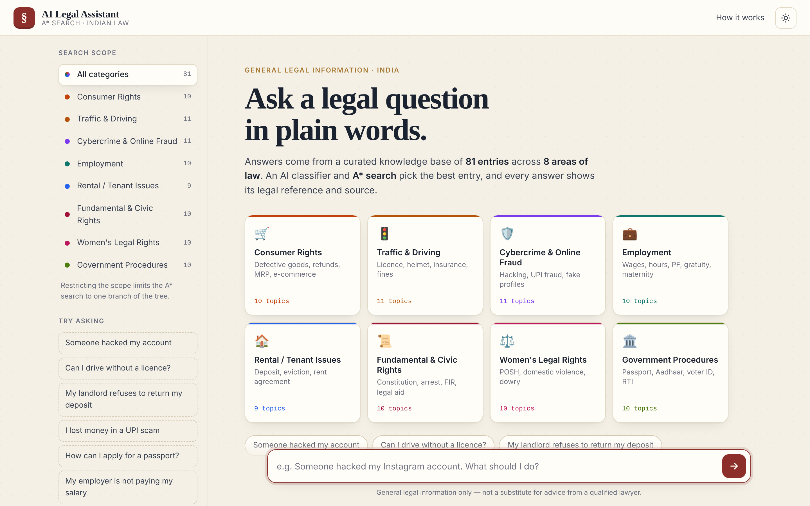
Figure 5.1 Home screen with categories, search scope and sample questions
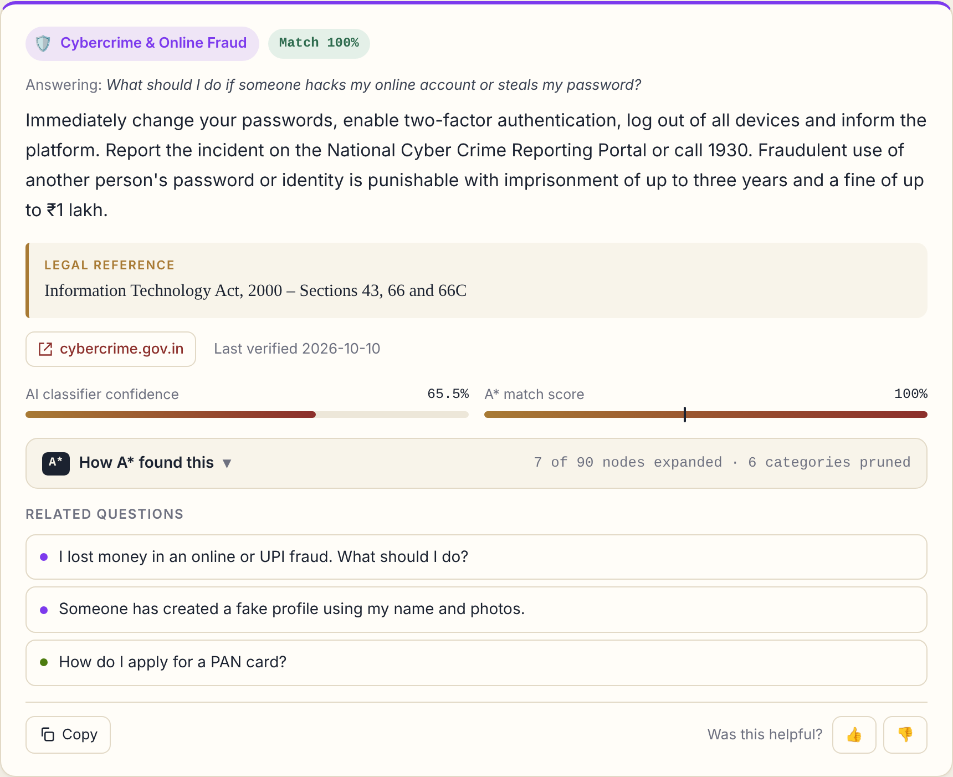
Figure 5.2 Answer card with legal reference, source, confidence and match score
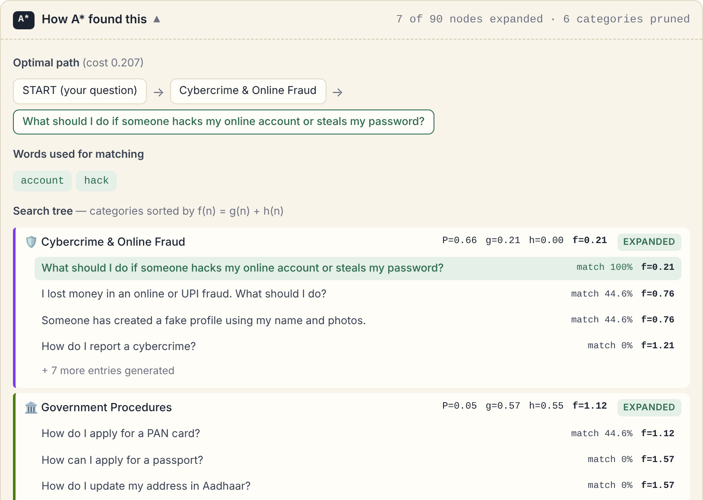
Figure 5.3 A* search trace – optimal path, matched words and search tree
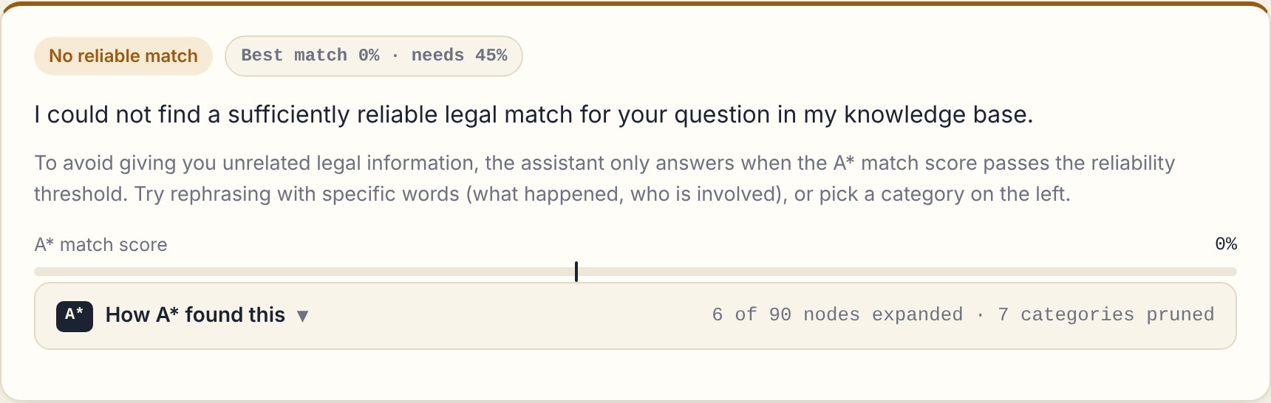
Figure 5.4 Out-of-scope question rejected by the reliability check

Discussion of Results
The results show that the system performs its main functions, category estimation, optimal retrieval with A* and reliable rejection, within its supported domain. The admissible heuristic lets A* prune most of the search space without losing optimality, and the threshold stops unrelated answers for topics such as divorce or visas that are not stored. The main limitation is coverage: questions on topics that are not stored, or that use vocabulary absent from the stored questions and keywords, score low and are rejected. For a legal application this is intentional, since a refusal is safer than an unrelated answer.
CHAPTER 6

CONCLUSION AND FUTURE WORK

Conclusion
The AI-Based Legal Assistant provides simple and accessible general legal information for common questions in India. It combines a supervised classifier (TF-IDF and Logistic Regression) with A* informed search over a START → CATEGORY → ENTRY state space. The classifier probabilities form part of the path cost, and an admissible word-coverage heuristic guarantees that A* returns the optimal entry while pruning categories that cannot hold a better answer. A reliability threshold keeps weak matches from being presented as answers, and every response carries its legal reference and official source. In testing, all twelve functional test cases passed, all 40 held-out questions were answered in the correct category, A* reached each answer after only three expansions, and the classifier reached 100% category accuracy on the test set. The system is intended only for general legal information and is not a replacement for qualified legal professionals.

Limitations
- Limited knowledge base: only selected topics in eight categories are covered.
- Dependence on vocabulary: questions using words absent from the stored questions and keywords may be rejected.
- Small test set: 40 questions may not represent all real user questions.
- Limited legal reasoning: the system retrieves stored information and does not reason about individual cases.
- Maintenance and language: entries must be re-verified as laws change, and only English is supported.

Future Enhancements
- Expansion of the knowledge base with more Acts and state-specific laws.
- Multilingual support for Tamil, Hindi and other Indian languages, and voice interaction.
- Semantic similarity or learned heuristics that preserve admissibility.
- A* search over the sections of uploaded Acts and judgments, with automatic verification of entries against India Code.
- Use of the helpful / not-helpful feedback log to refine keywords and training data.
The assistant thus offers a foundation for a larger legal-information platform with multilingual and voice-based help, guided navigation through government procedures and a mobile application, while keeping its purpose of giving accessible, explainable and source-backed general legal information.
CHAPTER 7

REFERENCES
Chalkidis, I., Fergadiotis, M., Malakasiotis, P., Aletras, N. and Androutsopoulos, I. (2020) ‘LEGAL-BERT: The Muppets straight out of Law School’, Findings of the Association for Computational Linguistics: EMNLP 2020, pp.2898-2904.
Department of Consumer Affairs, Government of India (2026) ‘e-Daakhil: Online Consumer Complaint Filing Portal’, available at https://edaakhil.nic.in.
Hart, P.E., Nilsson, N.J. and Raphael, B. (1968) ‘A Formal Basis for the Heuristic Determination of Minimum Cost Paths’, IEEE Transactions on Systems Science and Cybernetics, Vol.4, No.2, pp.100-107.
Legislative Department, Government of India (2026) ‘India Code: Digital Repository of All Central and State Acts’, available at https://www.indiacode.nic.in.
Ministry of Home Affairs, Government of India (2026) ‘National Cyber Crime Reporting Portal’, available at https://cybercrime.gov.in.
Pallets Projects (2026) ‘Flask Documentation’, available at https://flask.palletsprojects.com.
Paul, S., Mandal, A., Goyal, P. and Ghosh, S. (2023) ‘Pre-trained Language Models for the Legal Domain: A Case Study on Indian Law’, Proceedings of the Nineteenth International Conference on Artificial Intelligence and Law (ICAIL 2023), Braga, Portugal.
Pedregosa, F. et al. (2011) ‘Scikit-learn: Machine Learning in Python’, Journal of Machine Learning Research, Vol.12, pp.2825-2830.
Queudot, M., Charton, É. and Meurs, M.-J. (2020) ‘Improving Access to Justice with Legal Chatbots’, Stats, Vol.3, No.3, pp.356-375.
Russell, S. and Norvig, P. (2020) Artificial Intelligence: A Modern Approach, 4th Edition, Pearson Education.
Zhong, H., Xiao, C., Tu, C., Zhang, T., Liu, Z. and Sun, M. (2020) ‘How Does NLP Benefit Legal System: A Summary of Legal Artificial Intelligence’, Proceedings of the 58th Annual Meeting of the Association for Computational Linguistics, pp.5218-5230.

