Explainable Legal Information Retrieval for Indian Citizens Using A* Search and Supervised Question Classification

Sajine Santhakumar
Department of Computer Science and Engineering
Rajalakshmi Engineering College
Chennai, India
sajinesanthakumar.2024.cse@rajalakshmi.edu.in
Roshini S
Department of Computer Science and Engineering
Rajalakshmi Engineering College
Chennai, India
roshini.s.2024.cse@rajalakshmi.edu.in

Abstract—Many people in India run into everyday legal problems: a salary that has not been paid, a security deposit the landlord will not return, a social media account taken over by someone else. The law that applies is public, but it is spread across Acts and government portals, and keyword search breaks down when a question is phrased in ordinary words. Chatbots that always return their closest match make things worse by answering confidently when they should not. This paper presents a lightweight legal information assistant that treats retrieval as a search problem. A TF-IDF and logistic regression classifier estimates how likely a question is to belong to each of eight legal categories, and these probabilities become part of the path cost of an A* search over a START–category–entry state space. An admissible word-coverage heuristic guarantees that the lowest-cost entry is returned while most categories are pruned, and a reliability threshold lets the system decline questions it cannot answer well. Every answer cites the relevant Act or section and an official source, and the full search trace is shown to the user. On 40 held-out questions, every answer came from the correct category, and A* reached each answer after three node expansions while scoring about 10 of the 81 knowledge-base entries.
Keywords—A* search, admissible heuristic, legal information retrieval, explainable AI, question classification, intelligent agents

Introduction
Legal information in India is public but scattered. Central Acts are published on India Code, everyday procedures live on separate portals for passports, Aadhaar, consumer complaints and cybercrime reporting, and the criminal law itself was recently re-codified, with the Bharatiya Nyaya Sanhita and the Bharatiya Nagarik Suraksha Sanhita replacing the IPC and CrPC from July 2024. For someone who only wants to know what to do after losing money in a UPI scam, this fragmentation is a real barrier.
Two problems make a useful assistant harder to build than it first appears. The first is vocabulary. People rarely use legal terms: “someone hacked my account” and “what should I do if someone steals or misuses my password” describe the same situation but share almost no words. The second is knowing when not to answer. A retrieval system that always returns its nearest neighbour will answer a question about divorce with whichever entry happens to be closest, and in a legal setting a wrong answer is worse than no answer.
Much recent work on legal AI relies on large pre-trained language models [1]–[3], and existing legal chatbots have been built mainly for other jurisdictions [4]. These systems are capable, but they need GPUs, behave largely as black boxes and are usually aimed at lawyers rather than citizens. We take a different route that runs on an ordinary laptop and stays transparent: we frame retrieval as a problem-solving task and solve it with A* search [5], letting a learned classifier supply part of the path cost.
The main contributions of this paper are as follows:
- a formulation of legal FAQ retrieval as a state-space search problem in which classifier probabilities act as edge costs rather than hard filters;
- an admissible heuristic based on category word coverage that keeps A* optimal while pruning most of the search space;
- a reliability rule that declines weak or overly general matches instead of guessing; and
- a working, source-backed assistant covering 81 curated entries on Indian law, with an interface that exposes the complete search trace.
Section II reviews related work. Section III describes the proposed method, Section IV covers the implementation, Section V reports the results, and Section VI concludes the paper.

Related Work
Zhong et al. [1] survey legal AI and divide existing methods into embedding-based and symbol-based approaches, evaluating them on judgment prediction, similar-case matching and legal question answering. Their experiments on Chinese datasets show that legal question answering is still far below human performance, and they argue for models that are easier to interpret. That argument shaped our decision to show users how each answer was found.
Chalkidis et al. [2] adapted BERT to legal text by further pre-training, and by pre-training from scratch, on about 12 GB of English legislation, court cases and contracts. LEGAL-BERT improves legal text classification and tagging, but its computing cost and its focus on EU and US law make it a poor fit for a citizen-facing tool on Indian law. Paul et al. [3] address the Indian setting directly by continuing pre-training on roughly 5.4 million Indian legal documents. Their InLegalBERT models help with statute identification and judgment prediction, yet they are built for legal professionals and do not produce plain-language guidance.
Closer to our use case, Queudot et al. [4] built retrieval-based legal chatbots for immigration questions and for employees of a Canadian bank, comparing StarSpace intent classifiers with a fine-tuned BERT model. They report that unseen vocabulary hurts retrieval and that BERT is expensive at inference time. We address vocabulary mismatch with synonym normalisation and curated keywords, and we add an explicit path for refusing to answer.
Our search component builds on A* [5], which expands nodes in order of f(n) = g(n) + h(n) and returns an optimal solution whenever the heuristic never over-estimates the remaining cost. A* is a standard tool for path finding [6] but is rarely applied to FAQ or document retrieval. Table I summarises how the reviewed work relates to ours.
- Comparison with Related Work
Work | Approach | Limitation | Our response
Zhong et al. [1] | Survey of legal AI | Black-box models; Chinese data | Visible A* trace with sources
Chalkidis et al. [2] | LEGAL-BERT | GPU cost; EU/US law | CPU-only model; Indian law
Paul et al. [3] | InLegalBERT | Aimed at professionals | Plain-language answers
Queudot et al. [4] | Retrieval chatbots | Unseen vocabulary | Synonyms, keywords, refusal
Hart et al. [5] | A* search | Needs a good heuristic | Admissible coverage heuristic

Proposed Method

System Overview
Fig. 1 shows the overall pipeline. A question typed into the web interface is normalised, passed to a category classifier and then handed to an A* search over the knowledge base. The best entry is shown only if it passes a reliability check; otherwise the user is told that no reliable match exists. The design follows the goal-based agent model [6]: the question is the percept, the curated knowledge base is the environment, and the answer card or refusal message is the action.
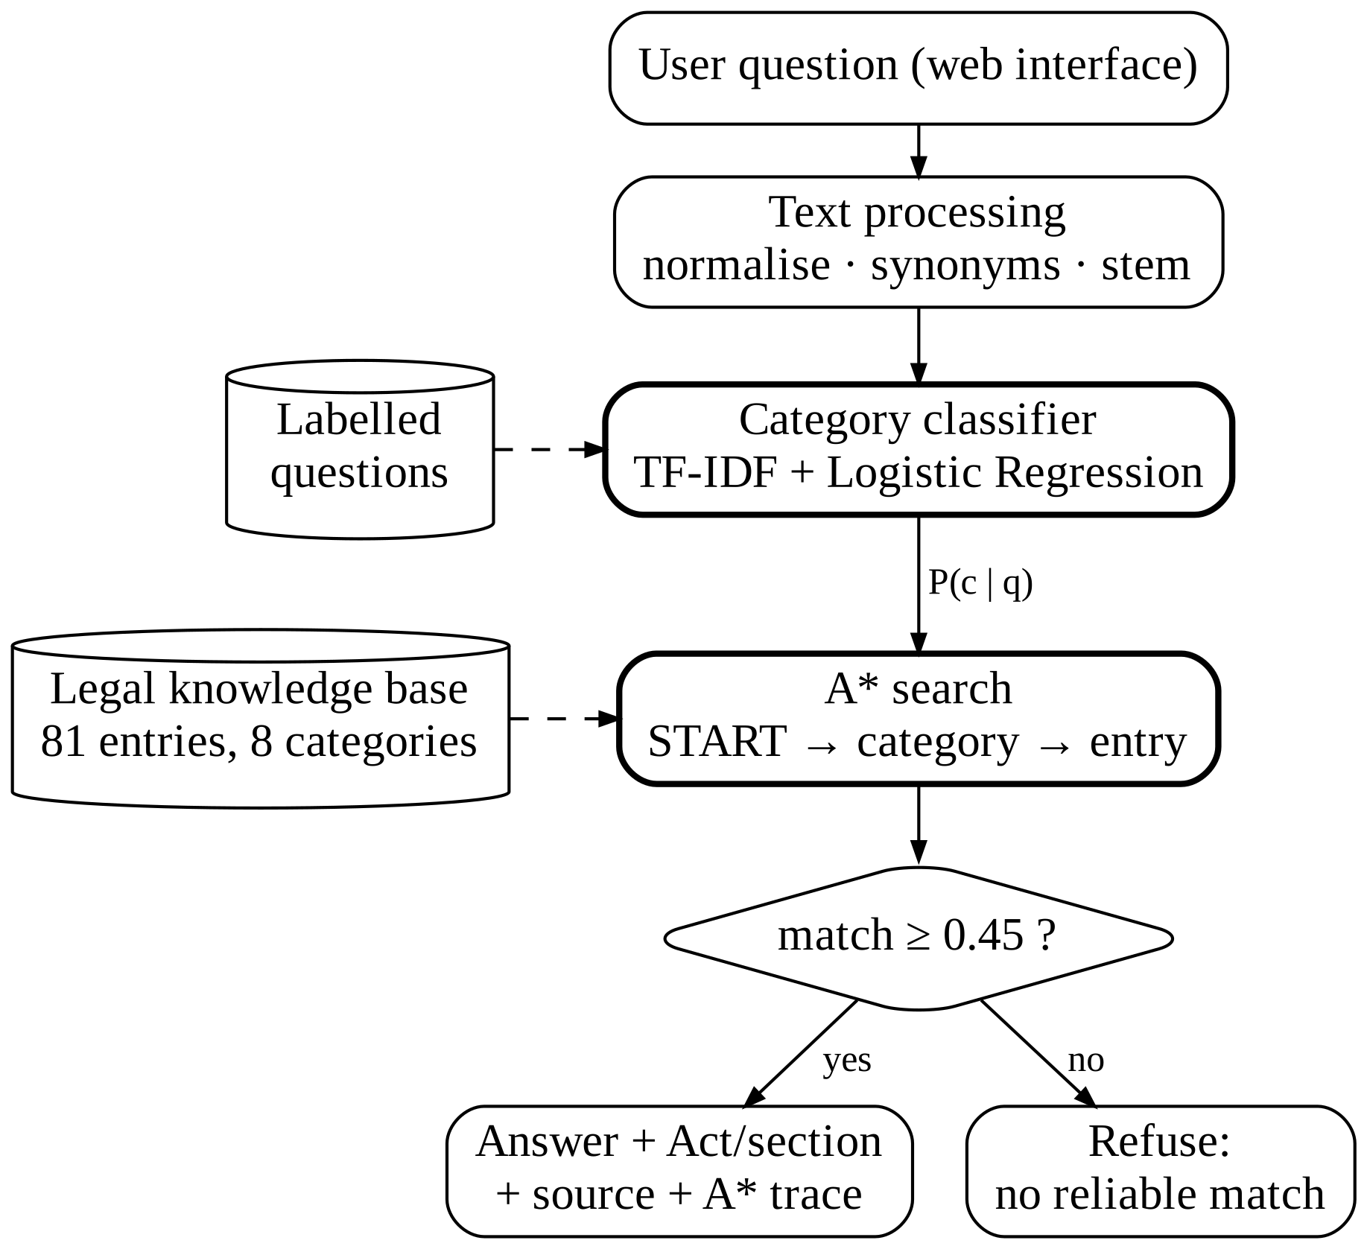
- Architecture of the proposed legal information assistant.

Knowledge Base
The knowledge base contains 81 hand-curated entries in eight categories: consumer rights, traffic and driving, cybercrime and online fraud, employment, rental and tenancy, fundamental and civic rights, women’s legal rights, and government procedures. Each entry stores a representative question, a list of alternative phrasings and keywords, a plain-language answer, the relevant legal reference (for example, Section 66C of the Information Technology Act, 2000), a link to an official source such as India Code [7], and the date on which it was last reviewed. The entries reflect the 2023 criminal codes and the labour codes that came into force in November 2025.

Text Processing and Category Classification
Each question is lower-cased, passed through a small synonym table (“license” to “licence”, “hacked” to “hack”, “house owner” to “landlord”), stripped of stop words and lightly stemmed. For classification we use TF-IDF features over unigrams and bigrams with a multinomial logistic regression model [8], trained on 160 labelled questions together with the questions and keywords of the knowledge base. The model outputs P(c | q) for every category c. We deliberately keep all eight probabilities rather than only the top prediction, and pass them to the search.

Retrieval as A* Search
The state space has three levels: a START node, one node for each category and one node for each entry, giving 90 nodes in total. A path START → c → e has the cost
g(e) = α (1 − P(c | q)) + (1 − m(q, e)) (1)
where α = 0.6 weights the classifier term and m(q, e) is the match score between question q and entry e. The match score is the IDF-weighted share of the question’s terms that also appear in the entry’s question or keywords:
m(q, e) = Σ_{t ∈ q ∩ e} w(t) / Σ_{t ∈ q} w(t) (2)
Terms that occur nowhere in the knowledge base receive the largest weight, so out-of-scope words pull the score down. A short list of generic legal words such as “punishment”, “complaint” and “file” is down-weighted so that these words cannot carry a match on their own. For a category node the heuristic is
h(c) = 1 − m(q, V_{c}) (3)
where V_{c} is the set of all terms used by the entries of category c; entry nodes have h(e) = 0. Nodes are expanded in increasing order of f(n) = g(n) + h(n) using a priority queue and a closed set.

Admissibility of the Heuristic
An entry of category c cannot contain a term that is missing from V_{c}, so m(q, e) ≤ m(q, V_{c}) for every entry e in c. It follows that h(c) ≤ 1 − m(q, e), which is the true remaining cost from c to its best entry, so the heuristic never over-estimates. By the result of Hart et al. [5], the first entry removed from the open list is therefore optimal, and any category whose f-value already exceeds the cost of that entry is never expanded. Because the classifier enters as a cost rather than a filter, a misclassified question can still reach the right entry in another category whenever that path is cheaper.
Once the first goal has been found, the search simply continues until three more entries leave the open list. These are offered to the user as related questions at almost no extra cost.

Reliability Check
The best entry is shown only if m(q, e) ≥ 0.45 and at least one non-generic term of the question has matched. The first condition rejects questions outside the knowledge base. The second catches vague questions such as “How do I file a complaint?”, which match many entries through generic words alone, and asks the user for more detail instead.

Worked Example
Fig. 2 traces the question “Someone hacked my account.” The classifier assigns a probability of 0.66 to the cybercrime category, which gives that category g = 0.21. Its vocabulary covers both query terms, so h = 0 and f = 0.21. A* expands the category, finds the entry on hacked accounts with a perfect match and stops after three expansions. Six of the eight categories have f ≈ 1.57 and are never opened.
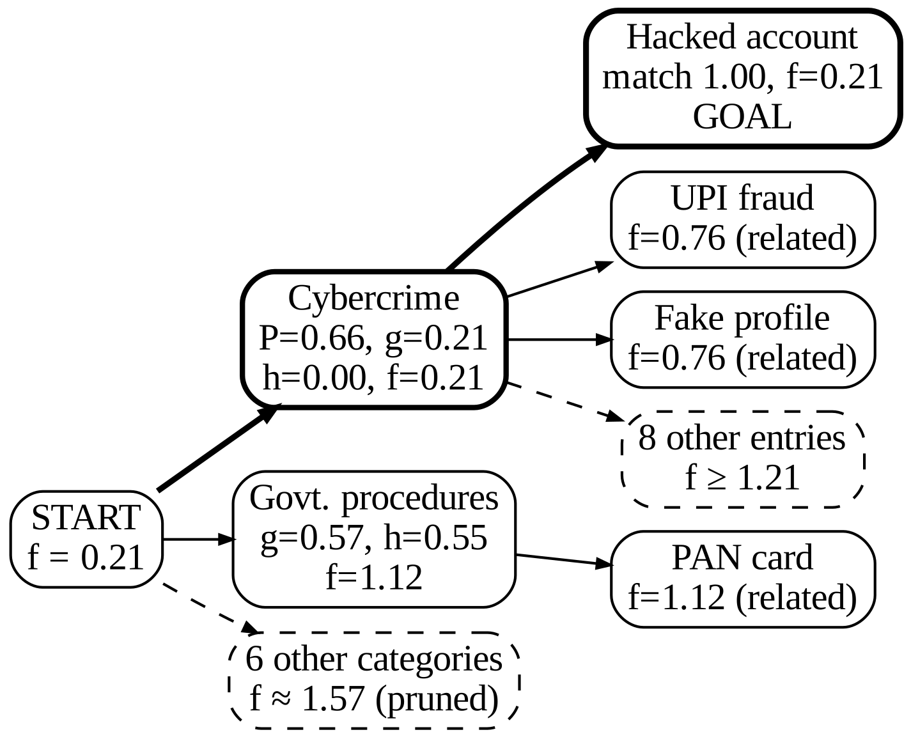
- A* search tree for “Someone hacked my account”. Bold edges show the optimal path; dashed nodes are pruned or not expanded.

Implementation
The system is written in Python 3.12. scikit-learn [8] provides the vectoriser and the classifier, pandas loads the CSV knowledge base, and the A* search uses Python’s heapq module as its open list. A Flask application exposes the agent through a JSON endpoint, and a single-page HTML, CSS and JavaScript interface presents each answer as a card with the category, the answer text, the legal reference, a link to the official source, the classifier confidence, the match score and a list of related questions (Fig. 3).
A collapsible panel under each answer lists the optimal path, every expanded node with its g, h and f values, and the categories that were pruned. Users can restrict the search to a single category, which limits A* to one branch of the tree, and can rate each answer as helpful or not; these ratings are logged for later review. The complete system runs on an ordinary laptop without a GPU or any external AI service.
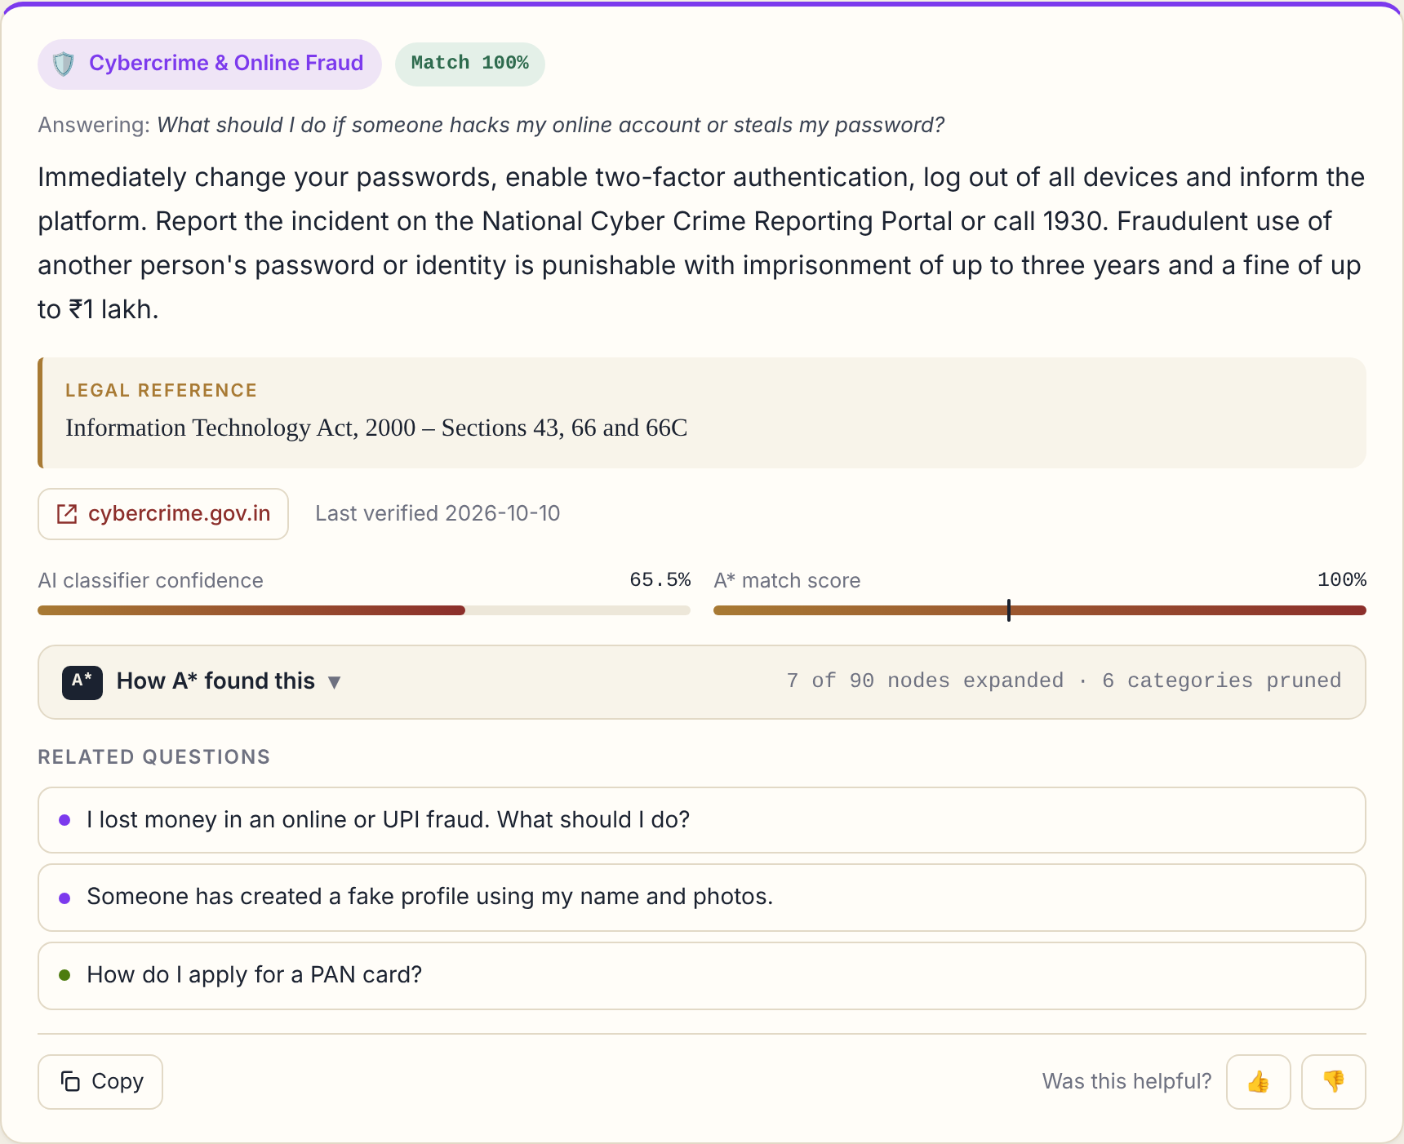
- Answer card for “Someone hacked my account”, showing the legal reference, official source, classifier confidence and match score.

Results and Discussion

Experimental Setup
We evaluated the system on 40 held-out questions, five per category, written separately from the 160 training questions. We also ran twelve functional test cases, including two out-of-scope questions (on divorce and foreign visas), one overly general question and an empty input. All timings were measured on a laptop CPU.

Category Classification
Table II reports the classification results. The classifier labelled all 40 test questions correctly. We read this figure with some caution: the test set is small and written in a style close to the training data, and real users will phrase things less predictably. This is exactly why the classifier contributes a cost to the search instead of making the final decision on its own.
- Category Classification Results
Metric | Value
Accuracy | 100.0%
Precision (weighted) | 1.00
Recall (weighted) | 1.00
F1-score (weighted) | 1.00
Test questions | 40

Retrieval and Search Efficiency
Table III summarises the behaviour of the search. Every test question was answered from the expected category, with an average match score of 0.88. A* reached the answer after exactly three expansions for every question and scored on average 10.1 of the 81 entries, an 87.5% reduction compared with scoring the whole knowledge base, while the admissible heuristic guarantees the same optimal answer. Including the three related questions, an average of 6.2 nodes were expanded and 6.8 of the 8 categories were pruned. Average processing time was 1.3 ms per question.
- A* Search Performance on 40 Test Questions
Measure | Value
Answered from expected category | 40 / 40
Average match score | 0.88
Expansions to reach the answer | 3
Entries scored by A* (average) | 10.1 of 81
Entries scored by exhaustive search | 81 of 81
Categories pruned (average) | 6.8 of 8
Processing time per question | 1.3 ms
Functional test cases passed | 12 / 12

Discussion
The refusal path behaved as intended. The questions on divorce and visas scored 0.0 and were declined instead of being matched to an unrelated entry, and the vague complaint question was flagged as too general. The trace panel also turned out to be useful during development: when a question failed, the list of matched words usually showed at once whether a synonym or keyword was missing.
The approach has clear limits. Coverage is bounded by the 81 curated entries, and a question whose vocabulary appears nowhere in the knowledge base is rejected even when its topic is covered. The system retrieves stored information rather than reasoning about a person’s particular circumstances, and legal content changes over time, so the entries must be re-verified periodically.

Conclusion and Future Work
We have presented a legal information assistant that treats retrieval as an A* search, uses a supervised classifier as a source of path costs and declines to answer when the best match is weak. The admissible heuristic keeps the search optimal while pruning most of the knowledge base, and the visible search trace makes every answer easy to check. In future work we plan to extend the knowledge base to state-specific law, add support for Tamil and Hindi, explore semantic similarity measures that preserve admissibility, and use the logged feedback to refine keywords and training data.

Acknowledgment
The authors thank the Department of Computer Science and Engineering, Rajalakshmi Engineering College, for guidance and support throughout this work.

References
- H. Zhong, C. Xiao, C. Tu, T. Zhang, Z. Liu, and M. Sun, “How does NLP benefit legal system: A summary of legal artificial intelligence,” in Proc. 58th Annu. Meeting Assoc. Comput. Linguistics (ACL), 2020, pp. 5218–5230.
- I. Chalkidis, M. Fergadiotis, P. Malakasiotis, N. Aletras, and I. Androutsopoulos, “LEGAL-BERT: The muppets straight out of law school,” in Findings Assoc. Comput. Linguistics: EMNLP 2020, 2020, pp. 2898–2904.
- S. Paul, A. Mandal, P. Goyal, and S. Ghosh, “Pre-trained language models for the legal domain: A case study on Indian law,” in Proc. 19th Int. Conf. Artif. Intell. Law (ICAIL), Braga, Portugal, 2023.
- M. Queudot, É. Charton, and M.-J. Meurs, “Improving access to justice with legal chatbots,” Stats, vol. 3, no. 3, pp. 356–375, 2020.
- P. E. Hart, N. J. Nilsson, and B. Raphael, “A formal basis for the heuristic determination of minimum cost paths,” IEEE Trans. Syst. Sci. Cybern., vol. 4, no. 2, pp. 100–107, 1968.
- S. Russell and P. Norvig, Artificial Intelligence: A Modern Approach, 4th ed. Hoboken, NJ, USA: Pearson, 2020.
- Legislative Department, Government of India, “India Code: Digital repository of all central and state Acts.” [Online]. Available: https://www.indiacode.nic.in
- F. Pedregosa et al., “Scikit-learn: Machine learning in Python,” J. Mach. Learn. Res., vol. 12, pp. 2825–2830, 2011.

