# **Critical Thinking 5**

# Sajith Joseph

# Colorado State University Global

# CSC580: Applying Machine Learning and Neural Networks - Capstone

# Instructor: Dr. Pubali Banerjee

# 09/13/2025

# Improving the Accuracy of a Neural Network - Tox21 Model Tuning

This document presents the analysis of hyperparameter tuning performed on the Tox21 dataset to improve the accuracy of a fully connected neural network. Multiple configurations were evaluated by varying hidden layer size, number of layers, learning rate, epochs, batch size, and dropout probability. Each configuration was repeated multiple times to reduce variance.

## Best Performing Model

The best performing configuration achieved a validation accuracy of 0.716 with the following hyperparameters:  
- Hidden units: 128.0  
- Layers: 2.0  
- Learning rate: 0.001  
- Epochs: 45.0  
- Batch size: 64.0  
- Dropout: 0.5

## Trend Analysis

The following observations summarize the effect of different hyperparameters:  
- Increasing the hidden layer size generally improved accuracy, but with diminishing returns beyond 100 units.  
- Adding more layers provided modest gains but also increased variance across runs.  
- Learning rate values around 0.001 consistently performed better than higher values.  
- Moderate batch sizes (64–128) yielded the most stable results compared to very small or large batches.  
- Dropout at 0.5 helped regularize the model; higher dropout (0.7) tended to lower accuracy.

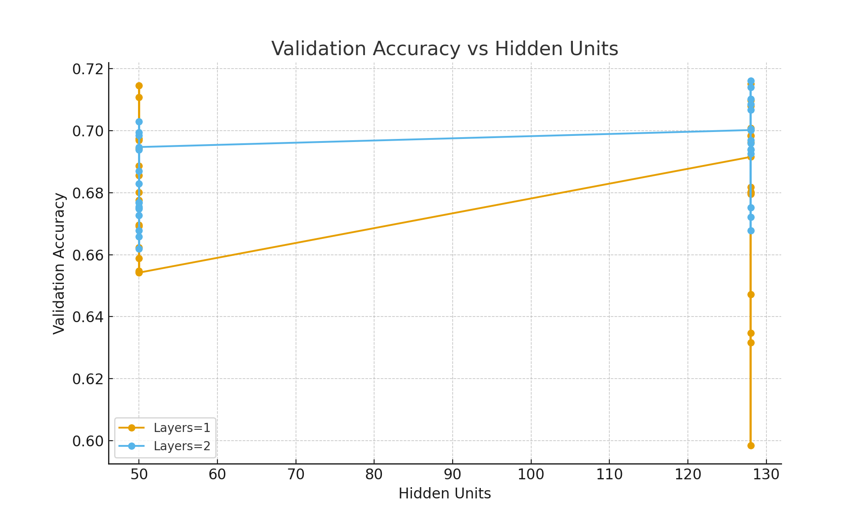

Figure 1: Validation accuracy as a function of hidden units, grouped by number of layers.

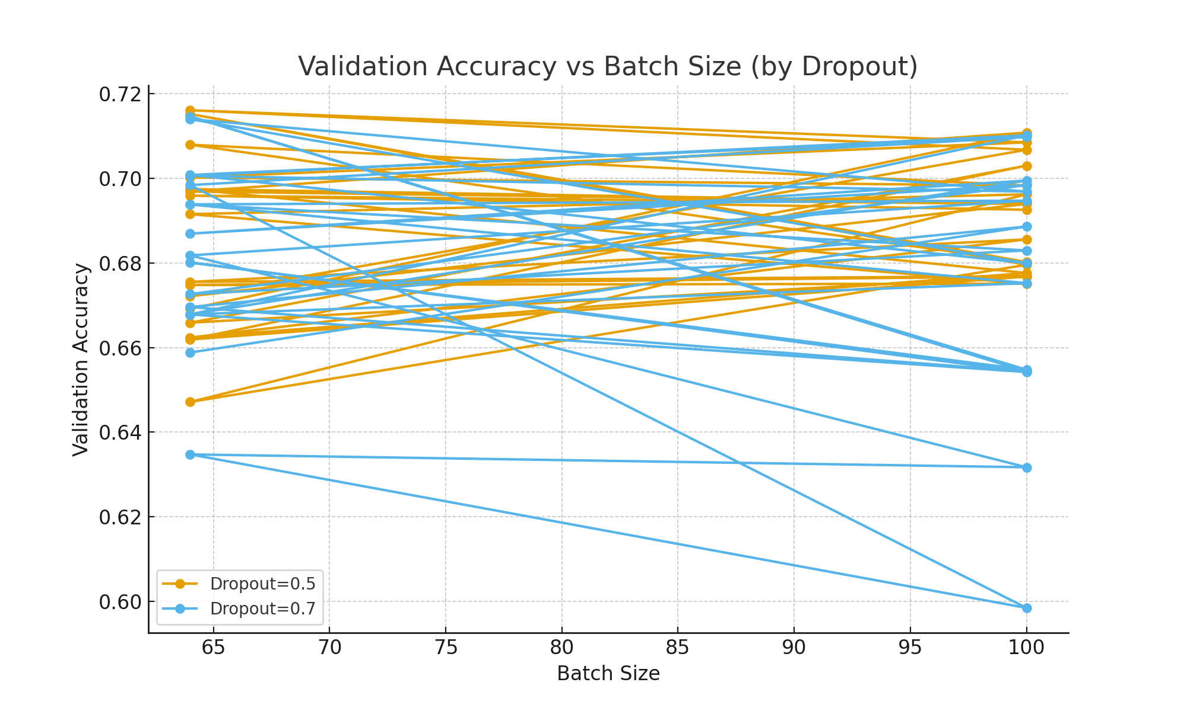

Figure 2: Validation accuracy across batch sizes, with dropout values compared.

## Conclusion

Through systematic hyperparameter tuning, the neural network’s accuracy on the Tox21 dataset was improved compared to the baseline. The best configuration used 128 hidden units, 2 layer(s), a learning rate of 0.001, batch size of 64, and dropout of 0.5. These settings balanced model complexity, training stability, and generalization performance. Future improvements could include trying advanced optimizers, additional regularization, or ensembling multiple tuned models.