**Creating Resource Group**

**SEA region**

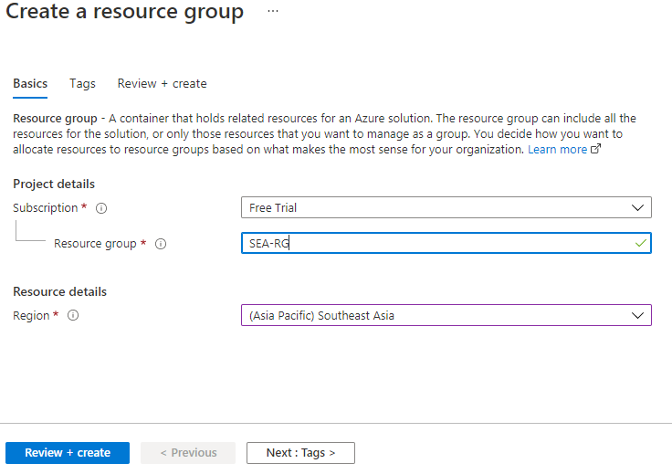



**EAST US**

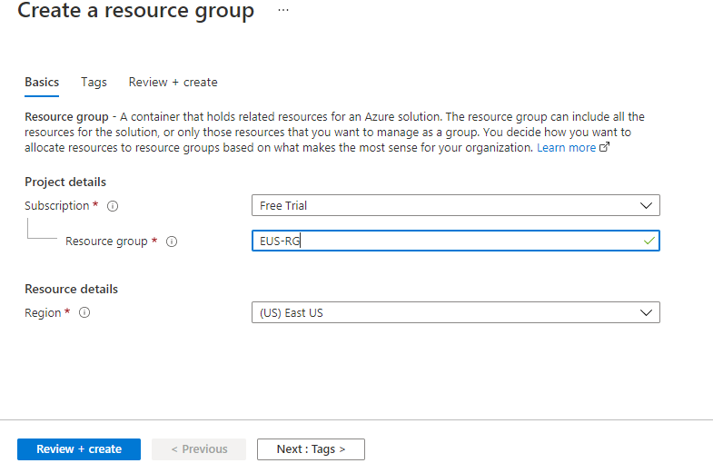



**Vnet creation**

**Vnet-SEA**

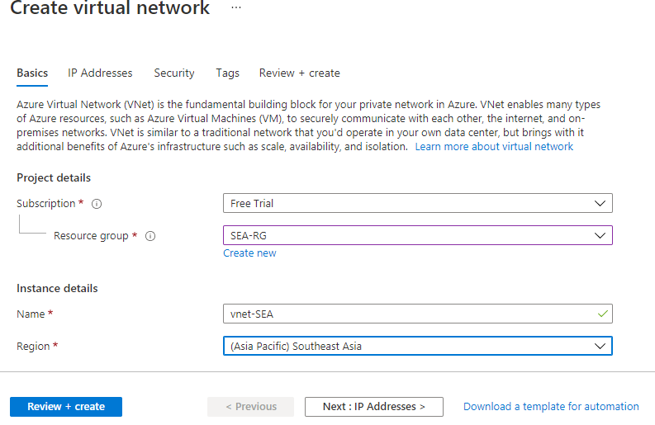

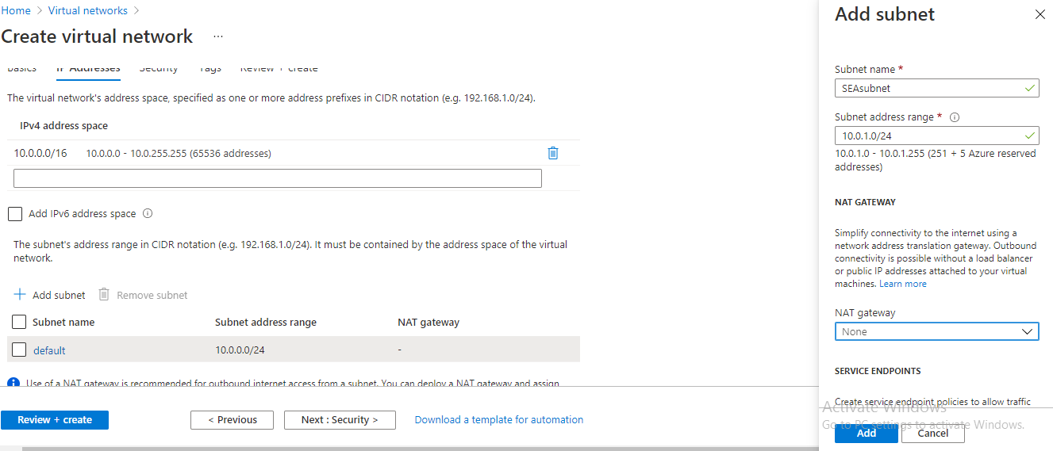

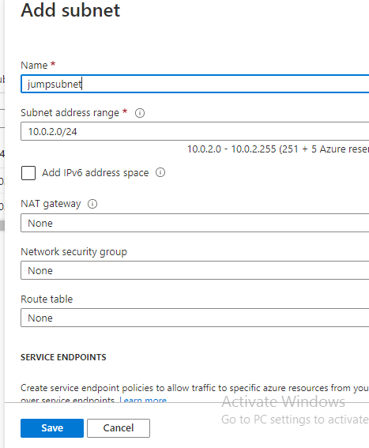

**Vnet-EUS**

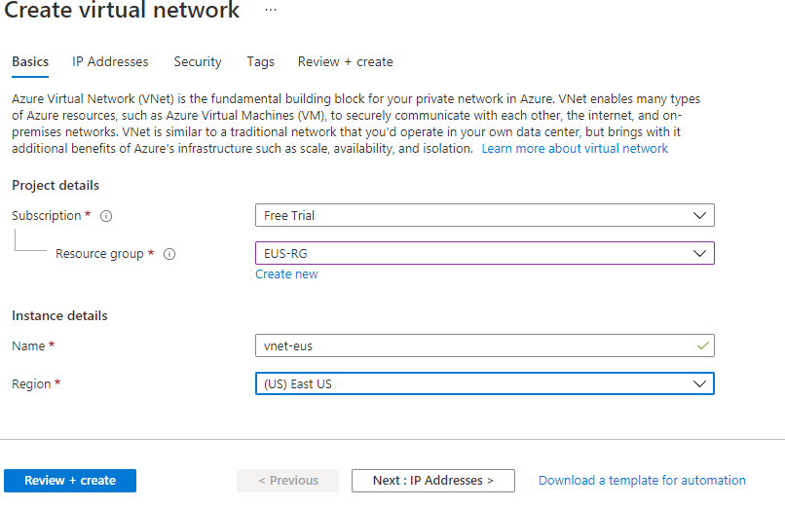

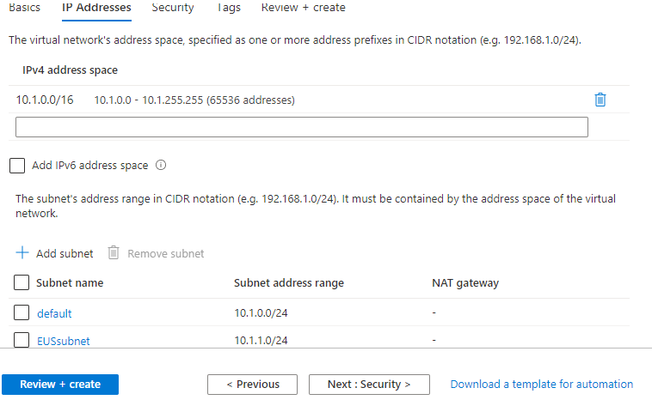

**NSG creation and Rules**

**SEA**

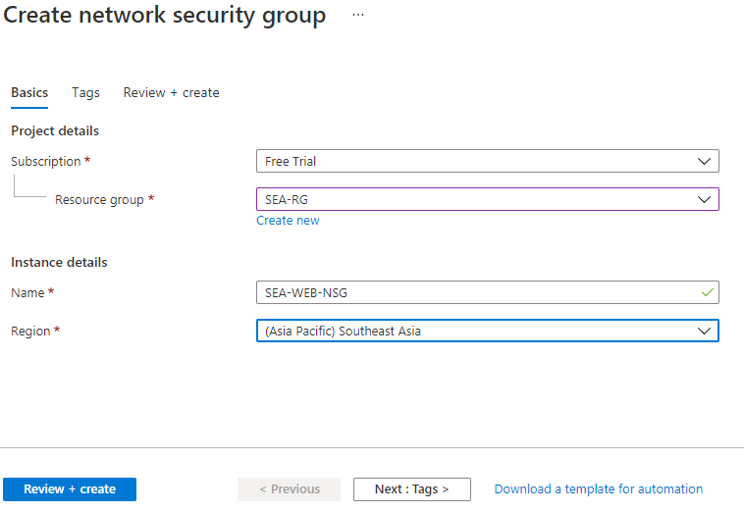

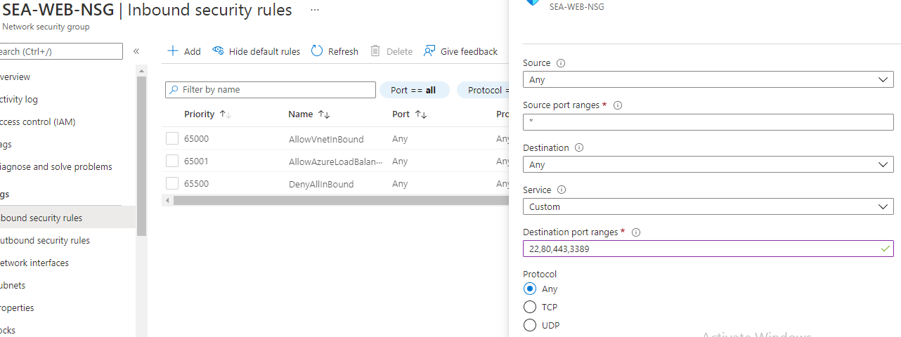

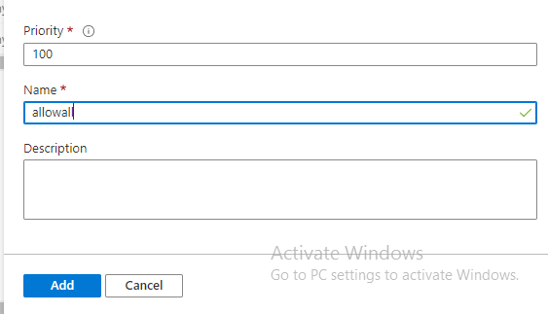

**Associating to the SEAsubnet**

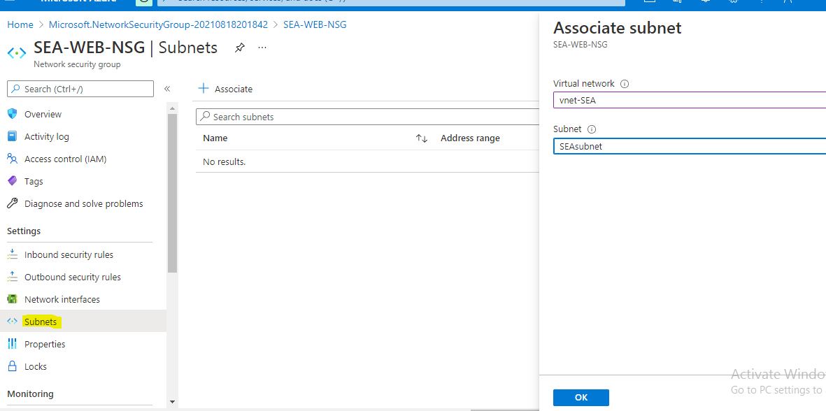

SEA jump NSG

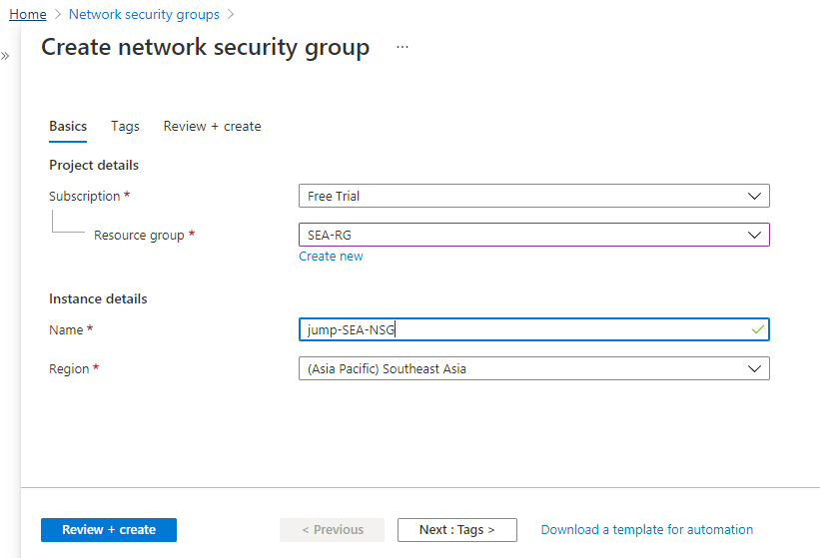

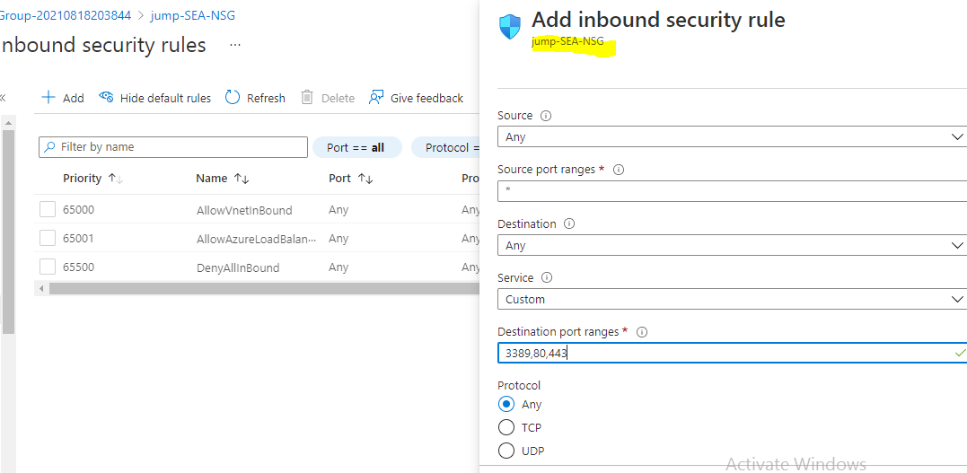

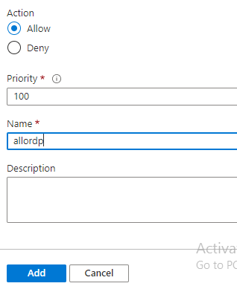

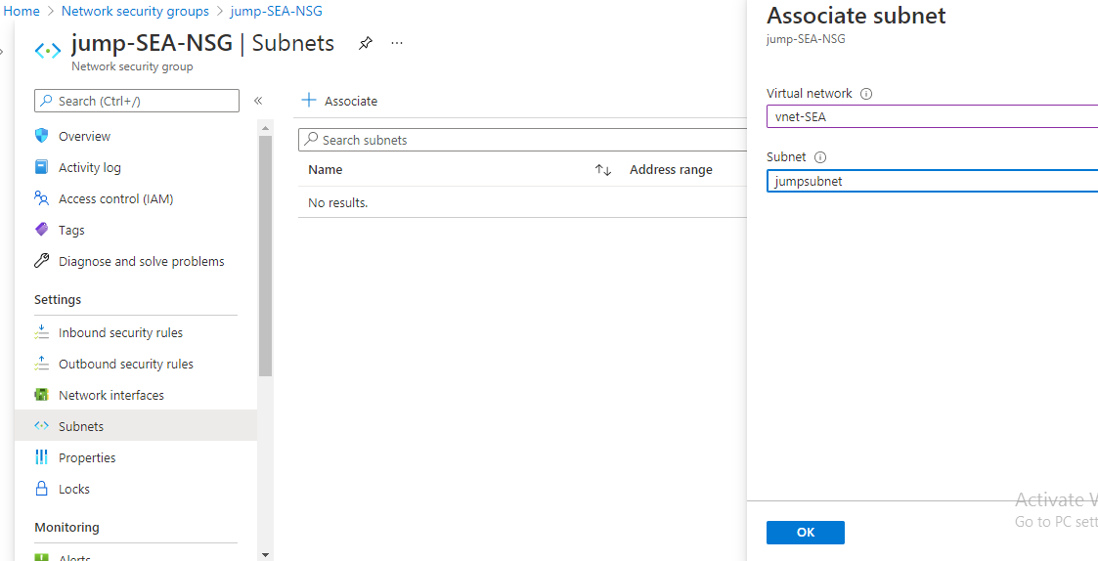

EUS

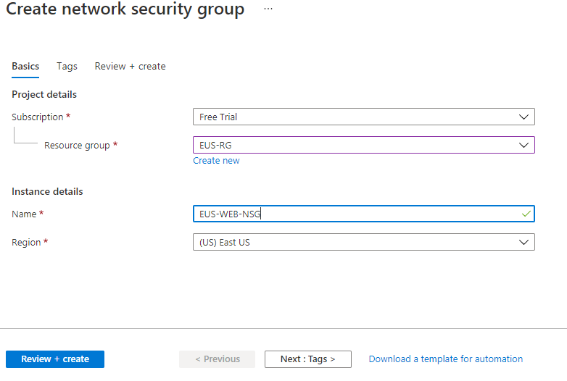

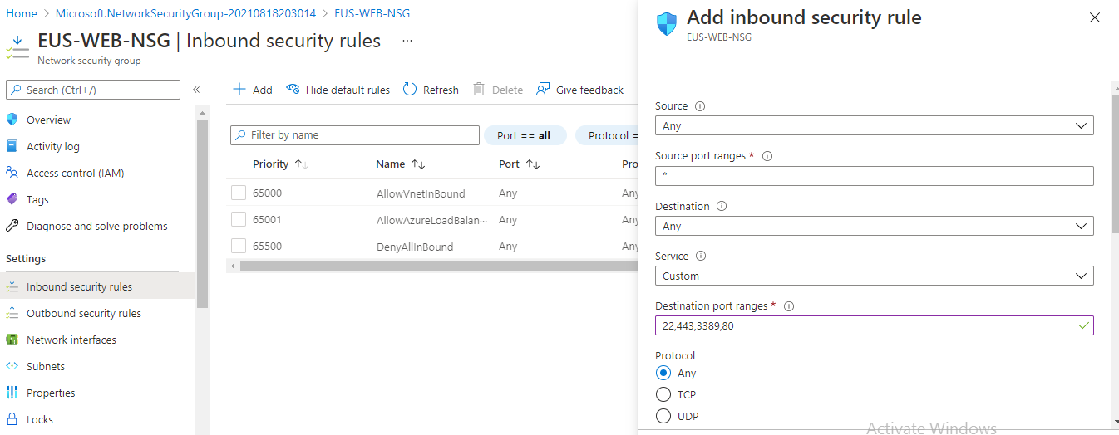

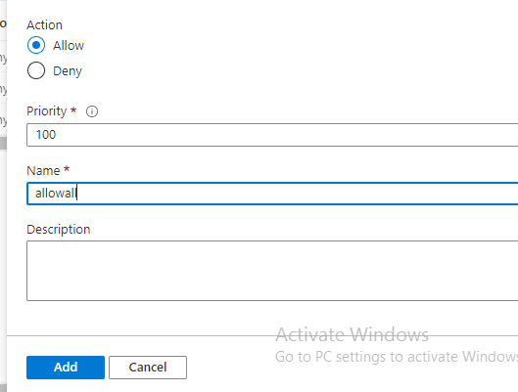

**Associating to the eusubnet**

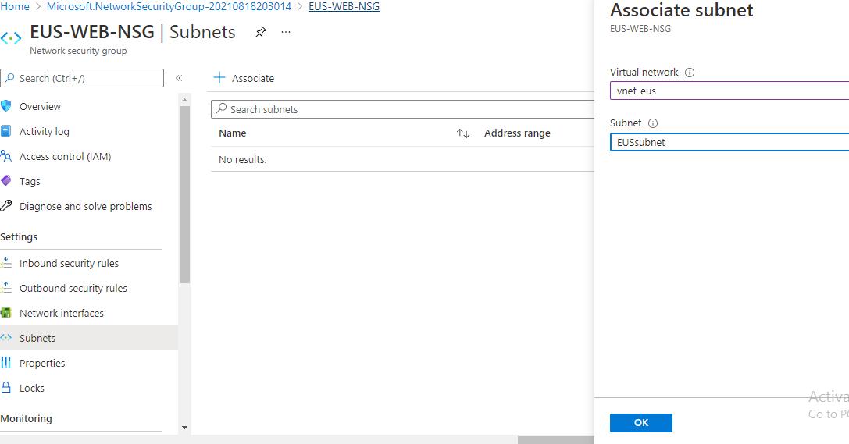

1. **two web servers with 99.95% high availability**

**Created availability set**

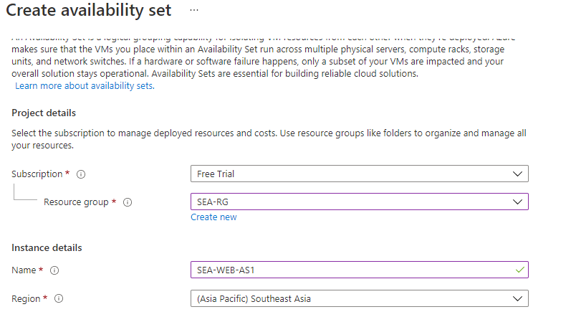

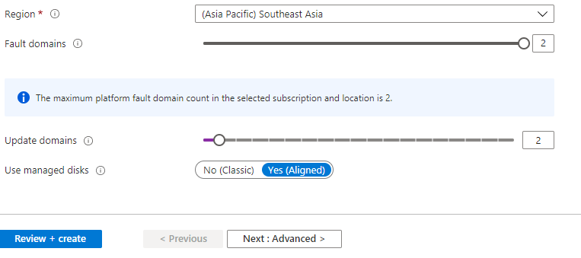

**Creating VM’s- SEA-webserver1**

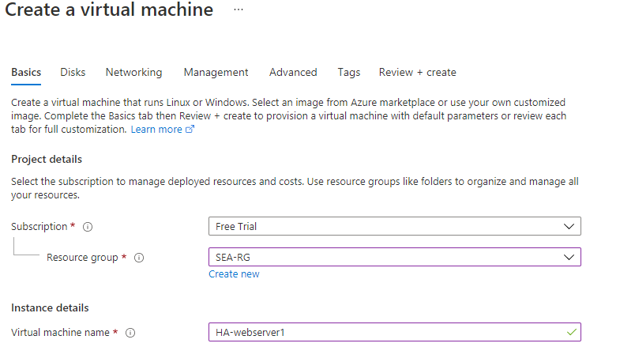

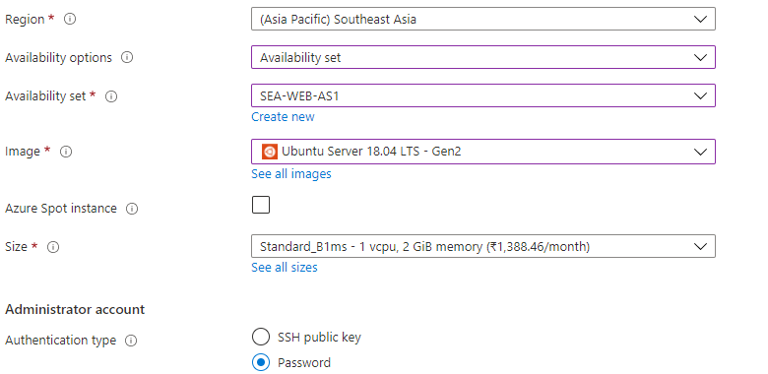

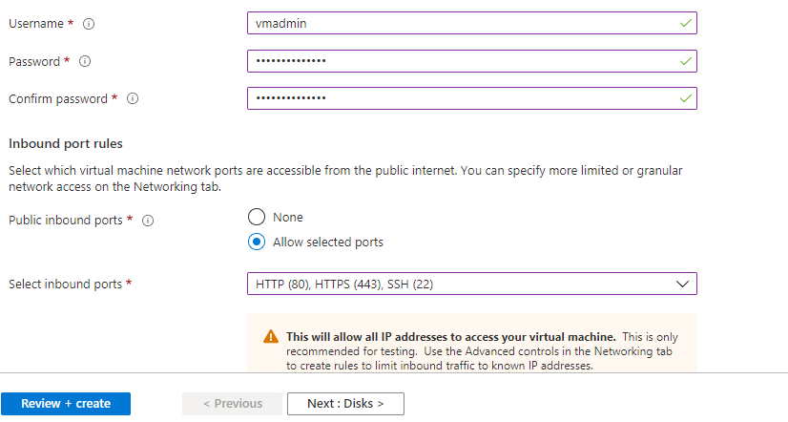

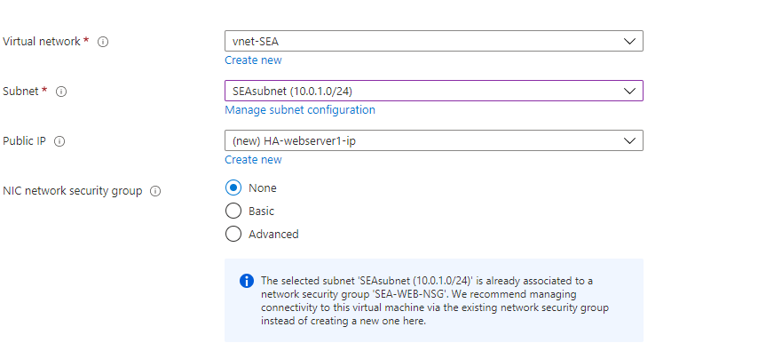

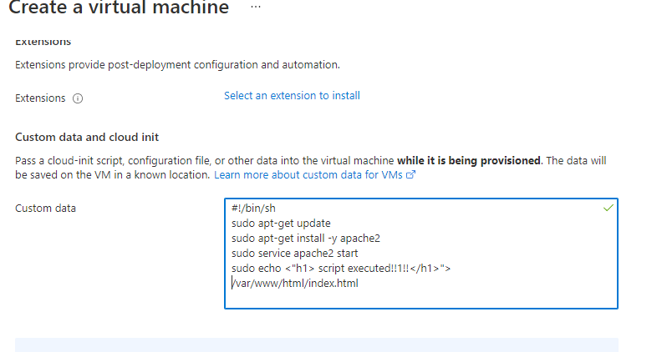

**Webserver 2:**

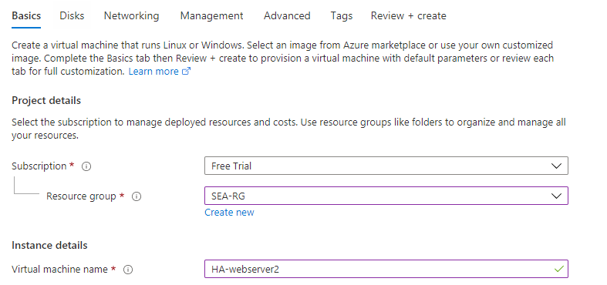

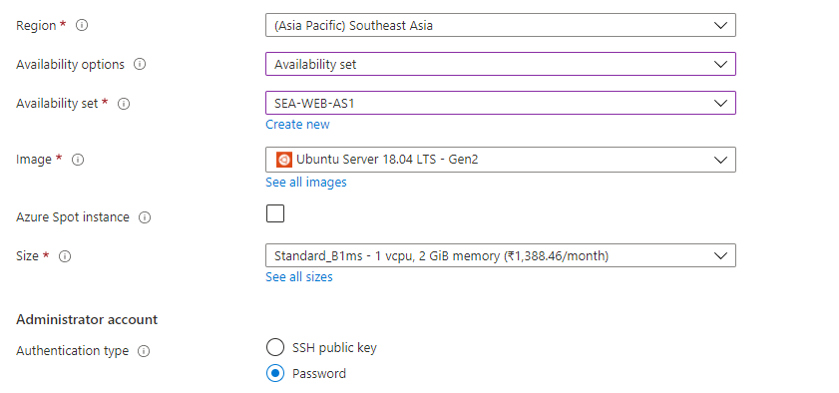

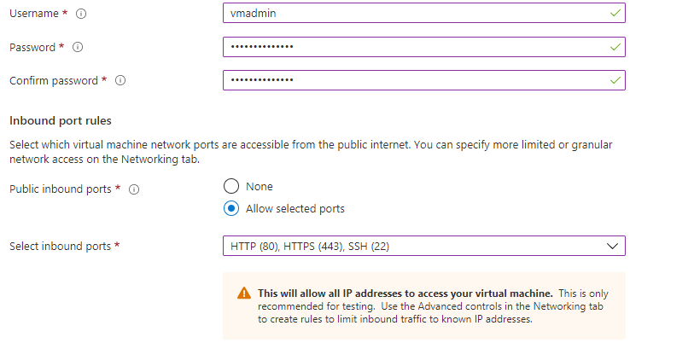

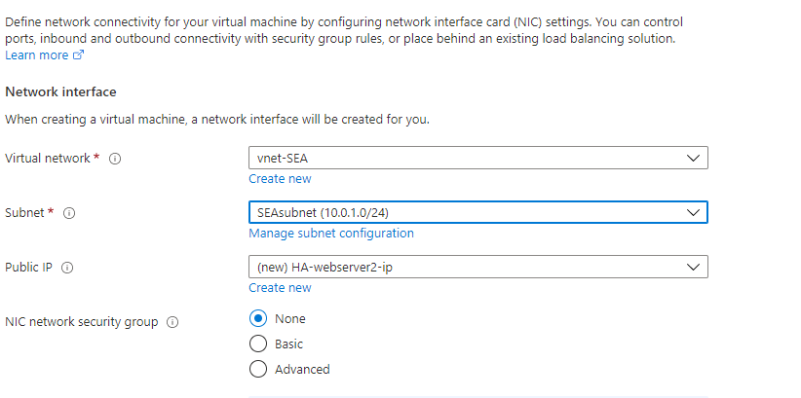

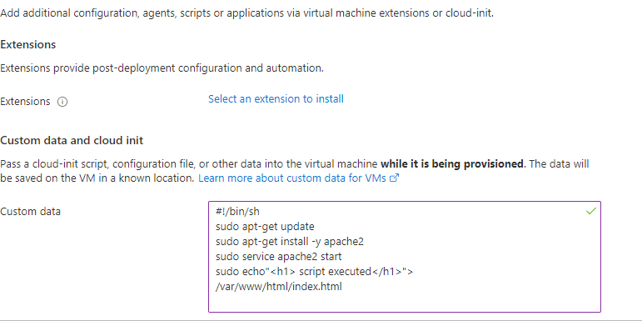

**webserver1 output**

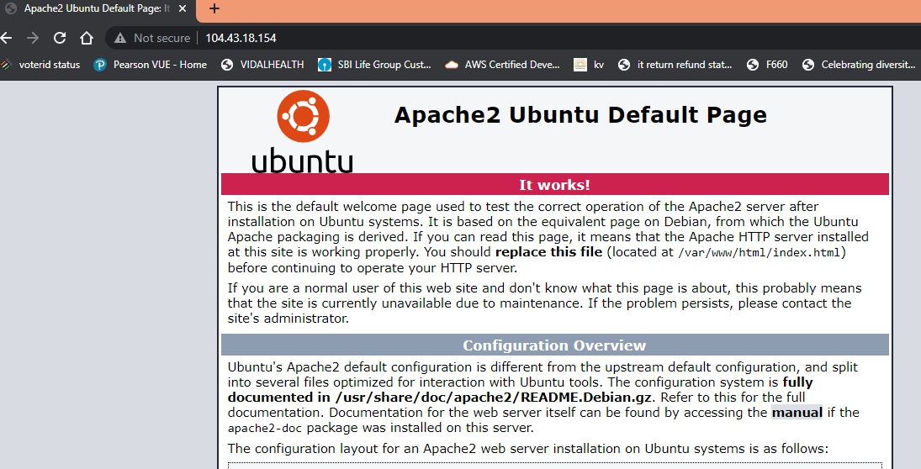

**Web server 2 output**

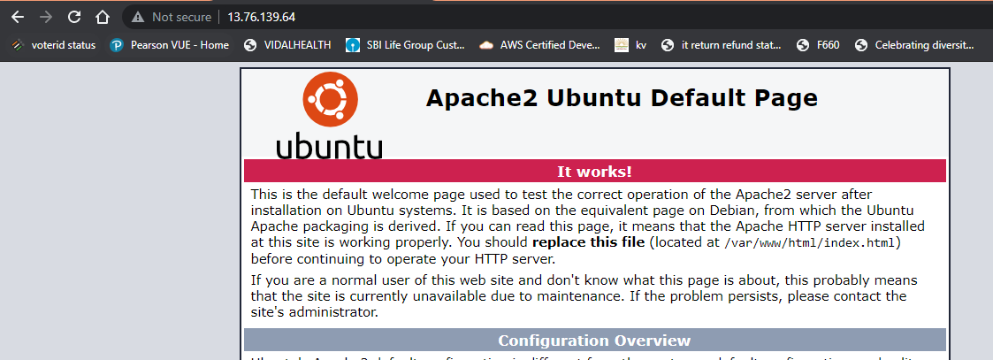

1. **These web services has to be utilized with proper balance with client affinity with Public IP**

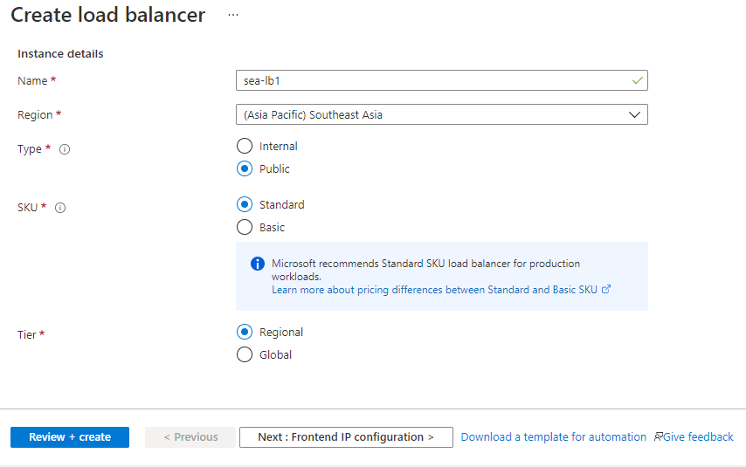

**Front end ip**

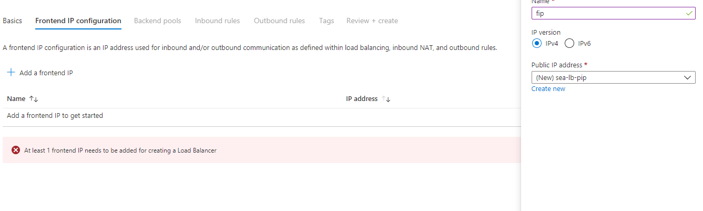

**Back end ip**

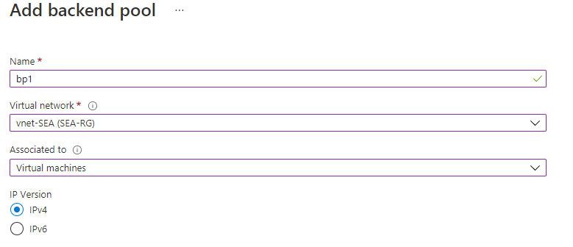

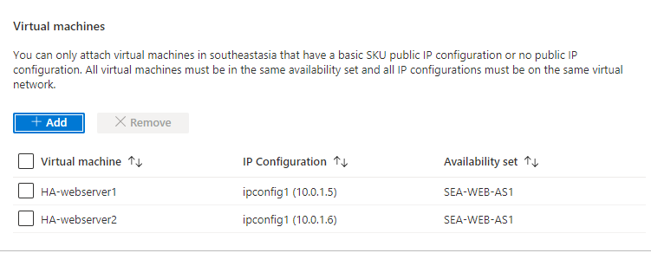

**Health probe**

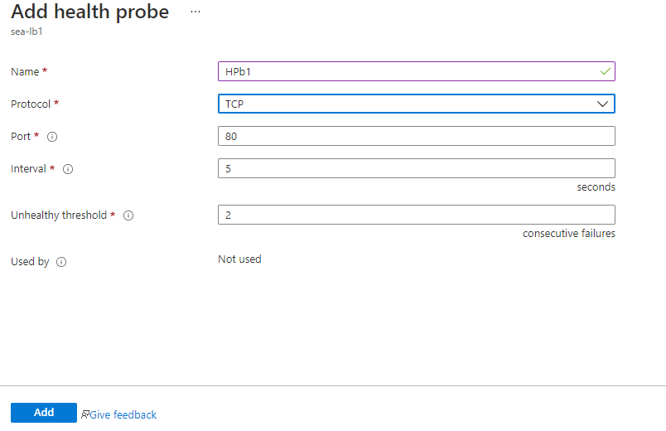

**Load balancing rule**

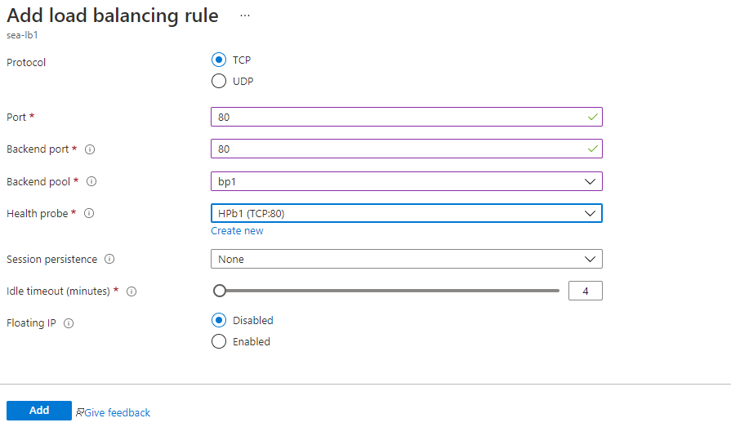



**Inbound NAT for webserver 1**

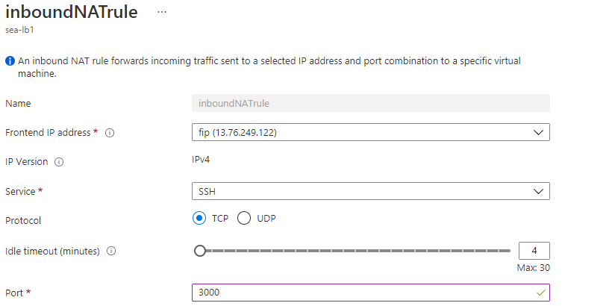

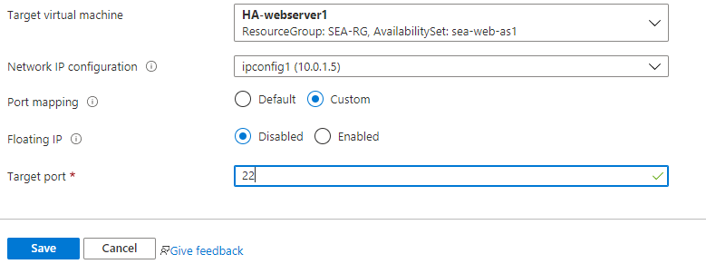

**Webserver 2**

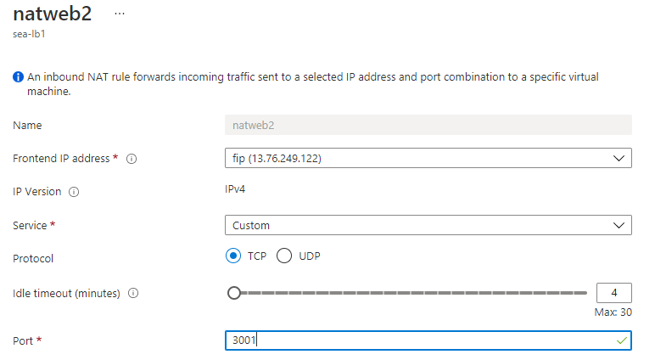

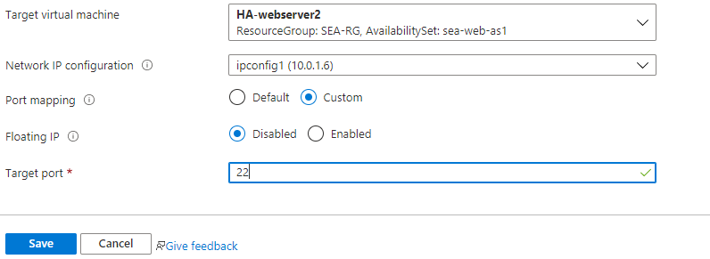

**LB output**

## 

**A jump port should accessible from internet to upload contents to web servers**

**JUMP host**

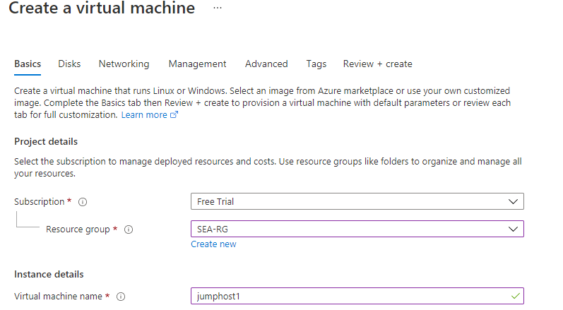

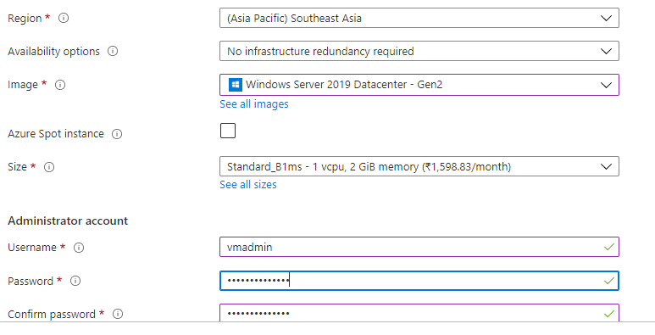

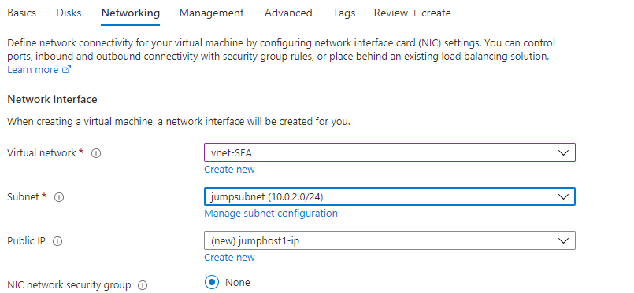

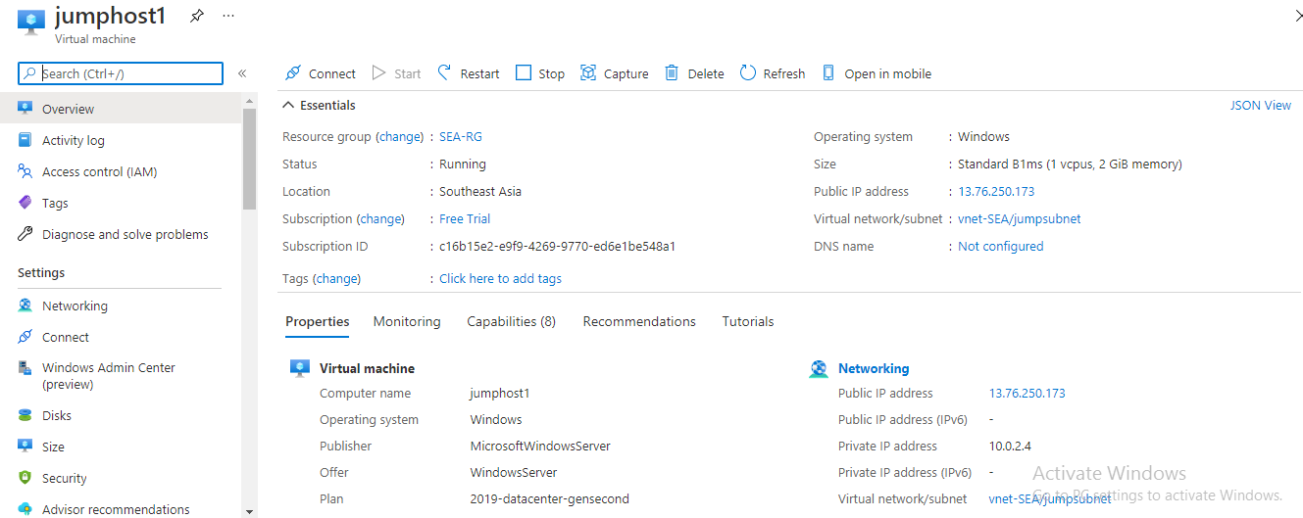

**Connected to Jump Server and accessing the web servers:**

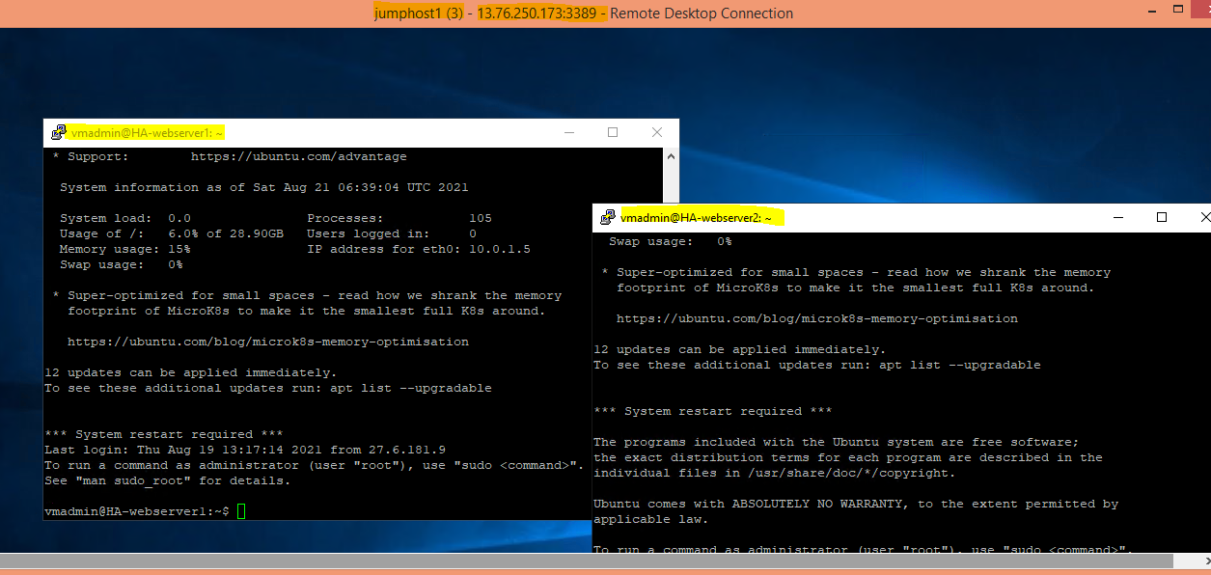

**Protect web server traffic restricted to allowed based on ip addresses which will be updated as warranted**

Changing NSG to allow traffic only from selected IP Addresses

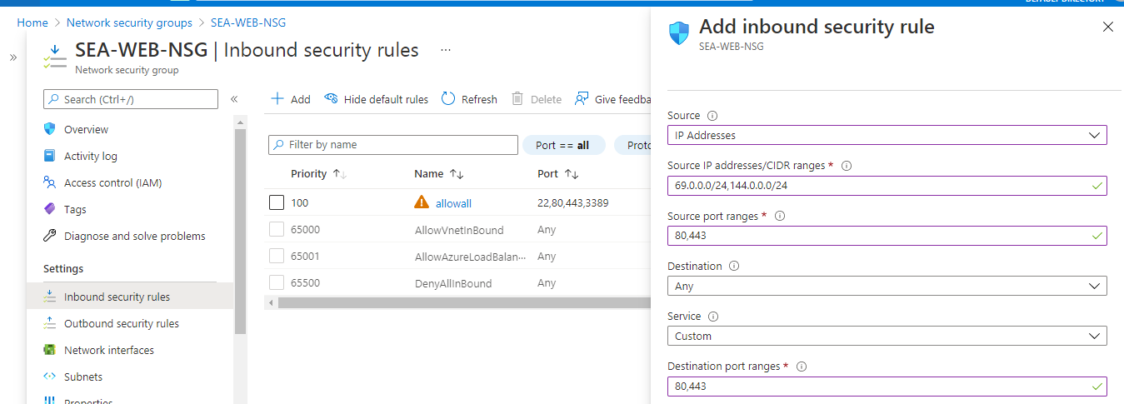

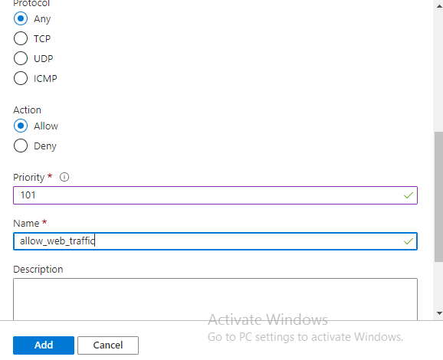

**Enable backup for Web Servers**

**Creating backup vault**

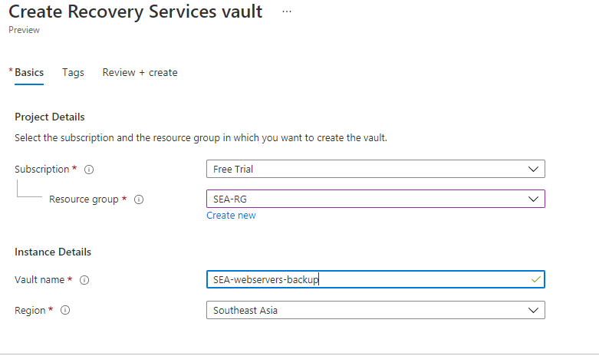

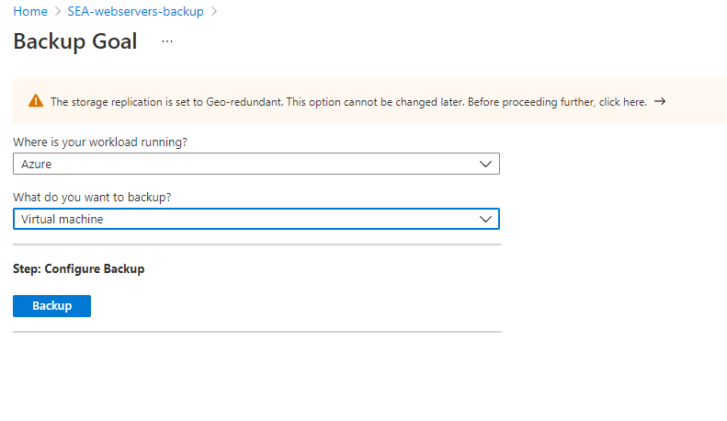

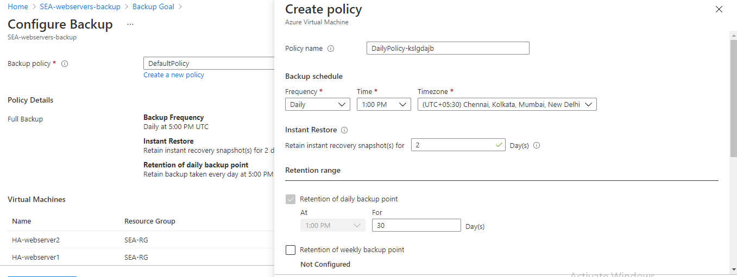

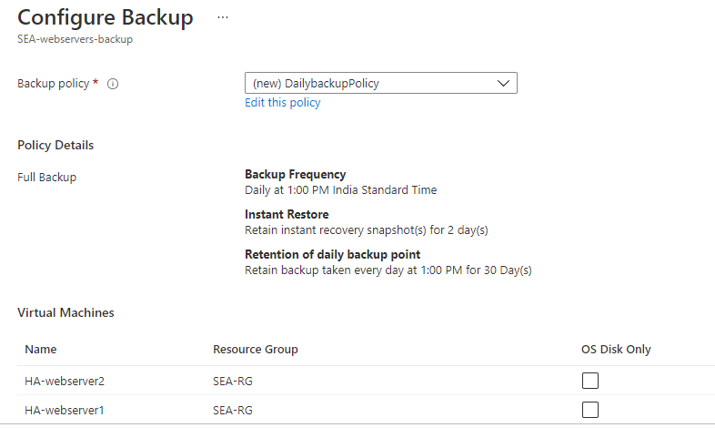 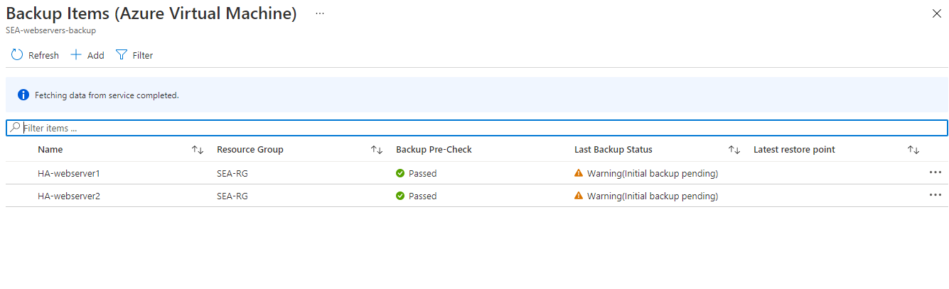

**Have alert generated in case of 80% above cpu usage**

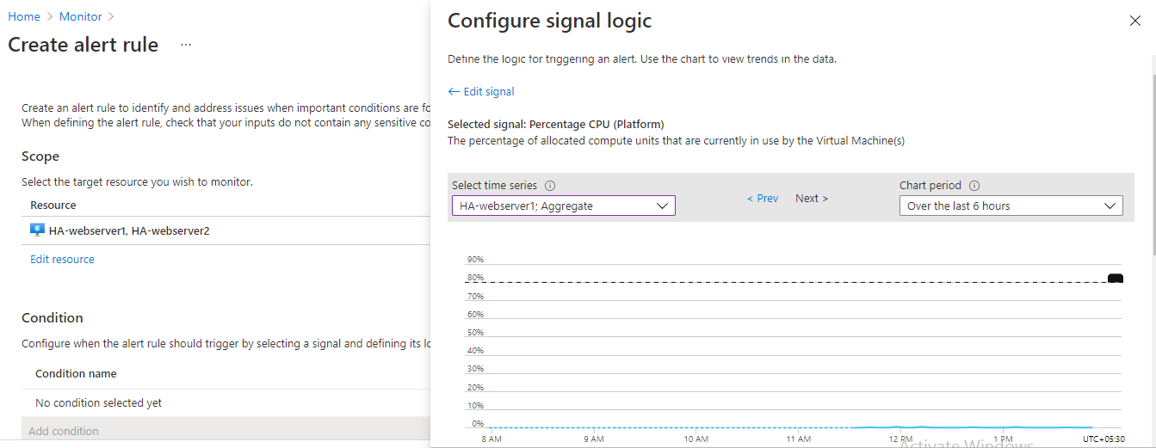

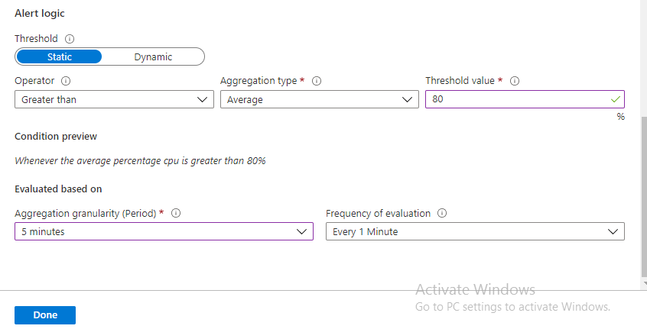

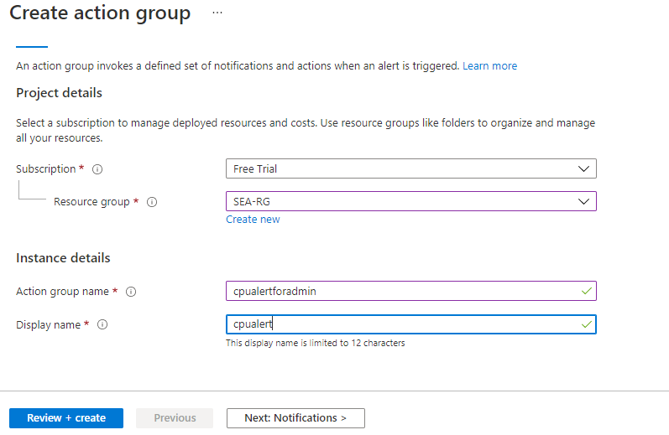

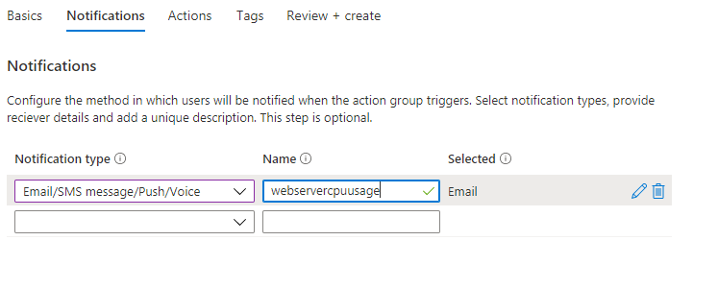

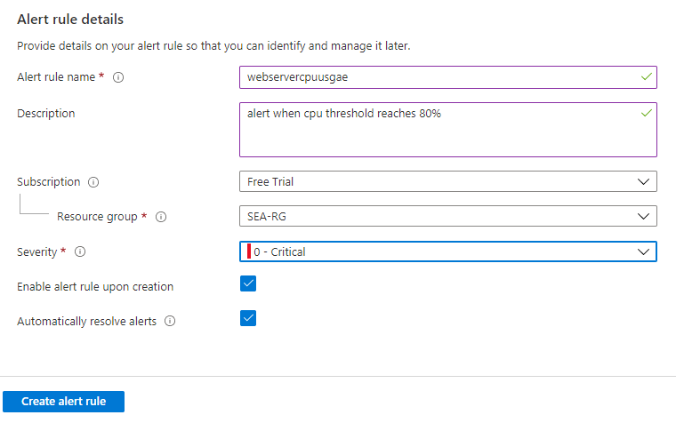

Eg: take any windows vm and create one batch file to generate CPU alert



**EastUS server (Server11) should be accessible from internet via public IP**

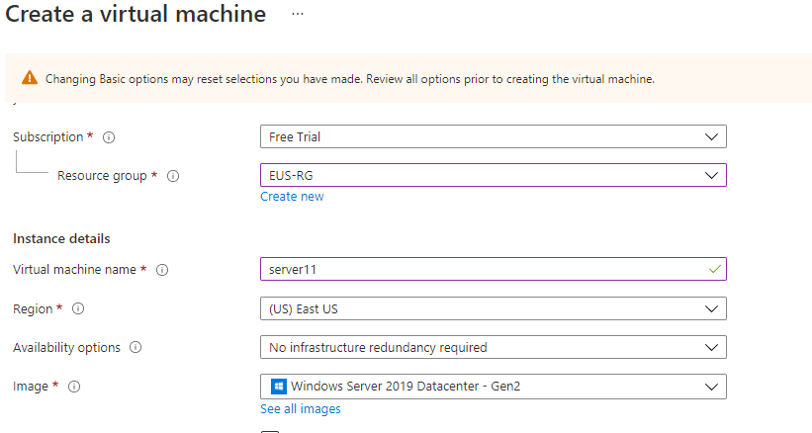

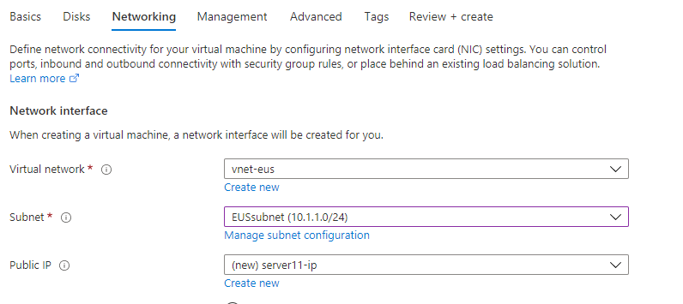

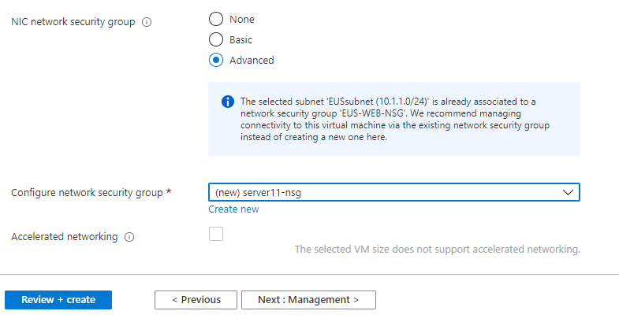

A Virtual Machine is created as with the following settings.

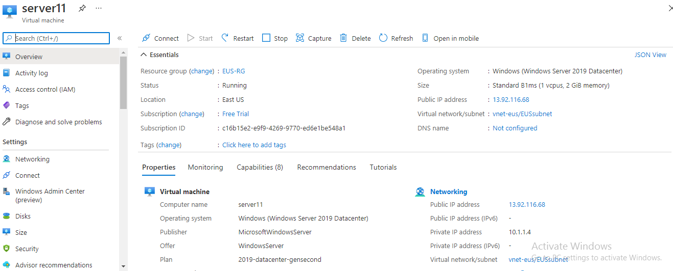

A Public IP Address is configured to be accessible over the internet.

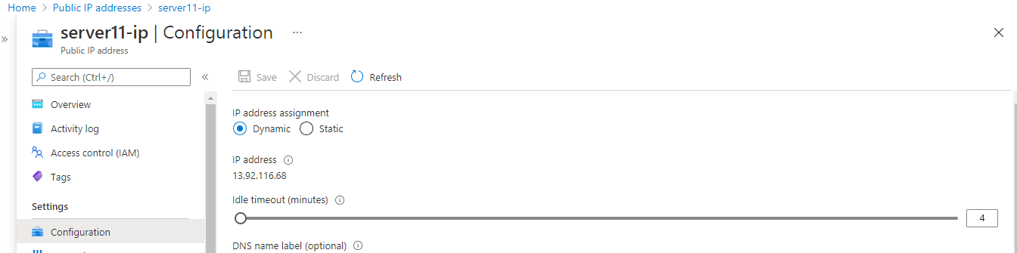

#### Network Security Group

Network Security Group is provided to restrict connections from other resources except those within the virtual network.

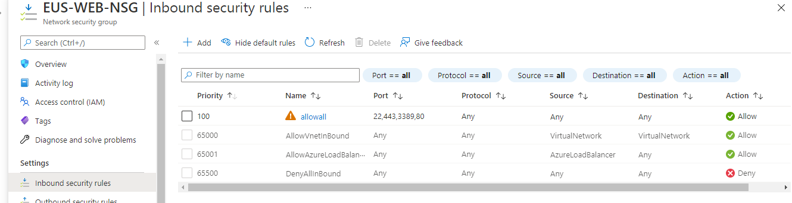

**Establish secure Connection to SEA-EUS Azure sites**

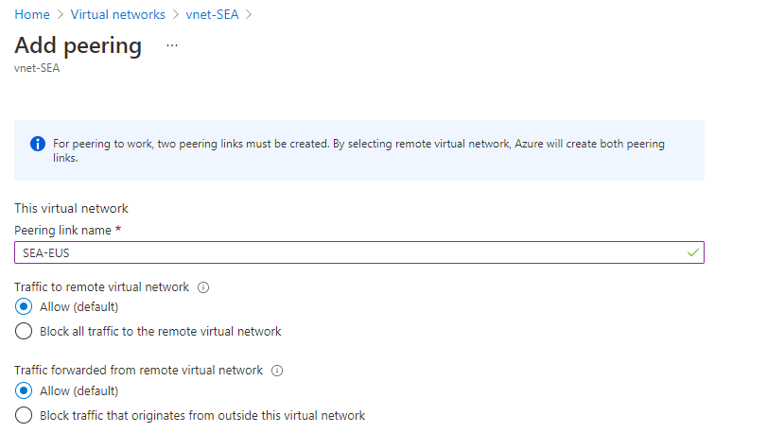

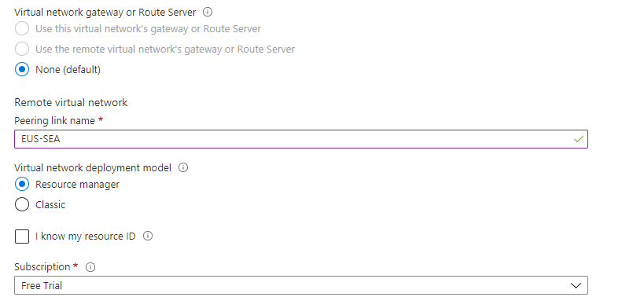

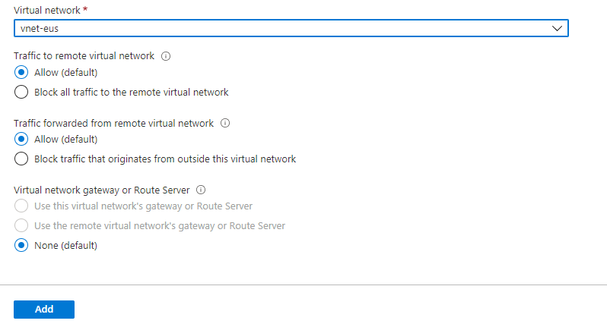

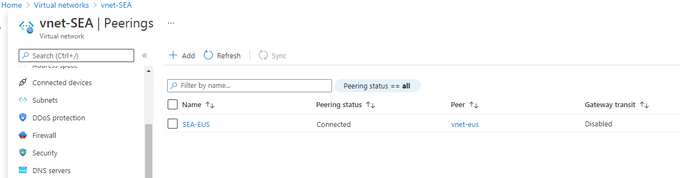

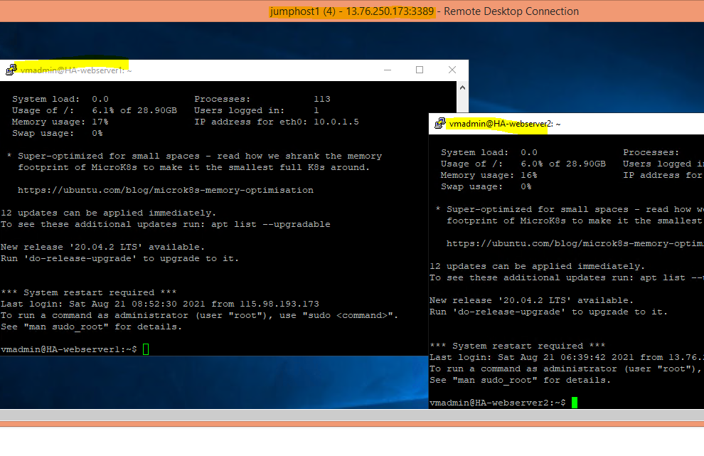

**EUS based resources should provide data resiliency in case of azure datacentre failure**

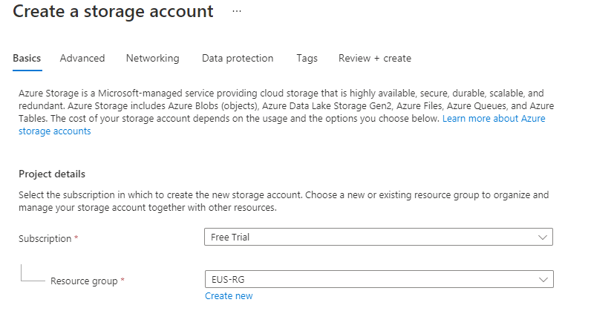

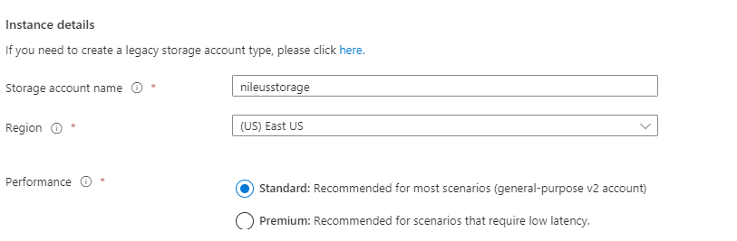

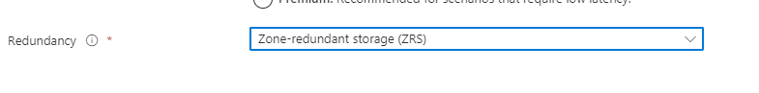

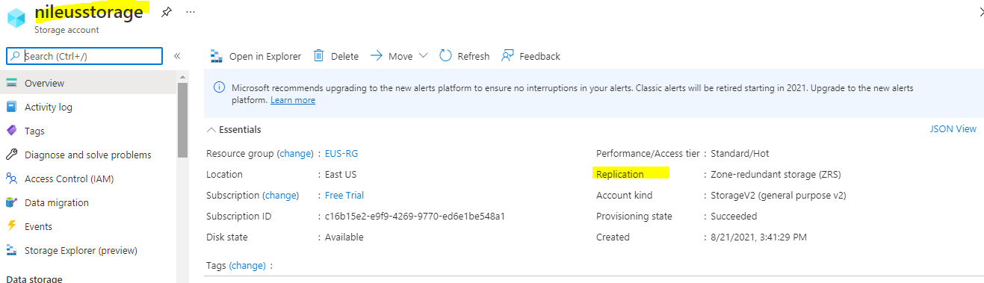

**SEA data resources must provide high resiliency in case of even multiple azure data center failures**

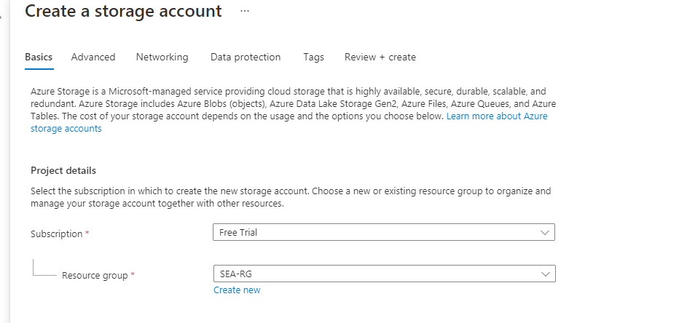

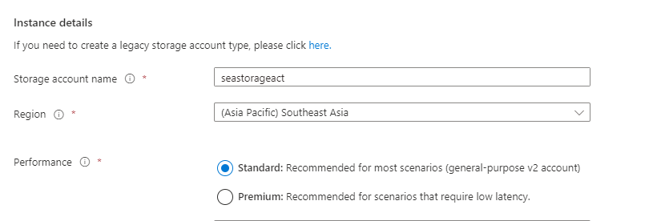

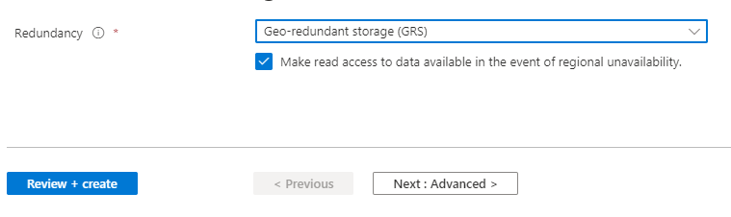

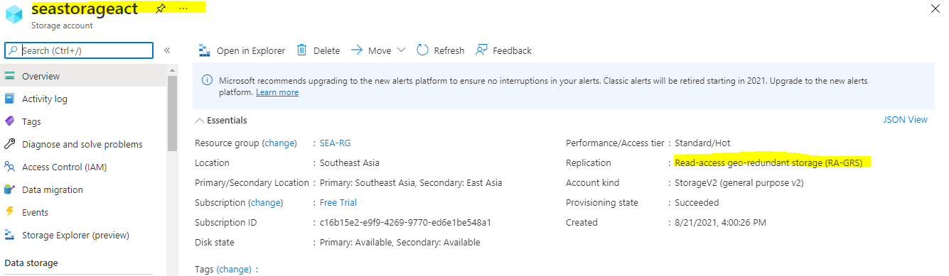

**The storage should be accessible by applications with secure access. provide access urls and keys**

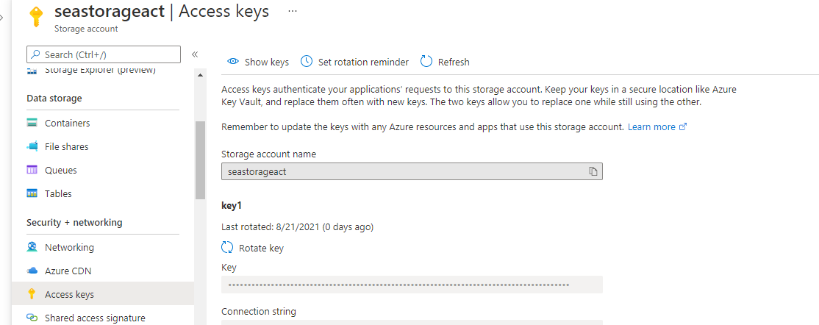

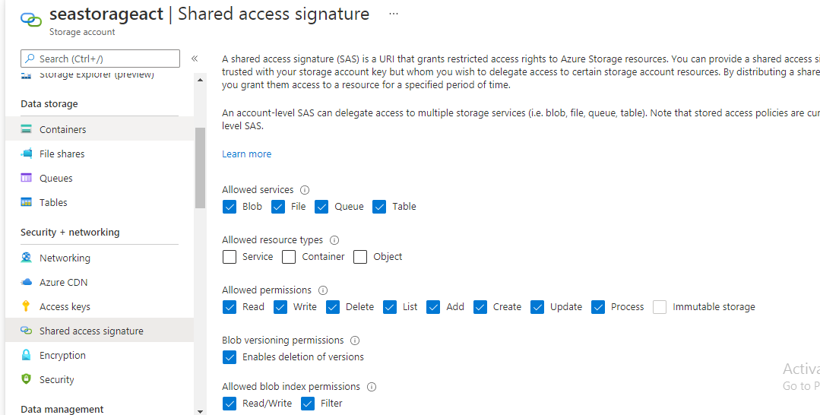

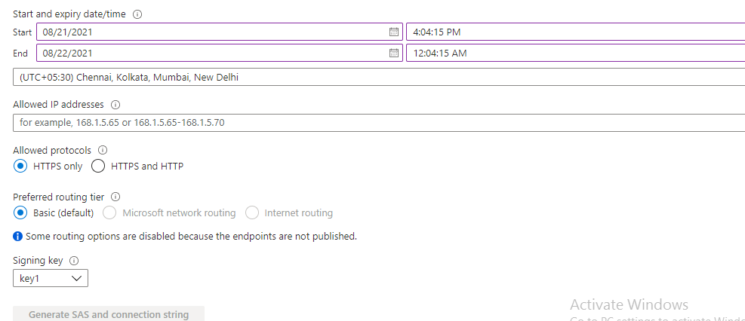

**Sales manager should access his resource from windows explorer**

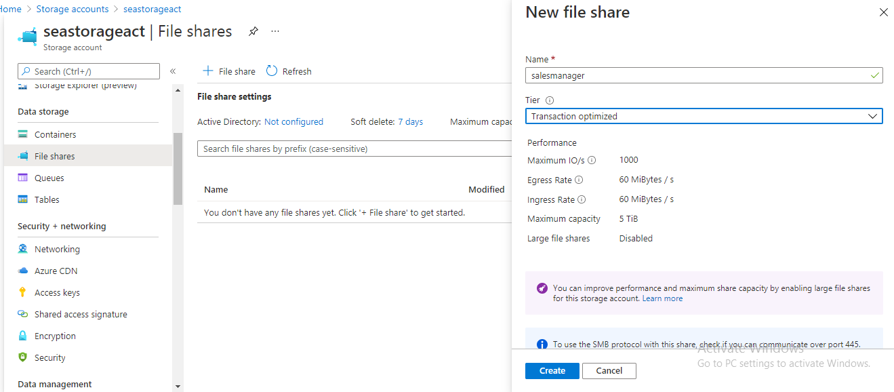

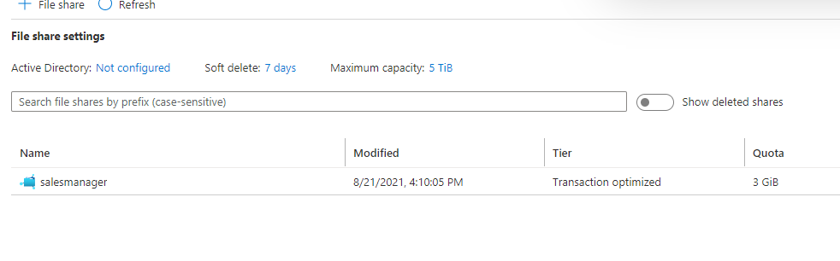

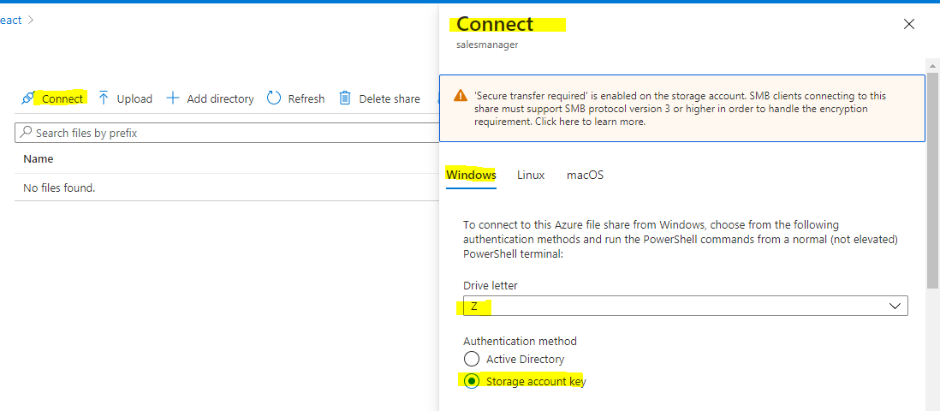

$connectTestResult = Test-NetConnection -ComputerName seastorageact.file.core.windows.net -Port 445

if ($connectTestResult.TcpTestSucceeded) {

# Save the password so the drive will persist on reboot

cmd.exe /C "cmdkey /add:`"seastorageact.file.core.windows.net`" /user:`"localhost\seastorageact`" /pass:`"nUUEcjQnzA0v+hY8X1Y9V/MUhJF0l7KPTBMa8Si+iXOJJQjCFYoIz7Xlo3BBKJsSN1gNLmOuBETqU+as+xoJGA==`""

# Mount the drive

New-PSDrive -Name Z -PSProvider FileSystem -Root "\\seastorageact.file.core.windows.net\salesmanager" -Persist

} else {

Write-Error -Message "Unable to reach the Azure storage account via port 445. Check to make sure your organization or ISP is not blocking port 445, or use Azure P2S VPN, Azure S2S VPN, or Express Route to tunnel SMB traffic over a different port."

}

Copy above script and paste into ant winvm to get file share access

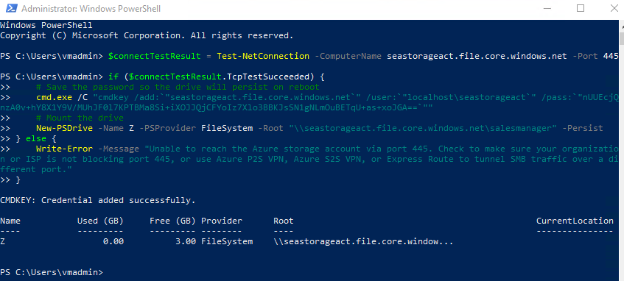

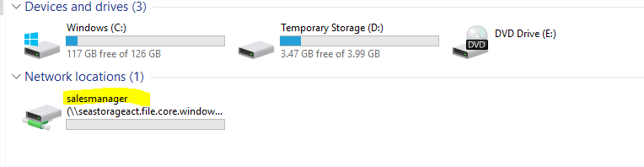

**Create Vmadmin user who can manage all VM in the subscription**

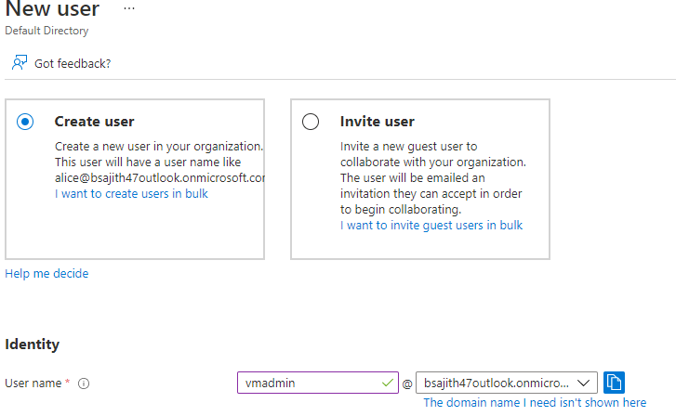

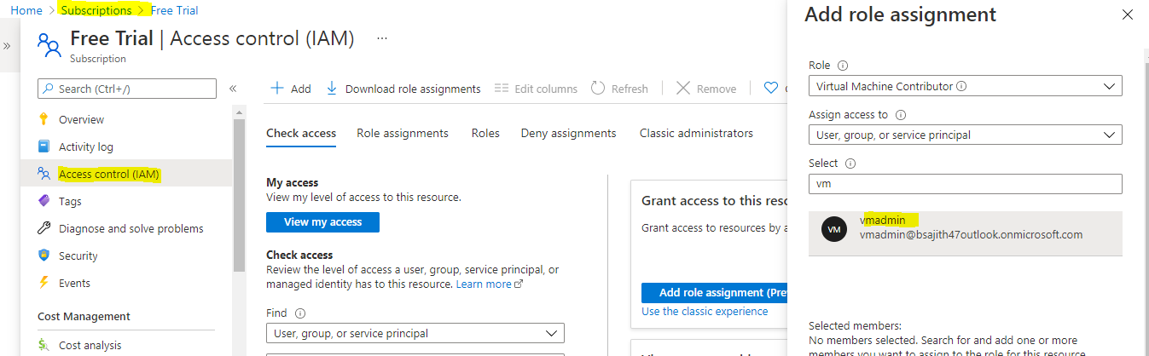

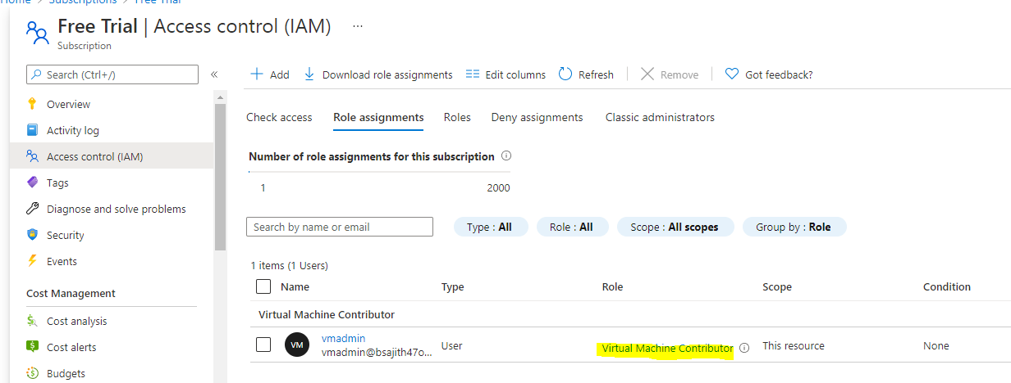

**Create Backup_admin user who can manage backup only in EUS servers in EURG**

