Building a Private RAG-Based AI Document Assistant

Introduction
Enterprises handle large contracts and procurement documents that can exceed 100 pages. Reviewing these documents manually takes time and can lead to missed clauses. This project introduces a private AI assistant that reads documents, summarizes them, and answers questions while keeping all data inside the company network.

What the AI Does
This system reads PDF documents, extracts information, summarizes contracts, and answers questions such as payment terms or penalty clauses. The system works completely offline within the organization’s infrastructure.

Architecture Overview
The solution follows a Retrieval Augmented Generation (RAG) architecture using a vector database and a local language model.
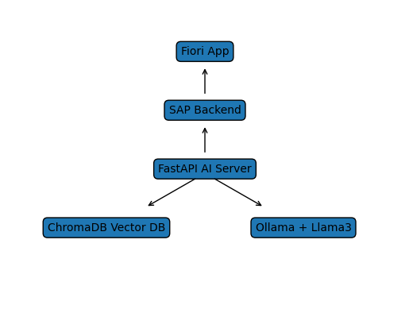

How It Works
1. A PDF document is uploaded.
2. Text is extracted and split into chunks.
3. Each chunk is converted into embeddings.
4. Embeddings are stored in ChromaDB.
5. When a user asks a question, similar chunks are retrieved.
6. Llama3 generates the final answer using the retrieved context.

Technology Stack
Python, FastAPI, Uvicorn, ChromaDB, Sentence Transformers, Torch, pdfplumber, Ollama, and the Llama3 language model.

Benefits
- Faster document review
- Reduced risk of missing clauses
- Private AI with no external API calls
- Improved executive decision making

Conclusion
This AI assistant acts as a private enterprise document analyst capable of understanding large contracts and answering questions instantly. It improves procurement workflows while maintaining strict data privacy.

