TECHNICAL CASE STUDY

Design and Validation of a Multi-Tier Microsoft 365 Backup Architecture
  - On-Premises Recovery Staging, Deduplicated Disk Protection and LTO-9 Retention
Sajid Sarwar
Independent Researcher • Kuwait
Version 1.0 • 4 October 2026
ORCID 0009-0002-2120-9631 • DOI 10.5281/zenodo.23133779

Publication notice
This public edition is a sanitized derivative of an internal implementation record. Organization names, tenant identifiers, hostnames, IP addresses, application identifiers, account names, job identifiers, media identifiers and screenshots have been removed or generalized. The paper describes an engineering pattern and validation method; it is not an official statement by any employer or product vendor.

Abstract
This paper presents a sanitized enterprise case study of a multi-tier Microsoft 365 protection architecture. The design combined a four-node virtual Cohesity DataProtect cluster for primary Microsoft 365 protection, a Windows-based recovery connector for controlled export and inspection, Veritas NetBackup with a Media Server Deduplication Pool (MSDP) for secondary disk retention, and LTO-9 tape for long-term archival retention. The implementation covered Exchange Online, OneDrive and SharePoint Online. Validation was deliberately performed at several boundaries: source-protection job completion, Exchange Online recovery package generation, PST content inspection in Microsoft Outlook, secondary backup creation on MSDP, and Storage Lifecycle Policy duplication to tape. A representative validation batch contained approximately 16.7 GB of logical data across 24 files; both the disk backup and tape duplication completed successfully, and the tape operation completed in approximately 5 minutes 34 seconds. The case demonstrates that operational assurance depends on more than a successful backup status: the recovery object must be accessible, the secondary lifecycle must complete, and each handoff must be auditable. The paper also records limitations, including the absence of a forced tape-only restore, incomplete granular recovery testing for OneDrive and SharePoint Online, disabled immutability during the proof of concept, and the lack of a formal RPO/RTO or cost study. These limitations define the next production-readiness tests rather than being hidden from the result.
Keywords: Microsoft 365, Cohesity DataProtect, Veritas NetBackup, MSDP, LTO-9, enterprise backup, recovery validation, long-term retention, data protection

At a glance
Design dimension | Implemented pattern
Primary workloads | Exchange Online, OneDrive and SharePoint Online
Primary protection | Four-node virtual data-protection cluster
Recovery interface | Dedicated Windows connector and controlled export staging
Secondary disk copy | NetBackup MSDP with 42-day retention
Long-term copy | LTO-9 duplication with policy-defined indefinite retention
Strongest recovery evidence | PST generated, attached in Outlook and message content opened
Principal unresolved test | Forced restore from tape-only copy

Core finding
A backup chain should be accepted only after the organization has proved both recoverability and lifecycle continuity. “Job completed” is a checkpoint—not the final assurance statement.

1. Introduction
Microsoft 365 concentrates collaboration data in a software-as-a-service platform, but organizations still retain responsibility for information governance, identities, access and the recovery outcomes they require. Microsoft describes data and identity as responsibilities that remain with the customer across cloud service models, while Microsoft 365 Backup documentation frames recovery around accidental deletion, malicious deletion, overwrite and encryption events [1], [2].
The implementation studied here was driven by an additional enterprise requirement: selected Microsoft 365 recovery data needed an on-premises path and a long-term copy on established tape infrastructure. The architecture therefore connected cloud-native workloads to an on-premises primary protection platform, a controlled recovery/export server, an existing enterprise backup platform, a deduplicated disk pool and an LTO-9 library.
The project was not designed as a benchmark or as a universal product comparison. It was an applied engineering exercise with a practical acceptance question: can the organization protect Microsoft 365 content, recover it into an inspectable form, preserve it through the existing disk-and-tape lifecycle, and prove each handoff with traceable evidence?

1.1 Contributions
- A vendor-neutral description of a five-stage Microsoft 365-to-tape architecture.
- A validation framework that separates job success, content recoverability and copy-chain completion.
- Measured implementation evidence from a representative proof-of-concept batch.
- A clear record of unresolved tests and production-readiness actions.
- A publication-safe reporting approach that excludes operational identifiers and confidential screenshots.

1.2 Research question
Question
Can a Microsoft 365 backup workflow be extended through an on-premises recovery handoff into an existing NetBackup disk-and-LTO lifecycle while preserving recoverability, auditability and controlled retention?

2. Design Objectives and Constraints
The target design was evaluated against six engineering objectives.
Objective | Acceptance intent
Workload coverage | Protect Exchange Online, OneDrive and SharePoint Online through one registered source.
On-premises control | Maintain a primary protection layer and a controlled export path within the data center.
Recoverability | Generate a usable recovery object and inspect application-level content.
Reuse of existing services | Use the established NetBackup, MSDP and tape environment for the secondary lifecycle.
Retention separation | Keep a shorter operational disk copy and a longer archival tape copy.
Traceability | Relate each export batch to protection, backup, duplication and media evidence.

2.1 Constraints
The solution was implemented as a proof of concept within existing virtualization, network, backup and tape services. It therefore inherited established operational controls and product boundaries. The connector server acted as both the recovery-processing endpoint and the NetBackup client, creating a deliberate handoff between the primary Microsoft 365 protection layer and the secondary enterprise-backup layer.
The design also depended on controlled staging capacity. Exported recovery packages and extracted content were retained only until the disk and tape copies were confirmed. This made batch naming, reconciliation and cleanup approval part of the architecture—not merely an operating-system file-management task.

3. Reference Architecture
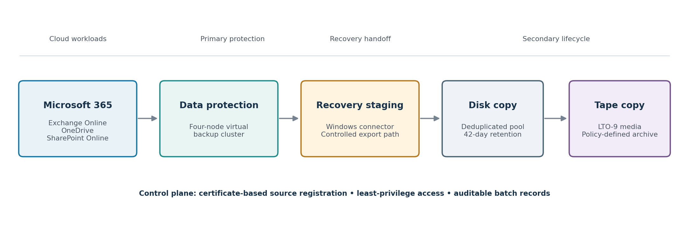
Figure 1. Sanitized logical architecture and control boundary.
The architecture is intentionally linear at the data path while remaining layered in responsibility. Microsoft 365 is the protected source. Cohesity DataProtect provides the primary protection and recovery orchestration. The Windows connector generates or receives recovery packages and exposes an approved staging path. NetBackup protects that path to MSDP, and a Storage Lifecycle Policy duplicates the completed image to LTO-9.

3.1 Primary protection layer
A four-node virtual cluster was deployed with identical node sizing. The aggregate allocation was 32 vCPU, 250 GB RAM, 1 TB of operating-system capacity, 4 TB of metadata capacity and 64 TB of raw data-tier capacity. The deployed system reported an encrypted storage domain using AES-256-GCM, a three-month key-rotation interval, node-level failure-domain protection and a FIPS 140-3 status. These values describe the observed implementation, not a blanket certification claim for every version or deployment mode.

3.2 Microsoft 365 source registration
The Microsoft 365 tenant was registered using certificate-based application authentication. Exchange Online, OneDrive and SharePoint Online were enabled through the same source. Vendor documentation identifies certificate-based registration and explicit workload permissions as supported onboarding elements [3]. Public reporting should never disclose the tenant domain, application identifier, certificate name or privileged account details.

3.3 Recovery connector and staging
A dedicated Windows Server 2022 virtual machine provided recovery processing and a 5 TB staging disk. It contained Outlook Classic, the Cohesity agent and the NetBackup client. The staging folder was restricted to the intended export scope; the secondary backup selection was corrected during implementation so that only this controlled path was protected rather than every local drive.

3.4 Secondary disk and tape lifecycle
NetBackup 10.5 protected the staging path through an MS-Windows policy. The associated Storage Lifecycle Policy contained two operations: a primary backup to MSDP with 42-day retention and a subsequent duplication to an LTO-9 storage unit with policy-defined indefinite retention. Veritas documents the SLP pattern of a backup operation followed by a duplication operation to a secondary destination [4]. LTO-9 media provides 18 TB native cartridge capacity according to the LTO Program [6].

4. Implementation Method
The work was divided into five gated phases. Each phase produced evidence that was reviewed before the next integration boundary was accepted.
Phase | Principal activity | Gate
1 | Deploy four virtual appliances, form the cluster and verify storage and node health. | All nodes active; capacity, encryption and failure-domain settings visible.
2 | Register the Microsoft 365 source and configure protection for three workload families. | Source discovery successful; protection jobs complete without object failures.
3 | Prepare the recovery connector and generate Exchange Online exports. | PST package created; folder structure and message content accessible in Outlook.
4 | Install and trust the NetBackup client; configure policy and two-operation SLP. | Scope restricted to the approved staging path; disk and tape destinations assigned.
5 | Run a representative staging backup and monitor disk-to-tape duplication. | Both operations complete successfully; image and media evidence reconciled.

4.1 Controlled export-batch procedure
- Confirm that the required Microsoft 365 protection job has completed successfully.
- Define the workload, user or site, date range and approval reference for the export batch.
- Generate the recovery package through the dedicated connector.
- Inspect a representative recovered object before the batch is accepted for secondary protection.
- Place only approved batch content in the restricted staging path.
- Run the secondary backup and verify the MSDP image.
- Verify SLP duplication and record the associated tape-media evidence.
- Remove staging content only after both copies are confirmed and cleanup is approved.

4.2 Security and governance controls
The security design emphasized certificate-based service authentication, encrypted storage, scoped staging, documented copy ownership and evidence-driven cleanup. NIST SP 800-209 treats data protection, isolation, restoration assurance, encryption, configuration control and incident recovery as storage-security concerns [5]. The implementation mapped directly to several of those themes, but production acceptance still requires formal identity review, hardening, immutable-copy decisions and scheduled restore exercises.

5. Validation Framework
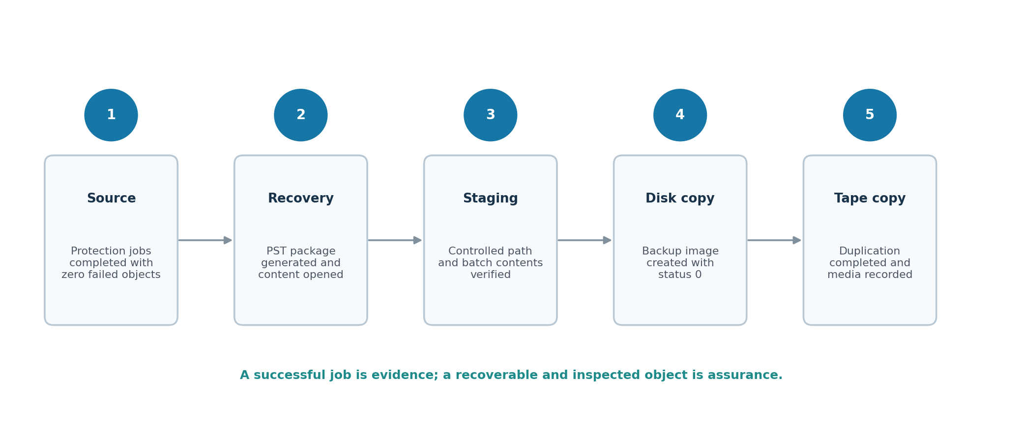
Figure 2. Five checkpoints used to distinguish successful protection from demonstrated recoverability.
Validation was performed as a chain because each platform can report success while a downstream dependency remains untested. The following evidence classes were used.
Checkpoint | Evidence | Assurance provided
Source protection | Protection-group results and failed-object counts. | The selected cloud objects entered the protection workflow.
Recovery generation | Recovery task and exported package. | The primary platform could materialize a recovery object.
Content inspection | PST attached in Outlook; folders and messages opened. | At least one application-level recovery object was usable.
Disk protection | Backup image, file count, logical size and status. | The approved staging batch reached the secondary disk tier.
Tape lifecycle | Duplication result, second-copy record and media association. | The image reached the long-term media tier and was catalogued.

5.1 Recovery-content test
Two Exchange Online exports were used for complementary purposes. A larger export produced a compressed package of approximately 7.6 GB and an extracted PST of approximately 9.0 GB, demonstrating that the connector could process a multi-gigabyte mailbox. A smaller content-validation export produced a PST of approximately 34.5 MB. That PST was attached in Outlook, its folder structure was browsed, 272 Inbox items were visible, and individual messages were opened successfully.

5.2 Secondary backup and duplication test
The representative staging batch contained approximately 16.7 GB of logical data across 24 files. NetBackup completed the MSDP backup with status 0. The SLP then duplicated approximately 16.7 GB to LTO-9 and completed with status 0 in about 5 minutes 34 seconds. The catalog showed two copies with the intended retention classes: 42 days on disk and policy-defined indefinite retention on tape.
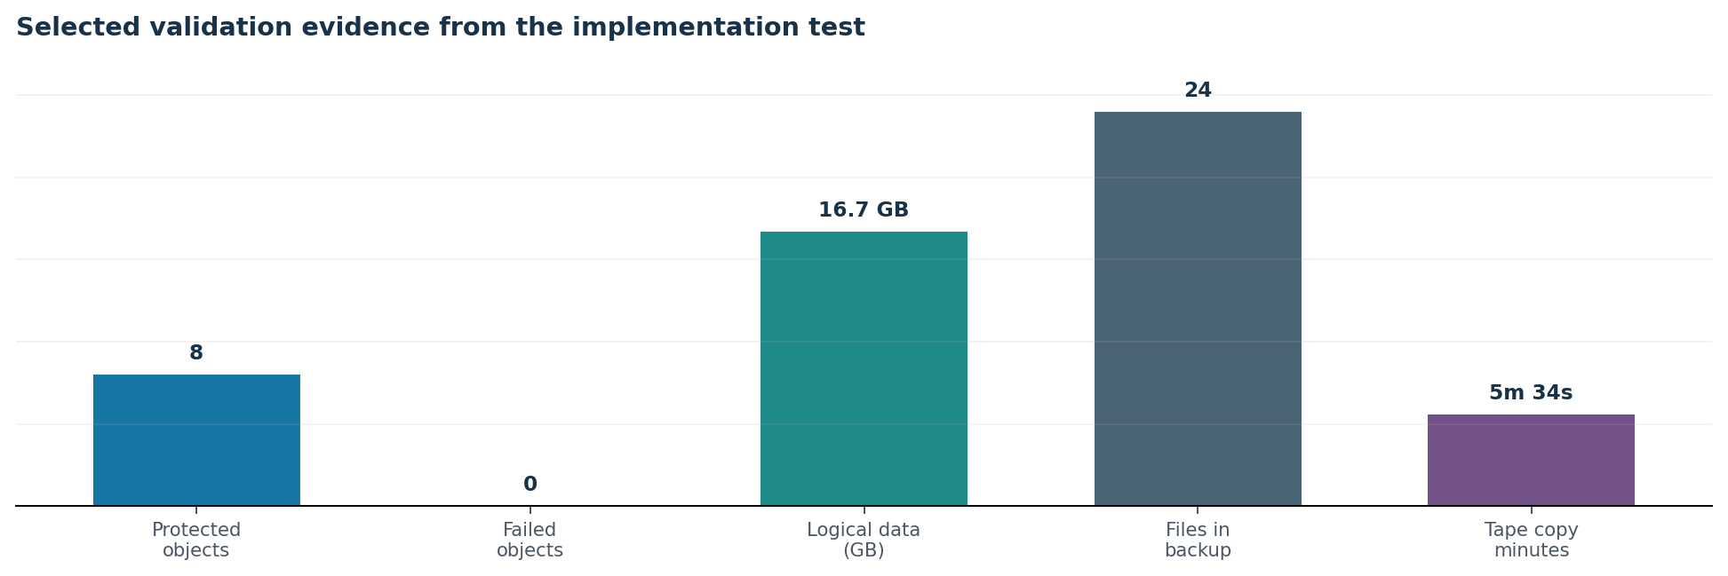
Figure 3. Selected evidence values. Protected-object count combines two successful test groups (five and three objects).
Interpretation caution
The short tape-duplication interval is an observed proof-of-concept result, not a general throughput benchmark. Deduplication, Accelerator behavior, existing segments, hardware, contention and batch composition can materially change elapsed time.

6. Results and Discussion

6.1 What the proof of concept established
- The four-node primary protection cluster was healthy and presented the expected aggregate resources.
- The Microsoft 365 source was registered using certificate authentication and exposed the three target workload families.
- Two test protection groups completed with eight successful objects in total and zero failed objects.
- Exchange Online data was exported to PST and inspected at the content level in Outlook.
- The controlled staging path was protected to MSDP and duplicated to LTO-9 through a two-operation SLP.
- The second copy appeared in image and media records with the intended retention class.

6.2 Why the staging handoff is useful
The connector provides a practical bridge between an application-aware Microsoft 365 recovery workflow and an established enterprise backup system. It also creates an inspection point: content can be validated, approved and grouped before it enters a long-term retention process. This improves traceability but introduces new responsibilities for staging capacity, permissions, malware scanning, naming, duplicate control and secure cleanup.

6.3 Why tape remains relevant in this pattern
The tape tier supplies a media-separated long-term copy that can be governed independently of the primary SaaS and disk systems. This does not automatically make the copy immutable or recoverable. Media handling, encryption, catalog protection, off-site rotation, periodic read testing and documented restore authority determine the real assurance level. The LTO Program reports 18 TB native capacity for LTO-9, but capacity alone is not a resilience control [6].

6.4 Operational evidence model
For each export batch, the operational record should link the source-protection run, recovery task, export manifest, secondary backup image, duplication job, media identifier, retention class and cleanup approval. The public paper intentionally omits the identifiers observed during the implementation; production records should retain them in an access-controlled system.

7. Limitations and Threats to Validity
Limitation | Effect on conclusion | Required follow-up
No forced tape-only restore | Tape write and catalog evidence were verified, but full recovery from the archival copy was not demonstrated. | Run a restore with the disk copy unavailable or explicitly expired; record retrieval, mount and content validation.
Exchange-focused recovery proof | The strongest content inspection applies to PST recovery, not all protected workloads. | Perform file-level OneDrive recovery and item/site-level SharePoint recovery.
Immutability disabled in the proof of concept | The local primary copy was not tested under a locked-retention configuration. | Evaluate supported immutability/DataLock controls and privileged-access separation.
Retention not fully approved | The proof-of-concept local retention differed from the intended production value. | Obtain records-owner approval and map all tiers to policy and legal requirements.
No formal RPO/RTO test | Successful recovery does not establish recovery-time or recovery-point compliance. | Define service objectives and run timed recovery scenarios at representative scale.
No cost or scale study | The design is validated functionally, not economically or at full tenant scale. | Model capacity growth, export windows, connector concurrency, media consumption and operational effort.

Reporting principle
Limitations are part of the engineering result. Stating them prevents a successful proof of concept from being mistaken for complete production certification.

8. Production-Readiness Roadmap
Priority | Action | Completion evidence
P0 | Perform and time a forced tape-only restore of a representative batch. | Recovered data is opened and compared with the export manifest.
P0 | Complete granular OneDrive and SharePoint recovery tests. | Files, permissions/metadata and selected site content are verified.
P0 | Approve the retention schedule and legal hold process. | Signed policy maps retention and deletion authority across all tiers.
P1 | Harden the connector and isolate privileged roles. | Baseline, service accounts, firewall rules and monitoring are approved.
P1 | Evaluate immutable or locked retention controls. | Control test demonstrates resistance to unauthorized expiry or deletion.
P1 | Protect the backup catalog and configuration records. | Catalog recovery procedure is tested and stored separately.
P2 | Automate export manifests and copy-chain reconciliation. | A batch report links all evidence and flags missing copies.
P2 | Establish quarterly recovery drills. | Trend report covers success rate, RTO, RPO, exceptions and corrective action.

8.1 Suggested operational acceptance criteria
- Every protected workload has at least one documented application-level recovery test.
- Every long-term batch has a manifest and two independently verified copy records.
- Tape-only restoration is repeated on a defined schedule, not treated as a one-time project event.
- Retention, immutability and deletion authority are approved by infrastructure, security and records owners.
- RPO and RTO are measured under realistic data volume and failure scenarios.

9. Conclusion
The case study shows that a Microsoft 365 protection workflow can be extended through a controlled on-premises recovery handoff into an existing NetBackup disk-and-LTO lifecycle. The proof of concept validated source protection, Exchange recovery package generation, PST content access, MSDP backup and tape duplication. The architecture also reused established enterprise services instead of creating a separate tape-management path.
The more important result is methodological. A successful backup job is necessary but insufficient. Confidence comes from inspecting recovered content, validating every downstream copy, recording the chain of evidence and repeating recovery tests under the conditions that matter—especially when the archival copy is the only remaining source.
Final takeaway
Backup success creates confidence. Tested, repeatable and independently evidenced recovery creates assurance.

References
[1] Microsoft. “Overview of Microsoft 365 Backup.” 2026. https://learn.microsoft.com/en-us/microsoft-365/backup/backup-overview?view=o365-worldwide Accessed 4 October 2026.
[2] Microsoft. “Shared responsibility in the cloud.” n.d.. https://learn.microsoft.com/en-us/azure/security/fundamentals/shared-responsibility/ Accessed 4 October 2026.
[3] Cohesity. “Manual Registration for Microsoft 365 Sources.” 2026. https://docs.cohesity.com/baas/data-protect/M365/register-m365-sources-manually.htm Accessed 4 October 2026.
[4] Veritas. “Storage Lifecycle Policies.” n.d.. https://www.veritas.com/support/en_US/doc/130196782-130510586-0/va_731_v127366322-130510586 Accessed 4 October 2026.
[5] National Institute of Standards and Technology. “Security Guidelines for Storage Infrastructure (SP 800-209).” 2020. https://doi.org/10.6028/NIST.SP.800-209 Accessed 4 October 2026.
[6] LTO Program. “LTO Generation 9 Technology.” n.d.. https://www.lto.org/lto-9/ Accessed 4 October 2026.
[7] Cohesity. “Cohesity Data Protection for Microsoft 365—Best Practices and Recommendations.” 2024. https://www.cohesity.com/resource-assets/guides/data-protection-for-m365-best-practices-guide-en.pdf Accessed 4 October 2026.

Appendix A. Public Sanitization Standard
The public edition excludes or generalizes the following classes of information from the internal implementation record:
Removed or generalized | Public treatment
Organization, tenant and domain names | “Organization A” or generic Microsoft 365 tenant references
Hostnames, IP addresses, VLANs and switch details | Role-based component names and logical boundaries only
Application IDs, certificate names and accounts | Authentication method and control objective only
Mailbox/user names and message screenshots | Anonymous test mailbox and aggregate validation result
Backup image, job and media identifiers | Status, size, retention and elapsed-time evidence only
Product-console screenshots | New, sanitized diagrams and tables created for publication
Internal classification and support-access details | Omitted entirely

Appendix B. Reproducible Validation Checklist
1. Record the protected workload, object count, policy, run time and exception count.
2. Generate a recovery object from a known restore point and preserve the task record.
3. Open and inspect representative application content; record the validation method.
4. Create a batch manifest containing paths, sizes, file counts and cryptographic hashes where feasible.
5. Back up only the approved staging scope; capture image size, file count, status and retention.
6. Verify the second copy, destination, retention and media association.
7. Run a restore from each required tier, including a forced archival-only restore.
8. Reconcile the restored content with the manifest and document any exceptions.
9. Approve cleanup only after the copy chain and restore evidence are complete.
END OF PUBLICATION

