Janssen Research & Development

JNJ-75201646 Whole Blood EC Estimate Analysis

JNJ-75201646 Whole Blood Cytotoxicity and T Cell Activation Drug Discovery Analysis Report

Heme Cancer, Large Molecule, NME Declaration Support

JNJ-75201646
Report Date: November 27, 2020
Prepared by: Author’s Name (namesurname@its.jnj.com)
Scientific Recipient: Scientist’s Name
Report Number: 2020-xxxx

EXECUTIVE SUMMARY
This report is the base for TMEDS group report template in RMarkdown Word.
[table of contents]

1. INTRODUCTION
This report template uses the Iris flower data set as the basis of an example of an analysis reporting using the TMEDS report template. Additional Rmarkdown help can be found at this website: https://github.com/adam-p/markdown-here/wiki/Markdown-Cheatsheet

1.1 Background

1.2 Objectives
Purpose: to clearly identify key research questions to be investigated.

2. METHODOLOGY
Purpose: to identify and describe the basic elements of statistical analysis, such as the different models and analysis methods to be used, the underlying assumptions, decision rules, if any.

2.1 Data Exploration
To be updated

2.2 Methods
All analyses were performed in R version 4.0.2.

3. RESULTS
This section presents, in a summarized form, the final results from the study. If the project has undergone numerous revisions in assumptions, scenarios and focus, then only the more salient results are to be considered. Graphics and tables should be used to summarize the key results.
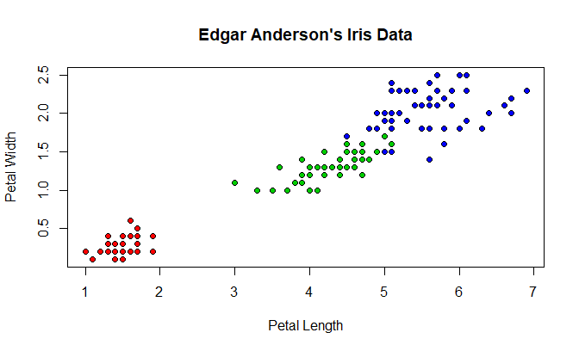
Figure 1: Scatterplot Matrix of Iris Measures
Figure 1 shows simple scatter plot of petal length and petal width from Iris dataset available in R.

3.1 Exploratory data analysis
Table 1 presents summary statistics of physical characteristics of irises by species. These data are plotted against each other in scatterplots in Figure 1.
Table 1: Summary Statistics of Iris Measures by Species
Species | meanWidth | meanLength
setosa | 3.428 | 5.006
versicolor | 2.770 | 5.936
virginica | 2.974 | 6.588

3.2 Modeling

3.2.1 Subsubsection

4. CONCLUSIONS AND RECOMMENDATIONS

APPENDIX 1: SUPPORTING ANALYSES

APPENDIX 2: LIST OF DATASETS AND LOCATION
Flow Cytometry data: Whole Blood Spike-in Individual-122319-KP edits.pzfx
Location: jsendeck/Projects/2020/Pillarisetti/2020-12337/dat/

APPENDIX 3: PROGRAMMING CODE
See /filepath/HTML Template_Onco for code details.

R Session Information
R version 4.0.2 (2020-06-22)
Platform: x86_64-w64-mingw32/x64 (64-bit)
locale: LC_COLLATE=English_United States.1252, LC_CTYPE=English_United States.1252, LC_MONETARY=English_United States.1252, LC_NUMERIC=C and LC_TIME=English_United States.1252
attached base packages: stats, graphics, grDevices, utils, datasets, methods and base
other attached packages: pander(v.0.6.4), forcats(v.0.5.1), stringr(v.1.4.0), dplyr(v.1.0.5), purrr(v.0.3.4), readr(v.1.4.0), tidyr(v.1.1.3), tibble(v.3.1.0), ggplot2(v.3.3.3), tidyverse(v.1.3.0), kableExtra(v.1.3.4) and knitr(v.1.31)
loaded via a namespace (and not attached): tidyselect(v.1.1.0), xfun(v.0.27), haven(v.2.3.1), colorspace(v.2.0-0), vctrs(v.0.3.7), generics(v.0.1.0), htmltools(v.0.5.1.1), viridisLite(v.0.3.0), yaml(v.2.2.1), utf8(v.1.2.1), rlang(v.0.4.10), pillar(v.1.5.1), withr(v.2.4.1), glue(v.1.4.2), DBI(v.1.1.1), dbplyr(v.2.1.1), readxl(v.1.3.1), modelr(v.0.1.8), lifecycle(v.1.0.0), cellranger(v.1.1.0), munsell(v.0.5.0), gtable(v.0.3.0), rvest(v.1.0.0), evaluate(v.0.14), fansi(v.0.4.2), highr(v.0.8), broom(v.0.7.6), Rcpp(v.1.0.6), scales(v.1.1.1), backports(v.1.2.1), webshot(v.0.5.2), jsonlite(v.1.7.2), fs(v.1.5.0), systemfonts(v.1.0.1), hms(v.1.0.0), digest(v.0.6.27), stringi(v.1.5.3), bookdown(v.0.24), grid(v.4.0.2), cli(v.2.4.0), tools(v.4.0.2), magrittr(v.2.0.1), crayon(v.1.4.1), pkgconfig(v.2.0.3), ellipsis(v.0.3.1), xml2(v.1.3.2), reprex(v.2.0.0), lubridate(v.1.7.10), assertthat(v.0.2.1), rmarkdown(v.2.11), svglite(v.2.0.0), httr(v.1.4.2), rstudioapi(v.0.13), R6(v.2.5.0) and compiler(v.4.0.2)

