MIE 237 Winter 2020, Term Project Report
Research Topic: Effect of Multi-tasking walking
Project Group #23
Xiaorong Duan, 1003165647
Sajad Hashemi, 1005502920
Muhammad Shahzeb Ahmed, 1005173214

Abstract
This report analyses the effects of multitasking between tasks of the same and different modalities. This proposal hypothesizes that a person multitasking between activities that require cognitive resources of the same modality will show decreased performance in terms of time and accuracy as compared to multitasking between tasks of different modalities. Due to the prevalence and safety concerns of walking and texting, this experiment was designed to test the decline in attendance as a result of divided attention. Ninety-six total participants will be divided into three groups of thirty-two to complete the experiment. Our results show that multitasking between tasks of different modalities negatively impacts performance significantly, while multitasking between tasks of the same modality only has a slight impact.

Table of Contents
INTRODUCTION 2
Background 2
Purpose 2
METHODOLOGY 2
Experiment Structure 2
Variables 3
hypotheses 4
Hypotheses for Time 4
hypotheses for Accuracy 4
hypotheses for Time for Modality 4
ANALYSES 4
RESULTS 5
Overview 5
Justification for Use of Means 6
Shapiro-Wilk Test 6
Quantile-Quantile Plot 7
Testing for Variance Homogeneity 8
One-Tailed Independent t-Test 8
Regression Analysis 9
LIMITATIONS 11
CONCLUSION 11
REFERENCES 12
APPENDICES 13
Appendix A 13
Appendix B 14
Appendix C 17
Appendix D 19

INTRODUCTION

Background
Multitasking is something most people have done before and are familiar with. However, many people are unaware of how it affects the performance of their daily tasks, while others believe they are good at it. The Multiple Resource Theory asserts that people have limited resources available for mental processing. In performing a single task, a person can allocate all mental resources towards that one task. However, performing tasks that use the same modality simultaneously allocates the resource pool to the different tasks, therefore leading to a declined performance in each task.

Purpose
This study aims to elucidate the effect of multitasking on walking. Specifically, the goal of this study is to examine the effect of distractions caused by the use of smartphones on an ordinary task such as walking. According to the Governors Highway Safety Association of the United States, pedestrians account for 16% of motor deaths in 2016, compared to 11% in 2010. Moreover, the number of smartphones in active use in the U.S. has increased by 236% from 2010 to 2016 [1]. As such, the use of smartphones poses a critical risk to the health and safety of many pedestrians. Examining the link between smartphone usage and distractions to the task of walking allows for a better understanding of the effect distractions play on user awareness.

METHODOLOGY

Experiment Structure
The experiment consists of three components, each of which includes participants asked to follow a narrow trail of tape to completion. The control group is to complete the trail without the presence of any distractions. The second set of participants is asked to go through the task with a distraction of the primary modality: visual. As such, participants are asked to text while they walk along the trail. The third batch is presented with a distraction of the secondary modality: auditory. The participants are asked to follow the trail while talking on their phones. In either case, participants are asked to remember as much of their conversation on their phones as they can. This is an attempt to mimic real texting while walking circumstances.
The participants for this test will be chosen from the undergraduate students at the University of Toronto due to ease of access and their smartphone usage, being greatest amongst the age demographic of 18 to 24 years [2].
The data will be collected by conducting an experiment consisting of an obstacle pathway. The recording of the data is done by recording the time-to-completion using a timer, and the percent accuracy, using ruled paper on the border of the path. A cell phone camera will also be used to facilitate more accurate recordings. The pathway will have a width of 1 meter, and a length of 32 meters [3][4].
This is how the experiment would have been set up, however, due to COVID-19, data had to be generated randomly and electronically. Our generated data consists of 32 participants for each test type condition 0 - control, condition 1 - same modality, and condition 3 - different modality, with a seed number of 56472920.
Biases would have been present during data collection had the experiment been done. These include different levels of coordination between people from more physical programs than by people from less physical programs. Another possible bias stems from the data collected not being indicative of a real undergraduate student at the University of Toronto.

Variables
To study the distracting effect of using smartphones while walking, the experiment consists of participants asked to traverse a mock side-walk. Participants are divided into three categories: participants walking along the path as the baseline task, with no secondary task; participants completing the task while texting; and participants completing the course while talking on their phones. As such, the three levels discussed above are the independent variables of this experiment. The effect of each distraction will be measured by comparing the performances of participants who undertook the distraction-including task to the baseline performance of participants who were not presented with any distractions. This performance data consists of the two dependent variables that will be assessed in this study: time-to-completion and percent-accuracy. The first is simply the time it takes for a participant to complete the course, and the latter is the amount by which they stay within the boundary of the path.

hypotheses
We hypothesize that a person multitasking between tasks of the same modality, texting and walking along a path, will show decreased performance in terms of time and accuracy as compared to multitasking between tasks of different modalities, walking and talking. However, we believe the control group, that is not multitasking, will outperform them both.

Hypotheses for Time
$H_{0}: time_{distraction} = time_{no distraction}$
$H_{1}: time_{distraction} >time_{no distraction}$

hypotheses for Accuracy
$H_{0}:a_{distraction} = a_{no distraction}$
$H_{1}: a_{distraction} < a_{no distraction}$

hypotheses for Time for Modality
$H_{0}: time_{same modality} = time_{different modality}$
$H_{1}: time_{same modality} >time_{different modality}$
hypotheses for Accuracy for Modality
$H_{0}:a_{same modality} = a_{different modality}$
$H_{1}: a_{same modality} < a_{different modality}$

ANALYSES
This section will discuss the analysis conducted on the data using R, as well as elaborate on why each analysis was conducted.
Summary statistics were used to gain a general understanding of the data and the relations between the results of each of the three conditions. At this stage, two questions needed to be answered in order to reject the null hypotheses. Firstly, whether the use of averages is justified as the point of comparison between the three conditions. The second question was whether the data was reliable enough to support the hypotheses.
The report answers the first question using the Shapiro-Wilk test and quantile-quantile plots. The Shapiro-Wilk test determines whether the samples come from a Normal distribution, so as to allow for the use of the mean of a sample as a meaningful indicator of the relation of a sample for a certain condition to its counterpart in another condition. Quantile-Quantile plots were also used to ensure normality.
The second question is answered using Levene’s test, one-tailed independent t-tests, and regression analysis. Levene’s test determines whether the population variances of each sample are equal, in order to be able to conduct a t-test for ascertaining whether the means for every pair for each of the three conditions are statistically different. Regression analysis was used as another means of testing the null hypothesis and reviewing the results of the aforementioned t-tests.

RESULTS
The following section describes the results of the analyses conducted on the experiment data.

Overview
The summary statistics for each condition tested in this experiment are tabulated in Appendix A. These summary statistics show that the mean response times for Condition 0, Condition 1 and Condition 2 were 50.78 seconds, 58.39 seconds and 52.10 seconds, respectively. This result is corroborated by the null hypotheses, which states that the response time for participants distracted in the same modality will be greater than that of participants distracted in a different modality. The sample data these values come from are illustrated in Figure 1 as histograms.
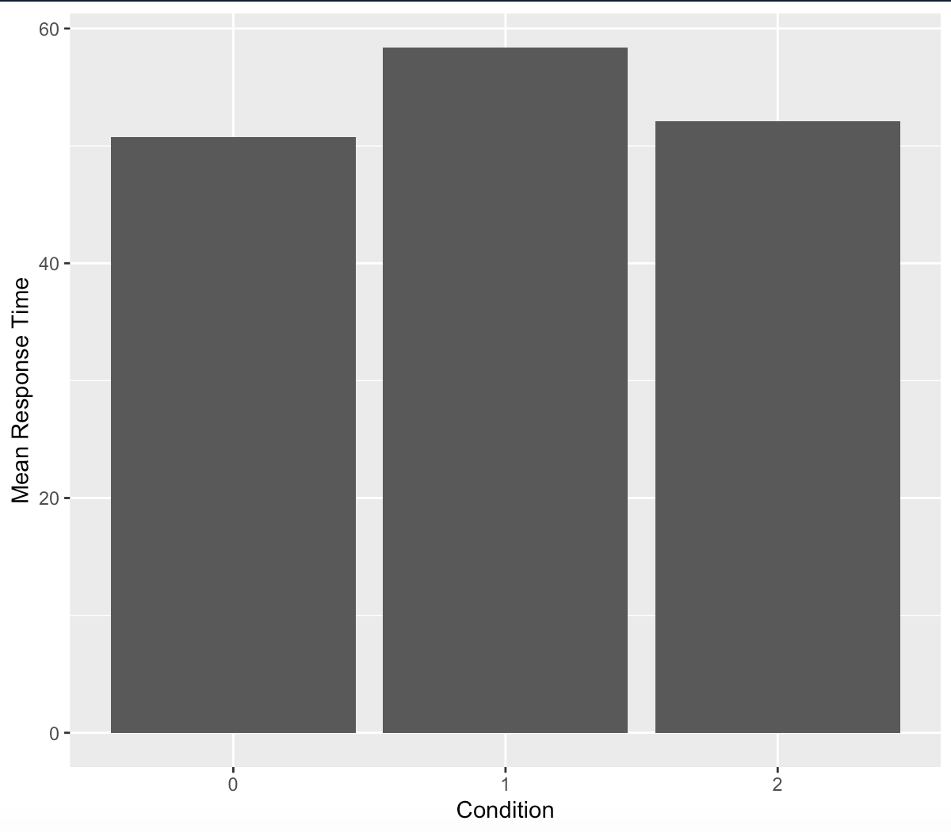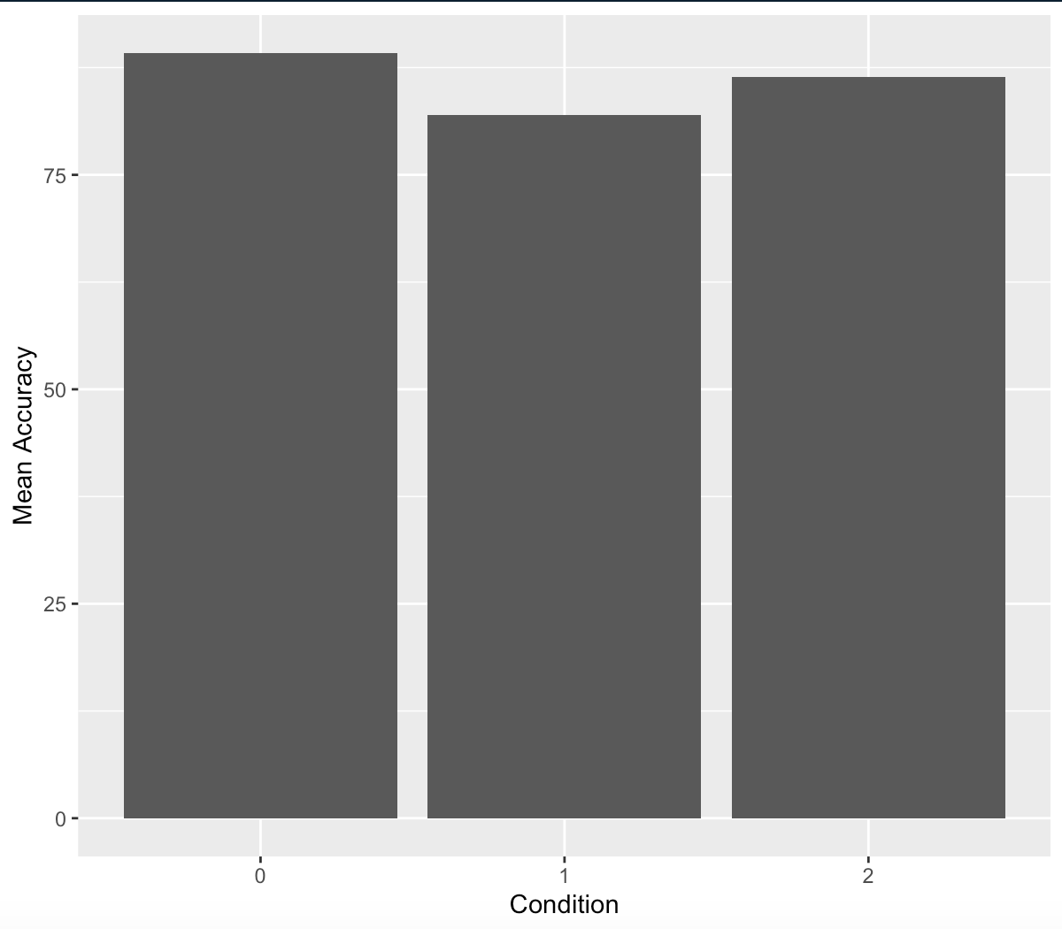

Figure 1: Response times histograms for conditions 0 (baseline), 1(same modality), and 2 (different modality), respectively.
Figure 2: Accuracy histograms for conditions 0 (baseline), 1(same modality), and 2 (different modality), respectively.

Further, a similar trend was seen in participant accuracy for the various conditions tested. The summary statistics mentioned in Appendix A show that the mean accuracy for a given participant is 89.21% for Condition 0, 81.98% for Condition 1, and 86.43% for Condition 2. The data these values are calculated from are illustrated in Figure 2. The null hypothesis states that the accuracy of a participant distracted in the same modality will be less than that of a participant distracted in a different modality. Thus, this information fails to disprove the null hypotheses.
However, this conclusion depends on the means of the above-mentioned data being reliable in the sense that the samples they originate from are independent, as well the values of the averages themselves being significantly different. This will be discussed in the following subsection.

Justification for Use of Means
In the previous subsection, averages were used as a means of comparison between the three conditions. It is enough to show that the samples come from a Normal distribution to justify this approach, due to symmetry. Two methods were used to confirm normality: the Shapiro-Wilk test and quantile-quantile plots. Then, two-sample independent t-tests were used to ensure a significant difference exists between the means of each condition.

Shapiro-Wilk Test
The Shapiro-Wilk test is an inferential analysis technique which tests for normality. Applying this test to the data yielded Table 1, below. The Shapiro-Wilk test confirms the normality of the data.
Table 1: Results from Shapiro-Wilk Test
 | Response Time | Accuracy
Condition 0: Baseline | W=0.97271, p-value=0.5773 | W=0.96447, p-value=0.3621
Condition 1: Same Modality | W=0.99146, p-value=0.9954 | W=0.97084, p-value=0.523
Condition 2: Different Modality | W=0.9607, p-value=0.287 | W=0.97866, p-value=0.7598

Quantile-Quantile Plot
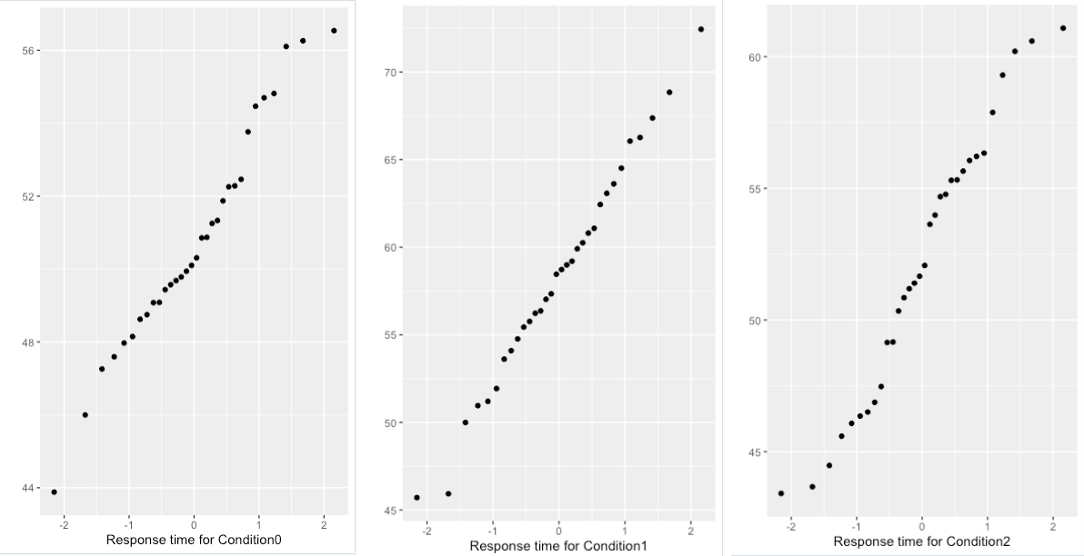
To further test the normality of our collected data, quantile-quantile plots were constructed for response times and accuracy of the data for each of the three conditions. Figures 3 and 4 suggest a linear relation, indicating that response times and accuracies are normally distributed for all the three conditions 0 (baseline), 1(same modality), and 2 (different modality).

Figure 3: Response time qq-plots for conditions 0 (baseline), 1 (same modality), and 2 (different modality), respectively.
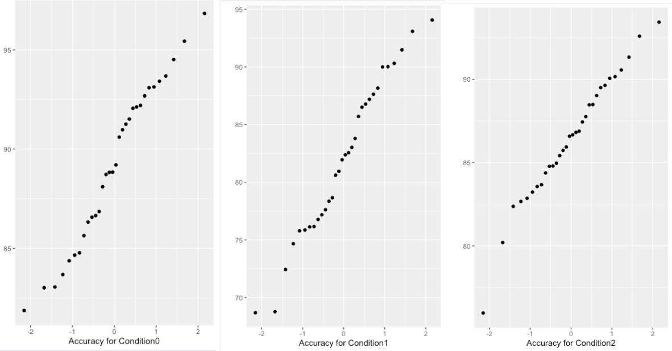
Figure 4: Accuracy qq-plots for conditions 0 (baseline), 1(same modality), and 2 (different modality), respectively.

Testing for Variance Homogeneity
In order to ensure that the variances of the populations from which each sample is drawn are equal, Levene’s test is used. This test states that if a p-value is less than 0.05, the hypotheses $H_{A}$ that the variable is normally distributed is rejected.
Table 2: Levene Test results for variance for conditions 0, 1, and 2 for response time and accuracy
 | P-value | F-value | Reject/FTR $H_{A}$
Response Time | 0.00165 | 6.8697 | Reject
Accuracy | 0.000211 | 9.2827 | Reject

After conducting Levene test to check for the homogeneity of variances in the response time and accuracy for the three conditions, it was found that the p-values for both response time and accuracy are less than 0.05, and therefore the collected data for response time and accuracy does not have homogeneous variance. Due to these violations of parametric assumptions, our analysis resulted as non-significant. We could argue that if we applied more appropriate methods (e.g., transformations or non-parametric assumptions), we may have obtained more interesting results.

One-Tailed Independent t-Test
When the p-value is less than the significance value 0.05, the null hypotheses: $μ_{A}-{ μ}_{B}=0$ is rejected. One-Tailed t-tests were conducted to determine if there is a significant difference between the means of Condition 0 and Condition 1, Condition 0 and Condition 2, and Condition 1 and Condition 2.
Table 3: Illustration of the results of the T-test for response times between the various conditions.
 | T-Value | P-Value
Condition 0 and 1 | 6.1191 | 1.09e-07
Condition 0 and 2 | 1.247 | 0.1091
Condition 1 and 2 | 4.3454 | 2.75e-05

The one sided t-test results suggest that the response time when a distraction with different modality is introduced is greater than the response time of the base-case scenario. This means that the distraction with the different modality slows the participant down. Moreover, the t-test results comparing the base case with the same modality distraction suggest that the hypotheses suggesting equal reaction times for base case and same modality distractions cannot be rejected. Therefore, it is concluded that the response time is not very different. Moreover, the t-tests suggest that the reaction time when different modality distraction is present is greater than when the same modality distraction is present.
Table 4: Illustration the results of the T-test for accuracy percentages between the various conditions.
 | T-Value | P-Value
Condition 0 and 1 | 5.1375 | 2.267e-06
Condition 0 and 2 | 2.8546 | 0.002934
Condition 1 and 2 | 3.2397 | 0.001091

Furthermore, the one-sided t-test suggests that accuracy suffers when a distraction of different modality is introduced, as well as when a distraction of the same modality is introduced. This essentially suggests that accuracy is decreased when a distraction of any kind is present. Furthermore, the t-test results suggest that the distraction of different modality affects the accuracy of the task more than the distraction of same modality.

Regression Analysis
A different approach was taken to test the hypotheses of the experiment. Fitting curve to the reaction time, and accuracy for: baseline to different modality, baseline to same modality, and different modality to same modality, result in obtaining six linear models. The models are then analyzed for drawing conclusions specific to the data collected.
Residuals: The residuals of the response time and accuracy values collected are normally distributed. The plots of these residuals are included in Appendix B. Furthermore, the q-q plot of the residuals of accuracy data and response time data show that these values are normally distributed (refer to Appendix B for the q-q plots).
A summary of the six fitted models brings insight into how the response time and accuracy change with respect to different conditions. The table in Appendix C contains the obtained results. The results suggest that for the collected response time data, the null hypotheses is to be rejected for baseline to different modality, and different modality to same modality, essentially suggesting that the relationship is sloped. Specifically, it suggests a positive slope for the first, and a negative slope for the ladder, which matched the obtained results from the t-tests. Therefore, it can be inferred that the response time is affected when a distraction of the same modality is introduced. The results further suggest that the response time is greater (slower-response time) when a task has distraction with different modality compared to when the task has the same modality distraction. In the case of baseline to same modality for response time data, the results suggest that the slope 𝞫1 is zero (null hypotheses was rejected). Therefore, suggesting that the response time is not affected significantly when a distraction with a different modality is introduced.
Furthermore, for the collected accuracy data, in case of all baseline to different modality, baseline to same modality, and different modality to same modality, the data suggest that the linear fit is sloped. Specifically, the data suggests a negative slope for base-line to different modality, positive slope for different modality to same modality, and negative slope from baseline to same modality. Therefore, it is implied that accuracy is affected when a distraction of the same modality is introduced, as well as when a distraction with a different modality is introduced. The results further suggest that accuracy is affected more when a task has distraction with different modality compared to when the task has the same modality distraction. Again the obtained results match with the results obtained from the t-tests.
However, the r-squared values tend to be small. This can be explained by the non-homogeneity of variances. The fitted model of the residuals are provided in appendix D. The model suggests that the variation of the residuals is not homogenous. This further suggests that the model is not a good linear model because of the non-homogeneity of its variance. Due to these violations of parametric assumptions, our analysis resulted as non-significant. We could argue that If we applied more appropriate methods (e.g., transformations or non-parametric assumptions), we may have obtained more interesting results.

LIMITATIONS
This section describes the limitations and shortcomings of the experiment, had it been undertaken. These include limitations in the experimental design, as well as the data accumulated.
Firstly, we were limited by our equipment available to measure accuracy. We had planned to have two team members walk with the participant to record the percentage of accuracy that they stayed within the bounds of the course. This could lead to a discrepancy between feet, since there are two different people recording each foot from different angles, as well as a discrepancy between participants. Another method we considered using to measure accuracy was by having the participants step in chalk and then we would have a trace of their footprints in our path, where we could measure the percentage of each footprint that remained within the bounds. However, this would be extremely messy to be feasible indoors, and there was too much snow at the time to do this experiment outdoors. Additionally, the variance for the data is not homogeneous. These violations of parametric assumptions resulted in our analysis being non-significant. In order to obtain more interesting results, we could have applied more appropriate methods such as transformations or non-parametric assumptions.

CONCLUSION
Therefore, the results above suggest that the distraction with different modality significantly increases the response time. But the distraction with the same modality has only a slightly increased response time. The findings also suggest that the distraction with different modality affects the response time more than the distraction with the same modality. Moreover, the accuracy suffers as the distraction with the different modality is introduced, as well as as the distraction with the same modality is introduced. Again, the distraction with different modality affects the accuracy more than the distraction with same modality. Thus, the null hypotheses could not be rejected.

REFERENCES
[1] "No National Progress in Reducing Pedestrian Fatalities | GHSA", Ghsa.org, 2020. [Online]. Available: https://www.ghsa.org/resources/news-releases/pedestrians18. [Accessed: 13- Feb- 2020].
[2] Deloitte, “2017 Global Mobile Consumer Survey: US edition”, Deloitte, Jul-2017
[3] Toronto.ca. (2020). [online] Available at: https://www.toronto.ca/wpcontent/uploads/2017/11/98b5-Chapter-4.pdf [Accessed 13 Feb. 2020].
[4] "Average Walking Speed: Pace, and Comparisons by Age and Sex", Healthline, 2020. [Online]. Available: https://www.healthline.com/health/exercise-fitness/average-walking-speed. [Accessed 13 Feb. 2020].

APPENDICES

Appendix A
The following table gives an overview of the response times under each condition.
 | Condition 0 | Condition 1 | Condition 2
Minimum | 43.88 | 45.71 | 43.42
First Quantile | 49.00 | 54.60 | 37.32
Median | 50.20 | 58.59 | 51.87
Mean | 50.78 | 58.39 | 52.10
Third Quantile | 52.33 | 62.60 | 55.75
Maximum | 56.54 | 72.44 | 61.08

The following table gives an overview of the accuracy of a participant under each condition.
 | Condition 0 | Condition 1 | Condition 2
Minimum | 81.87 | 68.68 | 75.97
First Quantile | 86.15 | 76.62 | 84.20
Median | 89.02 | 82.16 | 86.62
Mean | 89.21 | 81.98 | 86.43
Third Quantile | 92.32 | 87.30 | 89.15
Maximum | 96.83 | 94.07 | 93.43

Appendix B
Plot of residuals distributed around mean = 0

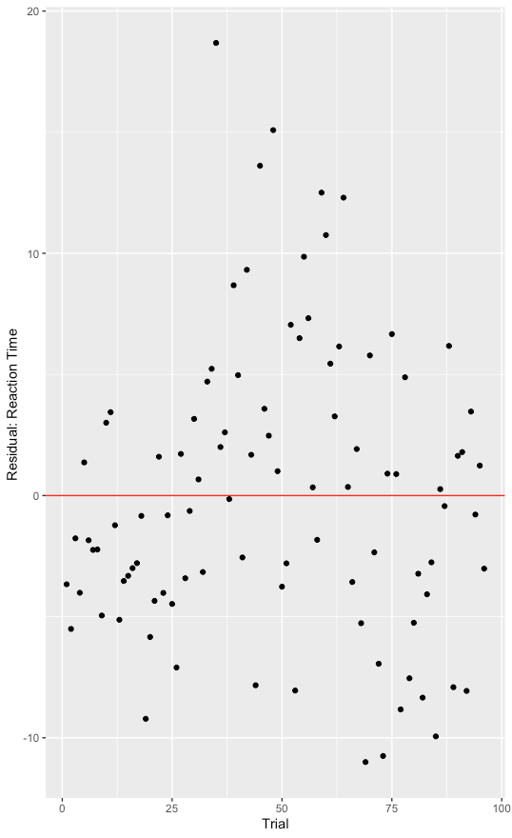

Plot of residuals distributed around mean = 0
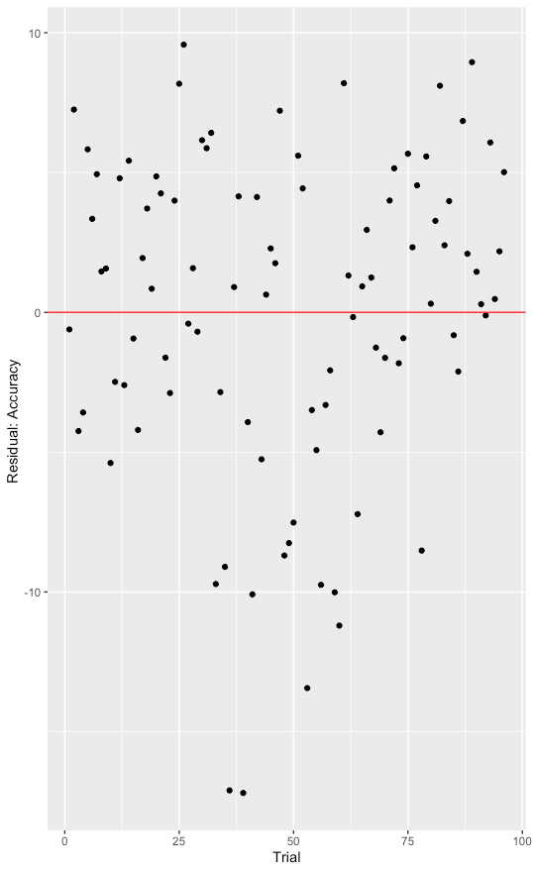

qq-plot for residuals for response times
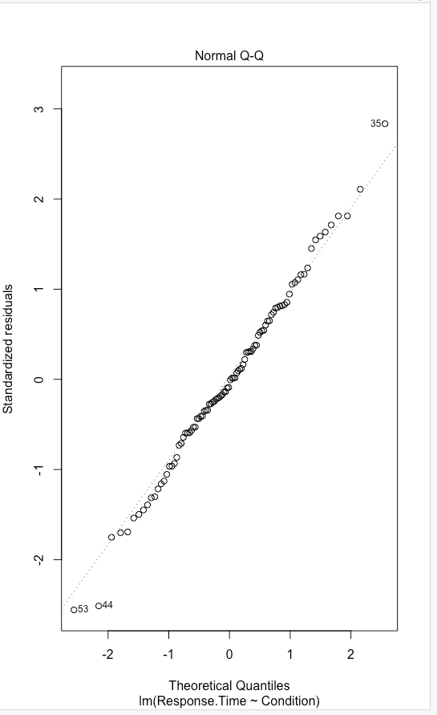

qq-plot for residuals for accuracy

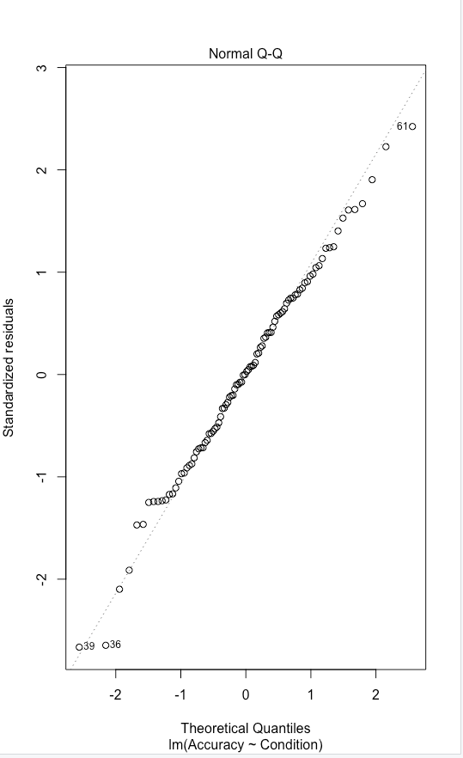

Appendix C
Regression analysis response time and accuracy
Response Time
   | 𝞫1 value | Adjusted R-squared | P-value (H0: 𝞫1 = 0) | reject/FTR
  baseline to different modality | 7.6048 | 0.3665 | 6.99e-08 | reject
  different modality to same modality | -6.285 | 0.2211 | 5.25e-05 | reject
  baseline to same modality | 1.3197 | 0.008732 | 0.217 | FTR
Accuracy
   | 𝞫1 value | Adjusted R-squared | P-value (H0: 𝞫1 = 0)
  baseline to different modality | -7.2308 | 0.2873 | 3e-06 | reject
  different modality to same modality | 4.4575 | 0.131 | 0.00193 | reject
  baseline to same modality | -2.7732 | 0.1019 | 0.005853 | reject

Appendix D
Fitted model for residuals of reaction time
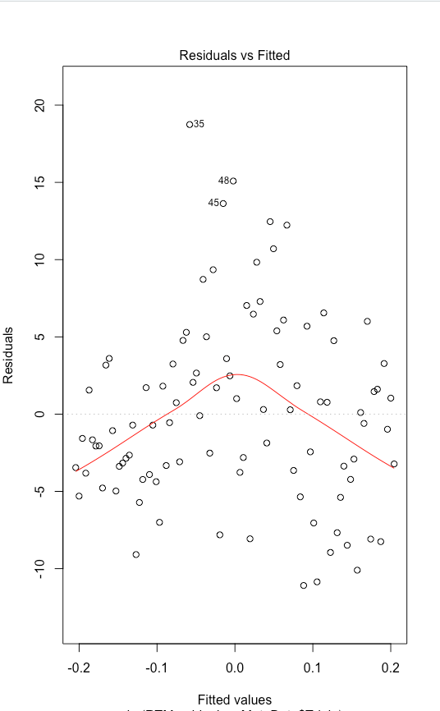

Fitted model for residuals of reaction time
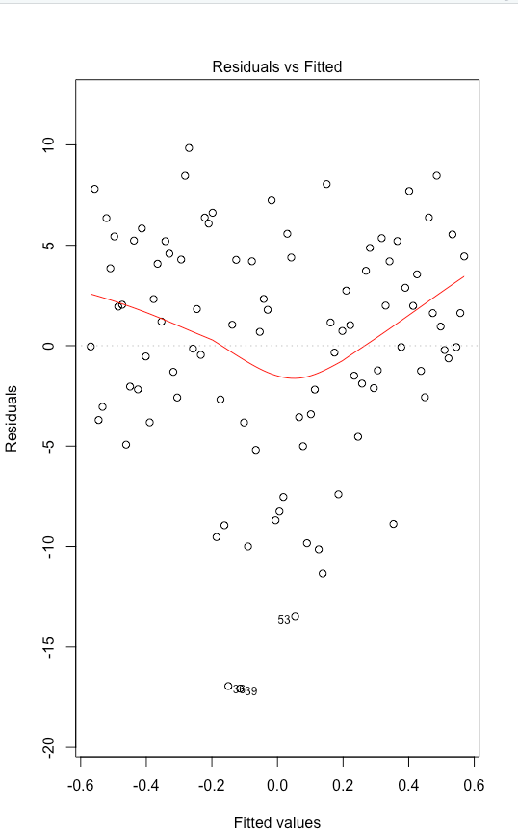

Attribution Table for MIE237-Term Project

This form must be filled out and signed by each team member for your term project. The completed form must be attached to the report, though not included as part of the document (i.e., not included in the table of contents, page numbers, or word count limits). It should accurately reflect each team members’ contribution to the project.
If there are irreconcilable differences that prevent all team members from signing the attribution table, then each team member must write a letter (max 800 words) explaining their position on the difference and suggest a solution.
Making fraudulent claims in an attribution table displays intent to deceive and is a serious academic offence.
Section | Student Names and Student Number
Section | Xiaorong Duan  1003165647 | Sajad Hashemi  1005502920 | Muhammad Shahzeb Ahmed  1005173214
Introduction | WD,FC, ET | WD,FC, ET | WD, FC, ET
Methodology | WD, FC, ET | WD, FC, ET | WD, FC, ET
Analyses | ET,FR,FC | ET, FR, FC | WD, FC, ET
Results | ET,FR,FC | EX, WD, MR, ET, FR, FC | WD, MR, ET
Limitations | WD, MR, ET | ET, FR, FC | ET, FC
Conclusion | ET,FR,FC | ET, FR, FC | ET, FR
References | ET, FR, FC | ET, FR, FC | ET, FR, FC
Appendices | ET, FR, FC | ET, FR, FC | ET, FR, FC
All | ET, FR, FC | ET, FR, FC | ET, FR, FC

RS – research
EX – ran the experiment
DA – performed the data analyses in R
WD – wrote first draft
MR – major revision
ET – edited for grammar and spelling
OR – other
FR – final read through of complete document for flow and consistency
FC – final compilation of completed document
CM – responsible for compiling the elements into the complete document

Fill in abbreviations for roles for each of the required content elements. You do not have to fill in every cell. The “all” row refers to the complete report and should indicate who was responsible for the final compilation and final read through of the completed document.
If you put OR (other) in a cell please put it in as OR1, OR2, etc. Explain briefly below the role referred to:
OR1: _____________________________
OR2: _____________________________

By signing below, you verify that you have:
- Read the attribution table and agree that it accurately reflects your contribution to the associated document.
- Written the sections of the document attributed to you and that they are entirely original.
- Accurately cited and referenced any ideas or expressions of ideas taken from other sources according to an accepted standard.
- Read the University of Toronto Code of Behaviour on Academic Matters and understand the definition of academic offense includes (but is not limited to) all forms of plagiarism. Additionally, you understand that if you provide another student with any part of your own or your team’s work, for whatever reason, and the student having received the work uses it for the purposes of committing an academic offence, then you are considered an equal party in the offence and will be subject to academic sanctions.

Print Name: Sajjad Hashemi Signature: _________________________
Print Name: Muhammad Shahzeb Ahmed Signature: _________________________
Print Name: Xiaorong Duan Signature: _________________________

