**UNI PARTITE GRAPH OF LQ**

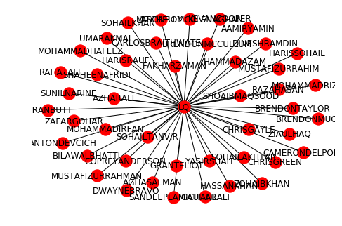

Lahore Qalandar after changing most of there players in all the season been most unsuccessful team in PSL

**UNI PARTITE GRAPH OF KK**

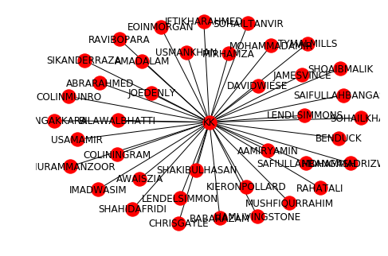

Analysis of this Karachi kings players shows that they have changed team players more than other teams but not than Lahore Qalandar.

**DATA COLLECTION:**

We can get the information of PSL from any website and their bio and from which team have played can get from any information but we have collected the data from <https://www.cricbuzz.com/cricket-series/2656/pakistan-super-league-2018/squads>

**INTRODUCTION:**

After completing the course of Discrete structure.We have to make projects which include nodes and edges through which we have to make a graph. Our sir give us project.

**DEFINITION OF BIPARTITE GRAPH**

*Bipartite graph is a graph whose vertices can be divided into two disjoint and independent sets*

*Our project give you description about PSL (Pakistan super league) players from which team have played in different season*

PSL (PAKISTAN SUPER LEAGUE) PLAYERS GRAPH

**UNI PARTITE GRAPH OF PZ**

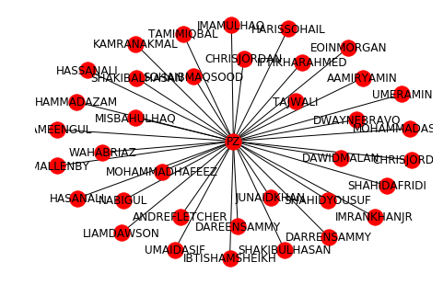

Analysis of Peshawar Zalmi team shows graph that after Quetta the second team which changed fewest player is Peshawar

**UNI PARTITE GRAPH OF MS**

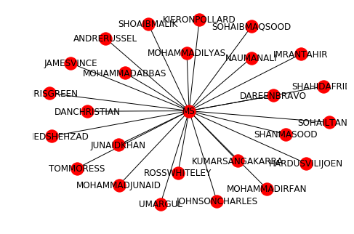

Analysis Of Multan Sultan Graph shows that Multan have changed few players because they have played only 2 season

**UNI PARTITE GRAPH OF IU**

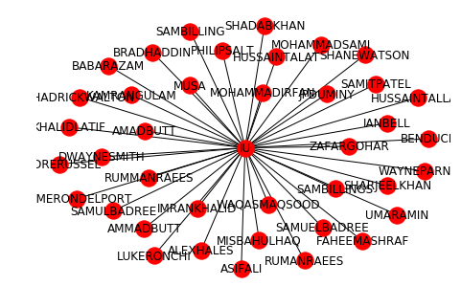

Analysis of Islamabad United player graph that after Quetta the third team which changed fewest player is Islamabad

**UNI PARTITE GRAPH OF QG**

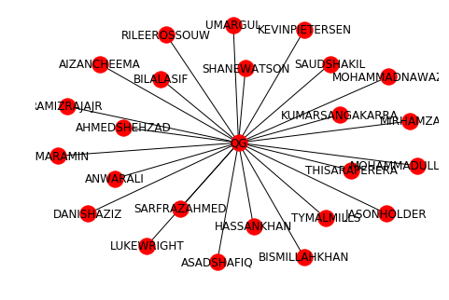

Quetta Gladiator has changed very few players total in 4 season. And it has been a one of the successful team .

Whole Graph of PSL total four season look like and the degree distribution is .

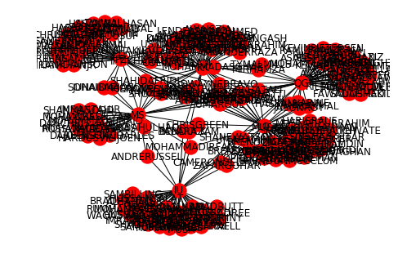

In this picture the light color state to be the teams and dark color shows the player in who has played different season in different teams.

